The quality of LED light alters the biometrics, bioactive compounds, mineral composition, and anatomy of in vitro micropropagated pitaya
Evens Clairvil*
Departamento de Biologia, Universidade Federal de Lavras, Lavras, Minas Gerais, Brazil. CEP: 37203-202. ORCID: https://orcid.org/0000-0002-0607-5236
*Corresponding author. E-mail: clairvilevens1@gmail.com
Marcelo de Almeida Guimarães
Departamento de Fitotecnia, Universidade Federal do Ceará, Fortaleza, Ceará, Brazil. ORCID: https://orcid.org/0000-0002-5329-022X
Luana de Jesus Sartori
Departamento de Biologia, Universidade Federal de Lavras, Lavras, Minas Gerais, Brazil. ORCID: https://orcid.org/0000-0003-0764-977X
Filipe Almendagna Rodrigues
Departamento de Agricultura, Universidade Federal de Lavras, Lavras, Minas Gerais, Brazil. ORCID: https://orcid.org/0000-0003-2433-4374
José Fábio Ferreira de Souza
Departamento de Fitopatologia, Universidade Federal de Lavras, Lavras, Minas Gerais, Brazil. ORCID: https://orcid.org/0009-0002-7913-7781
Eduardo Alves
Departamento de Fitopatologia, Universidade Federal de Lavras, Lavras, Minas Gerais, Brazil. ORCID: https://orcid.org/0000-0003-3185-9291
Joyce Dória
Departamento de Agricultura, Universidade Federal de Lavras, Lavras, Minas Gerais, Brazil. ORCID: https://orcid.org/0000-0002-7727-5016
Moacir Pasqual
Departamento de Agricultura, Universidade Federal de Lavras, Lavras, Minas Gerais, Brazil. ORCID: https://orcid.org/0000-0001-5612-9186
ABSTRACT
Light quality is a key environmental factor regulating plant physiology, acting both as an energy source for photosynthesis and as a signal controlling growth and development through photoreceptors. This study evaluated the effects of different LED light qualities (white, blue, purple, and red) on the biometric, physiological, biochemical, elemental, and anatomical characteristics of cladodes of Selenicereus undatus (Haw.) D.R. Hunt and Hylocereus polyrhizus (Salm-Dyck) R. Bauer (Cactaceae) micropropagated in vitro and cultured on MS medium for 65 days. Growth parameters, photosynthetic pigments, bioactive compounds, mineral composition, and anatomical traits were assessed. Selenicereus undatus showed greater biometric performance, with higher cladode diameter, shoot length, and biomass accumulation, particularly under purple and red light. In contrast, H. polyrhizus exhibited higher accumulation of photosynthetic pigments, especially under white light. Raman spectral analysis indicated treatment-dependent variation in carotenoid-related profiles in S. undatus, whereas H. polyrhizus showed stronger responses under purple and white light. Elemental analysis identified potassium as the predominant element in both species; however, S. undatus showed higher relative accumulation of Mg, P, Cl, and Zn, while H. polyrhizus exhibited higher levels of K, Ca, S, Fe, and Na. Principal component analysis revealed treatment-dependent variation in elemental profiles, with red light associated with higher relative Na and Cl, and blue light associated with higher relative Fe and Mn. Overall, purple and red light were associated with stronger growth responses in S. undatus, whereas white and blue light were more favorable for H. polyrhizus. These findings highlight species-specific responses to LED light environments and provide a basis for optimizing in vitro cultivation strategies for pitaya. Because light intensity was estimated using lux-based measurements and literature-derived conversion factors, PPFD values among treatments should be interpreted as approximate, and observed responses may reflect combined effects of spectral composition and estimated photon flux density.

Keywords: Hylocereus polyrhizus; Photomorphogenesis; Plant tissue culture; Selenicereus undatus; Vascular anatomy.

Key Message: LED light quality differentially modulates Selenicereus undatus and Hylocereus polyrhizus physiology and anatomy, optimizing micropropagation according to species-specific responses for growth and pigmentation.

Abbreviations: PPFD: Photosynthetic Photon Flux Density; LQ: Light Qualities; WL: White Light; BL: Blue Light; PL: Purple Light; RL: Red Light; CR: Central Rib; RM: Rib Margins; CE: Chemical Elements; Dm: Mean Diameter; SL: Shoot Length; FMS: Fresh Mass of Shoot; SDM: Shoot Dry Mass; RFM: Root Fresh Mass; RDM: Root Dry Mass; PP: Photosynthetic Pigments; Chl a: Chlorophyll a; Chl b: Chlorophyll b; Chl a+b: Total Chlorophylls; Car: Carotenoids; spp.: Species; PCA: Principal Component Analysis.

INTRODUCTION
The current scenario of large-scale plant production faces significant limitations imposed by regional and environmental constraints, hindering the commercial availability of high-value medicinal species (Anuruddi et al., 2023). Traditional cultivation, characterized by long development periods that can exceed three years, represents an additional barrier to the commercial availability of plants (Tian et al., 2021). In this context, in vitro cultivation techniques emerge as viable technological alternatives, providing rapid and consistent production of plant biomass, a particularly relevant aspect considering that more than 60% of anticancer drugs are derived from plants (Garcia-Oliveira et al., 2021; Wawrosch & Zotchev, 2021; Sarropoulou et al., 2023).
Among the species of high nutraceutical and pharmacological value, the pitaya species Selenicereus undatus (Haw.) D.R. Hunt and Hylocereus polyrhizus (Salm-Dyck) R. Bauer (Cactaceae), both threatened with extinction, possess important specific qualities that make them plants of global interest (Nishikito et al., 2023; Chen et al., 2024). S. undatus is recognized for its high nutritional value and rich composition of bioactive phytochemicals with nutraceutical properties, whereas H. polyrhizus stands out for its therapeutic potential in the prevention of diabetes, obesity, and cancer (Ravichandran et al., 2021; Yang et al., 2024). Considering that the traditional cultivation of these species from seeds requires up to three years to reach commercial maturity (Oo et al., 2023), their in vitro multiplication may represent an efficient biotechnological solution, with optimization potential through strategies based on light quality (Suman et al., 2017; Fan et al., 2022).
Light radiation, or light quality, is one of the most decisive environmental factors in regulating plant physiology, performing complementary functions throughout the plant life cycle. Light acts as an energy source for carbon assimilation processes during photosynthesis and, simultaneously, plays a crucial signaling role in regulating growth and developmental mechanisms through the activation of specific photoreceptors (Paradiso & Proietti, 2022). This functional duality establishes light as a central modulator of both primary and secondary metabolism, directly influencing immediate morphogenic responses and the biosynthesis of specialized metabolites (Hashim et al., 2021).
The implementation of Light-Emitting Diode (LED) technologies has revolutionized spectral quality control in cultivation systems. This technology enables the emission of wavelength ranges tailored to the specific physiological needs of plants, making it possible to induce targeted morphogenic responses (Dou et al., 2019; Hashim et al., 2021). In in vitro cultivation environments, the modulation of light quality assumes great importance, since different spectra trigger specific metabolic activities, optimizing both vegetative growth and the production of bioactive compounds (Manivannan et al., 2021). Scientific evidence indicates that strategic spectral combinations significantly enhance the in vitro development of multiple plant species (Ali et al., 2019; Chen et al., 2020; Silva et al., 2020).
The physiological characterization of light qualities reveals distinct functional specificities. White light, characterized by its broad and balanced spectrum, is effective in root development, shoot proliferation, aerial biomass accumulation, and carotenoid pigment synthesis in species such as Vanilla planifolia and Saccharum officinarum (Bello-Bello et al., 2016; De Araújo Silva et al., 2016; Cavallaro et al., 2022). Red light, recognized as the light quality with the highest photosynthetic efficiency, is widely used to optimize in vitro survival and enhance the production of secondary metabolites, acting as an efficient elicitor in the biosynthesis of pharmacologically active compounds (Hogewoning et al., 2010). Blue light plays regulatory roles in stomatal opening and transpiration and helps prevent morphological disorders associated with the “red light syndrome” (Lee et al., 2007; Davis & Burns, 2016). Combined light spectra, particularly purple light, resulting from the combination of blue and red wavelengths, have shown superior effectiveness in the cultivation of plants with pharmacological properties (Cuong et al., 2019; Nadeem et al., 2019). This combination of different LED light qualities contributes to an increase in net photosynthetic rate and dry biomass accumulation and is widely applied in the controlled cultivation of species such as potato (Solanum tuberosum), Brazilian ginseng (Pfaffia glomerata), and Brassica chinensis (Hogewoning et al., 2010; Ani et al., 2015; Luz et al., 2015).
Despite the established advances in light quality modulation to enhance growth efficiency and phytochemical production, significant gaps still, remain in the understanding of aspects related to cladodes of in vitro cultivated pitaya species. This study evaluated the effects of different LED light qualities (white, blue, purple, and red) on the biometric, physiological, biochemical, elemental, and anatomical characteristics of cladodes from Selenicereus undatus (Haw.) D.R. Hunt and Hylocereus polyrhizus (Salm-Dyck) R. Bauer (Cactaceae) micropropagated in vitro and cultured in MS medium for 65 days.

MATERIALS AND METHODS
The experiment was conducted at the Laboratório de Cultura de Tecidos of the Departamento de Agricultura, Universidade Federal de Lavras (UFLA), in Lavras, Minas Gerais State, Brazil.

Plant material and in vitro culture
Plants (2.5 ± 0.5 cm) of Selenicereus undatus (Haw.) D.R. Hunt and Hylocereus polyrhizus (Salm-Dyck) R. Bauer, previously established in MS medium (Murashige and Skoog, 1962) without plant growth regulators, were used as a source of explants. Cladodes (~1.5 cm in length) were inoculated into 250 mL glass flasks containing 50 mL of MS medium supplemented with 30 g L⁻¹ sucrose and 5.6 g L⁻¹ agar (Agargel Indústria e Comércio Ltda). The medium pH was adjusted to 6.0 ± 0.2 prior to autoclaving at 121 °C and 1.2 atm for 20 min. Five cladodes were inoculated per flask under sterile conditions in a laminar flow chamber (VECO®, HLFS-12).
Cultures were maintained in a growth room at 25 ± 2 °C for 65 days under a 16 h photoperiod. LED lamps (Empalux® FT8 HO, 36 W / 6400 K) with different spectral compositions provided illumination: white (WL), blue (BL), purple (PL), and red (RL).
Light intensity at shelf level was measured using a digital lux meter (Politerm®, POL-10B). Measurements were taken at three positions (left, center, and right) across the culture shelves (1.29 m²), positioned 21 cm below the LED sources and approximately 3 cm above the top of the culture flasks. Mean illuminance (lux) values were converted to estimated photosynthetic photon flux density (PPFD, μmol m⁻² s⁻¹) using spectrum-dependent conversion factors derived from established relationships between photometric (lux) and quantum (PAR) measurements in controlled environment lighting systems (Yeh & Chung, 2009; Hernández & Kubota, 2016; Bugbee, 2014). Because the conversion depends strongly on spectral composition, specific factors were applied for each LED treatment (white, blue, red, and purple), resulting in estimated PPFD values of approximately 40, 31, 34, and 32 μmol m⁻² s⁻¹, respectively.
Given the inherent limitations of lux-based measurements and their dependence on spectral distribution, particularly in narrow-band LED systems, PPFD values are presented as estimates. Nevertheless, lighting conditions were standardized to ensure comparable photosynthetically active radiation levels across treatments, allowing treatment effects to be primarily attributed to spectral quality rather than major differences in photon flux density.
Biometric characteristics
Biometric parameters, including cladode diameter (mm), shoot length (cm), and fresh and dry masses (g) of the shoot and root of the cladodes, were measured in ten randomly selected plants from each treatment, 65 days after inoculation. Cladode diameter and shoot length were measured using a millimeter ruler. Fresh masses of the shoot and root were determined immediately after sample collection using an analytical balance (OHAUS, model PR224BR) with four decimal places. Subsequently, the plant material was dried in a forced-air oven at 65 °C for 72 hours until constant weight was achieved. After drying, the samples were allowed to reach thermal stabilization in a styrofoam box, and then the dry masses of the shoot and root were measured using the same analytical balance.

Photosynthetic pigments
The analysis of photosynthetic pigments was performed using cladodes (± 0.050 g) from five plants of Selenicereus undatus and Hylocereus polyrhizus, randomly selected from each treatment after 65 days of in vitro cultivation. The cladodes were transferred to test tubes containing 5 mL of 80% acetone for the extraction of chlorophylls and carotenoids. The tubes were wrapped in aluminum foil to prevent chlorophyll degradation. Twenty-four hours after storage in a refrigerator at ± 4 °C, the absorbance of the samples was measured using a Multiskan GO spectrophotometer (Thermo Fisher Scientific) at wavelengths of 470 nm (Abs₄₇₀), 647 nm (Abs₆₄₇), and 663 nm (Abs₆₆₃) (Scopel et al., 2011). The contents of chlorophyll ‘a’, chlorophyll ‘b’, total chlorophylls, and carotenoids were calculated based on equations (Lichtenthaler & Wellburn, 1983 and Lichtenthaler & Babani, 2021). Absorbance measurements were performed in five replicates per treatment, with each replicate evaluated in hexaplicate. The analysis was performed using SkanIt Software 5.0 for Microplate Readers, version 5.0.0.42.

Raman spectroscopic analysis
Raman microscopy (RM) was used to evaluate the presence of bioactive compounds, particularly spectral bands associated with betacyanins (1000–1200 cm⁻¹), phenolic compounds (1400–1600 cm⁻¹), and other antioxidant-related metabolites (1000–1600 cm⁻¹) in fresh cladodes of Selenicereus undatus and Hylocereus polyrhizus cultured under different LED light qualities. For this analysis, three plants per treatment were randomly selected and considered as biological replicates. From each plant, cladode samples were collected 65 days after inoculation and analyzed using a Confocal Raman Microscopy system (Alpha300, Witec) equipped with a 785 nm laser and 10× and 50× objectives. Multiple spectra were acquired per sample to ensure representativeness of the chemical profile. This analysis was performed as a comparative and exploratory assessment of metabolite-related spectral patterns among treatments.

Energy-dispersive X-ray spectroscopy (EDX)
Energy-dispersive X-ray spectroscopy (EDX) analyses were performed using a scanning electron microscope (TESCAN-CLARA) equipped with a Bruker Quantax EDX detector (XFlash 6|60). Three plants per treatment were randomly selected and used as biological replicates. From each plant, cladode samples were collected 65 days after inoculation and prepared for elemental analysis. Samples were mounted on aluminum stubs using double-sided carbon tape (HOGOTEK, model 7321) and dried at 70 °C for 12 hours, followed by storage in a desiccator with silica gel for at least 24 hours prior to analysis. EDX analyses were conducted at 20 keV with magnifications of 200× and 400×, and were used to determine the relative atomic percentages of selected elements (K, Ca, S, Mg, P, Cl, Fe, Mn, Na, and Zn) in the central ribs and along the rib margins of the cladodes. This analysis was performed as a comparative assessment of elemental distribution patterns among treatments.

Anatomical analyses
The anatomical analyses were performed on cladodes and roots from five plants per treatment, randomly collected after 65 days of in vitro cultivation. The cladodes and roots were fixed in FAA solution (formalin, acetic acid, and 50% ethanol in a 0.05:0.05:0.90 ratio) for 72 hours. Subsequently, dehydration was performed using alcohol at increasing concentrations (70%, 80%, 90%, and 100%), with 2-hour intervals between each step (Johansen, 1940). The samples were immersed in a solution composed of 50% alcohol and 50% pure resin for 72 hours, fixed with pure resin, and hardened in a solution containing 15% pure resin and 1% hardener to facilitate the sectioning process (Clairvil et al., 2025; Clairvil et al., 2026). Anatomical analysis was performed on five transverse sections per plant; with cuts of nine μm thickness obtained using a semi-automatic rotary microtome (MRS 3500). The sections were stained with 0.05% Toluidine Blue solution and mounted on permanent slides using glycerinated gelatin.
The analyses included counting the number of vascular bundles and measuring the cross-sectional area (mm²) of the cladodes, root area (mm²) and total root diameter (µm) measured from one outer edge of the epidermis to the opposite side. The sections were observed under a light microscope (Nikon, Eclipse E100) equipped with a digital camera (Infinity) for image capture. The photomicrographs obtained were used to measure the anatomical characteristics.
The cross-sectional area of the cladodes was measured using a 4× objective lens; the number of vascular bundles, root area, and total root diameter were measured using a 20× objective lens. All measurements were performed using the calibrated UTHSCSA-ImageTool® software. Due to the image size relative to the field of view of the microscope-mounted camera, each cladode cross-section was photographed in two parts (upper and lower) to facilitate measurement of the total area.

Statistical analysis
The experiment was conducted in a completely randomized design with two plant species (Selenicereus undatus (Haw.) D.R. Hunt and Hylocereus polyrhizus (Salm-Dyck) R. Bauer) and four LED light qualities (white, blue, purple, and red), arranged in a 2 × 4 factorial scheme. Data were analyzed using R Studio software (version 4.2.2). Analysis of variance (ANOVA) was performed to evaluate the effects of treatments and their interactions. When significant differences were detected (p ≤ 0.05), means were compared using Tukey’s honestly significant difference (HSD) post hoc test at a 5% probability level. Results are presented as mean ± standard error, and significant differences among treatments are indicated by different letters in figures and tables.

RESULTS AND DISCUSSION
Different LED light spectra influenced the initial growth of Selenicereus undatus (Haw.) D.R. Hunt and Hylocereus polyrhizus (Salm-Dyck) R. Bauer (Figure 1).
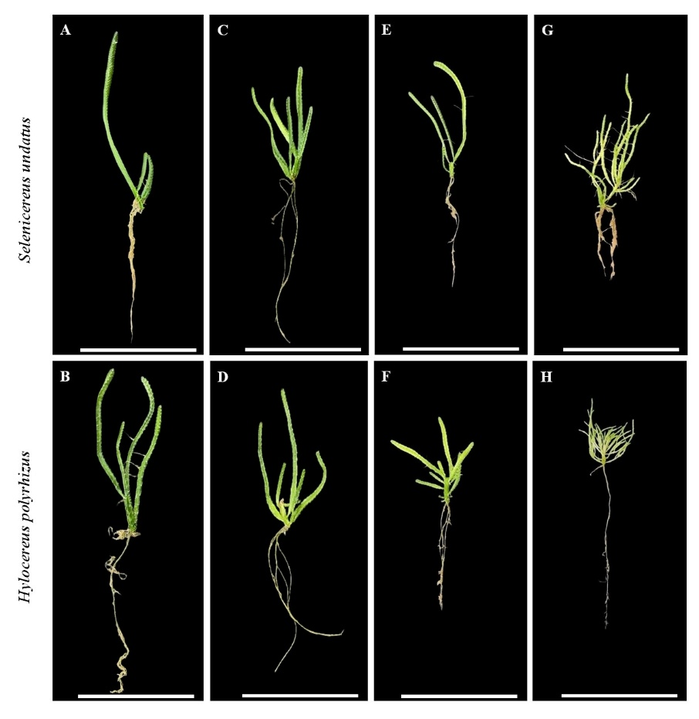

Figure 1. Specimens of Selenicereus undatus (Haw.) D.R. Hunt and Hylocereus polyrhizus (Salm-Dyck) R. Bauer after 65 days of in vitro cultivation under different LED light qualities [White (A–B), Blue (C–D), Purple (E–F), and Red (G–H)]. Scale bar = 2 cm.

After 65 days of exposing S. undatus and H. polyrhizus plants to different LED light qualities [White (WL), Blue (BL), Purple (PL), Red (RL)], no significant interactions were observed with respect to cladode diameter (Table 1). In contrast, significant interactions were observed for biometric variables (shoot length, and fresh and dry mass of the shoot and root), photosynthetic pigment content, and anatomical parameters (number of vascular bundles and cross-sectional area of the cladodes, root area and total root diameter) (Tables 2 and 3; Figures 4 and 5).

Table 1. Mean cladode diameter (Dm; mm) of pitaya species Selenicereus undatus (Haw.) D.R. Hunt and Hylocereus polyrhizus (Salm-Dyck) R. Bauer after 65 days of in vitro cultivation under different light qualities (LQ) [White: WL; Blue: BL; Purple: PL; Red: RL].
spp. | Dm | LQ | Dm
S. undatus | 0.728±0.013ª | WL | 0.694±0.017B
H. polyrhizus | 0.690±0.009^{b} | BL | 0.703±0.019B
 |  | PL | 0.723±0.023A
C.V. = 6.45% |  | RL | 0.715±0.024A
Means (± standard error) followed by different lowercase letters (species) and uppercase letters (light quality) within the same column differ significantly according to Tukey's honestly significant difference (HSD) test at the 5% significance level (p ≤ 0.05). Values represent factor means due to the absence of a significant interaction between species and light quality. C.V. = coefficient of variation (%).
The mean cladode diameter of S. undatus, considering all evaluated light qualities, was greater than that of H. polyrhizus. The highest mean cladode diameters were observed under purple (0.723 mm) and red (0.715 mm) light, which did not differ significantly from each other, but were higher than those recorded under blue and white light (Table 1).
The greater cladode diameter observed under red and purple LED treatments is consistent with previous studies reporting improved growth of pitaya under light environments enriched in red wavelengths (Huang et al., 2022). Similarly, the response observed under the combined red and blue spectrum (purple light) agrees with reports indicating that mixed wavelengths may be more suitable for in vitro plant development than monochromatic light conditions. In the present study, red and purple LED treatments were associated with greater cladode expansion than blue light, suggesting that spectral composition contributed to the observed morphological differences.
However, because slight differences in estimated PPFD among treatments could not be completely eliminated, the responses should be interpreted as resulting from the combined influence of light spectrum and photon flux density rather than spectral quality alone. Previous studies have suggested that red wavelengths may influence photomorphogenic responses through phytochrome-related processes (Huang et al., 2022); however, these mechanisms were not directly assessed in the present study and are therefore considered only as potential explanations for the observed growth patterns.

The biometric characteristics of S. undatus and H. polyrhizus propagules did not differ significantly under white light. However, under blue, purple, and red light, S. undatus exhibited greater shoot length (1.410, 1.613, and 1.694 cm, respectively), shoot fresh mass (1.029, 1.256, and 1.218 g, respectively), and shoot dry mass (0.362, 0.408, and 0.401 g, respectively), as well as higher root fresh mass (0.698, 0.904, and 0.816 g, respectively) and root dry mass (0.017, 0.023, and 0.026 g, respectively) (Table 2).
Table 2. Shoot length (LAP, cm), shoot fresh mass (FMAP, g plant⁻¹) and root fresh mass (DMAP, g plant⁻¹), and shoot dry mass (FMR, g plant⁻¹) and root dry mass (DMR, g plant⁻¹) of cladodes of pitaya species Selenicereus undatus (Haw.) D.R. Hunt and Hylocereus polyrhizus (Salm-Dyck) R. Bauer after 65 days of in vitro cultivation under different light qualities (LQ) [White (WL); Blue (BL); Purple (PL); Red (RL)].
 | spp. | LQ |  |  |  | C.V.
 | spp. | WL | BL | PL | RL | C.V.
LAP | S. undatus | 1.361^{0.132}Ba | 1.410^{0.165}Ba | 1.613^{0.321}Aa | 1.694^{0.344}Aa | 8.97
LAP | H. polyrhizus | 1.354^{0.176}Ba | 1.253^{0.116}Cb | 1.372^{0.143}Bb | 1.502^{0.118}Ab
FMAP | S. undatus | 0.908^{0.074}Ca | 1.029^{0.133}Ba | 1.256^{0.276}Aa | 1.218^{0.330}Aa | 8.99
FMAP | H. polyrhizus | 0.886^{0.097}Aa | 0.876^{0.020}Ab | 0.870^{0.046}Ab | 0.847^{0.043}Ab
DMAP | S. undatus | 0.303^{0.003}Ba | 0.362^{0.006}Aa | 0.408^{0.007}Aa | 0.401^{0.014}Aa | 10.17
DMAP | H. polyrhizus | 0.304^{0.005}Aa | 0.288^{0.003}Ab | 0.295^{0.002}Ab | 0.300^{0.001}Ab
FMR | S. undatus | 0.477^{0.037}Ba | 0.698^{0.078}Aa | 0.904^{0.163}Aa | 0.816^{0.339}Aa | 24.57
FMR | H. polyrhizus | 0.564^{0.082}Aa | 0.462^{0.002}Ab | 0.597^{0.072}Ab | 0.415^{0.021}Ab
DMR | S. undatus | 0.011^{0.002}Ba | 0.017^{0.002}Aa | 0.023^{0.003}Aa | 0.026^{0.008}Aa | 14.39
DMR | H. polyrhizus | 0.006^{0.001}Aa | 0.004^{0.001}Ab | 0.010^{0.001}Ab | 0.006^{0.001}Ab
Means (± standard error) followed by the same uppercase letter within rows (light quality) and the same lowercase letter within columns (species) are not significantly different according to Tukey's honestly significant difference (HSD) test (p ≤ 0.05). C.V. = coefficient of variation (%).

The cladodes of S. undatus exhibited the greatest shoot length under purple (1.613 cm) and red (1.694 cm) light, whereas in H. polyrhizus, the highest value was observed under red light (1.502 cm). Similarly, the shoot fresh mass of S. undatus cladodes was highest under purple (1.256 g) and red (1.218 g) light.
Shoot dry mass, as well as root fresh and dry mass, were also greater under purple (0.408, 0.904, and 0.023 g, respectively), red (0.401, 0.816, and 0.026 g, respectively), and blue (0.362, 0.698, and 0.017 g, respectively) light. In contrast, no significant differences in fresh or dry mass were observed among light qualities for H. polyrhizus cladodes (Table 2).
The superior biometric performance of Selenicereus undatus compared with Hylocereus polyrhizus suggests interspecific differences in growth responses under the evaluated LED treatments, reflecting distinct developmental characteristics between the two species. In this study, phenotypic plasticity is interpreted in a trait-specific context, referring to the capacity of each species to modify distinct phenotypic traits in response to LED light treatments. Accordingly, we distinguish between morphological plasticity (growth and anatomical traits) and mineral plasticity (variation in elemental composition), rather than treating plasticity as a single integrated response. These findings are consistent with previous reports demonstrating greater morphological plasticity in S. undatus under controlled environmental conditions (Cavallaro et al., 2022) and support the need to optimize LED lighting according to species-specific requirements during pitaya micropropagation (De Vasconcelos Dias et al., 2025). Under the experimental conditions of the present study, red and purple LED treatments were associated with greater vegetative development in S. undatus. Previous studies have suggested that red and blue wavelengths may influence plant growth through photoreceptor-related processes (Huang et al., 2022; Yun et al., 2023); however, since these processes were not directly investigated, they are considered here only as possible explanations for the observed responses. In contrast, H. polyrhizus exhibited greater mineral plasticity, as indicated by stronger modulation of tissue mineral composition under the LED treatments. These results indicate that phenotypic plasticity is expressed at different biological levels in the two species, with S. undatus showing stronger morphological responsiveness and H. polyrhizus showing stronger variation in mineral composition.
Greater biomass accumulation in S. undatus indicates higher vegetative growth performance under the evaluated in vitro conditions. Although S. undatus is a Crassulacean Acid Metabolism (CAM) species, CAM activity was not assessed in the present study; therefore, the results should be interpreted as differences in growth performance rather than as evidence of changes in carbon assimilation pathways. Previous studies have likewise reported that LED light quality influences biomass accumulation and morphogenesis in pitaya under controlled conditions (Nhut et al., 2003; Cavallaro et al., 2022; Shang et al., 2023).
In contrast, Hylocereus polyrhizus exhibited lower overall biometric performance, with the greatest growth observed under white light, suggesting that broader-spectrum illumination may provide more favorable conditions for its development under the experimental conditions. The reduced growth observed under red light indicates species-specific differences in responses to LED treatments, reflecting distinct growth patterns among pitaya species during in vitro culture (Sarropoulou et al., 2023; Cossa et al., 2024; Kim et al., 2025).
Because slight differences in estimated PPFD among LED treatments could not be completely eliminated, the observed responses likely reflect the combined influence of spectral composition and photon flux density.

Photosynthetic pigment contents varied between the pitaya species S. undatus and H. polyrhizus, as well as in response to light quality during in vitro cultivation. In S. undatus, cladodes showed higher accumulation of chlorophyll a and total chlorophyll under blue light (0.615 and 0.687 μg g⁻¹, respectively). Chlorophyll b and carotenoids reached their highest levels under blue (0.452 and 0.416 μg g⁻¹, respectively), white (0.425 and 0.378 μg g⁻¹, respectively), and purple light (0.412 and 0.376 μg g⁻¹, respectively), with no significant differences among these treatments. In contrast, H. polyrhizus exhibited higher concentrations of photosynthetic pigments under white light, with chlorophyll a at 0.709 μg g⁻¹, chlorophyll b at 0.532 μg g⁻¹, total chlorophyll at 0.798 μg g⁻¹, and carotenoids at 0.488 μg g⁻¹. In both species, the lowest pigment concentrations were observed under red light; however, in H. polyrhizus, no significant differences were detected among red, blue, and purple light for chlorophyll b and total chlorophyll (Table 3).

Table 3. Photosynthetic pigment contents (PP) – chlorophyll a (Chl a), chlorophyll b (Chl b), total chlorophylls (Chl a+b), and carotenoids (Car), in μg g⁻¹ of fresh mass of cladodes from pitaya species Selenicereus undatus (Haw.) D.R. Hunt and Hylocereus polyrhizus (Salm-Dyck) R. Bauer after 65 days of in vitro cultivation under different light qualities (LQ) [White (WL); Blue (BL); Purple (PL); Red (RL)].
PP | spp. | LQ |  |  |  | C.V.
 | spp. | WL | BL | PL | RL | C.V.
Chl a | S. undatus | 0.542^{0.028}Bb | 0.615^{0.016}Aa | 0.502^{0.014}Ba | 0.344^{0.003}Cb | 7.99
Chl a | H. polyrhizus | 0.709^{0.035}Aa | 0.579^{0.027}Ba | 0.561^{0.020}Ba | 0.506^{0.017}Ca
Chl b | S. undatus | 0.425^{0.017}Ab | 0.452^{0.010}Aa | 0.412^{0.010}Aa | 0.282^{0.003}Bb | 8.60
Chl b | H. polyrhizus | 0.532^{0.012}Aa | 0.442^{0.009}Ba | 0.415^{0.008}Ba | 0.383^{0.006}Ba
Chl a+b | S. undatus | 0.618^{0.045}Bb | 0.687^{0.025}Aa | 0.582^{0.023}Ba | 0.399^{0.006}Cb | 8.05
Chl a+b | H. polyrhizus | 0.798^{0.047}Aa | 0.655^{0.036}Ba | 0.629^{0.028}Ba | 0.571^{0.022}Ba
Car | S. undatus | 0.378^{0.010}Ab | 0.416^{0.005}Aa | 0.376^{0.005}Aa | 0.238^{0.002}Bb | 7.86
Car | H. polyrhizus | 0.488^{0.010}Aa | 0.421^{0.008}Ba | 0.386^{0.008}Ba | 0.350^{0.005}Ca
Means (± standard error) followed by the same uppercase letter within rows (light quality) and the same lowercase letter within columns (species) are not significantly different according to Tukey's honestly significant difference (HSD) test (p ≤ 0.05). C.V. = coefficient of variation (%).

Between the species, H. polyrhizus exhibited higher pigment contents than S. undatus under white and red light. Under blue and purple light, no significant differences in pigment contents were observed between the two species (Table 3).
The higher pigment contents recorded in Hylocereus polyrhizus under white light, compared with the other LED treatments, indicate species-specific differences in pigment accumulation relative to Selenicereus undatus (Yaoyuan et al., 2025). This pattern is supported by differences in total chlorophyll content, suggesting that the two species respond differently to the evaluated lighting conditions (Sumi et al., 2025; Yaoyuan et al., 2025). White light, characterized by a broader spectral distribution than monochromatic LEDs, was associated with greater pigment accumulation in H. polyrhizus. Previous studies have reported that the simultaneous presence of blue and red wavelengths supports chlorophyll biosynthesis, photomorphogenic responses, and balanced excitation of photosystems I and II, contributing to more efficient light utilization (Baidya et al., 2021; Liu & Van Iersel, 2021; Yaoyuan et al., 2025). Although these physiological processes were not directly investigated in the present study, they provide plausible explanations for the observed responses.
Similarly, the greater pigment accumulation observed in Selenicereus undatus under blue light is consistent with previous reports describing positive effects of blue wavelengths on pigment accumulation under controlled conditions. Blue light has been associated with regulation of photoreceptor-related processes involved in chlorophyll biosynthesis and chloroplast development in several species (Raqiba & Sibi, 2019; Liu & Van Iersel, 2021; Wu et al., 2024; Yaoyuan et al., 2025). However, since photoreceptor activity and gene expression were not assessed in the present study, these mechanisms should be considered as possible explanations rather than direct evidence.
In contrast, both pitaya species exhibited lower pigment accumulation under red light compared with broader-spectrum treatments. This suggests that monochromatic red light alone may be less effective in maintaining chlorophyll and carotenoid levels under the experimental conditions. Previous studies have likewise reported that the absence of blue wavelengths may reduce pigment accumulation by limiting physiological processes associated with chlorophyll biosynthesis (Sumi et al., 2025; Yaoyuan et al., 2025).
Because slight differences in estimated PPFD among LED treatments could not be completely eliminated, pigment responses should be interpreted as resulting from the combined influence of spectral composition and photon flux density.

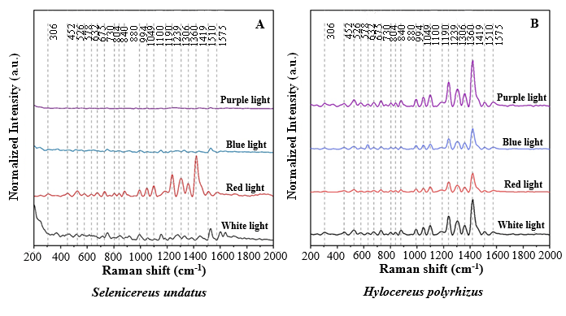
The synthesis of bioactive compounds in the cladodes of S. undatus and H. polyrhizus varied under different LED light qualities, as reflected by differences in Raman spectral features associated with betalains (1000–1200 cm⁻¹), phenolic compounds (1400–1600 cm⁻¹), and antioxidant-related regions (1000–1600 cm⁻¹) (Figure 2).

Figure 2. Raman spectra of Selenicereus undatus (Haw.) D.R. Hunt and Hylocereus polyrhizus (Salm-Dyck) R. Bauer after 65 days of in vitro cultivation, under different light qualities [Purple, Blue, Red, and White]: comparative analysis of biochemical profiles. Data represent the mean of three replicates per treatment.

These spectral regions have been previously identified as relevant for the detection of secondary metabolite-related compounds in plant tissues (Vershinina et al., 2025; De Angelis et al., 2025). In the present study, differences among treatments were expressed as variations in Raman signal intensity and spectral profiles rather than quantitative metabolite concentrations.
Hylocereus polyrhizus showed more pronounced Raman signal intensities across several spectral regions under white, blue, and purple light, whereas S. undatus exhibited relatively stronger signals under red light. The most evident spectral features were observed in H. polyrhizus under purple light and in S. undatus under red light, particularly in the 1400–1500 cm⁻¹ region (Figure 2), indicating treatment-dependent variation in biochemical composition.
In S. undatus, spectral variations indicated changes in the relative intensity of bands associated with betalains, phenolic compounds, and antioxidant-related molecules under different light qualities (Figure 2). White and red light were associated with more pronounced spectral signals, whereas purple light showed comparatively lower signal intensity. Blue light induced intermediate responses. Previous studies have reported that red and blue wavelengths can influence secondary metabolism through photoreceptor-mediated signaling pathways involved in plant metabolic regulation (Griffin & Toledo-Ortiz, 2022; Pierik & Ballaré, 2021). However, since gene expression and photoreceptor activity were not assessed, these mechanisms should be considered as potential explanatory frameworks rather than direct evidence.
Similarly, H. polyrhizus exhibited marked spectral variations across treatments, with white light associated with more complex Raman spectral profiles, followed by purple and red light, whereas blue light showed comparatively lower spectral intensity in the analyzed regions (Figure 2). The association between spectral features and antioxidant-related compounds is consistent with previous reports describing the antioxidant potential of pitaya betacyanins (Chen et al., 2021; Paśko et al., 2021). In addition, the observed differences between species are consistent with previous studies reporting interspecific variation in betalain accumulation within the genus Hylocereus (Choo et al., 2019; Chen et al., 2021; Khoo et al., 2022).
Overall, white light was associated with more complex Raman spectral profiles in both species, suggesting greater diversity of detectable bioactive compounds under this treatment. H. polyrhizus showed greater variation in spectral responses across treatments, whereas S. undatus exhibited a more moderate spectral response under the evaluated conditions (Figure 2).
These contrasting patterns indicate species-specific differences in biochemical composition as reflected by Raman spectral profiles under different light qualities. Previous studies have suggested that photoreceptor-mediated signaling may influence secondary metabolism in plants (Griffin & Toledo-Ortiz, 2022; Xie et al., 2025). However, since these regulatory processes were not experimentally assessed in the present study, they are discussed here only as a general biological context rather than as mechanistic explanations.

The elemental composition of S. undatus cladodes varied significantly between the central ribs (CR) and rib margins (RM), as well as among different light qualities (white, blue, purple, and red) (Table 4).

Table 4. Percentage distribution (atomic %) of chemical elements (CE) in cladodes of pitaya species Selenicereus undatus (Haw.) D.R. Hunt and Hylocereus polyrhizus (Salm-Dyck) R. Bauer after 65 days of in vitro cultivation under different light qualities (LQ) [White (WL); Blue (BL); Purple (PL); Red (RL)].
 |  | LQ
CE |  | WL |  | BL |  | PL |  | RL
(%) | spp. | CR | RM | CR | RM | CR | RM | CR | RM
K | S. undatus | 57.49^{1.88} | 43.08^{1.55} | 48.14^{1.68} | 74.45^{2.47} | 49.46^{1.76} | 69.53^{2.35} | 70.35^{2.44} | 59.07^{2.05}
K | H. polyrhizus | 69.69^{2.92} | 58.11^{2.12} | 57.01^{1.89} | 66.43^{0.89} | 43.61^{1.48} | 54.88^{1.95} | 33.37^{1.21} | 44.74^{1.54}
Ca | S. undatus | 6.39^{0.38} | 25.73^{1.03} | 27.88^{1.08} | 11.17^{0.63} | 17.44^{0.83} | 13.28^{0.71} | 23.37^{1.09} | 18.89^{0.87}
Ca | H. polyrhizus | 20.51^{1.64} | 19.36^{1.01} | 17.24^{0.37} | 17.77^{0.08} | 35.51^{1.22} | 27.56^{1.15} | 21.67^{0.86} | 5.50^{0.42}
S | S. undatus | 7.37^{0.44} | 6.06^{0.53} | 3.01^{0.41} | 0.64^{0.03} | 3.07^{0.47} | 1.78^{0.41} | 0.00^{0.00} | 0.17^{0.01}
S | H. polyrhizus | 0.00^{0.00} | 1.35^{0.02} | 7.74^{0.10} | 5.99^{0.01} | 4.67^{0.10} | 4.41^{0.55} | 26.91^{1.19} | 25.86^{1.14}
Mg | S. undatus | 10.80^{0.85} | 13.62^{1.20} | 6.18^{0.79} | 0.00^{0.00} | 16.25^{1.37} | 0.28^{0.03} | 0.00^{0.00} | 9.07^{1.02}
Mg | H. polyrhizus | 0.00^{0.00} | 0.00^{0.00} | 4.36^{0.06} | 0.00^{0.00} | 5.78^{0.07} | 2.80^{0.06} | 9.41^{0.88} | 12.05^{1.00}
P | S. undatus | 8.17^{0.50} | 6.45^{0.58} | 6.54^{0.55} | 2.56^{0.43} | 8.67^{0.69} | 5.22^{0.55} | 0.00^{0.00} | 3.87^{0.53}
P | H. polyrhizus | 0.00^{0.00} | 0.00^{0.00} | 5.03^{0.07} | 1.69^{0.01} | 2.62^{0.05} | 1.15^{0.05} | 5.64^{0.48} | 8.05^{0.55}
Cl | S. undatus | 8.67^{0.45} | 3.61^{0.42} | 6.94^{0.49} | 8.48^{0.54} | 4.91^{0.48} | 8.54^{0.57} | 4.12^{0.51} | 4.71^{0.48}
Cl | H. polyrhizus | 0.00^{0.00} | 1.10^{0.06} | 7.55^{0.14} | 6.10^{0.03} | 5.74^{0.38} | 7.46^{0.60} | 1.46^{0.02} | 3.13^{0.34}
Fe | S. undatus | 0.55^{0.18} | 0.78^{0.29} | 0.91^{0.27} | 1.41^{0.31} | 0.13^{0.01} | 0.72^{0.30} | 0.91^{0.37} | 1.40^{0.35}
Fe | H. polyrhizus | 8.52^{0.96} | 19.84^{0.91} | 1.05^{0.02} | 1.45^{0.00} | 1.14^{0.02} | 1.15^{0.06} | 1.25^{0.00} | 0.29^{0.22}
Mn | S. undatus | 0.27^{0.16} | 0.61^{0.28} | 0.33^{0.15} | 0.91^{0.28} | 0.07^{0.01} | 0.47^{0.03} | 1.25^{0.37} | 2.40^{0.36}
Mn | H. polyrhizus | 0.44^{0.03} | 0.24^{0.00} | 0.00^{0.00} | 0.56^{0.00} | 0.92^{0.02} | 0.34^{0.01} | 0.30^{0.02} | 0.23^{0.00}
Na | S. undatus | 0.00^{0.00} | 0.00^{0.00} | 0.00^{0.00} | 0.00^{0.00} | 0.00^{0.00} | 0.00^{0.00} | 0.00^{0.00} | 0.00^{0.00}
Na | H. polyrhizus | 0.00^{0.00} | 0.00^{0.00} | 0.00^{0.00} | 0.00^{0.00} | 0.00^{0.00} | 0.00^{0.00} | 0.19^{0.04} | 0.00^{0.00}
Zn | S. undatus | 0.29^{0.19} | 0.08^{0.04} | 0.07^{0.02} | 0.37^{0.03} | 0.00^{0.00} | 0.17^{0.04} | 0.00^{0.00} | 0.42^{0.04}
Zn | H. polyrhizus | 0.84^{0.07} | 0.00^{0.00} | 0.02^{0.00} | 0.00^{0.00} | 0.00^{0.00} | 0.00^{0.00} | 0.00^{0.00} | 0.15^{0.00}
Percentage distribution (atomic %) of chemical elements (CE) in cladodes of Selenicereus undatus (Haw.) D.R. Hunt and Hylocereus polyrhizus (Salm-Dyck) R. Bauer. Values are expressed as mean ± standard error (n = 3). CR = central ribs; RM = rib margins.

Potassium (K) was the predominant mineral under all evaluated conditions, particularly under blue light, where S. undatus reached 74.55% in the rib margins (RM) and 70.35% in the central ribs (CR). In H. polyrhizus, K concentrations were also high, reaching 69.69% under white light in the CR and 66.43% under blue light in the RM (Table 4).
The elevated K values highlight its importance as a major mineral constituent involved in plant cellular functions and osmotic regulation (Pinho et al., 2017). In Selenicereus undatus, higher K levels were observed under red light, while in Hylocereus polyrhizus the highest concentration occurred under white light, indicating species and treatment-dependent variation in elemental composition (Lima et al., 2021; Soufi et al., 2023).
The highest calcium (Ca) contents were observed in H. polyrhizus under purple light, in both the central ribs (CR) and rib margins (RM). In S. undatus, maximum Ca content occurred under blue light in the CR (27.88%) and under white light in the RM (25.73%) (Table 4). These results indicate differences in Ca distribution between species and LED treatments. Previous studies have reported that light conditions may influence Ca accumulation in plant tissues (Soufi et al., 2023; Ahmed et al., 2023); however, no physiological measurements were conducted in the present study to further explain these patterns.
Sulfur (S) content was highest in H. polyrhizus under red light (26.91% in the central ribs [CR] and 25.86% in the rib margins [RM]), whereas in S. undatus it was highest under white light (7.37% in the CR and 6.06% in the RM) (Table 4). These results further demonstrate variation in elemental composition between species under different LED treatments. Sulfur levels are known to vary under different environmental conditions (Soufi et al., 2023), although no functional analyses were performed in the present study.
Magnesium (Mg), phosphorus (P), and chlorine (Cl) contents were higher in S. undatus under purple light in the central ribs (CR) and under white light in the rib margins (RM). In H. polyrhizus, Mg and P contents were highest under red light (12.05% and 8.05% in the CR; 9.41% and 5.64% in the RM, respectively). Chlorine (Cl) content was highest under white light in the CR (7.55%) and under red light in the RM (7.46%) (Table 4). The observed differences indicate treatment-dependent variation in mineral distribution between species.
Regarding micronutrients, Fe showed the highest levels in H. polyrhizus under white light in both the CR and RM. Mn content peaked in S. undatus under red light (2.40% in the RM and 1.25% in the CR). Sodium (Na) was not detected in S. undatus, while very low levels were observed in H. polyrhizus under red light in the CR (0.19%). Zn content in S. undatus was highest under red light in the RM (0.42%) and under white light in the CR (0.29%), whereas in H. polyrhizus it reached its highest values under white light in the CR (0.84%) and red light in the RM (0.15%) (Table 4).
The higher Fe levels observed in H. polyrhizus under white light reflect differences in micronutrient distribution among treatments and species. Similarly, variation in Mn and Zn contents indicates differential elemental accumulation patterns under the evaluated LED conditions. The relatively low Zn concentrations observed in both species agree with previous reports describing limited Zn accumulation in pitaya tissues (Yasmin et al., 2024). The absence or very low levels of Na in both species indicate low sodium accumulation under the experimental conditions.

Principal component analysis (PCA) of the mineral composition of the vascular tissues of S. undatus and H. polyrhizus after 65 days of in vitro cultivation under different light qualities [white (WL), blue (BL), purple (PL), and red (RL)] explained 55.8% of the total variance across the first two principal components, indicating a strong contribution of variables associated with nutrient uptake under the different treatments (Figure 3A–B).
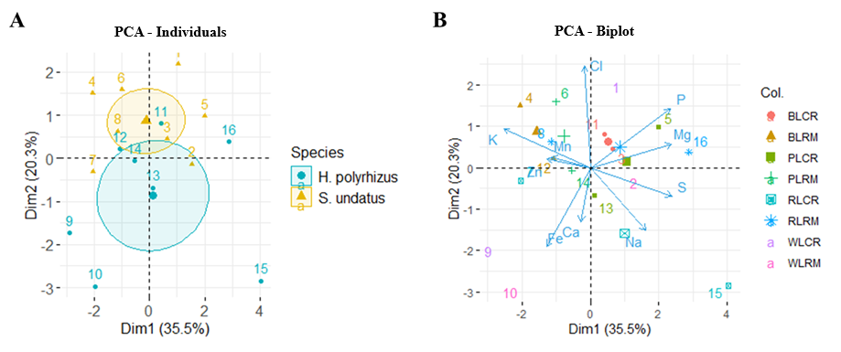

Figure 3A–B. Principal component analysis (PCA) of the mineral composition of vascular tissues of cladodes (central ribs and rib margins) of pitaya species (Sp.) Selenicereus undatus (Haw.) D.R. Hunt (orange symbols) and Hylocereus polyrhizus (Salm-Dyck) R. Bauer (blue symbols), after 65 days of in vitro cultivation, under different light qualities [White (WL); Blue (BL), Purple (PL), and Red (RL)]. (A) Distribution of individuals along the first two principal axes (Dim1 = 35.5%; Dim2 = 20.3%). (B) Biplot showing the correlation between the variables (mineral elements) and the evaluated treatments. The numbered points (1–16) represent the combinations of species, cladode regions, and light qualities, as follows: 1 (BLCR) = H. polyrhizus under blue light; 2 (BLRM) = S. undatus under blue light; 3 (PLCR) = H. polyrhizus under purple light; 4 (PLRM) = S. undatus under purple light; 5 (RLCR) = H. polyrhizus under red light; 6 (RLRM) = S. undatus under red light; 7 (WLCR) = H. polyrhizus under white light (control); 8 (WLRM) = S. undatus under white light (control); 9 (BLCR) = H. polyrhizus under blue light (control); 10 (BLRM) = S. undatus under blue light (control); 11 (PLCR) = H. polyrhizus under purple light; 12 (PLRM) = S. undatus under purple light; 13 (RLCR) = H. polyrhizus under red light; 14 (RLRM) = S. undatus under red light; 15 (WLCR) = H. polyrhizus under white light (control); and 16 (WLRM) = S. undatus under white light (control).

Dim1 explained 35.5% of the total variability, primarily separating H. polyrhizus and S. undatus according to spectral light conditions. Dim2 explained 20.3% of the variability and was associated with differences between cladode regions (central ribs [CR] and rib margins [RM]) within each species (Figure 3A–B).
The first principal component describes a spectral gradient in which red light was associated with higher relative accumulation of sodium and chlorine in the analyzed tissues. This pattern reflects treatment-dependent variation in elemental composition as determined by EDX analysis. Previous studies have reported that light conditions can influence mineral composition and ion distribution in plants (Ramezani et al., 2023). In contrast, blue light was associated with higher relative abundance of iron and manganese, elements involved in plant metabolic and photosynthetic processes (Soufi et al., 2023). However, since ion transport and physiological mechanisms were not investigated in the present study, these associations should be interpreted as descriptive patterns rather than evidence of specific regulatory processes.
The second principal component, which discriminated between tissue types, indicates differences in mineral distribution between the central ribs (CR) and rib margins (RM). The central ribs (CR) showed relatively higher accumulation of P, S, and Mg, whereas the rib margins (RM) were characterized by higher relative contents of K and Ca. This distribution is consistent with previous studies describing tissue-dependent patterns of mineral allocation in succulent plants (Nganko et al., 2024; Peng et al., 2025).
Among the two species, Selenicereus undatus exhibited a more stable mineral profile across the evaluated LED treatments, particularly under purple light, whereas Hylocereus polyrhizus showed greater variability in elemental composition. These differences indicate species-specific responses to the evaluated lighting conditions and suggest that mineral accumulation is influenced by genotype environment interactions. Although previous studies have linked mineral homeostasis with ion transport regulation and stress-related metabolic processes (Zhu et al., 2025; Peng et al., 2025), these mechanisms were not assessed in the present study and therefore cannot be inferred from the results. Further studies integrating physiological and molecular analyses are required to clarify the mechanisms underlying these interspecific differences.

Analysis of vascular bundle number and cladode cross-sectional area revealed significant differences between S. undatus and H. polyrhizus cultivated in vitro under different light qualities (Figures 4 and 5).

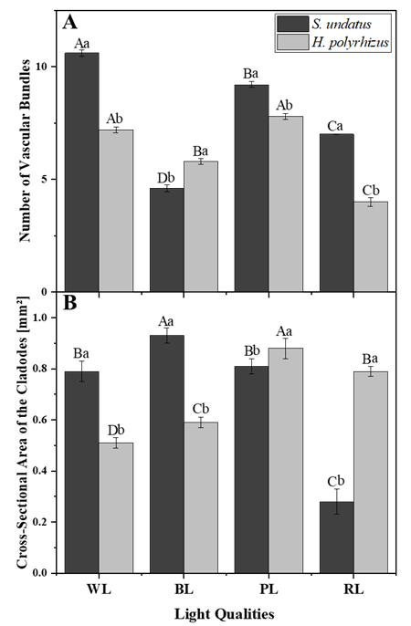

Figure 4. (A) Number of vascular bundles and (B) cross-sectional area of cladodes of the pitaya species Selenicereus undatus (Haw.) D.R. Hunt and Hylocereus polyrhizus (Salm-Dyck) R. Bauer after 65 days of in vitro cultivation under different light qualities [white (WL), blue (BL), purple (PL), and red (RL)]. Anatomical traits are presented as means ± standard error (n = 5). Means followed by the same lowercase letter within each light quality (species comparison) and the same uppercase letter within each species (light quality comparison) are not significantly different according to Tukey's honestly significant difference (HSD) test at the 5% significance level (p ≤ 0.05).

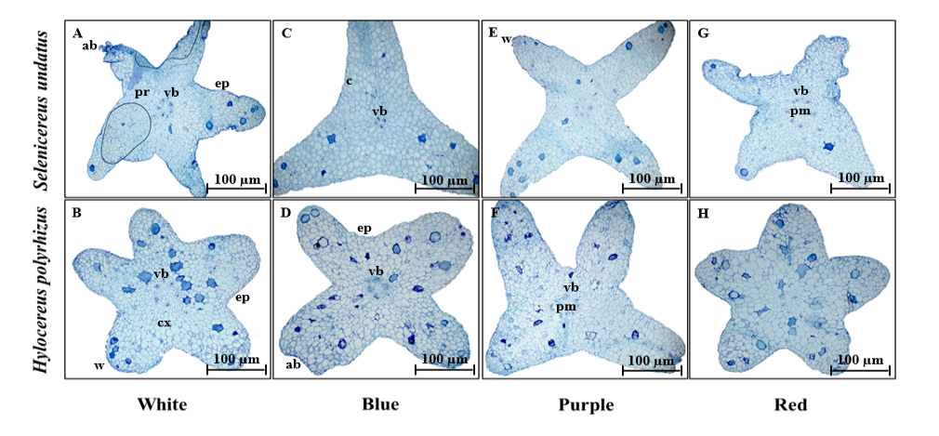

Figure 5. Cross-sectional area of cladodes of pitaya species, Selenicereus undatus (Haw.) D.R. Hunt and Hylocereus polyrhizus (Salm-Dyck) R. Bauer, after 65 days of in vitro cultivation, under different light qualities [White (A–B), Blue (C–D), Purple (E–F), and Red (G–H)]. Legend: c = cuticle; ep = epidermis; pr = storage parenchyma; pm = medullary parenchyma; cx = cortex; w = wing; ab = axillary bud (areole); vb = vascular bundle. Scale bar = 100 µm.

The number of vascular bundles was higher in S. undatus than in H. polyrhizus under white (10.6 vs. 7.2), purple (9.2 vs. 7.8), and red light (7.0 vs. 4.0), whereas under blue light, H. polyrhizus exhibited a higher number (5.8 vs. 4.6) (Figures 4A and 5). In S. undatus, the number of vascular bundles was highest under white light, followed by purple and red light, and lowest under blue light. In H. polyrhizus, the highest values were observed under purple (7.8) and white light (7.2), which did not differ significantly, followed by blue light (5.8), with the lowest values under red light (4.0) (Figures 4A and 5).
The cladode cross-sectional area was greater in S. undatus than in H. polyrhizus under blue (0.93 vs. 0.59 mm²) and white light (0.79 vs. 0.51 mm²), whereas H. polyrhizus exhibited larger areas under purple (0.88 vs. 0.81 mm²) and red light (0.79 vs. 0.28 mm²) (Figures 4B and 5). In S. undatus, cross-sectional area was highest under blue light, followed by purple and white light, which did not differ significantly, and lowest under red light. In contrast, H. polyrhizus showed the highest cross-sectional area under purple light, followed by red and blue light, and the lowest under white light (Figures 4B and 5).

These anatomical patterns are consistent with previous studies reporting that LED spectral quality influences vascular development and tissue differentiation in plants (Ahsan et al., 2024; Chen et al., 2025). In Selenicereus undatus, the greater number of vascular bundles observed under white and blue light suggests that these conditions were associated with higher vascular development during in vitro culture. Previous studies have reported that blue light is involved in vascular development and tissue differentiation processes in plants (Yang et al., 2017; Bantis et al., 2020; Mani et al., 2024). However, since molecular and signaling processes were not assessed in the present study, these mechanisms should be considered only as possible explanations for the observed anatomical differences.
Blue light has also been reported to promote vascular reconnection in grafted watermelon, whereas red light may delay early stages of vascular development (Bantis et al., 2020; Wu et al., 2024). In the present study, the lower number of vascular bundles under red light in both species suggests reduced vascular development under this spectral condition.
The increased cross-sectional area observed under blue and purple light in S. undatus was associated with enhanced tissue expansion and structural development.
The comparatively lower responsiveness of Hylocereus polyrhizus indicates species-specific differences in anatomical plasticity under the evaluated LED treatments, reflecting distinct developmental responses between the two pitaya species during in vitro culture. This observation is consistent with previous studies on cacti showing that anatomical responses vary among species depending on environmental and culture conditions (Soto Acosta et al., 2023; Hong & Huang, 2024).
Root anatomical analysis of S. undatus and H. polyrhizus under different light conditions revealed significant differences in total diameter and cross-sectional area (Figure 6).
The total root diameter was greater in S. undatus than in H. polyrhizus under red, purple, and white light, whereas the opposite trend was observed under blue light (Figures 6A and 7).
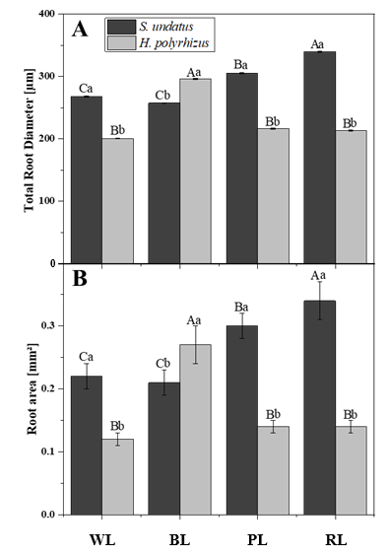

Figure 6. (A) Total root diameter and (B) root area of cladodes of the pitaya species Selenicereus undatus (Haw.) D.R. Hunt and Hylocereus polyrhizus (Salm-Dyck) R. Bauer after 65 days of in vitro cultivation under different light qualities [white (WL), blue (BL), purple (PL), and red (RL)]. Anatomical traits are presented as means ± standard error (n = 5). Means followed by the same lowercase letter within each light quality (species comparison) and the same uppercase letter within each species (light quality comparison) are not significantly different according to Tukey's honestly significant difference (HSD) test at the 5% significance level (p ≤ 0.05).

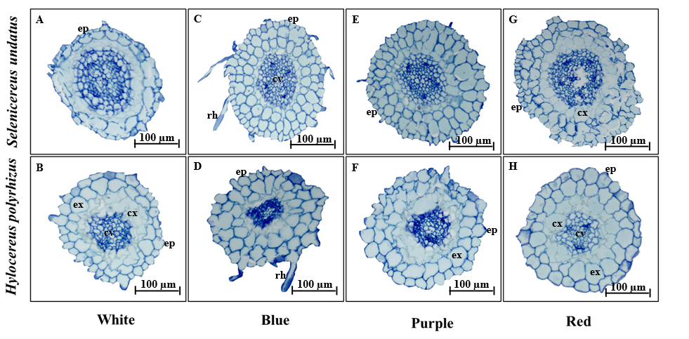

Figure 7. Photomicrographs of transverse sections of roots of pitaya species, Selenicereus undatus (Haw.) D.R. Hunt and Hylocereus polyrhizus (Salm-Dyck) R. Bauer, after 65 days of in vitro cultivation, under different light qualities [White (A–B), Blue (C–D), Purple (E–F), and Red (G–H)]. Legend: ep = epidermis; cx = cortex; cv = vascular cylinder; ex = exodermis; rh = root hairs. Scale bar = 100 µm.

The total root diameter of Selenicereus undatus was highest under red light (339.54 µm), followed by purple light (305.37 µm), while lower values were observed under white and blue light (267.63 and 257.40 µm, respectively), with no significant differences between the latter two treatments. In Hylocereus polyrhizus, the highest total root diameter was recorded under blue light, whereas no significant differences were observed among purple, red, and white light (Figures 6A and 7).
Root area was greater in S. undatus than in H. polyrhizus under red (0.34 vs. 0.14 mm²), purple (0.29 vs. 0.14 mm²), and white light (0.22 vs. 0.12 mm²), whereas under blue light, H. polyrhizus showed a higher value than S. undatus (0.27 vs. 0.21 mm²) (Figures 6B and 7). In S. undatus, root area was highest under red light, followed by purple light, with no significant differences under white and blue light. In contrast, H. polyrhizus showed the highest root area under blue light, with no significant differences among red, purple, and white light (Figures 6B and 7).
These results are consistent with previous studies reporting that LED light quality influences root system development in Selenicereus undatus and Hylocereus polyrhizus (Hua et al., 2016; Pauls et al., 2023; Li et al., 2024). In S. undatus, the greater root diameter and root area observed under red and purple light suggest that these spectral conditions were associated with enhanced root development under the experimental conditions.
Previous studies have reported that red and far-red wavelengths can influence plant growth through phytochrome-related processes and associated physiological regulation (Kiss et al., 2003; De Wit et al., 2016; Samalova et al., 2024). However, since hormonal regulation and photoreceptor activity were not evaluated in the present study, these mechanisms should be considered only as possible explanations for the observed responses rather than causal interpretations.
The relatively consistent root response of S. undatus across treatments, compared with the more variable response observed in H. polyrhizus, suggests species-specific differences in root development under the evaluated LED conditions. This pattern reflects distinct genotypic responses to the growth environment rather than uniform sensitivity across species. Previous studies have also reported that light quality can influence plant anatomical and morphological traits (Zheng & Van Labeke, 2017), which may contribute to differences in overall growth responses between species.
It should be noted that lux-based estimations were used to approximate PPFD under LED treatments using literature-derived conversion factors. However, lux is a photometric unit weighted by human visual sensitivity and is not fully appropriate for narrow-spectrum LED light sources, particularly in red and blue wavelengths. Although this approach allows comparative evaluation among treatments, the resulting PPFD values remain approximate and should be interpreted with caution. Therefore, observed responses may reflect a combination of spectral composition and estimated photon flux density.

CONCLUSIONS
LED light quality was associated with in vitro growth and morphophysiological responses of Selenicereus undatus (Haw.) D.R. Hunt and Hylocereus polyrhizus (Salm-Dyck) R. Bauer, with variation depending on the evaluated trait. A significant interaction between species and light quality was observed for most variables, except cladode diameter, which was independently influenced by both factors.
Selenicereus undatus showed greater vegetative growth, biomass accumulation, and vascular development, particularly under purple and red light, indicating higher morphoanatomical plasticity. In contrast, Hylocereus polyrhizus exhibited higher pigment accumulation under white light, suggesting differences in light utilization strategies between species.
Light quality was also associated with changes in mineral composition and secondary metabolism. Red light was associated with higher potassium accumulation, while blue light was associated with higher levels of redox-related elements. In addition, spectral treatments influenced pigment and antioxidant profiles differently between species.
Overall, purple and red light were associated with stronger growth responses in S. undatus, whereas white and blue light were more favorable for H. polyrhizus. These findings highlight species-specific responses to LED light environments and provide guidance for pitaya micropropagation.
It should be noted that PPFD values were estimated using lux-based measurements and literature-derived conversion factors; therefore, light intensity differences among treatments should be interpreted with caution, and responses may reflect combined effects of spectral composition and estimated photon flux density.
Acknowledgments
The authors of this work thank the Coordenação de Aperfeiçoamento de Pessoal de Nível Superior – Brasil (CAPES), the Conselho Nacional de Desenvolvimento Científico e Tecnológico (CNPq), and the Fundação de Amparo à Pesquisa do Estado de Minas Gerais (FAPEMIG) for financial support for the experiments and for funding scholarships and research productivity grants.

Declarations:
Funding: Not applicable.
Conflict of interest: The authors declare that they have no conflict of interest.
Ethics declaration: Not applicable.
Consent to participate: Not applicable.
Consent for publication: Not applicable.
Data availability statement: Not applicable.

Author's contribution: Conceptual idea: Evens, C.; Marcelo, A. G.; Methodological design: Evens, C.; Marcelo, A. G; Filipe, A. R.; Data collection: Evens, C.; Marcelo, A. G.; Data analysis and interpretation: Evens, C.; Marcelo, A. G.; Filipe, A. R.; Luana, J.S.; José, F.F.S.; Eduardo A., and Writing and editing: Evens, C.; Marcelo, A. G.; Filipe, A. R.; Luana, J.S.; José, F.F.S.; Eduardo A.; Joyce, D.; Moacir, P.

REFERENCES
Ahmed N, Zhang B, Bozdar B, Chachar S, Rai M, Li J et al (2023) The power of magnesium: unlocking the potential for increased yield, quality, and stress tolerance of horticultural crops. Frontiers in Plant Science, 14:1285512. https://doi.org/10.3389/fpls.2023.1285512
Ahn G, Jung IJ, Cha JY, Jeong SY, Shin, GI, Ji MG et al (2022) Phytochrome B positively regulates red light-mediated ER stress response in Arabidopsis. Frontiers in Plant Science, 13:846294. https://doi.org/10.3389/fpls.2022.846294
Ahsan SM, Injamum-Ul-Hoque M, Shaffique S, Ayoobi A, Rahman MA, Rahman MM, Choi HW (2024) Illuminating Cannabis sativa L.: The power of light in enhancing C. sativa growth and secondary metabolite production. Plants, 13(19):2774. https://doi.org/10.3390/plants13192774
Ali H, Khan MA, Kayani WK, Dilshad E, Rani R, Khan RS (2019) Production of biomass and medicinal metabolites through adventitious roots in Ajuga bracteosa under different spectral lights. J. Photochem. Photobiol. B Biol. 193:109–117. https://doi.org/10.1016/j.jphotobiol.2019.02.010
Ani NN, Harun AN, Samsuri SFM, Ahmad R (2015) Effect of red and blue lights on photomorphogenesis in Brassica chinensis. The Malaysia-Japan Model on Technology Partnership: International Proceedings 2013 of Malaysia-Japan Academic Scholar Conference 4:49-58. https://doi.org/10.1007/978-4-431-54439-5_5
Anuruddi HIGK, Nakandalage N, Fonseka DK (2023) New insights for the production of medicinal plant materials: ex vitro and in vitro propagation. In Biosynthesis of Bioactive Compounds in Medicinal and Aromatic Plants: Manipulation by Conventional and Biotechnological Approaches. Cham: Springer Nature Switzerland, 181-212. https://doi.org/10.1007/978-3-031-35221-8_9
Baidya A, Akter T, Islam MR, Shah AA, Hossain MA, Salam MA, Paul SI (2021) Effect of different wavelengths of LED light on the growth, chlorophyll, β-carotene content and proximate composition of Chlorella ellipsoidea. Heliyon, 7(12). https://doi.org/10.1016/j.heliyon.2021.e08525
Bantis F, Koukounaras A, Siomos AS, Fotelli, MN, Kintzonidis D (2020) Bichromatic red and blue LEDs during healing enhance the vegetative growth and quality of grafted watermelon seedlings. Scientia Horticulturae, 261:109000. https://doi.org/10.1016/j.scienta.2019.109000
Bello-Bello JJ, Martínez-Estrada E, Caamal-Velázquez JH, Morales-Ramos V (2016) Effect of LED light quality on in vitro shoot proliferation and growth of vanilla (Vanilla planifolia Andrews). African Journal of Biotechnology, 15(8):272-277. https://doi.org/10.5897/AJB2015.14662
Bugbee B (2016, May). Toward an optimal spectral quality for plant growth and development: the importance of radiation capture. In VIII International Symposium on Light in Horticulture, 1134:1-12. https://doi.org/10.17660/ActaHortic.2016.1134.1
Cavallaro V, Pellegrino A, Muleo R, Forgione I (2022) Light and plant growth regulators on in vitro proliferation. Plants, 11(7):844. https://doi.org/10.3390/plants11070844
Chen CC, Lee MR, Wu CR, Ke HJ, Xie HM, Tsay HS et al (2020) LED lights affecting morphogenesis and isosteroidal alkaloid contents in Fritillaria cirrhosa D. Don—an important Chinese medicinal herb. Plants 9:1351. https://doi.org/10.3390/plants9101351
Chen R, Ding Y, Liu W, Zhan X, Lin K, Lian K et al (2025) Physiological effects and technical strategies of LED supplemental lighting for pitaya cultivation: a review. PeerJ, 13, e19720. https://doi.org/10.7717/peerj.19720
Chen SY, Xu CY, Mazhar MS, Naiker M (2024) Nutritional value and therapeutic benefits of Dragon fruit: A comprehensive review with implications for Establishing Australian industry standards. Molecules, 29(23):5676. https://doi.org/10.3390/molecules29235676
Chen Z, Zhong B, Barrow CJ, Dunshea FR, Suleria HA (2021) Identification of phenolic compounds in Australian grown dragon fruits by LC-ESI-QTOF-MS/MS and determination of their antioxidant potential. Arabian Journal of Chemistry, 14(6):103151. https://doi.org/10.1016/j.arabjc.2021.103151
Choo KY, Ong YY, Lim RLH, Tan CP, Ho CW (2019) Study on bioaccessibility of betacyanins from red dragon fruit (Hylocereus polyrhizus). Food Science and Biotechnology, 28(4):1163-1169. https://doi.org/10.1007/s10068-018-00550-z
Clairvil E, Feitosa BH, Guimarães MDA, Rodrigues FA, Dória J, Dias GDMG et al (2025). Agar concentration interferes with the biometry, photosynthetic pigment content, and anatomy of Selenicereus undatus in vitro. Ciência e Agrotecnologia, 49:e021624. https://doi.org/10.1590/1413-7054202549021624
Clairvil E, Guimarães MA, Rodrigues FA, Dória J, Dias GMG et al (2026). Light quality and zinc concentrations interfere with the in-vitro cultivation of Selenicereus undatus. Bragantia, 85, e20250133. https://doi.org/10.1590/1678-4499.20250133
Cossa MCV, Rocha JPM, De Assis RMA, Leite JJF, Texeira LF, Bertolucci SKV, Pinto JEBP (2024) Impact of photon flux density and light spectral quality on biomass production and arbutin compound accumulation in Origanum majorana L. plantlets. Plant Cell, Tissue and Organ Culture (PCTOC), 156(1):12. https://doi.org/10.1007/s11240-023-02658-5
Cuong DM, Ha TW, Park CH, Kim NS, Yeo HJ, Chun SW et al (2019) Effects of LED lights on expression of genes involved in phenylpropanoid biosynthesis and accumulation of phenylpropanoids in wheat sprout. Agronomy, 9(6):307. https://doi.org/10.3390/agronomy9060307
Davis PA, Burns C (2016) Photobiology in protected horticulture. Food and Energy Security, 5(4):223-238. https://doi.org/10.1002/fes3.97
De Angelis M, Amicucci C, Banchelli M, D'Andrea C, Gori A, Agati G et al (2025) Rapid determination of phenolic composition in chamomile (Matricaria recutita L.) using surface-enhanced Raman spectroscopy. Food Chemistry, 463:141084. https://doi.org/10.1016/j.foodchem.2024.141084
De Araújo Silva MM, de Oliveira ALB, Oliveira-Filho RA, Camara T, Willadino L, Gouveia-Neto A (2016) The effect of spectral light quality on in vitro culture of sugarcane. Acta Scientiarum. Biological Sciences, 38(2):157-161. https://doi.org/10.4025/actascibiolsci.v38i2.31109
De Vasconcelos Dias M, Rodrigues FA, de Souza Ribeiro M, Dambroz C, Dória J, Pasqual M (2025) Physiological and morphological responses of Selenicereus species to salt stress in vitro. Plant Cell, Tissue and Organ Culture (PCTOC), 162(2):26. https://doi.org/10.1007/s11240-025-03082-7
De Wit M, Galvão VC, Fankhauser C (2016) Light-mediated hormonal regulation of plant growth and development. Annual review of plant biology, 67(1):513-537. https://doi.org/10.1146/annurev-arplant-043015-112252
Dou H, Niu G, Gu M (2019) Pre-harvest UV-B radiation and photosynthetic photon flux density interactively affect plant photosynthesis, growth, and secondary metabolites accumulation in basil (Ocimum basilicum) plants. Agronomy, 9(8):434. https://doi.org/10.3390/agronomy9080434
Fan C, Manivannan A, Wei H (2022) Light Quality‐Mediated Influence of Morphogenesis in Micropropagated Horticultural Crops: A Comprehensive Overview. BioMed Research International, 2022(1):4615079. https://doi.org/10.1155/2022/4615079
Garcia-Oliveira P, Otero P, Pereira AG, Chamorro F, Carpena M, Echave J et al (2021). Status and challenges of plant-anticancer compounds in cancer treatment. Pharmaceuticals, 14(2):157. https://doi.org/10.3390/ph14020157
Griffin J. H, Toledo-Ortiz G (2022) Plant photoreceptors and their signalling components in chloroplastic anterograde and retrograde communication. Journal of Experimental Botany, 73(21):7126-7138. https://doi.org/10.1093/jxb/erac220
Hashim M, Ahmad B, Drouet S, Hano C, Abbasi BH, Anjum S (2021) Comparative effects of different light sources on the production of key secondary metabolites in plants in vitro cultures. Plants, 10(8):1521. https://doi.org/10.3390/plants10081521
Hernández R, Kubota C (2016) Physiological responses of cucumber seedlings under different blue and red photon flux ratios using LEDs. Environmental and experimental botany, 121:66-74. https://doi.org/10.1016/j.envexpbot.2015.04.001
Hogewoning SW, Trouwborst G, Maljaars H, Poorter H, Van Ieperen W, Harbinson J (2010) Blue light dose–responses of leaf photosynthesis, morphology, and chemical composition of Cucumis sativus grown under different combinations of red and blue light. Journal of experimental botany, 61(11):3107-3117. https://doi.org/10.1093/jxb/erq132
Hong Z, Huang W (2024) Meta-analysis of Genetic Markers for Yield and Quality Traits in Dragon Fruit. Tree Genetics and Molecular Breeding, 14(6): 14(6):295-303. http://dx.doi.org/10.5376/tgmb.2024.14.0029
Hua Q, Zhou Q, Gan S, Wu J, Chen C, Li J et al (2016) Proteomic analysis of Hylocereus polyrhizus reveals metabolic pathway changes. International Journal of Molecular Sciences, 17(10):1606. https://doi.org/10.3390/ijms17101606
Huang W, Yang G, Liu D, Li Q, Zheng L, Ma J (2022) Metabolomics and transcriptomics analysis of vitro growth in pitaya plantlets with different LED Light spectra treatment. Industrial Crops and Products, 186:115237. https://doi.org/10.1016/j.indcrop.2022.115237
Johansen, D. A. (1940). Plant microtechnique. McGraw Hill Book Co., 2nd ed. New York, 523pp.
Khoo HE, He X, Tang Y, Li Z, Li C, Zeng et al (2022) Betacyanins and anthocyanins in pulp and peel of red pitaya (Hylocereus polyrhizus cv. Jindu), inhibition of oxidative stress, lipid reducing, and cytotoxic effects. Frontiers in Nutrition, 9:894438. https://doi.org/10.3389/fnut.2022.894438
Kim JY, Im NH, Shim SY, Lee HB (2025) Photosynthetic acclimation of crassulacean acid metabolism orchid Phalaenopsis in response to light level. Scientific Reports, 15(1):13016. https://doi.org/10.1038/s41598-025-96167-4
Kiss JZ, Mullen JL, Correll MJ, Hangarter RP (2003) Phytochromes A and B mediate red-light-induced positive phototropism in roots. Plant physiology, 131(3):1411-1417. https://doi.org/10.1104/pp.013847
Lee S, Tewari R, Hahn, Paek KY (2007) Photon flux density and light quality induce changes in growth, stomatal development, photosynthesis and transpiration of Withania ssomnifera (L.) Dunal. plantlets. Plant Cell Tiss Org 90:141-151. https://doi.org/10.1007/s11240-006-9191-2
Li J, Muneer MA, Sun A, Guo Q, Wang Y, Huang Z et al (2023). Magnesium application improves the morphology, nutrients uptake, photosynthetic traits, and quality of tobacco (Nicotiana tabacum L.) under cold stress. Frontiers in Plant Science, 14:1078128. https://doi.org/10.3389/fpls.2023.1078128
Li P, Ma X, Li Z, Yao H, Lu G, Hu, H, Ding Y (2024) A review on the advances of dragon fruit. Tropical Plants, 3(1):e041. https://doi.org/10.48130/tp-0024-0041
Lichtenthaler HK, Babani F (2021) Contents of photosynthetic pigments and ratios of chlorophyll a/b and chlorophylls to carotenoids (a+ b)/(x+ c) in C4 plants as compared to C3 plants. Photosynthetica, 60(1):3. https://doi.org/10.32615/ps.2021.041
Lichtenthaler HK, Wellburn AR (1983) Determinations of total carotenoids and chlorophylla and b of leaf extracts in different solvents. Biochemical Society Transactions, 11(5):591-592. https://doi.org/10.1042/bst0110591
Lima DDC, Mendes NVB, Diógenes MFS, Corrêa MCDM, Natale W, Taniguchi CAK (2021) Initial growth and nutrient accumulation in pitaya plants at different phenological stages. Revista Caatinga, 34:720-727. https://doi.org/10.1590/1983-21252021v34n324rc
Liu J, Van Iersel MW (2021) Photosynthetic physiology of blue, green, and red light: Light intensity effects and underlying mechanisms. Frontiers in plant science, 12:619987. https://doi.org/10.3389/fpls.2021.619987
Luz TCLA, Cardoso LD, Alves RBN, Matsumoto K (2015) Photomorphogenesis by led lighting on potato and Brazilian ginseng for medium-term in vitro conservation. Acta Hortic 1113:513-517. https://doi.org/10.17660/ActaHortic.2015.1083.67
Mani M, Faisal M, Alatar AA, Shekhawat MS (2024) Silicon nanoparticle (s) induced morpho-anatomical traits and improved micropropagation of white fleshed dragon fruit [Selenicereus undatus (Haworth)]. Phosphorus, Sulfur, and Silicon and the Related Elements, 199(7-9):598-606. https://doi.org/10.1080/10426507.2024.2408774
Manivannan A, Soundararajan P, Park YG, Jeong BR (2021) Physiological and proteomic insights into red and blue light-mediated enhancement of in vitro growth in Scrophularia kakudensis—A potential medicinal plant. Frontiers in plant science, 11:607007. https://doi.org/10.3389/fpls.2020.607007
Murashige T, Skoog F (1962) A revised medium for rapid growth and bio assays with tobacco tissue cultures. Physiologia plantarum, 15(3), 473-497. https://doi.org/10.1111/j.1399-3054.1962.tb08052.x
Nadeem M, Abbasi BH, Younas M, Ahmad W, Zahir A, Hano C (2019) LED-enhanced biosynthesis of biologically active ingredients in callus cultures of Ocimum basilicum. Journal of Photochemistry and Photobiology B: Biology, 190:172-178. https://doi.org/10.1016/j.jphotobiol.2018.09.011
Nganko JM, Koffi EPM, Kane M, Gbaha P, Yao KB (2024) Application of principal component analysis (PCA) to the study of the influence of the thermochemical treatment process of tropical wood sawdust on the calorific, mechanical, physicochemical and combustion properties of the resulting fuel briquettes. Biofuels, 15(10):1281-1294. https://doi.org/10.1080/17597269.2024.2361981
Nhut DT, Takamura T, Watanabe H, Okamoto K, Tanaka M (2003) Responses of strawberry plantlets cultured in vitro under superbright red and blue light-emitting diodes (LEDs). Plant Cell Tissue Organ Cult 73:43–52. https://doi.org/10.1023/A:1022638508007
Nikalje GC, Suprasanna P (2018) Coping with metal toxicity–cues from halophytes. Frontiers in Plant Science, 9:777. https://doi.org/10.3389/fpls.2018.00777
Ning X, Lin M, Huang G, Mao J, Gao Z, Wang X (2023) Research progress on iron absorption, transport, and molecular regulation strategy in plants. Frontiers in plant science, 14:1190768. https://doi.org/10.3389/fpls.2023.1190768
Nishikito DF, Borges ACA, Laurindo LF, Otoboni AMB, Direito R, Goulart RDA et al (2023) Anti-inflammatory, antioxidant, and other health effects of dragon fruit and potential delivery systems for its bioactive compounds. Pharmaceutics, 15(1):159. https://doi.org/10.3390/pharmaceutics15010159
Oo KT, Lynn ZM, Oo KZ, Htwe MY, Htet WT, Soe WW, Tun W (2023) In vitro Propagation of Three Pitaya Varieties (Hylocereus undatus, Hylocereus polyrhizus and Hylocereus megalanthus) with the Use of Different BAP Concentrations. Journal of Scientific and Innovative Research, 12(2):33-39.
Paradiso R, Proietti S (2022) Light-quality manipulation to control plant growth and photomorphogenesis in greenhouse horticulture: The state of the art and the opportunities of modern LED systems. Journal of Plant Growth Regulation, 41(2):742-780. https://doi.org/10.1007/s00344-021-10337-y
Paśko P, Galanty A, Zagrodzki P, Luksirikul P, Barasch D, Nemirovski A, Gorinstein S (2021) Dragon fruits as a reservoir of natural polyphenolics with chemopreventive properties. Molecules, 26(8):2158. https://doi.org/10.3390/molecules26082158
Pauls B, Lautenschläger T, Neinhuis C (2023) Anatomical and Biomechanical Properties of the Junction between Stem and Aerial Roots of Selenicereus undatus. Plants, 12(13) :2544. https://doi.org/10.3390/plants12132544
Peng Y, Zhu H, Wang Y, Kang J, Hu L, Li L et al (2025). Revisiting the role of light signaling in plant responses to salt stress. Horticulture Research, 12(1):uhae262. https://doi.org/10.1093/hr/uhae262
Pierik R, Ballaré CL (2021) Control of plant growth and defense by photoreceptors: from mechanisms to opportunities in agriculture. Molecular Plant, 14(1):61-76. https://doi.org/10.1016/j.molp.2020.11.021
Pinho P, Jokinen K, Halonen L (2017) The influence of the LED light spectrum on the growth and nutrient uptake of hydroponically grown lettuce. Lighting Research & Technology, 49(7):866-881. https://doi.org/10.1177/1477153516642269
Ramezani M, Thompson D, Moreno M, Joshi V (2023) Biochemical repercussions of light spectra on nitrogen metabolism in spinach (Spinacia oleracea) under a controlled environment. Frontiers in Plant Science, 14:1283730. https://doi.org/10.3389/fpls.2023.1283730
Raqiba H, Sibi G (2019) Light emitting diode (LED) illumination for enhanced growth and cellular composition in three microalgae. HSOA Advances in Microbiology Research, 3(1):1–7.
Ravichandran G, Lakshmanan DK, Murugesan S, Elangovan A, Rajasekaran NS, Thilagar S (2021) Attenuation of protein glycation by functional polyphenolics of dragon fruit (Hylocereus polyrhizus); an in vitro and in silico evaluation. Food research international, 140:110081. https://doi.org/10.1016/j.foodres.2020.110081
Samalova M, Melnikava A, Elsayad K, Peaucelle, A, Gahurova E, Gumulec J et al (2024) Hormone-regulated expansins: expression, localization, and cell wall biomechanics in Arabidopsis root growth. Plant Physiology, 194(1):209-228. https://doi.org/10.1093/plphys/kiad228
Sarropoulou V, Sperdouli I, Adamakis ID, Grigoriadou K (2023) The use of different LEDs wavelength and light intensities for in vitro proliferation of cherry rootstock: Influence on photosynthesis and photomorphogenesis. Plant Cell, Tissue and Organ Culture (PCTOC), 152(2):317-330. https://doi.org/10.1007/s11240-022-02408-z
Scopel W, Barbosa JZ & Vieira ML (2011) Extração de pigmentos foliares em plantas de canola. Unoesc & Ciência-ACET, 2(1):87-94.
Shang W, Song Y, Zhang C, Shi L, Shen Y, Li X et al (2023). Effects of light quality on growth, photosynthetic characteristics, and endogenous hormones in in vitro-cultured Lilium plantlets. Horticulture, Environment, and Biotechnology, 64(1):65-81. https://doi.org/10.1007/s13580-022-00468-w
Silva TD, Batista DS, Fortini EA, de Castro KM, Felipe SHS, Fernandes AM et al (2020) Blue and red light affects morphogenesis and 20-hydroxyecdisone content of in vitro Pfaffia glomerata accessions. J. Photochem. Photobiol. B Biol. 203:111761. https://doi.org/10.1016/j.jphotobiol.2019.111761
Soto Acosta ME, Perea M, Ruiz AI, Hilal M, Albornoz PL, Isla MI (2023) Adaptative strategies in gymnocalycium species (cactaceae) and the presence of ectomycorrhizae associated with survival in arid environments. Plants, 12(15) :2774. https://doi.org/10.3390/plants12152774
Soufi HR, Roosta HR, Fatehi F, Ghorbanpour M (2023) Spectral composition of LED light differentially affects biomass, photosynthesis, nutrient profile, and foliar nitrate accumulation of lettuce grown under various replacement methods of nutrient solution. Food Science & Nutrition, 11(12):8143-8162. https://doi.org/10.1002/fsn3.3735
Suman K, Rani AR, Reddy PV (2017) Response of dragon fruit (Hylocereus undatus) explants on MS media with growth regulators under in vitro for mass multiplication. Agric. Update 12 (TECHSEAR-9), 12:1-8. https://10.15740/HAS/AU/12.TECHSEAR(9)2017/000-000
Sumi MJ, Jahan N, Thamid SS, Tarik MEI, Hassannejad S, Rahimi M, Imran S (2025) LED light effect on growth, pigments, and antioxidants of lettuce (Lactuca sativa L.) baby greens. BMC Plant Biology, 25(1):582. https://doi.org/10.1186/s12870-025-06621-8
Tian Z, Wang JW, Li J, Han B (2021) Designing future crops: challenges and strategies for sustainable agriculture. The Plant Journal, 105(5):1165-1178. https://doi.org/10.1111/tpj.15107
Vershinina Y, Reshetnikova E, Lv S, Kolesnik I, Kapitanova O, Veselova I (2025) Raman and IR spectroscopy as a promising approach to rapid and non-destructive monitoring of chlorogenic acid in protein matrices. Frontiers in Chemistry, 13:1543663. https://doi.org/10.3389/fchem.2025.1543663
Wawrosch C, Zotchev SB (2021) Production of bioactive plant secondary metabolites through in vitro technologies—status and outlook. Applied Microbiology and Biotechnology, 105(18):6649-6668. https://doi.org/10.1007/s00253-021-11539-w
Wu BS, Mansoori M, Schwalb M, Islam S, Naznin MT, Addo PW et al (2024). Light emitting diode effect of red, blue, and amber light on photosynthesis and plant growth parameters. Journal of Photochemistry and Photobiology B: Biology, 256:112939. https://doi.org/10.1016/j.jphotobiol.2024.112939
Wu X, Zhang X, Wang Y, Wu C, Sun Y, Zhang Y et al (2024). Additional far-red light promotes adventitious rooting of double-root-cutting grafted watermelon seedlings. Horticultural Plant Journal, 10(6):1424-1436. https://doi.org/10.1016/j.hpj.2022.11.012
Xie H, Zeng J, Feng W, Gao W, Lai Z, Liu S (2025) Differential Expression of Amaranth AtrDODA Gene Family Members in Betalain Synthesis and Functional Analysis of AtrDODA1-1 Promoter. Plants, 14(3):454. https://doi.org/10.3390/plants14030454
Yang ZY, Zheng XW, Jiang WH, Chen GZ, Liang QZ, Xu GZ, & Yi RH (2024) Selenicereus undatus (Dragon Fruit) Phytochemicals for Managing Three Human Pathogenic Bacteria: An In Vitro and In Silico Approach. Metabolites, 14(11):577. https://doi.org/10.3390/metabo14110577
Yang Z, Liu B, Su J, Liao J, Lin C, Oka Y (2017) Cryptochromes orchestrate transcription regulation of diverse blue light responses in plants. Photochemistry and Photobiology, 93(1):112-127. https://doi.org/10.1111/php.12663
Yaoyuan Z, Lau NS, Subramaniam S (2025) Illuminating the harvest: the regulatory effects of LEDs on pigment accumulation in various food crops. Physiology and Molecular Biology of Plants, 1-16. https://doi.org/10.1007/s12298-025-01596-0
Yasmin A, Sumi MJ, Akter K, Rabbi RHM, Almoallim HS, Ansari MJ, Hossain A, Imran S (2024) Comparative analysis of nutrient composition and antioxidant activity in three dragon fruit cultivars. PeerJ 12:e17719 https://doi.org/10.7717/peerj.17719
Yeh N, Chung JP (2009) High-brightness LEDs—Energy efficient lighting sources and their potential in indoor plant cultivation. Renewable and Sustainable Energy Reviews, 13(8):2175-2180. https://doi.org/10.1016/j.rser.2009.01.027
Yun F, Liu H, Deng Y, Hou X, Liao W (2023) The role of light-regulated auxin signaling in root development. International Journal of Molecular Sciences, 24(6):5253. https://doi.org/10.3390/ijms24065253
Zheng L, Van Labeke MC (2017) Long-term effects of red-and blue-light emitting diodes on leaf anatomy and photosynthetic efficiency of three ornamental pot plants. Frontiers in plant science, 8:917. https://doi.org/10.3389/fpls.2017.00917
Zhu X, Wu C, Hui J (2025) Effect of Light Intensity on Anthocyanin Synthesis Assessed Using Leaves of Aglaonema commutatum. Genes, 16(4):375. https://doi.org/10.3390/genes16040375

