Supplementary Materials 1: Details of SEM Images.
Figure numbers used are the same as in the main text.

Figure 5:
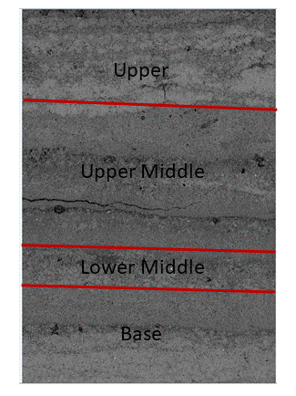
Fig.5 Composite SEM image of undeformed rock. Sample is divided into Base Zone, Lower Middle (LM), Upper Middle (UM), Zone and Upper Zone as shown by lines

Figure 6:
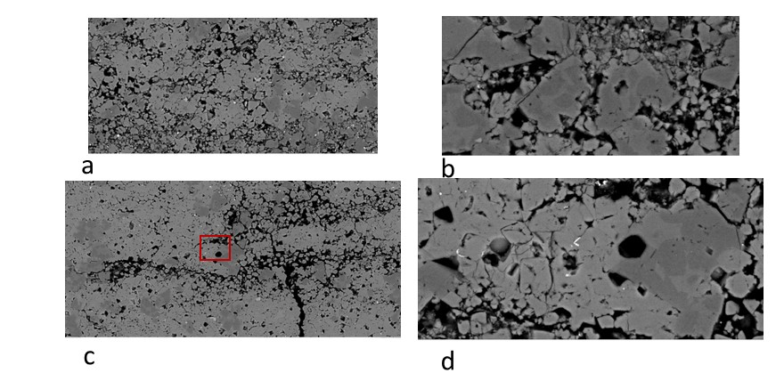

Fig. 6 SEM images of undeformed laminite. (a) Area near top of sample. Field of view ~ 10mm. Crystalline nature of calcite is clear. Variation in cementation degree by lamina is visible: laminae are typically 1 to 2 mm thick. No visible evidence of natural deformation features (joints, fractures or bands); (b) Detail of fig.7a. Field of view ~ 2mm. Individual crystal size is quite variable and pores tend to occur in clumps. Pore throats are typically of significantly sub-micron width. Indications of smaller crystals contained within larger pores; (c) Rare example of cementation variation with the morphological character of an open fracture; (d) Detail of c (red box). No clear evidence of crystal damage.

Figure 7
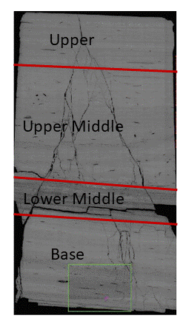
Fig. 8 L20 composite ESEM image grouped into Base, Lower Middle (LM), Upper Middle (UM), Zone and Upper Zones

Figure 8
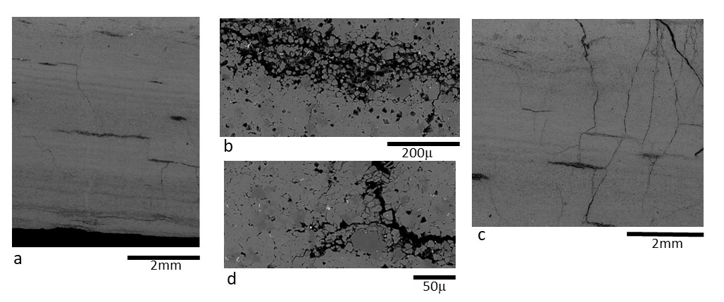
Fig. 8 SEM images of part of Base Zone shown in green box of figure 8. (a) From left side of green box. Shows a small number of steep fractures. (b) Detail of (a) which suggests that these new sub-micron width fractures terminate at, or initiate at, higher porosity areas which are approximately parallel the lamina boundaries. (c) From right side of green box of figure 8. Shows more development of fractures. (d) Detail of (c). Damage is only seen clearly at a few micron resolution. Note widest openings are approx. 1-2 microns. Some indication that less well cemented regions and laminae have been preferentially damaged.

Figure 9
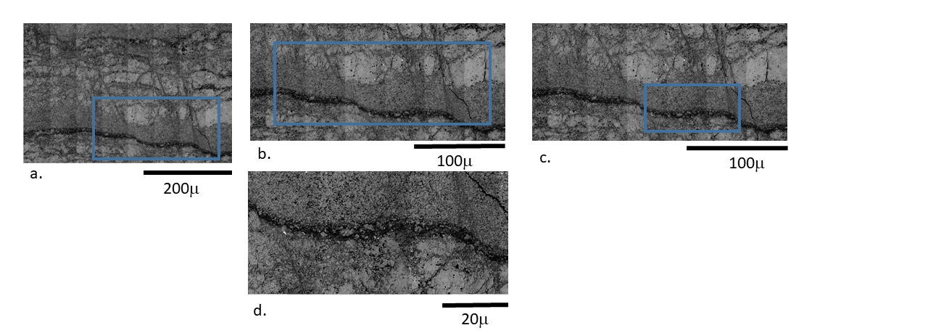
Fig. 9 from sample L20.(a.) Image is full of a large number of steeply inclined dominantly shear-offset deformation bands, width approximately 20microns. (b.) Detail of a. showing a more porous lamina subsection (dark zone to base of figure). Porosity of similar zones been estimated as approaching 50% by Buckman et al (2018). Porous zone is more wavy than in the undeformed laminite and this figure supports its offset by deformation bands which are filled with much finer grained material. Some, but not all, deformation bands continue across the porous zone which is consistent with outcrop studies of natural deformation. Rock outside deformation bands is generally still visibly crystalline but with very short almost vertical partly open fractures becoming visible. These short fractures do not obviously connect to create an efficient fracture network and tend to occur along now-cemented crystal boundaries. (c.) Porous zone clearly has somewhat diffuse boundary and apparently contains floating particles (as seen in 2D). Parts are clearly open as seen in 2D with some obstructions rather than having a connected solid framework. Deformation bands are a mixture of predominantly open sub-regions and cataclastic damage sub-regions regions with (even) finer broken material: these latter are visually consistent with a low permeability material. The crystal character in these deformation bands is no longer obvious and has probably been replaced by a cataclastic almost granular texture: (d.) detail of (c.) confirms damage at crystal-crystal boundaries is common.

Figure 10
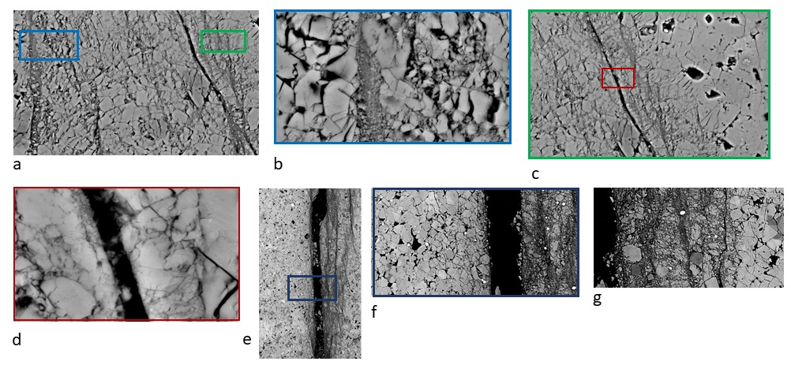
Figure 10. SEM images taken from UM and Upper Zones. (a) Example of appearance of fractures and deformation bands. Fracture width approx. 50μm. Most are steeply dipping. Some other fracture-like features are filled with broken fragments and debris. Indications of shallow dipping less well-defined deformation bands between the better developed steeper features. Most crystals show some damage. (b) From top left of fig. 11a as shown by blue rectangle. Feature is clearly filled with broken particles. At higher magnification distributed damage is seen to the left of the feature as well as the right. Crystal breakage is abundant. (c) From top right corner of fig.11a as shown by green rectangle. Main feature is open fracture along part of length: note this is after flow experiments. Crystal damage occurs both sides of the feature. There appear to be several smaller steep zones on the right side as well as distributed damage. Crystal-shaped open spaces may be original or possibly due to plucking during thin section making. (d) Detail of fig. 11c. Is this clear open fracture a result of water having cleaned it out? Potentially some fragments, possibly attached fragments remaining in the open fracture. But this does not preclude flowing water having removed many fragments. (e) Overview of feature with both open fracture and highly sheared zone to right side. Sheared zone appears to consist of dark zones that are normally local shear displacement foci in a less extremely sheared, larger particle size, matrix. Clearly crystalline rock to right and left with little permanent strain. Open fracture aperture estimated around 20 microns. (f). Detail of fig. 11e as shown by blue box, with both open fracture and highly sheared zone to right side. Sheared zone appears to consist of dark zones that are typically local shear displacement foci in a less extremely sheared, larger particle size, matrix. Clearly crystalline and low deformation rock to right and left. Open fracture aperture estimated around 20 microns. (g) Detail of fig. 11f bottom right corner and extending further to bottom and right. Texture of deformed rock is typical of natural shear zones in and around cataclastic-dominated fault zones

