Supplementary Materials 2: Details of Experimental Setup.
This document contains more detailed information about the setup and operation of the flow experiment in the neutron beam.
The orientation of the radiographs.

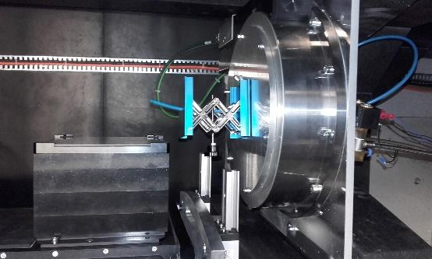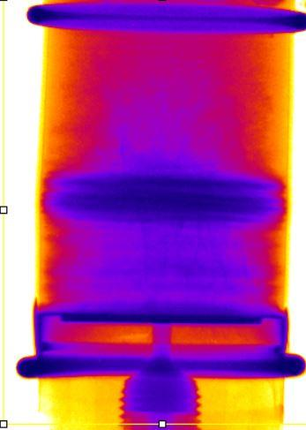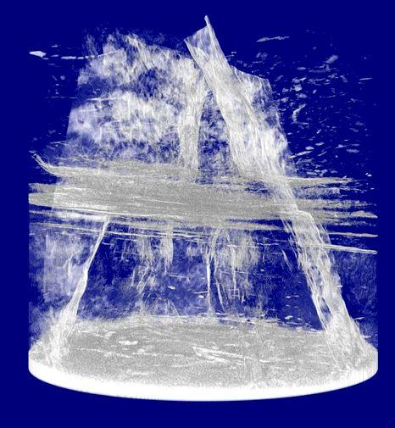

(a) (b) (c)
(a) Relative positions and orientations of neutron beam (blue arrow), sample (red) and camera (green) in the experimental chamber; (b) Neutron radiography acquired while sample is static and oriented so well developed fractures are normal to neutron beam direction of flight. See also Supplementary Materials 1; (c) XRT of sample in same orientation as (b). Blue arrow shows viewing direction.

