Supplementary Material 5: Supporting Material for D2O entry into Base Zone, LM Zone and into UM and Upper Zones
Base Zone
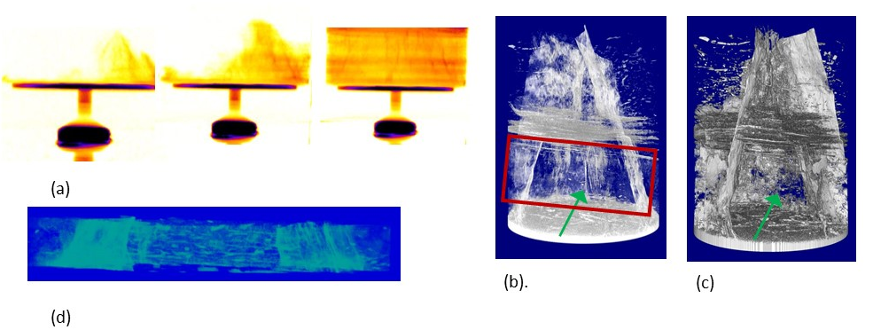
- Neutron radiographic images of the Base Zone as D₂O starts to enter base of sample and moves generally upwards and to the right through the Base Zone. Earliest image to left, latest to right. Also see Supplementary Materials 1. Pale yellow is lowest detected water density and black highest. (b) X-ray tomograph with image transparency used: this view emphasises open fractures and lower density (more porous) laminae. Green arrow shows sample orientation for radiographic image acquisition. Resolution is 40 microns. Red rectangle identifies the Base Zone. (c) As for b but with no use of transparency. Also shows commonly occurring ellipsoidal microfossils (d) Base Zone portion of neutron tomogram acquired at the flow experiment end when H₂O first reaches sample top.

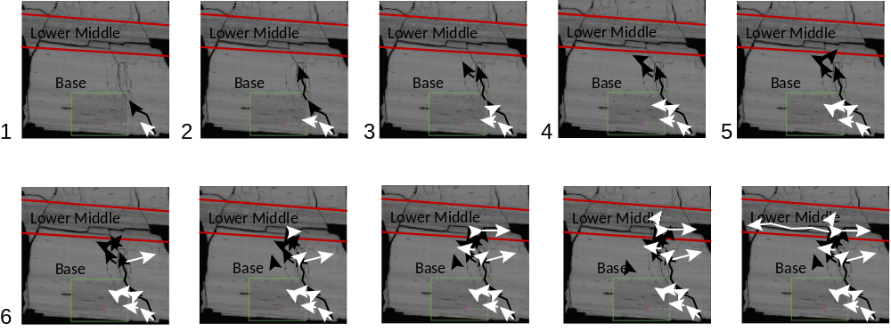
Illustration of the principal fluid movements in matrix (white arrows) and fractures (black arrows) in the Base and LM Zones. The numbers indicate steps of equal intervals in the radiograph sequence. Each arrow shows the main progress of fluid movement over that interval. The background is the composite SEM image, while the radiographs are projections through the sample. In this 2D depiction, there cannot be a 1-to-1 correspondence between fluid movement and the governing features. The pattern shows that fluid moves more rapidly along fractures, and then ceases movement while fluid moves into matrix adjacent to parts of the fracture where flow already took place. Note that some intervals have more than one major flow pathway. Water movement into Base Zone continues through all images.
LM Zone
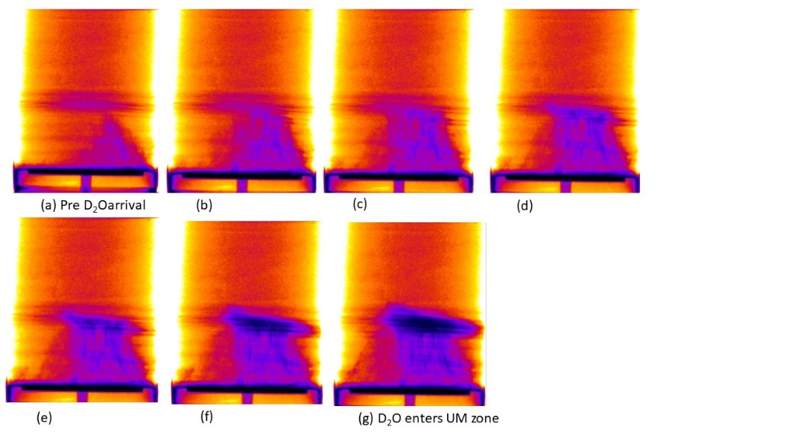
Sequential in time false colour radiographies of D₂O entry into the LM Zone progressing left to right and upper row to lower row. Note (a) is immediately before D₂O enters the base of the LM zone.

Illustration of the principal fluid movements in matrix (white arrows) and fractures (black arrows) in the Base and LM Zones superposed on composite SEM image (fig. 8). Numbers are equal intervals in the radiograph sequence. Each arrow shows the main progress of fluid movement over that interval. Water movement into LM Zone occurs in 6-10+.

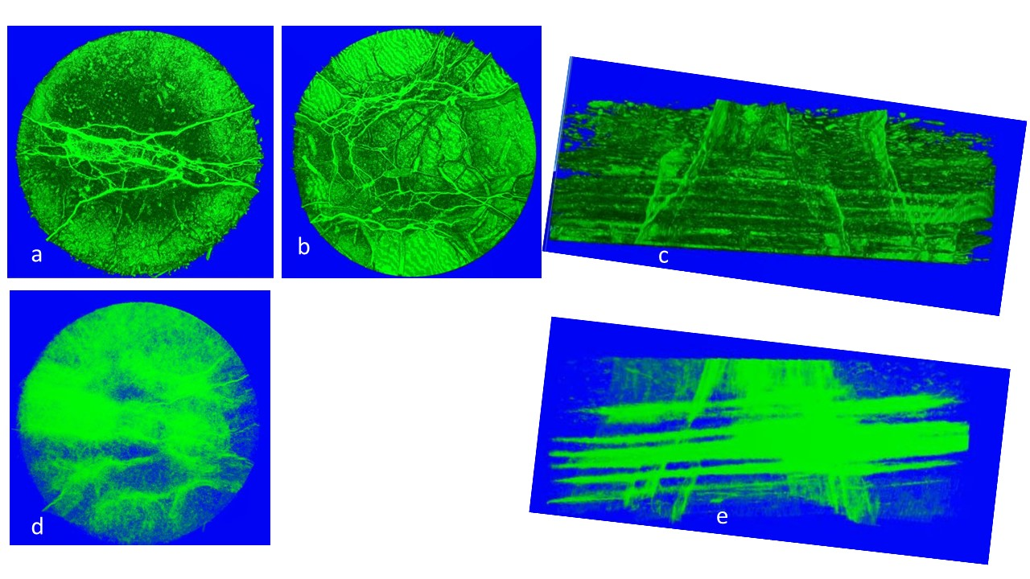XRT of LM Zone. (a) View of LM Zone from the top show, a few fractures and a large number of laminae-parallel small ellipsoidal objects. These last are microfossils. (b) View from the base. Many more open fractures are seen, as expected given the large fracture density in the Base Zone. (c) Side view of LM Zone showing well developed lamina-parallel density variation consistent with more and less porous laminae together with some steep open fractures with occasional top to base connectivity. (d) As for (a) but with high transparency. Note some regions of higher density towards middle and edges of LM Zone. (e) As for (c) but with high transparency. The alternation of higher and lower porosity laminae is more obvious as are a region of steep open fractures to the right and en-echlon open fractures to the left.
UM and Upper Zone
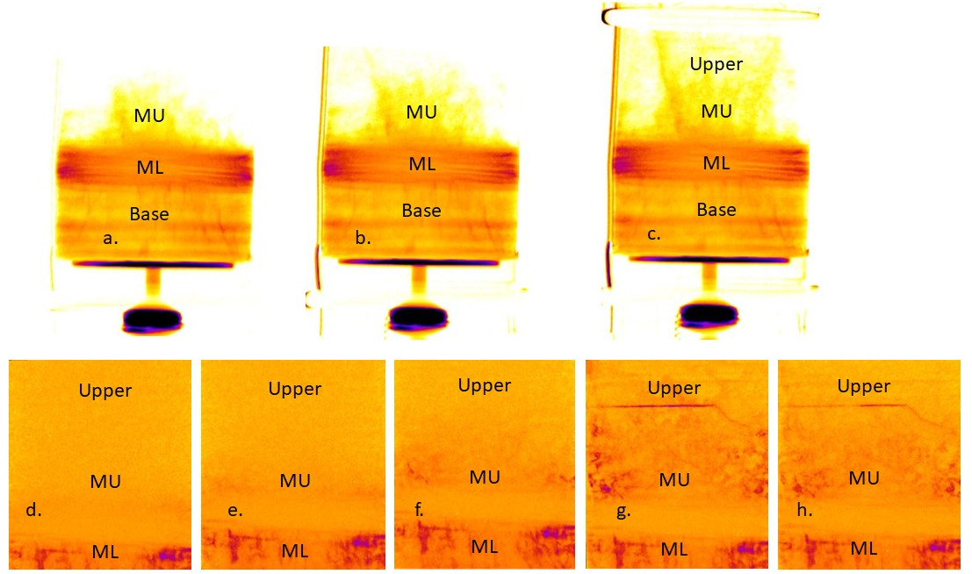
a-c: Sequential false colour L20 radiographic images during D₂O ingress show early (a), mid (b) and late (c) stages of D₂O entry into the UM and Upper Zones. Base of sample and its water reservoir are shown. (d-h) Incremental changes in D₂O occupancy with d being earliest and h being latest. Here only ML Zone and above are shown.

