Supplementary material
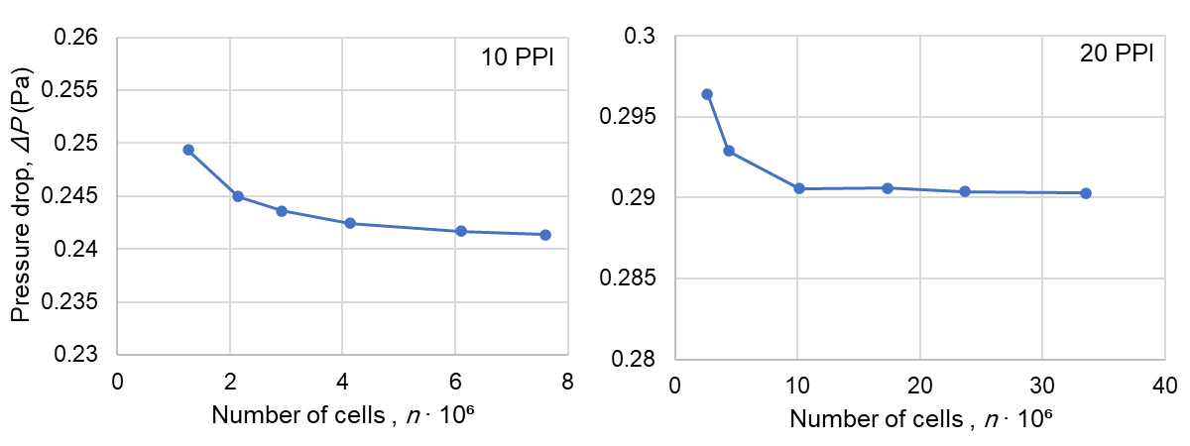
Figure S1. Pressure drop calculations for a grid independence tests performed for 10 PPI (left) and 20 PPI OCF (right)
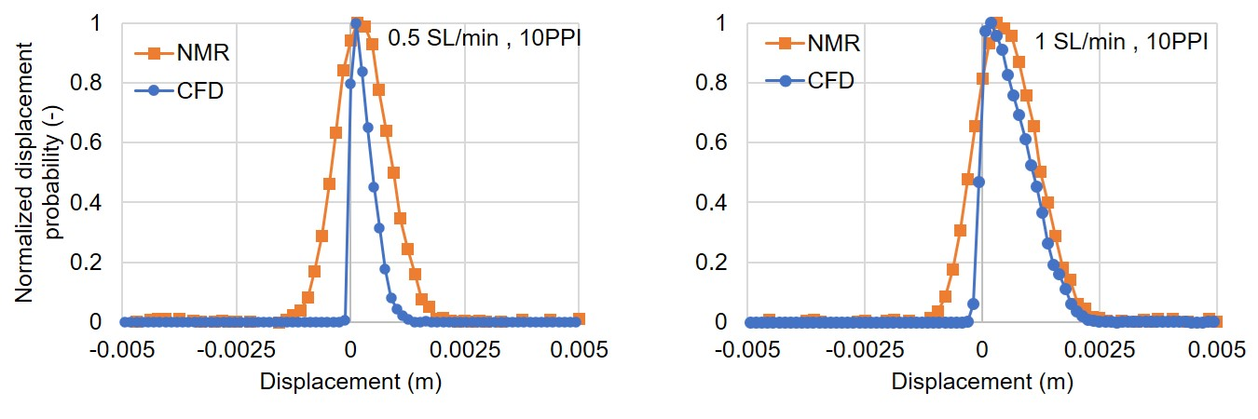
Figure S2. Comparison between the obtained displacement distributions of gas flow within 10 PPI open-cell foam for different flow rates of 0.5 and SL/min from NMR experimental measurements and stationary CFD simulations.
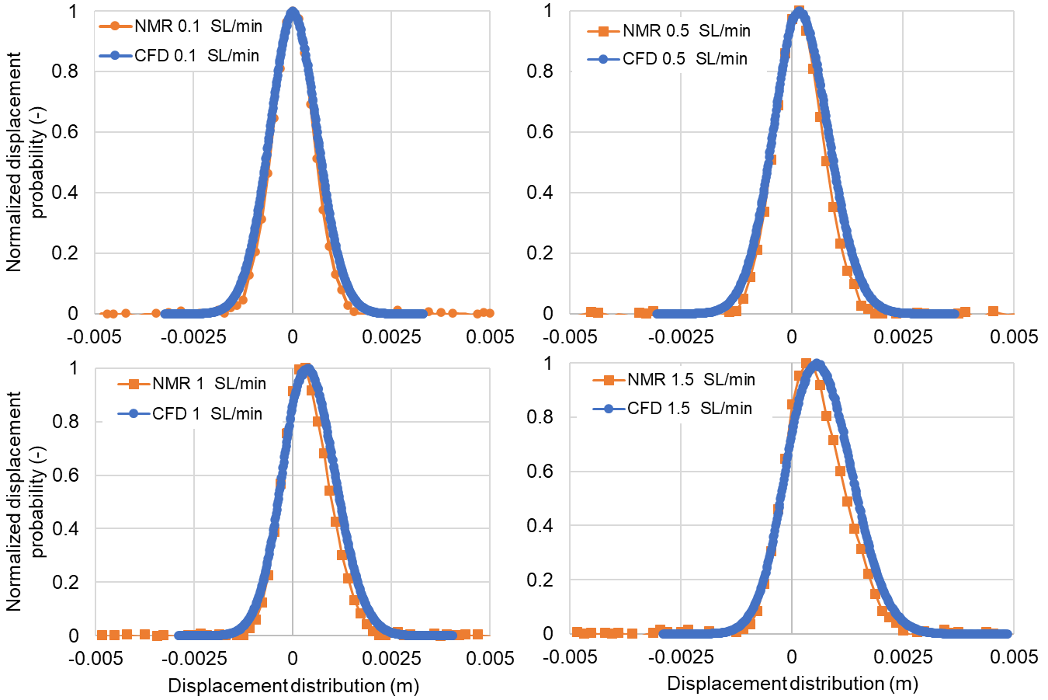
Figure S3. Comparison between the obtained displacement distributions of gas flow within 20 PPI open-cell foam for different flow rates of 0.1, 0.5, 1 and 1.5 SL/min from NMR experimental measurements and CFD-PT simulations

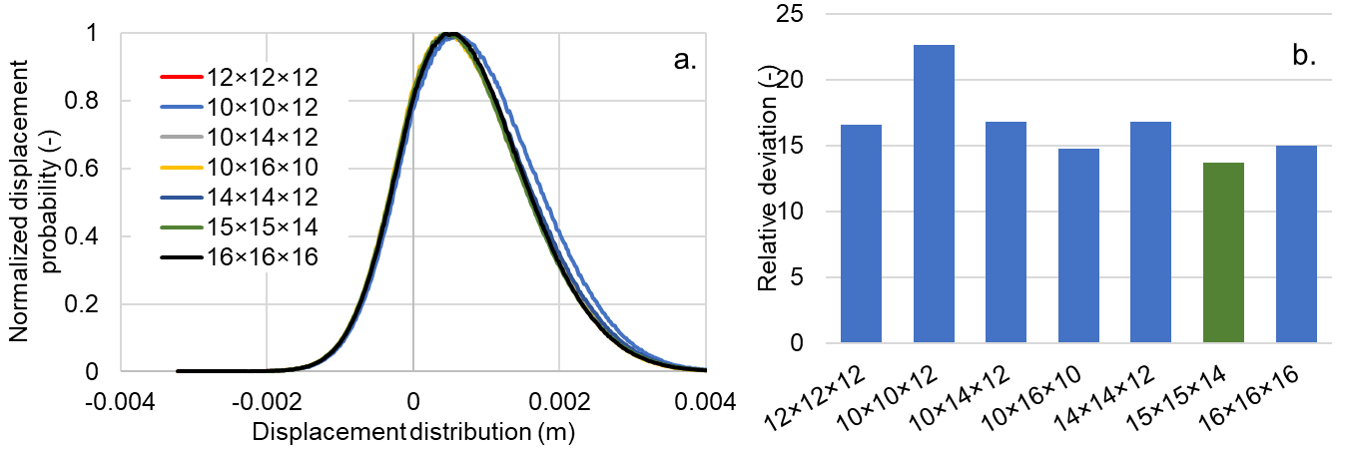
Figure S4. The effect of ROI sizes on the displacement distributions (a) and relative deviations of FWHM from the NMR data(b). The green column in section b show the size of ROI interest which had slightly better agreement compared to the considered size of ROI (15×15×14 mm)

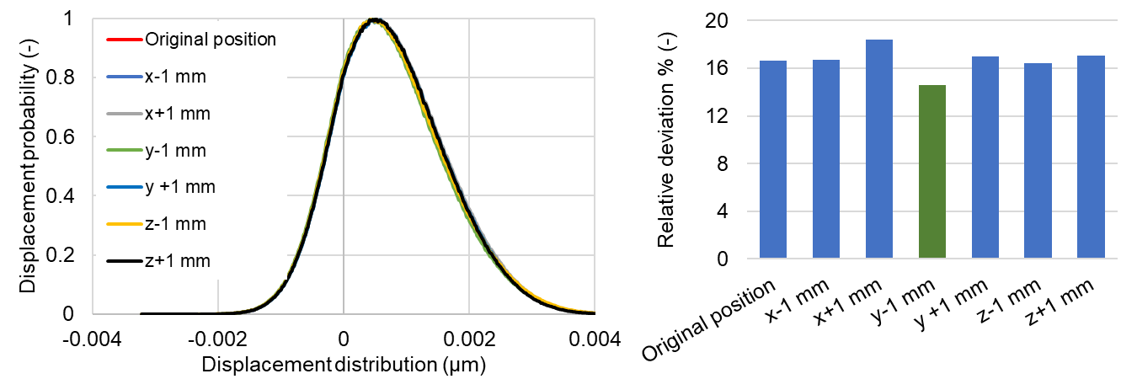
Figure S5. The effect of ROI position on the displacement distribution (a) and the relative deviation of FWHM from NMR data (b)

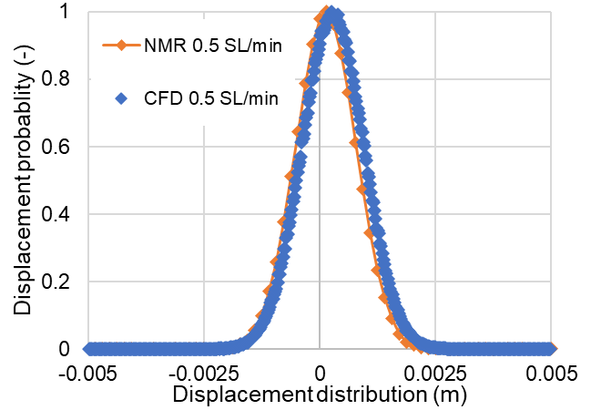
Figure S6. Result of the obtained displacement distribution from CFD-PT simulation and NMR measurements for flow rates of a. 0.5 SL/min through an empty pipe.
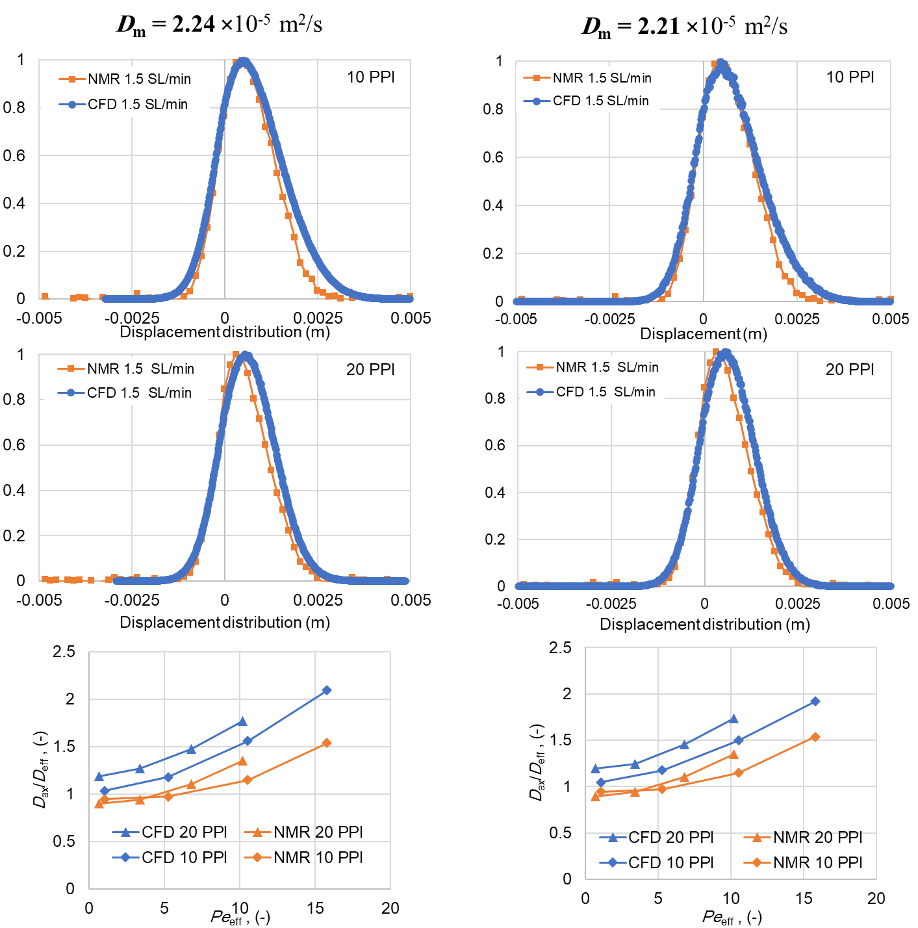
Figure S7. The influence of the implemented molecular diffusion coefficients on the quality of agreement with NMR data. The upper and middle panels show the displacement distribution within 10 PPI and 20 PPI OCFs and flow rate of 1.5 SL/min, respectively. Two panels in the bottom show the comparison of D_{ax} / D_{eff} values of CFD-PT with NMR data for all of the investigated OCFs and flow rates.

