Supplementary materials

Figure S1 Infrared spectra of complex 1 with ligand bpy.

Figure S2 Infrared spectra of complex 2 with ligand phen.

Table S1 Infrared spectra of both complexes with characteristic absorption bands.
functional group | complex 1  (wavenumbers [cm⁻¹] with intensity of absorption bands) | complex 2  (wavenumbers [cm⁻¹] with intensity of absorption bands)
ν(O-H) (crystal water) | 3277b | 3243b
ν(O-H) (aqua ligand) | 3119b | -
ν_{ar}(C-H) | 3063-3035b | 3086b, 3054b
δ(O-H) | 1639m, 1606m | 1640m, 1603m
ν_{ar}(C-N) | 1575m | 1583m
ν_{ar}(C-C) | 1439m | 1480s
ν(S-O) | 1097-980s | 1035-966s
ν(Fe-O) | 894w, 412s | -
δ(S-O) | 593m | 596m
ν(Fe-N) | 421m | 427w
intensity of absorption bands: b-broad, m-medium, s-strong, w-weak.
Figure S3 Infrared spectra of complex 2 measured in the temperature range 30-200 °C.

Figure S4 Disordered sulphate anion of complex 2. Using ball model of atoms with radius 0.255 Å, where lighter colors represent atoms with lower SOF.

Figure S5 Hydrophilic anions are positioned between the layers of hydrophobic cations in complex 2.

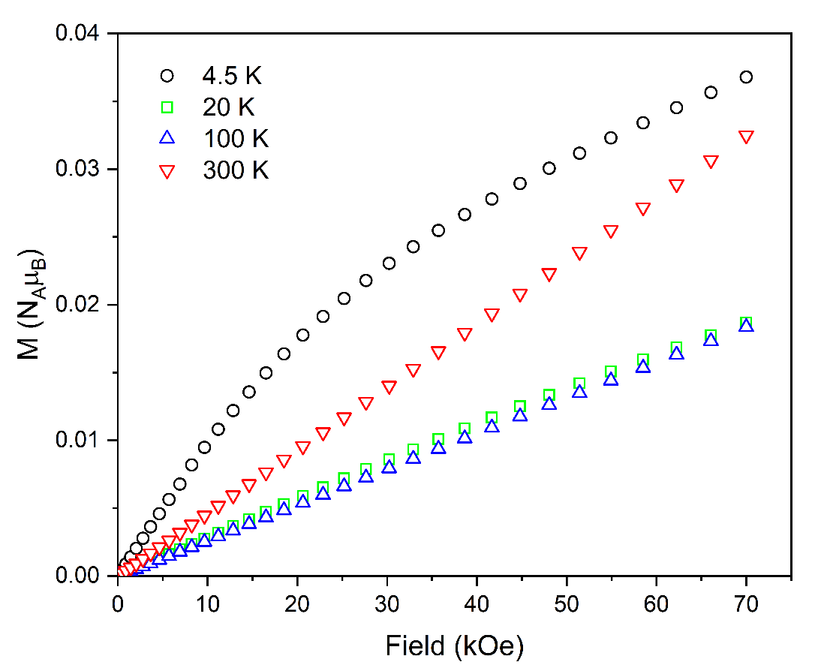
Figure S6 Field dependence of magnetization of 1 at different temperatures.

Figure S7 The XRPD pattern for complex 1 compared with calculated pattern.

Figure S8 The XRPD pattern for complex 2 compared with calculated pattern.

