Supporting Information

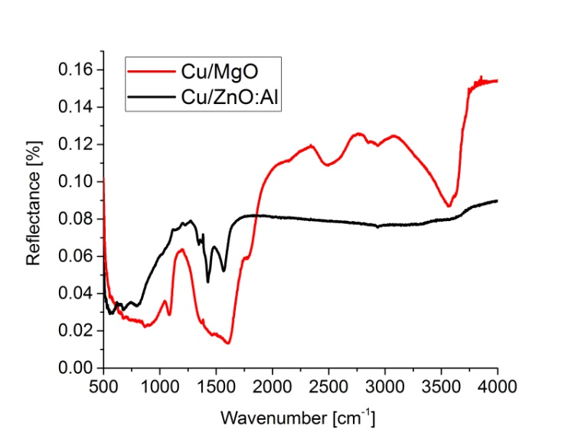

Fig S1 Diffuse reflectance spectra recorded at 300 K of the catalysts reduced at 523 K in 5% hydrogen in argon flow

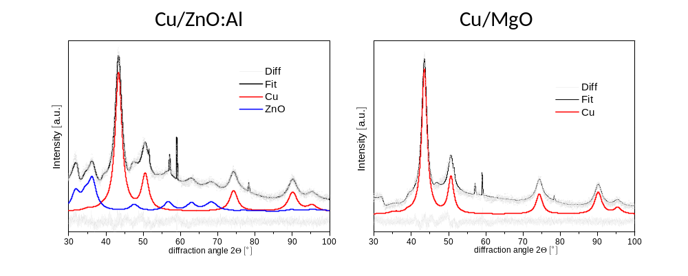
Fig S2 In-situ XRD data of the reduced Cu/ZnO:Al (left) and Cu/MgO (right) catalyst. The MgO phase is still XRD amorphous. The Cu domain sizes extracted from the Rietveld Fits of the patterns are listed in Table 1

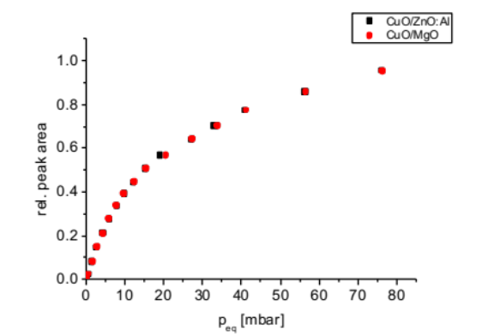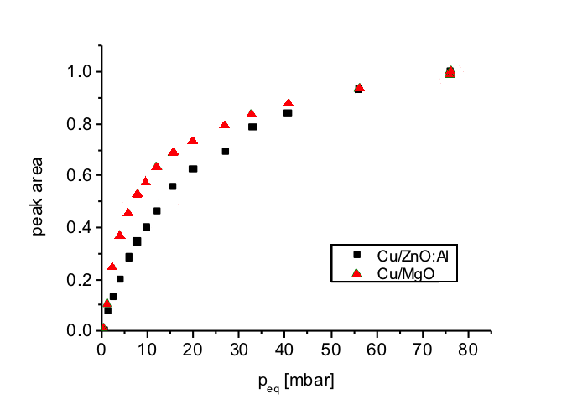

Fig S3 CO adsorption isotherms of calcined (left) and reduced catalysts (right) recorded at 300 K

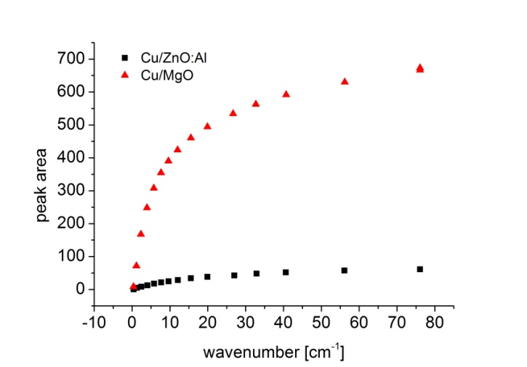

Fig S4 CO adsorption isotherms (not normalized) of the reduced catalysts recorded at 300 K

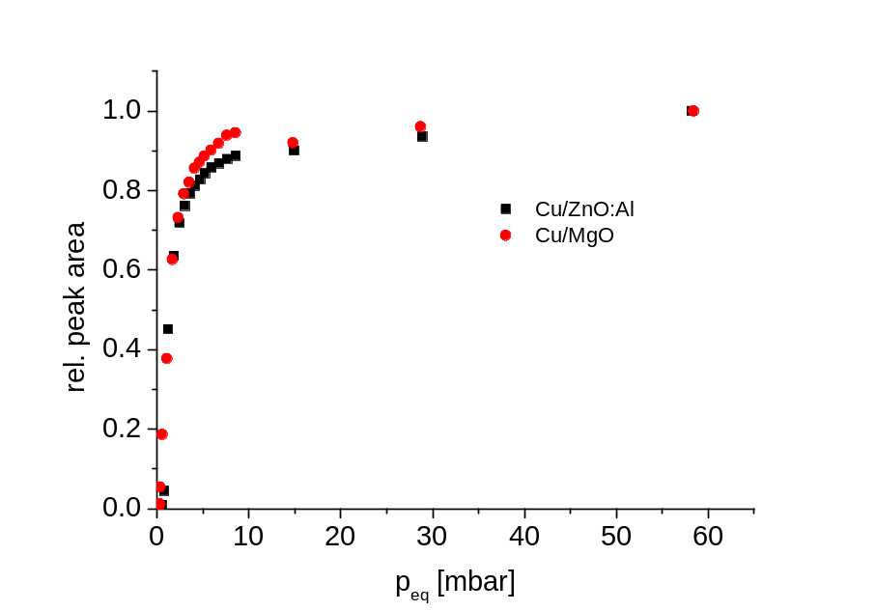

Fig S5 CO adsorption isotherms of the reduced catalysts recorded at 77 K

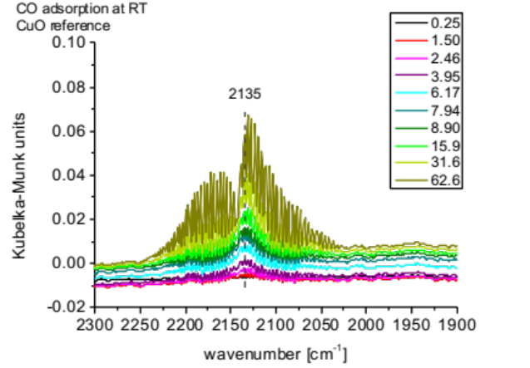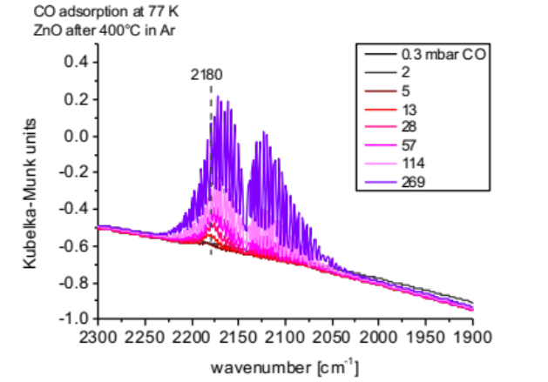

Fig S6 Reference spectra of CO adsorbed on CuO measured at 300 K (left) and ZnO (right) measured at 77 K
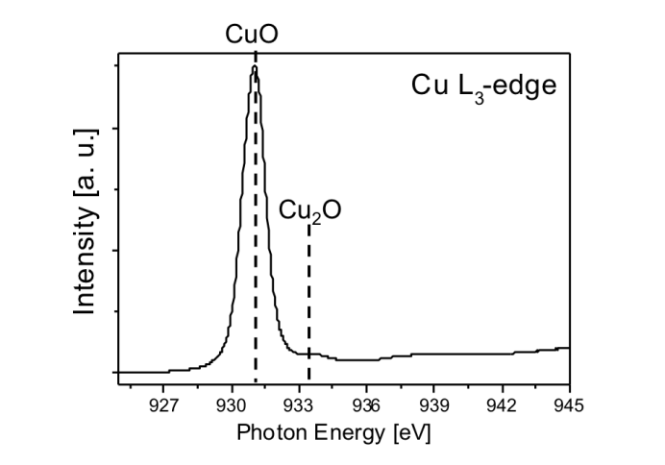
Fig S7 NEXAFS Cu L₃-edge measurement of the calcined CuO/ZnO:Al catalysts at ambient pressure (1 bar) and room temperature under inert gas

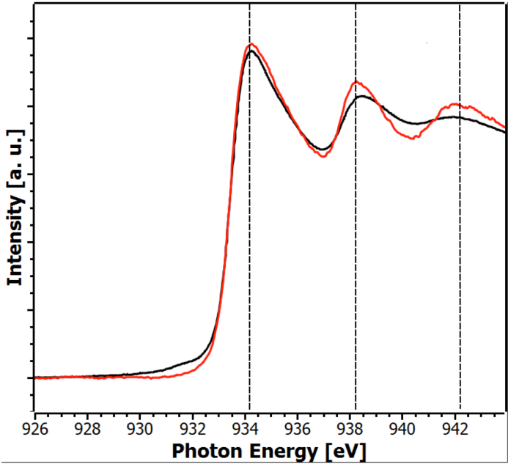
Fig S8 Cu L₃-edge NEXAFS measurement of the Cu/ZnO:Al catalyst at 523 K and 1 bar pressure under reductive atmosphere (10% H₂ in He, dwell 90 min, black curve). The red curve shows a possible fit based on reference measurements; The quality of the fit is between 930-932 eV and for the resonances at 938 eV, respectively 942 eV, insufficient

