Hydrotreatment of fast pyrolysis bio-oil fractions over nickel-based catalyst

Caroline Carriel Schmitt^{1,2}, Klaus Raffelt¹, Anna Zimina^{1,4}, Bärbel Krause³, Thomas Otto¹, Michael Rapp², Jan-Dierk Grunwaldt^{1,4}, Nicolaus Dahmen¹

¹Institute of Catalysis Research and Technology (IKFT) – Karlsruhe Institute of Technology (KIT), Germany
²Institute of Microstructure Technology (IMT) – Karlsruhe Institute of Technology (KIT), Germany.
³Institute for Photon Science and Synchrotron Radiation (IPS) - Karlsruhe Institute of Technology (KIT), Germany.
Hermann-von-Helmholtz-Platz 1, 76344 Eggenstein-Leopoldshafen, Germany
⁴Institute for Chemical Technology and Polymer Chemistry (ITCP) – Karlsruhe Institute of Technology (KIT), Germany

The supplementary material brings further results in order to complement the discussion presented in the manuscript.
GC-MS Results
Figures
Figure S.1 Qualitative results obtained by GC-MS for the light phases products after upgrading at different conditions of pressure and temperature. Feed: FPBO, Product: ULP.

Figure S.2 Qualitative results obtained by GC-MS for the light phases products after upgrading at different conditions of pressure and temperature. Feed: HP, Product: ULP.

Figure S.3 Qualitative results obtained by GC-MS for the heavy phases products after upgrading at different conditions of pressure and temperature. Feed: FPBO, product: UO.

Figure S.4 Qualitative results obtained by GC-MS for the heavy phases products after upgrading at different conditions of pressure and temperature. Feed: HP, product: UO.
¹H-NMR
Figure S.5 ¹H-NMR spectra integration of the upgraded products at different temperatures and 100 bar. a) UO, Feed: FPBO; b) UO, Feed: HP; c) ULP, Feed: FPBO; d) ULP, Feed: HP; Integration regions: 0.5-1.5 ppm- alkanes; 1.5-3.0-α proton to carboxylic acid or keto-group, α proton to unsaturated group; 3.0-4.3-alcohols, ethers, alkenes; 4.3-6.0-carbohydrates, water, O-H exchanging group; 6.0-8.5-(hetero)-aromatic; 9.5-10.1-aldehydes.

SEM-EDX Results
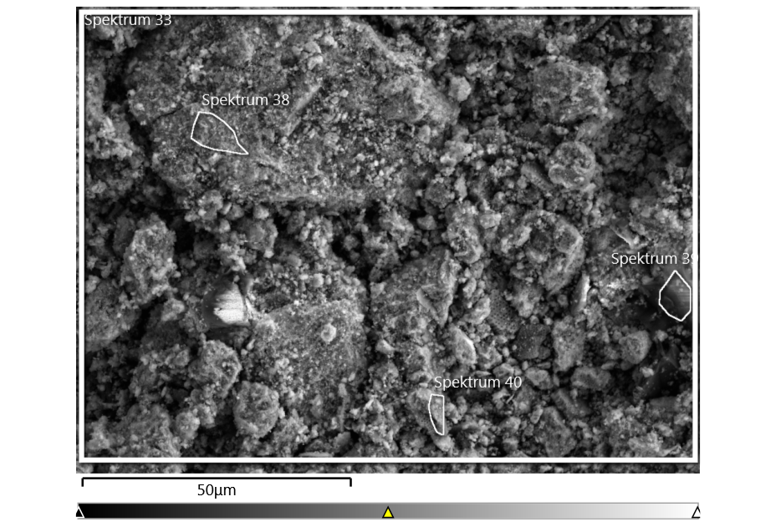
Figure S.6 SEM-EDX specific regions of the fresh catalyst.

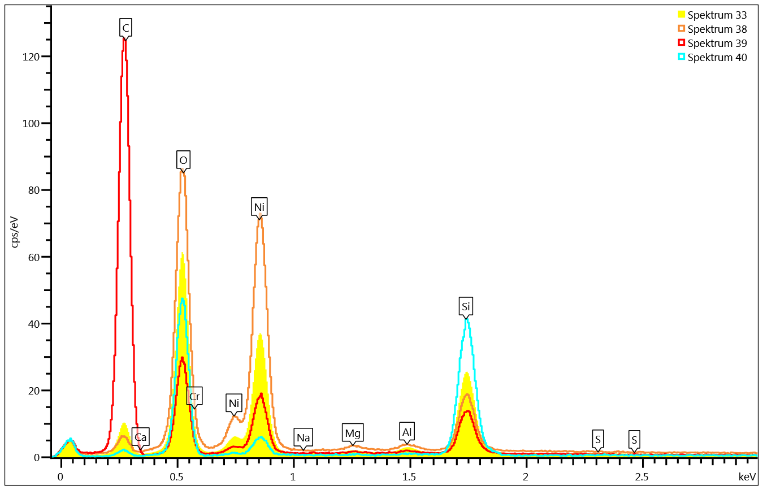
Figure S.7 EDX Spectra fresh catalyst.

Table S2. Elemental distribution over the catalyst surface by SEM-EDX. Fresh catalyst.
Compound | Spectra 38 | Spectra 39 | Spectra 40
C (wt.%) | 4.3 | 63.8 | 5.7
O (wt.%) | 24.6 | 15.9 | 44.4
Si (wt.%) | 6.2 | 4.7 | 36.9
Cr (wt.%) | 7.3 | 0.6 | n.d.
Ni (wt.%) | 56.4 | 14.6 | 12.4

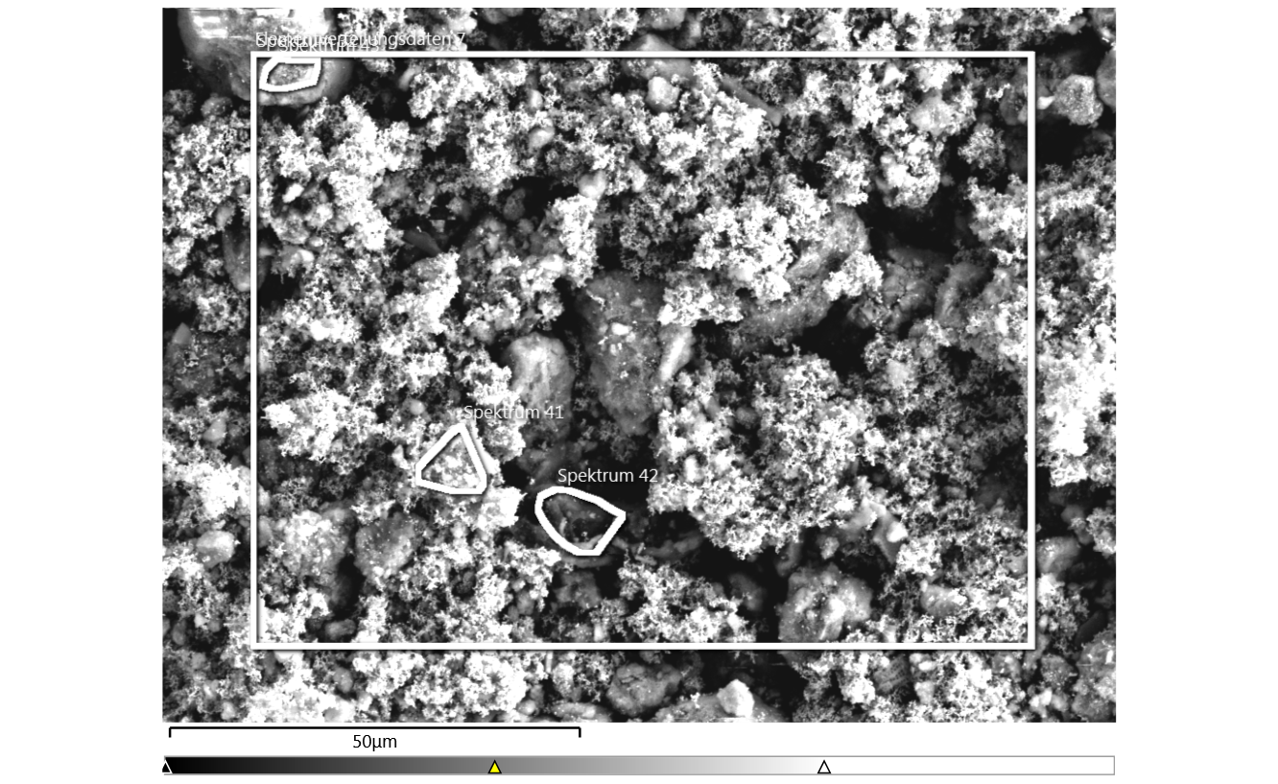
Figure S.8 SEM-EDX specific regions of the spent catalyst. Reaction conditions: 325ºC, 80 bar, Feed: FPBO.

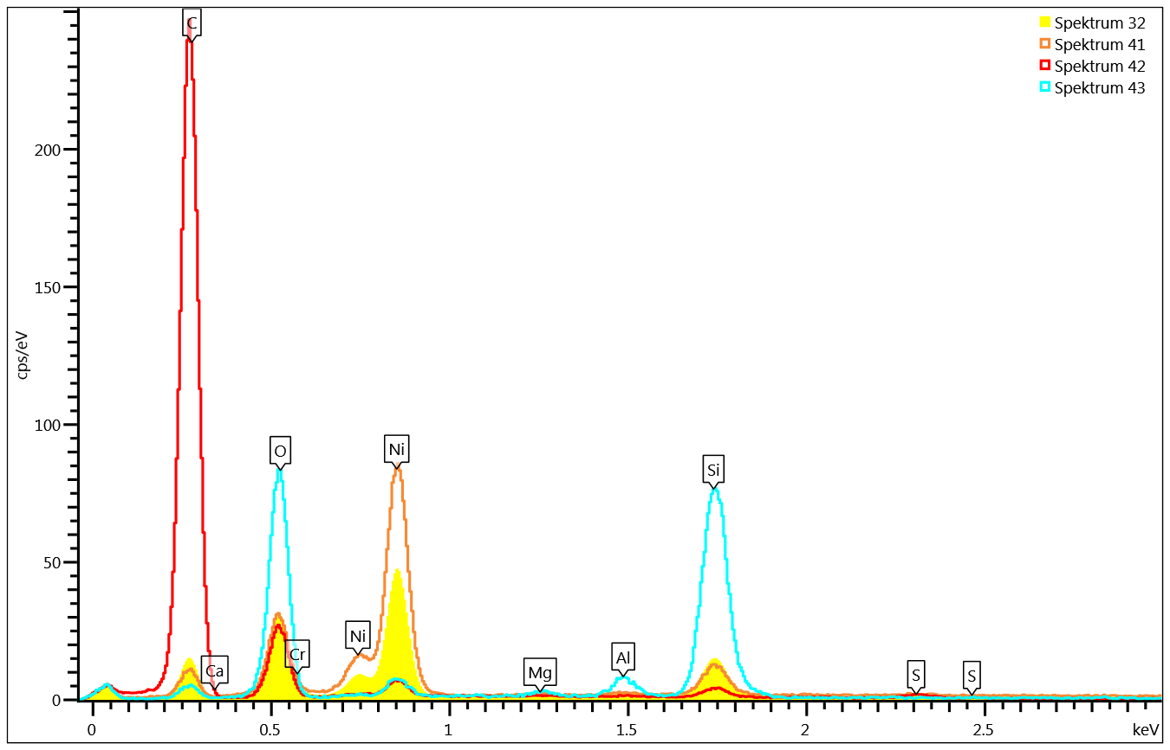
Figure S.9 EDX Spectra spent catalyst. Reaction conditions: 325ºC, 80 bar, Feed: HP+LP.

Table S3. Elemental distribution over the catalyst surface by SEM-EDX. Spent catalyst.
Reaction conditions: 325ºC, 80 bar, Feed: FPBO.
Compound | Spectra 41 | Spectra 42 | Spectra 43
C (wt.%) | 10.1 | 76.8 | 8.3
O (wt.%) | 10.1 | 13.9 | 42.8
Mg (wt.%) | 0.2 | 0.1 | 0.7
Si (wt.%) | 4.6 | 1.0 | 37.1
S (wt.%) | 0.2 | 0.6 | n.d.
Cr (wt.%) | 6.1 | 2.2 | n.d.
Ni (wt.%) | 68.2 | 4.3 | 7.9
Ca (wt. %) | n.d. | 0.9 | 0.3

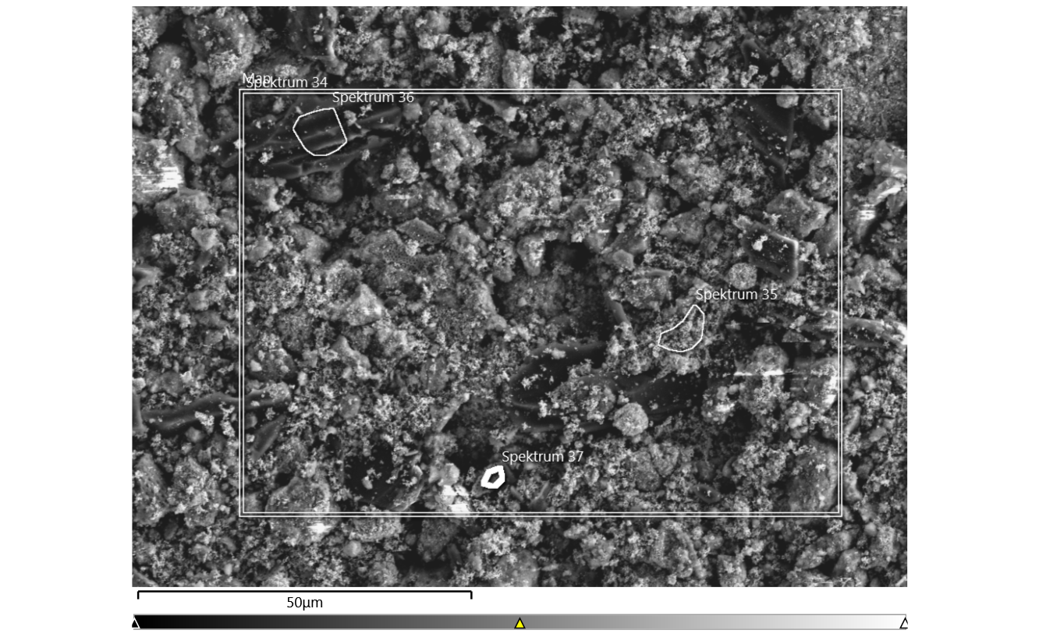
Figure S.10 SEM-EDX specific regions of the spent catalyst. Reaction conditions: 325ºC, 80 bar, Feed: HP.

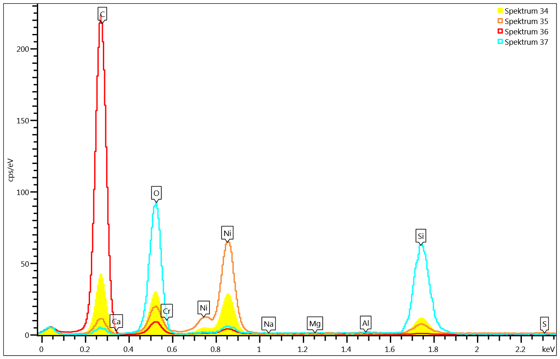
Figure S.11 EDX Spectra spent catalyst. Reaction conditions: 325ºC, 80 bar, Feed: HP.

Table S4. Elemental distribution over the catalyst surface by SEM-EDX. Spent catalyst.
Reaction conditions: 325ºC, 80 bar, Feed: HP
 | Spectra  34 | Spectra 35 | Spectra 36 | Spectra 37
C (wt.%) | 37.7 | 11.4 | 88.6 | 6.4
O (wt.%) | 16.1 | 8.4 | 6.3 | 47.0
Mg (wt.%) | 0.2 | 0.1 | 0.1 | 0.1
Si (wt.%) | 7.3 | 4.2 | 0.3 | 40.0
Cr (wt.%) | 5.5 | 4.9 | 1.1 | n.d.
Ni (wt.%) | 32.2 | 70.2 | 3.5 | 6.1
Ca (wt.%) | 0.1 | 0.1 | 0.1 | 0.3
S (wt.%) | 0.2 | 0.3 | 0.1 | n.d.

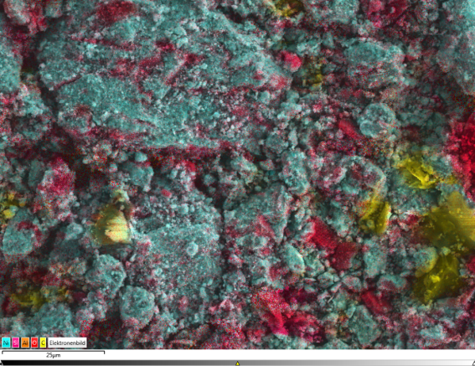(a)
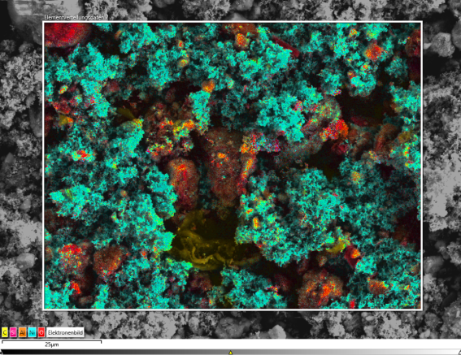(b)
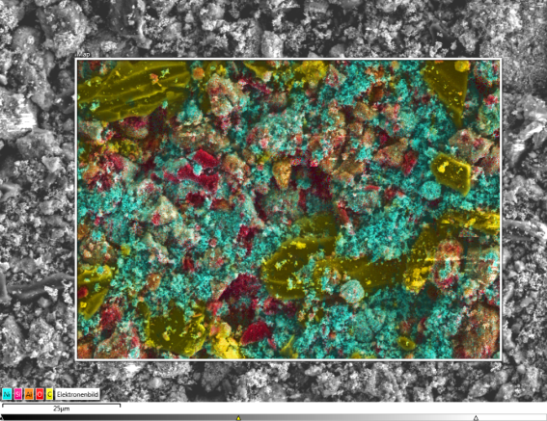(c)
Figure S.12 Surface mapping of the main compounds in the catalysts surface. (a) Fresh catalyst; (b) Spent catalyst (325 ºC, 80 bar, feed: FPBO); (c) Spent catalyst (325 ºC, 80 bar, feed: HP).Yellow: carbon, green: nickel, pink: sulfur, red: oxygen.
Figure S.13 Main reactions observed by GC-MS. (a) hydrogenation; (b) demethoxylation

Figure S.14 Thermogravimetric analysis of spent catalysts. (a) Feed: FPBO; (b) Feed: HP.

