Supplementary information

S1. Re-dissolution of Mo precursor during catalyst preparation
In an additional experiment, a ZrO₂ sample was impregnated with Mo precursor (4 wt.% Mo) and dried at 90°C for 4 h. Then, a part of the sample was exposed to distilled water (10 times the amount of H₂O used for Incipient Wetness Impregnation) and agitated intensively for 1 min. The wet sample was filtered and again dried at 90°C. The surface of the washed and unwashed samples was analysed by X-ray photoelectron spectroscopy (XPS). XP spectra were recorded on an Escalab 250Xi system (Thermo Fisher Scientific) operating at a pressure below 2.5 x 10⁻⁷ mbar. Monochromatic Al Kα radiation (1486.6 eV) was used for excitation. The analyser operated at a pass energy of 20 eV, while binding energy scale was calibrated using Au4f_{5/2} (84 eV), Ag3d_{5/2} (368.2 eV), Cu2p_{3/2} (932.6 eV) lines of gold, silver and copper metal. Atomic Mo/Zr ratios were derived from the peak areas of the Mo3d and Zr3d region after subtraction of the Shirley background. The atomic Mo/Zr ratio of the washed sample was found to be 9.8, which is slightly higher than that of the unwashed sample (8.7). From these results, we conclude that during incipient wetness impregnation with Pt(NO₃), the Mo is not substantially re-dissolved. However, increased surface mobility and possible re-arrangement of Mo species during Pt impregnation cannot be excluded.

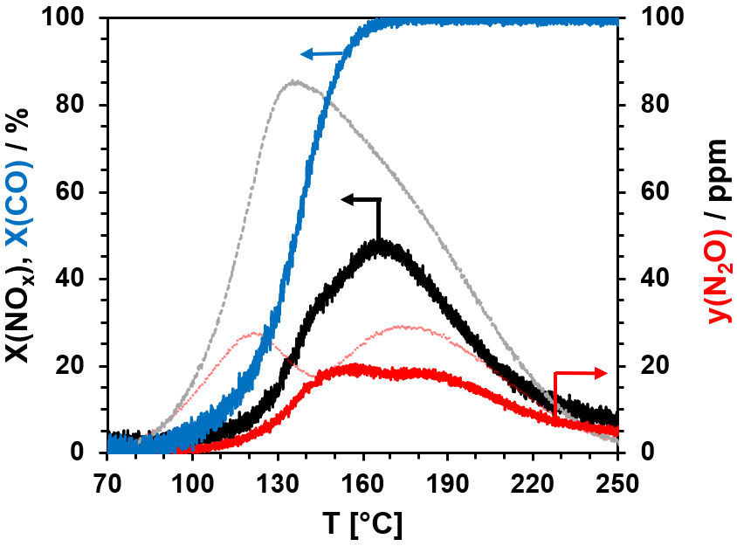
Figure S2: NO_{x} and CO conversion as well as N₂O formation in H₂-deNO_{x} with 200 ppm CO on 0.25Pt/3Mo/ZrO₂. Conditions: 200 ppm NO_{x}, 200 ppm CO, 2000 ppm H₂, 5 vol.% O₂, 10 vol.% H₂O, N₂ balance, 160,000 h⁻¹.
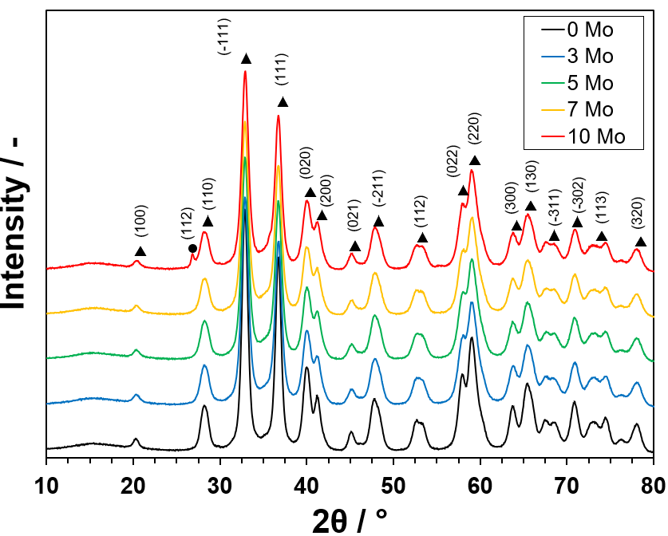
Figure S3: PXRD patterns of Pt/xMo/ZrO₂ samples; reflexes are attributed to monoclinic ZrO₂ () and β-MoO₃ ().

Table S4: Pt dispersion (D_{Pt}) ª, Pt particle size (d_{Pt}) ^{b}, turnover frequency of NO (TOF) and specific N₂ formation rate (ṅ(N₂)/n_{a}(Pt)) at 130°C of the Pt/xMo/ZrO₂ samples.
w(Mo) / wt.% | D_{Pt} / % | d_{Pt} / nm | TOF at 130°C / s⁻¹ | ṅ(N₂)/n_{a}(Pt) at 130°C / s⁻¹
0 | 14 | 8.0 | 4.9∙10⁴ | 5.9E∙10³
1 | 49 | 2.3 | 2.5∙10⁴ | 4.4E∙10³
2 | 54 | 2.1 | 2.8∙10⁴ | 7.5E∙10³
3 | 56 | 2.0 | 3.5∙10⁴ | 1.4E∙10⁴
4 | 39 | 2.9 | 4.3∙10⁴ | 1.5E∙10⁴
7 | 11 | 10.8 | 5.1∙10⁴ | 1.1E∙10⁴
10 | 4 | 25.0 | 4.1∙10⁴ | 9.9E∙10³
ª D_{Pt} = n_{a}(Pt) / n_{Pt}, n_{a}(Pt) was obtained from CO-TPD
^{b} d_{Pt} = 6 V_{Pt}/(a_{Pt} ∙ D_{Pt})

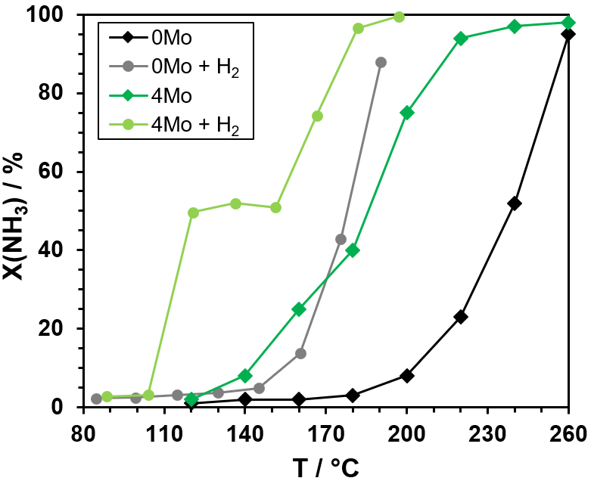
Figure S5: Oxidation of NH₃ with and without H₂ on 0.25Pt/ZrO₂ and 0.25Pt/4Mo/ZrO₂. Conditions: 100 ppm NH₃, 2000 ppm (optional), 5 vol.% O₂, 10 vol.% H₂O, N₂ balance,
160,000 h⁻¹

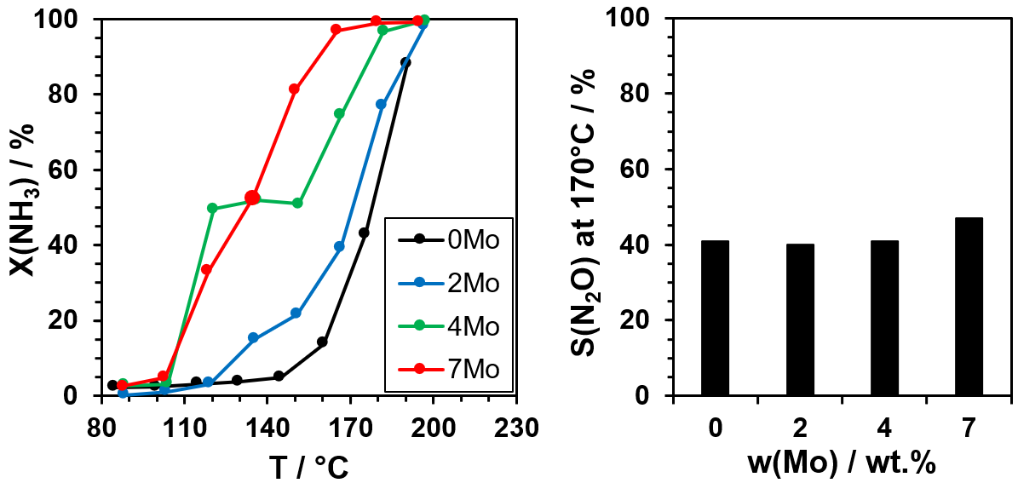
Figure S6: NH₃ oxidation (left) and N₂O selectivity at 170°C (right) during NH₃ oxidation with H₂ on the 0.25Pt/xMo/ZrO₂ catalysts. Conditions: 100 ppm NH₃, 2000 ppm H₂, 5 vol.% O₂, 10 vol.% H₂O, N₂ balance, 160,000 h⁻¹.

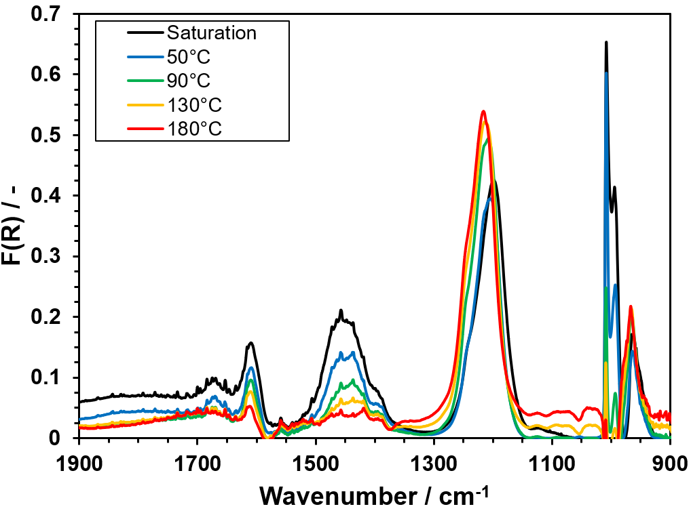
Figure S7: DRIFT spectra of Pt/4Mo/ZrO₂ after exposure to 1000 ppm NH₃ at 50°C and flushing with N₂ for 30 min at 50°C, 90°C, 130°C and 180°C.

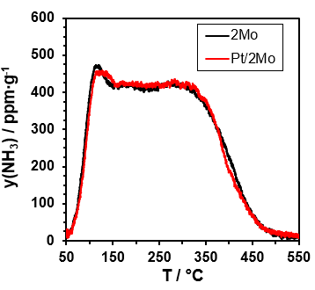
Figure S8: NH₃-TPD profiles of the 2Mo/ZrO₂ and Pt/2Mo/ZrO₂ samples after saturation at 50°C with 1000 ppm NH₃ (N₂ balance). TPD conditions: m = 300 mg, F(N₂) = 500 ml/min, ΔT/Δt = 10 K/min.

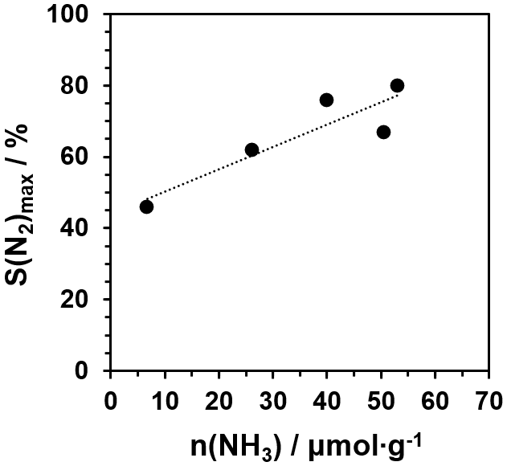
Figure S9: Correlation of specific NH₃ quantities desorbed above 300°C in NH₃-TPD and maximum N₂selectivities in H₂-deNO_{x} of 0.25Pt/xMo/ZrO₂ catalysts (x = 2, 3, 4, 5, 7).

