Supplementary Information (SI)

Table S1: Assignment of the DRIFTS bands and thermal stability range of adsorbates.
Species | ṽ (vibration mode) / cm⁻¹ | Temperature range | Ref.
Hydroxyl | 3697 (ν_{OH}), 3665 (ν_{OH}), 3626 (ν_{OH}) | -100 °C–250 °C | [23, 34, 35]
Polyoxymethylene | 2981 (ν_{CH2}), 2921 (ν_{CH2}), 2786 (ν_{CH2}) 1470 (δ_{CH2}), 1433 (ω_{CH2}), 1382 (ω_{CH2}), 1239 (R_{CO}),1104 (R_{CO}), 947 (R_{CO}) | -100 °C–50 °C | [25, 26]
[CH₂O]_{n} oligomers | 2938 (ν_{CH2}), 1406 (δ_{CH2}) | 50 °C–100 °C | [23, 24]
Methoxy | 2970 (ν_{CH2}), 2860 (ν_{CH2}), 1174, (ν_{CO})  1091 (ν_{a,CO}), 1069 (ν_{CO}) | 50 °C–150 °C | [23, 26, 28]
Formate | 2960 (ν_{a,COO}+ δ_{CH}), 2875 (ν_{CH}),  1564 (ν_{a,COO}), 1378 (δ_{CH}), 1355 (ν_{s,COO}) | 50 °C–250 °C | [23, 24, 26]
Carbonate | 1573 (ν_{CO}), 1311 (ν_{as,OCO}), 1285(ν_{as,COO}) | 100 °C–300 °C | [19, 29, 30]
Water | 3600–3000 (ν_{OH}), 1644 (δ_{OH}) | -100 °C–300 °C | [19, 23, 27]

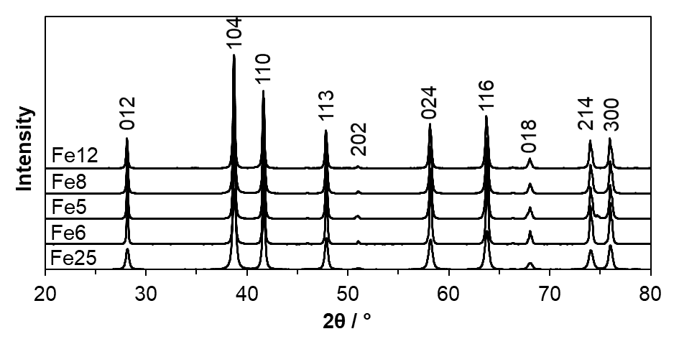
100
Figure S1: XRD patterns of the investigated materials, exclusively containing α-Fe₂O₃.

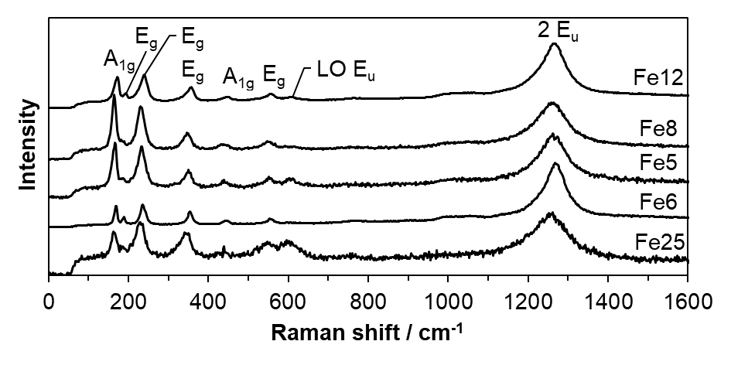
500
Figure S2: LRS of the investigated materials, exclusively containing α-Fe₂O₃.

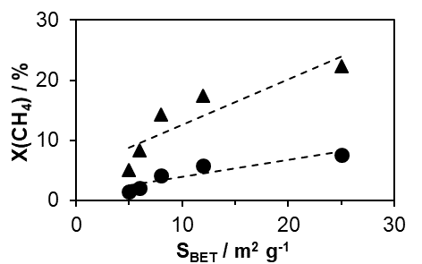 | 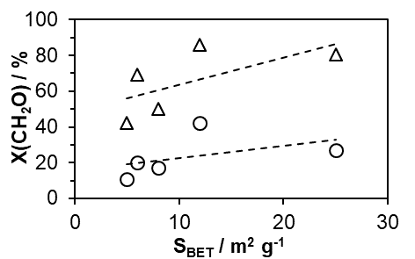
Figure S3: Relation of the CH₄ conversion at 550 () and 500 °C () (left) and the CH₂O conversion at 250 () and 200 °C () with the BET surface areas of the catalysts; the lines are a guide for the eyes.

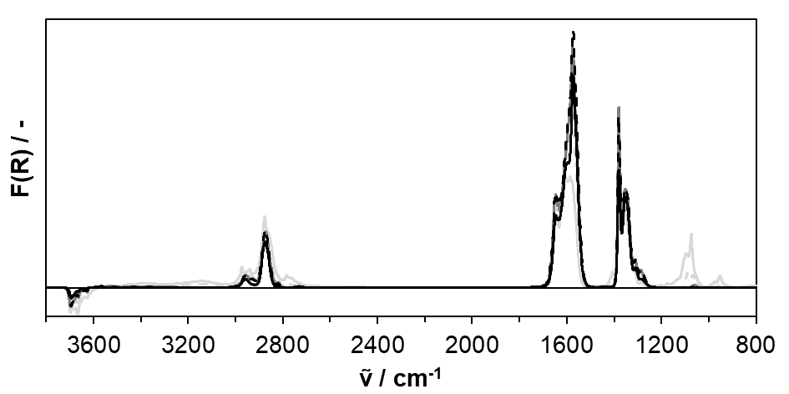
0
0.25
Figure S4: DRIFT spectra of the Fe25 catalyst after CH₂O exposure (50 °C) and subsequent flushing with N₂ at 50 °C (―), 100 °C (dashed ―), 150 °C (―), 200 °C (dashed ―) and 250 °C (―). Conditions: y(CH₂O) = 500 ppm, y(O₂) = 5 vol%, N₂ balance, F = 200 ml min⁻¹ (STP).

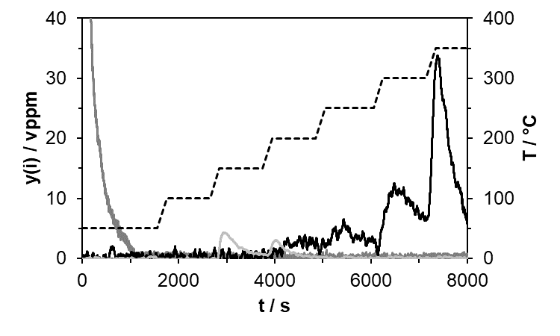
Figure S5: Gas phase fractions (CH₂O (―), CH₃OH (―), CO₂ (―)) and temperature profile (dashed line) during DRIFTS experiment.

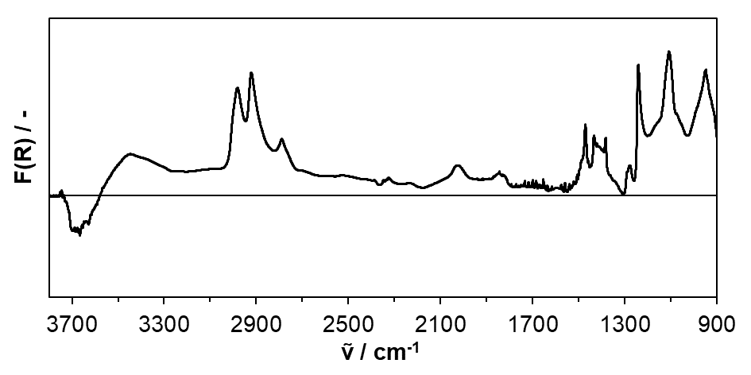
0
0.35
Figure S6: DRIFT spectrum of the Fe25 catalyst after CH₂O exposure at -100 °C. Conditions: y(CH₂O) = 500 ppm, y(O₂) = 5 vol%, N₂ balance, F = 200 ml min⁻¹ (STP).

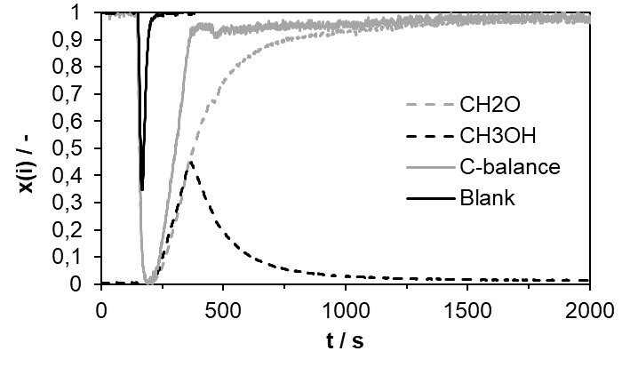
CH₂O
CH₃OH
C balance
Blank
Figure S7: Step function experiment using the Fe25 catalyst. Conditions: y(CH₂O) = 500 ppm, y(O₂) = 5 vol%, N₂ balance, T = 150 °C, S.V. = 100,000 h⁻¹ (STP).

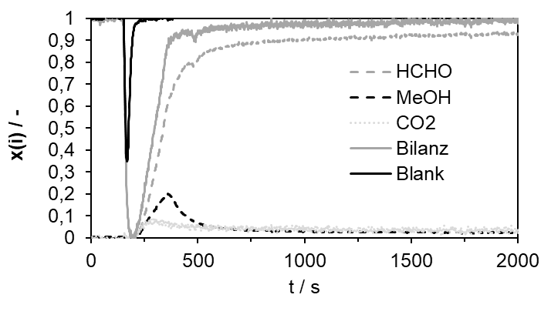
CH₂O
CH₃OH
CO₂
C balance
Blank
Figure S8: Step function experiment using the Fe25 catalyst. Conditions: y(CH₂O) = 500 ppm, y(O₂) = 5 vol%, N₂ balance, T = 200 °C, S.V. = 100,000 h⁻¹ (STP).

