Supplementary information

Chemo-enzymatic synthesis of enantiopure β-blocker
(S)-metoprolol and derivatives

Pål L. Bøckmann and Elisabeth E. Jacobsen*

Department of Chemistry, Norwegian University of Science and Technology (NTNU)
Høgskoleringen 5, N-7491 Trondheim, Norway.
Office phone: (+47) 73 59 62 56, Cell phone: (+47) 98 84 35 59
e-mail: elisabeth.e.jacobsen@ntnu.no

Figure 1-7: Spectroscopic data of 1-chloro-3-(4-(2-methoxyethyl)phenoxy)propan-2-ol, 1a.

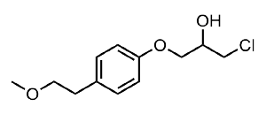
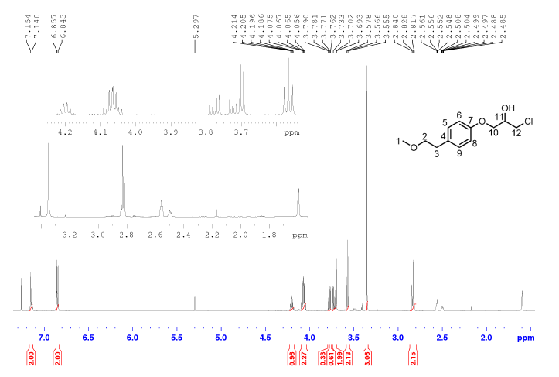
Figure 1. ¹H NMR spectrum of 1-chloro-3-(4-(2-methoxyethyl)phenoxy)propan-2-ol, 1a.

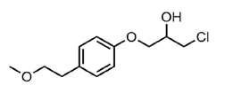
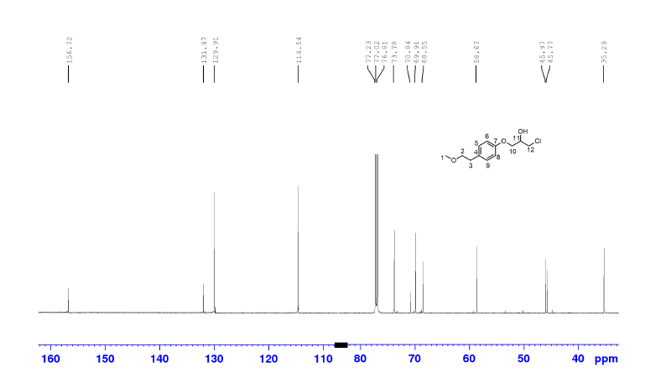
Figure 2. ¹³C NMR spectrum of 1-chloro-3-(4-(2-methoxyethyl)phenoxy)propan-2-ol, 1a.

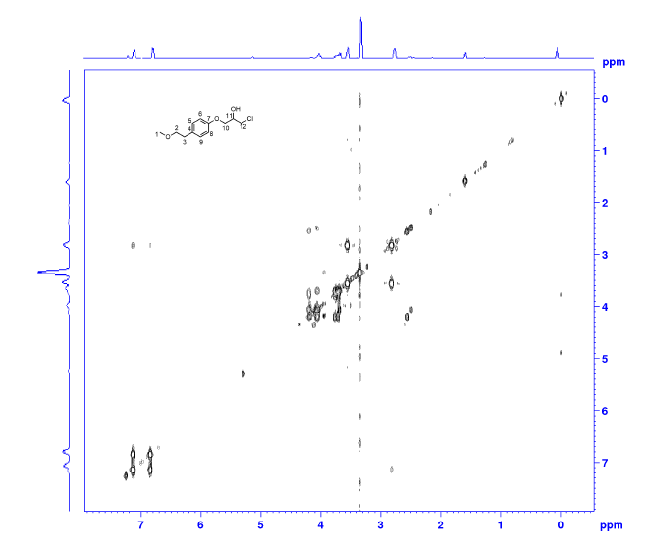

Figure 3. COSY spectrum of 1-chloro-3-(4-(2-methoxyethyl)phenoxy)propan-2-ol, 1a.

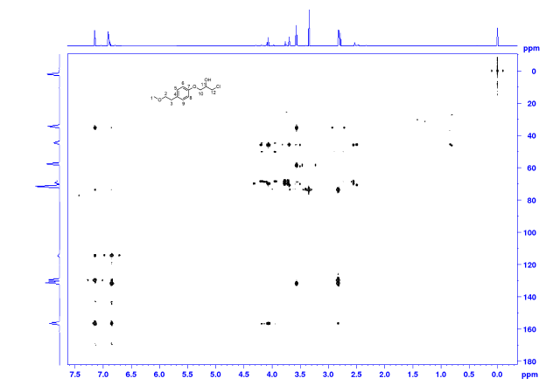

Figure 4. HMBC spectrum of 1-chloro-3-(4-(2-methoxyethyl)phenoxy)propan-2-ol, 1a.
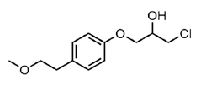
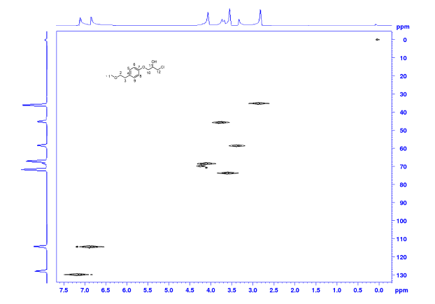
Figure 5. HSQC spectrum of 1-chloro-3-(4-(2-methoxyethyl)phenoxy)propan-2-ol, 1a.

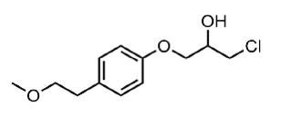
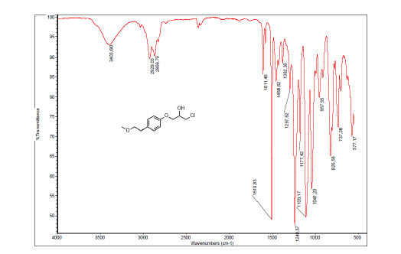

Figure 6. IR spectrum of 1-chloro-3-(4-(2-methoxyethyl)phenoxy)propan-2-ol, 1a.

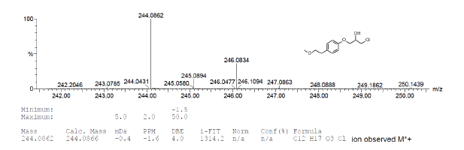
Figure 7. MS spectrum of 1-chloro-3-(4-(2-methoxyethyl)phenoxy)propan-2-ol, 1a.

Figure 8-14: Spectroscopic data of 2-((4-(2-methoxyethyl)phenoxy)methyl)oxirane, 1b.

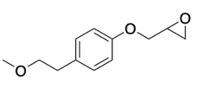
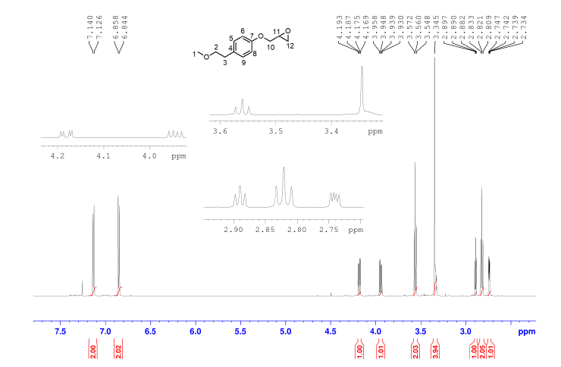

Figure 8. ¹H NMR spectrum of 2-((4-(2-methoxyethyl)phenoxy)methyl)oxirane, 1b.

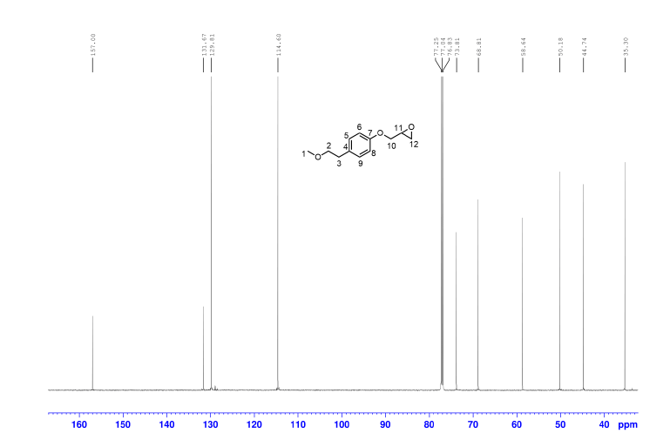

Figure 9. ¹³C NMR spectrum of 2-((4-(2-methoxyethyl)phenoxy)methyl)oxirane, 1b.

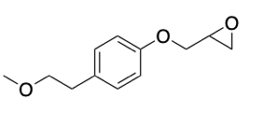
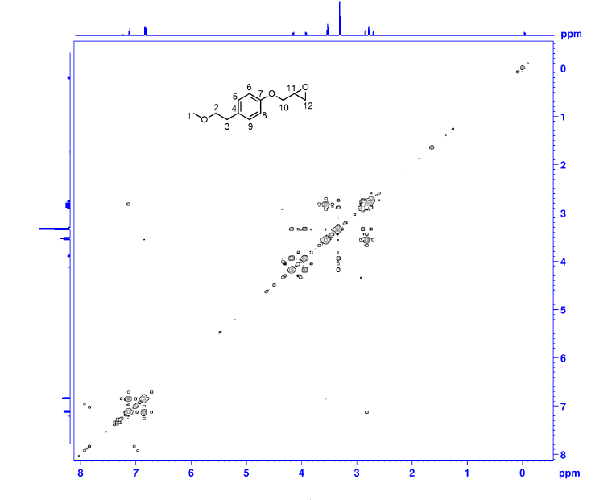
Figure 10. COSY spectrum of 2-((4-(2-methoxyethyl)phenoxy)methyl)oxirane, 1b.

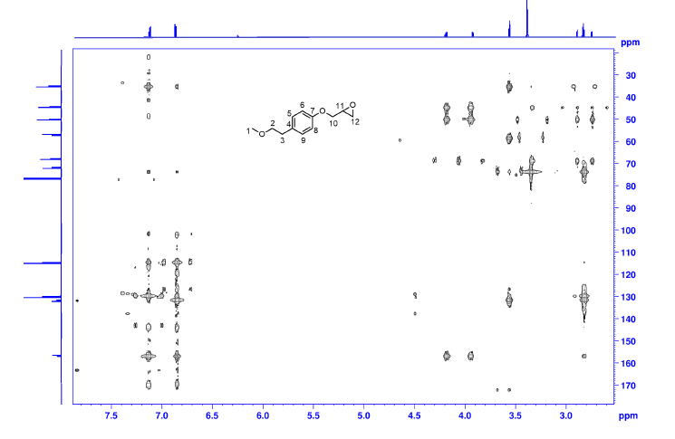

Figure 11. HMBC spectrum of 2-((4-(2-methoxyethyl)phenoxy)methyl)oxirane, 1b.

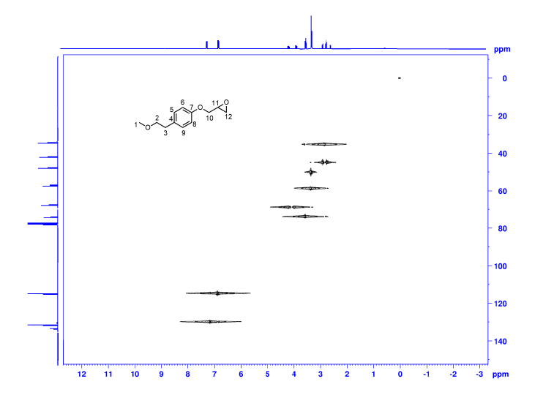

Figure 12. HSQC spectrum of 2-((4-(2-methoxyethyl)phenoxy)methyl)oxirane, 1b.

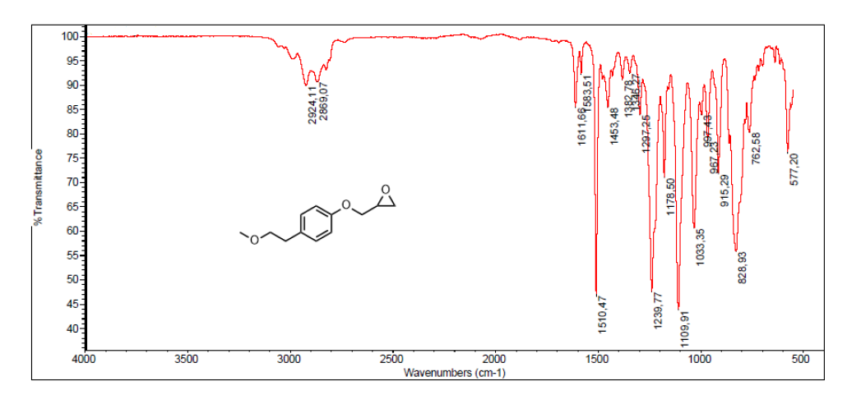

Figure 13. IR spectrum of 2-((4-(2-methoxyethyl)phenoxy)methyl)oxirane, 1b.
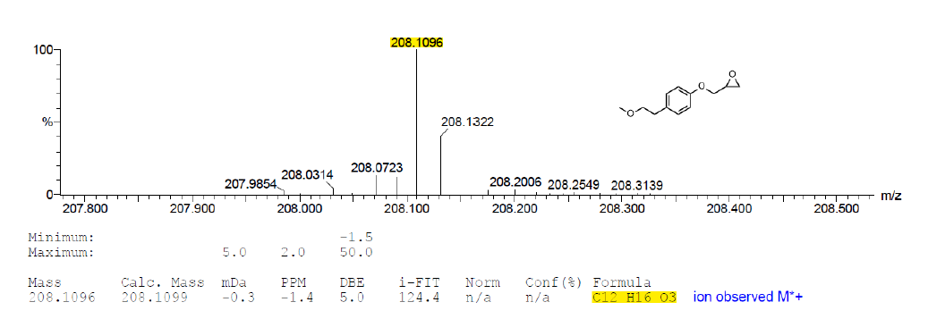

Figure 14. MS spectrum of 2-((4-(2-methoxyethyl)phenoxy)methyl)oxirane, 1b.

Figure 15-18: Chromatographic data of 1-chloro-3-(4-(2-methoxyethyl)phenoxy)propan-2-ol, 1a ,of the butanoate ester of 1-chloro-3-(4-(2-methoxyethyl)phenoxy)propan-2-ol, 2 and of (R)-1a and (S)-1a.

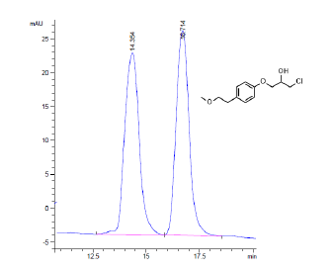

Figure 15. Racemic 1a resolved on HPLC on a Chiralcel OD-H column, method hexane:2-propanol 83:17, flow: 0.6 mL min⁻¹, UV 254 nm, t_{R} = 14.354 min, (S)-1a); 16.714 min, (R)-1a.

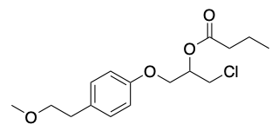
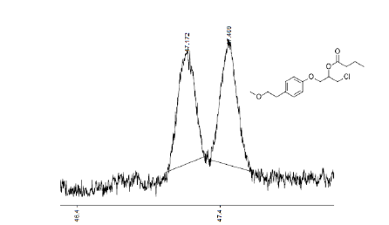

Figure 16. Racemic 2 resolved on chiral GLC with CP Chirasil DEX column, t_{R} = 47.172 min, (R)-2; 47.469 min, (S)-2. R_{s} = 1.55.

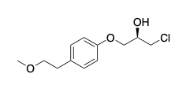
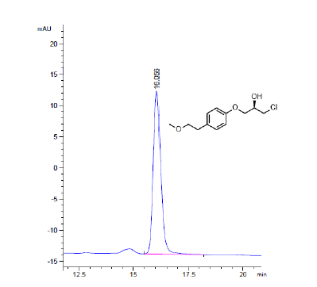

Figure 17. (R)-1a (99 % ee) resolved on HPLC on a Chiralcel OD-H column, method hexane:2-propanol 83:17, flow: 0.6 mL min⁻¹, UV 254 nm, t_{R} = 16.055 min.

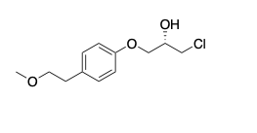
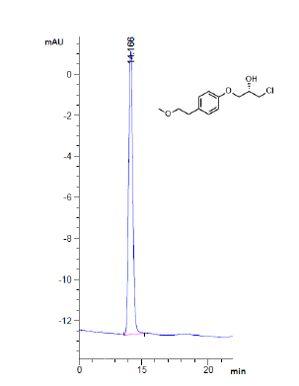
Figure 18. (S)-1a (99.9 % ee) resolved on HPLC on a Chiralcel OD-H column, method hexane:2-propanol 83:17, flow: 0.6 mL min⁻¹, UV 254 nm, t_{R} = 14.186 min.

Figures 19-25: Spectroscopic data of (S)-metoprolol, (S)-3.

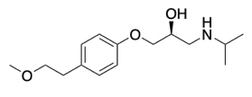
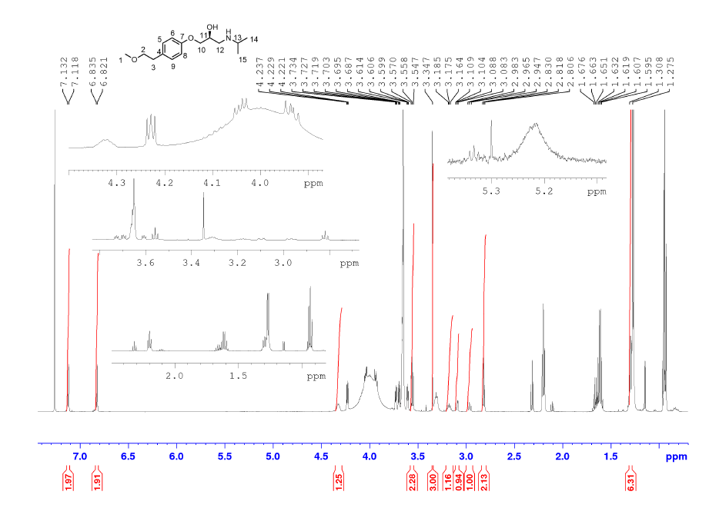

Figure 19. ¹H NMR spectrum of (S)-metoprolol ((S)-3).

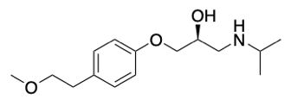
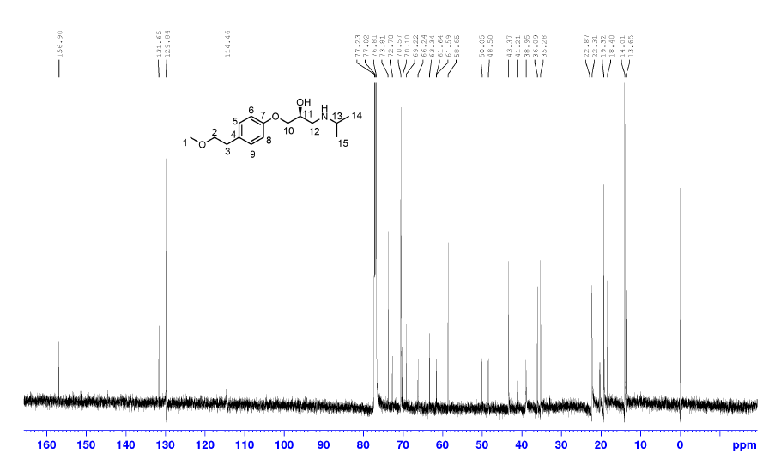

Figure 20. ¹³C NMR spectrum of (S)-metoprolol ((S)-3).
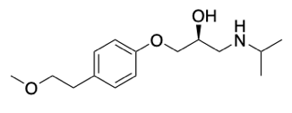
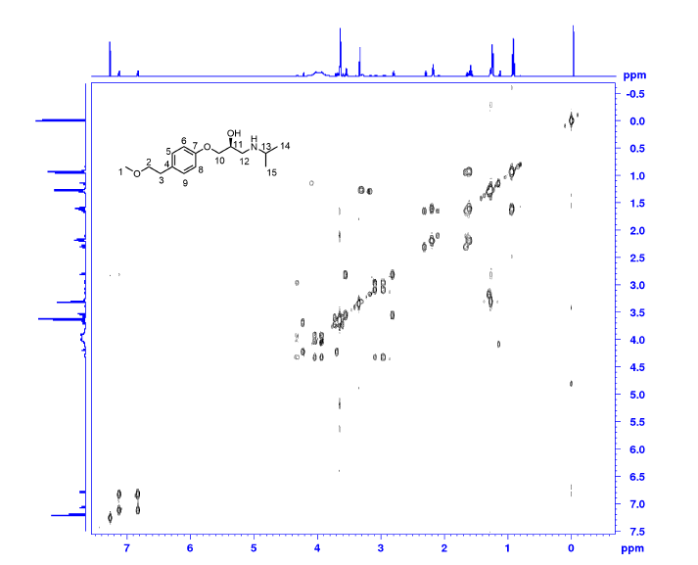

Figure 21. COSY spectrum of (S)-metoprolol ((S)-3).

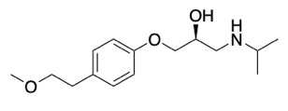
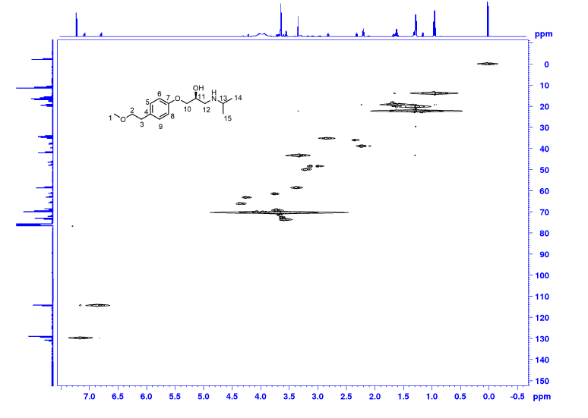
Figure 22. HSQC spectrum of (S)-metoprolol ((S)-3).
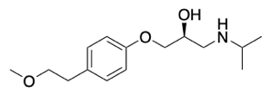
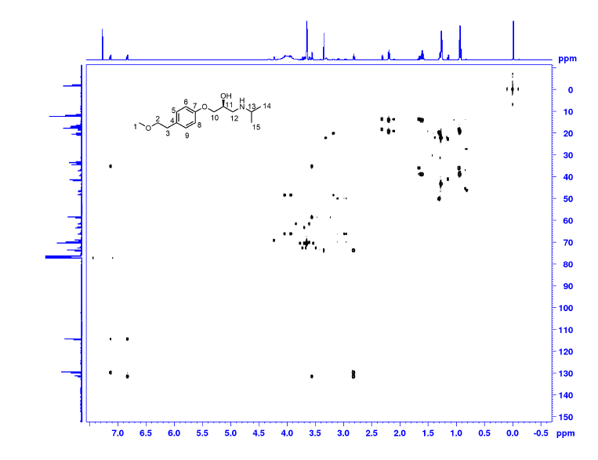
Figure 23. HMBC spectrum of (S)-metoprolol ((S)-3).

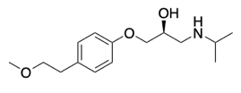
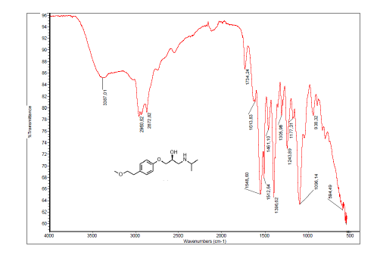
Figure 24. IR spectrum of (S)-metoprolol ((S)-3).

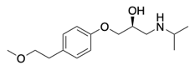
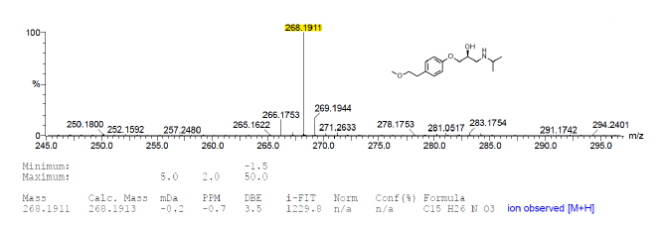

Figure 25. MS spectrum of (S)-metoprolol ((S)-3).

Figure 26: HPLC chromatogram of (S)-metoprolol, (S)-3.

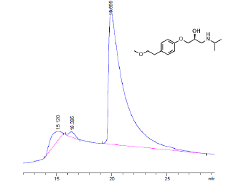
Figure 26. HPLC chromatogram of (S)-metoprolol ((S)-3). resolved on HPLC on a Chiralcel OD-H column, method hexane:2-propanol 83:17, flow: 0.6 mL min⁻¹, UV 254 nm, t_{R} = 19.889.

