Supporting Information

CO₂ Conversion via Low-Temperature RWGS enabled by multicomponent catalysts: Could transition metals outperform Pt?

G. Torres-Sempere*, J. González-Arias, A. Penkova, J.L. Santos, L.F. Bobadilla, J.A. Odriozola, L. Pastor-Pérez, T.R. Reina*
Inorganic Chemistry Department and Materials Sciences Institute, University of Seville-CSIC, Seville, Spain
Co-corresponding authors:gtorres1@us.es , tramirez@us.es
Figure S1. N₂ adsorption isotherms at 77k for the multicomponent catalysts

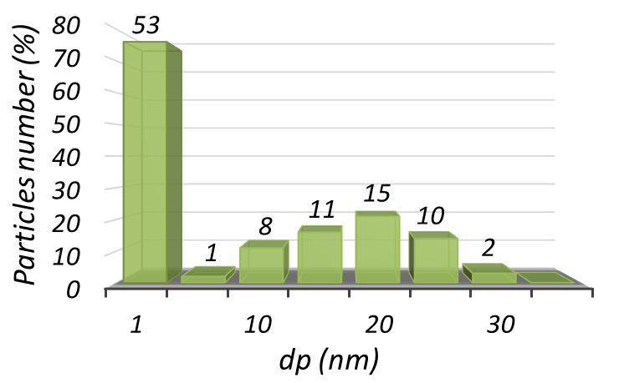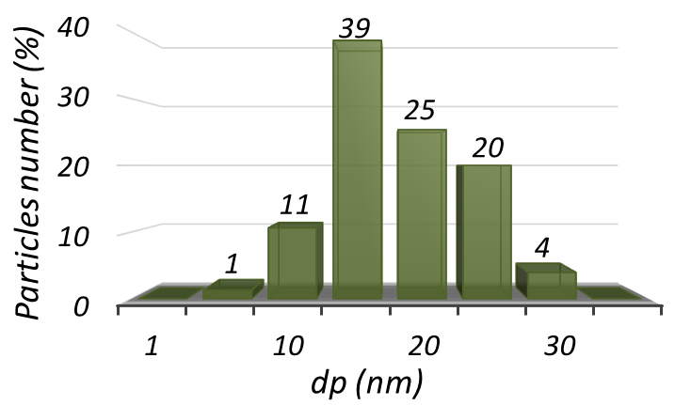
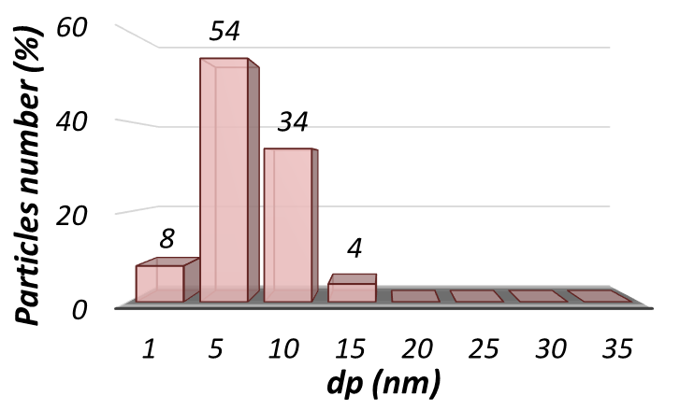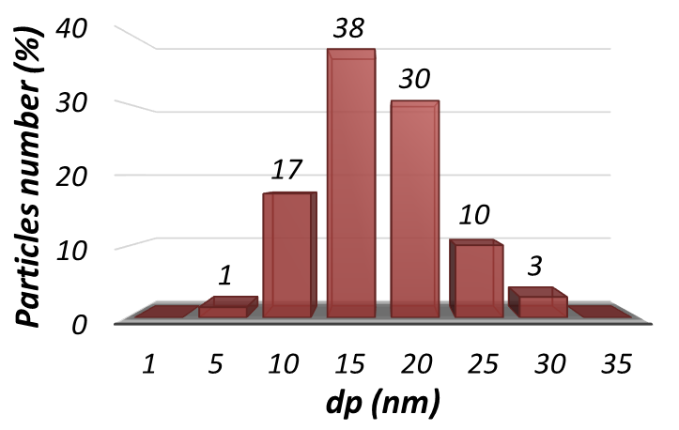
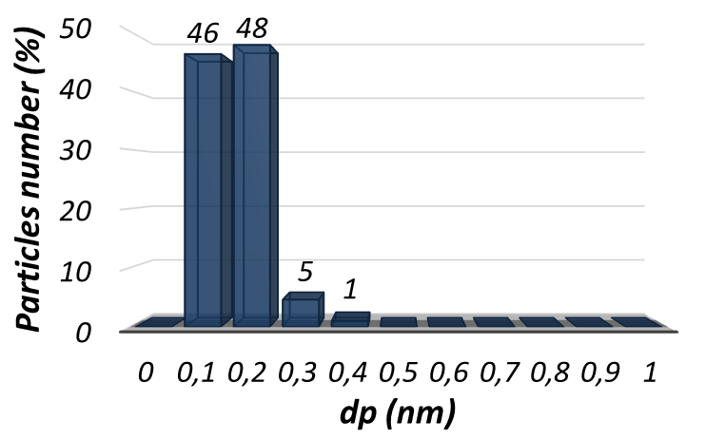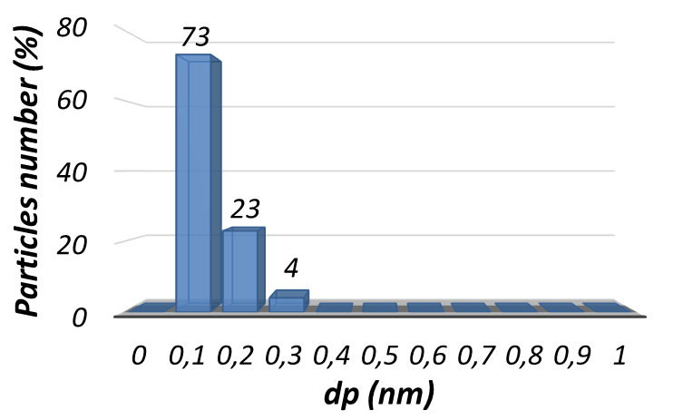
Figure S2. Particle size distribution of Cu/TiO₂ (A), CuCs/TiO₂ (B), Ni/TiO₂ (C), NiCs/TiO₂ (D), Pt/TiO₂ (E) and PtCs/TiO₂ (F).

