Supplementary Material

Simultaneous voltammetric determination of neurodegenerative biomarkers at nanomolar levels using a Fe₃O₄ nanoparticle-decorated glassy carbon microsphere nanocomposite

Matheus B. Souza ª, Jaqueline S. Santos ^{b}, Rafael N. Barros ^{c}, Fernanda A. Trenkel ^{d}, Leonardo M. S. Gomes ^{d}, Luis H. C. Andrade ^{d}, Sandro M. Lima ^{d}, Antonio R. Fiorucci ^{d}, Etenaldo F. Santiago ^{d}, Gilberto J. Arruda ^{d *}

ª Chemistry Postgraduate Program, Analytics Department, São Paulo State University (UNESP), Araraquara, SP, Brazil.
^{b} Genetics Department, Luiz de Queiroz College of Agriculture (ESALQ), University of São Paulo (USP), Piracicaba, SP, Brazil
^{c} Department of Bioprocess Engineering and Biotechnology, Federal University of Paraná (UFPR), Curitiba, PR, Brazil.
^{d} Natural Resources Postgraduate Program, Center for Natural Resources Study (CERNA), Mato Grosso do Sul State University (UEMS), Dourados, MS, Brazil.

*Corresponding author:
Gilberto José de Arruda (arruda@uems.br)

Fig. S1: CVs dataset for A) OGPE, B) GCM/OGPE, C) NaOH/GCM/OGPE and D) Fe₃O₄/GCM/OGPE electrodes. E) Ip as a function of v^{1/2}. F) enlargement of figure E. a) 25 mV s⁻¹; b) 50 mV s⁻¹; c) 75 mV s⁻¹; d) 100 mV s⁻¹; e) 125 mV s⁻¹; f) 150 mV s⁻¹; g) 175 mV s⁻¹; h) 200 mV s⁻¹. 1 mM ferrocene monocarboxylic acid in 0.5 M KCl.

Fig. S2: (A) CVs and (B) Nyquist plot for OGPE, GCM/OGPE, NaOH/GCM/OGPE, and Fe₃O₄/GCM/OGPE electrodes. 10 mM ferrocenemonocarboxylic acid in 0.5 M KCl. v = 100 mV s⁻¹.

Table S1: Values obtained for the physicochemical parameters derived from EIS (n = 3).
Electrodes | ECSA  10⁻² cm² | Cdl  10⁻⁶ | Rs  Ω | Rct  10³ Ω | RF  10⁻² | Kº  10⁻⁴ cm s⁻¹ | D  10⁻² cm² s⁻¹ | χ²  10⁻⁴
OGPE | 755.4 ± 3.9 | 0.4 ± 0.0 | 48.0 ± 3.9 | 2.1 ± 0.4 | 85.8 ± 1.0 | 1.3 ± 0.0 | 0.6 ± 0.2 | 52.9
GCM/OGPE | 789.9 ± 7.9 | 0.4 ± 0.1 | 53.7 ± 2.6 | 1.0 ± 0.1 | 89.8 ± 0.9 | 3.1 ± 0.0 | 1.0 ± 0.0 | 87.6
NaOH/GCM/OGPE | 763.4 ± 5.0 | 0.3 ± 0.0 | 70.4 ± 1.3 | 1.2 ± 0.1 | 86.8 ± 0.0 | 2.6 ± 0.1 | 1.2 ± 0.0 | 73.0
Fe₃O₄/GCM/OGPE | 791.0 ± 0.1 | 0.3 ± 0.0 | 44.7 ± 0.7 | 1.4 ± 0.2 | 89.9 ± 1.6 | 2.0 ± 0.1 | 1.2 ± 0.0 | 67.6
SD = Standard deviation; A_{geometric} = 8,8 × 10⁻² cm²; RF (Roughness factor) = A_{Electrochemically} /A_{geometric}.; ECSA = Electrochemically Surface area

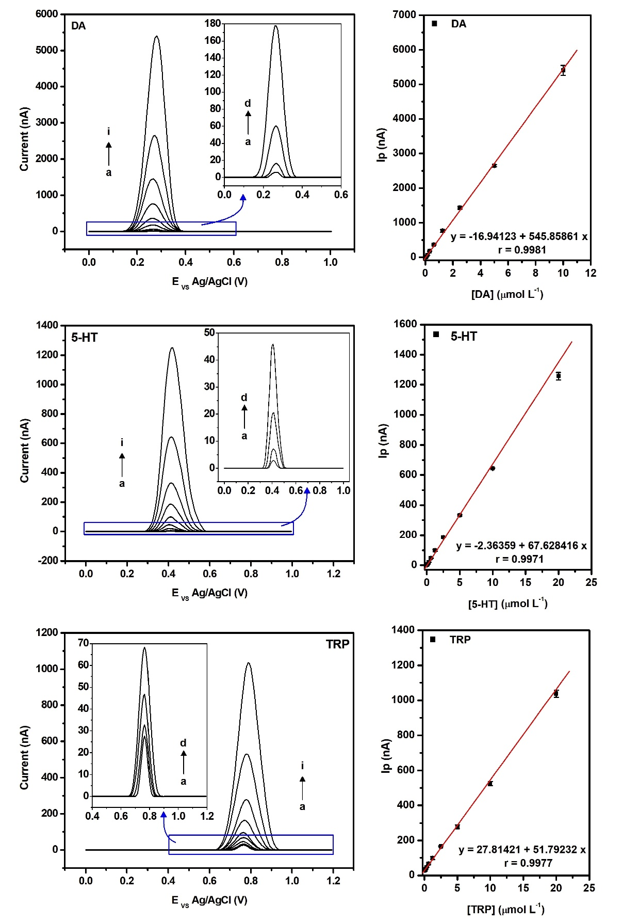
Fig. S3: Individual analytical curves for DA, 5-HT and L-Trp with CPE/GC/Fe₃O₄ electrode. a) DA 0.039 µM, 5-HT and L-Trp 0.078 µM b) DA 0.078 µM 0.156 µM to 5-HT and L-Trp c) DA 0.156 µM, 5-HT and L-Trp 0.312 µM d) DA 0.312 µM, 5-HT and L-Trp 0.625 µM, e) DA 0.625 µM, 5-HT and L-Trp 1.250 µM f) DA 1.250 µM, 5-HT and L-Trp 2.500 µM g) DA 2.500 µM, 5-HT and L-Trp 5.000 µM h) DA 5.000 µM, 5-HT and L-Trp 10.000 µM i) DA 10.000 µM, 5-HT and L-Trp 20.000 µM.

Table S2: Optimization of the instrumental parameters of the pulse application in the SWV.
Parameter | Range | Optimized
Step potential (mV) | 1.0 – 15.0 | 7.0
Amplitude (mV) | 10.0 – 70.0 | 40.0
Frequency (Hz) | 2.5 – 10.0 | 7.5

Fig. S4: Repeatability, precision, and stability study. A) Ep; B) Ip. [DA] = [5-HT] = [TRP] = 100 nM. [PB] = 0.2 M pH 7.5

