Supporting Information
TABLE OF CONTENS
S1 Materials and Methods 2
S1.1 Hairy root induction 2
S1.2 Extraction of loratadine (LOR) metabolites from
infiltrated leaves and isolated chloroplasts of N. tabacum 2
S2 Tables 3
Table S2.1 List of primer pairs employed for PCR assays 3
Table S2.2 Relative transcript levels in the leaves 4
S3 Figures 5
Figure S3.1 Schematic representation of T-DNA within the GB2.0 Ω-level
expression vectors 5
Figure S3.2 Transplastomic and control plantlets 6
Figure S3.3 Transplastomic (CYP2D6 and GFP::LicBM3) plants
under greenhouse conditions and content of photosynthetic
pigments 7
Figure S3.4 Relative transcript levels in transgenic hairy root cultures 8
Figure S3.5 Structures of substrates and products of CYP2D6 reactions 9
Figure S3.6 HPLC-MS chromatograms of the extracts of transplastomic
N. tabacum plants expressing CYP2D6 10
Figure S3.7 HPLC-MS chromatograms of leaf and isolated chloroplast
extracts of transplastomic N. tabacum plants expressing CYP2D6 11
Figure S3.8 Yield of DCL in transgenic hairy root cultures of N. tabacum 12
Figure S3.9 Western blot analysis of GFP::LicBM3 accumulation 13
S4. References 14
S1. Materials and Methods

S1.1 Hairy root induction

The bacteria carrying the binary vectors were grown in the liquid YEB medium containing 100 mg/l spectinomycin and 100 μM acetosyringone at 28 °C for 48 h. The cells were harvested by centrifugation (5 min at 1000 g), resuspended in the triple volume of the liquid MS medium (Murashige and Skoog 1962), supplied with a half concentration of inorganic salts and 15 g/l sucrose and 100 μM acetosyringone, and incubated at 28 °C for 1 h. The leaf explants of in vitro plants N. tabacum cv. Petit Havana (1x1 cm) were incubated with the suspension of A. rhizogenes for 5-7 min, placed onto the solid MS medium without selective agents and cultivated in the dark at 25 °C. After 96 h, the explants were rinsed three times with autoclaved water and one time with autoclaved water containing 400 mg/l cefotaxime, wiped on a filter paper and transferred onto the solid MS medium containing 450 mg/l cefotaxime. The explants were cultivated in dark at 25 °C. After 4-5 weeks, the emerging roots were detached and propagated on the solid MS medium containing 50 mg/l kanamycin. After PCR analysis confirming the presence of transgenes, the hairy root cultures were maintained on the solidified MS medium without selective agents in the dark at 25 °C with a 30–45 day period of cultivation.

S1.2 Extraction of loratadine (LOR) metabolites from infiltrated leaves and isolated chloroplasts of N. tabacum

Lyophilized leaf samples (ground with a glass stick or a metal spatula) or lyophilized chloroplast preparations were extracted with 500μL of 80% (v/v) MeOH for 5 min under sonication and for further 60 min on an orbital shaker (750rpm) at 37°C. The samples were centrifuged for 5 min at 17,000×g, and the residue was re-extracted with 250μL of 80% (v/v) MeOH for 10 min under the same conditions. Extracts were combined and centrifuged, and the supernatants were applied in HPLC and HPLC–MS analyses.

S2. Tables
Table S1. List of primer pairs employed for PCR assays.
Target sequence | Primer sequences (5'-3') | Amplicon size (bp)
rbcL of N. tabacum  aadA | rbcLfor: aacctaaattggggttatctgc  aadArev: gagtcgatacttcggcgatcac | 1364
GFP::LicBM3  accD of N. tabacum | GFPfor2: aacagctcctcgcccttgc  accDrev: ctcctccgaatgaaattcaatg | 1558
CYP2D6  accD of N. tabacum | 2D6for2: taactgcgagtggaacgagtg  accDrev: ctcctccgaatgaaattcaatg | 1627
rbcL of N. tabacum  accD of N. tabacum | rbcLfor: aacctaaattggggttatctgc  accDrev: ctcctccgaatgaaattcaatg | 2602 (wild type);  5352 (GFP::LicBM3);  5475 (CYP2D6)
rolB | rolBfor: atggatcccaaattgctattccttccacga  rolBrev: ttaggcttctttcttcaggtttactgcagc | 776
rolC | rolCfor: ctcctgacatcaaactcgtc  rolCrev: tgcttcgagttatgggtaca | 586
virD1 | virDfor: atgtcgcaaggcagtaagccca  virDrev ggagtctttcagcatggagcaa | 432
GFP::LicBM3 | GFPfor: atatcgtctcactcgaatggtgagcaagggcgaggag  GFPrev: gcgccgtctcactcgaagcttaaccgttaggatagtat | 1406
CYP2D6 | 2D6for: gcgccgtctcactcgaatgggattagaggcactcg  2D6rev: gcatcgtctcactcgaagcttatcttggcacagcac | 1529

Table S2.2 Relative transcript levels in the leaves of N. benthamiana transiently expressing the reporter GFP::licBM3 and cyp2D6 genes with native microsomal leader sequence (TE; mean of four biological repeats for each gene; two technical repeats of each) or with N-fused CTP sequence (TE/CTP; mean of four biological repeats for each gene; two technical repeats of each), transplastomic T1 plants of N. tabacum (TP; the mean of five transplastomic plants two technical repeats of each) and transgenic hairy root cultures of N. tabacum (HR; the mean of four transgenic lines (cyp2D6) or three transgenic lines (GFP::LicBM3), three biological repeats of each, two technical repeats of each).
 | Relative expression
 | Normalized by NtIN1, expressed in plastome (mean ± SD) | Normalized by NtEF1α, expressed in nucleus (mean ± SD)
TE cyp2D6 | - | 0.88 ± 0.85 (n = 4)
TE GFP::LicBM3 | - | 2.62 ± 2.40 (n = 4)
TE/CTP cyp2D6 | - | 2. 051 ± 0.54 (n = 4)
TE/CTP GFP::LicBM3 | - | 6.16 ± 1.82 (n = 4)
TP cyp2D6 | 1190.03 ± 1060.84 (n = 5) | 352.44 ± 145.03 (n = 5)
TP GFP::LicBM3 | 620.84 ± 268.23 (n = 5) | 275.64 ± 149.65 (n = 5)
HR cyp2D6 | - | 0.062 ± 0.0432 (n = 4)
HR GFP::LicBM3 | - | 0.481 ± 0.479 (n = 3)

S3. Figures
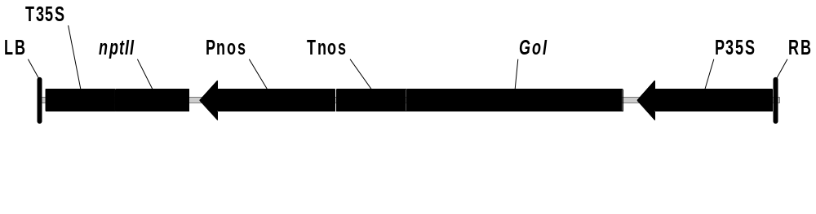
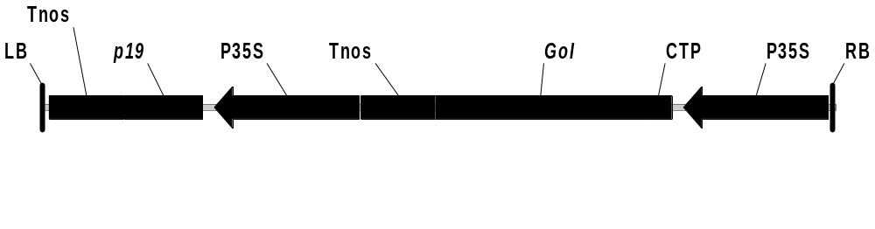
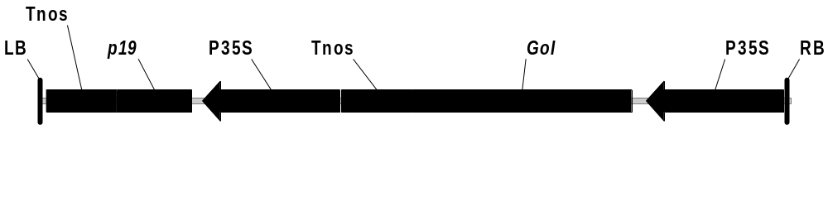
A

B

C

Figure S3.1 Schematic representation of T-DNA within the GB2.0 Ω-level expression vectors. Transcriptional units include gene of interest (GoI, native (A) or fused to the chloroplast transit peptide sequence (CTP) (B)) under control of the CaMV 35S promoter fused to the TMV
Ω leader sequence (P35S) and the nopaline synthase terminator (Tnos), adjacent to the right border (RB), and the p19 gene of tomato bushy stunt virus encoding a suppressor of gene silencing under control of P35S and Tnos, or the gene encoding neomycin phosphotransferase (nptII) (C) under control of nopaline synthase promoter (Pnos) and the CaMV 35S terminator (T35S) adjacent to the left border (LB). Constructs (A) and (B) were used for transient expression; construct (C) was applied for establishing of hairy root cultures.

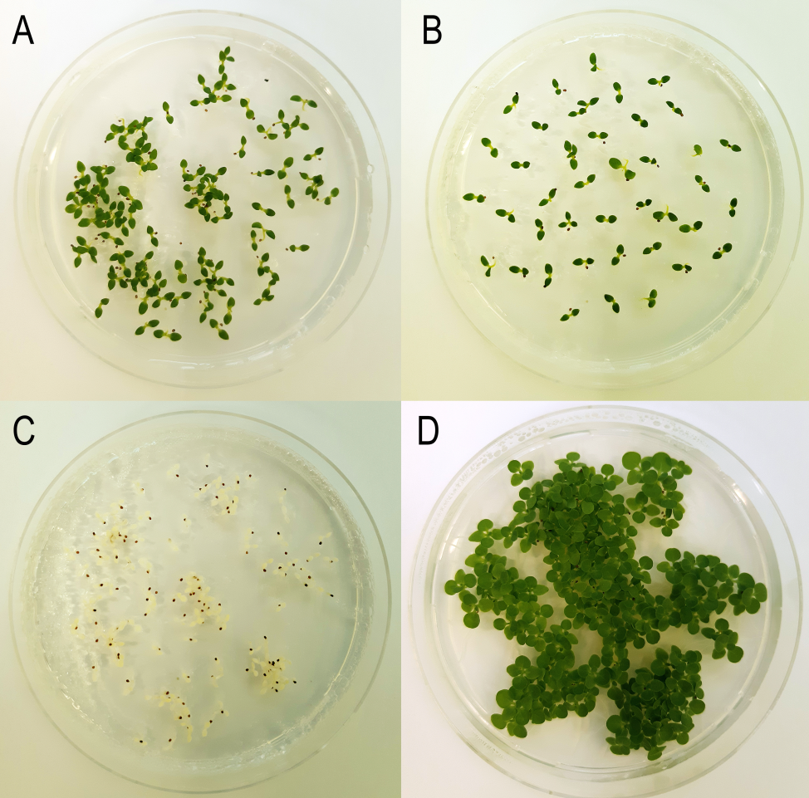

Figure S3.2 Transplastomic (GFP::LicBM3 (A) CYP2D6 (B)) (T1) and control (non-transformed wild type) plantlets (C) induced from seeds on MS medium containing spectinomycin and streptomycin (16 days after germination), and control plantlets induced from seeds on MS medium without selective antibiotics (D).

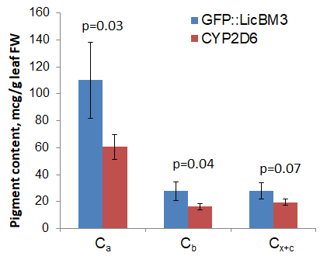
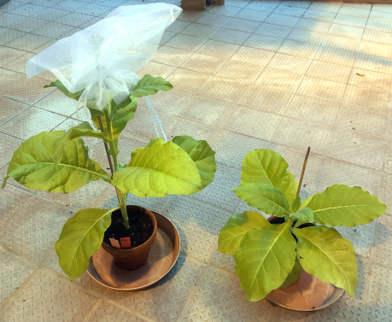
A B

Figure S3.3 (A) Transplastomic T1 plants (left: GFP::LicBM3; right: CYP2D6 ) grown in the greenhouse (26 days after transferring into soil). (B) Content of chlorophylls a and b (C_{a} and C_{b}) and total carotenoids (C_{x+c}) in the leaf samples (measured in 4 plants of each line in 3 technical repeats, bars represent standard deviation); p values were calculated using t-test for two samples with unequal variances.

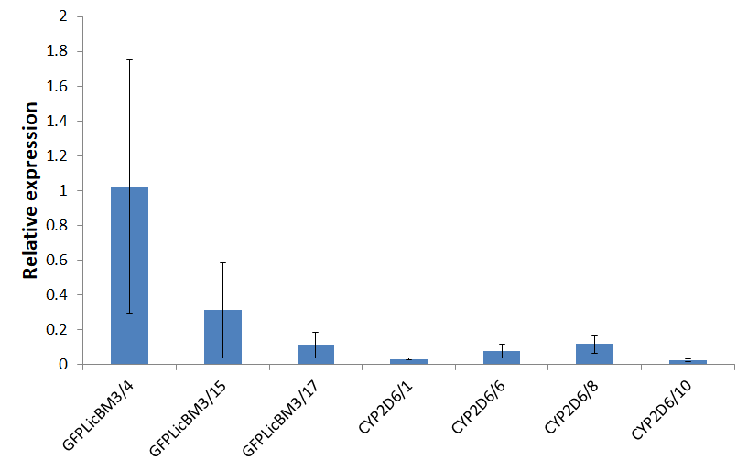

Figure S3.4 Relative transcript levels in transgenic hairy root cultures of N. tabacum. The gene NtEF1α, expressed in nucleus, was used for normalization of RT-qPCR data. The bars represent standard deviations of three biological repeats, each measured in two technical repeats.

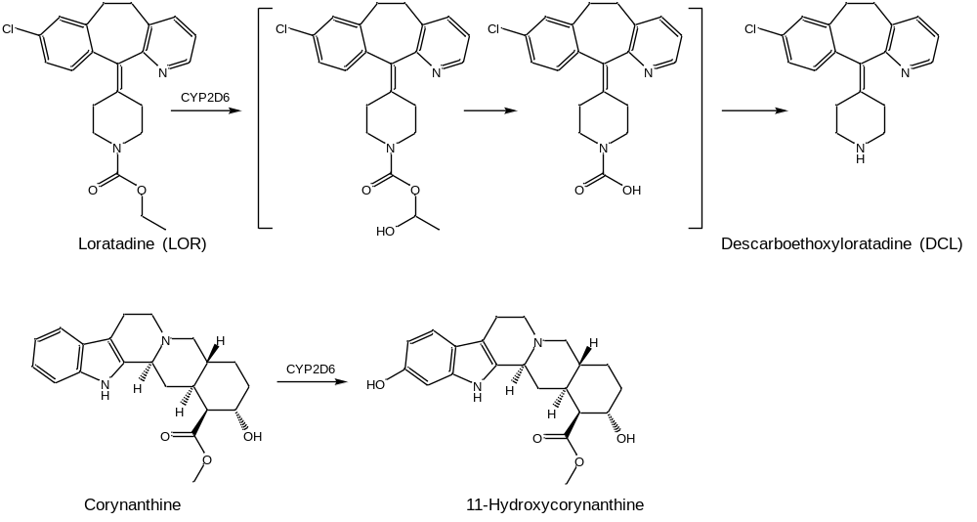
A
B
Figure S3.5 Structures of substrates and products of CYP2D6 reactions: (A) conversion of LOR to DCL; (B) conversion of corynanthine to 11-hydroxycorynanthine (Sheludko et al. 2018).

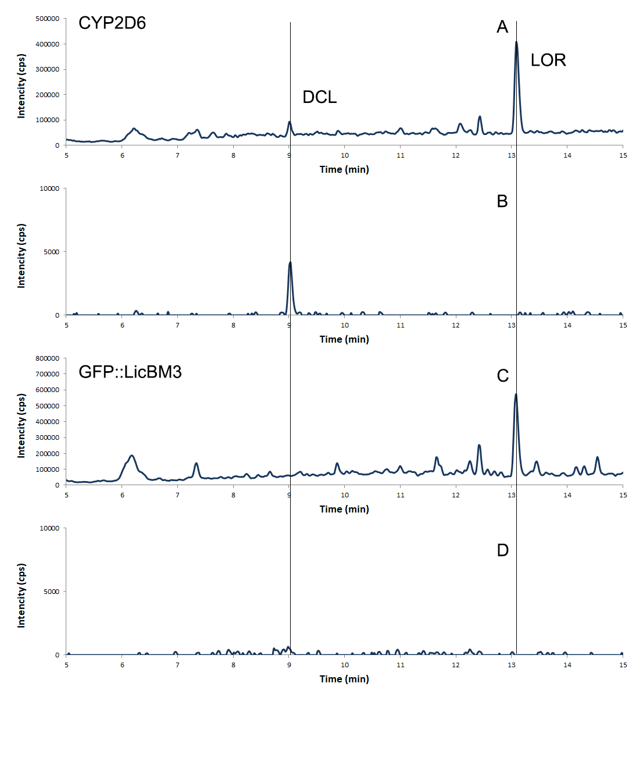
Figure S3.6 Fragments of HPLC-MS chromatograms of the extracts of transplastomic N. tabacum plants expressing CYP2D6. (A) Total ion chromatogram of the extract of N. tabacum CYP2D6 supplemented with LOR; (B) extracted ion m/z 311 chromatogram; (C) total ion chromatogram of the extract of N. tabacum GFP::LicBM3 supplemented with LOR; (D) extracted ion m/z 311 chromatogram.

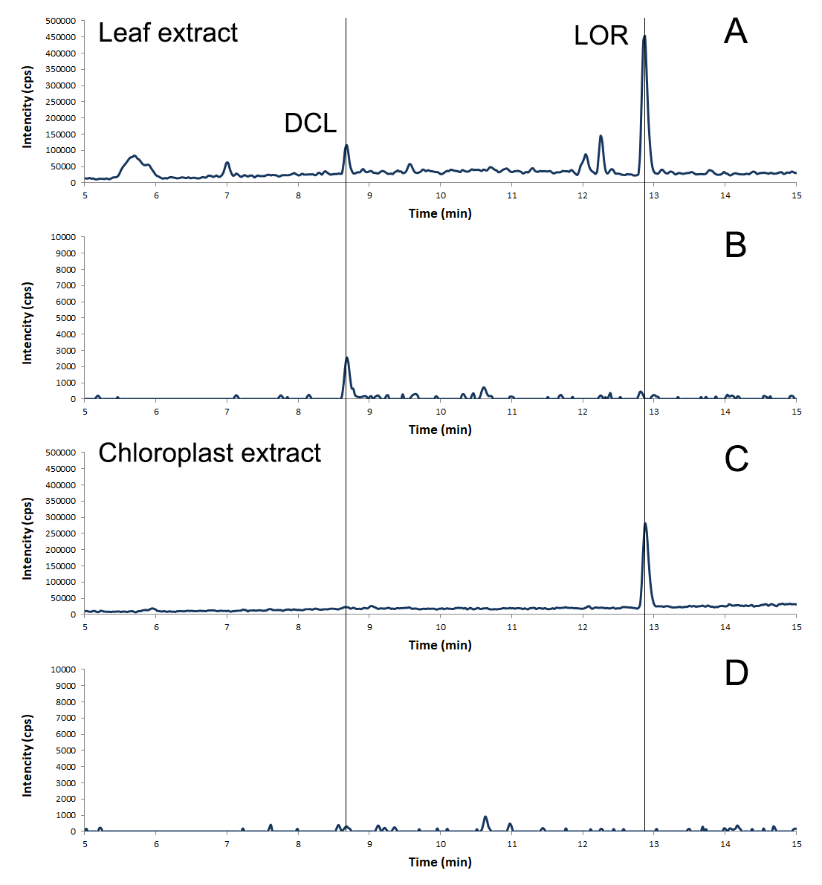Figure S3.7 Fragments of HPLC-MS chromatograms of leaf and isolated chloroplast extracts of transplastomic N. tabacum plants expressing CYP2D6. (A) Total ion chromatogram of the leaf extract of N. tabacum CYP2D6 supplemented with LOR; (B) extracted ion m/z 313 chromatogram; (C) total ion chromatogram of the isolated chloroplast extract of N. tabacum CYP2D6 supplemented with LOR; (D) extracted ion m/z 313 chromatogram.

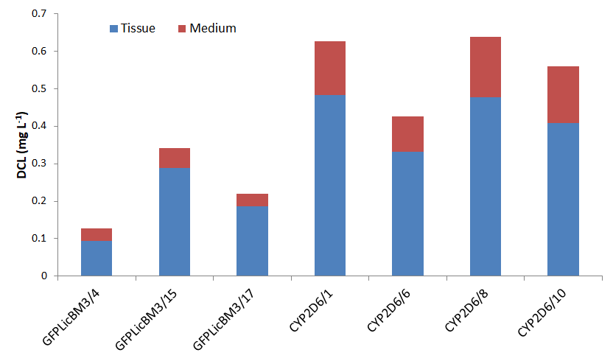
Figure S3.8 Yield of DCL in transgenic hairy root cultures of N. tabacum (tissue and culture medium; four transgenic lines of hairy root cultures transformed with cyp2D6 and three transgenic lines transformed with GFP::licBM3).

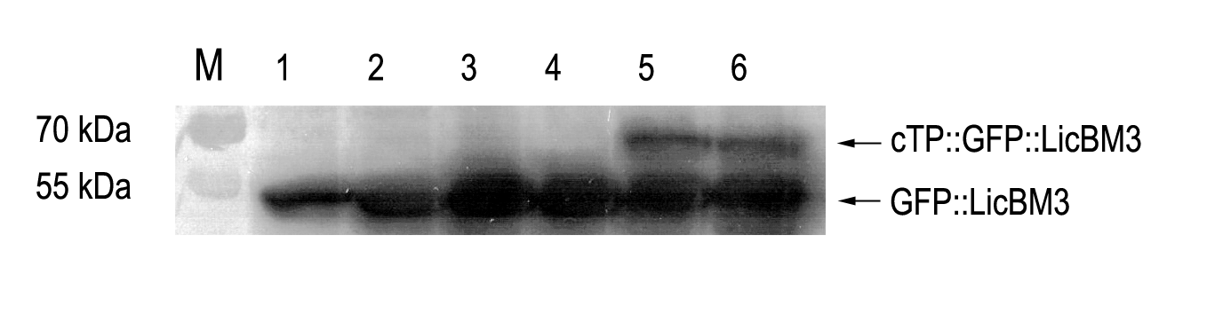

Figure S3.9 Western blot analysis of GFP::LicBM3 accumulation. Lanes 1,2: T1 transplastomic plants carrying GFP::LicBM3 gene; lanes 3,4: plants transiently expressing GFP::LicBM3 gene; lanes 5,6: plants transiently expressing GFP::LicBM3 gene with the sequence encoding chloroplast targeting peptide. The band of 52 kDa observed in all plant samples corresponds to the GFP::LicBM3; the plants expressing GFP::LicBM3 gene with the sequence encoding chloroplast transit peptide accumulate also the unprocessed protein of 58 kDa.

4. References
Murashige T, Skoog F (1962) A Revised Medium for Rapid Growth and Bio Assays with Tobacco Tissue Cultures. Physiol Plantarum 15 (3):473-497. doi:DOI 10.1111/j.1399-3054.1962.tb08052.x
Sheludko YV, Gerasymenko IM, Warzecha H (2018) Transient Expression of Human Cytochrome P450s 2D6 and 3A4 in Nicotiana benthamiana Provides a Possibility for Rapid Substrate Testing and Production of Novel Compounds. Biotechnology journal 13 (11):e1700696. doi:10.1002/biot.201700696

