Supporting Information

Importance of Hydration and Surface Structure for Friction of Acrylamide Hydrogels

Rok Simič, Melis Yetkin, Kaihuan Zhang, Nicholas D. Spencer*

Laboratory for Surface Science and Technology, Department of Materials, ETH Zürich, Switzerland.
* Corresponding author: nspencer@ethz.ch

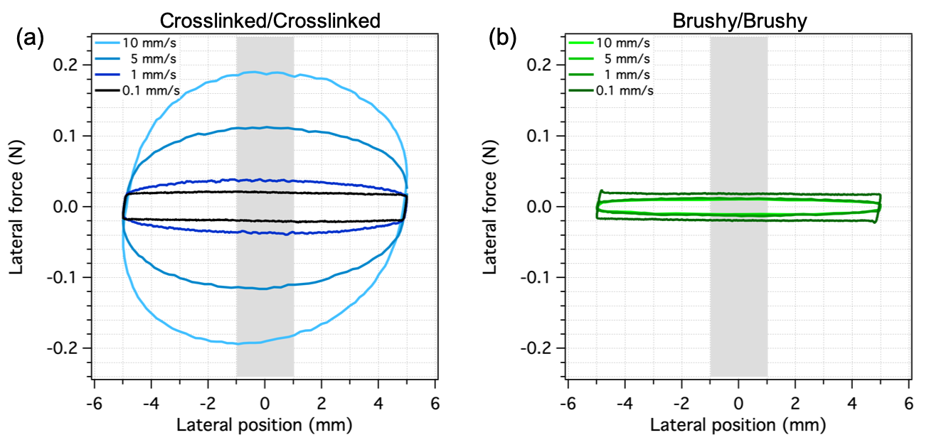
Figure S1. Representative friction loops for (a) crosslinked and (b) brushy hydrogels in a self-mated contact. The shaded area represents the analyzed part of the friction loop. Due to the characteristic speed-dependent friction of the crosslinked/crosslinked pair, combined with sinusoidally changing sliding speed within one cycle, the friction loops of the crosslinked/crosslinked pair appear oval.

