Supporting information

AFM images for fractal dimension measurements

Relative humidity 30%

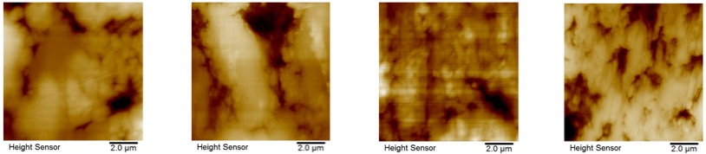

Relative humidity 90%

