Supplementary Information

A sticky situation or rough going? Influencing haptic perception of wood coatings through frictional and topographical design
Kathryn L. Harris¹, Elizabeth S. Collier¹, Lisa Skedung¹ & Mark W. Rutland*^{1,2}

¹RISE Research Institutes of Sweden, Malvinas väg 3, SE-114 28 Stockholm, Sweden
²Department of Chemistry, KTH Royal Institute of Technology, Drottning Kristinas väg 51, SE-114 28 Stockholm, Sweden

- Adjective rating scales used in the perception tests
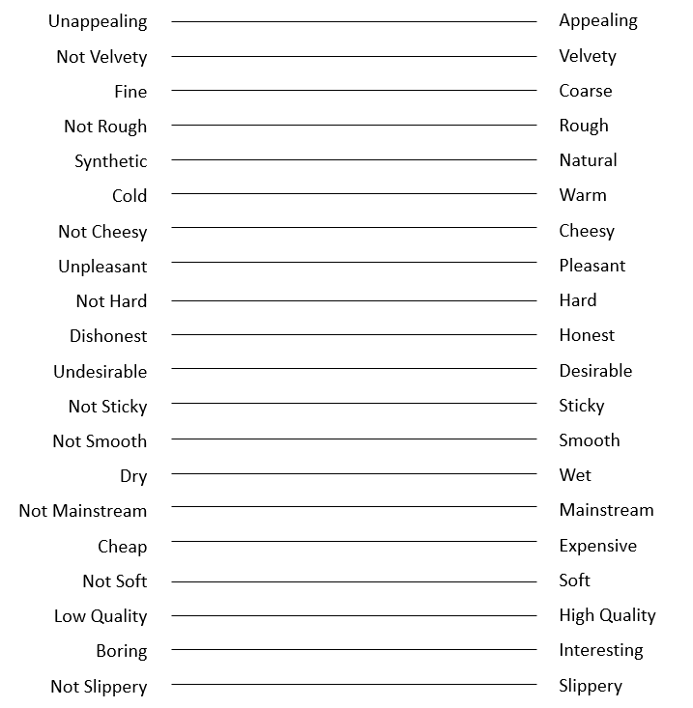
Figure 1: Visual analogue scales used in the experiment to collect ratings of different adjective pairs for the surfaces in series 1 and 2.
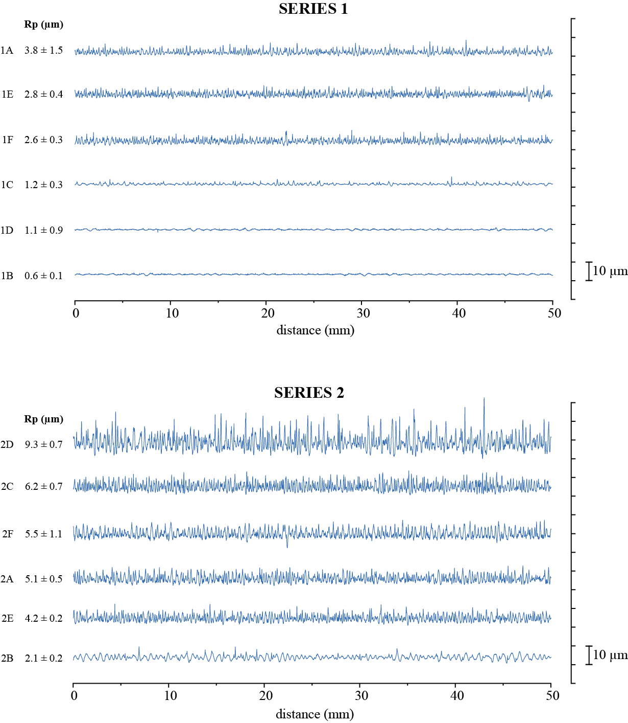
Figure 2: Selected topographical profiles for one of each of the surfaces in the two series. The data have been levelled, large curvature has been removed using a quadratic subtraction, and a 25 µm short and a 0.8 mm long wavelength cutoff have been applied. Scans are presented in order of descending mean Rp value from top to bottom within each plot.
2. MANOVA results for Series 1
We assessed which of the adjectives showed significant variation across the samples within each series in order to better understand which attributes may be related to discriminability. Separate multivariate analyses of variance (MANOVA) were performed for each series to test for differences in perception between the samples. For series 1, significant differences across the six samples were found for ratings of pleasantness [F(5, 51) = 2.49, p = .043] and stickiness [F(5, 51) = 2.52, p = .041]. No other significant differences were found.
3. MANOVA results for Series 2
For series 2, significant differences were found between the six samples for ratings of coarseness [F(5, 51) = 3.90, p = .004], hardness [F(5, 51) = 2.73, p = .029], pleasantness [F(5, 51) = 5.06, p = .001], roughness [F(5, 51) = 4.31, p = .002], smoothness [F(5, 51) = 5.16, p = .001], softness [F(5, 51) = 3.56, p = 0.008], stickiness [F(5, 51) = 7.56, p < .001], and wetness [F(5, 51) = 3.06, p = .017]. No other significant differences were found.

