Waviness affects friction and abrasive wear
Supplementary information
Yulong Li^{1,2}, Nikolay Garabedian^{1,2}, Johannes Schneider^{1,2}, Christian Greiner^{1,2}
¹Institute for Applied Materials (IAM), Karlsruhe Institute of Technology (KIT), Kaiserstr. 12, 76131 Karlsruhe, Germany
²MicroTribology Center (µTC), Strasse am Forum 5, 76131 Karlsruhe, Germany
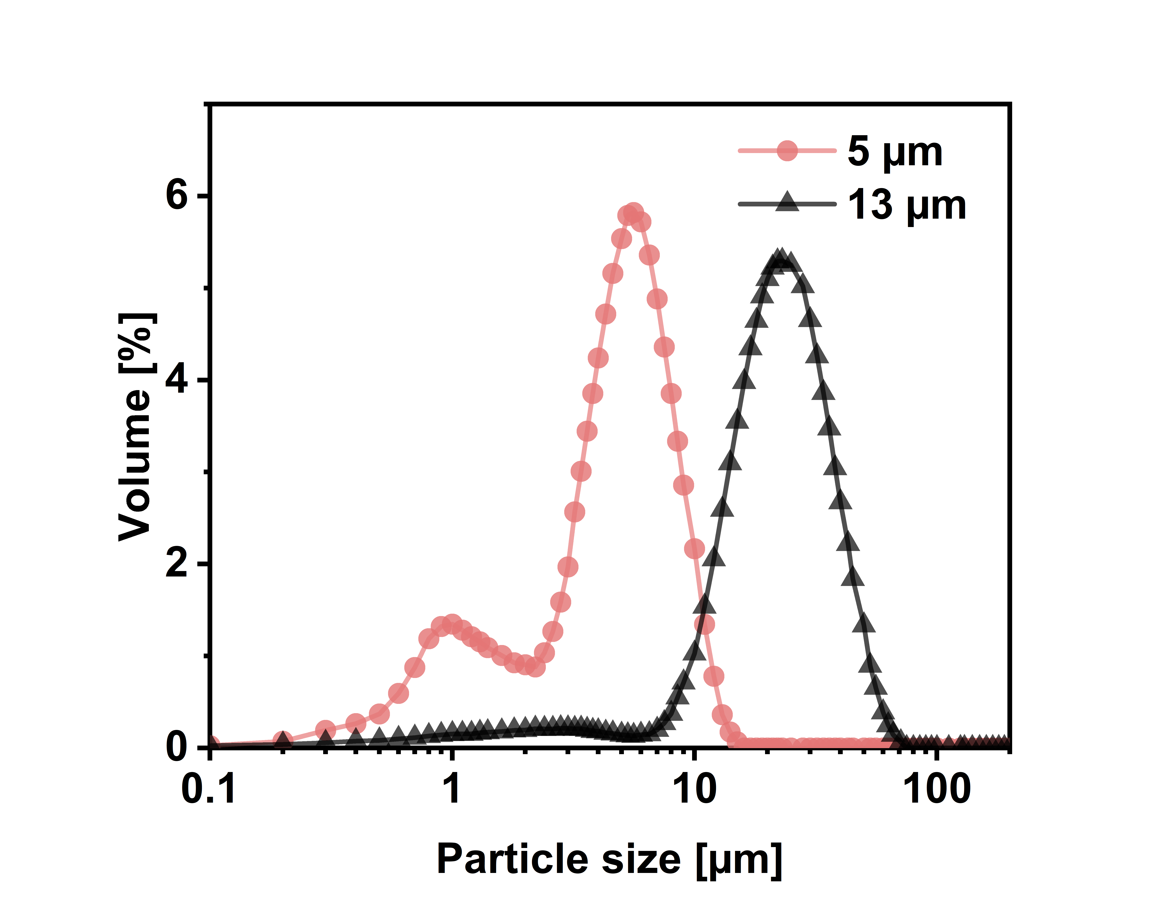
Figure S1: Particle size characterization of two kinds of water-based aluminum oxide slurries with different abrasive particle sizes.
Figure S2: Friction coefficient as a function of sliding distance: 5_S_50, tested with the 5 µm slurry and small waviness for a short distance (50 m).

Figure S3: Comparing friction coefficient with roughness R_{a} waviness profile on 5_S_50, tested with the 5 µm slurry and small waviness for a short distance (50 m): (a) friction coefficient & roughness R_{a}; (b) friction coefficient & waviness profile.
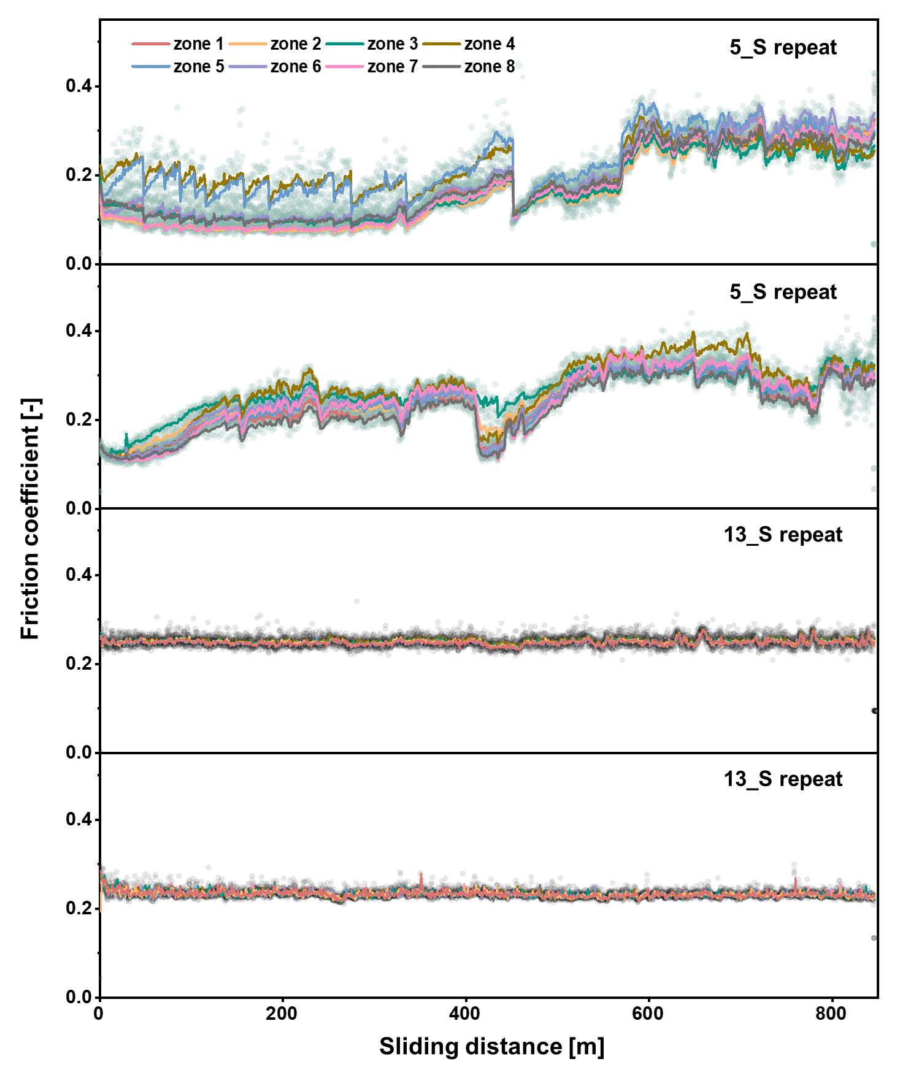
Figure S4: Repeats for 5_S and 13_S with the same experimental settings as for the data presented in Figure 4; friction coefficient on the disk is divided into eight zones: 5_S, tested with 5 µm slurry and small waviness; 13_S, tested with 13 µm slurry and small waviness; 13_L, tested with 13 µm slurry and large waviness.
Figure S5: SEM images of 13_S, tested with the 13 µm slurry and small waviness; friction coefficient was comparable along the sliding track: (a) around 0° (the boundary between zone 1 and zone 8) ;(b) 180° (the boundary between zone 4 and zone 5).

