Supplementary Information
Combining Carbon Nanoparticle Coatings and Laser Surface Textures for Enhanced Lubricity under High Loads

T. MacLucas^{1,*}, P. Grützmacher², P. Leonhard-Trautmann¹, S. Suarez¹, C. Gachot^{2,*} and F. Mücklich¹

¹ Chair of Functional Materials, Saarland University, Campus D3.3, Saarbrücken 66123, Germany
² Institute for Engineering Design and Product Development, TU Wien, Lehárgasse 6, 1060 Vienna, Austria

* Corresponding authors:
T. MacLucas, E-mail: timothy.maclucas@uni-saarland.de,
C. Gachot, E-mail: Carsten.gachot@tuwien.at

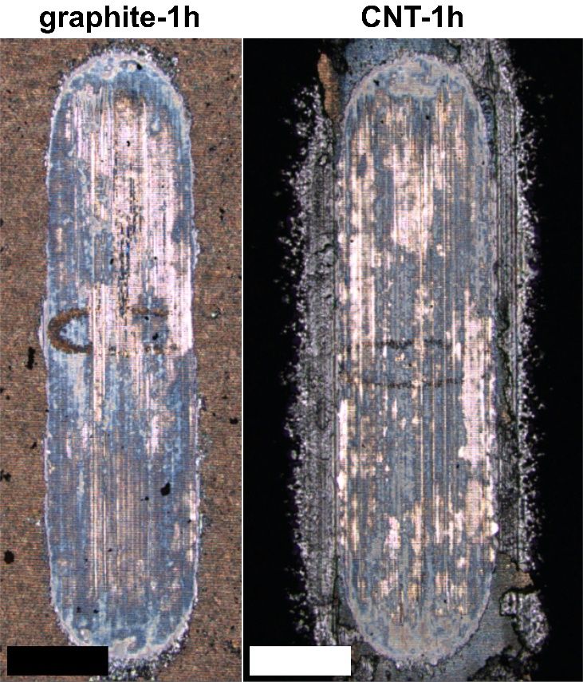
Fig. S1 CLS micrographs of the substrate wear tracks of graphite-1h and CNT-1h after friction testing against an alumina counter body for 3600 s at 20 N. The scale bars are 200 µm.

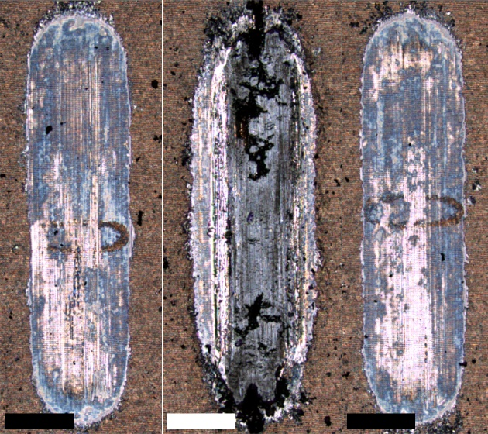
Fig. S2 CLS micrographs of the 3 different graphite-coated substrate wear tracks after friction testing against an alumina counter body for 3600 s at 20 N. The scale bars are 200 µm.

