Supporting Information: Competition Between Growth and Removal in Zirconia
Nanocrystal-derived Tribofilms: The Role of Co-Additives

Parker LaMascus¹, Meagan B. Elinski^{1,2}, Daniel Delghandi¹, Julia Griffin³, Lei Zheng⁴, Andrew Jackson^{1,4}, Robert J. Wiacek⁴, Robert W. Carpick^{1*}

¹Department of Mechanical Engineering & Applied Mechanics, University of Pennsylvania, Philadelphia, Pennsylvania 19104, United States
²Department of Chemistry, Hope College, Holland, Michigan 49423, United States
³Department of Chemistry, Mount Holyoke College, South Hadley, Massachusetts 01075, United States
⁴Pixelligent Technologies LLC, Baltimore, Maryland 21224, United States
*Corresponding author. E-mail: carpick@seas.upenn.edu. Tel: (215) 898-4608.

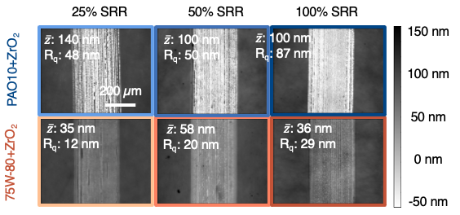
SI1 End-of-test morphologies for white light interferometry (WLI) of MTM ball specimens on which tribofilms were formed in 2 hours of rolling-sliding contact (top: PAO10; bottom: 75W-80). The RMS roughness R_{q,ball} and mean tribofilm heights $\overline{z}$ with respect to the substrate are indicated on each plot (the corresponding end-of-test images for the ball specimens are in Figure 3 of the main text).

SI1 depicts the end-of-test morphologies for the disc specimens that were counterpaired with the ball specimens of the main text’s Figure 3. Matching our findings there, the tribofilms formed in 75W-80+ZrO₂ are uniformly smoother than those formed in PAO10 at the same SRR. Moreover, as the SRR increases, so does end-of-test roughness measured by WLI. These data further support the main text’s assertion that co-additives contribute to a smoother interface for these MTM experiments. The numbers shown in the insets of Figure SI1 are used for the calculation of composite roughness that is reported in Fig. 3.

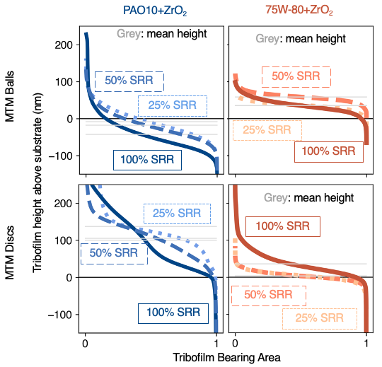
SI2 Bearing area curves for end-of-test MTM specimens (top: ball specimens, bottom: disc specimens). Grey lines provide the mean height above the substrate.

For all WLI data shown (Fig. 3 of the main text and SI1), bearing area curves of the tribofilms were measured for a look at the distribution of tribofilm asperity heights. A steeper bearing area curve, as is the case with all PAO10 curves, suggests that more rolling-sliding contact will be borne by the asperities of the interface, increasing friction. The bearing area curves of 75W-80+ZrO₂ specimens are less steep, suggesting that less contact is borne by the asperities of tribofilms formed in co-additized oil.

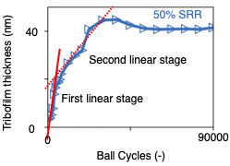
SI 3 Process for obtaining the SLIM growth rates shown in Figure 7 of the main text.A visual example of the estimation of two linear growth stages for the SLIM data of the PAO10+1wt%ZrO₂ ball specimen at 50% SRR (red lines extended to guide the eye).

S03 clarifies the analytical method used to obtain the SLIM growth rates reported in Fig. 7. For each SLIM and traction timeseries reported in this paper, the growth rate of tribofilm was estimated by interpolating between the initial step of the experiment and the saturation of the signal (SI3, left). Any transience between initiation and saturation was excluded, leading to two linear fits in many cases.
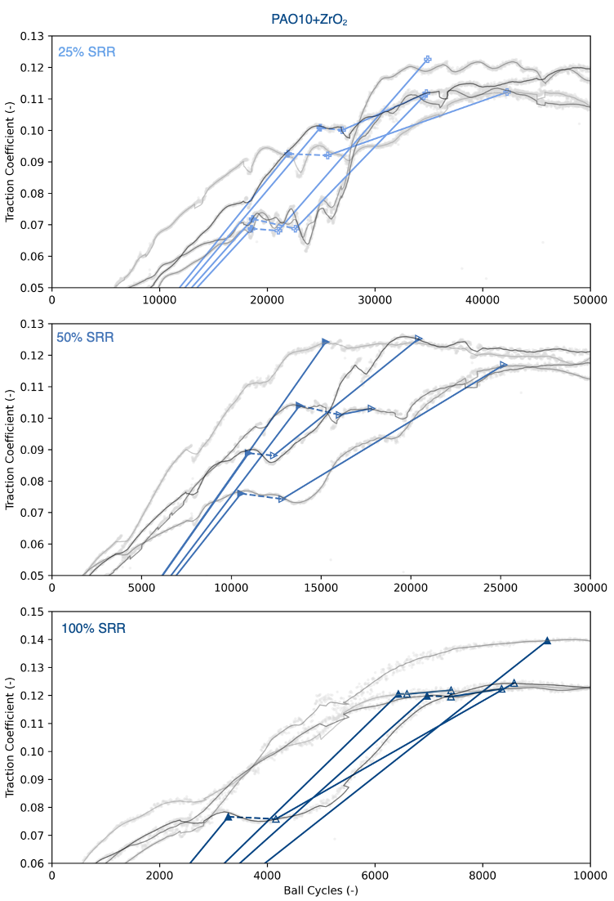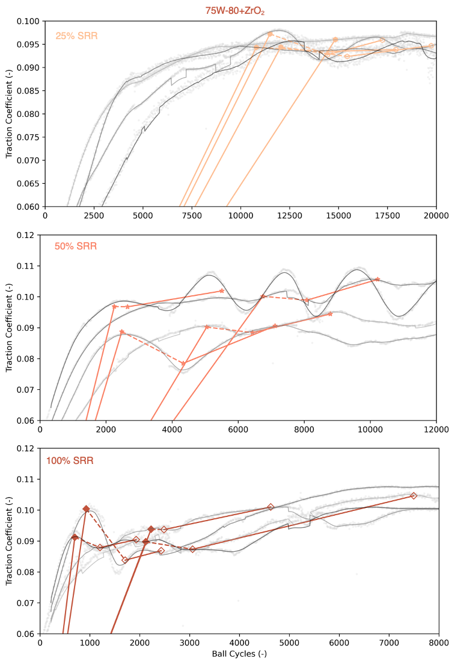

SI4 Process for obtaining the traction growth rates shown in Figure 7 of the main text. Upper set: linear fits used to estimate traction growth rate on the twelve PAO10 traction trends used in this study. Raw traction data is shown via gray scatterplot, while grey trendlines describe the polynomial fit of smoothed data to permit differentiation. Open colored symbols are the second stage of linear growth, while solid colored symbols are the first stage. For traction data, each first stage rate is calculated from (0,0) for ease of calculation. Lower set: a similar set of fits for the twelve 75W-80 trends used in this study. Note that x- and y-limits on vary throughout to maximize the visibility of each individual plot.

S04 clarifies the analytical method used to calculate traction growth rates reported in Fig. 7. To automate growth rate calculation for the 16 traction timeseries reported here, a 50-second running average was used to smooth the timeseries, and a 16-order polynomial fit was applied to make the curves differentiable. Thereafter, a second derivative test enabled algorithmic determination of local minima and maxima. The slope from (0,0) to the first local maximum was assigned as the first-stage growth rate, and the slope from the first local minimum to the second local maximum was assigned as the second-stage growth rate (Fig. 7).

Description of Media
Media is attached which shows annotated videos of tribofilm growth for each SRR and blend under consideration. Tribofilm removal events are visible in many cases, like the images shown in Fig. 2 of the main text.

