Appendices

A. Example Items Critical Thinking Tests
B. Example Items Practice Conditions
A. Example Items Critical Thinking Tests
Below, we translated an example item of each task category administered in the critical thinking tests (* = correct answer) and the explanation.
Syllogistic reasoning item
Below, you will find two premises that you must assume are true.
Indicate whether the conclusion follows logically from the given premises.
Premise 1. No safety instrument leads to decrease in incidents.
Premise 2. Some risk inventories and evaluations (RIE’s) lead to a decrease in
incidents.
Conclusion: Some RIE’s are no safety instruments

- The conclusion follows logically from the premises*
- The conclusion does not follow logically from the premises
Explain briefly why you chose this answer:

Explanation: This assignment requires participants not to confuse logical validity of the conclusion with the believability of the conclusion, which probably seems unbelievable due to prior beliefs or real-world knowledge (RIE’s are well-known safety instruments in the domain of Safety and Security). For more information, see Evans (2002).
Conjunction item
The Dutch national police has investigated crime in the major cities of the Netherlands. The city Rotterdam was part of the research and was selected by chance from the list of cities. Which of the following statements is most likely? (Choose one answer).
- The Rotterdam police had to cut off staff and the number of street robberies in Rotterdam has increased
- The number of street robberies in Rotterdam has increased*
Explain briefly why you chose this answer:

Explanation: This assignment requires participants not to violate the conjunction rule that states that the probability of a conjunction cannot be more probable that one of its constituents. For more information, see Tversky and Kahneman (1983).
Wason selection item
The Dutch airport Schiphol is keen on a substantial flight expansion. ‘No problem at all’, the airport claims. But is that really true? The additional flights may not produce negative environmental effects. Schiphol has had the following rule for years:
If Schiphol increases the number of flights, the total CO₂ emissions from air traffic must have decreased by 10% compared to the previous years.
In a presentation about the importance of Schiphol as ‘engine of the Dutch economy’, it is expertly explained that the aircraft of today fly even more economically and that the total CO₂ emissions from air traffic decreased by 20% compared to last year.
Assume that you are an official at the Dutch Ministry of Infrastructure and Environment and – based on the above rule – you have to decide whether Schiphol can realize the intended flight expansion. If the statements from the presentation are true, Schiphol would be allowed to continue the intended expansion. However, there are also indications that the claims of Schiphol are incorrect and that the airport has wakened the negative environmental effects of air traffic. You decide to have an independent researcher chart whether Schiphol has complied with the rule in the past. The researcher investigates four random years and draws up four separate reports. There are only two findings in each report:
- The total CO₂ emissions from air traffic compared to the previous years did / did not decrease
- Schiphol expanded / did not expand the number of flights that year

Below you see only one of the two findings from each of the four annual reports. You will have to read the entire report to find the second finding of the year in question. Which annual report(s) should you read to check whether Schiphol has complied with the rule in the past? Choose one or more of the options below, but only choose the options that are necessary to check if Schiphol had complied with the rule.

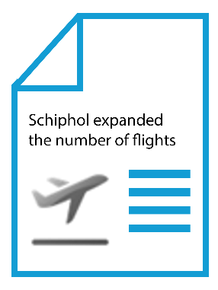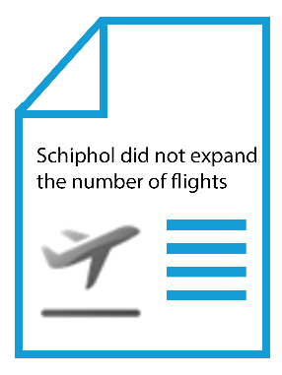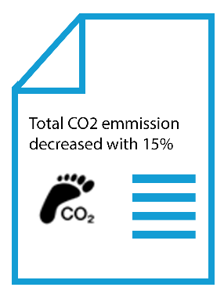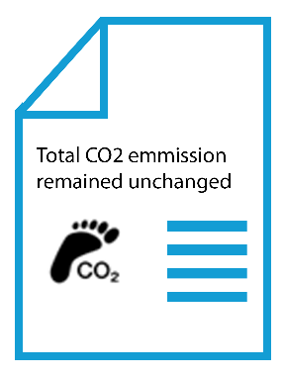
O* O O O*
Explanation: This assignment requires people to not only confirm the logical rule but also look for falsification of the rule. People who choose combination of the second and third report probably fail to apply logical principles, verify rules rather than to falsify them, or demonstrate matching bias by selecting options explicitly mentioned in the conditional statement. For more information, see Evans (2002).
Base-rate item
Imagine you work at the Human Recourses department of a large oil company. The director is considering a reorganization of the company but she is afraid that this can have negative consequences for the atmosphere at work. She asks you for advice. You are aware of the fact that few reorganization are successful, that is, in few situations both the company and the employees are satisfied with the end result. You decide to search for success factors and find out that many successful reorganizations are supported by an external consultancy.
What information would you want in order to estimate the probability that the reorganization at your company will be successful given that it is supported by an external consultancy? Below are four pieces of information that may or may not be relevant for determining the probability. Please indicate all of the pieces of information that are necessary to determine the probability, but only those pieces of information that are necessary to do so.
- Percentage of successful reorganizations with support of an external consultancy
- Percentage of all successful reorganizations
- Percentage of all unsuccessful reorganizations
- Percentage of unsuccessful reorganizations with support of an external consultancy
Correct answer: a+b+d or a+c+d.
Explanation: People should not overrate the first piece of information (a) as this percentage is unformative for the probability estimation as long as you do not know how many ‘unsuccessful’ reorganizations had support of an external consultancy. For more information, see for example Stanovich, West, and Toplak (2016).

B. Example Items Practice Conditions
Below, we translated an example of a practice task of each practice condition.
Example item contrasting examples condition
Tom and Laura were presented with the following assignment. Below the assignment, you can see their step-by-step solution to the problem. Please, study the assignment and the solutions of Tom and Laura carefully.

Assignment 1
Below, you will find two premises that you must assume are true.
Indicate whether the conclusion follows logically from the given premises.
Premise 1. No crisis situation is without danger.
Premise 2. Some transport accidents are without danger.
Conclusion: Some transport accidents are no crisis situation.
- The conclusion follows logically from the premises
- The conclusion does not follow logically from the premises

Tom’s solution
Step 1. According to premise 1, no crisis situation is without danger and therefore the circle crisis situations should be placed outside the circle without danger.
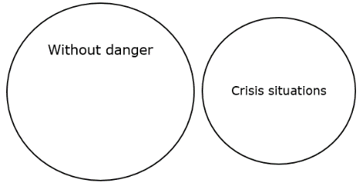

Step 2. According to statement 2, some transport accidents are without danger and therefore the circle some transport accidents should be placed within the circle without danger.
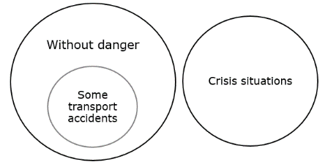

Laura’s solution
Step 1. According to premise 1, no crisis situation is without danger and therefore the circle crisis situations should be placed outside the circle without danger.
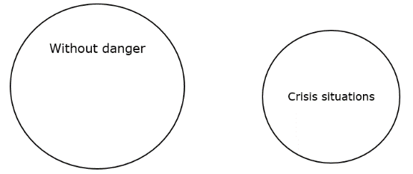
Step 2. According to statement 2, some transport accidents are without danger.

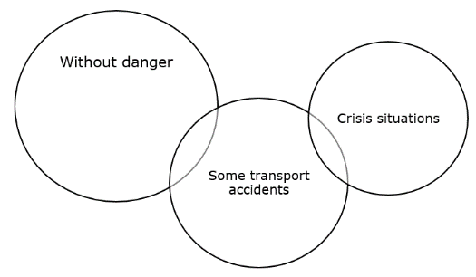

Step 3. There is no overlap between some transport accidents and crisis situations. Therefore, I can say with certainty that some transport accidents are no crisis situation and I choose answer a.

- The conclusion follows logically from the premises
- The conclusion does not follow logically from the premises

Step 3. The fact that some transport accidents are without danger does not mean that some other transport accidents are no crisis situations. You cannot know for sure whether some transport accidents are no crisis situation and therefore I choose answer b.

- The conclusion follows logically from the premises
- The conclusion does not follow logically from the premises

Compare the solutions of Tom and Laura. Which solution is incorrect?
- Tom’s solution is incorrect
- Laura’s solution is incorrect
At which step the solution is incorrect?
- Step 1
- Step 2
- Step 3
Example item correct examples condition
Tom was presented with the following assignment. Below the assignment, you can see his step-by-step solution to the problem. Please, study the assignment and Tom’s solution carefully.

Assignment 1
Below, you will find two premises that you must assume are true.
Indicate whether the conclusion follows logically from the given premises.
Premise 1. No crisis situation is without danger.
Premise 2. Some transport accidents are without danger.
Conclusion: Some transport accidents are no crisis situation.
- The conclusion follows logically from the premises
- The conclusion does not follow logically from the premises
Tom’s solution
Step 1. According to premise 1, no crisis situation is without danger and therefore the circle crisis situations should be placed outside the circle without danger.

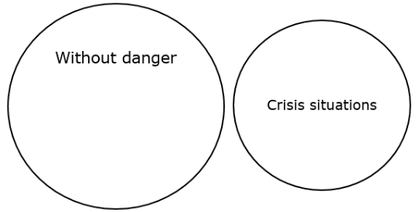
Step 2. According to statement 2, some transport accidents are without danger and therefore the circle some transport accidents should be placed within the circle without danger.
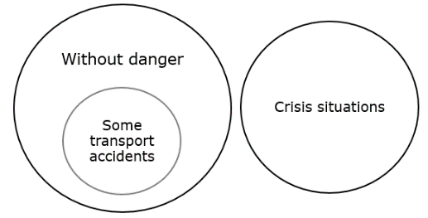
Step 3. There is no overlap between some transport accidents and crisis situations. Therefore, I can say with certainty that some transport accidents are no crisis situation and I choose answer a.

- The conclusion follows logically from the premises
- The conclusion does not follow logically from the premises

Tom’s solution is correct. Indicate for each step what is correct about his reasoning:

Step 1

Step 2

Step 3

Example item erroneous examples condition
Laura was presented with the following assignment. Below the assignment, you can see her step-by-step solution to the problem. Please, study the assignment and Laura’s solution carefully.

Assignment 1
Below, you will find two premises that you must assume are true.
Indicate whether the conclusion follows logically from the given premises.
Premise 1. No crisis situation is without danger.
Premise 2. Some transport accidents are without danger.
Conclusion: Some transport accidents are no crisis situation.
- The conclusion follows logically from the premises
- The conclusion does not follow logically from the premises

Laura’s solution
Step 1. According to premise 1, no crisis situation is without danger and therefore the circle crisis situations should be placed outside the circle without danger.
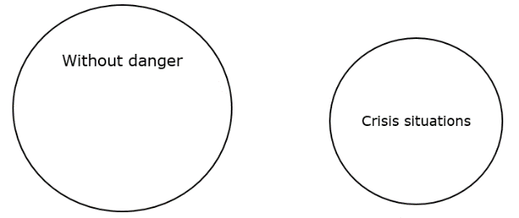
Step 2. According to statement 2, some transport accidents are without danger.
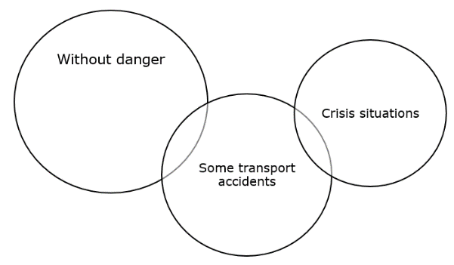
Step 3. The fact that some transport accidents are without danger does not mean that some other transport accidents are no crisis situations. You cannot know for sure whether some transport accidents are no crisis situation and therefore I choose answer b.

- The conclusion follows logically from the premises
- The conclusion does not follow logically from the premises

Laura’s solution is incorrect. At which step the solution is incorrect? What would be the correct reasoning?

- Step 1

- Step 2

- Step 3

Example item practice problems condition
Below you will find assignment, followed by two answer options. Please study the assignment carefully and choose the best answer option.

Assignment 1
Below, you will find two premises that you must assume are true.
Indicate whether the conclusion follows logically from the given premises.
Premise 1. No crisis situation is without danger.
Premise 2. Some transport accidents are without danger.
Conclusion: Some transport accidents are no crisis situation.
- The conclusion follows logically from the premises
- The conclusion does not follow logically from the premises
Explain briefly why you chose this answer:

