Complete or Faded Double-content Examples of Video-based Analyses - How do they Impact Student Teachers’ Professional Vision of Classroom Management?
Supplemental Materials
Supplement S1. Example for the Faded Double-content Example From Time Block 2
Supplement S2. Example for the Faded Double-content Example From Time Block 3
Supplement S3. Measure of Cognitive Processes of PVCM
Supplement S4. Measure of Expert Features of PVCM
Supplement S1
Figure S1
Example for the Faded Double-content Example From Time Block 2
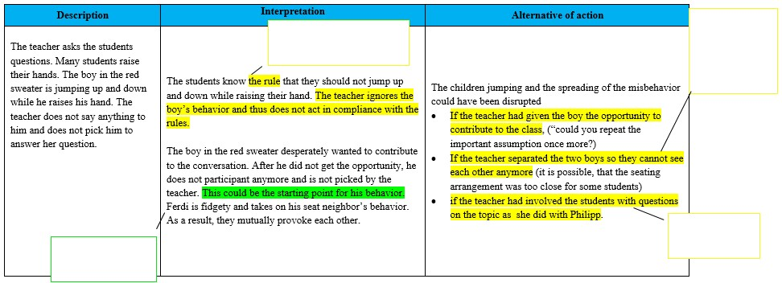
Supplement S2
Figure S2
Example for the Faded Double-content Example From Time Block 3
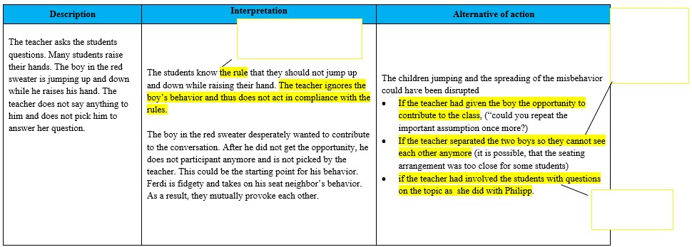

Supplement S3
Table S3
Measure of Cognitive Processes of PVCM (Simplified and Adapted from Gippert et al., 2022)
Cognitive process of PVCM | Points | Definition | Example
Noticing + reasoning | 0 | The relevant noticed event was not addressed in the video-based analysis. | The teacher lets the signal sound, but not all the students become quiet. The rule is either not yet fully established, or some children may not be concerned about the consequence of not following the rule. Alternatively, they may be too engrossed in their work.
Noticing + reasoning | 1 | The relevant noticed event was addressed at least once in the video-based analysis.
Noticing + reasoning | 0 | The relevant noticed event was not reasoned on or the reasoning did not match the expert rating.
Noticing + reasoning | 1 | The relevant noticed event was reasoned on matching the master rating.
Noticing + reasoning | 0 | The reasoning was not explained or the explanation did not match the master rating.
Noticing + reasoning | 1 | The reasoning was explained matching the master rating.
Alternatives of action | 0 | No alternative of action was provided for the noticed relevant event. | Some students need to be addressed separately, for example, with physical proximity (placing a hand on them). Alternatively, the teacher gives the students more time and waits until they realize on their own that a new unit is starting. In general, rules must be followed because that is their purpose, so there should be further practice/reflection on the meaning of the signal.
Alternatives of action | 1 | An alternative of action was provided for the noticed relevant event.
Alternatives of action | 0 | No explanation for the generated alternative of action was provided.
Alternatives of action | 1 | An explanation for the generated alternative of action was provided.
Irrelevant events | 0 | The noticed event was not mentioned in the master rating. Therefore, its reasoning and provided alternative of action was not considered in further analyses. | Noticing + reasoning: The teacher explains exactly what the students should say during the presentation. The guidance proves to be useful, as the presenters do not know which statements need to be made. This is also reflected in the repeated follow-up questions from the teacher. The teacher aims to ensure that the presenting students only present the key results of their research, but still say enough for the other students to understand.  Alternative of action: For a smoother process, short bullet points could be written on the board, outlining exactly what the students should say in the presentation. These could be agreed upon collectively beforehand. It would also be helpful to give the students a few more minutes of preparation time before the presentation. This way, the students will clearly understand what necessary statements should be included, allowing all other students to follow the results and understand how they were reached.
Note. PVCM = Professional Vision of Classroom Management; we counted the number of points achieved for noticing + reasoning and alternatives of action.

Supplement S4
Table S4
Measure of Expert Features of PVCM (Adapted from Wolff et al., 2015)
Category | Points | Definition | Example
Concepts of classroom management | 1 | Scientific terms (withitness, smoothness, momentum, group focus, group mobilization) are used. | At this point in the lesson, there is little group mobilization. Only a few students are actively engaged, and the level of activity is very low.
Focus on students | 1 | Students’ engagement, attention, listening, or learning in the classroom situation is addressed. | Most students are only passively involved in the lessons. This affects the attention of many students, causing them not to pay proper attention. This is also evident in that some students do not even know what the lesson is about.
Inferences | 1 | Inferences about students or teachers, predictions of classroom management, and explanations are provided. | It should be noted that the teacher uses the bell to ensure silence, as it can be heard by all the children, allowing her not to raise her voice. Unfortunately, she did not wait until silence was achieved, which may lead the children to perceive the bell’s signal as less relevant.
Multiple perspectives | 1 | More than one point of view is addressed (e.g., that of students and teachers). | The student was apparently still very focused on her task or wanted to finish it. The teacher does not notice this and does not intervene. This may be because the student is relatively quiet.
Note. For each category, we counted the number of expert features used in student teachers’ written video-based analysis.

