Online Supplementary Material 3. Additional MCMC Diagnostics
Figure 2
Trace Plots and Autocorrelation Plots for the Beta Regression Model (Teacher Turns)
a) Trace Plots: Teacher Turns (Beta Regression) b) Autocorrelation Plots: Teacher Turns (Beta Regression)
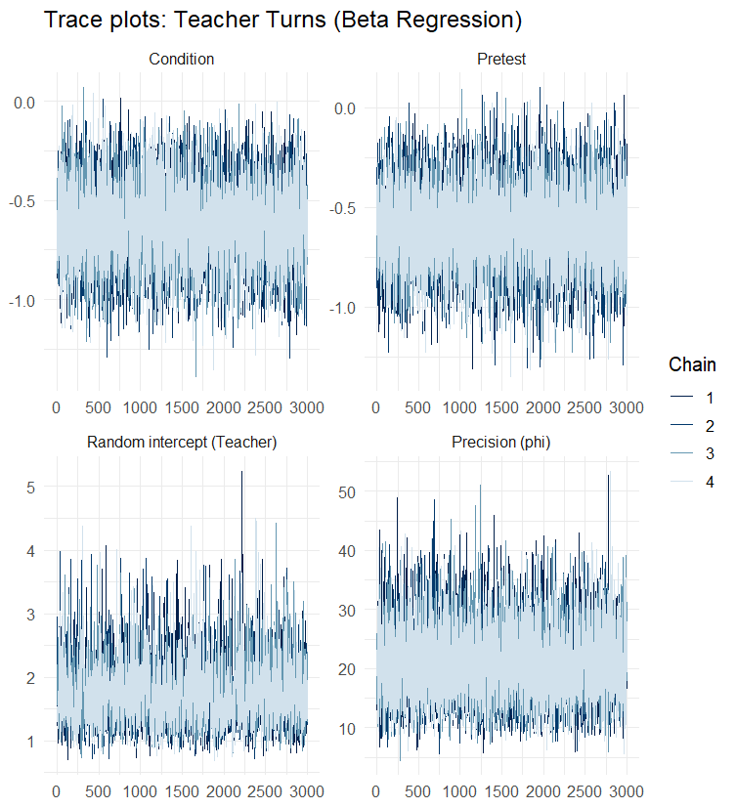
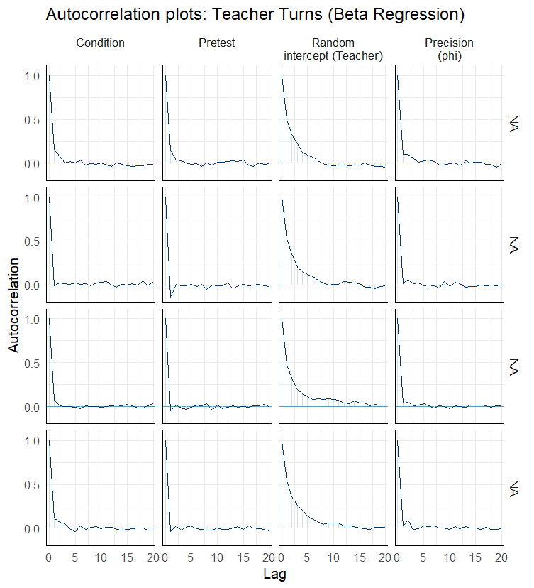

Note. Trace plots were inspected for adequate mixing and stationarity across chains. Autocorrelation plots were examined to assess the decay of serial dependence across lags. Convergence was further evaluated using standard diagnostics (e.g., R̂ values close to 1.00, sufficient effective sample sizes). This note applies to all subsequent figures.
Figure 3
Trace Plots and Autocorrelation Plots for the Gamma Model (Reasoning)
a) Trace Plots: Reasoning b) Autocorrelation Plots: Reasoning
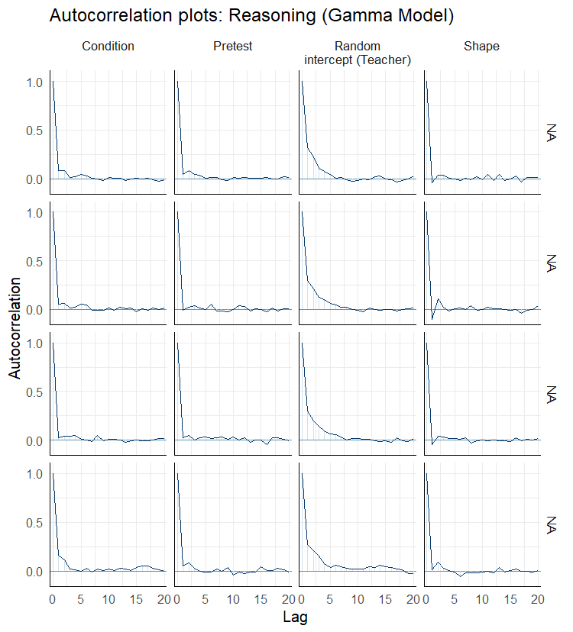
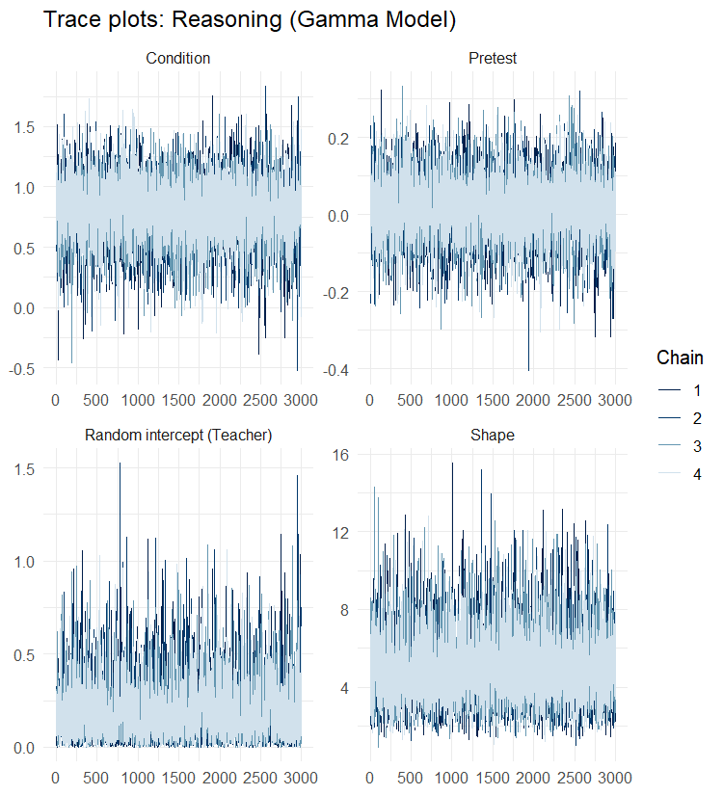

Figure 4
Trace Plots and Autocorrelation Plots for the Hurdle-Gamma Model (e.g., Teacher Turn Allocation)
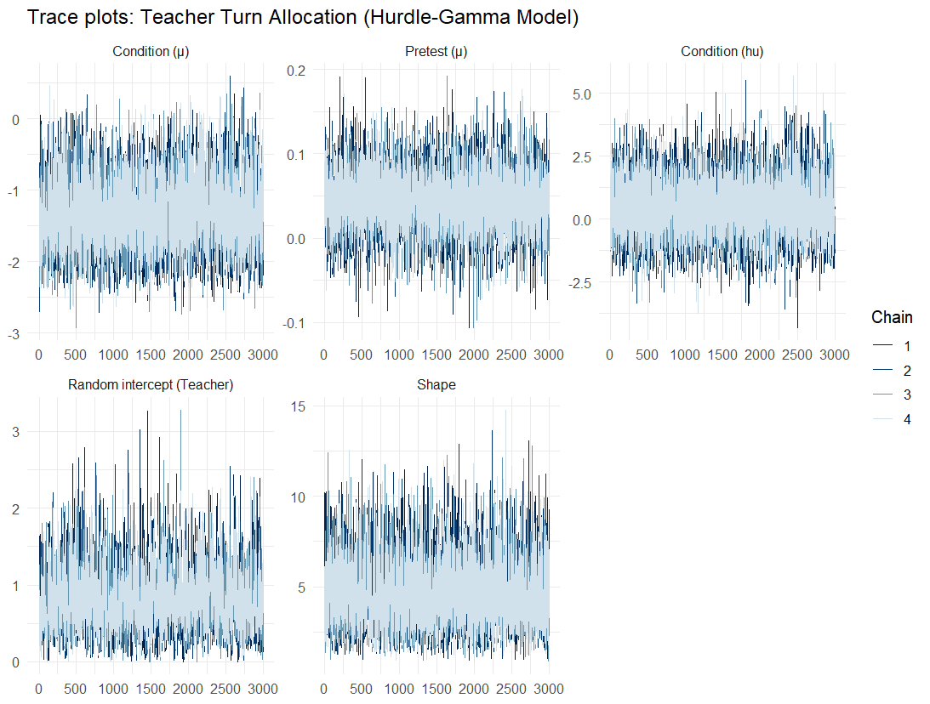
a) Trace Plots: Teacher Turn Allocation

b) Autocorrelation Plots: Teacher Turn Allocation
