Supplementary material
Winter Habitat Selection of Corvids in an Urban Ecosystem
Klaudia Szala^{1,2}, Łukasz Dylewski^{1,3}, Marcin Tobolka¹*
¹Institute of Zoology, Poznań University of Life Sciences, Wojska Polskiego 71c, 60-625 Poznań, Poland
²Department of Avian Biology and Ecology, Faculty of Biology, Adam Mickiewicz University, Uniwersytetu Poznańskiego 6, 61-614 Poznań, Poland
³Institute of Dendrology, Polish Academy of Sciences, Parkowa 5, 62-035 Kórnik, Poland
*corresponding author: tobolkamarcin@gmail.com, +48 665 633 663

Table A1: Mean, minimum, maximum values and standard deviation for every landscape category, length of watercourses and tram tracks and walnut trees and garbage cans number per research site.
Name of category | mean | SD | min | max | units
Block of flats | 2.6295 | 5.3953 | 0.0000 | 21.0990 | ha
Garden plots | 0.1997 | 0.8206 | 0.0000 | 4.4040 | ha
Houses | 6.4384 | 7.7537 | 0.0000 | 24.2150 | ha
Industrial areas | 1.0002 | 2.6286 | 0.0000 | 10.0970 | ha
Open areas | 7.2311 | 8.7587 | 0.0000 | 24.8680 | ha
Parks | 0.7994 | 1.9553 | 0.0000 | 8.8680 | ha
Wastelands | 1.0472 | 2.4677 | 0.0000 | 8.2990 | ha
Tenement houses | 1.7858 | 4.3494 | 0.0000 | 14.6830 | ha
Trees | 3.0113 | 6.1869 | 0.0000 | 23.6830 | ha
Water | 0.7988 | 2.7436 | 0.0000 | 14.9690 | ha
Length of watercourses | 157.26 | 0.00 | 10622.55 | 263.66 | m
Length of tram tracks | 126.44 | 0.00 | 1327.46 | 320.30 | m
Number of walnut trees | 13.3 | 0 | 58 | 17.2 | -
Number of garbage cans | 37.3 | 0 | 146 | 45.4 | -

Table A2: The best models explaining abundance of corvids ranked according to their ΔAICc values (variables: surface of parks, length of tram tracks, surface of the water, length of watercourses, distance from the research site to Warta river, surface of wastelands, surface of tenement houses, number of walnut trees, number of garbage cans, surface of trees, surface of industrial areas).
Model | df | logLik | AICc | delta | weight
Abundance of hooded crow
surf_park + tram_track + surf_water | 5 | -51.56 | 115.43 | 0.00 | 0.11
surf_park + watercourses + tram_track + surf_water | 6 | -50.36 | 116.09 | 0.66 | 0.08
surf_park + dist_river + tram_track + surf_water | 6 | -50.46 | 116.29 | 0.86 | 0.07
surf_park + wasteland + tram_track + surf_water | 6 | -51.00 | 117.35 | 1.93 | 0.04
Abundance of rook
ten_house + walnut + dist_river + garb_cans + watercourses + surf_water | 8 | -77.16 | 176.58 | 0.00 | 0.15
walnut + dist_river + garb_cans + watercourses + surf_water | 7 | -79.02 | 176.71 | 0.13 | 0.14
walnut + surf_park + dist_river + garb_cans + watercourses + surf_water | 8 | -77.87 | 177.99 | 1.42 | 0.07
Abundance of jackdaw
garb_cans + surf_water + surf_tree | 5 | -61.76 | 135.83 | 0.00 | 0.07
surf_indust + garb_cans + surf_water + surf_tree | 6 | -60.54 | 136.45 | 0.62 | 0.05
walnut + garb_cans + watercourses + surf_water + surf_tree | 7 | -58.93 | 136.53 | 0.70 | 0.05
garb_cans + watercourses + surf_water + surf_tree | 6 | -60.61 | 136.57 | 0.75 | 0.05
garb_cans + watercourses + surf_tree | 5 | -62.58 | 137.46 | 1.64 | 0.03
Abundance of European jay
surf_tree | 3 | -36.38 | 79.62 | 0.00 | 0.03
tram_track + surf_tree | 4 | -35.57 | 80.63 | 1.01 | 0.02
tram_track | 3 | -37.05 | 80.96 | 1.34 | 0.02
walnut + surf_tree | 4 | -35.74 | 80.96 | 1.35 | 0.02
garb_cans | 3 | -37.35 | 81.56 | 1.95 | 0.01
garb_cans + surf_tree | 4 | -36.06 | 81.59 | 1.98 | 0.01
surf_indust + surf_tree | 4 | -36.06 | 81.61 | 1.99 | 0.01
Abundance of magpie
walnut + garb_cans + watercourses + surf_tree | 6 | -91.95 | 199.26 | 0.00 | 0.03
walnut + garb_cans + surf_tree | 5 | -93.59 | 199.50 | 0.24 | 0.03
ten_house + walnut + surf_tree | 5 | -94.01 | 200.32 | 1.06 | 0.02
walnut + garb_cans + watercourses + tram_track + surf_tree | 7 | -90.91 | 200.50 | 1.23 | 0.02
ten_house + walnut + garb_cans + surf_tree | 6 | -92.57 | 200.50 | 1.24 | 0.02
ten_house + walnut + garb_cans + watercourses + surf_tree | 7 | -90.97 | 200.61 | 1.35 | 0.02
walnut + surf_tree | 4 | -95.72 | 200.93 | 1.67 | 0.01
walnut + garb_cans + watercourses | 5 | -94.32 | 200.94 | 1.68 | 0.01
ten_house + walnut + surf_park + surf_tree | 6 | -92.93 | 201.22 | 1.95 | 0.01
garb_cans + watercourses + tram_track + surf_tree | 6 | -92.94 | 201.25 | 1.98 | 0.01

Table A3: Canonical correspondence analysis (CCA) results – environmental factors that significantly predicted the corvids community in the urban environment in the winter period (variables: surface of trees, number of garbage cans, length of watercourses, distance from the river, surface of open areas and surface of tenement houses).
Variable | Explain % | Pseudo-F | p | Intra-set correlations
 |  |  |  | Axis 1 | Axis 2
Surf_tree | 26.5 | 10.4 | 0.002 | 0.649 | 0.681
Garb_cans | 21.7 | 8.1 | 0.002 | -0.623 | 0.142
Watercourses | 14.2 | 4.8 | 0.008 | 0.434 | -0.436
Dist_river | 11.4 | 3.7 | 0.018 | 0.421 | -0.207
Surf_open | 11.3 | 3.7 | 0.026 | 0.423 | -0.261
Ten_house | 8.1 | 2.6 | 0.042 | -0.355 | 0.093

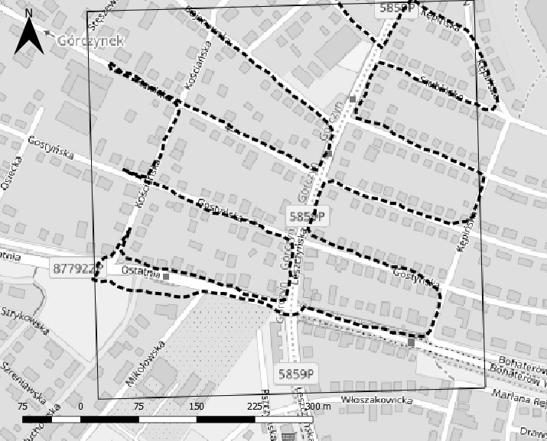
Fig. A1 An example of field visit (2017-01-14, research site no. 24 “Górczynek”). Black dotted line is the route of the observer recorded with a smartphone with the GPS localisation application: Geo Tracker, version.3.3.0.1338 (Bogdanovich, 2016). Map based on Open Street Map background raster layer

