Supplementary material
Table S1. Phytoplankton taxa found in the investigated water bodies. Late April/May, July and September samples are represented by letters M, J, S. Presence of a taxa in a sample is indicated by a ‘+’, which is given if at least one organism was observed in a sample.
 |  |  | PDK1 |  |  |  |  |  |  | PDK2 |  |  |  |  |  | PDK3 |  |  |  |  |  | PCAN1 |  |  |  |  |  | PCAN2 |  |  |  |  | PCAN3 |  |  | LDK1 |  |  | LDK2 |  |  | LDK3
Taxonomic classification |  |  | M |  |  | J |  | S |  | M |  | J |  | S |  | M |  | J |  | S |  | M |  | J |  | S |  | M |  | J |  | S | M | J | S | M | J | S | M | J | S | M | J | S
Phylum |  | Chlorophyta (Green algae)
Order |  | Trebouxiales
Genus |  | Botryococcus |  |  |  |  |  |  |  |  |  |  |  | + |  |  |  |  |  |  |  |  |  |  |  |  |  |  |  |  |  |  |  |  |  | + | + |  | + | + | + | + | + | +
Order |  | Sphaeropleales
Genus |  | Acutodesmus |  | + |  |  |  |  |  | + |  | + |  | + |  | + |  | + |  | + |  |  |  |  |  |  |  | + |  |  |  | + | + | + | + | + |  | +
Genus |  | Ankistrodesmus |  | + |  |  |  | + |  | + |  |  |  | + |  |  |  |  |  |  |  |  |  |  |  |  |  | + |  | + |  | + | + |  | +
Genus |  | Ankyra |  |  |  |  |  |  |  |  |  |  |  | + |  | + |  | + |  |  |  |  |  | + |  | + |  |  |  |  |  |  |  |  |  |  |  |  |  | + | + |  | +
Genus |  | Coelastrum |  |  |  |  |  |  |  |  |  | + |  | + |  |  |  | + |  |  |  |  |  |  |  |  |  |  |  |  |  | + | + | +
Genus |  | Crucigenia |  |  |  |  |  |  |  | + |  |  |  | +
Genus |  | Desmodesmus |  | + |  |  |  |  |  | + |  | + |  | + |  | + |  | + |  | + |  |  |  |  |  |  |  | + |  | + |  |  | + | + | + | + |  | + | + | + | +
Group |  | Eutetramorus/  coenochloris/  sphaerocystis |  |  |  |  |  |  |  |  |  |  |  |  |  |  |  |  |  |  |  |  |  |  |  |  |  |  |  |  |  |  |  |  |  | + | + | + | + | + | +
Genus |  | Golenkinia |  |  |  |  |  |  |  |  |  |  |  |  |  |  |  |  |  |  |  |  |  |  |  |  |  |  |  |  |  |  |  | +
Genus |  | Kirchneriella |  |  |  |  |  |  |  |  |  |  |  |  |  |  |  |  |  |  |  |  |  |  |  |  |  |  |  | + |  | + | + |  | + |  | + |  |  | + | +
Genus |  | Korshikoviella |  |  |  |  |  |  |  |  |  |  |  |  |  | + |  | + |  |  |  |  |  |  |  |  |  |  |  |  |  |  | +
Genus |  | Monoraphidium |  | + |  | + |  | + |  | + |  | + |  | + |  |  |  | + |  | + |  |  |  |  |  |  |  |  |  | + |  | + | + | + | + |  |  |  | + |  |  | +
Genus |  | Pediastrum |  |  |  |  |  |  |  | + |  | + |  | + |  |  |  |  |  | + |  |  |  |  |  |  |  | + |  | + |  | + | + | + | + | + |  |  | + |  | +
Genus |  | Scenedesmus |  | + |  | + |  | + |  | + |  | + |  | + |  | + |  |  |  | + |  |  |  |  |  |  |  | + |  | + |  | + |  | + | + |  | +
Genus |  | Tetraedron |  |  |  |  |  |  |  | + |  | + |  | + |  |  |  |  |  |  |  |  |  |  |  |  |  |  |  |  |  |  | + | + | +
Genus |  | Tetrastrum |  |  |  |  |  |  |  | + |  | + |  | +
Genus |  | Quadrigula |  |  |  |  |  |  |  |  |  | + |  | + |  |  |  |  |  |  |  |  |  |  |  |  |  |  |  |  |  |  |  |  |  |  |  |  | + | + | +
Group |  | Unidentified single celled sphaeropleales |  | + |  | + |  |  |  | + |  | + |  | + |  |  |  | + |  | + |  |  |  | + |  | + |  | + |  | + |  | + | + | + | + | + | + | + | + | + |  |  | +
Group |  | Unidentified colonial sphaeropleales |  |  |  |  |  |  |  |  |  | + |  | + |  |  |  |  |  |  |  |  |  |  |  |  |  |  |  |  |  |  |  |  | +
Order |  | Volvocales
Genus |  | Chlamydomonas |  | + |  |  |  |  |  |  |  |  |  |  |  |  |  | +
Genus |  | Eudorina |  |  |  |  |  |  |  |  |  |  |  |  |  |  |  |  |  |  |  |  |  |  |  |  |  | + |  |  |  |  | + | + |  |  | + |  |  | +
Genus |  | Gonium |  |  |  |  |  |  |  |  |  |  |  |  |  |  |  |  |  |  |  |  |  |  |  |  |  | + |  |  |  | + | + | + | +
Genus |  | Pandorina |  |  |  |  |  |  |  |  |  |  |  |  |  |  |  |  |  |  |  |  |  | + |  |  |  |  |  |  |  |  | + | + | +
Genus |  | Volvox |  |  |  |  |  |  |  |  |  |  |  |  |  |  |  |  |  |  |  |  |  |  |  |  |  |  |  |  |  |  |  |  |  |  | + |  | + | +
Group |  | Unidentified single celled volvocales |  |  |  |  |  |  |  |  |  |  |  |  |  |  |  |  |  |  |  |  |  |  |  | + |  | + |  | + |  |  | + | + |  | + |  |  |  | + |  |  |  | +
Order |  | Chlorococcales
Genus |  | Quadricoccus |  |  |  |  |  |  |  | + |  | + |  | + |  |  |  |  |  | + |  |  |  |  |  |  |  |  |  |  |  | + |  |  | +
Genus |  | Treubaria |  |  |  |  |  |  |  |  |  |  |  |  |  |  |  |  |  |  |  |  |  |  |  |  |  |  |  |  |  |  |  | +
Group |  | Unidentified colonial chlorococcales |  |  |  |  |  |  |  |  |  |  |  |  |  |  |  |  |  |  |  |  |  |  |  |  |  | +
Order |  | Chlorelalles
Genus |  | Actinastrum |  |  |  |  |  |  |  | + |  | + |  | +
Genus |  | Chlorella |  |  |  |  |  |  |  |  |  |  |  |  |  |  |  | +
Genus |  | Crucigeniella |  |  |  |  |  |  |  | + |  |  |  | + |  |  |  |  |  | + |  |  |  |  |  |  |  |  |  |  |  | + |  |  | +
Genus |  | Dictyosphaerium |  | + |  |  |  |  |  | + |  | + |  | + |  |  |  |  |  |  |  |  |  |  |  |  |  | + |  |  |  | + |  | + |  | + | +
Genus |  | Didymocystis |  |  |  |  |  |  |  | + |  | + |  | + |  |  |  |  |  |  |  |  |  |  |  |  |  |  |  |  |  |  | + | + | +
Genus |  | Eremosphaera |  |  |  |  |  |  |  |  |  |  |  |  |  |  |  |  |  |  |  |  |  |  |  |  |  |  |  |  |  |  |  |  |  |  |  |  |  |  |  |  | + | +
Genus |  | Keratococcus |  |  |  |  |  |  |  |  |  |  |  |  |  |  |  | +
Genus |  | Lagerheimia |  |  |  |  |  |  |  | + |  | + |  | + |  |  |  |  |  |  |  |  |  |  |  |  |  |  |  |  |  |  |  |  |  | +
Genus |  | Micractinium |  |  |  |  |  |  |  |  |  |  |  |  |  |  |  |  |  |  |  |  |  |  |  |  |  |  |  |  |  |  |  | + | +
Genus |  | Nephrocytium |  |  |  |  |  |  |  |  |  | + |  | + |  |  |  |  |  |  |  |  |  |  |  |  |  |  |  |  |  |  |  |  | +
Genus |  | Oocystis |  |  |  |  |  |  |  | + |  | + |  |  |  |  |  | + |  | + |  |  |  |  |  |  |  |  |  |  |  |  | + | + | + |  |  |  | + |  | + |  | +
Order |  | Ulotrichales
Genus |  | Elakatothrix |  |  |  |  |  |  |  |  |  | + |  | + |  |  |  |  |  | + |  |  |  |  |  |  |  |  |  |  |  |  |  |  |  |  |  |  | + |  |  | + | + | +
Genus |  | Koliella |  |  |  |  |  |  |  | + |  | + |  | + |  |  |  |  |  |  |  | +
Order |  | Zygnematales
Genus |  | Closterium |  | + |  |  |  | + |  | + |  | + |  | + |  |  |  |  |  |  |  |  |  |  |  | + |  |  |  |  |  |  | + |  |  | + | + | + | + | + | + | + | +
Genus |  | Cosmarium |  | + |  | + |  |  |  | + |  | + |  | + |  |  |  |  |  |  |  |  |  | + |  | + |  |  |  | + |  |  |  |  |  |  |  | +
Genus |  | Gonatozygon |  | +
Genus |  | Micrasterias |  |  |  |  |  |  |  |  |  |  |  |  |  |  |  |  |  |  |  |  |  |  |  |  |  |  |  |  |  |  |  |  |  |  |  |  |  | +
Genus |  | Staurastrum |  |  |  |  |  |  |  | + |  | + |  | + |  |  |  |  |  |  |  |  |  |  |  | + |  |  |  | + |  |  | + | + | + | + | + | + | + | + | + |  | +
Genus |  | Staurodesmus |  |  |  |  |  |  |  |  |  |  |  |  |  |  |  |  |  |  |  |  |  |  |  |  |  | + |  |  |  |  |  |  |  |  |  |  | + | + | + | +
Genus |  | Teilingia |  |  |  |  |  |  |  |  |  | + |  | +
Genus |  | Xanthidium |  |  |  |  |  |  |  |  |  |  |  |  |  |  |  |  |  |  |  |  |  |  |  |  |  |  |  |  |  |  |  |  |  |  |  |  | +
Group |  | Unidentified zygnematales |  |  |  |  |  |  |  |  |  |  |  |  |  |  |  |  |  |  |  |  |  |  |  |  |  |  |  |  |  |  | + | + | +
Group |  | Unidentified single celled chlorophyta |  |  |  |  |  | + |  | + |  | + |  | + |  | + |  | + |  | + |  |  |  | + |  | + |  | + |  | + |  | + | + | + | + | + | + | + | + |  |  |  | + | +
Group |  | Unidentified colonial chlorophyta |  |  |  |  |  |  |  | + |  | + |  | + |  |  |  | + |  |  |  |  |  |  |  |  |  |  |  |  |  |  | + |  |  | + | + | + |  | + |  |  | + | +
Phylum |  | Cyanophyta (Cyanobacteria, blue-green algae)
Order |  | Chroococcales
Genus |  | Aphanocapsa |  |  |  |  | + |  | + |  | + |  | + |  | + |  |  |  |  |  |  |  |  |  |  |  |  |  |  |  | + | + |  | + | + | + | + | + |  | + |  | +
Genus |  | Aphanothece |  |  |  |  |  |  |  |  | + |  | + |  | + |  |  |  |  |  |  |  |  |  |  |  |  |  |  |  |  |  |  |  |  | + |  |  |  |  |  |  | + | +
Genus |  | Geminocystis |  |  |  |  | + |  | +
Genus |  | Merismopedia |  |  |  |  |  |  |  |  |  |  |  |  |  |  |  |  |  |  |  |  |  |  | + |  |  |  | + |  | + | + |  |  |  |  |  |  |  |  |  | + | + | +
Genus |  | Microcystis |  |  |  |  | + |  | + |  | + |  | + |  | + |  |  |  |  |  |  |  |  |  |  |  |  |  | + |  |  | + |  | + | + |  |  | +
Genus |  | Rhabdoglea |  |  |  |  |  |  |  |  |  |  |  |  |  |  |  |  |  |  |  |  |  |  |  |  |  |  |  |  |  | + |  |  |  |  |  |  |  |  |  | +
Genus |  | Snowella |  |  |  |  |  |  | + |  |  |  |  |  | + |  |  |  |  |  |  |  |  |  |  |  |  |  |  |  |  | + | + |  | + | + |  | +
Genus |  | Synechocystis |  |  |  |  | + |  | + |  | + |  |  |  |  |  |  |  |  |  |  |  |  |  |  |  | + |  |  |  |  |  |  | + | + |  |  | +
Genus |  | Woronichinia |  |  |  |  |  |  |  |  |  |  |  |  |  |  |  |  |  |  |  |  |  |  |  |  |  |  |  |  |  |  |  |  |  | +
Group |  | Coccoidal chroococcales |  |  | + |  | + |  | + |  | + |  | + |  | + |  | + |  | + |  | + |  | + |  | + |  | + |  | + |  | + | + | + | + | + | + | + | + | + | + | + | + | + | +
Group |  | Rod shaped chroococcales |  |  | + |  | + |  | + |  | + |  | + |  | + |  |  |  | + |  | + |  | + |  | + |  | + |  | + |  | + | + | + | + | + | + | + | + | + | + | + | + |  | +
Group |  | Unidentified colonial chroococcales |  |  |  |  |  |  |  |  | + |  | + |  | + |  |  |  |  |  | + |  |  |  |  |  |  |  |  |  | + | + |  |  | + | + |  | + |  |  |  | +
Group |  | Microcystis/Aphanocapsa |  |  |  |  |  |  | + |  |  |  |  |  |  |  |  |  |  |  |  |  |  |  |  |  |  |  | + |  | + | + |  |  |  |  | +
Order |  | Nostocales
Genus |  | Anabaena |  |  |  |  |  |  | + |  | + |  | + |  | + |  |  |  |  |  | + |  |  |  |  |  |  |  |  |  |  |  |  |  |  | + | + | + | + | + | + | + | + | +
Genus |  | Anabaenopsis |  |  |  |  |  |  |  |  | + |  | + |  | + |  |  |  |  |  |  |  |  |  |  |  |  |  |  |  |  |  |  |  |  | +
Order |  | Oscillatoriales
Genus |  | Oscillatoria |  |  | + |  |  |  | + |  |  |  |  |  |  |  |  |  |  |  |  |  | + |  |  |  | + |  | + |  | + | + | +
Genus |  | Lyngbya |  |  | +
Genus |  | Planktothrix |  |  |  |  |  |  |  |  |  |  |  |  |  |  |  |  |  |  |  |  |  |  |  |  |  |  |  |  |  |  | + |  | + |  |  |  |  | +
Genus |  | Pseudanabaena |  |  | + |  | + |  | + |  | + |  | + |  | + |  | + |  | + |  | + |  |  |  | + |  | + |  | + |  |  | + | + | + | + | + | + | + | + |  | + | +
Group |  | Unidentified oscillatoriales |  |  | + |  | + |  | + |  |  |  |  |  | + |  | + |  | + |  | + |  | + |  | + |  | + |  |  |  | + | + | + | + | + | + | + | + |  | +
Group |  | Unidentified filamentous cyanophyta |  |  |  |  |  |  |  |  |  |  |  |  |  |  |  |  |  |  |  |  |  |  |  |  |  |  | + |  | + |  |  | + | +
Phylum |  | Euglenophyta
Genus |  | Euglena |  |  | + |  | + |  | + |  | + |  | + |  | + |  |  |  | + |  | + |  | + |  | + |  |  |  | + |  | + | + | + | + | +
Genus |  | Lepocinclis |  |  |  |  |  |  |  |  |  |  |  |  |  |  |  |  |  |  |  |  |  |  |  |  |  |  |  |  |  |  |  | +
Genus |  | Phacus |  |  | + |  |  |  |  |  | + |  | + |  | + |  | + |  | + |  | + |  | + |  |  |  |  |  | + |  | + | + |  | + | +
Genus |  | Trachelomonas |  |  | + |  | + |  | + |  | + |  | + |  | + |  |  |  | + |  | + |  |  |  | + |  | + |  | + |  | + | + |  | + | + | + | + | + |  | + | + | +
Genus |  | Strombomonass |  |  |  |  |  |  |  |  | + |  | + |  | + |  |  |  |  |  |  |  |  |  |  |  |  |  | + |  | + |  |  | + | +
Group |  | Unidentified euglenophyta |  |  | + |  |  |  | + |  | + |  | + |  | + |  | + |  | + |  |  |  | + |  | + |  | + |  | + |  | + | + | + | + | + |  | + |  |  |  |  | +
Phylum |  | Chrysophyta
Genus |  | Chrysococcus |  |  |  |  |  |  |  |  |  |  |  |  |  |  |  |  |  |  |  |  |  |  |  |  |  |  |  |  |  |  |  |  | +
Genus |  | Dinobryon |  |  |  |  |  |  |  |  | + |  | + |  |  |  |  |  |  |  |  |  | + |  | + |  | + |  |  |  |  |  | + |  |  |  |  |  | + |  |  |  | +
Genus |  | Kephyrion |  |  |  |  |  |  |  |  | + |  | + |  | +
Genus |  | Mallomonas |  |  |  |  |  |  |  |  |  |  | + |  |  |  |  |  |  |  |  |  | + |  |  |  |  |  |  |  |  |  | + | + | +
Genus |  | Synura |  |  |  |  |  |  |  |  |  |  |  |  |  |  |  |  |  |  |  |  |  |  |  |  | + |  |  |  |  |  |  | +
Genus |  | Uroglena |  |  |  |  |  |  |  |  |  |  |  |  |  |  |  |  |  |  |  |  |  |  | +
Group |  | Spores |  |  |  |  |  |  |  |  |  |  |  |  |  |  |  |  |  |  | +
Group |  | Unidentified single celled chrysophyta |  |  | + |  |  |  |  |  | + |  | + |  | + |  |  |  |  |  |  |  | + |  |  |  | + |  |  |  |  |  | +
Phylum |  | Cryptophyta |  |  | + |  | + |  | + |  | + |  | + |  | + |  | + |  | + |  | + |  | + |  | + |  | + |  | + |  | + | + | + | + | + | + | + | + | + | + | + | + | + | +
Phylum |  | Xanthophyta
Genus |  | Centritractus |  |  |  |  |  |  |  |  | + |  | + |  | +
Genus |  | Goniochloris |  |  |  |  |  |  |  |  |  |  | + |  | + |  |  |  | + |  |  |  |  |  |  |  |  |  |  |  | + |  |  |  | +
Genus |  | Isthmochloron |  |  |  |  |  |  |  |  |  |  |  |  |  |  |  |  |  |  |  |  |  |  |  |  |  |  |  |  | + | + |  |  |  |  |  |  | + | + | +
Phylum |  | Dinophyta
Genus |  | Ceratium |  |  |  |  |  |  |  |  |  |  |  |  |  |  |  |  |  |  |  |  |  |  |  |  |  |  |  |  | + | + |  | + | + |  | + | + |  | + | +
Genus |  | Peridinium |  |  | + |  | + |  | + |  | + |  | + |  | + |  |  |  |  |  |  |  | + |  |  |  |  |  | + |  | + |  | + | + | + |  |  |  | + |  |  | +
Phylum |  | Haptophyta (Prymnesiophyta)
Genus |  | Chrysochromulina |  |  |  |  |  |  |  |  |  |  |  |  |  |  |  |  | + |  |  |  |  |  |  |  |  |  |  |  |  |  |  |  |  | + | +
Phylum |  | Bacillariophyta
Group |  | Pennate |  |  | + |  | + |  | + |  | + |  | + |  | + |  | + |  | + |  | + |  | + |  | + |  | + |  | + |  | + | + | + | + | + | + | + |  |  | + |  | +
Group |  | Centric |  |  |  |  |  |  |  |  | + |  | + |  | + |  |  |  |  |  |  |  | + |  |  |  |  |  | + |  | + | + | + | + | +
Group |  | Colony or filament forming |  |  |  |  |  |  |  |  | + |  | + |  | + |  |  |  |  |  |  |  | + |  |  |  |  |  |  |  |  |  | + | + |  | + | + | +
Group |  | Unidentified
Group |  | Single celled |  |  | + |  | + |  | + |  | + |  |  |  |  |  | + |  | + |  |  |  | + |  | + |  | + |  | + |  | + |  | + | + |  |  |  |  |  |  |  | + | + | +
Group |  | Colonial |  |  |  |  | + |  | + |  |  |  | + |  | + |  |  |  | + |  | + |  |  |  |  |  | + |  | + |  |  |  |  |  | + |  | + |  | + | + |  |  |  | +
Group |  | Filamentous |  |  |  |  | + |  |  |  |  |  |  |  |  |  |  |  |  |  |  |  |  |  |  |  |  |  | + |  |  |  |  |  |  |  |  | + |  |  |  | + | +
Group |  | Euglenophyte cysts |  |  |  |  |  |  |  |  |  |  | + |  | + |  |  |  |  |  |  |  | + |  | + |  |  |  | + |  | + | + | + | + | + | + | +

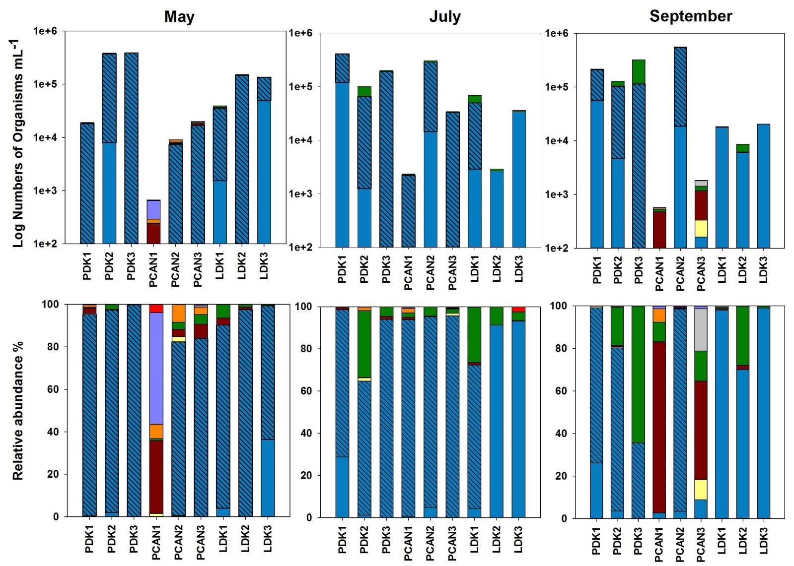

Fig. S1 Numbers of organisms in Danish ponds, lakes, and Canadian ponds counted in late April/May, July and September

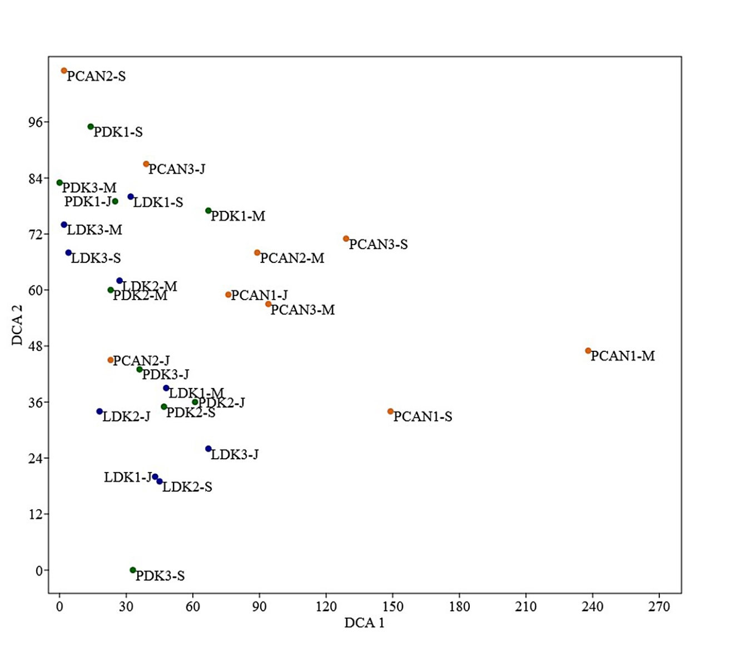
Fig. S2 DCA analysis based on relative abundance of phytoplankton phyla and groups

