Shading enhances plant species richness and diversity on an extensive green roof
Henk-Jan van der Kolk^{1,}*, Petra van den Berg¹, Gerard Korthals¹ & T. Martijn Bezemer^{1,2}

¹Netherlands Institute of Ecology, Wageningen, The Netherlands
²Institute of Biology, Section Plant Ecology and Phytochemistry, Leiden University, Leiden, The Netherlands
*Corresponding author: H.vanderKolk@nioo.knaw.nl

ORCID iD
Henk-Jan van der Kolk 0000-0002-8023-379X
T. Martijn Bezemer 0000-0002-2878-3479

Key words: Biodiversity; Green roof; Microclimate; Succulents; Urban ecology; Vegetation.

Abstract
Green roofs can promote biodiversity in urban areas. The extent to which green roofs stimulate plant diversity can depend on roof characteristics such as roof age, substrate depth and shading. We exploratively studied the vegetation on a Dutch green roof in 50 permanent plots (1m²) over eight years (2012-2019) following roof construction. Plots were situated either on low substrate depth (6 cm light-weight extensive substrate) or high substrate depth (6 cm light-weight extensive substrate topped with 14 cm native soil) and differed in the amount of shading received from a higher building floor. Increased substrate depth and shading additively increased plant species richness and plant diversity, with high shaded plots supporting on average 6.4 more plant species than low unshaded plots. Shading likely acts via reducing drought stress, whereas increasing substrate depth with native soil may also enhance plant diversity via addition of nutrients and native seeds. The vegetation composition on the roof was dynamic and changed over the years. Sedum acre was initially dominant but disappeared within the first years, whereas Sedum kamtschaticum increased and became dominant in the last years. Trifolium arvense was the most abundant forb species and was especially dominant three years after roof construction. We conclude that increased substrate depth and shading can promote plant species richness and diversity and recommend that both aspects are considered when green roofs are designed. Shading can be achieved by a stepped building architecture and by placing structures on the roof itself, such as solar panels on standards.

Introduction
Green roofs are increasingly popular in urban areas since they provide a range of benefits including retention of rainwater, cooling of buildings and promoting biodiversity (Oberndorfer et al. 2007; Berardi et al. 2014; Filazzola et al. 2019). Biodiversity is promoted on green roofs by the higher presence and abundance of native plant species and arthropods compared to conventional roofs (Madre et al 2013; Madre et al 2014; Schrader and Böning 2006). Some green roofs harbour plant species that are locally rare or endangered, which emphasises their potential to enhance biodiversity in urban areas (Gabrych et al. 2016).
Green roofs vary largely in their design, complexity and vegetation structure, but can generally be classified as being either ‘extensive’ or ‘intensive’ (Berndtsson et al. 2009; Berardi et al. 2014). Extensive green roofs have a thin and light-weight substrate supporting vegetation with mosses and succulents. Intensive green roofs have a thick and heavy substrate supporting a more complex vegetation structure, often with bushes or trees (Berardi et al. 2014). More complex green roof vegetation often facilitates a higher plant and arthropod diversity (Madre et al. 2013). Extensive green roofs, however, generally require less complex roof structures and are therefore more widely applied nowadays (Oberndorfer et al. 2007; Berardi et al. 2014).
Extensive green roofs typically have short vegetation dominated by drought resistant succulents, mosses and herbs. Since extensive green roofs have a relative shallow substrate depth and are often fully exposed to the sun without access to water reservoirs, drought stress is limiting plant growth and diversity (Olly et al. 2011; Bates et al. 2013; Brown and Lundholm 2015). Some green roof characteristics, such as the inclusion of water reservoirs under the roof, irrigation systems, or increased substrate depth and shading, can reduce drought stress and thereby influence the vegetation (MacIvor et al. 2013). Higher substrate depths can alter the composition of the vegetation and generally promote plant growth and plant species richness (Durhman et al. 2007; Getter and Rowe 2008; Rowe et al. 2012; Heim and Lundholm 2014; Madre et al. 2014; Brown and Lundholm 2015; Gabrych et al. 2016). Existing studies suggest that also shading can increase plant species richness by reducing drought stress (Köhler et al. 2012; Carlisle and Piana 2015). However, the number of studies investigating the effect of shading on roof vegetation is limited. Also, the vegetation on extensive green roofs is often dynamic (Rowe et al. 2012), and it is therefore important to assess the impact of roof characteristics on the vegetation over longer time periods.
Here, we studied the vegetation development for a period of eight years following roof construction on an extensive green roof. Our study roof differs from many other green roofs in that parts of the roof are shaded by a higher building floor. Using this dataset, we could thus explore (1) how vegetation composition and vegetation characteristics (e.g. species richness) changed over the years and whether this was affected by spring precipitation, and (2) how vegetation characteristics differed between roof parts with low and high substrate depths and with various amounts of shading.

Methods
Study site
The study was conducted on the roof of the main building of the Netherlands Institute of Ecology (NIOO-KNAW) in Wageningen, the Netherlands (51.9871°N, 5.6712°E; Figure 1). The green roof was constructed in 2010 using an extensive lightweight substrate (a mixture of light-weight stones, such as lava stone and perlite, and compost) with a depth of 6cm and applying a mixture of Sedum plugs containing seven different species: Sedum acre, S. album, S. hispanicum, S. kamtschaticum, S. spurium, S. rupestre and S. sexangulare. In 2011, substrate depth was increased at some parts of the roof to 20cm (Figure 1) by applying native soil originating from the south side of the building. These parts of the roof can also be considered semi-intensive (Catalano et al. 2016). A seed mixture containing native forbs was then sown on the whole roof (Supplementary Table S1). Henceforth, we refer to the 6cm substrate depth as ‘low substrate depth’ and to the increased roof parts as ‘high substrate depth’. The green roof was situated on top of the second floor, 8.5m above ground level. In the middle of the building, a third floor extended 11.3m above the green roof (19.8m above ground level), thereby shading parts of the green roof in different extends (Figure 1). No water or nutrients were applied on the roof. Once per year, after 15 October which is after the growth season had finished, the roof vegetation was mown and removed and tree saplings were removed. Since the roof vegetation was generally short and tree saplings rare (mostly Betula pubescens saplings in 2012 and 2013, only incidentally saplings of other species or in later years; Supplementary Table S2), and because it was done after the growth season ended, the effects of this annual maintenance on the vegetation was likely minimal.

Data collection
On the roof 50 permanent quadrats (1x1m) were surveyed from 2012 to 2019. Plots were located either on low (n=29) or high (n=21) substrate depth and differed from each other in the amount of shading (Figure 1). We calculated shading as the percentage of daytime that plots were shaded throughout the whole year. For this purpose, we combined the exact plot locations, the outline and height of the higher third floor of the building, and sun positions and angles to derive whether a plot was shaded for each minute daytime. Sun positions and angles were calculated using the sunAngle function from the oce R package (Kelley & Richards 2017). The plots were surveyed in seven years during the eight years following roof construction: 21 June 2012, 14 June 2013, 11 June 2014, 22 July 2015, 28 June 2017, 30 June 2018 and 28 June 2019. During the surveys, the cover (in %) of all plant species was recorded in all plots. The number of plots (out of 50) in which each species was recorded during each year is presented in Supplementary Table S2.
Precipitation data were provided by the Royal Netherlands Meteorological Institute for the meteorological station Deelen (52.06°N, 5.89°E), located 17 km northeast of the green roof (KNMI, 2019).

Data analysis
All data processing and analyses were performed in R (R Core Team 2019). First a principal component analysis (PCA) was performed to explore how the vegetation composition changed over the surveyed years. For every year, the mean and standard error of the positions on the first and second PCA axis were calculated for low and high substrate depth plots. Linear mixed model analysis was then used to examine the effects of year, precipitation, substrate depth and shading on (1) species richness, (2) Shannon diversity index (Shannon 1948), (3) Forb cover (%), (4) Grass cover (%) and (5) Sedum cover (%). We used year after construction (2012 = year 1), spring precipitation (sum of precipitation in February-May of the surveyed year, standardized), substrate depth (high or low) and percentage of shading as explanatory variables. After visual inspection of our data we added the interaction between substrate depth and shading only for the model with grass cover as response variable. We added plot number and year as random factors to the model to correct for repeated measures. We used the lmer function to fit linear mixed models and the drop1 function with a Chi square likelihood ratio test to detect significant effects.

Results
Vegetation changes
The vegetation composition on the roof markedly changed during the eight years following roof construction (Figure 2; Figure 3). Changes in vegetation composition were mostly determined by changes in Sedum, Trifolium arvense and Festuca cover (Figure 3). More specifically, the first PCA axis (explaining 26.9% of the variation), represented the shift in the plant community from being dominated by Sedum acre and Sedum album in the early years, to being dominated by Sedum kamtschaticum in the later years. The second PCA axis (explaining 16.0% of the variation) represented the high cover of Sedum hispanicum and Trifolium arvense around 2014, and change towards increased cover of Sedum sexangulare and Festuca in later years. Vegetation composition changes for those two PCA axes were more pronounced in the early years than in the later years (Figure 3).
Although Sedum was prominent throughout the whole study period, the cover of the individual Sedum species changed drastically. In the first two years after roof establishment, Sedum acre and Sedum album were prominent. Both species, however, strongly declined and almost disappeared in 2014 (Figure 4). Sedum hispanicum was the most dominant Sedum species from 2013-2017. Sedum kamtschaticum strongly increased and became most dominant in 2018-2019 (Figure 4). Forb cover was dominated by Trifolium arvense. Trifolium arvense cover spiked and this species was very abundant in 2014 (Figure 2b; Figure 5), but stabilized at lower covers in the last years. Other prominent forb species, such as Achillea millefolium, Hypochaeris radicata and Silene latifolia, were sown upon roof construction (Supplementary Table S1) and remained present throughout the whole study period. Grass cover was dominated by Festuca, which became more prominent in the last years (Figure 3).
Despite clear changes in vegetation composition, we detected no significant trends in species richness, species diversity, total forb cover or total Sedum cover during the whole study period (Figure 5; Table 1). Species richness, however, showed a declining trend until 2018 but strongly increased in 2019 (Figure 5a). Due to the increasing abundance of the grass Festuca, grass cover increased significantly during the eight years of the study (Figure 5c; Table 1). This increase was especially evident in high substrate depth plots, where grass cover increased until 2017, but slightly decreased again in 2018 and 2019 (Figure 5c). Spring precipitation was positively correlated with forb cover and negatively correlated with grass cover. However, only the correlation with grass cover was significant (Table 1).

Substrate depth and shading
Vegetation characteristics differed markedly between plots that were situated on high or low substrate depth. Both species richness and species diversity were higher in plots with high substrate depth (Table 1; Figure 5a, 5b). On average, there were 3.45 more plant species in high compared to low substrate depth plots. The difference in species richness and diversity between low and high substrate depth became, however, less pronounced in more recent years (Figure 5a, 5b). Forb cover was persistently higher in plots on high substrate depth (Table 1; Figure 5d). Sedum cover was on average lower in plots on high substrate depth, being most pronounced in 2015-2017 (Table 1; Figure 5f).
Species richness and species diversity were significantly higher in plots that were more shaded (Table 1; Figure 6). On average, there were 2.95 more plant species in plots that were shaded for 50% of the time than in non-shaded plots (Table 1). The effects of substrate depth and shading were additive, since shading affected species richness in a similar manner for plots with low and high substrate depth (Figure 6a). Grass cover was higher, especially in plots on low substrate depths, but Sedum cover lower in shaded plots (Table 1; Figure 6).

Discussion
We observed large vegetation changes on an extensive green roof throughout eight years following roof construction. Importantly, we found that both the amount of shading and increased substrate depth were positively correlated with plant species richness and plant diversity. We discuss the potential environmental mechanisms that underly the observed effects of shading, substrate depth and temporal trends.

Shading
Shading enhances plant species richness and diversity most likely by reducing drought stress (Getter et al. 2009), one of the limiting factors for plant growth on extensive green roofs (Nagase and Dunnett 2010; Bousselot et al. 2011). Indeed, only few herb species (Festuca spec., Hypochaeris radicata, Trifolium arvense) were observed on the parts of our roof which were most sun exposed and had a low substrate depth. A wider range of herb species, including Trifolium pratense, Vicia hirsuta and Veronica arvensis, grew on shaded parts of the roof, although their abundance was often limited.
Shading in our study was partially confounded with other factors, since the presence of an upper floor could have altered precipitation regimes on different parts of the roof. Specifically, the prevailing southwest wind direction could lead to the vegetation near the southwest edge receiving more precipitation than the vegetation near the northeast edge. Also, additional water and nutrients (e.g. nitrogen in rain water) may run off the walls of the upper floor and promote plant growth in the edge vegetation. Indeed, we observed that the abundance of non-succulents was higher in the vegetation directly edging the upper floor. However, the effects of shading were still visible in plots that were several meters from the edge, where effects of the upper floor on precipitation and nutrient flows are not expected to occur anymore. In order to be able to statistically account for confounding factors, we recommend that nutrients, moisture and actual light levels are measured at a plot level in future studies on the effects of shading on green roof vegetation.
There are multiple ways to increase shading and thereby plant diversity on extensive green roofs. Firstly, shading can be provided by higher floors, such as in this study, or by surrounding buildings (Carlisle and Piana 2015). Secondly, high solar panels on extensive green roofs can provide shading on underlying and adjacent ground and thereby enhance plant species richness (Köhler et al., 2002; van der Kolk and van den Berg, 2019). Thirdly, a slightly tilted roof orientated oppositely from the sun can reduce sun exposure and thus promote the maintenance of the quality of the vegetation. For example, the vegetation quality, an index combining vegetation cover with species richness, was found to be lower on completely sun exposed south orientated roofs in comparison with roofs that were tilted and less exposed to the sun (Köhler and Poll 2010).

Substrate depth
The positive effect of increased substrate depth on plant diversity is consistent with previous studies (Rowe et al. 2012; Heim and Lundholm 2014; Madre et al. 2014; Brown and Lundholm 2015; Gabrych et al. 2016). In general, increased substrate depth stimulates plant growth by increasing the availability of nutrients and reducing drought stress. On our roof, the high and low parts differed not only in their substrate depth, but also in the substrate composition. Since the substrate at the high parts was topped up with native soil, also the seed bank, soil biota and additional nutrients present in the soil could have positively contributed to the vegetation development. More importantly, however, we observed that the effects of shading were apparent in both substrate depths and that the effects were thus additive: The highest plant species richness and diversity were found in plots with high substrate depth and high levels of shading. Combined application of shading and increased substrate depth may thus enhance plant diversity more than one of the two factors solely.

Temporal trends
The vegetation composition was dynamic during the eight-year study period. Interestingly, Sedum acre, a species that is widely applied on extensive green roofs, drastically declined and disappeared within the first few years after roof construction. In contrast, Sedum acre abundance increased on green roofs in the United Kingdom (Bates et al. 2013). In the study by Bates et al. (2013), however, no other Sedum species were present on the roof. On our roof Sedum acre may have been outcompeted by other Sedum species, specifically Sedum hispanicum and the broad-leaved species Sedum spurium and Sedum kamtschaticum. In support, Rowe et al. (2012) found that the cover of broad-leaved Sedum species increased over seven years on substrate depths of 5.0cm and 7.5cm at the expense of other species, whereas Sedum acre performed better only on a very low substrate depth of 2.5cm.
Variation in weather condition determines the extent of drought stress exhibited on the vegetation, leading to year-to-year variation in species presence and thus species richness and diversity (Köhler 2006). Our results suggest that grasses profit from drier springs, whereas forbs may profit from wetter springs. Interestingly, we also observed that the ongoing decline in species richness and species diversity over the years ceased in 2019, when the roof vegetation was highly diverse again. Probably the exceptionally dry summer of 2018 may have caused a reduction in grass cover which opened up roof surface that was colonized by other forb species in 2019. For example, we observed that species that were common in the first years but were declining (e.g. Linaria vulgaris, Silene latifolia and Veronica arvensis) revived in 2019. There were, however, also species that disappeared in 2019 (e.g. Centaurea jacea and Dactylorhiza majalis). These observations indicate that the effects of precipitation on the vegetation are complex, and longer time series are needed to detect consistent effects of weather on green roof vegetation (e.g. Köhler 2006). Combined, succession and weather may determine how the vegetation develops throughout the years on extensive green roofs.
From a plant diversity perspective, the dynamic vegetation development throughout the years is positive since many native plant species established and flourished on the green roof. In total, we recorded 84 plant species in the plots, most of which established spontaneously. Trifolium arvense, for example, is a native plant species that largely determined patterns in overall forb cover. High abundance of Trifolium arvense was also observed by Bates et al. (2013) on green roofs in the United Kingdom and the species’ potential for green roofs has been stressed by Madre et al. (2014). The heterogeneity in substrate depths and shading enabled more native plant species to establish in particular micro-climates, such as the orchid Dactylorhiza majalis on shaded and presumably moist parts of the roof (Figure 2d). The non-shaded parts of the roof with low substrate depth resemble conventional Sedum roofs, but also had the lowest plant diversity. This is in line with the general idea that roofs designed as ‘biodiverse roofs’ support a higher biodiversity than conventional ‘Sedum roofs’ (Williams et al. 2014). Yet, the number of studies that compare biodiversity between different green roof substrates is limited, and there is still a need for more empirical data to increase our understanding of how green roof plant communities are shaped by substrate types and environmental circumstances (Williams et al. 2014).

Conclusion
In conclusion, our study provides an example of how shading and increased substrate depth can promote plant diversity on extensive green roofs. We suggest that both aspects are considered when new green roofs are constructed. Shading can be achieved by designing buildings with cascading floors, placing solar panels on standards on the roof or any other structures that can provide shading, such as large tree trunks, insect hotels or wooden fences.

Acknowledgements
We thank Gerdien Bos-Groenendijk for surveying the vegetation on the green roof from 2012 to 2014. We thank the two anonymous reviewers for their critical comments on this manuscript.

Data availability
Data will be made available in Dryad upon acceptance.

References
Bates AJ, Sadler JP, Mackay R (2013) Vegetation development over four years on two green roofs in the UK. Urban For Urban Gree 12:98-108. https://doi.org/10.1016/j.ufug.2012.12.003
Berardi U, GhaffarianHoseini A, GhaffarianHoseini A (2014) State-of-the-art analysis of the environmental benefits of green roofs. Apply Energ 115:411-428. https://doi.org/10.1016/j.apenergy.2013.10.047
Berndtsson JC, Bengtsson L, Jinno K (2009) Runoff water quality from intensive and extensive vegetated roofs. Ecol Eng 35:369-380. https://doi.org/10.1016/j.ecoleng.2008.09.020
Bousselot JM, Klett JE, Koski RD (2011) Moisture content of extensive green roof substrate and growth response of 15 temperate plant species during dry down. HortScience 46:518-522. https://doi.org/10.21273/HORTSCI.46.3.518
Brown C, Lundholm J (2015). Microclimate and substrate depth influence green roof plant community dynamics. Landscape Urban Plan 143:134-142. https://doi.org/10.1016/j.landurbplan.2015.07.009
Carlisle S, Piana M (2015) Green roof plant assemblage and dynamics. In Green Roof Ecosystems, pp. 285-310. Springer, Cham.
Catalano C, Marcenò C, Laudicina VA, Guarino R (2016) Thirty years unmanaged green roofs: Ecological research and design implications. Landscape Urban Plan 149:11-19. https://doi.org/10.1016/j.landurbplan.2016.01.003
Durhman AK, Rowe DB, Rugh CL (2007) Effect of substrate depth on initial growth, coverage, and survival of 25 succulent green roof plant taxa. HortScience 42:588-595. https://doi.org/10.21273/HORTSCI.42.3.588
Filazzola A, Shrestha N, MacIvor JS (2019) The contribution of constructed green infrastructure to urban biodiversity: A synthesis and meta‐analysis. J Appl Ecol 56:2131–2143. https://doi.org/10.1111/1365-2664.13475
Gabrych M, Kotze DJ, Lehvävirta S (2016) Substrate depth and roof age strongly affect plant abundances on sedum-moss and meadow green roofs in Helsinki, Finland. Ecol Eng 86:95-104. https://doi.org/10.1016/j.ecoleng.2015.10.022
Getter KL, Rowe DB (2008) Media depth influences Sedum green roof establishment. Urban Ecosyst 11:361. https://doi.org/10.1007/s11252-008-0052-0
Getter KL, Rowe DB, Cregg BM (2009) Solar radiation intensity influences extensive green roof plant communities. Urban For Urban Gree 8:269-281. https://doi.org/10.1016/j.ufug.2009.06.005
Heim A, Lundholm J (2014) The effects of substrate depth heterogeneity on plant species coexistence on an extensive green roof. Ecol Eng 68:184-188. https://doi.org/10.1016/j.ecoleng.2014.03.023
Kelley D, Richards C (2017) oce: Analysis of Oceanographic Data. R package version 0.9-22.
KNMI (2019). Uurgegevens van het weer in Nederland. https://www.knmi.nl/nederland-nu/klimatologie/uurgegevens. Accessed 1 November 2019.
Köhler M, Schmidt M, Laar M, Wachsmann U, Krauter S (2002) Photovoltaic panels on greened roofs - positive interaction between two elements of sustainable architecture. World climate & energy event, Rio de Janeiro, pp. 151-158.
Köhler M (2006) Long-term vegetation research on two extensive green roofs in Berlin. Urban Habitats 4:3-26.
Köhler M, Poll PH (2010) Long-term performance of selected old Berlin greenroofs in comparison to younger extensive greenroofs in Berlin. Ecol Eng 36:722-729. https://doi.org/10.1016/j.ecoleng.2009.12.019
MacIvor JS, Margolis L, Puncher CL, Matthews BJC (2013) Decoupling factors affecting plant diversity and cover on extensive green roofs. J Environ Manage 130:297-305. https://doi.org/10.1016/j.jenvman.2013.09.014
Madre F, Vergnes A, Machon N, Clergeau P (2013) A comparison of 3 types of green roof as habitats for arthropods. Ecol Eng 57:109-117. https://doi.org/10.1016/j.ecoleng.2013.04.029
Madre F, Vergnes A, Machon N, Clergeau P (2014) Green roofs as habitats for wild plant species in urban landscapes: first insights from a large-scale sampling. Landscape Urban Plan 122:100-107. https://doi.org/10.1016/j.landurbplan.2013.11.012
Nagase A, Dunnett N (2010) Drought tolerance in different vegetation types for extensive green roofs: effects of watering and diversity. Landscape Urban Plan 97:318-327. https://doi.org/10.1016/j.landurbplan.2010.07.005
Oberndorfer E, Lundholm J, Bass B, Coffman RR, Doshi H, Dunnett N, Gaffin S, Köhler M, Liu KKY, Rowe B (2007) Green roofs as urban ecosystems: ecological structures, functions, and services. BioScience 57:823-833. https://doi.org/10.1641/B571005
Olly LM, Bates AJ, Sadler JP, Mackay R (2011) An initial experimental assessment of the influence of substrate depth on floral assemblage for extensive green roofs. Urban For Urban Gree 10:311-316. https://doi.org/10.1016/j.ufug.2011.07.005
R Core Team (2019) R: A language and environment for statistical computing. R Foundation for Statistical Computing, Vienna, Austria. https://www.R-project.org
Rowe DB, Getter KL, Durhman AK (2012) Effect of green roof media depth on Crassulacean plant succession over seven years. Landscape Urban Plan 104: 310-319. https://doi.org/10.1016/j.landurbplan.2011.11.010
Schrader S, Böning M (2006) Soil formation on green roofs and its contribution to urban biodiversity with emphasis on Collembolans. Pedobiologia 50:347-356.
van der Kolk H, van den Berg P (2019) Hoogstaande zonnecollectoren faciliteren hoge plantendiversiteit op groendak. De Levende Natuur 120:189-192.
Williams NS, Lundholm J, MacIvor JS (2014) Do green roofs help urban biodiversity conservation? J Appl Ecol 51:1643-1649. https://doi.org/10.1111/1365-2664.12333
Shannon CE (1948) A mathematical theory of communication. Bell Syst Tech J 27:379-423. https://doi.org/10.1002/j.1538-7305.1948.tb01338.x

Table 1 Results from linear mixed models testing the effects of year, precipitation (total precipitation February-May, standardized), substrate depth and shading on Species richness (species per plot), Shannon index, Forb cover (%), Grass cover (%) and Sedum cover (%) on plots on the green roof. High substrate depth was used as baseline in the models. Significance: ns = not significant. * = 0.01 ≤ P < 0.05, ** = 0.001 ≤ P<0.01, *** = P < 0.001.
 | Species richness |  |  | Shannon index |  |  | Forb cover (%) |  |  | Grass cover (%) |  |  | Sedum cover (%)
 | Est. | SE | sig. | Est. | SE | sig. | Est. | SE | sig. | Est. | SE | sig. | Est. | SE | sig.
Intercept | 12.2 | 1.27 |  | 1.49 | 0.10 |  | 67.1 | 11.4 |  | 2.01 | 3.71 |  | 59.6 | 8.53
Year after construction | -0.38 | 0.24 | ns | 0.00 | 0.02 | ns | -3.85 | 2.20 | ns | 1.92 | 0.35 | ** | -0.88 | 1.50 | ns
Precipitation | 0.17 | 0.58 | ns | -0.06 | 0.05 | ns | 12.2 | 5.38 | ns | -2.93 | 0.87 | * | -1.97 | 3.67 | ns
Substrate Low | -3.45 | 0.44 | *** | -0.28 | 0.04 | *** | -34.4 | 2.84 | *** | -6.53 | 4.06 |  | 10.9 | 4.05 | *
Shading (per 10%) | 0.59 | 0.13 | *** | 0.03 | 0.01 | ** | 0.61 | 0.82 | ns | 1.59 | 1.19 |  | -2.96 | 1.16 | *
Substrate Low * Shading |  |  |  |  |  |  |  |  |  | 3.16 | 1.43 | *

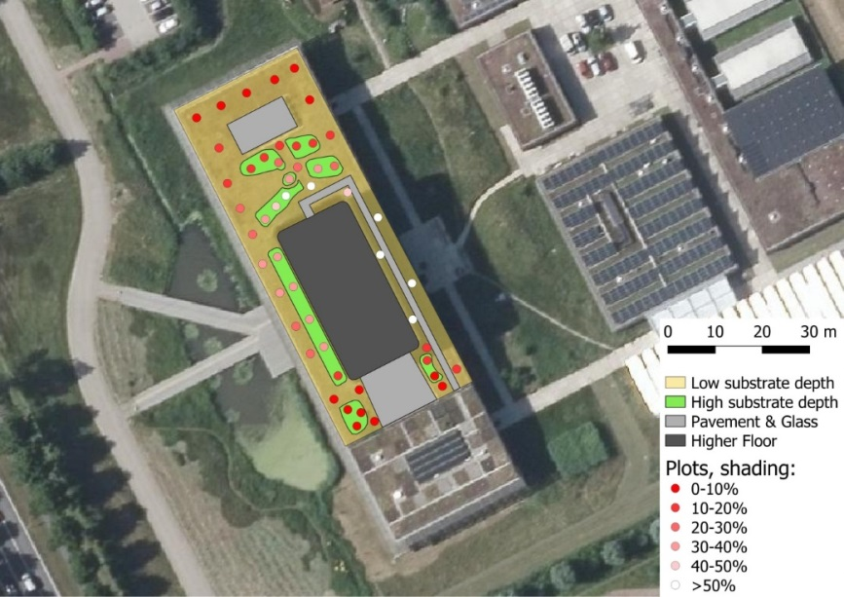
Figure 1 Satellite image of the studied green roof with plot locations. The red gradient depicts the percentage of daytime that plots were shaded throughout the year. Imagery source: beeldmateriaal.nl.
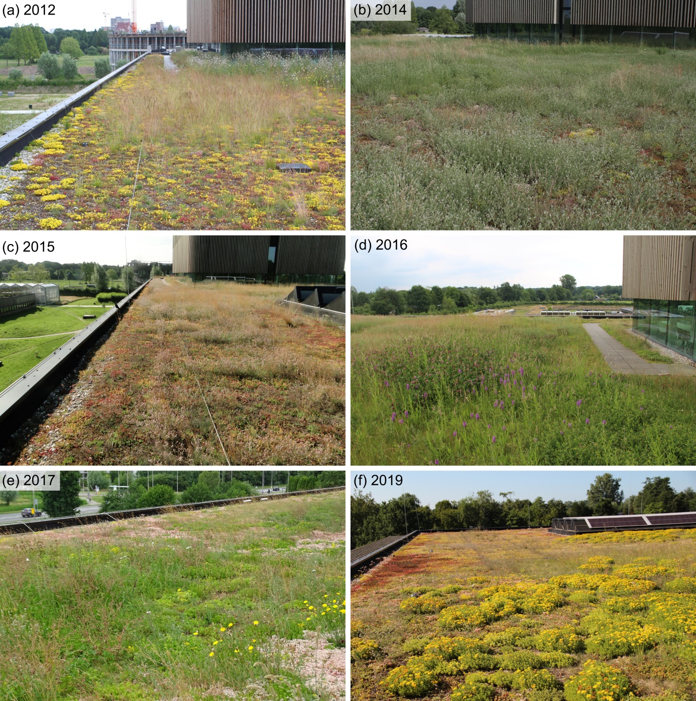
Figure 2 Vegetation on the roof throughout the years. Note the dominance of Sedum acre in 2012, dominance of Trifolium arvense in 2014, abundance of Dactylorhiza majalis in 2016 and dominance of Sedum kamtschaticum in 2019. Pictures by Gerdien Bos-Groenendijk (a, b), Henk-Jan van der Kolk (c) and Petra van den Berg (d, e, f).

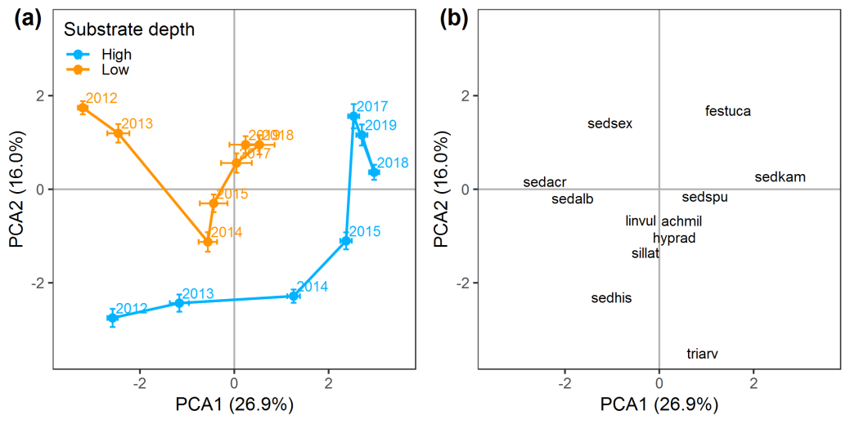
Figure 3 PCA sample plot (a) and species plot (b) showing vegetation development over the years in plots with high and low substrate depth. In (a) average of all plots (± SE) for high (n=21) and low (n=29) substrate depths are depicted. All plant species were included in the analysis but for visual reasons only in (b) the 12 species with the highest scores are depicted. achmil = Achillea millefolium, festuca = Festuca spec., hyprad = Hypochaeris radicata, linvul = Linaria vulgaris, sedacr = Sedum acre, sedalb = Sedum album, sedhis = Sedum hispanicum, sedkam = Sedum kamtschaticum, sedsex = Sedum sexangulare, sedspu = Sedum spurium, sillat = Silene latifolium, triarv = Trifolium arvense.

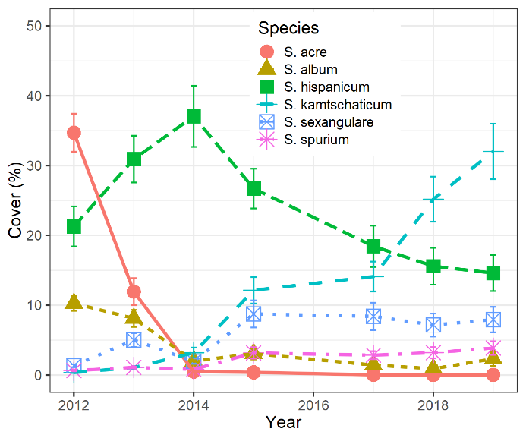
Figure 4 Changes in average cover in all plots (n=50) of the six dominant Sedum species in the eight years following roof construction.

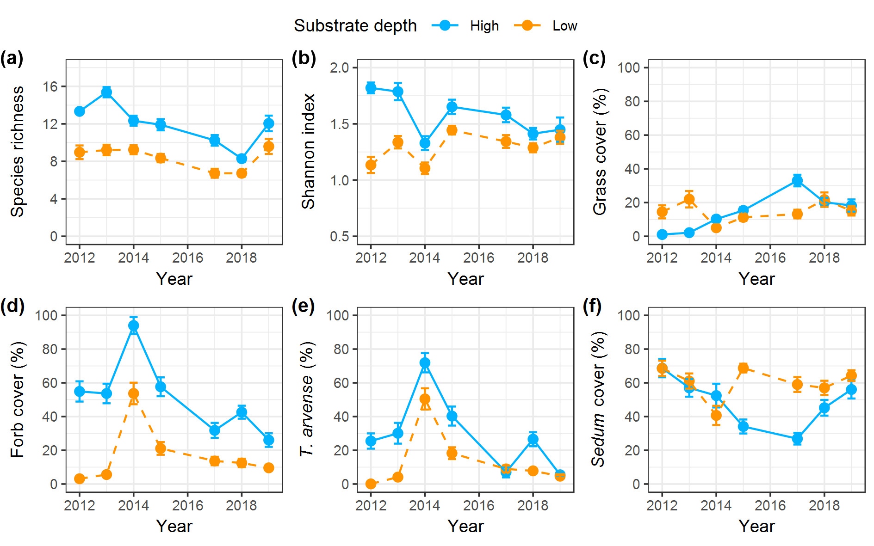
Figure 5 Development of species richness (a), Shannon diversity index (b), grass cover (c), forb cover (d), Trifolium arvense cover (e) and Sedum cover (f) in plots with high and low substrate depths. Means are shown (± SE).

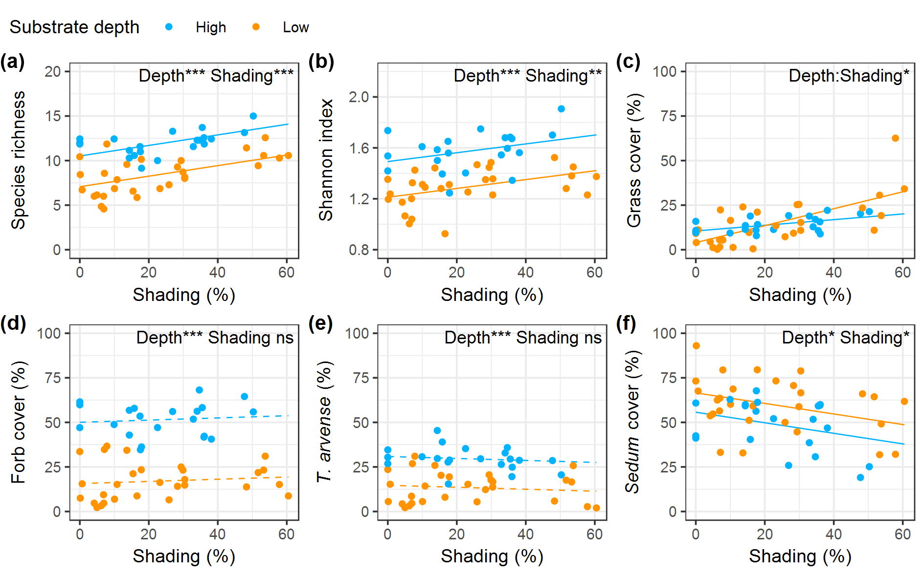
Figure 6 Effect of substrate depth and shading on species richness (a), Shannon diversity index (b), grass cover (c), forb cover (d), Trifolium arvense cover (e) and Sedum cover (f) in high and low plots. Every point is the mean value over all years of one plot (n=50). Results from statistical models testing the effects of substrate depth (Depth) and shading (Shading) are also presented. * = 0.01 ≤ P < 0.05, ** = 0.001 ≤ P<0.01, *** = P < 0.001; ns = not significant.

