Topsoil carbon stocks in urban green spaces of The Hague, the Netherlands

A.J. Kortleve, J.M. Mogollón, T.J. Heimovaara, J. Gebert

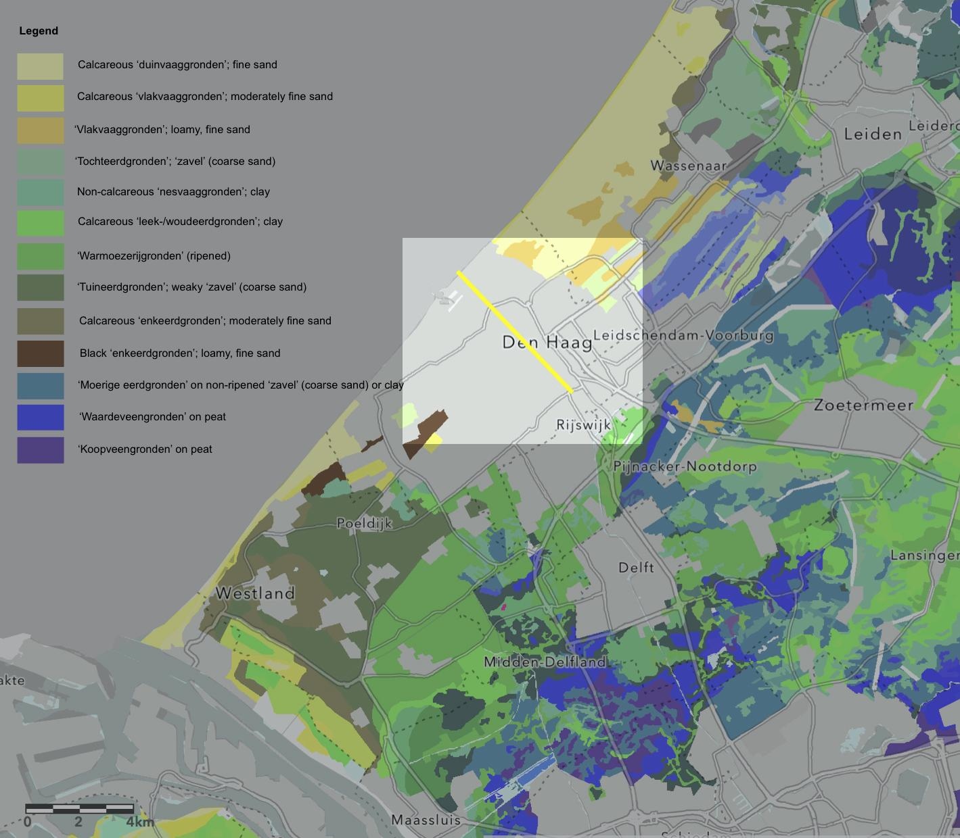
Fig. S1 Soil map of The Hague and surrounds (adapted from BRO, n.d.). Soil classification according to the Dutch soil classification system (De Bakker et al., 1989) (1:50,000 – 1:100,000). The yellow line represents the transect of Fig. 1

Table S1 Overview of each sample plot with their corresponding multi-faceted urban soil classification
Sample plot | Greenspace description | Urban soil classification
1 | Playground in between buildings | Sandy loam, slightly acidic, low to high contamination by heavy metals (Bhagirath, 2019 & 2020), approximately 900 m², with a shape of two adjacent rectangles, flat, surrounded by buildings, publicly owned but privately managed, insignificant from the historical and ecological perspective, but socially and aesthetically valuable.
2 | Two street trees (in poor condition) on small plot of grass | Loamy sand, neutral, low contamination by heavy metals and PAHs (Bhagirath, 2019 & 2020), approximately 20 m² and with a rectangular shape, flat, adjacent to open car park and pavement, publicly owned, insignificant from the historical and social perspective, with low ecologic and aesthetic value.
3 | Church surrounded by grass with chestnut trees | Loamy sand, neutral, no data on contamination levels, approximately 0.4 ha, with a rectangular shape, mildly hilly, surrounded by buildings on 2 sides and roads on the other two sides, publicly owned. The church itself has a high historical value, but the grass it is surrounded by appears to be only of social value. Combined, the greenspace has high aesthetic value but is of limited ecological value.
4 | Pond adjacent to a strip of trees on grass | Sandy loam, neutral, slightly contaminated with heavy metals and mineral oils (Ensing, 2017), approximately 0.2 ha, with an elongated rectangular shape, flat, surrounded by an unpaved path on one side and the main road on the other side, publicly owned. The pond has high historical value and combined, the pond and the greenspace are socially, aesthetically, and ecologically valuable.
5 | Horse chestnut tree (planted in 1880) | Loamy sand, neutral, no data on contamination levels, approximately 20 m², with a round shape, in the middle of an open square, flat, surrounded by buildings and roads, publicly owned, historically, socially and aesthetically valuable, with limited ecological value.
6 | Palace garden | Sandy loam, moderately acidic, slight contamination of the topsoil led to soil replacement in the playground area (Hopman, 2007), but no data on the contamination levels of the remaining soil, approximately 1 ha, with a rectangular shape, flat, surrounded by roads of three sides and stables with greenery on the other side, publicly owned, historically, aesthetically, socially and ecologically valuable.
7 | Shrubbery on the roadside (recently planted (between 2018 and 2020) | Sandy loam, slightly acidic, slightly contaminated by heavy metals (Haring, 2018), approximately 300 m², in a triangular shape, flat, next to a pond and the main road, publicly owned, insignificant from the historical and social perspective, but somewhat ecologically and aesthetically valuable.
8 | Row of 12 street trees | Sandy loam, neutral, no data on contamination levels, 12 rectangular patches of approximately 5 m², flat, next to a pond and the main road, publicly owned, insignificant from the historical or social perspectives, with some ecological and aesthetic value.
9 | Monument surrounded by 36 horse chestnut trees on plots of grass | Silt clay loam, moderately acidic, no data on contamination levels, 4 rectangles of 500 m², flat, surrounding the monument with a road in the middle, publicly owned, with high historical, ecological, aesthetical value, and somewhat socially valuable.
10 | Park with pond in the middle | Sandy loam, neutral, the soil was slightly contaminated with heavy metals and PAHs before construction (Gemeente Den Haag, 1993). The deeper soil (below 1.5 m) was regarded as uncontaminated and the report advised to keep it separate from the other soil to allow for unrestricted reuse of the material (Hoomweg, 1999).  More recently, the slight contamination of heavy metals (Zn, Hg, Pb) was confirmed by an investigation of soil adjacent to the park (Naussauplein) (Gaspar-Goetheer, 2016; Rodenburg, 2019). Currently, the Western part of the park is classified as ‘slightly contaminated’ while there is no data for the Eastern part of the park (Van der Made, 2016). Oval shape of approximately 1 ha, steep decline towards the pond, surrounded by buildings, publicly owned. The buildings have some historical value but the green itself not so much although it is used for ceremonial purposes sometimes. The park has low ecological value but is socially and aesthetically valuable.
11 | Plot of trees with shrubs within the premises of the Jewish cemetery | Sandy loam, strongly acidic, adjacent to the cemetery elevated levels of heavy metals (Hg, Pb, Cu) have been detected (Gaspar-Goetheer, 2016) and adjacent to the cemetery there is also a large plot of strongly contaminated soil (Van der Made, 2016), but no data on contamination levels of the cemetery itself were found. Approximately 1.6 ha and an irregular-shaped polygon, flat, surrounded by forest on two sides and roads on the other two, privately owned, ecologically, socially, aesthetically and historically valuable.
12 | Private park/ forest (since the 15th/16th century) | Sandy loam, extremely acidic, no data on contamination levels, approximately 27 ha with a square shape, mildly hilly, surrounded by roads and forests, privately owned, ecologically, socially, aesthetically and historically valuable.
13 | Urban forest, since 1100-1400 but many trees replaced mid 20th century | Sandy loam, very strongly acidic, no data on contamination levels, approximately 111 ha (including sample plots 14 & 15) with a rectangular shape, hilly, surrounded by roads and forest, publicly owned, with limited historical value, but ecologically, socially and aesthetically valuable.
14 | Urban forest, since 1100-1400 but many trees replaced mid 20th century | Sandy loam, slightly acidic, the soil directly next to the bike lanes contained slightly elevated levels of heavy metals (Riemens, 2018), but no data on contamination levels of the remaining soil, approximately 111 ha (including sample plots 13 & 15) with a rectangular shape, hilly, surrounded by roads and forest, publicly owned, with limited historical value, but ecologically, socially and aesthetically valuable.
15 | Urban forest, since 1100-1400 but many trees replaced mid 20th century | Sandy loam, strongly acidic, no data on contamination levels, approximately 111 ha (including sample plots 13 & 14) with a rectangular shape, very steep decline towards the lake, surrounded by roads and forest, publicly owned, with limited historical value, but ecologically, socially and aesthetically valuable.
16 | Large roundabout with trees on grass | Loamy sand, slightly acidic, the subsoil consists of a debris-containing layer mixed with sand which is slightly contaminated with Pb (van den Heuvel, 2016), no data on the contamination levels of the topsoil, approximately 300 m², circular-shaped, flat, surrounded by roads, publicly owned, insignificant from the historical and social perspective, with limited ecological and aesthetic value.
17 | Street trees on strips of grass | Loamy sand, neutral, not-to-slightly contaminated by heavy metals (Smit, 2009), approximately 0.2 ha, narrow-rectangularly shaped, flat, surrounded by roads on all sides, publicly owned, insignificant from the historical and social perspective, but aesthetically and ecologically valuable.
18 | Plot of shrubs on pavement | Sandy loam, neutral, the topsoil is not contaminated but the subsoil is slightly contaminated by heavy metals (van der Bijl, 2013), approximately 0.1 ha, triangularly shaped, flat, surrounded by buildings on 2 sides and a pavement on the other side, privately owned, insignificant from the historical and social perspective, with limited aesthetic and ecological value.
19 | Park on top of a hill | Sandy loam, slightly acidic, no data on contamination levels, approximately 8 ha, irregularly shaped polygon, hilly, surrounded by roads and buildings, historically, aesthetically and ecologically valuable, but of limited social value due to its neglected management.
20 | Plot of shrubs on pavement | Sandy loam, slightly acidic, no data on contamination levels, three rectangular plots of approximately 0.1 ha, flat, surrounded by buildings, publicly owned, insignificant from the social and historical perspective, with limited aesthetic and ecological value.
21 | Plot of trees with shrubbery in between buildings | Silty loam, slightly acidic, slight contamination by heavy metals has been detected around the greenspace (not measured inside the greenspace) (Smit, 2015), rectangular plot of 300 m², flat, surrounded by buildings, privately owned, insignificant from the historic, social and ecological perspective, with some aesthetic value.
22 | Shrubs and trees surrounding a paved playground | Loamy sand, neutral, not contaminated (van der Bijl, 2011), but much rubbish detected in and on the soil, 2 rectangular strips of 300 m² each, flat, surrounding the paved playground with roads on the other sides, publicly owned, insignificant from the historic perspective, with limited aesthetical, ecological, and social value.
23 | Playground on field of grass with a couple of young, newly planted trees | Silt clay loam, neutral, suspected to be contaminated with heavy metals and PAHs but this suspicion has not been confirmed by lab analysis (Bouw, 2006), rectangular shape of 0.13 ha, flat, surrounded by buildings on 3 sides and a road on the other side, publicly owned, insignificant from the historical perspective, with limited ecological and aesthetic value, but socially valuable.
24 | Playground in dunes | Sand, neutral, no data on contamination levels, circle of approximately 0.2 ha, mildly hilly, surrounded by roads, publicly owned, insignificant from the historical perspective, but ecologically, aesthetically and socially valuable.
25 | Dune thickets | Sand, moderately alkaline, no data on contamination levels, rectangle of approximately 200 m², hilly, surrounded by roads, publicly owned, insignificant from the historical and social perspective, but aesthetically and ecologically valuable.

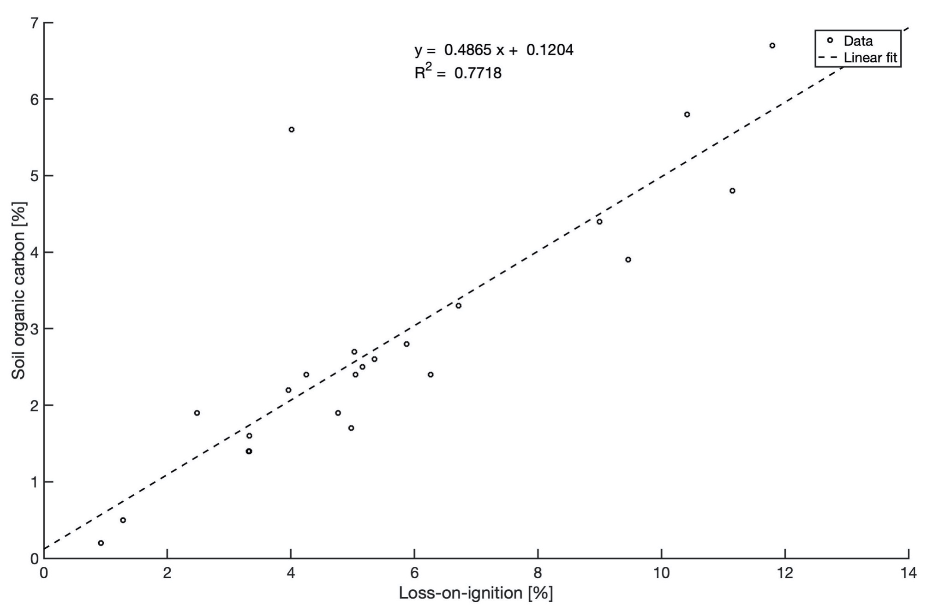
Fig. S2 The relationship between loss-on-ignition (LOI) and SOC in 25 urban soil samples

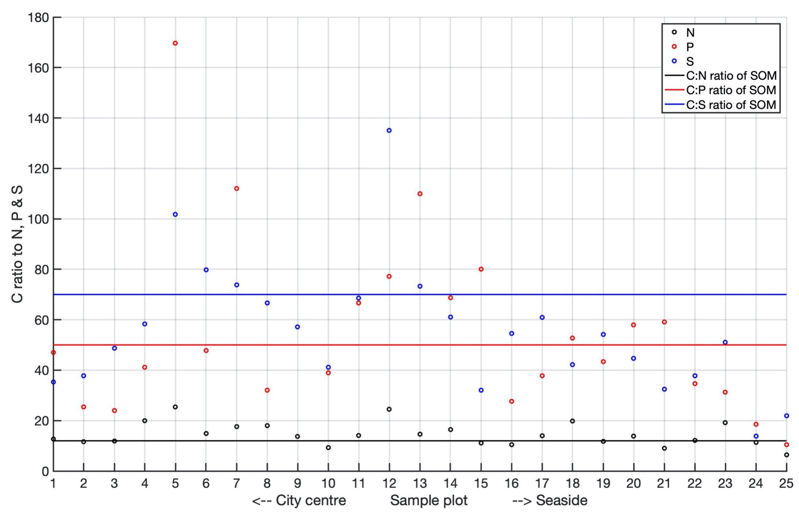
Fig. S3 C:N:P:S ratio of the sampled soil along the transect in relation to the C:N:P:S of SOM according to Kirkby et al. (2011)

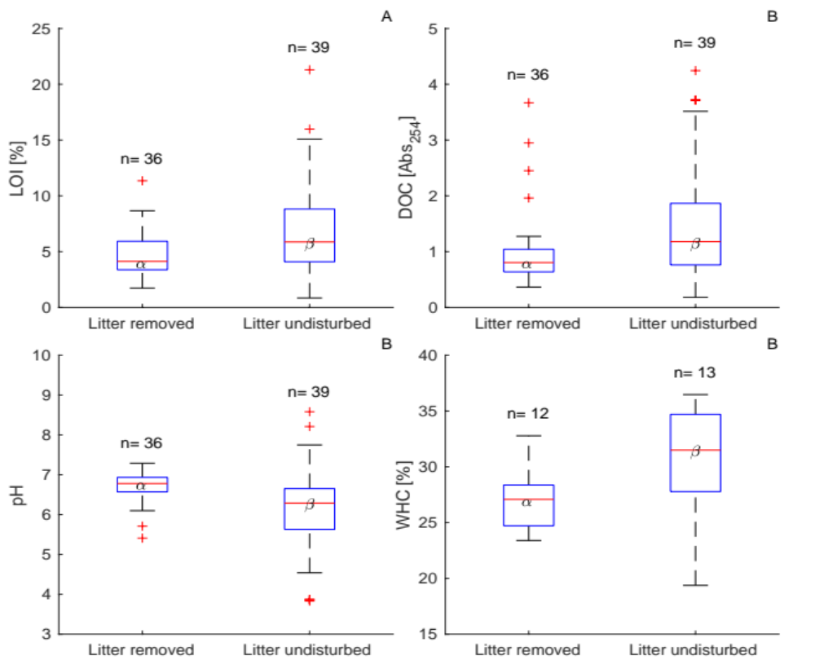
Fig. S4 Variability of loss-on-ignition (LOI; A), DOC (B), pH (C) and the water-holding capacity (WHC) of the soil (D) in dependency of litter management. Line = median, box = first and third quartiles, whiskers = highest and lowest data points excluding outliers (plus signs). α, β = indication of statistical similarity or difference.

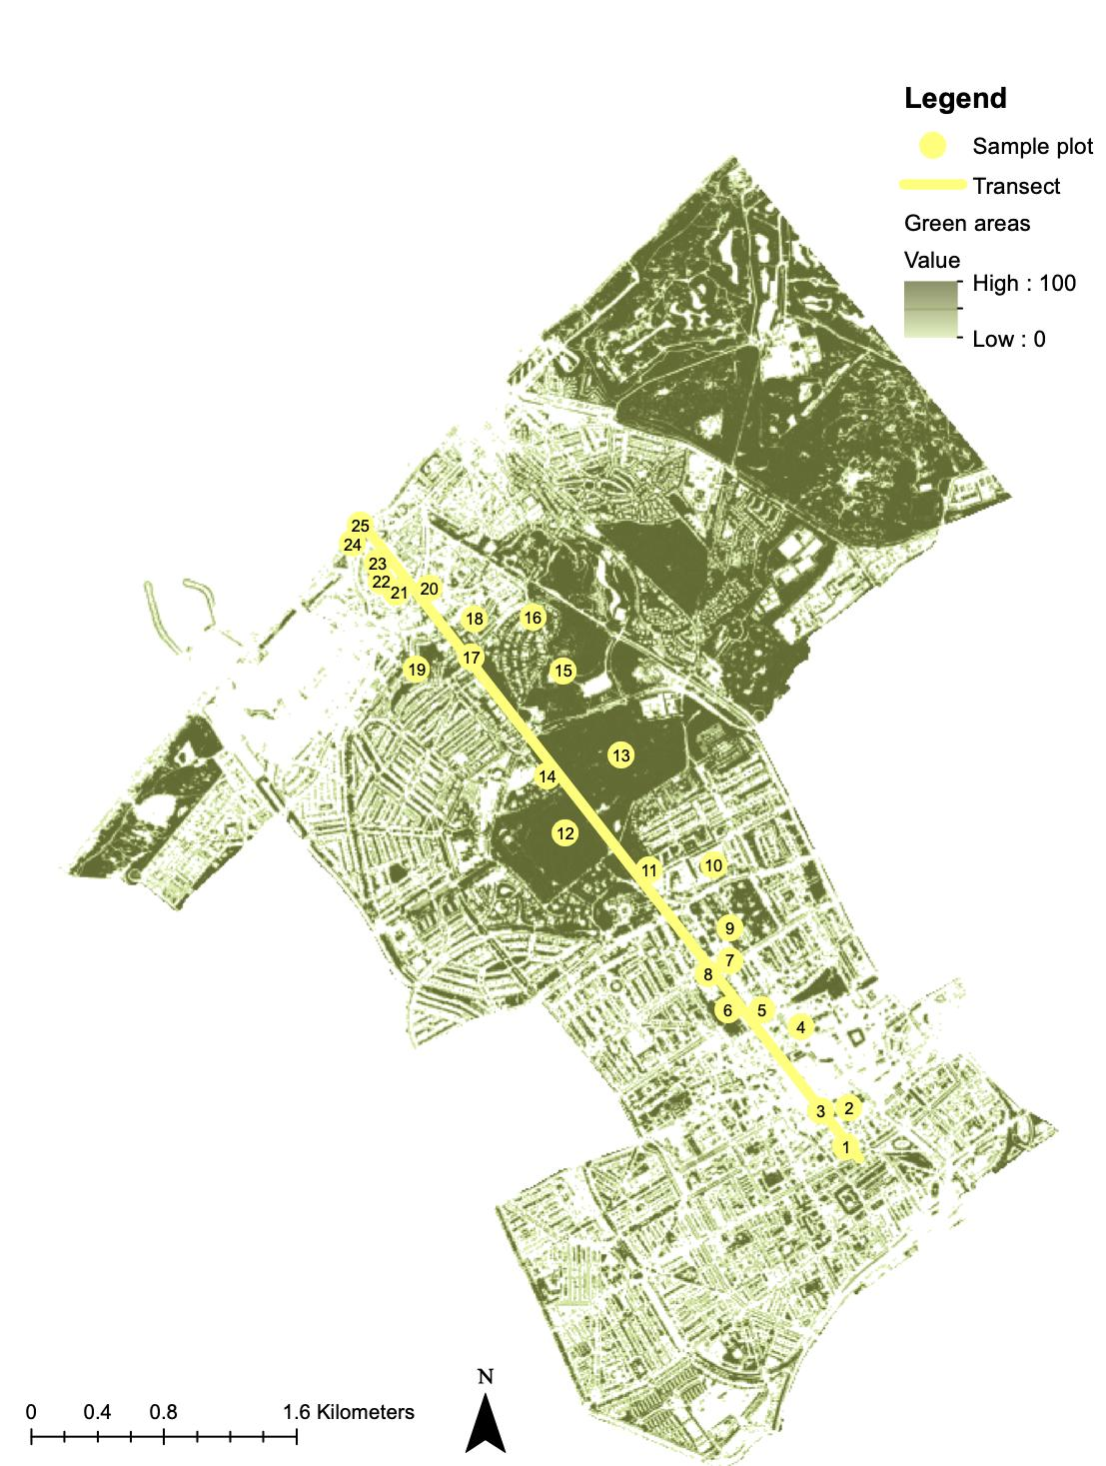
Fig. S5 Green surface area map of The Hague’s districts ‘Centre’ and ‘Scheveningen’ (based on RIVM, 2017)

Table S2 Overview of all soil parameters for each sample plot (n = 25). Soil parameters that were measured at the each individual sample site (A, B, C) are recorded as well as soil parameters that were measured from the mixed sample (mix of sample sites). For SOC_{min_TOP} and SOC_{deg} replicas were taken of the mixed sample which are both recorded in the cell.
Sample plot | Sample site | LOI  [%] | SOC [%] | Total C  [%] | CaCO₃  [g kg_{DW}⁻¹] | BD  [g cm⁻³] | N  [mg kg_{DW}⁻¹] | P  [mg kg_{DW}⁻¹] | S  [mg kg_{DW}⁻¹] | Clay [%] | DOC [Abs₂₅₄] | WHC [%] | pH | EC  [μS cm^{-1]} | SOC_{min_TOP} [mg C m⁻² day⁻¹] | SOC_{deg} [mg C g_{SOC}⁻¹]
1 | A | 3.7 | 2.4 | 2.5 | 13 | 1.0 | 1900 | 510 | 680 | 12 | 49 | 28 | 6.28 | 64 | 2.4  1.9 | 0.4  0.3
1 | B | 6.1 | 2.4 | 2.5 | 13 | 1.7 |  |  |  |  | 67 | 28 | 6.57 | 57 | 2.4  1.9 | 0.4  0.3
1 | C | 5.4 | 2.4 | 2.5 | 13 | 1.2 |  |  |  |  | 70 | 28 | 6.78 | 71 | 2.4  1.9 | 0.4  0.3
2 | A | 3.9 | 1.4 | 1.8 | 22 | 1.7 | 1200 | 550 | 370 | 6.5 | 55 | 24 | 6.78 | 251 | 1.8  1.9 | 0.7  0.7
2 | B | 3.4 | 1.4 | 1.8 | 22 | 1.6 |  |  |  |  | 61 | 24 | 7.12 | 88 | 1.8  1.9 | 0.7  0.7
2 | C | 2.6 | 1.4 | 1.8 | 22 | 1.7 |  |  |  |  | 85 | 24 | 6.86 | 121 | 1.8  1.9 | 0.7  0.7
3 | A | 4.0 | 1.9 | 2.2 | 17 | 1.6 | 1600 | 790 | 390 | 6.5 | 64 | 25 | 7.29 | 95 | 1.3  1.2 | 0.4  0.3
3 | B | 3.4 | 1.9 | 2.2 | 17 | 1.5 |  |  |  |  | 45 | 25 | 7.2 | 69 | 1.3  1.2 | 0.4  0.3
3 | C | 6.9 | 1.9 | 2.2 | 17 | 1.6 |  |  |  |  | 99 | 25 | 6.78 | 127 | 1.3  1.2 | 0.4  0.3
4 | A | 5.4 | 2.8 | 3.1 | 22 | 1.6 | 1400 | 680 | 480 | 4 | 79 | 28 | 6.91 | 87 | 2.0  1.6 | 0.4  0.3
4 | B | 6.4 | 2.8 | 3.1 | 22 | 1.5 |  |  |  |  | 82 | 28 | 7.12 | 113 | 2.0  1.6 | 0.4  0.3
4 | C | 5.9 | 2.8 | 3.1 | 22 | 1.3 |  |  |  |  | 73 | 28 | 6.86 | 81 | 2.0  1.6 | 0.4  0.3
5 | A | 4.2 | 5.6 | 5.6 | 2.9 | 1.0 | 2200 | 330 | 550 | 6.5 | 60 | 26 | 6.65 | 127 | 3.1  3.2 | 0.2  0.2
5 | B | 4.4 | 5.6 | 5.6 | 2.9 | 1.1 |  |  |  |  | 52 | 26 | 6.57 | 145 | 3.1  3.2 | 0.2  0.2
5 | C | 3.5 | 5.6 | 5.6 | 2.9 | 1.3 |  |  |  |  | 56 | 26 | 6.61 | 91 | 3.1  3.2 | 0.2  0.2
6 | A | 9.2 | 6.7 | 6.6 | 0.1 | 1.3 | 4500 | 1400 | 840 | 14.5 | 101 | 36 | 5.59 | 134 | 4.0  3.7 | 0.2  0.2
6 | B | 15.1 | 6.7 | 6.6 | 0.1 | 1.2 |  |  |  |  | 299 | 36 | 6.19 | 128 | 4.0  3.7 | 0.2  0.2
6 | C | 11.1 | 6.7 | 6.6 | 0.1 | 1.1 |  |  |  |  | 131 | 36 | 6.23 | 120 | 4.0  3.7 | 0.2  0.2
7 | A | 8.0 | 6.5 | 7.2 | 16 | 1.3 | 3700 | 580 | 880 | 4 | 135 | 34 | 6.61 | 125 | 6.1  5.8 | 0.3  0.3
7 | B | 8.7 | 6.5 | 7.2 | 16 | 1.3 |  |  |  |  | 124 | 34 | 6.83 | 161 | 6.1  5.8 | 0.3  0.3
7 | C | 21.3 | 6.5 | 7.2 | 16 | 0.8 |  |  |  |  | 343 | 34 | 5.93 | 195 | 6.1  5.8 | 0.3  0.3
8 | A | 3.4 | 1.6 | 1.7 | 9 | 1.5 | 890 | 500 | 240 | 4 | 41 | 26 | 6.53 | 59 | 1.6  1.7 | 0.5  0.5
8 | B | 2.9 | 1.6 | 1.7 | 9 | 1.2 |  |  |  |  | 30 | 26 | 6.87 | 82 | 1.6  1.7 | 0.5  0.5
8 | C | 3.7 | 1.6 | 1.7 | 9 | 1.4 |  |  |  |  | 30 | 26 | 6.66 | 89 | 1.6  1.7 | 0.5  0.5
9 | A | 7.0 | 4.4 | 4.4 | 0.1 | 1.3 | 3200 | 770 | 770 | 37.5 | 196 | 33 | 6.1 | 100 | 4.2  2.3 | 0.4  0.3
9 | B | 11.4 | 4.4 | 4.4 | 0.1 | 1.2 |  |  |  |  | 156 | 33 | 5.71 | 61 | 4.2  2.3 | 0.4  0.3
9 | C | 8.7 | 4.4 | 4.4 | 0.1 | 1.3 |  |  |  |  | 237 | 33 | 5.41 | 75 | 4.2  2.3 | 0.4  0.3
10 | A | 2.9 | 1.4 | 1.5 | 9.6 | 1.6 | 1500 | 360 | 340 | 14.5 | 60 | 31 | 6.87 | 75 | 1.5  1.4 | 0.5  0.5
10 | B | 3.4 | 1.4 | 1.5 | 9.6 | 1.6 |  |  |  |  | 89 | 31 | 6.79 | 65 | 1.5  1.4 | 0.5  0.5
10 | C | 3.7 | 1.4 | 1.5 | 9.6 | 1.4 |  |  |  |  | 38 | 31 | 6.91 | 132 | 1.5  1.4 | 0.5  0.5
11 | A | 4.9 | 2.4 | 2.5 | 0.1 | 0.6 | 1700 | 360 | 350 | 4 | 128 | 30 | 5.89 | 49 | 4.0  4.0 | 0.4  0.4
11 | B | 4.1 | 2.4 | 2.5 | 0.1 | 0.5 |  |  |  |  | 91 | 30 | 4.81 | 32 | 4.0  4.0 | 0.4  0.4
11 | C | 3.8 | 2.4 | 2.5 | 0.1 | 0.9 |  |  |  |  | 130 | 30 | 4.77 | 41 | 4.0  4.0 | 0.4  0.4
12 | A | 4.4 | 2.7 | 2.7 | 0.1 | 0.6 | 1100 | 350 | 200 | 4 | 152 | 34 | 3.87 | 50 | 5.2  7.7 | 0.3  0.5
12 | B | 4.1 | 2.7 | 2.7 | 0.1 | 0.5 |  |  |  |  | 158 | 34 | 3.87 | 50 | 5.2  7.7 | 0.3  0.5
12 | C | 6.6 | 2.7 | 2.7 | 0.1 | 0.4 |  |  |  |  | 227 | 34 | 3.83 | 68 | 5.2  7.7 | 0.3  0.5
13 | A | 5.3 | 2.2 | 2.2 | 0.1 | 1.2 | 1500 | 200 | 300 | 4 | 136 | 28 | 5.59 | 60 | 2.6  2.1 | 0.5  0.4
13 | B | 4.8 | 2.2 | 2.2 | 0.1 | 1.1 |  |  |  |  | 194 | 28 | 4.73 | 43 | 2.6  2.1 | 0.5  0.4
13 | C | 1.8 | 2.2 | 2.2 | 0.1 | 1.3 |  |  |  |  | 66 | 28 | 4.56 | 37 | 2.6  2.1 | 0.5  0.4
14 | A | 8.8 | 3.3 | 3.8 | 25 | 0.7 | 2000 | 480 | 540 | 4 | 45 | 31 | 6.21 | 86 | 3.3  3.5 | 0.3  0.3
14 | B | 5.4 | 3.3 | 3.8 | 25 | 0.8 |  |  |  |  | 78 | 31 | 6.66 | 112 | 3.3  3.5 | 0.3  0.3
14 | C | 5.9 | 3.3 | 3.8 | 25 | 1.1 |  |  |  |  | 58 | 31 | 6.63 | 88 | 3.3  3.5 | 0.3  0.3
15 | A | 10.1 | 4.8 | 5.0 | 2.5 | 0.9 | 4300 | 600 | 1500 | 10 | 121 | 35 | 6.42 | 117 | 6.5  6.3 | 0.3  0.3
15 | B | 8.8 | 4.8 | 5.0 | 2.5 | 0.3 |  |  |  |  | 247 | 35 | 4.54 | 76 | 6.5  6.3 | 0.3  0.3
15 | C | 14.6 | 4.8 | 5.0 | 2.5 | 1.0 |  |  |  |  | 283 | 35 | 5.75 | 112 | 6.5  6.3 | 0.3  0.3
16 | A | 5.4 | 2.4 | 2.6 | 5.4 | 1.4 | 2300 | 870 | 440 | 2.5 | 86 | 28 | 6.17 | 87 | 1.7  1.4 | 0.3  0.3
16 | B | 6.3 | 2.4 | 2.6 | 5.4 | 1.4 |  |  |  |  | 296 | 28 | 6.21 | 74 | 1.7  1.4 | 0.3  0.3
16 | C | 7.0 | 2.4 | 2.6 | 5.4 | 1.3 |  |  |  |  | 296 | 28 | 6.29 | 62 | 1.7  1.4 | 0.3  0.3
17 | A | 3.2 | 1.4 | 2.1 | 67 | 1.6 | 1000 | 370 | 230 | 6.5 | 56 | 23 | 7.04 | 97 | 2.0  2.4 | 0.6  0.7
17 | B | 2.2 | 1.4 | 2.1 | 67 | 1.6 |  |  |  |  | 43 | 23 | 7 | 90 | 2.0  2.4 | 0.6  0.7
17 | C | 4.6 | 1.4 | 2.1 | 67 | 0.9 |  |  |  |  | 68 | 23 | 7.08 | 88 | 2.0  2.4 | 0.6  0.7
18 | A | 1.7 | 1.9 | 2.0 | 40 | 1.4 | 960 | 360 | 450 | 2.5 | 30 | 24 | 6.96 | 57 | 2.2  1.7 | 0.5  0.4
18 | B | 3.6 | 1.9 | 2.0 | 40 | 1.3 |  |  |  |  | 45 | 24 | 6.75 | 56 | 2.2  1.7 | 0.5  0.4
18 | C | 2.1 | 1.9 | 2.0 | 40 | 1.2 |  |  |  |  | 25 | 24 | 7.12 | 67 | 2.2  1.7 | 0.5  0.4
19 | A | 4.4 | 2.6 | 2.6 | 1.5 | 1.4 | 2200 | 600 | 480 | 4 | 46 | 30 | 6.46 | 112 | 1.2  2.9 | 0.2  0.5
19 | B | 6.5 | 2.6 | 2.6 | 1.5 | 1.3 |  |  |  |  | 57 | 30 | 6.25 | 88 | 1.2  2.9 | 0.2  0.5
19 | C | 5.2 | 2.6 | 2.6 | 1.5 | 1.1 |  |  |  |  | 88 | 30 | 6 | 94 | 1.2  2.9 | 0.2  0.5
20 | A | 12.3 | 5.8 | 5.7 | 4.5 | 1.2 | 4200 | 1000 | 1300 | 4 | 107 | 36 | 6.54 | 140 | 2.5  2.5 | 0.2  0.2
20 | B | 6.0 | 5.8 | 5.7 | 4.5 | 1.3 |  |  |  |  | 81 | 36 | 6.34 | 88 | 2.5  2.5 | 0.2  0.2
20 | C | 12.9 | 5.8 | 5.7 | 4.5 | 1.1 |  |  |  |  | 156 | 36 | 6.29 | 123 | 2.5  2.5 | 0.2  0.2
21 | A | 5.9 | 3.9 | 3.9 | 6.9 | 1.3 | 4300 | 660 | 1200 | 23.5 | 56 | 35 | 6.71 | 71 | 3.7  3.9 | 0.4  0.4
21 | B | 16.0 | 3.9 | 3.9 | 6.9 | 1.0 |  |  |  |  | 300 | 35 | 6.04 | 131 | 3.7  3.9 | 0.4  0.4
21 | C | 6.5 | 3.9 | 3.9 | 6.9 | 1.2 |  |  |  |  | 64 | 35 | 6.29 | 66 | 3.7  3.9 | 0.4  0.4
22 | A | 5.9 | 1.7 | 2.2 | 16 | 1.3 | 1400 | 490 | 450 | 2.5 | 89 | 27 | 6.42 | 72 | 1.5  1.6 | 0.4  0.4
22 | B | 4.1 | 1.7 | 2.2 | 16 | 1.4 |  |  |  |  | 63 | 27 | 6.63 | 86 | 1.5  1.6 | 0.4  0.4
22 | C | 4.9 | 1.7 | 2.2 | 16 | 1.1 |  |  |  |  | 72 | 27 | 6.88 | 148 | 1.5  1.6 | 0.4  0.4
23 | A | 5.1 | 2.5 | 2.8 | 15 | 1.5 | 1300 | 800 | 490 | 21 | 75 | 29 | 6.83 | 88 | 2.2  1.9 | 0.4  0.3
23 | B | 6.0 | 2.5 | 2.8 | 15 | 1.4 |  |  |  |  | 72 | 29 | 6.71 | 92 | 2.2  1.9 | 0.4  0.3
23 | C | 4.3 | 2.5 | 2.8 | 15 | 1.3 |  |  |  |  | 56 | 29 | 6.7 | 72 | 2.2  1.9 | 0.4  0.3
24 | A | 1.5 | 0.5 | 0.8 | 24 | 1.4 | 440 | 270 | 360 | 2.5 | 29 | 20 | 6.95 | 59 | 1.1  1.0 | 1.0  1.0
24 | B | 1.1 | 0.5 | 0.8 | 24 | 1.6 |  |  |  |  | 17 | 20 | 7.17 | 53 | 1.1  1.0 | 1.0  1.0
24 | C | 1.2 | 0.5 | 0.8 | 24 | 1.3 |  |  |  |  | 24 | 20 | 7.21 | 51 | 1.1  1.0 | 1.0  1.0
25 | A | 0.9 | 0.2 | 0.7 | 41 | 1.8 | 310 | 190 | 91 | 2.5 | 18 | 19 | 7.75 | 63 | 1.1  0.8 | 2.9  2.1
25 | B | 0.8 | 0.2 | 0.7 | 41 | 1.7 |  |  |  |  | 13 | 19 | 8.21 | 59 | 1.1  0.8 | 2.9  2.1
25 | C | 1.0 | 0.2 | 0.7 | 41 | 1.4 |  |  |  |  | 10 | 19 | 8.58 | 55 | 1.1  0.8 | 2.9  2.1

References

Bhagirath, R. (2019). Milieuhygiënisch vooronderzoek. Zuidwal deelplan B (wijk 14) te Den Haag. DSB/OG.

Bhagirath, R. (2020). Verkennend en nader bodem- en asbestonderzoek. Zuidwal deelplan B (wijk 14) te Den Haag. DSB/OG.

Bouw, J.W. (2006). Historisch onderzoek Adriaan Coenenstraat te Den Haag. Dienst stedelijke ontwikkeling.

Ensing, L.H. (2017). Verkennend bodemonderzoek: ORAC’s wijk Voorhout (wijk 12) te Den Haag. ATKB.

Gaspar-Goetheer, M.E.C. (2016). Verkennend en aanvullend bodemonderzoek: Plaatsing Ondergrondse afvalcontainers (ORAC) Archipelbuurt, Wijk 46 te Den Haag. Geofoxx milieu expertise.

Gemeente Den Haag. (1993). Historisch onderzoek. Lokatie: Burgemeester de Monchyplein. Hoofdafdeling Bodem en Water.

Haring, O. (2018). Verkennend bodemonderzoek: Groot Onderhoud Amaliastraat Den Haag. Ingenieursbureau Land.

Hoomweg, M. (1999). Bodemkwaliteitsonderzoek. Locatie Burgemeester De Monchyplein. Ingenieursbureau Den Haag, Civiele Techniek en Milieu.

Hopman, L. (2007). Analyses raport Paleistuinen. AL Control Laboraties.

Kirkby, C. A., Kirkegaard, J. A., Richardson, A. E., Wade, L. J., Blanchard, C., & Batten, G. (2011). Stable soil organic matter: a comparison of C: N: P: S ratios in Australian and other world soils. Geoderma, 163(3-4), 197-208.

Riemens, A. (2018). Rapportage in-situ partijkeuring grond ter plaatse van ‘fietspad’ Scheveningse Weg te Den Haag. Van der Helm milieubeheer.

RIVM. (2017). Groenkaart van Nederland. Retrieved 01/10/2020 from https://www.atlasleefomgeving.nl//kaarten?config=3ef897de-127f-471a-959b-93b7597de188&gm-x=150000&gm-y=455000&gm-z=3&gm-b=1544180834512,true,1%3B1544725575974,true,0.8%3B&activateOnStart=layermanager,info

Rodenburg, M. (2019). Verkennend milieukundig (asbest)bodemonderzoek Nassauplein (ORAC CE-01) te Den Haag. Van Der Helm Milieubeheer.

Smit, P. (2009). Verkennend bodemonderzoek Scheveningseweg te Den Haag. Ingenieursbureau Den Haag, Afdeling Realisatie & Techniek, team Mileu.

Smit, P. (2015). Verkennend en nader bodemonderzoek Oud Scheveningen fase 2 te Den Haag. Ingenieursbureau Den Haag Afdeling Milieu.

van den Heuvel, B. (2016). Aanvullend grondonderzoek: Van Stolkweg 35 te Den Haag. ATKB.

van der Bijl, M. (2011). Oriënterend onderzoek Dr. De Visserplein 58-66 te Den Haag. ATKB.

van der Bijl, M. (2013). Verkennend en nader bodemonderzoek ORAC buurt 04 Visserijbuurt te Den Haag. Ingenieursbureau Den Haag, afdeling Milieu.

van der Made, E. (2016). Historisch vooronderzoek: Archipelbuurt te Den Haag (wijk 46, ORAC). Geofoxx milieu expertise.

