Supplementary Material C – Time Series Plots
This section contains time series plots for invertebrate abundance (Figure C1), invertebrate richness (Figure C2), bird abundance (Figure C3) and bird richness (Figure C4) and related floral measurements and model output for all rooftops. Complete regression model output for invertebrate and bird abundance versus floral abundance (Figure C5) and richness (Figure C6) is provided in Table C7. Each model was run as a separate model with a single explanatory variable since floral abundance and diversity were also highly collinear (p<0.001). The reference site was only sampled twice before the roof was built and with one-year in-between sampling efforts.

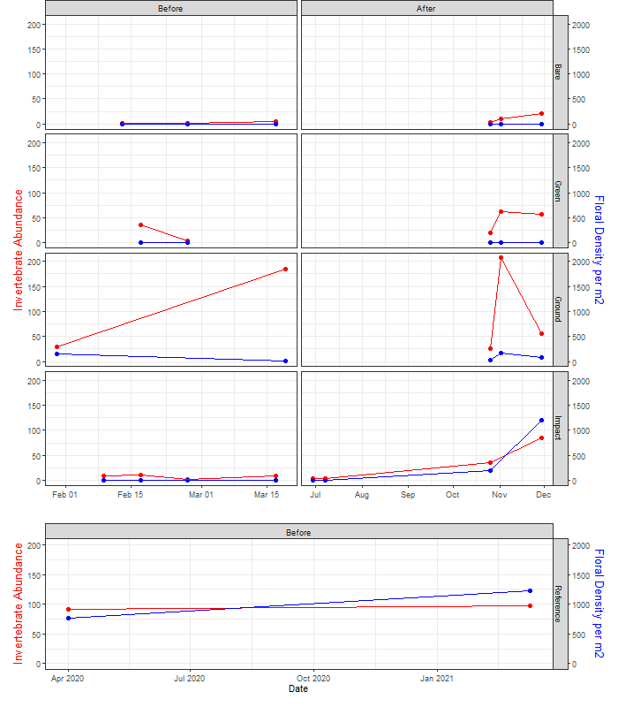
2020
2021

Figure C1. Invertebrate and floral abundance through time for each roof.

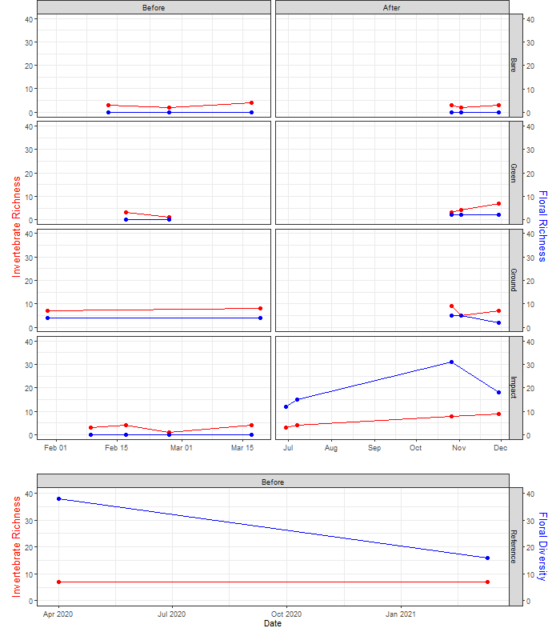
2020
2021

Figure C2. Invertebrate and floral richness through time for each roof.

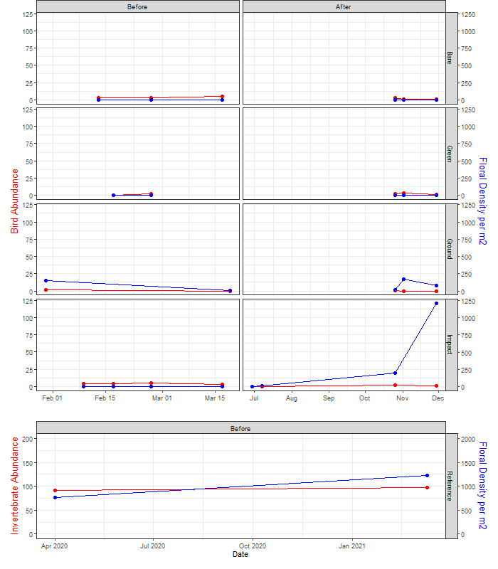
2020
2021

Figure C3. Bird and floral abundance through time for each roof.

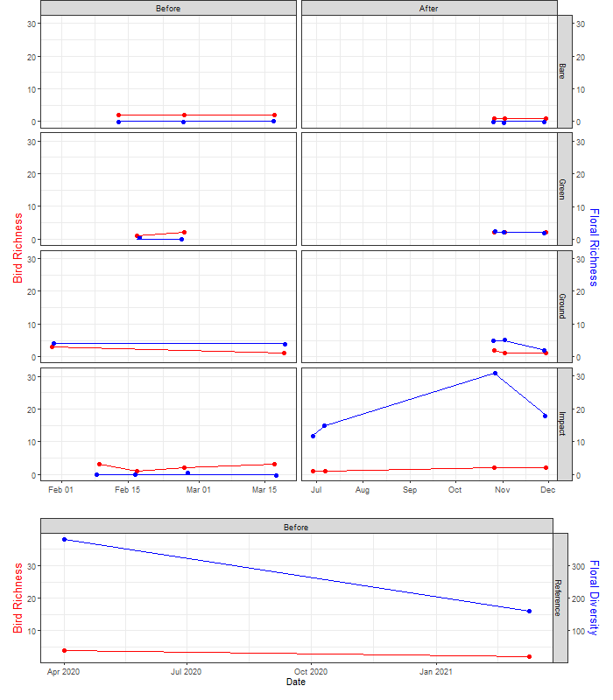
2020
2021

Figure C4. Bird and floral richness through time for each roof.

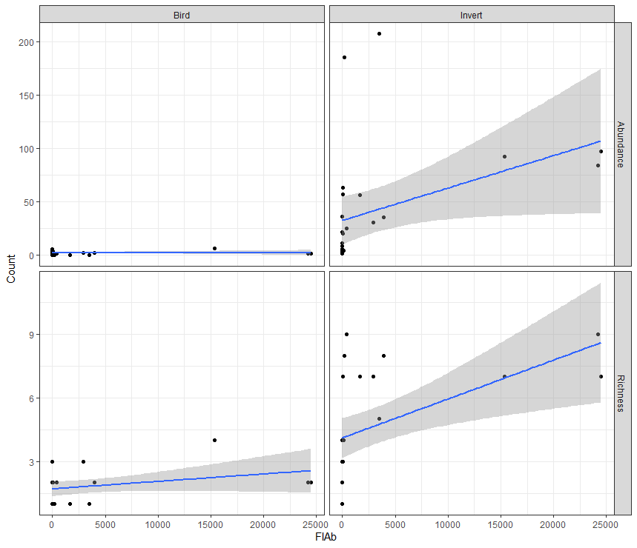

Figure C5. Invertebrate abundance (A), bird abundance (B), bird richness (C) and invertebrate richness (D) versus floral abundance across all sites

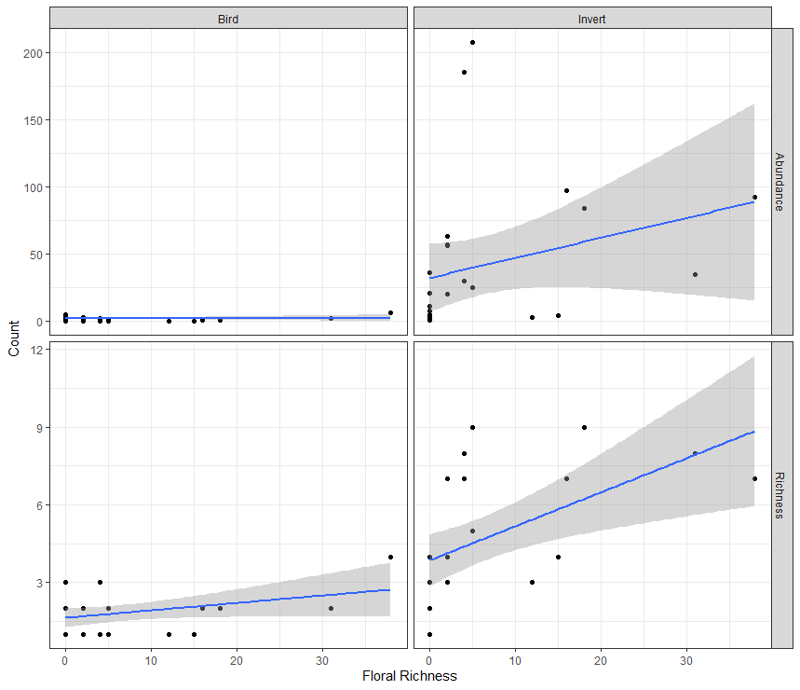

Figure C6. Invertebrate abundance (A), bird abundance (B), bird richness (C) and invertebrate richness (D) versus floral richness across all sites

Table C7. Model output for each of the richness and abundance models for a) the impact site alone, and b) all sites combined.
‘Invert’ refers to invertebrates; ‘Abund’ refers to abundance. Invertebrate and Bird abundance was modelled using a Poisson distribution, with a z-statistic and richness was modelled using a Gaussian distribution with a t-statistic.
Response | Effect | Estimate | Std. | test-statistic | p-value
- Impact Site
Invert Abund | (Intercept) | 2.29 | 0.13 | 17.63 | <2e-16***
 | Flower Density | 0.018 | 0.001 | 12.79 | <2e-16***
Invert Abund | (Intercept) | 2.07 | 0.15 | 13.67 | <2e-16***
 | Flower Richness | 0.07 | 0.01 | 8.95 | <2e-16***
Invert Richness | (Intercept) | 3.75 | 0.830 | 4.515 | 0.0063**
 | Flower Density | 0.048 | 0.018 | 2.673 | 0.044*
Invert Richness | (Intercept) | 2.78 | 0.88 | 3.16 | 0.02*
 | Flower Richness | 0.20 | 0.07 | 2.93 | 0.03*
Bird Abund | (Intercept) | 0.97 | 0.24 | 4.03 | 5.55e-05
 | Flower Density | -0.01 | 0.01 | -0.98 | 0.33
Bird Abund | (Intercept) | 1.28 | 0.26 | 4.90 | 9.62E-07***
 | Flower Richness | -0.07 | 0.03 | -2.11 | 0.04*
Bird Richness | (Intercept) | 1.85 | 0.35 | 5.32 | 0.002**
 | Flower Density | 0.001 | 0.01 | 0.17 | 0.87
Bird Richness | (Intercept) | 2.07 | 0.41 | 5.02 | 0.0024**
 | Flower Richness | -0.02 | 0.03 | -0.69 | 0.51

Response | Effect | Estimate | Std. |  | test-statistic | p-value
- All Sites
Invert Abund | (Intercept) | 3.49 | 3.7E-02 | 95.5 |  | <2e-16***
 | Flower Density | 4.9E-05 | 3.1E-06 | 15.9 |  | <2e-16***
Invert Abund | (Intercept) | 3.47 | 0.039 | 87.2 |  | <2e-16***
 | Flower Richness | 0.037 | 0.0031 | 11.7 |  | <2e-16***
Invert Richness | (Intercept) | 4.11 | 0.45 | 9.06 |  | 3.24E-09***
 | Flower Density | 0.04 | 0.01 | 3.03 |  | 0.006**
Invert Richness | (Intercept) | 3.74 | 0.48 | 7.78 |  | 5.13E-08***
 | Flower Richness | 0.18 | 0.05 | 3.44 |  | 0.00214**
Bird Abund | (Intercept) | 0.71 | 0.15 | 4.78 |  | 1.76E-06***
 | Flower Density | -1.20E-04 | 4.01E-03 | -0.03 |  | 0.98
Bird Abund | (Intercept) | 2.07 | 0.42 |  | 4.91 | 5.16E-05***
 | Flower Richness | -0.01 | 0.04 |  | -0.13 | 0.899
Bird Richness | (Intercept) | 1.70 | 0.17 |  | 10.26 | 2.97E-10***
 | Flower Density | 0.007 | 0.004 |  | 1.58 | 0.13
Bird Richness | (Intercept) | 1.66 | 0.18 |  | 9.01 | 3.62e-09***
 | Flower Richness | 0.03 | 0.02 |  | 1.47 | 0.156

