Supplementary materials
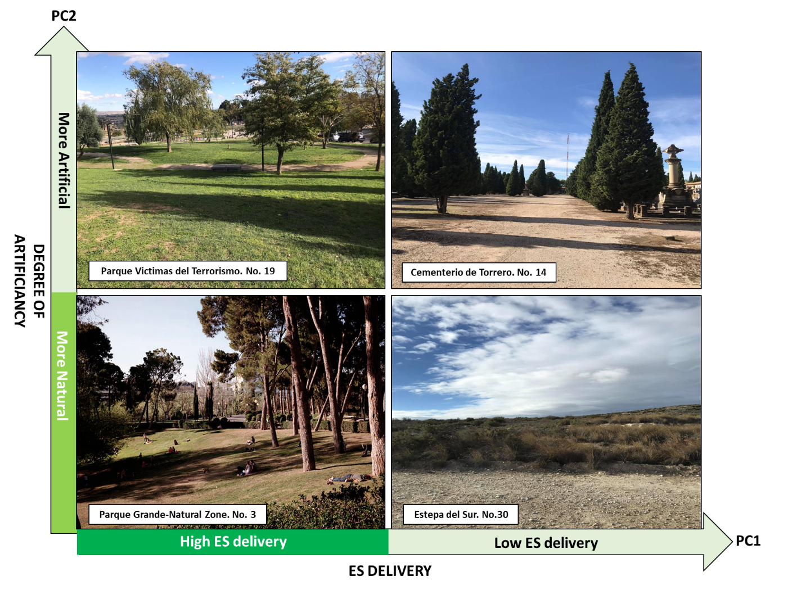
Fig. S1. On PC1, high ES delivery UGI sites versus low ES delivery UGI sites. On PC2, natural UGI sites with less human intervention versus more artificial UGI sites with more human intervention in the UGI site.
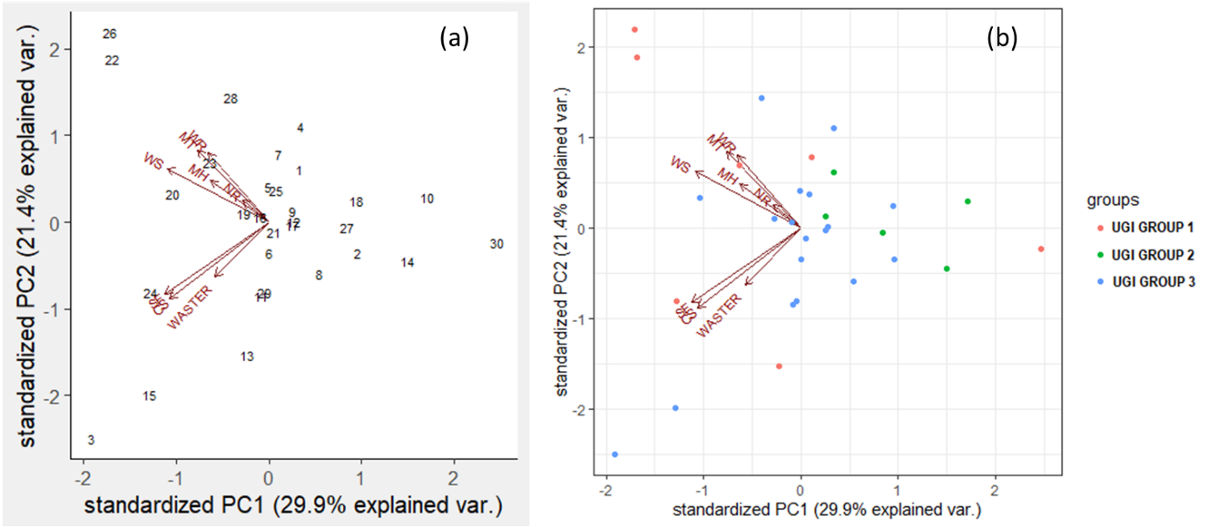
Fig. S2. PCA ordination (using first two axes) of UGI sites according to their supply of ES: Water Regulation (WR), Waste Regulation (WASTER), Nutrient Regulation (NR), Carbon sequestration (CS), Temperature (MT) and Humidity Regulation (MH) .(a) each number represents a UGI site found in Table S1. (b) shows the distribution of different UGI sites corresponding to each UGI Group.
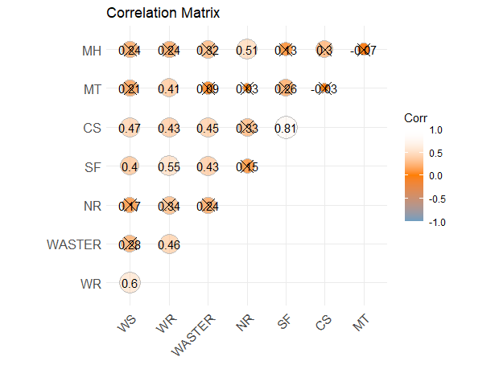
Fig. S3. Correlation Matrix of the 8 ES. The value of the coefficient of correlation varies from -1 to 1. The X inside the circle represent non-significant correlation: Water Regulation (WR), Waste Regulation (WASTER), Nutrient Regulation (NR), Carbon sequestration (CS), Temperature (MT) and Humidity Regulation (MH)
Table S1: A comprehensive list of the 30 sampled UGI sites of Zaragoza
Number | Name | Type_of_UGI | Latitude | Longitude | Total_area (Ha)
1 | Plaza de San Francisco | Square | 41°38'27.34"N | 0°53'41.60"W | 1,66
2 | Campus San Francisco | University Park | 41°38'31.03"N | 0°53'54.53"W | 11,65
3 | Parque Grande - Natural zone | Urban Forest | 41°37'51.90"N | 0°53'36.28"W | 10,5
4 | Parque Grande-Rio Huerva | River | 41°38'11.85"N | 0°53'55.77"W | 2,39
5 | Parque Pignatelli | Urban Park | 41°38'13.94"N | 0°53'6.91"W | 2,68
6 | Parque de la Alfajería | Urban Park | 41°39'23.83"N | 0°53'49.59"W | 5
7 | Ebro River, 100 m upstream Rio Gallego mouth | River | 41°39'1.48"N | 0°51'1.49"W | 18,74
8 | Parque Sedetania | Urban Park | 41°39'14.73"N | 0°55'5.23"W | 4,5
9 | Street trees Valdespartera | Street trees | 41°37'45.70"N | 0°55'55.37"W | 2,28
10 | Canal Imperial-Zone 1 | Canal | 41°37'28.77"N | 0°54'24.29"W | 1,24
11 | Canal Imperial - Zone 3 | Canal | 41°38'1.74"N | 0°54'49.62"W | 3,75
12 | Parque Glorietas de Goya | Urban Park | 41°38'51.24"N | 0°52'8.41"W | 2,61
13 | Pinares de Venecia | Urban Forest | 41°37'40.46"N | 0°53'38.97"W | 318
14 | Cementerio de Torrero | Cemetery | 41°37'16.72"N | 0°53'7.64"W | 53
15 | Parque del Tio Jorge | Urban Park | 41°39'52.95"N | 0°52'37.14"W | 15,15
16 | Parque Che Guevara | Urban Park | 41°40'15.89"N | 0°52'54.07"W | 3,52
17 | Parque del Respeto | Urban Park | 41°40'13.08"N | 0°53'45.35"W | 3
18 | Parque Tapices de Goya | Urban Park | 41°41'7.58"N | 0°52'35.34"W | 4,16
19 | Parque Víctimas del Terrorismo | Urban Park | 41°37'48.03"N | 0°52'29.91"W | 1,9
20 | Parque Teresa Serrato | Pocket Park | 41°38'32.72"N | 0°54'38.05"W | 0,41
21 | Parque del Oeste | Urban Park | 41°38'54.29"N | 0°55'45.25"W | 13,2
22 | Peña del Cuervo | Meander | 41°44'30.35"N | 0°48'33.25"W | 17,9
23 | Vedado de Peñaflor | Forest | 41°45'59.82"N | 0°46'29.62"W | 88
24 | Galacho de Justibol | Meander | 41°42'13.53"N | 0°55'52.61"W | 122
25 | Parque del Agua – Artificial part | Urban Park | 41°40'7.10"N | 0°54'43.72"W | 79,2
26 | Parque del Agua – Natural zone | Urban Park | 41°40'2.32"N | 0°55'9.62"W | 45,1
27 | Huertos del Ebro | Agricultural land | 41°40'49.29"N | 0°54'25.59"W | 4,7
28 | Agricultural land beside Huertos del Ebro | Community garden | 41°40'47.20"N | 0°54'13.30"W | 5,5
29 | Rotonda de la Ciudad de Toulouse | Roundabout | 41°37'56.72"N | 0°54'18.24"W | 0,37
30 | Estepa del Sur | Steppe | 41°36'29.63"N | 0°53'50.51"W | 485,921

Table S2: Data of the 8 ES evaluated after normalization and of the 4 regulating factors considered as predictors of the ES for the 30 UGI sites studied.
NatFun | 9,85 | 8,80 | 3,05 | 7,75 | 3,65 | 6,35 | 7,60 | 2,80 | 4,70 | 3,20 | 4,65 | 8,45 | 8,90 | 4,25 | 9,55 | 5,75 | 3,20 | 4,20 | 2,70 | 3,85 | 3,25 | 3,60 | 4,55 | 3,10 | 3,60 | 2,25 | 2,40 | 3,05 | 3,35 | 4,40
Regularity | 1,00 | 1,00 | 5,00 | 1,00 | 5,00 | 2,00 | 1,00 | 4,00 | 2,00 | 3,00 | 5,00 | 1,00 | 1,00 | 2,00 | 1,00 | 3,00 | 5,00 | 5,00 | 4,00 | 4,00 | 5,00 | 3,00 | 2,00 | 4,00 | 4,00 | 5,00 | 4,00 | 4,00 | 4,00 | 3,00
Flatness | 40,00 | 30,00 | 100,00 | 50,00 | 50,00 | 40,00 | 70,00 | 100,00 | 90,00 | 95,00 | 95,00 | 70,00 | 65,00 | 20,00 | 50,00 | 70,00 | 100,00 | 60,00 | 60,00 | 100,00 | 50,00 | 80,00 | 25,00 | 80,00 | 85,00 | 85,00 | 100,00 | 95,00 | 95,00 | 100,00
Imperviousness | 3,00 | 7,00 | 60,00 | 10,00 | 30,00 | 25,00 | 15,00 | 80,00 | 40,00 | 46,00 | 15,00 | 5,00 | 7,00 | 55,00 | 5,00 | 16,50 | 43,00 | 32,00 | 60,00 | 26,00 | 40,00 | 40,00 | 34,00 | 40,00 | 40,00 | 75,00 | 70,00 | 60,00 | 40,00 | 35,00
WS | 55,8388 | 55,5768 | 21,3862 | 0,0059 | 22,6148 | 35,7249 | 31,3768 | 2,9950 | 13,9398 | 14,4723 | 32,6992 | 47,5779 | 30,7920 | 52,7803 | 23,4065 | 20,5124 | 33,6462 | 41,7760 | 8,2141 | 59,2115 | 23,8282 | 37,4703 | 30,7739 | 27,7434 | 20,0207 | 6,0252 | 6,5577 | 17,7702 | 26,9382 | 22,5513
WR | 10,804 | 10,132 | 1,672 | 1,000 | 2,553 | 2,099 | 2,018 | 1,258 | 2,800 | 2,018 | 18,775 | 7,743 | 3,216 | 1,334 | 5,989 | 3,303 | 2,476 | 3,302 | 1,483 | 3,742 | 2,325 | 2,308 | 2,508 | 2,063 | 2,744 | 1,215 | 1,334 | 1,867 | 2,612 | 2,351
WASTER | 14,5410 | 7,4761 | 4,7258 | 0,0049 | 53,0233 | 13,5886 | 6,4742 | 1,5123 | 4,1122 | 8,2962 | 6,0159 | 4,9329 | 27,6978 | 2,8966 | 6,9960 | 46,1232 | 10,6078 | 15,8986 | 19,4997 | 11,7598 | 16,7383 | 4,7543 | 6,9946 | 4,4189 | 6,3705 | 3,8578 | 6,7696 | 3,4039 | 6,4176 | 7,8603
NR | 7,2741 | 5,4170 | 39,6323 | 0,0004 | 4,2161 | 4,0807 | 2,9890 | 2,3754 | 14,3460 | 17,6148 | 8,4225 | 23,0769 | 15,3805 | 2,8926 | 27,0421 | 14,9759 | 62,0061 | 13,7773 | 12,7603 | 63,9357 | 25,7069 | 24,8881 | 73,5996 | 25,7301 | 35,4820 | 4,2629 | 14,5060 | 3,2169 | 27,2736 | 30,3484
SF | 0,1548 | 0,1625 | 0,1090 | 0,0000 | 0,1497 | 0,4219 | 0,1853 | 0,0271 | 0,2927 | 0,0884 | 0,1265 | 0,1649 | 0,2431 | 0,0489 | 0,1052 | 0,2635 | 0,1015 | 0,0721 | 0,1129 | 0,1462 | 0,1280 | 0,1404 | 0,1326 | 0,1374 | 0,1285 | 0,0770 | 0,1087 | 0,0816 | 0,1184 | 0,1287
CS | 17,3008 | 16,3267 | 9,6465 | 0,0018 | 4,5368 | 50,1798 | 39,1397 | 2,9024 | 16,9622 | 10,7837 | 11,4878 | 15,2610 | 30,1155 | 5,7382 | 11,1025 | 34,7460 | 13,6654 | 12,5941 | 14,6929 | 24,7470 | 19,0311 | 17,9570 | 21,4578 | 19,6055 | 14,9234 | 9,1288 | 11,2386 | 6,3136 | 14,4062 | 14,4620
MT | 100,0000 | 39,2694 | 54,5845 | 0,0066 | 26,6488 | 26,1394 | 10,7239 | 37,4397 | 40,2200 | 26,7828 | 28,4853 | 89,2058 | 54,7902 | 37,1453 | 45,7429 | 17,5769 | 17,9000 | 17,1000 | 17,4000 | 17,1000 | 17,9500 | 17,1200 | 17,2200 | 17,6000 | 17,3500 | 17,1000 | 17,2000 | 17,2100 | 26,1000 | 17,3200
MH | 40,23256 | 1,783745 | 29,18245 | 0,005876 | 37,24047 | 22,9801 | 6,904819 | 11,89163 | 12,1 | 25,67298 | 22,41669 | 99,98801 | 37,25797 | 40,68181 | 35,77955 | 51,36036 | 50,2 | 49,2 | 49,15 | 49,02 | 49,5 | 49,02 | 49,019 | 50,3 | 49,4 | 6,8 | 37,2 | 49,2 | 37,1 | 49,35
Groups | Group 1 | Group 1 | Group 2 | Group 1 | Group 3 | Group 3 | Group 1 | Group 2 | Group 3 | Group 2 | Group 3 | Group 1 | Group 1 | Group 3 | Group 1 | Group 3 | Group 3 | Group 3 | Group 3 | Group 3 | Group 3 | Group 3 | Group 3 | Group 3 | Group 3 | Group 2 | Group 3 | Group 3 | Group 2 | Group 3
Type | meander | forest | square | steppe | roudabout | urban forest | urban forest | canal | canal | community garden | agricultural land | urban park | meander | river | river | urban park | urban park | urban park | urban park | urban park | urban park | urban park | urban park | urban park | urban park | cemetry | university park | urban park | street trees | urban park
ID | 22 | 23 | 1 | 30 | 29 | 3 | 13 | 10 | 11 | 27 | 28 | 26 | 24 | 4 | 7 | 15 | 5 | 25 | 8 | 20 | 6 | 16 | 19 | 21 | 12 | 14 | 2 | 18 | 9 | 17
Site name | Peña del cuervo | Vedado de peñaflor | Plaza San Francisco | Estepa del sur | Roundabout de la Ciudad de Toulouse | Parque grande- parte natural | Pinares de venecia | Canal imperial-baja | Canal imperial-alta | Community gardens of Ebro | Agricultural land near the community gardens of the Ebro | Parque del agua - Natural zone | Galacho de Justibol | Parque Grande Rio Huerva | Rio Ebro - Parte Norte - at the mouth of Rio Gallego | Parque Tio Jorge | Parque Pignatelli | Parque del Agua - Unit 1- the artificial zone | Parque Sedetania | Parque Teresa Serrato | Parque de La Aljaferia | Parque Che Guevara | Parque Víctimas del Terrorismo | Parque Oliver | Parque Glorietas de Goya | Cementerio de Torrero | Campus de San Francisco | Parque Tapices de Goya | Valdespartera- street trees | Parque del Respeto

Table S3: Type, definition, value and explanation of the value of the 4 independent variables (predictors) used to assess the ES in the UGI of Zaragoza (modified from Hanna et. al 2023)
Type of Variables | Definition | Value | Explanation of the value
NatFun | Composed of Naturalness which is measured as the percentage of coverage of natural areas inside the UGI site, and Functioning which was defined as the degree of natural processes driving the dynamics of the UGI site, | 0-10 | (Value of Naturalness+ Value of Functioning)/2
Regularity | It’s the extent to which a site is designed using strict lines or well defined regular forms. For instance, a landscape designed park, containing symmetrical design and well defined shapes (strict lines of trees, round fountains, lines of pavement) in its design might have a value of 4 or 5 (depending on how artificial the park looks). On other hand, a natural forest is not artificially designed (because it is natural) have a value of 1 since strict lines of trees with equal spacing for example are rarely found in nature. | 1 to 5 | 1: 100% of the area is Irregular  2: 5-35% regular  3: 35-65% regular  4: 65-90% regular  5: 90-100% regular
Imperviousness | Area of the site that is occupied by artificial impervious surface such as pavements, structure, fountains, houses, sport playgrounds etc... | (ha) | The area is measured by Hectares (ha)
Flatness | % of flatness in the site | % | Depends on each site

Table S4: Principal Components values
PC | 1 | 2 | 3 | 4 | 5 | 6 | 7 | 8
Proportion of Variance | 0.299 | 0.2144 | 0.1827 | 0.1198 | 0.07586 | 0.05228 | 0.04284 | 0.0131
Cumulative Proportion | 0.299 | 0.5134 | 0.6961 | 0.8159 | 0.89178 | 0.94406 | 0.98690 | 1.0

Table S5: Mixed-effect models showing the best-fitting model equation, P-values (significant coefficients in bold type). Water Supply (WS), Water Regulation (WR), Waste Regulation (WASTER), Soil Formation (SF), Nutrient Regulation (NR), Carbon sequestration (CS), Temperature (MT) and Humidity Regulation (MH). It is important to note that not all predictors found in the equation of the model were presented in the interactions plot (Fig. 6), because the interaction between the pair of predictors and the ES was insignificant (p>0.05)
ES | Model | Std Error of the Estimate | Adjusted R Square | p-value | Equation of the model
WS | (a) | 11.59 | 0.4738 | 0.0001797 | -16.15Flatness* Log(NatFun) - 2.09Imperviousness* Log(NatFun)^2 -15.96Imperviousness*Flatness + 25.71
WR | (b) | 2.077 | 0.6933 | 1.741e-06 | 1.87Regularity -3.36Imperviousness + 1.32Flatness*Regularity - 4.59Imperviousness*Log(NatFun) - 4.7Imperviousness*Regularity+ 1.83
WASTER | (c) | 9.612 | 0.3599 | 0.00391 | 2.925Log(NatFun) + 4.673Regularity - 2.681Flatness - 6.586Flatness*Regularity + 14.2
NR | (d) | 19.04 | 0.1056 | 0.3983 | 5.595Flatness*Regularity + 16.285Log(NatFun) + 11.092Imperviousness*Regularity + 25.211
SF | (e) | 0.07703 | 0.1126 | 0.03922 | -0.008Imperviousness + 0.153
CS | (f) | 10.07 | 0.1233 | 0.03225 | -1.671Imperviousness + 17.801
MT | (g) | 14.31 | 0.5675 | 8.789e-05 | 8.11Regularity*Log(NatFun) -13.98Regularity^2*Log(NatFun) + 1.67Flatness*Log(NatFun) -25.87Imperviousness*Log(NatFun) -17.08Imperviousness*Log(NatFun)^2 + 20.01
MH | (h) | 19.22 | 0.1194 | 0.03463 | 4.816Flatnesss*Log(NatFun) + 40.848

