SUPPLEMENTARY INFORMATION
Table S1 Structural equation model results for species richness and temporal beta diversity.
SEM | Response | Predictor | DF | P-value | Std.Estimate
Species Richness | Local environmental variation | ~ land cover variation | 27 | 0.32 | -0.19
Species Richness | Local environmental variation | + log(area) | 27 | 0.87 | -0.03
Species Richness | Richness 2019 | ~ Richness 2014 | 25 | 0.03 | 0.39
Species Richness | Richness 2019 | + Local environmental variation | 25 | 0.12 | 0.26
Species Richness | Richness 2019 | + land cover variation | 25 | 0.11 | 0.26
Species Richness | Richness 2019 | + log(area) | 25 | 0.09 | 0.28
Temporal beta diversity | Local environmental variation | ~ land cover variation | 27 | 0.32 | -0.19
Temporal beta diversity | Local environmental variation | + log(area) | 27 | 0.87 | -0.03
Temporal beta diversity | Temporal beta diversity (species turnover) | ~ Local environmental variation | 25 | 0.22 | -0.25
Temporal beta diversity | Temporal beta diversity (species turnover) | + land cover variation | 25 | 0.89 | -0.03
Temporal beta diversity | Temporal beta diversity (species turnover) | + log(area) | 25 | 0.76 | -0.06

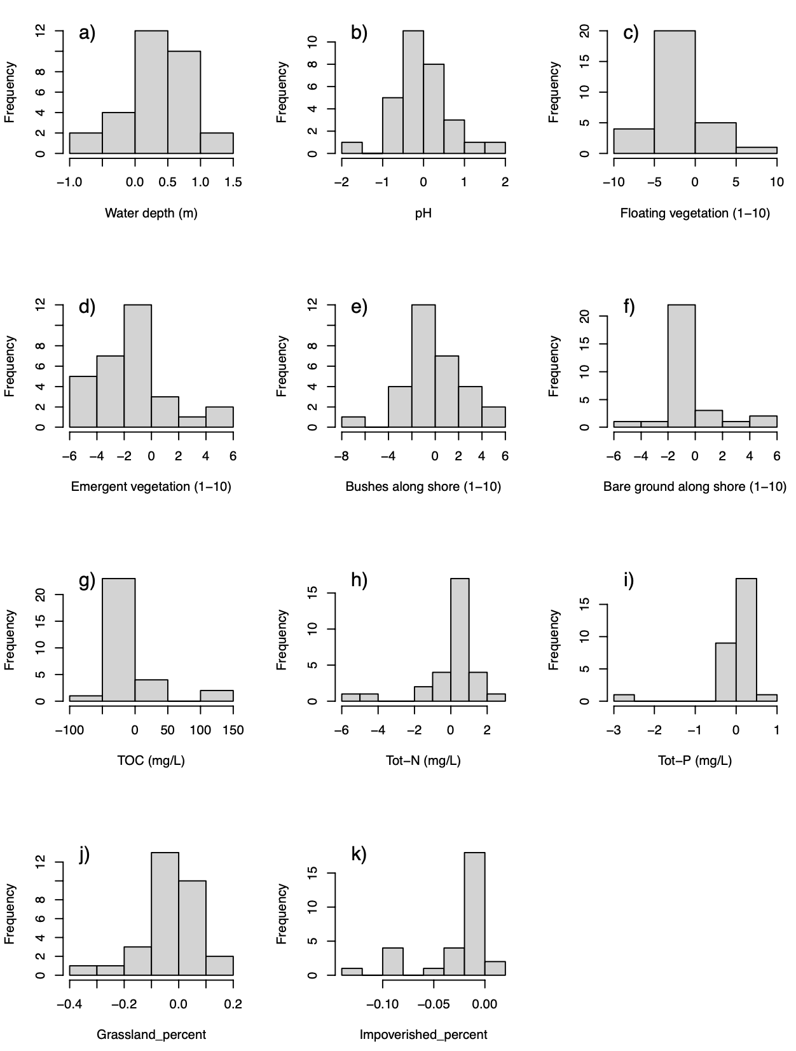
Figure S1 Histograms of change for pond environmental variables from 2014 to 2019 (a-i), and for land cover (absolute change) from 2015 to 2018.

