Supplementary information for a paper submitted to Urban Ecosystems

Small parks in residential neighborhoods as habitat for ground-dwelling beetles, spiders, and ants

Shinsaku Koji^{1,2*} • Shun Furukawa¹ • Natsuki Ichijo² • Yuki Yamaguchi³ • Akio Tanikawa⁴ • Kazuyuki Kudô⁵

¹ Graduate School of Science and Technology, Niigata University, Niigata, Japan
² College of Creative Studies, Niigata University, Niigata, Japan
³ Department of General Education, Nagaoka University of Technology, Nagaoka, Japan
⁴ Graduate School of Agricultural and Life Sciences, The University of Tokyo, Tokyo, Japan
⁵ Faculty of Education, Niigata University, Niigata, Japan

* Corresponding author: skoji@create.niigata-u.ac.jp

Contents
Fig. S1 Map of the sampling locations
Table S1 Profile of the small neighborhood parks involved in the study
Table S2 Species list of carabids
Table S3 Species list of spiders
Table S4 Species list of ants
Table S5 AICc values for models performed with the proportion of urbanized area at different spatial scales on the species richness and abundances of carabid beetles, spiders, and ants

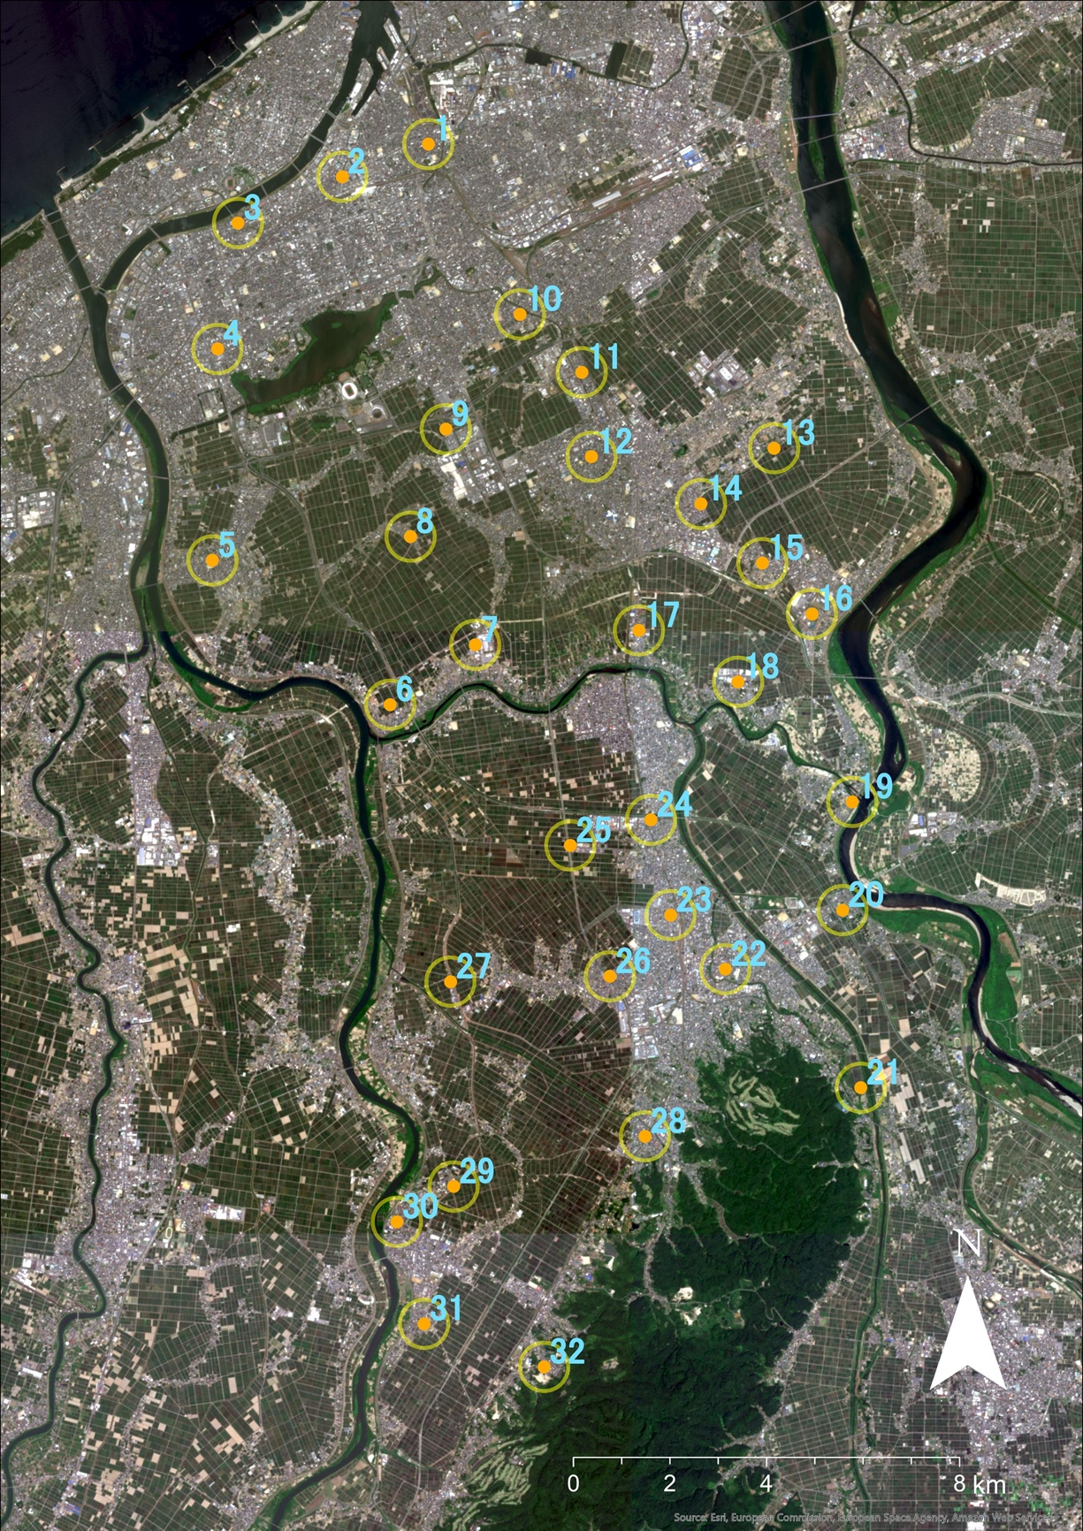

Fig. S1 Map of the sampling locations (orange dots) with 500 m buffers (yellow circles). Parks are numbered according to their code in Table S1. Sentinel-2 satellite image was obtained from Copernicus Open Access Hub
Table S1 Profile of the small neighborhood parks involved in the study
Code | Park name | Vegetation-litter factor | Soil  moisture  factor | Vegetation  complexity | Park  area  (m²) | Park  age  (year) | Tree  DBH  (cm) | Sky view  factor  (%) | Mowing  frequency | Impervious  surface | Non-  permeable  border (%) | Urbanization intensity  (%, buffer 250m/500m)
1 | Hinode | 1.78 | -2.27 | 0.16 | 3,400 | 77 | 28.2 | 43.2 | 3 | 0.05 | 100.0 | 92.5/90.6
2 | Benten | -0.78 | -1.59 | 0.75 | 1,900 | 60 | 26.7 | 37.0 | 2 | 0.46 | 100.0 | 95.1/94.9
3 | Kamitokorojima | -1.51 | -1.43 | 1.10 | 2,800 | 48 | 27.9 | 66.7 | 1.5 | 0.43 | 87.7 | 84.7/70.6
4 | Shinmei | -2.82 | 0.40 | 0.97 | 2,146 | 44 | 19.8 | 28.9 | 1 | 0.01 | 100.0 | 96.1/97.4
5 | Sonoki-kotobuki | -0.16 | -0.15 | 0.81 | 2,419 | 23 | 15.3 | 45.9 | 1 | 0.00 | 95.1 | 93.0/83.6
6 | Ryôkawa-momiji | -0.06 | 0.15 | 0.35 | 1,798 | 16 | 14.1 | 75.7 | 3 | 0.22 | 100.0 | 38.0/52.0
7 | Arinomi | -0.16 | 1.82 | 0.18 | 4,670 | 25 | 18.2 | 51.3 | 2 | 0.01 | 95.3 | 61.9/55.5
8 | Marugata | -0.46 | -0.78 | 0.67 | 562 | 27 | 16.4 | 42.2 | 1 | 0.32 | 44.3 | 37.6/17.0
9 | Yanagida | 0.26 | 1.77 | 0.85 | 1,918 | 12 | 16.6 | 60.7 | 1 | 0.03 | 100.0 | 64.2/59.3
10 | Yamafutatsu-honson | -3.76 | -1.17 | 0.35 | 525 | 24 | 35.8 | 33.9 | 2 | 0.24 | 42.4 | 87.3/78.8
11 | Nakajima | -2.02 | -0.08 | 0.47 | 2,190 | 44 | 20.2 | 56.6 | 2 | 0.04 | 100.0 | 81.8/62.2
12 | Nishimachi | 2.04 | -0.78 | 0.45 | 2,394 | 48 | 22.0 | 49.3 | 1 | 0.02 | 84.2 | 93.6/93.9
13 | Fujikoma-nouson | -3.41 | -0.17 | 0.51 | 2,051 | 39 | 33.5 | 59.9 | 1.5 | 0.02 | 51.5 | 23.0/37.3
14 | Sunaoka-newtown | 2.43 | 1.20 | 0.48 | 1,988 | 27 | 29.1 | 50.4 | 1 | 0.11 | 100.0 | 63.1/56.5
15 | Yokogoshi-daiichi-midori | 1.24 | -1.03 | 0.56 | 846 | 28 | 20.7 | 62.2 | 1 | 0.06 | 44.2 | 78.7/65.6
16 | Yokogoshi-satsuki | -1.10 | -1.55 | 0.33 | 702 | 37 | 18.0 | 65.2 | 1.5 | 0.01 | 82.3 | 78.9/78.3
17 | Nihongi-kotobuki | 0.77 | -2.06 | 0.79 | 1,242 | 39 | 16.9 | 67.3 | 1 | 0.00 | 60.8 | 78.0/38.9
18 | Daiichi-yasuragi | -1.00 | 3.29 | 0.78 | 7,262 | 31 | 20.5 | 58.5 | 1 | 0.14 | 65.9 | 80.7/59.9
19 | Manganji | 1.35 | 2.97 | 0.44 | 8,532 | 43 | 24.5 | 70.7 | 1.5 | 0.01 | 48.7 | 44.4/35.9
20 | Nakashinden | 1.17 | -1.47 | 0.26 | 1,919 | 16 | 20.2 | 64.9 | 1 | 0.05 | 16.7 | 69.4/47.3
21 | Nôdaigawa-bunryû-kinen | -0.20 | 2.02 | 0.37 | 7,722 | 29 | 27.2 | 56.5 | 3 | 0.08 | 58.9 | 5.8/13.7
22 | Nippoucho | 2.01 | -1.90 | 0.25 | 3,618 | 43 | 28.8 | 46.4 | 1 | 0.00 | 100.0 | 86.6/83.4
23 | Miyoshi-daini | 2.43 | 0.49 | 0.48 | 2,556 | 14 | 18.3 | 65.5 | 1 | 0.14 | 100.0 | 91.1/93.4
24 | Kawaguchi-himawari | 2.50 | -0.70 | 0.38 | 1,535 | 27 | 27.9 | 52.6 | 1 | 0.12 | 100.0 | 74.9/76.3
25 | Kitakami-nishi-daiichi | 2.22 | 1.84 | 0.68 | 850 | 26 | 18.0 | 52.5 | 1 | 0.02 | 67.4 | 34.2/16.9
26 | Koda-flower-park | -2.80 | -0.27 | 0.38 | 2,156 | 27 | 36.7 | 50.0 | 1.5 | 0.26 | 93.5 | 75.4/74.2
27 | Fûdo | 0.27 | -1.29 | 0.78 | 3,684 | 16 | 21.0 | 48.9 | 1 | 0.13 | 55.8 | 8.7/10.7
28 | Furutsudanchi-ekimae | 2.42 | -0.58 | 0.32 | 740 | 32 | 24.5 | 44.4 | 2 | 0.25 | 100.0 | 90.6/77.2
29 | Kosudo-nouson | 0.29 | 1.79 | 0.32 | 2,263 | 27 | 14.0 | 55.3 | 1 | 0.13 | 60.3 | 25.9/23.4
30 | Kosudo-jidou | 0.76 | 0.50 | 0.32 | 682 | 49 | 34.8 | 41.9 | 1.5 | 0.00 | 100.0 | 79.2/53.3
31 | Yokogawahama-nouson | -3.23 | 0.70 | 0.38 | 4,203 | 35 | 17.8 | 70.4 | 1 | 0.04 | 48.5 | 69.0/34.8
32 | Matsugaoka-nishi | -0.40 | 0.34 | 0.51 | 1,192 | 40 | 19.5 | 55.0 | 3 | 0.11 | 67.4 | 49.3/36.1

Table S2 Species list of carabids
Subfamily | Tribe | Species | Habª | Dis^{b} | Individuals
Scaritinae | Dyschiriini | Dyschirius steno Bates | G | M | 1
 | Scartini | Scarites terricola pacificus Bates | G | M | 16
Trechinae | Bembidiini | Asaphidion semilucidum Motschulsky | G | M | 3
 |  | Bembidion consummatum Bates | G | M | 1
 |  | Polyderis microscopicus Bates | G | M | 39
 |  | Tachys sericans Bates | G | M | 8
 |  | Tachyura fumicata Motschulsky | G | M | 1
 |  | Tachyura laetifica Bates | G | M | 7
 |  | Tachyura tosta Andrewes | G | M | 10
Patrobinae | Patrobini | Archipatrobus flavipes fravipes Motschulsky | G | M | 3
Harpalinae | Pterostichini | Caelostomus picipes (MacLeay) | F | M | 1
 |  | Lesticus magnus Motschulsky | G | M | 5
 |  | Myas cuprescens cuprescens Motschulsky | F | B | 1
 |  | Poecilus samurai Lutshnik | G | M | 3
 |  | Pterostichus sulcitarsis Morawitz | G | B | 1
 |  | Pterostichus haptoderoides japanensis Lutshnik | G | M | 3
 |  | Pterostichus japonicus Motschulsky | G | B | 37
 |  | Pterostichus microcephalus Motschulsky | G | B | 10
 | Platynini | Agonum chalcomum Bates | G | M | 1
 |  | Eucolpodes japonicum japonicum Motschulsky | G | M | 2
 |  | Platynus magnus Bates | G | M | 48
 | Sphodrini | Dolichus halensis Schaller | G | M | 76
 |  | Synuchus arcuaticollis Motschulsky | F | M | 2
 |  | Synuchus cycloderus Bates | F | M | 7
 |  | Synuchus dulcigradus Bates | F | M | 1
 |  | Synuchus nitidus Motschulsky | F | M | 20
 | Zabrini | Amara chalcites Dejean | G | M | 13
 |  | Amara congrua Morawitz | G | M | 33
 |  | Amara simplicidens Morawitz | G | M | 2
 |  | Amara macronota Solsky | G | M | 1
 |  | Amara chalcophaea chalcophaea Bates | G | M | 21
 |  | Amara lucens Baliani | G | M | 4
 | Harpalini | Anisodactylus punctatipennis Morawitz | G | M | 1
 |  | Anisodactylus sadoensis Schauberger | G | M | 5
 |  | Anisodactylus signatus Panzer | G | M | 18
 |  | Harpalus bungii Chaudoir | G | M | 2
 |  | Harpalus pallidipennis Morawitz | G | M | 43
 |  | Harpalus platynotus Bates | G | M | 2
 |  | Harpalus capito Morawitz | G | M | 1
 |  | Harpalus eous Tschitscherine | G | M | 18
 |  | Harpalus griseus Panzer | G | M | 234
 |  | Harpalus jureceki Jedlicka | G | M | 7
 |  | Harpalus pastor niigatanus Schauberger | G | M | 13
 |  | Harpalus simplicidens Schauberger | G | M | 3
 |  | Harpalus sinicus Hope | G | M | 53
 |  | Harpalus tinctulus tinctulus Bates | G | M | 77
 |  | Platymetopus flavilabris Fabricius | G | M | 4
 |  | Acupalpus inornatus Bates | G | M | 4
 |  | Bradycellus grandiceps Bates | G | M | 1
 |  | Bradycellus laeticolor Bates | G | M | 1
 |  | Stenolophus fulvicornis Bates | G | M | 1
 |  | Stenolophus difficilis Hope | G | M | 1
 |  | Stenolophus castaneipennis Bates | G | M | 1
 |  | Stenolophus propinquus Morawitz | G | M | 2
 | Licinini | Diplocheila zeelandica Redtenbacher | G | M | 1
 |  | Badister nigriceps Morawitz | G | M | 2
 | Chlaeniini | Chlaenius micans Fabricius | G | M | 3
 |  | Chlaenius pallipes Gebler | G | M | 1
 |  | Chlaenius nigricans Wiedemann | G | M | 3
 |  | Chlaenius posticalis Motschulsky | G | M | 4
 |  | Chlaenius abstersus Bates | G | M | 8
 |  | Chlaenius virgulifer Chaudoir | G | M | 10
 | Masoreini | Anaulacus adelioides Macleay | G | M | 13
Brachininae | Brachinini | Pheropsophus jessoensis Moravitz | G | M | 84
Total |  |  |  |  | 1002
ª Habitat specificity: F forest specialist; G habitat generalist
^{b} Dispersal: M macropterous; B brachypterous

Table S3 Species list of spiders
Family | Species | Hunª | Dis^{b} | Individuals
Atypidae | Atypus karschi | H | 2 | 2
 | Calommata signata | H | 2 | 34
Halonoproctidae | Latouchia typica | H | 2 | 4
Oonopidae | Gamasomorpha kusumii | H | 1 | 30
Titanoecidae | Nurscia albofasciata | W | 1 | 1
Hahniidae | Cicurina japonica | W | 2 | 2
 | Hahnia corticicola | W | 1 | 12
Agelenidae | Iwogumoa interuna | W | 2 | 8
 | Agelena silvatica | W | 2 | 4
 | Allagelena opulenta | W | 2 | 1
Lycosidae | Piratula piratoides | H | 2 | 5
 | Piratula procurvus | H | 2 | 5
 | Piratula sp. 1 | H | 2 | 14
 | Arctosa subamylacea | H | 2 | 5
 | Tricca japonica | H | 2 | 19
 | Trochosa ruricola | H | 2 | 1
 | Alopecosa moriutii | H | 2 | 30
 | Pardosa laura (s.l.)^{c} | H | 2 | 125
 | Pardosa astrigera | H | 2 | 185
Linyphiidae | Nematogmus sanguinolentus | W | 3 | 2
 | Ummeliata erigonoides | W | 3 | 9
 | Ummeliata osakaensis | W | 3 | 36
 | Ummeliata sp. | W | 3 | 1
 | Walckenaeria golovatchi | W | 3 | 1
 | Gnathonarium exsiccatum | W | 3 | 7
 | Erigone koshiensis | W | 3 | 29
 | Erigone prominens | W | 3 | 696
 | Erigone edentata | W | 3 | 230
 | Nippononeta ungulata | W | 3 | 22
 | Nippononeta obliqua | W | 3 | 5
 | Agyneta nigra | W | 3 | 57
 | Centromerus sylvaticus | W | 3 | 3
 | Microbathyphantes tateyamaensis | W | 3 | 1
 | Neriene oidedicata | W | 3 | 1
Theridiidae | Enoplognatha caricis | W | 2 | 1
 | Steatoda cingulata | W | 2 | 3
 | Steatoda erigoniformis | W | 2 | 13
 | Stemmops nipponicus | W | 2 | 1
Tetragnathidae | Pachygnatha quadrimaculata | W | 2 | 5
 | Pachygnatha tenera | W | 2 | 26
 | Tetragnatha squamata | W | 2 | 1
Ctenidae | Anahita fauna | H | 2 | 8
Philodromidae | Thanatus nipponicus | H | 2 | 1
 | Philodromus auricomus | H | 2 | 1
Gnaphosidae | Gnaphosa kompirensis | H | 2 | 62
 | Odontodrassus hondoensis | H | 2 | 30
 | Zelotes tortuosus | H | 2 | 51
 | Marinarozelotes jaxartensis | H | 2 | 1
 | Drassyllus shaanxiensis | H | 2 | 2
 | Drassyllus sanmenensis | H | 2 | 1
 | Micaria dives | H | 2 | 23
Thomisidae | Xysticus transversomaculatus | H | 2 | 133
 | Xystics saganus | H | 2 | 100
 | Xystics croceus | H | 2 | 1
 | Ozyptila matsumotoi | H | 2 | 14
Clubionidae | Clubiona pseudogermanica | H | 2 | 9
Liocranidae | Agroeca kamurai | H | 2 | 3
Trachelidae | Orthobula crucifera | H | 1 | 31
Phrurolithidae | Corealithus coreanus | H | 2 | 2
 | Labialithus labialis | H | 2 | 4
Salticidae | Attulus avocator | H | 2 | 2
 | Attulus penicillatus | H | 2 | 43
 | Carrhotus xanthogramma | H | 2 | 2
 | Heliophanus ussuricus | H | 2 | 2
 | Phintella arenicolor | H | 2 | 1
 | Evarcha albaria | H | 2 | 3
 | Mendoza elongata | H | 2 | 1
 | Euophrys kataokai | H | 2 | 3
 | Talavera ikedai | H | 2 | 1
 | Talavera sp. aff. aequipes | H | 2 | 1
Total |  |  |  | 2173
ª Hunting mode: H, hunter; W, web-builder
^{b} Dispersal class: 1, non-ballooner species; 2, species likely to balloon; 3, species known to balloon
^{c} Including Pardosa yamanoi and P. laura

Table S4 Species list of ants
Subfamily | Species | Habª | Nest^{b} | Individuals | Occurrence frequency
Ponerinae | Pachycondyla chinensis | O | B | 23 | 21
 | Hypoponera sauteri | F | B | 6 | 4
Myrmicinae | Pyramica benten | O | S | 2 | 1
 | Strumigenys lewisi | F | B | 15 | 6
 | Vollenhovia emeryi | F | W | 4 | 3
 | Solenopsis japonica | O | S | 11993 | 505
 | Tetramorium tsushimae | O | S | 15926 | 761
 | Crematogaster matsumurai | G | W | 65 | 49
 | Crematogaster osakensis | G | S | 20 | 15
 | Temnothorax congruus | G | W | 2 | 2
 | Temnothorax spinosior | O | S | 390 | 119
 | Pristomyrmex punctatus | G | B | 2248 | 424
Dolichoderinae | Technomyrmex gibbosus | O | W | 10 | 7
Formicinae | Formica japonica (s.l.) | O | S | 537 | 93
 | Lasius productus | F | W | 280 | 58
 | Lasius sakagamii | O | S | 153 | 44
 | Lasius spathepus | G | W | 1 | 1
 | Lasius sp.^{c} | F | W | 1 | 1
 | Nylanderia flavipes | G | B | 273 | 94
 | Paratrechina sakurae | O | S | 973 | 150
 | Camponotus japonicus | O | S | 20 | 4
 | Camponotus quadrinotatus | G | W | 2 | 2
 | Camponotus itoi | O | W | 2 | 1
Total |  |  |  | 32946 | 2365
ª Habitat specificity: F, forest specialist; G, habitat generalist; O, open-land species
^{b} Main nest stratum: W, wood and litter; S, soil and crevices; B, both
^{c} Lasius umbratus or L. meridionalis

Table S5 AICc values for models performed with the proportion of urbanized area at different spatial scales on the species richness and abundances of carabid beetles, spiders, and ants. The best models are reported in bold
 | 250 m | 500 m | 750 m | 1000 m
Carabid beetles
Species richness | 183.5467 | 179.2454 | 180.0089 | 183.7238
Abundance | 514.8514 | 462.4506 | 505.4789 | 569.2911
Spiders
Species richness | 178.9676 | 179.4171 | 179.4512 | 179.1739
Abundance | 585.5101 | 596.7122 | 598.0718 | 598.6935
Ants
Species richness | 154.0337 | 154.4077 | 154.2971 | 154.0387
Abundance | 227.4638 | 229.0769 | 228.8584 | 227.5154

