Impacts of urban heterogeneity in environmental and societal characteristics on coyote survival
Urban Ecosystems
Emily Zepeda^{1*}, Andrew Sih², Christopher J. Schell³, and Stanley Gehrt¹
* Corresponding author: zepeda.31@osu.edu
¹ School of Environment and Natural Resources, The Ohio State University, Columbus, Ohio, United States

Supplemental Material

S1. Correlation (blue line; correlation = 0.87, 95% CI [0.73, 0.94]) between tracking duration and estimated age at death for individuals with known birth years and postmortem recovery. Like the larger, study sample, this sample is subset to individuals whose last location was recorded within 30 days of their postmortem recovery. Red line represents a 1.0 correlation.

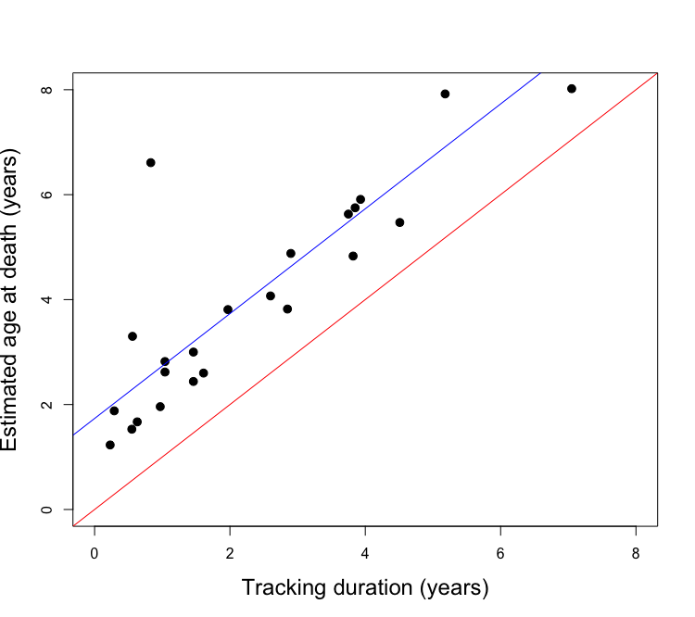

S2. Distributions of regional predictor values and sample predictor values. Regional environmental predictor distributions were calculated using the proportions of each environmental predictor in 10,000 circular polygons (radius = 2 km) placed randomly within the study region. Societal predictor regional distributions were generated using the values of the 6,014 American Community Survey block groups that make up the study region. Distributions were then scaled to match the number of cases in the sample data (94,343).
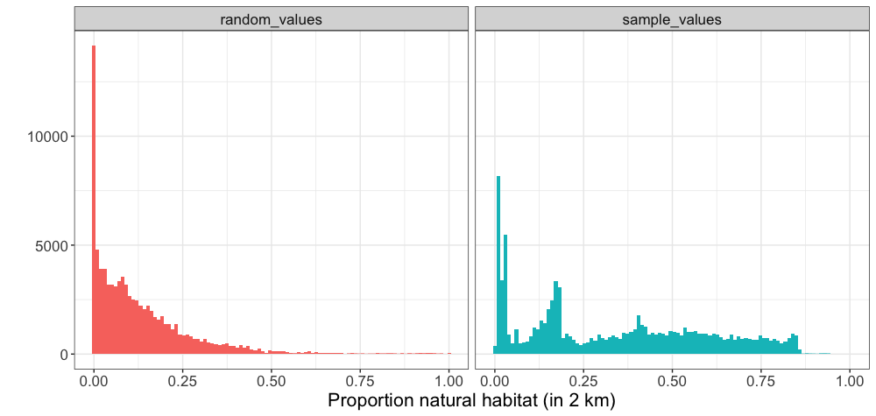
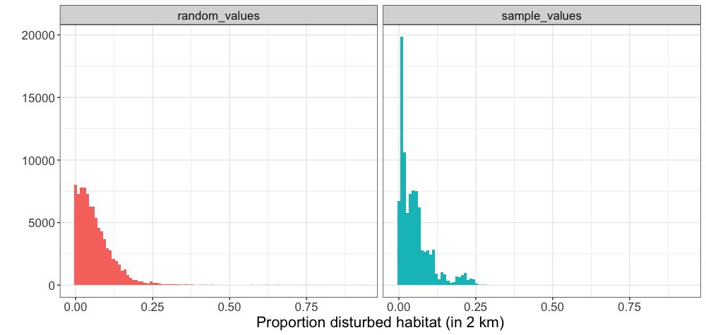

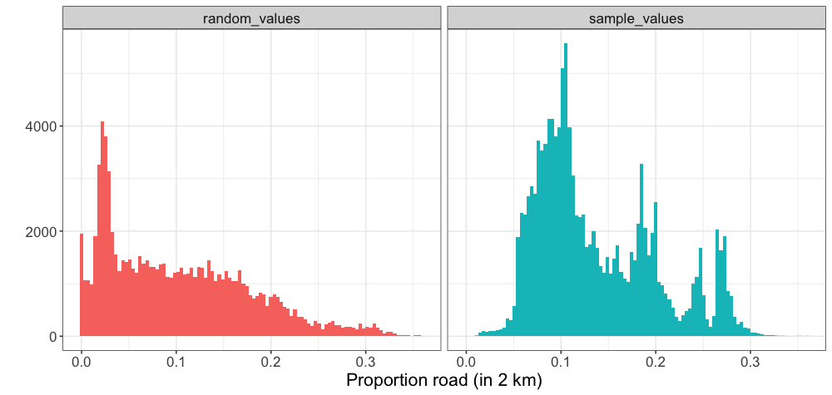

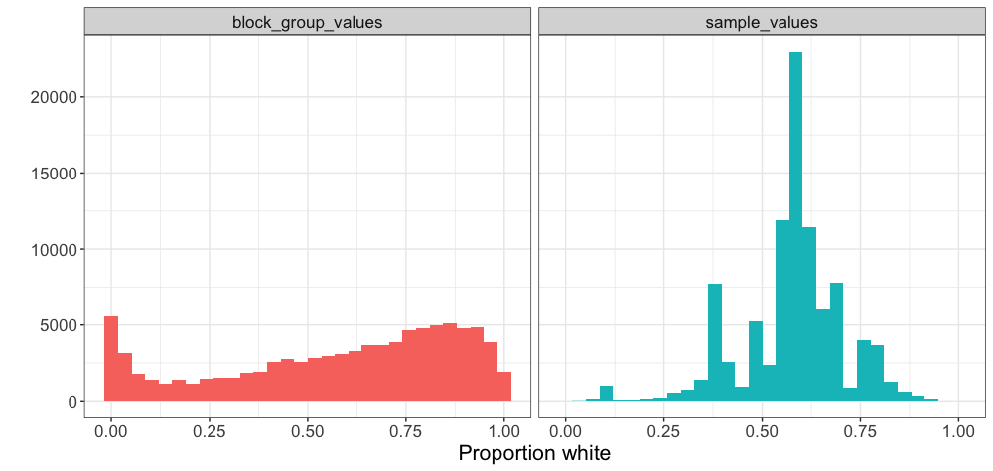
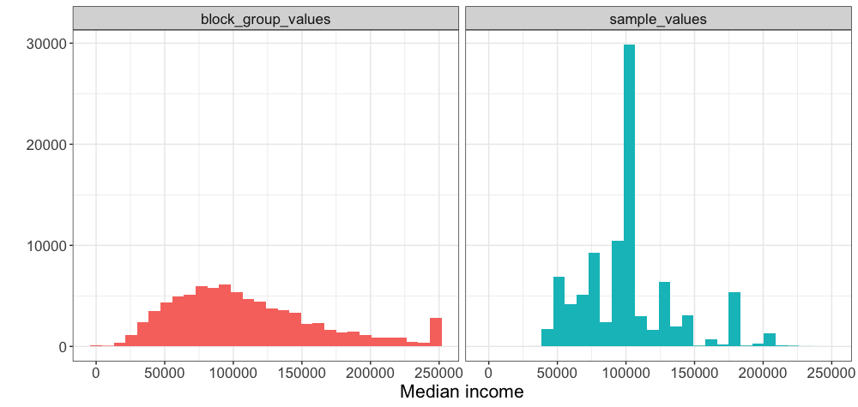

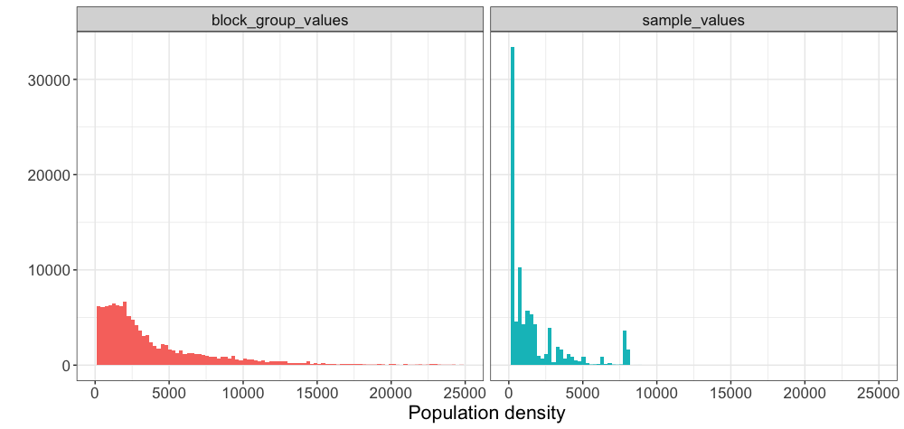

S3. Correlation matrix of predictor variables within a 2 km radius of recorded locations.

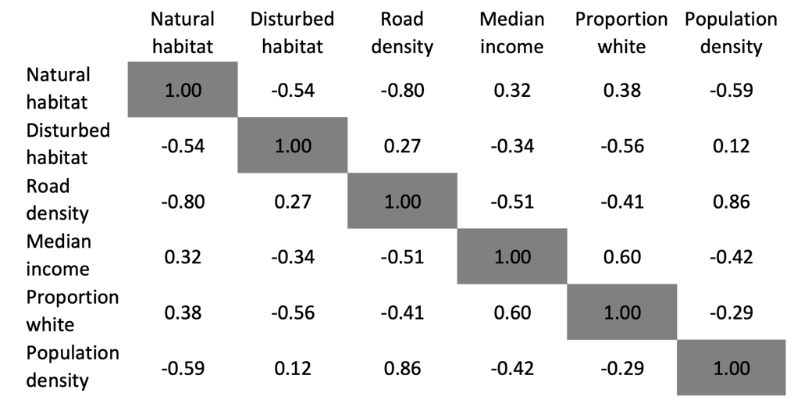

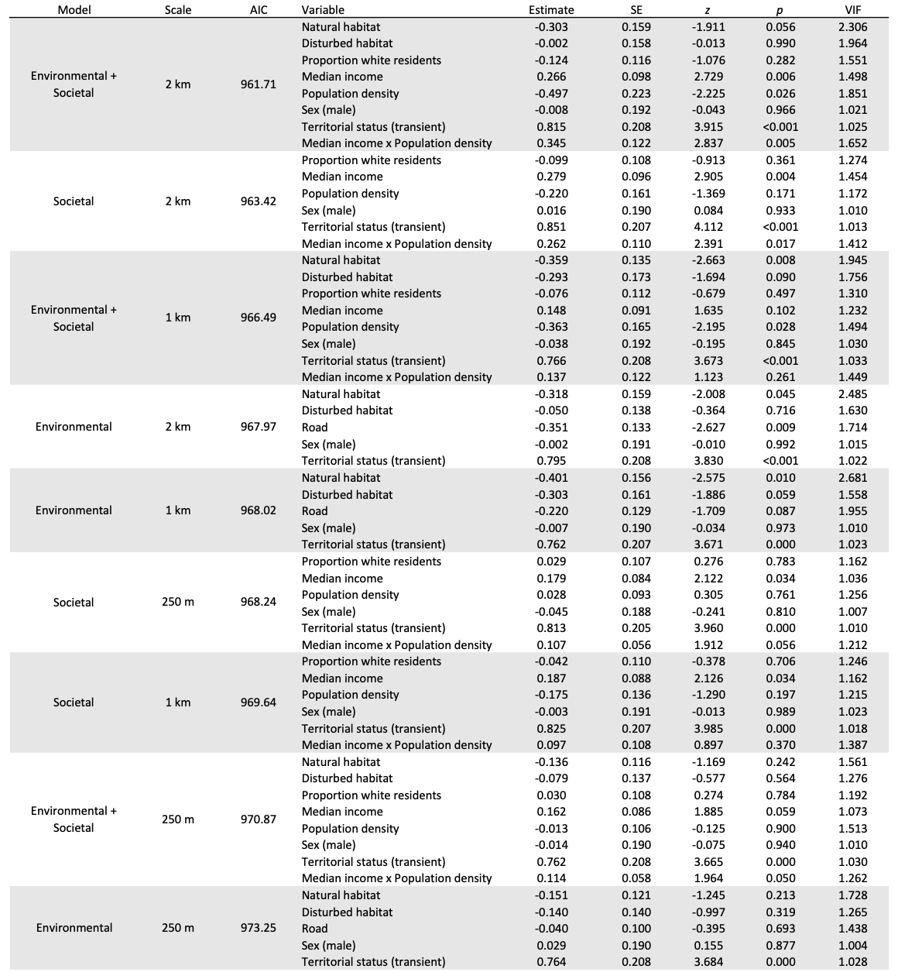
S4. Results of Cox proportional hazards models. Models are ordered according to their AIC score.

