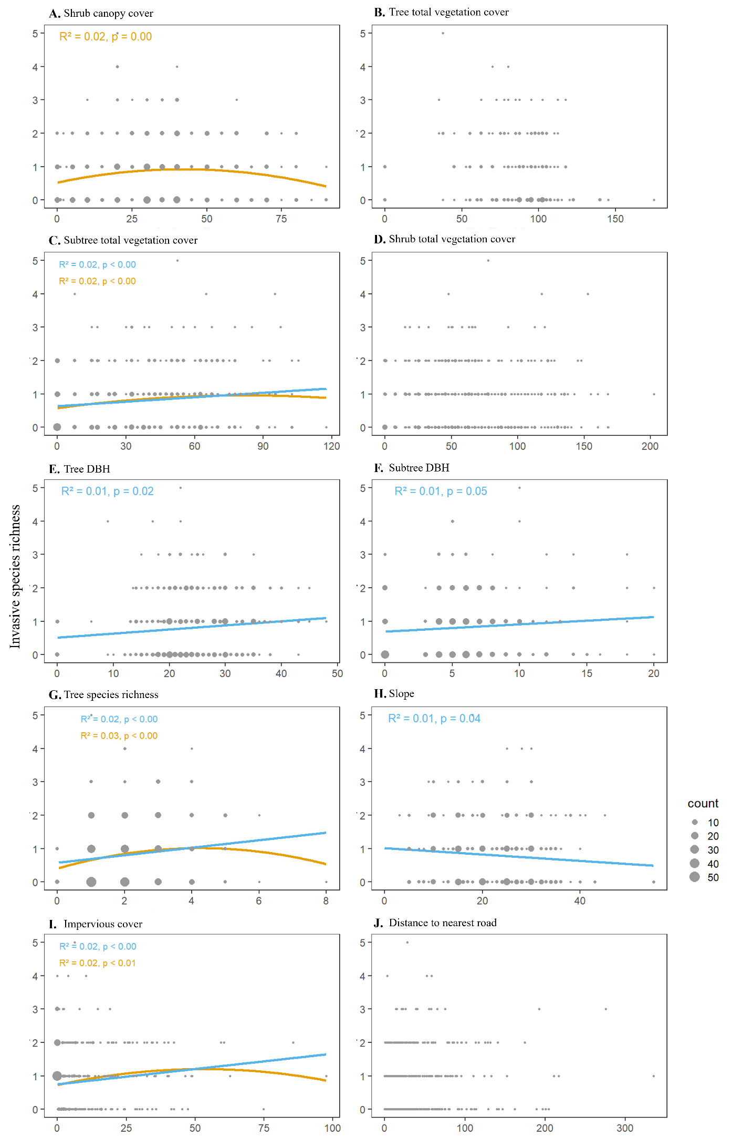
Figure S1. Relationship of invasive plant richness to variables (A. Shrub canopy cover, B. Tree total vegetation cover, C. Subtree total vegetation cover, D. Shrub total vegetation cover, E. Tree DBH, F. Subtree DBH, G. Tree species richness, H. slope, I. impervious cover, and J. Distance to nearest road). R² values and significance levels are shown for linear and nonlinear regressions if they are significant.

