SUPPLEMENTARY MATERIAL

Urban gradient resolution matters! Avian diversity patterns in a boreal green city
Urban Ecosystems

Michelle GARCÍA-ARROYO¹ (0000-0002-9167-4777)
Miguel A. GÓMEZ-MARTÍNEZ² (0000-0001-6637-2040)
Meri BACK¹ (0000-0002-1394-1155)
Heikki SETÄLÄ¹ (0000-0002-5230-4001)
Ian MACGREGOR-FORS¹* (0000-0003-3198-7322)

¹ Ecosystems and Environment Research Programme, Faculty of Biological and Environmental Sciences, University of Helsinki, Niemenkatu 73, Lahti 15140, Finland
² Instituto de Biotecnología y Ecología Aplicada (INBIOTECA), Universidad Veracruzana, Xalapa 91090, Mexico

*Corresponding author: E-mail: ian.macgregor@helsinki.fi

Online Resource 1
Geographical location of the survey sites showing two urban intensity gradients and the randomly selected survey sites that were included in the analyses for each one.

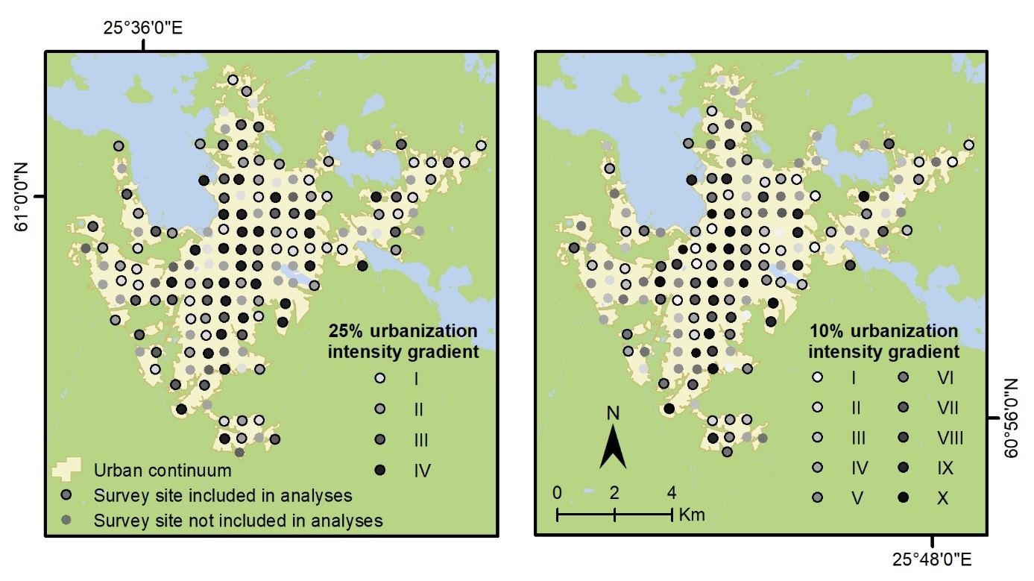
Online Resource 2
Non-conservative classification and regression tree (CART) plot depicting the relationships between key habitat variables (i.e., tree cover, built cover, noise level, and herbaceous plant cover) and the number of bird species. Below is a table with the complexity parameter values for this CART providing a summary of the overall fit of the model.
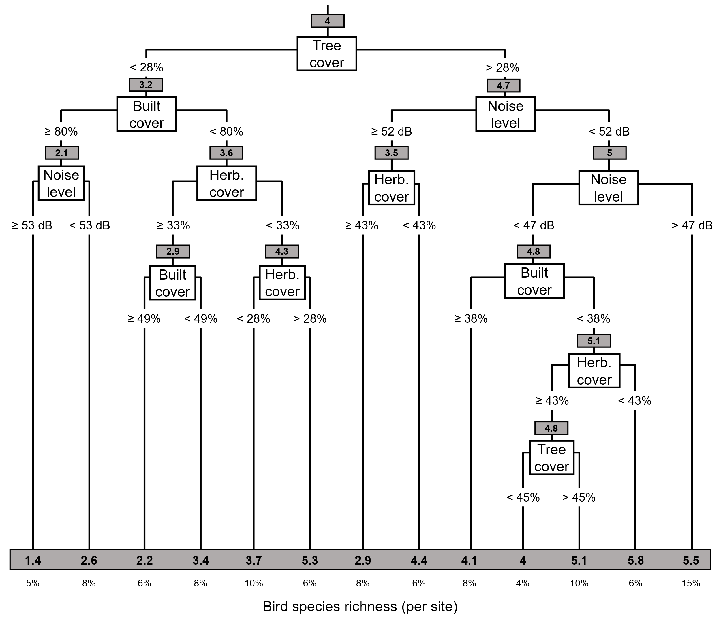
CP | nsplit | rel | error | ​xerror | xstd
1 | 0.17238775 | 0 | 1.0000000 | 1.0037194 | 0.09617312
2 | 0.06540273 | 1 | 0.8276123 | 0.8986333 | 0.08941120
3 | 0.05999483 | 2 | 0.7622095 | 0.9428115 | 0.09400991
4 | 0.04583007 | 3 | 0.7022147 | 0.8805207 | 0.08633609
5 | 0.03000628 | 4 | 0.6563846 | 0.8747860 | 0.08832385
6 | 0.02308569 | 5 | 0.6263783 | 0.8897250 | 0.08978337
7 | 0.01673844 | 6 | 0.6032927 | 0.9129027 | 0.09362459
8 | 0.01525416 | 8 | 0.5698158 | 0.9677423 | 0.09926236
9 | 0.01465361 | 9 | 0.5545616 | 0.9663083 | 0.09935635
10 | 0.01240787 | 10 | 0.5399080 | 0.9716311 | 0.10084608
11 | 0.01178962 | 11 | 0.5275001 | 1.0051535 | 0.10561548
12 | 0.01000000 | 12 | 0.5157105 | 1.0189258 | 0.10801140

Online Resource 3
NMDS plots depicting the similarities in bird species composition across the two urban intensity gradients assessed in the study. The overlaid plot illustrates the spatial variation in built cover along each gradient. Bird species names are labelled and coded for reference, providing insights into the distribution patterns of avian communities across the studied gradients. In cases where species names overlapped, they were replaced with the following numbers: 1) PHTR, DEMA, SYCO, PAMA; 2) CYCA, TUPI; 3) CHCH, RERE; 4) COCO, PHPH; 5) STVU, CHRI, BRLE; 6) LULU, CACA; 7) ERRU, COPA, RERE; 8) PHTR, CHCH (for species codes see Table 1).
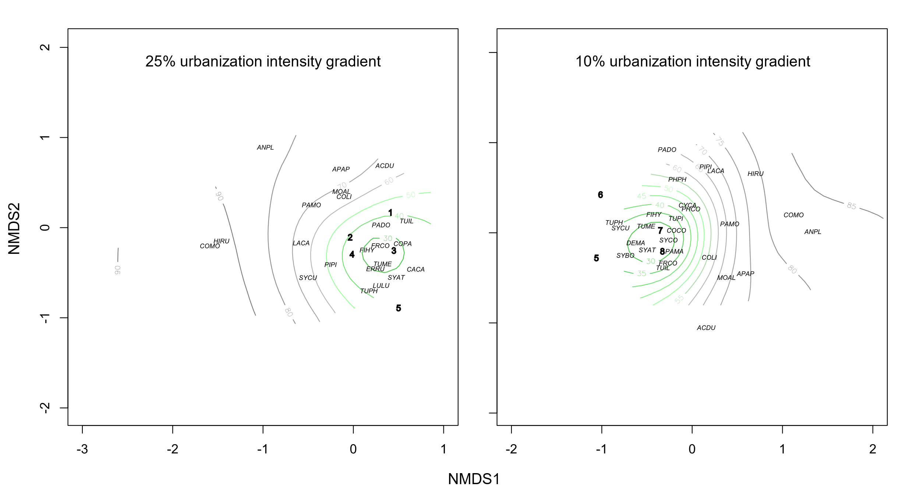
Online Resource 4
Generalized linear models (GLMs, Poisson error distribution, log link) of pairwise interactions among the set of four independent variables (i.e., noise level, tree cover, built cover, herbaceous plant cover) relating to the variance of bird species richness with a ΔAICc < 2. Significant values indicated with bold letters.

Models | AICc
Model 1 | 612.47
Built cover × Noise level +  Built cover × Tree cover +  Herbaceous plant cover × Noise level | P < 0.001  P = 0.006  P = 0.091
Model 2 | 613.07
Herbaceous plant cover +  Built cover × Noise level +  Built cover × Tree cover | P = 0.008  P < 0.001  P = 0.002
Model 3 | 613.21
Built cover × Noise level +  Built cover × Tree cover + | P < 0.001  P = 0.006
Model 4 | 613.41
Tree cover +  Tree cover × Noise level +  Built cover × Noise level +  Herbaceous plant cover × Tree cover | P < 0.001  P = 0.042  P = 0.007  P = 0.007
Model 5 | 614.06
Tree cover +  Built cover × Noise level +  Built cover × Tree cover +  Herbaceous plant cover × Noise level | P < 0.001  P = 0.002  P = 0.022  P = 0.067
Model 6 | 614.30
Built cover × Noise level +  Built cover × Tree cover +  Herbaceous plant cover × Noise level +  Herbaceous plant cover × Tree cover | P < 0.001  P = 0.006  P = 0.091  P = 0.586
Model 7 | 614.44
Tree cover × Noise level +  Built cover × Noise level +  Built cover × Tree cover +  Herbaceous plant cover × Noise level | P < 0.001  P < 0.001  P = 0.009  P = 0.099

Online Resource 5
Association between the variables included in the fittest GLM with bird species richness recorded in the citywide survey.

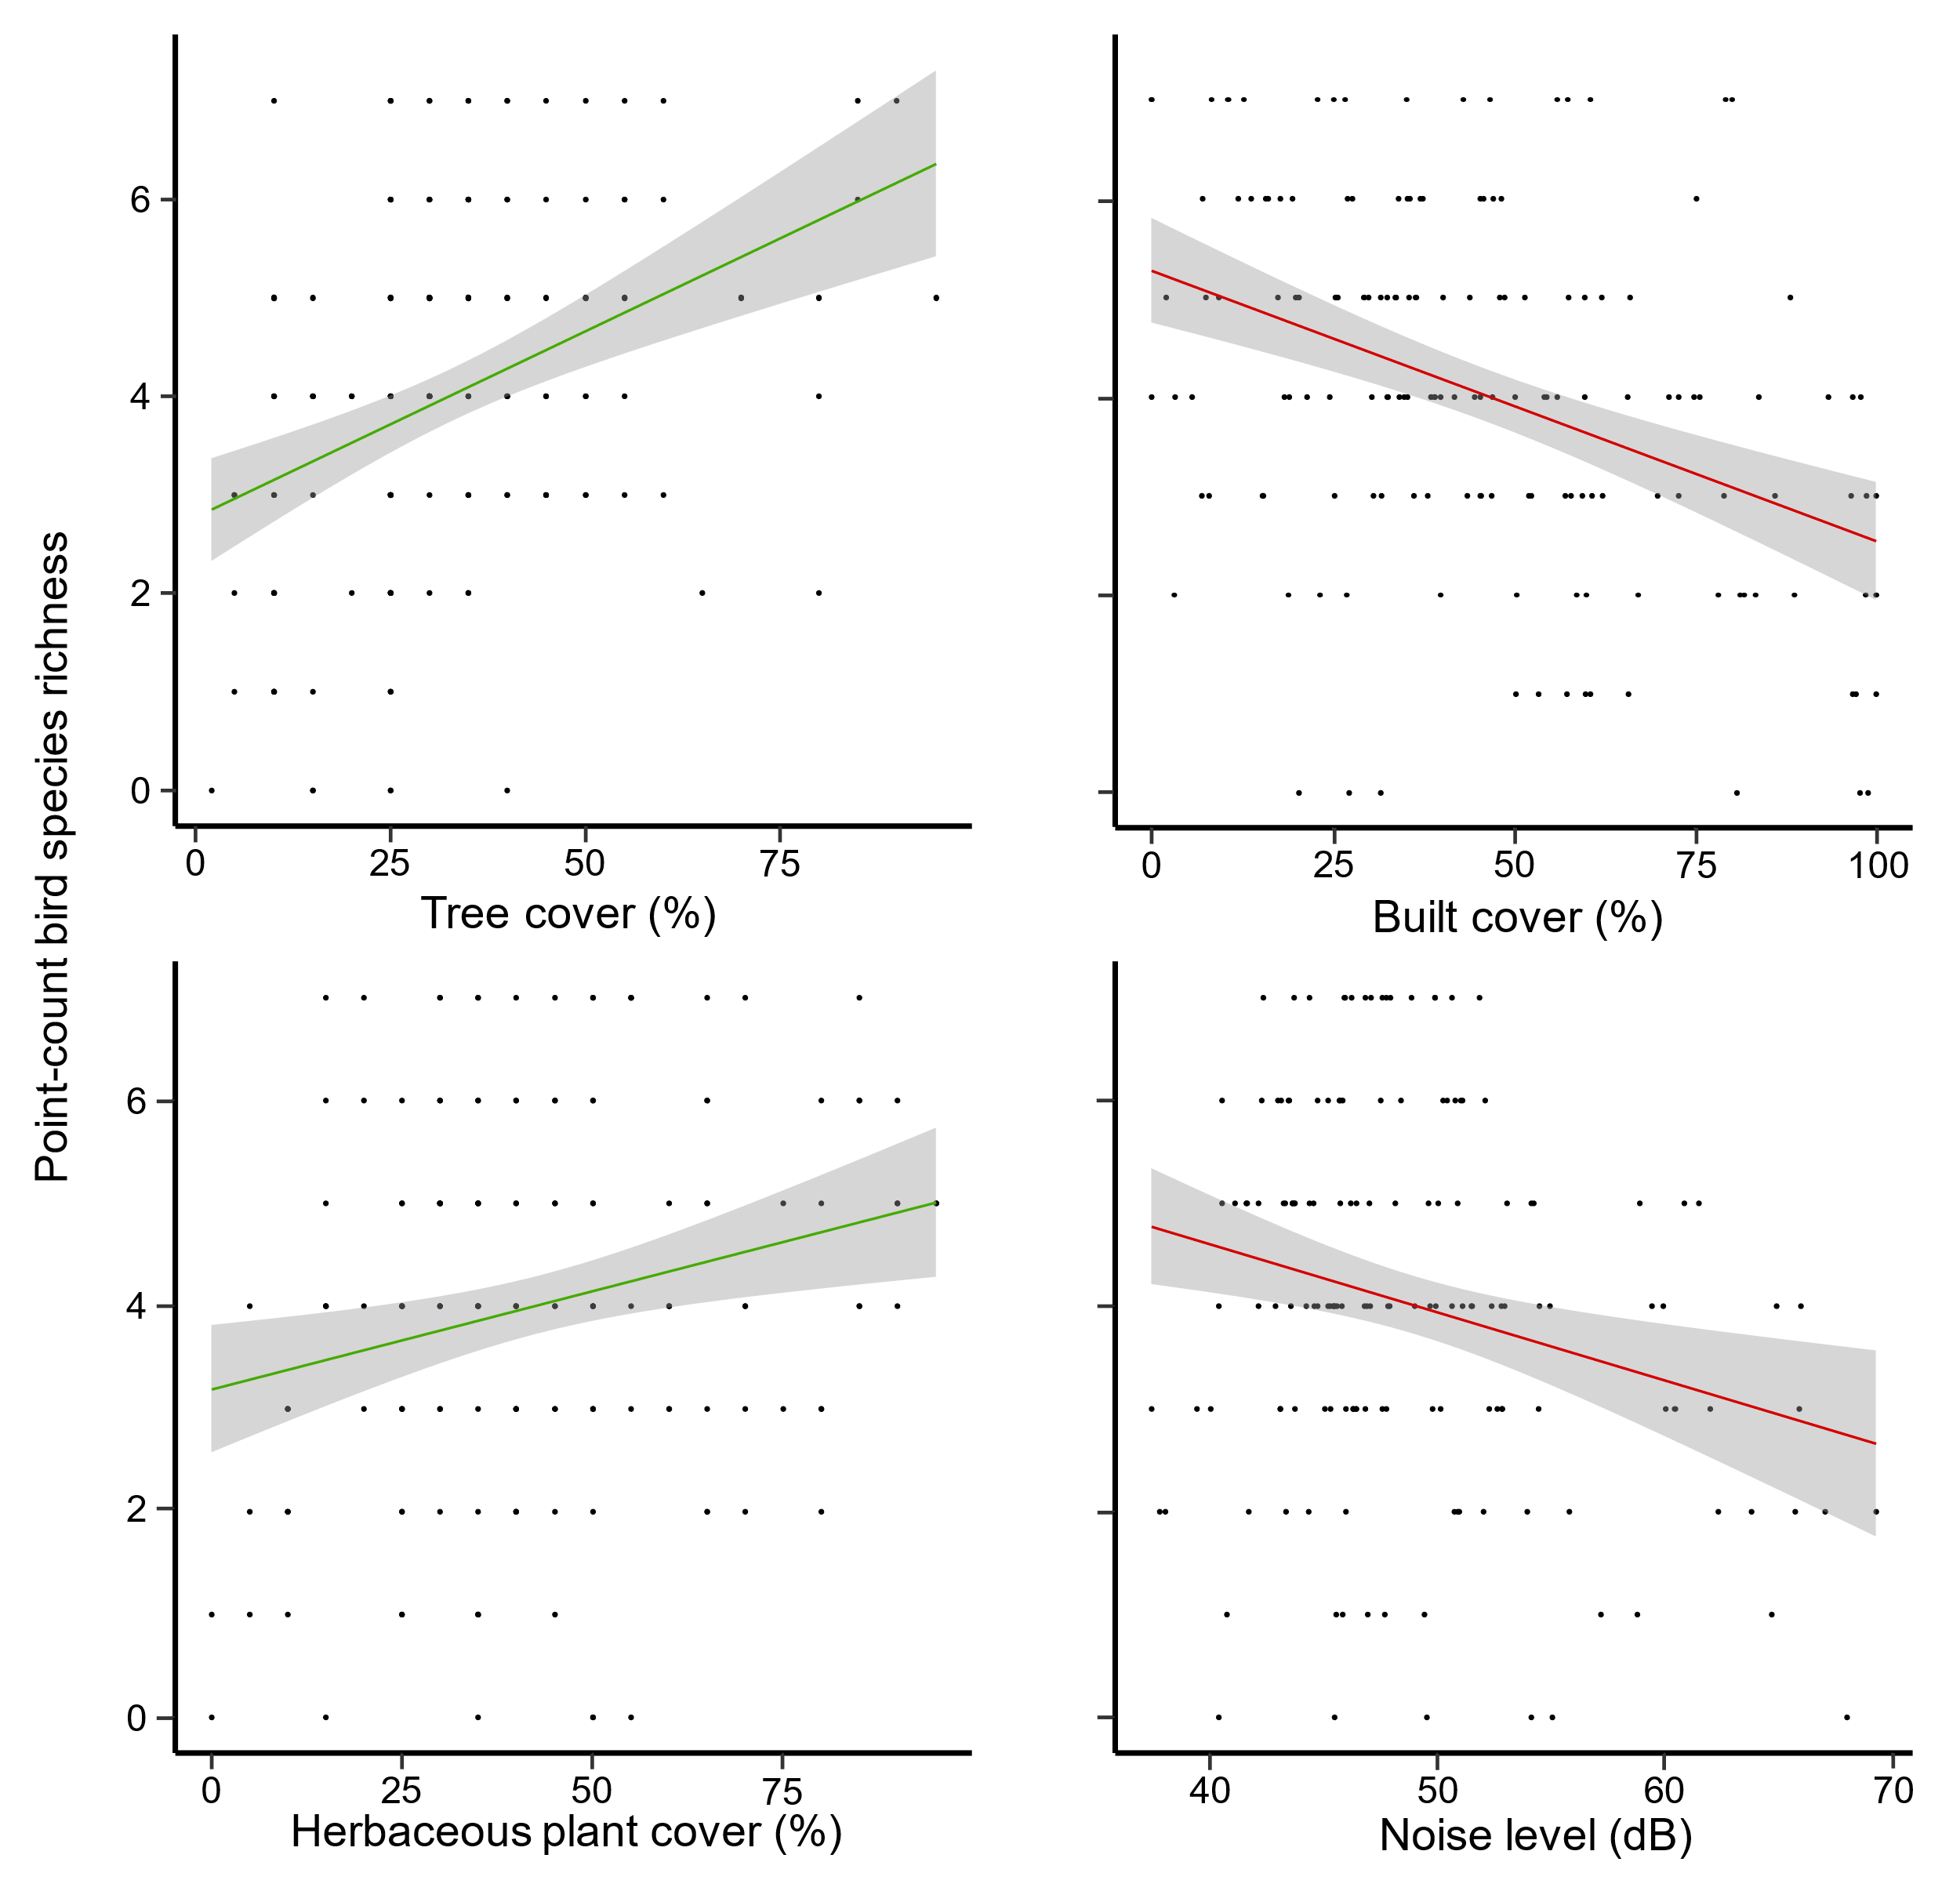

Online Resource 6
Number of bird species and abundance of individuals per habitat preferences (sensu Tobias et al. 2022) for both urbanization intensity gradient categories.

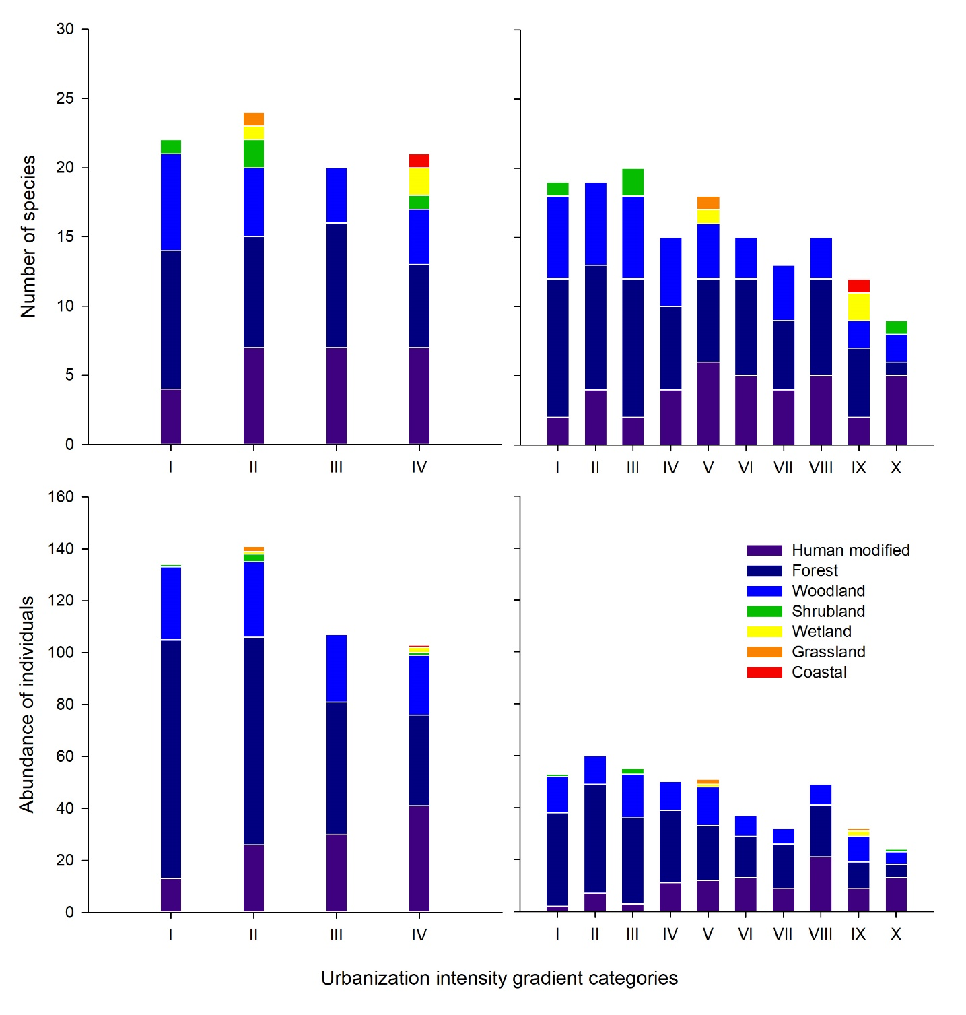

Online Resource 7
Number of bird species and abundance of individuals across trophic niches (sensu Tobias et al. 2022) for both urbanization intensity gradient categories.

