Airborne Betula, Poaceae, and Ambrosia artemisiifolia pollen and allergen exposure: A comparative study of urban and rural environments

Jana Ščevková*, Michal Hrabovský, Jozef Dušička, Matúš Žilka, Eva Zahradníková

*Jana Ščevková (author for correspondence)
address: Comenius University, Faculty of Natural Sciences, Department of Botany, Révová 39, 811 02 Bratislava, Slovakia
e-mail: jana.scevkova@uniba.sk
tel: +421-2-90142095
ORCID iD https://orcid.org/0000-0002-3432-4105

Fig. S1 Daily variation in precipitation totals, mean air temperature and Betula pollen allergen potency (PAP) levels in Bratislava (BA) and Kaplna (KP) in 2023‒2024.

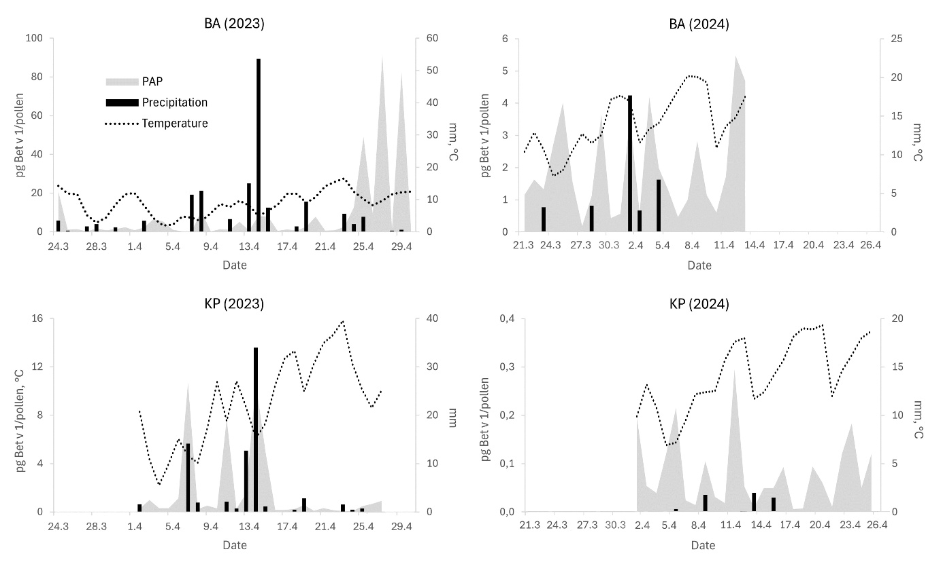
Fig. S2 Daily variation in precipitation totals, mean air temperature and Poaceae pollen allergen potency (PAP) levels in Bratislava (BA) and Kaplna (KP) in 2023‒2024.

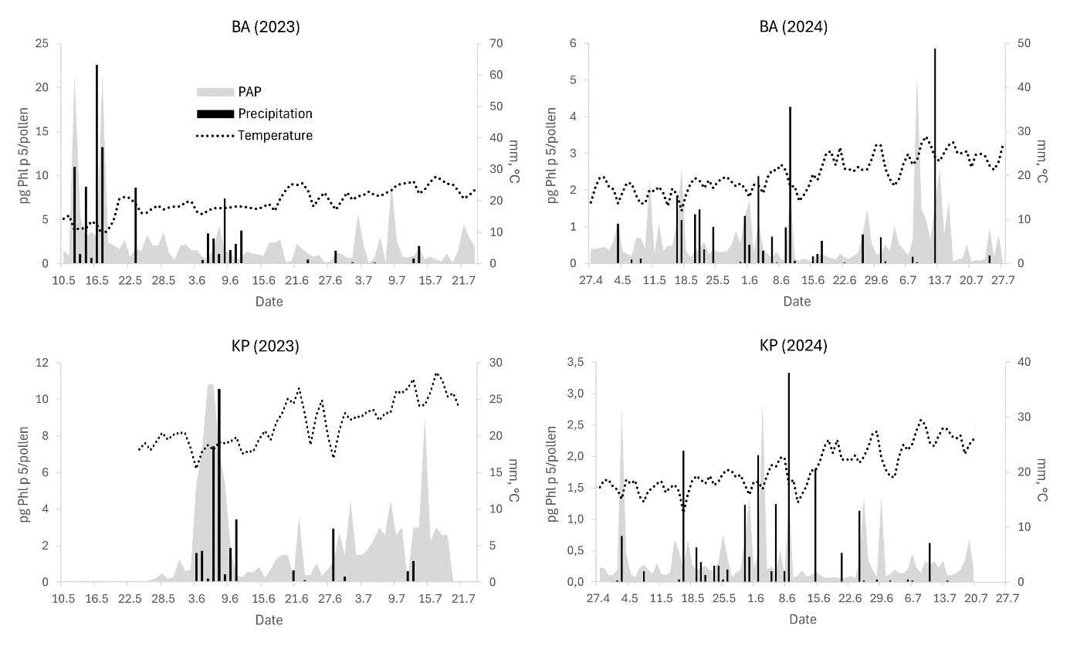
Fig. S3 Daily variation in precipitation totals, mean air temperature and Ambrosia pollen allergen potency (PAP) levels in Bratislava (BA) and Kaplna (KP) in 2023‒2024.

