SUPPLEMENTARY MATERIAL

Table S1. Extrapolated species richness for each territory and urban class sampled. The species richness estimators (Chao, First- and Second-order Jacknife, and Bootstrap) were calculated using the function specpool from the vegan R package (Oksanen et al. 2024).
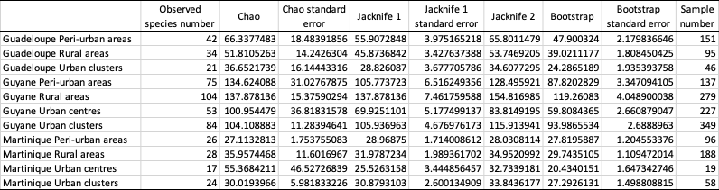

Figure S1. Species accumulation curves representing the total cumuled number of species depending on the number of samples – with 95% confidence intervals – drawn for each territory and urban class sampled. The curves were computed using the function specaccum from the vegan R package (Oksanen et al. 2024)

Figure S2. Sample-based rarefaction curves representing the number of species according to the numbe rof samples. The number of samples were rarefied to 58, which corresponds to the number of samples collected in the urban clusters of Martinique. The curves were computed using the iNEXT R package (Hsieh et al. 2016)

Figure S3. Co-occurrence matrices showing the positive and negative species associations among ant species sampled in French Guiana all areas included and for each urban class. Species names are positioned to indicate the columns and rows representing their pairwise relationships with other species. Only species with at least one positive or negative association are shown. Yellow squares indicate negative associations, blue squares indicate positive associations, and gray squares represent random associations between species pairs.

Figure S4. Co-occurrence matrices showing the positive and negative species associations among ant species sampled in Guadeloupe all areas included and for each urban class. Species names are positioned to indicate the columns and rows representing their pairwise relationships with other species. Only species with at least one positive or negative association are shown. Yellow squares indicate negative associations, blue squares indicate positive associations, and gray squares represent random associations between species pairs.

Figure S5. Co-occurrence matrices showing the positive and negative species associations among ant species sampled in Martinique all areas included and for each urban class. Species names are positioned to indicate the columns and rows representing their pairwise relationships with other species. Only species with at least one positive or negative association are shown. Yellow squares indicate negative associations, blue squares indicate positive associations, and gray squares represent random associations between species pairs.

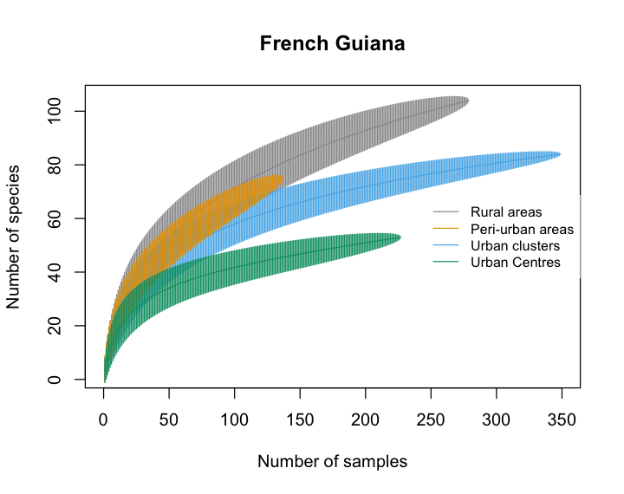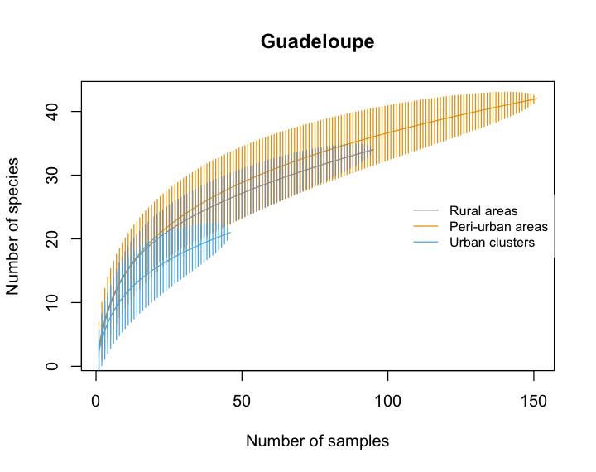
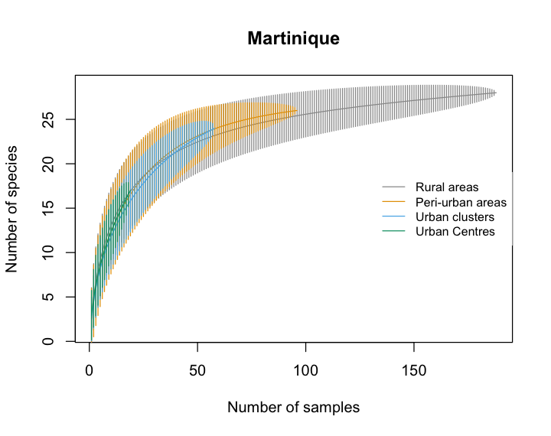
Figure S1.

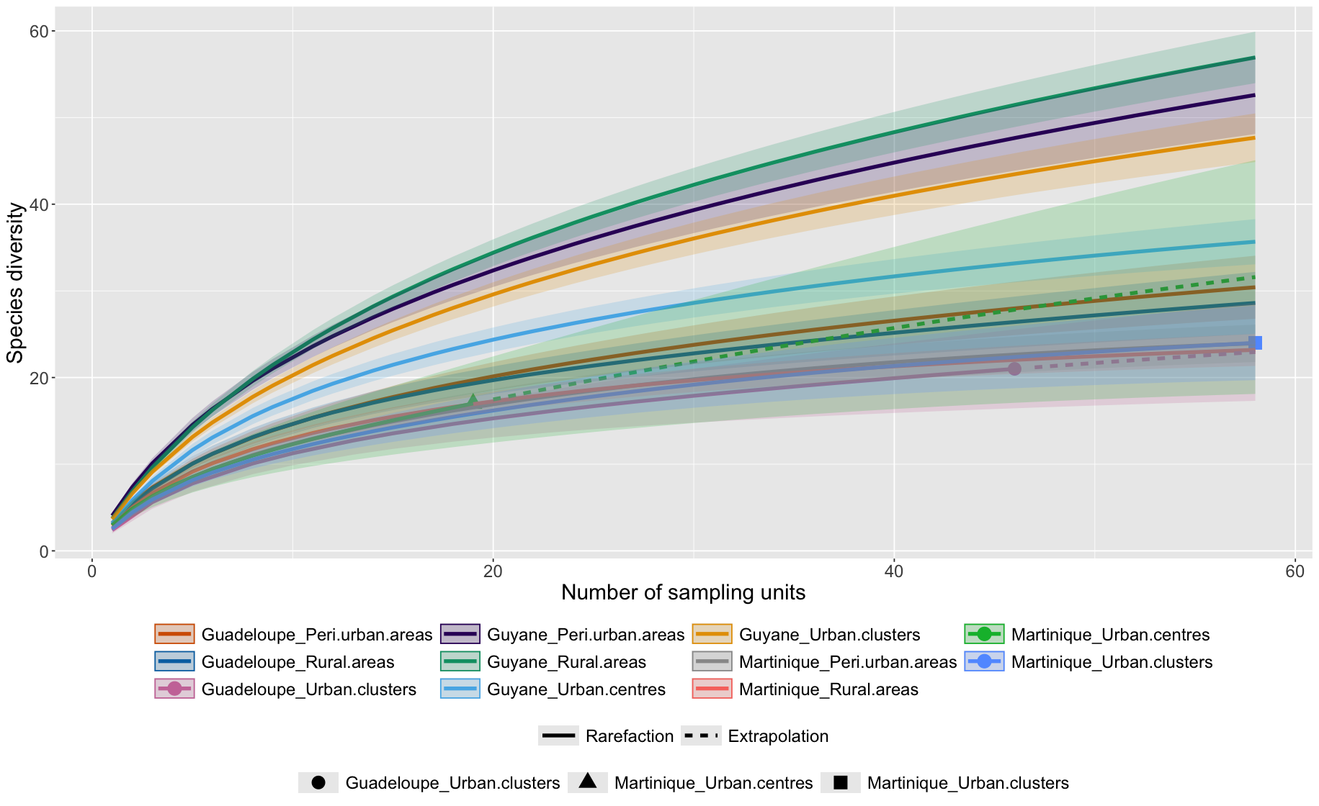
Figure S2.

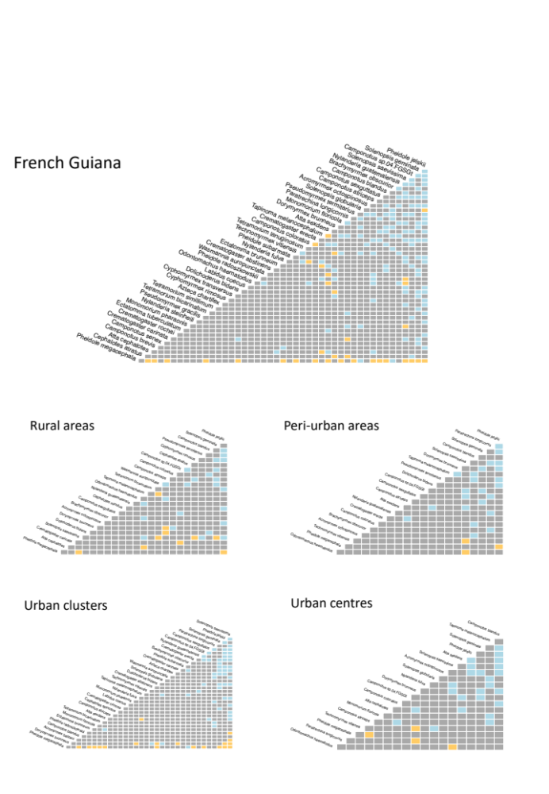
Figure S3.
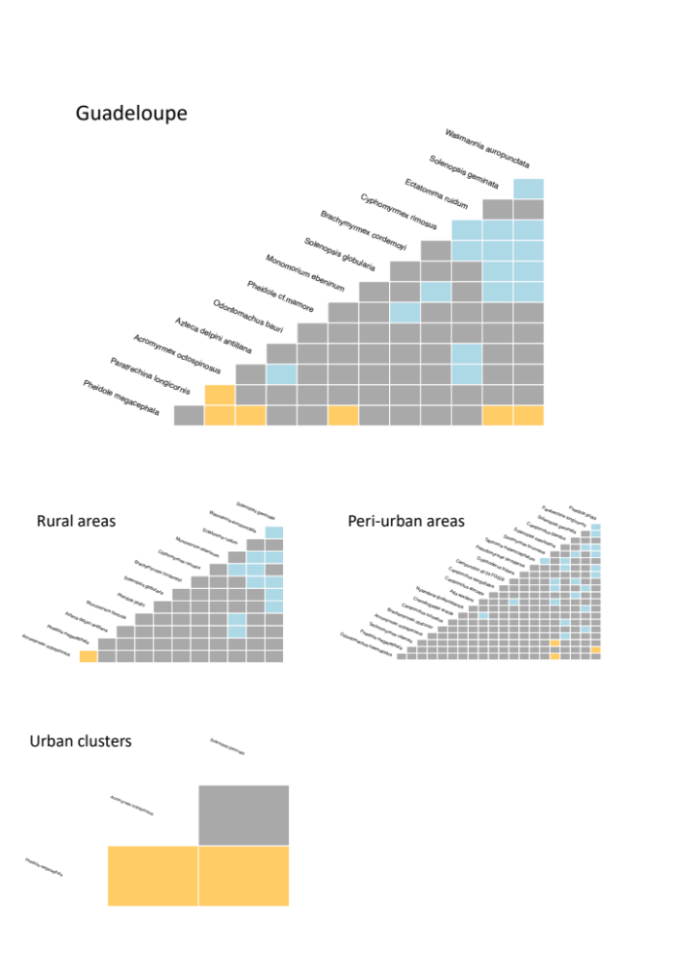
Figure S4.
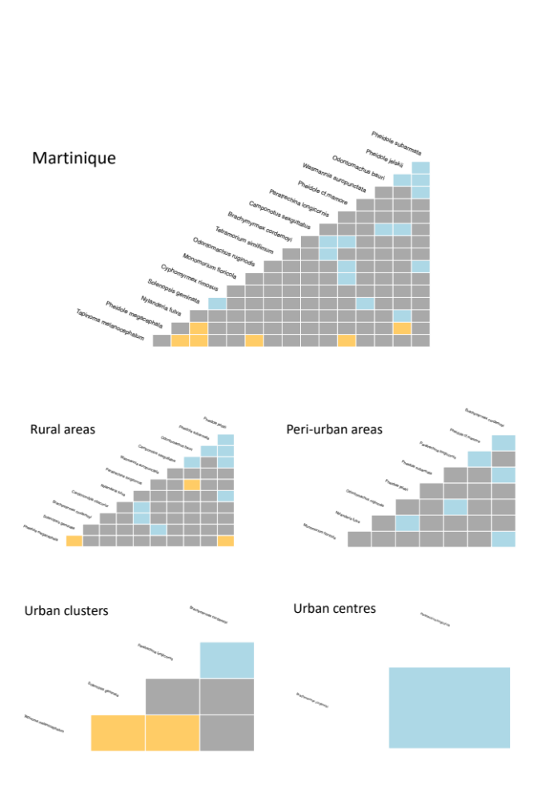
Figure S5.

References
Hsieh TC, Ma KH, Chao A (2016) iNEXT: an R package for rarefaction and extrapolation of species diversity (Hill numbers). Methods Ecol Evol 7:1451–1456. https://doi.org/10.1111/2041-210x.12613
Oksanen J, Simpson GL, Blanchet FG, et al (2024) vegan: Community Ecology Package. R package version 2.7-0, https://github.com/vegandevs/vegan.

