Urban earthworm communities are driven more by climate and elevation than urbanization intensity
Helen R. P. Phillips, Kevin Hoeffner, Bart Muys, Renée-Claire Le Bayon, Daniel Cluzeau, Kevin R. Butt, Jeanne Maréchal, Maria J. I. Briones, Thibaud Decaëns, Mickaël Hedde, Sylvain Gérard, Guénola Pérès, Lucas Petit-Dit-Grézériat, Céline Pelosi

Figure S1: Distribution of the seven climatic variables within the full dataset; mean and standard deviation (SD) of annual potential evapotranspiration (‘PET’) (a & b), annual precipitation (c & d) annual temperature (e & f), and aridity index (g).
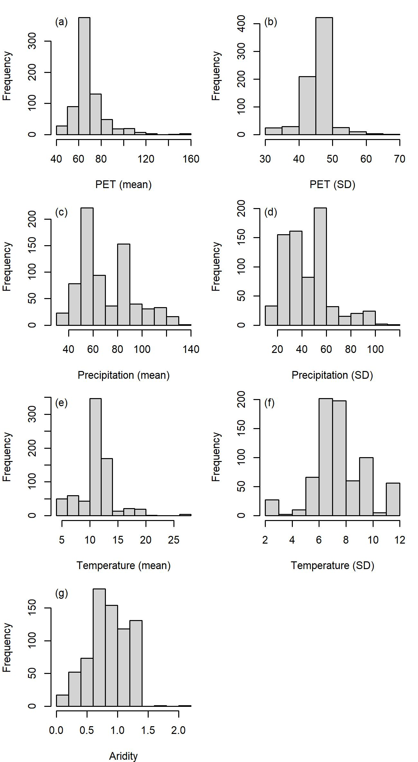

Figure S2: Frequency of soil types within the dataset. Soil type data from SoilGrids (Hengl et al., 2017). Each site was classified based on the soil type that had the highest probability of occurrence (‘MostProbable’ data layer). NB: Urban soil types Anthrosols, Technosols and Retisols are not considered in SoilGrids. Numbers atop of each bar indicate the number of records, smaller numbers in brackets the number of studies.

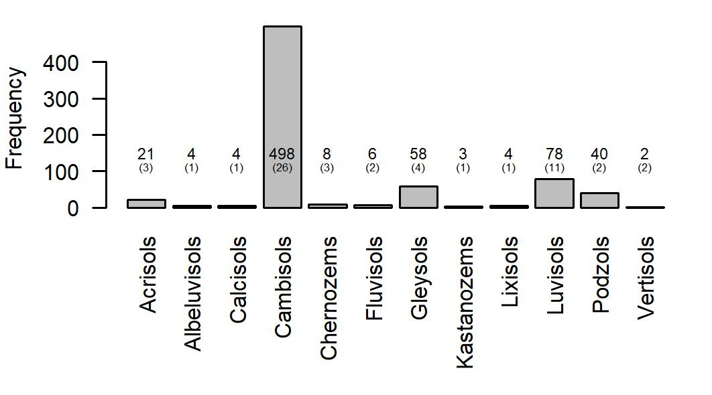

Table S1. Extracted dataset. See separate .xlsx file.
Table S2: Detailed information about the variables extracted from the selected papers
Data group | Data | Data Type and Unit | Details
Metadata | Author | Nominal | Surname of first author.
 | Year of publication | Date
 | Year of sampling | Date | When no information was available, we used the publication year minus 2, based on an estimated time of sample handling, identifying earthworms and analysing data.
 | Period of sampling | Text | To remove intra-annual variations in earthworm communities when several samplings were done within a year in a study, we kept only one date, i.e., the most central considering all the sampling dates and relevant for earthworm activity.
 | Extraction method | Nominal (6 classes) | Handsorting only, chemical extraction, mustard extraction, handsorting + chemical extraction, handsorting + mustard extraction, and electrical.  Data sampled using other methods were not included.
 | Level of aggregation | Rank (3 levels) | Aggregative status of the data: sampling point (level 1); mean of several sampling points on the same plot or parcel (pseudo-replicates; level 2); mean of several plots or parcels with the same land use (replicates; level 3).
Location | Coordinates | Decimal degrees | Either given by the authors, or georeferenced based on maps or place names in the text.
 | Localization quality | Rank (3 levels) | Precision of the sampling location: GPS coordinates provided by the authors (level 1); sampling location derived from a map or e.g., toponyms of street or park (level 2); biodiversity data was the average of sites from different locations, thus GPS of a random sampling point was used (level 3).
Land use and land cover | Local land use & use intensity | Nominal (9 classes) | Arable high intensity, arable medium intensity, grass high intensity, grass medium intensity, grass low intensity, lawn, ruderal, trees managed, and trees unmanaged.  Low intensity was categorized by i.e., mowing or 1-2 interventions per year, which could be biocides, fertilization or other soil disturbance; high intensity with i.e., recurrent physical or chemical disturbances > twice a year.  When land use intensities were missing, they were sometimes inferred. For example, unknown intensities for arable sites were assumed to be ‘high’ intensity. And tree sites with no intensity were assumed to be managed.
 | Corine land cover | Nominal (classes) | Land use, using the first level of Corine Land Cover (https://www.statistiques.developpement-durable.gouv.fr/corine-land-cover-0); Artificial areas: 100; Agricultural areas: 200; Forest and semi-natural areas: 300.
Earthworms | Species richness | Numerical | Given by the authors or calculated based on the list of observed according to the recorded species.
 | Abundance | Numerical (ind.m⁻²) | If available, with standard deviation or standard error, and the number of samples (N). When given in different units, the data were converted based on area sampled.
 | Biomass | Numerical (g.m⁻²) | If available, with standard deviation or standard error, and the number of samples (N). When given in different units, the data were converted based on area sampled.
 | Abundance per ecological category | Numerical (ind.m⁻²) | When not given, species were matched to ecological categories based on data in DriloBASE and Phillips et al., (2021). If data was still missing, additional published articles were searched for ecological information to infer the ecological category.
Soil | Texture | Numerical (%) | Percentages of the soil texture: sand, clay and silt.
 | pH | Numerical | We used conversion factors for the pH to incorporate data when given in pH_{CaCl2} and pH_{KCl}.  To obtain pH_{H2O} from pH_{CaCl2}, we converted by adding 0.8 to the pH_{CaCl2} value according to Lake (2000). To obtain pH_{H2O} from pH_{KCl}, we made the conversion by using the formula: pH_{H2O} = (0.91 x pH_{KCl}) + 1.34 (Grove & Richey 2022).
 | Organic matter | Numerical (%) | When authors gave the organic carbon, we used the factor of conversion of 1.724 proposed by Howard (1965).

Table S3: Detailed overview of external data used in the analysis
Dataset | Variable | Resolution | Temporally Matched | Treatment | Reference
CHELSA Monthly Timeseries v2.1 | Temperature mean | 30 arc seconds  Monthly from 1990 to 2018 | Matched annually. Sample years before 1990 were matched to 1990, and those are 2018 were matched to 2018. | Mean value across all months in the year of sample | Karger et al., 2021
CHELSA Monthly Timeseries v2.1 | Precipitation mean
CHELSA Monthly Timeseries v2.1 | Potential evapotranspiration mean
CHELSA Monthly Timeseries v2.1 | Temperature SD | 30 arc seconds  Monthly from 1990 to 2018 |  | Standard deviation of the mean value across all months in the year of sample | Karger et al., 2021
CHELSA Monthly Timeseries v2.1 | Precipitation SD
CHELSA Monthly Timeseries v2.1 | Potential evapotranspiration SD
Global Aridity Index Database version 3 | Aridity Index | 30 arc seconds  Mean from 1976-2000 | No | Each sample site matched to grid cell | Zomer et al., 2022
Köppen-Geiger Classification | Köppen | 0.5 degrees  Static map | No | Each sample site matched to grid cell | Rubel et al., 2010
Gridded Population of the World (GPW) version 4 | Human Population Density (humans.km⁻²) | 30 arc second  2000, 2005, 2010, 2015 and 2020 | Sample years matched to their closest 5-year interval (e.g, 2017 matched to 2015 and 2018 to 2020) | Each sample site matched to grid cell | CIESIN, 2018
GHS Urban Centre Database 2015 version 1.0 | Distance to Urban Core (metres) | 1km  Static map | No | Each sample point matched the nearest Urban core using the ‘distm’ function from the Geosphere package and a ‘distHaversine’ calculation | Florczyk et al., 2019
GHS Urban Centre Database 2015 version 1.0 | Area of Urban Centre (km²) | 1km  Static map | No | Each sample point matched to the nearest urban core. | Florczyk et al., 2019
Global Roads Inventory Project - GRIP version 4 | Density of all roads (m.km⁻²) | 0.08333 degrees  Static map | No | Each sample site matched to grid cell | Meijer et al., 2018
Land-Use Harmonization 2 (LUH2) dataset | Proportion of urban land use (1km) | 1km  2000 to 2015 | Matched annually. Sample years before 2000 were matched to 2000. | 0.25 x 0.25 degree cells were aggregated to form 1x1km grid cell.  Each sample site matched to grid cell | Hurtt et al., 2020
Digital Elevation - Global Multi-resolution Terrain Elevation Data 2010 | Elevation (m) | 30 second arc  Static map | No | Each sample site matched to grid cell | Danielson et al., 2011
High-resolution global topographic index values | Topographic Index | 15 second arc  Static map | No | Each sample site matched to grid cell | Marthews et al., 2015
Global Landform classification: Iwahashi and Pike classes | Landform Classification | 30 second arc  Static map | No | Each sample site matched to grid cell | Iwahashi & Pike, 2007  (from ESDAC, Joint Research Centre; Panagos et al., 2022)

Table S4: The number of records (n) and articles (N) within each Köppen category.
Köppen Class | n | N
Af | 2 | 1
Am | 3 | 1
BSk | 4 | 1
Cfa | 9 | 3
Cfb | 485 | 28
Csa | 24 | 2
Dfa | 28 | 1
Dfb | 65 | 6
Dfc | 48 | 2
Dwa | 55 | 2

Supplementary References
References from supplementary materials (Tables S2 & S3)

CIESIN. (2018). Gridded Population of the World, Version 4 (GPWv4): Basic Characteristics, Revision 11. Palisades, NY: NASA Socioeconomic Data and Applications Center (SEDAC). Columbia University Center for International Earth Science Information Network (CIESIN) - Columbia University.
Danielson, JJ., & Gesch, DB. (2011). Global Multi-resolution Terrain Elevation Data 2010(GMTED2010). In U.S. Geological Survey. https://doi.org/citeulike-article-id:13365221
Hengl, T., Mendes de Jesus, J., Heuvelink, G. B. M., Ruiperez Gonzalez, M., Kilibarda, M., Blagotić, A., Shangguan, W., Wright, M. N., Geng, X., Bauer-Marschallinger, B., Guevara, M. A., Vargas, R., MacMillan, R. A., Batjes, N. H., Leenaars, J. G. B., Ribeiro, E., Wheeler, I., Mantel, S., & Kempen, B. (2017). SoilGrids250m: Global gridded soil information based on machine learning. PLOS ONE, 12(2), e0169748. https://doi.org/10.1371/journal.pone.0169748
Howard, P. J. A. (1965). The Carbon-Organic Matter Factor in Various Soil Types. Oikos, 15(2). https://doi.org/10.2307/3565121
Hurtt, G. C., Chini, L., Sahajpal, R., Frolking, S., Bodirsky, B. L., Calvin, K., Doelman, J. C., Fisk, J., Fujimori, S., Goldewijk, K. K., Hasegawa, T., Havlik, P., Heinimann, A., Humpenöder, F., Jungclaus, J., Kaplan, J. O., Kennedy, J., Krisztin, T., Lawrence, D., … Zhang, X. (2020). Harmonization of global land use change and management for the period 850-2100 (LUH2) for CMIP6. Geoscientific Model Development, 13(11). https://doi.org/10.5194/gmd-13-5425-2020
Iwahashi, J., & Pike, R. J. (2007). Automated classifications of topography from DEMs by an unsupervised nested-means algorithm and a three-part geometric signature. Geomorphology, 86(3–4). https://doi.org/10.1016/j.geomorph.2006.09.012
Karger, D. N., Conrad, O., Böhner, J., Kawohl, T., Kreft, H., Soria-Auza, R. W., Zimmermann, N. E., Linder, H. P., & Kessler, M. (2021). Data from: Climatologies at high resolution for the earth’s land surface areas [Dataset]. EnviDat.
Lake, B. (2000). Understanding soil pH. https://www.dpi.nsw.gov.au/__data/assets/pdf_file/0003/167187/soil-ph.pdf
Meijer, J. R., Huijbregts, M. A. J., Schotten, K. C. G. J., & Schipper, A. M. (2018). Global patterns of current and future road infrastructure. Environmental Research Letters, 13(6). https://doi.org/10.1088/1748-9326/aabd42
Panagos, P., Van Liedekerke, M., Borrelli, P., Köninger, J., Ballabio, C., Orgiazzi, A., Lugato, E., Liakos, L., Hervas, J., Jones, A., & Montanarella, L. (2022). European Soil Data Centre 2.0: Soil data and knowledge in support of the EU policies. European Journal of Soil Science, 73(6). https://doi.org/10.1111/ejss.13315
Phillips, H. R. P., Bach, E. M., Bartz, M. L. C., Bennett, J. M., Beugnon, R., Briones, M. J. I., Brown, G. G., Ferlian, O., Gongalsky, K. B., Guerra, C. A., König-Ries, B., Krebs, J. J., Orgiazzi, A., Ramirez, K. S., Russell, D. J., Schwarz, B., Wall, D. H., Brose, U., Decaëns, T., … Eisenhauer, N. (2021). Global data on earthworm abundance, biomass, diversity and corresponding environmental properties. Scientific Data, 8(1), 136. https://doi.org/10.1038/s41597-021-00912-z
Rubel, F., & Kottek, M. (2010). Observed and projected climate shifts 1901-2100 depicted by world maps of the Köppen-Geiger climate classification. Meteorologische Zeitschrift, 19(2). https://doi.org/10.1127/0941-2948/2010/0430
Zomer, R. J., Xu, J., & Trabucco, A. (2022). Version 3 of the Global Aridity Index and Potential Evapotranspiration Database. Scientific Data, 9(1). https://doi.org/10.1038/s41597-022-01493-1

