Supplementary materials

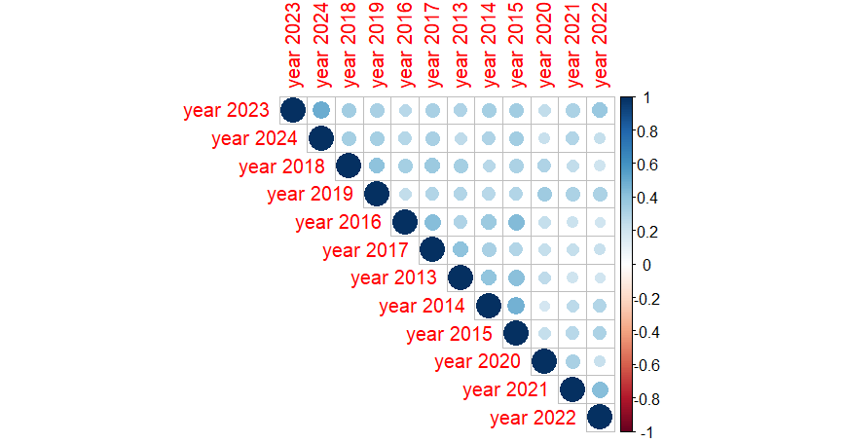

Figure S1. Correlation matrix between densities across years to implement the spatial GAM model.

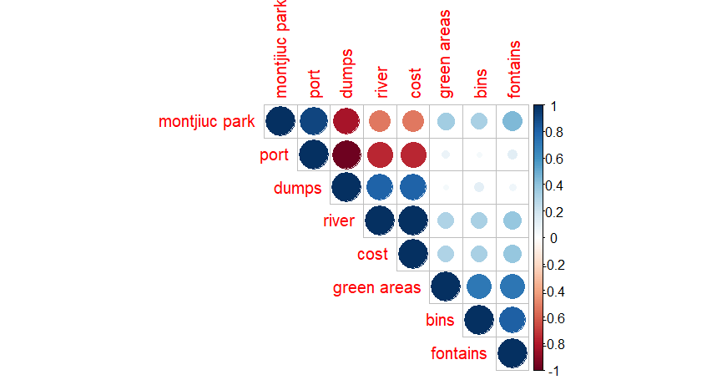

Figure S2. Correlation matrix between calculated distances to implement the spatial GAM model.

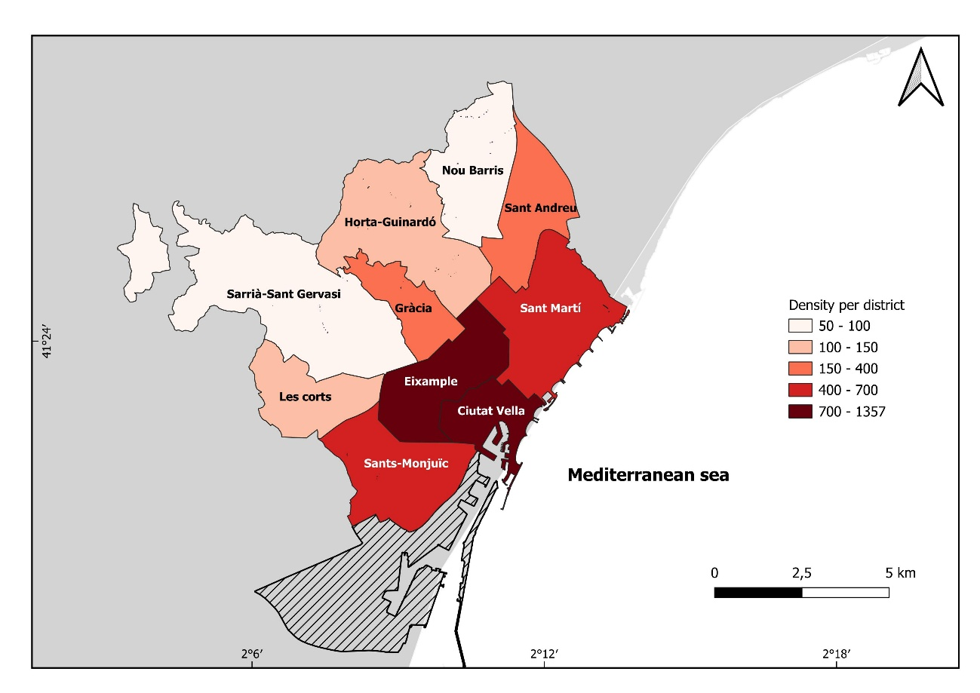
Figure S3. Total density (nº/km²) of reported nest available organized in districts within the city of Barcelona.

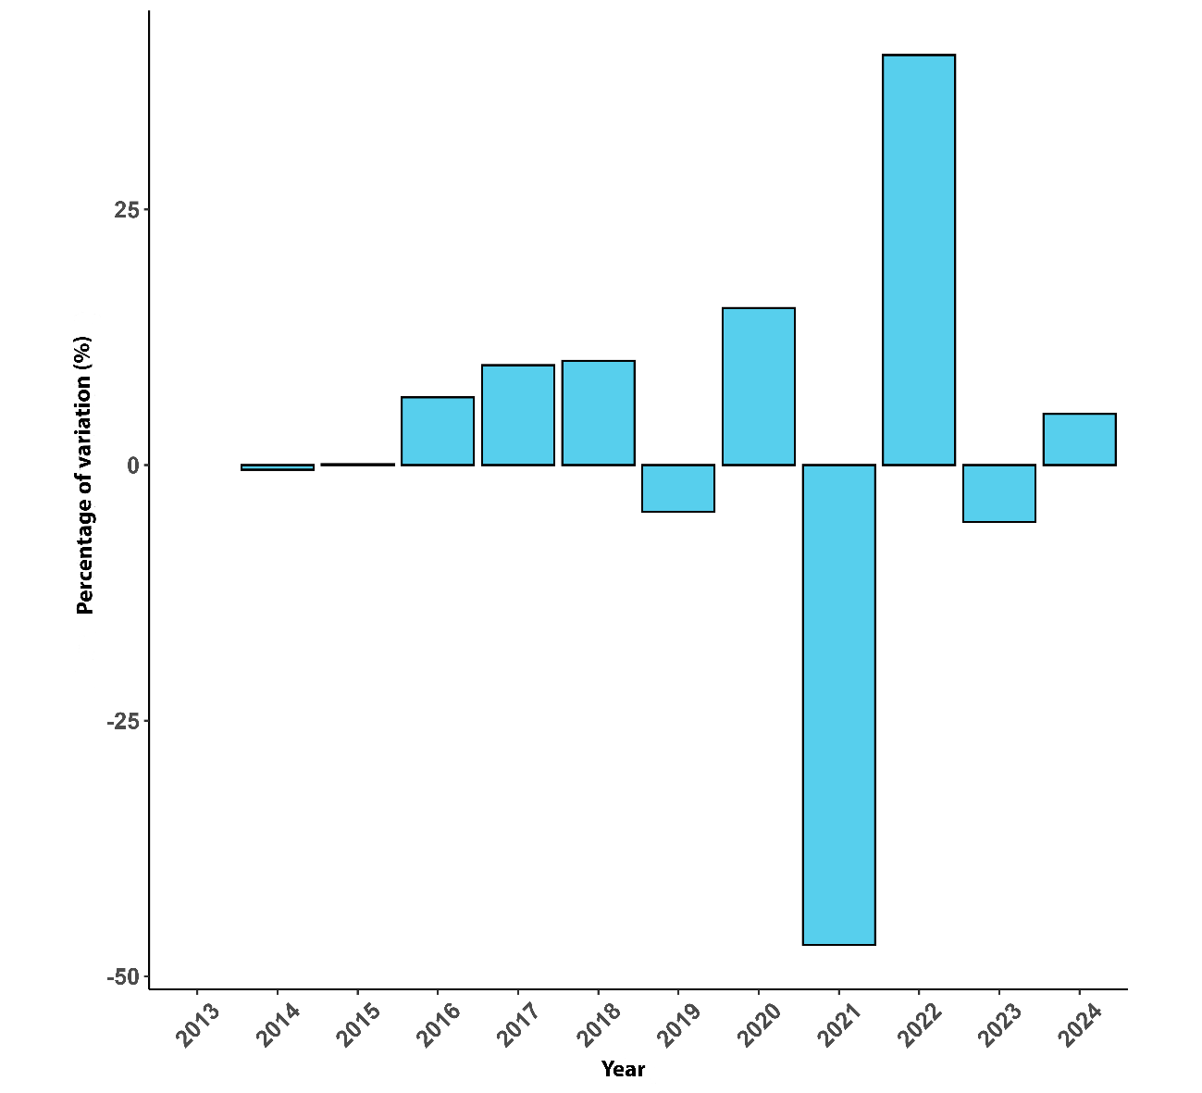

Figure S4. Percentage of variation between year 1 and year -1.

