Supporting information for the manuscript “Invasive alien plants and the city: distribution patterns in response to urban elements and urbanization in three of the largest cities in Italy”
S.3 PERMANOVA
Table S3 – Multivariate PERMANOVA and PAIR-WISE comparisons results across cities (A), urban categories (B) and urban elements (C) (* = significant dissimilarity p ≤ 0.05; ** = significant dissimilarity p ≤ 0.01).
a
Number of records - PERMANOVA
Source | DF | Pseudo-F | p (perm)
Cities | 2 | 20.814 | 0.001*
PAIR-WISE COMPARISON
Groups |  | t | p (perm)
Milano, Roma |  | 4.9447 | 0.001*
Milano, Torino |  | 2.1702 | 0.001*
Roma, Torino |  | 5.6405 | 0.001*

b
Number of records - PERMANOVA
Source | DF | Pseudo-F | p (perm)
Urban elements | 7 | 8.4013 | 0.0001
PAIR-WISE COMPARISON
Groups | t | p (perm)
Abandoned_areas, Agricultural_areas | 2.3712 | 0.0001**
Abandoned_areas, Buildings | 2.6934 | 0.0001**
Abandoned_areas, Green_areas | 2.8099 | 0.0001**
Abandoned_areas, Infrastructures | 2.5387 | 0.0001**
Abandoned_areas, Nat_env | 1.6142 | 0.0051**
Abandoned_areas, Service_areas | 2.8255 | 0.0001**
Abandoned_areas, Water | 1.7434 | 0.0017**
Agricultural_areas, Buildings | 3.6644 | 0.0001**
Agricultural_areas, Green_areas | 2.5981 | 0.0001**
Agricultural_areas, Infrastructures | 2.9114 | 0.0001**
Agricultural_areas, Nat_env | 2.1108 | 0.0002**
Agricultural_areas, Service_areas | 3.3282 | 0.0001**
Agricultural_areas, Water | 1.8053 | 0.0008**
Buildings, Green_areas | 4.4399 | 0.0001**
Buildings, Infrastructures | 4.2125 | 0.0001**
Buildings, Nat_env | 1.8429 | 0.0009**
Buildings, Service_areas | 1.686 | 0.0029**
Buildings, Water | 2.7091 | 0.0001**
Green_areas, Infrastructures | 1.678 | 0.0048**
Green_areas, Nat_env | 2.9094 | 0.0001**
Green_areas, Service_areas | 4.1277 | 0.0001**
Green_areas, Water | 3.0063 | 0.0001**
Infrastructures, Nat_env | 2.9105 | 0.0001**
Infrastructures, Service_areas | 4.1113 | 0.0001**
Infrastructures, Water | 3.038 | 0.0001**
Nat_env, Service_areas | 2.1668 | 0.0001**
Nat_env, Water | 1.3076 | 0.0559
Service_areas, Water | 2.8821 | 0.0001**

c
Number of records - PERMANOVA
Source | DF | Pseudo-F | p (perm)
Urban categories | 3 | 3.2418 | 0.0003*
PAIR-WISE COMPARISON
Groups |  | t | p (perm)
HL, HM |  | 1.5938 | 0.0173*
HL, LH |  | 2.1129 | 0.0009*
HL, LM |  | 2.3129 | 0.0001*
HM, LH |  | 1.5604 | 0.0262*
HM, LM |  | 1.8863 | 0.0052*
LH, LM |  | 0.99544 | 0.4043

Table S3.1 – Taxa contributing the most to dissimilarities in frequency of taxa (number of records of occurrence) among urban elements based on SIMPER Test (Resemblance: S17 Bray-Curtis similarity; Cut off for low contributions: 70.00%)
Groups Abandoned_areas & Agricultural_areas |  | Average dissimilarity = 75.15 |  |  |  |  |  |  | Groups Agricultural_areas & Green_areas |  | Average dissimilarity = 72.61
Species | Abandoned-Av.Abund | Agricultural- Av.Abund |  | Av.Diss | Diss/SD | Contrib% | Cum.% |  | Species | Agricultural -Av.Abund | Green - Av.Abund | Av.Diss | Diss/SD | Contrib% | Cum.%
Rob_pse | 4.82 | 4.38 |  | 12.26 | 0.82 | 16.31 | 16.31 |  | Sor_hal | 6.07 | 8.83 | 12.79 | 1.13 | 17.62 | 17.62
Sor_hal | 2.82 | 6.07 |  | 11.82 | 1.05 | 15.73 | 32.04 |  | Ail_alt | 2.3 | 9.08 | 11.77 | 1.04 | 16.21 | 33.82
Ail_alt | 6.36 | 2.3 |  | 11.07 | 0.96 | 14.73 | 46.77 |  | Phy_ame | 4.27 | 7.62 | 10.56 | 1.25 | 14.55 | 48.37
Phy_ame | 3.13 | 4.27 |  | 8.68 | 1.15 | 11.55 | 58.32 |  | Rob_pse | 4.38 | 4.08 | 9.38 | 0.77 | 12.92 | 61.29
Par_sp | 2.26 | 2.52 |  | 6.03 | 0.99 | 8.03 | 66.35 |  | Par_sp | 2.52 | 3.27 | 5.78 | 1 | 7.96 | 69.25
Ulm_sp | 3.05 | 1.1 |  | 5.37 | 0.86 | 7.14 | 73.5 |  | Ulm_sp | 1.1 | 4.07 | 5.22 | 0.75 | 7.19 | 76.44
Groups Abandoned_areas & Buildings |  | Average dissimilarity = 80.71 |  |  |  |  |  |  | Groups Buildings & Green_areas |  | Average dissimilarity = 83.17
Species | Abandoned-Av.Abund | Buildings- Av.Abund |  | Av.Diss | Diss/SD | Contrib% | Cum.% |  | Species | Buildings -Av.Abund | Green - Av.Abund | Av.Diss | Diss/SD | Contrib% | Cum.%
Ail_alt | 6.36 | 2.33 |  | 16.52 | 1.02 | 20.47 | 20.47 |  | Sor_hal | 0.65 | 8.83 | 16.3 | 1.08 | 19.6 | 19.6
Rob_pse | 4.82 | 0.54 |  | 10.72 | 0.75 | 13.28 | 33.75 |  | Ail_alt | 2.33 | 9.08 | 15.9 | 1.06 | 19.11 | 38.71
Phy_ame | 3.13 | 1.33 |  | 9.35 | 1.09 | 11.59 | 45.34 |  | Phy_ame | 1.33 | 7.62 | 13 | 1.26 | 15.63 | 54.34
Ulm_sp | 3.05 | 1.36 |  | 8.43 | 0.91 | 10.45 | 55.79 |  | Rob_pse | 0.54 | 4.08 | 7.62 | 0.68 | 9.17 | 63.5
Sor_hal | 2.82 | 0.65 |  | 8.1 | 0.8 | 10.04 | 65.83 |  | Ulm_sp | 1.36 | 4.07 | 7.25 | 0.82 | 8.71 | 72.22
Par_sp | 2.26 | 0.93 |  | 6.48 | 0.91 | 8.03 | 73.85
Groups Agricultural_areas & Buildings |  | Average dissimilarity = 83.87 |  |  |  |  |  |  | Groups Abandoned_areas & Infrastructures |  | Average dissimilarity = 73.93
Species | Agricultural-Av.Abund | Buildings- Av.Abund |  | Av.Diss | Diss/SD | Contrib% | Cum.% |  | Species | Abandoned -Av.Abund | Infrastructures - Av.Abund | Av.Diss | Diss/SD | Contrib% | Cum.%
Sor_hal | 6.07 | 0.65 |  | 16.79 | 1.12 | 20.03 | 20.03 |  | Ail_alt | 6.36 | 9.53 | 14.51 | 1.06 | 19.63 | 19.63
Rob_pse | 4.38 | 0.54 |  | 13.45 | 0.73 | 16.04 | 36.07 |  | Sor_hal | 2.82 | 8.58 | 11.8 | 0.98 | 15.96 | 35.58
Ail_alt | 2.3 | 2.33 |  | 10.25 | 0.88 | 12.22 | 48.28 |  | Rob_pse | 4.82 | 5.26 | 9.92 | 0.78 | 13.41 | 49
Phy_ame | 4.27 | 1.33 |  | 10.09 | 1.11 | 12.03 | 60.32 |  | Ulm_sp | 3.05 | 6.36 | 9.57 | 0.87 | 12.94 | 61.94
Par_sp | 2.52 | 0.93 |  | 7.2 | 0.94 | 8.59 | 68.9 |  | Phy_ame | 3.13 | 4.65 | 7.06 | 1.06 | 9.55 | 71.49
Ulm_sp | 1.1 | 1.36 |  | 5.34 | 0.76 | 6.37 | 75.27
Groups Abandoned_areas & Green_areas |  | Average dissimilarity = 74.18 |  |  |  |  |  |  | Groups Agricultural_areas & Infrastructures |  | Average dissimilarity = 73.77
Species | Abandoned -Av.Abund | Green - Av.Abund |  | Av.Diss | Diss/SD | Contrib% | Cum.% |  | Species | Agricultural -Av.Abund | Infrastructures - Av.Abund | Av.Diss | Diss/SD | Contrib% | Cum.%
Ail_alt | 6.36 | 9.08 |  | 14.03 | 1.09 | 18.91 | 18.91 |  | Sor_hal | 6.07 | 8.58 | 12.62 | 1.13 | 17.11 | 17.11
Sor_hal | 2.82 | 8.83 |  | 12.14 | 1.01 | 16.37 | 35.28 |  | Ail_alt | 2.3 | 9.53 | 12.57 | 0.98 | 17.04 | 34.15
Phy_ame | 3.13 | 7.62 |  | 9.85 | 1.18 | 13.28 | 48.57 |  | Rob_pse | 4.38 | 5.26 | 10.24 | 0.78 | 13.88 | 48.04
Rob_pse | 4.82 | 4.08 |  | 8.95 | 0.81 | 12.06 | 60.62 |  | Ulm_sp | 1.1 | 6.36 | 8.67 | 0.8 | 11.75 | 59.79
Ulm_sp | 3.05 | 4.07 |  | 6.65 | 0.88 | 8.96 | 69.59 |  | Phy_ame | 4.27 | 4.65 | 8.03 | 1.1 | 10.88 | 70.67
Par_sp | 2.26 | 3.27 |  | 5.6 | 0.99 | 7.54 | 77.13
Groups Buildings & Infrastructures |  | Average dissimilarity = 82.62 |  |  |  |  |  |  | Groups Abandoned_areas & Nat_env |  | Average dissimilarity = 78.32
Species | Buildings -Av.Abund | Infrastructures - Av.Abund |  | Av.Diss | Diss/SD | Contrib% | Cum.% |  | Species | Abandoned -Av.Abund | Natural - Av.Abund | Av.Diss | Diss/SD | Contrib% | Cum.%
Ail_alt | 2.33 | 9.53 |  | 16.5 | 1.03 | 19.97 | 19.97 |  | Ail_alt | 6.36 | 4.48 | 15.72 | 1 | 20.07 | 20.07
Sor_hal | 0.65 | 8.58 |  | 15.08 | 1.01 | 18.25 | 38.22 |  | Rob_pse | 4.82 | 3.83 | 13.02 | 0.91 | 16.63 | 36.69
Ulm_sp | 1.36 | 6.36 |  | 11.62 | 0.87 | 14.07 | 52.29 |  | Phy_ame | 3.13 | 2.02 | 8.38 | 1.07 | 10.71 | 47.4
Rob_pse | 0.54 | 5.26 |  | 8.92 | 0.62 | 10.8 | 63.08 |  | Sor_hal | 2.82 | 1.75 | 7.94 | 0.84 | 10.14 | 57.54
Phy_ame | 1.33 | 4.65 |  | 8.87 | 1.03 | 10.73 | 73.82 |  | Ulm_sp | 3.05 | 1.08 | 6.68 | 0.87 | 8.53 | 66.07
 |  |  |  |  |  |  |  |  | Par_sp | 2.26 | 1.44 | 5.9 | 0.9 | 7.53 | 73.6
Groups Green_areas & Infrastructures |  | Average dissimilarity = 69.84
Species | Green-Av.Abund | Infrastructures - Av.Abund |  | Av.Diss | Diss/SD | Contrib% | Cum.% |  | Groups Agricultural_areas & Nat_env |  | Average dissimilarity = 78.41
Ail_alt | 9.08 | 9.53 |  | 13.04 | 1.08 | 18.67 | 18.67 |  | Species | Agricultural -Av.Abund | Nat_env- Av.Abund | Av.Diss | Diss/SD | Contrib% | Cum.%
Sor_hal | 8.83 | 8.58 |  | 12.3 | 1.1 | 17.62 | 36.29 |  | Sor_hal | 6.07 | 1.75 | 13.9 | 1.06 | 17.73 | 17.73
Ulm_sp | 4.07 | 6.36 |  | 8.67 | 0.86 | 12.42 | 48.7 |  | Rob_pse | 4.38 | 3.83 | 13.83 | 0.85 | 17.63 | 35.36
Phy_ame | 7.62 | 4.65 |  | 8.46 | 1.17 | 12.11 | 60.81 |  | Ail_alt | 2.3 | 4.48 | 10.61 | 0.84 | 13.53 | 48.89
Rob_pse | 4.08 | 5.26 |  | 7.97 | 0.73 | 11.41 | 72.22 |  | Phy_ame | 4.27 | 2.02 | 9.18 | 1.08 | 11.7 | 60.59
 |  |  |  |  |  |  |  |  | Par_sp | 2.52 | 1.44 | 6.63 | 0.91 | 8.45 | 69.04
Groups Buildings & Nat_env |  | Average dissimilarity = 82.38 |  |  |  |  |  |  | Ulm_sp | 1.1 | 1.08 | 3.96 | 0.77 | 5.05 | 74.09
Species | Buildings -Av.Abund | Nat_env - Av.Abund |  | Av.Diss | Diss/SD | Contrib% | Cum.%
Ail_alt | 2.33 | 4.48 |  | 17.92 | 0.93 | 21.75 | 21.75 |  | Groups Green_areas & Nat_env |  | Average dissimilarity = 79.01
Rob_pse | 0.54 | 3.83 |  | 13.07 | 0.81 | 15.87 | 37.62 |  | Species | Buildings -Av.Abund | Nat_env - Av.Abund | Av.Diss | Diss/SD | Contrib% | Cum.%
Phy_ame | 1.33 | 2.02 |  | 8.62 | 0.97 | 10.47 | 48.09 |  | Ail_alt | 9.08 | 4.48 | 15.2 | 1.05 | 19.24 | 19.24
Sor_hal | 0.65 | 1.75 |  | 8.48 | 0.72 | 10.3 | 58.39 |  | Sor_hal | 8.83 | 1.75 | 13.94 | 1.03 | 17.64 | 36.87
Ulm_sp | 1.36 | 1.08 |  | 7.43 | 0.76 | 9.03 | 67.41 |  | Phy_ame | 7.62 | 2.02 | 11.64 | 1.21 | 14.74 | 51.61
Par_sp | 0.93 | 1.44 |  | 6.57 | 0.81 | 7.98 | 75.39 |  | Rob_pse | 4.08 | 3.83 | 9.76 | 0.85 | 12.35 | 63.96
 |  |  |  |  |  |  |  |  | Ulm_sp | 4.07 | 1.08 | 6.02 | 0.78 | 7.61 | 71.57
Groups Infrastructures & Nat_env |  | Average dissimilarity = 79.35
Species | Infrastructures -Av.Abund | Nat_env - Av.Abund |  | Av.Diss | Diss/SD | Contrib% | Cum.% |  | Groups Abandoned_areas & Service_areas |  | Average dissimilarity = 80.73
Ail_alt | 9.53 | 4.48 |  | 15.88 | 1.03 | 20.01 | 20.01 |  | Species | Abandoned_areas -Av.Abund | Service_areas- Av.Abund | Av.Diss | Diss/SD | Contrib% | Cum.%
Sor_hal | 8.58 | 1.75 |  | 13.21 | 0.99 | 16.65 | 36.65 |  | Ail_alt | 6.36 | 2.31 | 15.12 | 1.03 | 18.73 | 18.73
Rob_pse | 5.26 | 3.83 |  | 10.58 | 0.8 | 13.33 | 49.99 |  | Rob_pse | 4.82 | 0.05 | 9.83 | 0.71 | 12.17 | 30.9
Ulm_sp | 6.36 | 1.08 |  | 10.13 | 0.81 | 12.76 | 62.75 |  | Sor_hal | 2.82 | 1.88 | 9.5 | 0.83 | 11.76 | 42.67
Phy_ame | 4.65 | 2.02 |  | 8.09 | 1.03 | 10.2 | 72.95 |  | Phy_ame | 3.13 | 1.79 | 9.42 | 1.05 | 11.67 | 54.33
 |  |  |  |  |  |  |  |  | Ulm_sp | 3.05 | 0.94 | 7.54 | 0.87 | 9.34 | 63.67
Groups Agricultural_areas & Service_areas |  | Average dissimilarity = 81.85 |  |  |  |  |  |  | Par_sp | 2.26 | 0.99 | 6.19 | 0.94 | 7.67 | 71.34
Species | Agricultural_areas -Av.Abund | Service_areas - Av.Abund |  | Av.Diss | Diss/SD | Contrib% | Cum.%
Sor_hal | 6.07 | 1.88 |  | 15.83 | 1.11 | 19.35 | 19.35 |  | Groups Buildings & Service_areas |  | Average dissimilarity = 81.42
Rob_pse | 4.38 | 0.05 |  | 12.79 | 0.72 | 15.62 | 34.97 |  | Species | Buildings -Av.Abund | Service_areas- Av.Abund | Av.Diss | Diss/SD | Contrib% | Cum.%
Phy_ame | 4.27 | 1.79 |  | 10.21 | 1.1 | 12.47 | 47.44 |  | Ail_alt | 2.33 | 2.31 | 17 | 0.97 | 20.87 | 20.87
Ail_alt | 2.3 | 2.31 |  | 9.03 | 0.91 | 11.04 | 58.47 |  | Sor_hal | 0.65 | 1.88 | 10.89 | 0.73 | 13.37 | 34.25
Par_sp | 2.52 | 0.99 |  | 6.96 | 0.94 | 8.5 | 66.97 |  | Phy_ame | 1.33 | 1.79 | 10.6 | 0.96 | 13.01 | 47.26
Ulm_sp | 1.1 | 0.94 |  | 4.47 | 0.7 | 5.46 | 72.43 |  | Ulm_sp | 1.36 | 0.94 | 8.76 | 0.78 | 10.76 | 58.03
 |  |  |  |  |  |  |  |  | Par_sp | 0.93 | 0.99 | 7.17 | 0.85 | 8.81 | 66.83
Groups Green_areas & Service_areas |  | Average dissimilarity = 81.51 |  |  |  |  |  |  | Rey_jap | 0.06 | 1.09 | 4.51 | 0.46 | 5.54 | 72.37
Species | Green_areas -Av.Abund | Service_areas - Av.Abund |  | Av.Diss | Diss/SD | Contrib% | Cum.%
Sor_hal | 8.83 | 1.88 |  | 15.49 | 1.06 | 19 | 19 |  | Groups Infrastructures & Service_areas |  | Average dissimilarity = 81.77
Ail_alt | 9.08 | 2.31 |  | 15.11 | 1.08 | 18.54 | 37.54 |  | Species | Agricultural_areas -Av.Abund | Service_areas - Av.Abund | Av.Diss | Diss/SD | Contrib% | Cum.%
Phy_ame | 7.62 | 1.79 |  | 12.69 | 1.25 | 15.56 | 53.11 |  | Ail_alt | 9.53 | 2.31 | 15.92 | 1.02 | 19.47 | 19.47
Rob_pse | 4.08 | 0.05 |  | 7 | 0.65 | 8.59 | 61.7 |  | Sor_hal | 8.58 | 1.88 | 14.59 | 1.03 | 17.85 | 37.32
Ulm_sp | 4.07 | 0.94 |  | 6.61 | 0.78 | 8.11 | 69.81 |  | Ulm_sp | 6.36 | 0.94 | 11.07 | 0.84 | 13.54 | 50.85
Par_sp | 3.27 | 0.99 |  | 6.21 | 0.94 | 7.62 | 77.43 |  | Phy_ame | 4.65 | 1.79 | 8.78 | 1.04 | 10.73 | 61.59
 |  |  |  |  |  |  |  |  | Rob_pse | 5.26 | 0.05 | 8.34 | 0.59 | 10.19 | 71.78
Groups Nat_env & Service_areas |  | Average dissimilarity = 81.13
Species | Nat_env -Av.Abund | Service_areas - Av.Abund |  | Av.Diss | Diss/SD | Contrib% | Cum.% |  | Groups Abandoned_areas & Water |  | Average dissimilarity = 78.24
Ail_alt | 4.48 | 2.31 |  | 15.88 | 0.93 | 19.11 | 19.11 |  | Species | Abandoned_areas -Av.Abund | Water- Av.Abund | Av.Diss | Diss/SD | Contrib% | Cum.%
Rob_pse | 3.83 | 0.05 |  | 11.84 | 0.77 | 14.24 | 33.35 |  | Rob_pse | 4.82 | 6.27 | 13.33 | 0.89 | 17.04 | 17.04
Sor_hal | 1.75 | 1.88 |  | 10.88 | 0.8 | 13.09 | 46.44 |  | Ail_alt | 6.36 | 3.57 | 12.06 | 0.95 | 15.42 | 32.46
Phy_ame | 2.02 | 1.79 |  | 9.27 | 0.94 | 11.15 | 57.59 |  | Phy_ame | 3.13 | 4.63 | 8.46 | 1.04 | 10.82 | 43.27
Par_sp | 1.44 | 0.99 |  | 6.14 | 0.84 | 7.38 | 64.98 |  | Sor_hal | 2.82 | 3.35 | 7.3 | 0.81 | 9.33 | 52.6
Ulm_sp | 1.08 | 0.94 |  | 6.13 | 0.72 | 7.38 | 72.35 |  | Par_sp | 2.26 | 3.15 | 6.53 | 0.95 | 8.34 | 60.95
 |  |  |  |  |  |  |  |  | Ulm_sp | 3.05 | 2.17 | 6.49 | 0.8 | 8.3 | 69.25
Groups Buildings & Water |  | Average dissimilarity = 84.64 |  |  |  |  |  |  | Art_ann | 1.71 | 1.87 | 4.15 | 0.78 | 5.31 | 74.56
Species | Buildings -Av.Abund | Water - Av.Abund |  | Av.Diss | Diss/SD | Contrib% | Cum.%
Rob_pse | 0.54 | 6.27 |  | 14.78 | 0.82 | 17.47 | 17.47 |  | Groups Agricultural_areas & Water |  | Average dissimilarity = 77.14
Ail_alt | 2.33 | 3.57 |  | 12.4 | 0.85 | 14.65 | 32.12 |  | Species | Agricultural_areas -Av.Abund | Water- Av.Abund | Av.Diss | Diss/SD | Contrib% | Cum.%
Phy_ame | 1.33 | 4.63 |  | 9.23 | 0.98 | 10.9 | 43.02 |  | Rob_pse | 4.38 | 6.27 | 13.54 | 0.85 | 17.55 | 17.55
Par_sp | 0.93 | 3.15 |  | 8.09 | 0.89 | 9.56 | 52.58 |  | Sor_hal | 6.07 | 3.35 | 12.22 | 1.01 | 15.84 | 33.39
Sor_hal | 0.65 | 3.35 |  | 7.78 | 0.72 | 9.19 | 61.77 |  | Phy_ame | 4.27 | 4.63 | 9.32 | 1.08 | 12.08 | 45.47
Ulm_sp | 1.36 | 2.17 |  | 7.12 | 0.69 | 8.41 | 70.18 |  | Ail_alt | 2.3 | 3.57 | 7.52 | 0.86 | 9.75 | 55.22
 |  |  |  |  |  |  |  |  | Par_sp | 2.52 | 3.15 | 6.7 | 0.99 | 8.69 | 63.91
Groups Green_areas & Water |  | Average dissimilarity = 78.48 |  |  |  |  |  |  | Ulm_sp | 1.1 | 2.17 | 4.28 | 0.66 | 5.55 | 69.45
Species | Green_areas -Av.Abund | Water - Av.Abund |  | Av.Diss | Diss/SD | Contrib% | Cum.% |  | Art_ann | 1.13 | 1.87 | 3.46 | 0.73 | 4.49 | 73.94
Ail_alt | 9.08 | 3.57 |  | 12.46 | 1.01 | 15.88 | 15.88
Sor_hal | 8.83 | 3.35 |  | 12.39 | 0.99 | 15.78 | 31.66 |  | Groups Infrastructures & Water |  | Average dissimilarity = 78.94
Phy_ame | 7.62 | 4.63 |  | 10.92 | 1.19 | 13.92 | 45.58 |  | Species | Infrastructures -Av.Abund | Water- Av.Abund | Av.Diss | Diss/SD | Contrib% | Cum.%
Rob_pse | 4.08 | 6.27 |  | 10.33 | 0.84 | 13.17 | 58.75 |  | Ail_alt | 9.53 | 3.57 | 13.31 | 0.96 | 16.87 | 16.87
Par_sp | 3.27 | 3.15 |  | 6.12 | 0.97 | 7.79 | 66.54 |  | Sor_hal | 8.58 | 3.35 | 11.91 | 0.96 | 15.09 | 31.95
Ulm_sp | 4.07 | 2.17 |  | 5.93 | 0.75 | 7.56 | 74.1 |  | Rob_pse | 5.26 | 6.27 | 11.05 | 0.83 | 14 | 45.95
 |  |  |  |  |  |  |  |  | Ulm_sp | 6.36 | 2.17 | 9.36 | 0.8 | 11.86 | 57.81
Groups Nat_env & Water |  | Average dissimilarity = 80.78 |  |  |  |  |  |  | Phy_ame | 4.65 | 4.63 | 8.08 | 1.03 | 10.24 | 68.05
Species | Nat_env -Av.Abund | Water - Av.Abund | Av.Diss |  | Diss/SD | Contrib% | Cum.% |  | Par_sp | 2.64 | 3.15 | 5.29 | 0.91 | 6.7 | 74.75
Rob_pse | 3.83 | 6.27 | 15.26 |  | 0.91 | 18.89 | 18.89
Ail_alt | 4.48 | 3.57 | 12.12 |  | 0.84 | 15 | 33.89 |  | Groups Service_areas & Water |  | Average dissimilarity = 84.90
Phy_ame | 2.02 | 4.63 | 8.44 |  | 0.98 | 10.45 | 44.34 |  | Species | Service_areas -Av.Abund | Water- Av.Abund | Av.Diss | Diss/SD | Contrib% | Cum.%
Sor_hal | 1.75 | 3.35 | 7.99 |  | 0.77 | 9.89 | 54.23 |  | Rob_pse | 0.05 | 6.27 | 13.91 | 0.8 | 16.39 | 16.39
Par_sp | 1.44 | 3.15 | 7.2 |  | 0.88 | 8.92 | 63.15 |  | Ail_alt | 2.31 | 3.57 | 10.8 | 0.9 | 12.72 | 29.11
Ulm_sp | 1.08 | 2.17 | 5.29 |  | 0.65 | 6.54 | 69.69 |  | Phy_ame | 1.79 | 4.63 | 9.66 | 0.97 | 11.38 | 40.49
Ace_neg | 1.06 | 1.7 | 4.2 |  | 0.62 | 5.2 | 74.89 |  | Sor_hal | 1.88 | 3.35 | 9.6 | 0.77 | 11.3 | 51.8
 |  |  |  |  |  |  |  |  | Par_sp | 0.99 | 3.15 | 7.7 | 0.9 | 9.07 | 60.87
 |  |  |  |  |  |  |  |  | Ulm_sp | 0.94 | 2.17 | 6.1 | 0.65 | 7.19 | 68.05
 |  |  |  |  |  |  |  |  | Ace_neg | 0.48 | 1.7 | 4.14 | 0.52 | 4.88 | 72.94

Table S3.2 – Taxa contributing the most to dissimilarities in the frequency of taxa (number of records of occurrence) among urban categories based on SIMPER Test (Resemblance: S17 Bray-Curtis similarity; Cut off for low contributions: 70.00%)
Groups HL & HM |  | Average dissimilarity = 50.99 |  |  |  |  |  |  | Groups HM & LM |  | Average dissimilarity = 48.71
Species | HL-Av.Abund | HM- Av.Abund |  | Av.Diss | Diss/SD | Contrib% | Cum.% |  | Species | HM- Av.Abund | LM-Av.Abund | Av.Diss | Diss/SD | Contrib% | Cum.%
Ail_alt | 30.87 | 41.27 |  | 9.09 | 1.28 | 17.82 | 17.82 |  | Ail_alt | 41.27 | 25.2 | 8.83 | 1.14 | 18.12 | 18.12
Sor_hal | 20.67 | 21.97 |  | 6.73 | 1.05 | 13.19 | 31.02 |  | Sor_hal | 21.97 | 37.37 | 8.44 | 1.18 | 17.33 | 35.45
Ulm_sp | 21.07 | 22.1 |  | 6.17 | 0.86 | 12.09 | 43.11 |  | Rob_pse | 22.37 | 24.67 | 5.16 | 0.87 | 10.59 | 46.04
Phy_ame | 23 | 20.97 |  | 5.58 | 1.28 | 10.95 | 54.05 |  | Ulm_sp | 22.1 | 12.03 | 4.37 | 0.84 | 8.97 | 55.01
Rob_pse | 8.17 | 22.37 |  | 5.16 | 0.95 | 10.13 | 64.18 |  | Phy_ame | 20.97 | 22.07 | 4.29 | 0.98 | 8.82 | 63.83
Par_sp | 7.1 | 13.97 |  | 3.5 | 1.15 | 6.87 | 71.06 |  | Par_sp | 13.97 | 13.87 | 2.84 | 1.05 | 5.84 | 69.67
 |  |  |  |  |  |  |  |  | Art_ann | 8.43 | 5.67 | 2.07 | 0.77 | 4.24 | 73.91
Groups HL & LM |  | Average dissimilarity = 53.78
Species | HL- Av.Abund | LM- Av.Abund |  | Av.Diss | Diss/SD | Contrib% | Cum.% |  | Groups HM & LH |  | Average dissimilarity = 50.31
Sor_hal | 20.67 | 37.37 |  | 10.24 | 1.26 | 19.04 | 19.04 |  | Species | HM- Av.Abund | LH-Av.Abund | Av.Diss | Diss/SD | Contrib% | Cum.%
Ail_alt | 30.87 | 25.2 |  | 7.98 | 1.37 | 14.84 | 33.88 |  | Ail_alt | 41.27 | 25.77 | 9.26 | 1.15 | 18.41 | 18.41
Phy_ame | 23 | 22.07 |  | 7.4 | 1.2 | 13.77 | 47.65 |  | Sor_hal | 21.97 | 25.1 | 6.57 | 1.05 | 13.07 | 31.48
Rob_pse | 8.17 | 24.67 |  | 6.38 | 1.09 | 11.86 | 59.51 |  | Rob_pse | 22.37 | 27.83 | 5.97 | 0.88 | 11.87 | 43.35
Ulm_sp | 21.07 | 12.03 |  | 5.34 | 0.72 | 9.93 | 69.45 |  | Ulm_sp | 22.1 | 9.1 | 4.83 | 0.87 | 9.6 | 52.95
Par_sp | 7.1 | 13.87 |  | 3.41 | 1.03 | 6.33 | 75.78 |  | Phy_ame | 20.97 | 20.67 | 4.65 | 1.14 | 9.24 | 62.19
 |  |  |  |  |  |  |  |  | Par_sp | 13.97 | 13.67 | 3.3 | 1.23 | 6.56 | 68.75
Groups HL & LH |  | Average dissimilarity = 55.21 |  |  |  |  |  |  | Art_ann | 8.43 | 6.57 | 2.15 | 0.75 | 4.27 | 73.02
Species | HL- Av.Abund | LH- Av.Abund | Av.Diss |  | Diss/SD | Contrib% | Cum.%
Ail_alt | 30.87 | 25.77 | 8.17 |  | 1.28 | 14.8 | 14.8 |  | Groups LH & LM |  | Average dissimilarity = 46.05
Sor_hal | 20.67 | 25.1 | 7.87 |  | 1.13 | 14.25 | 29.05 |  | Species | HM- Av.Abund | LM-Av.Abund | Av.Diss | Diss/SD | Contrib% | Cum.%
Rob_pse | 8.17 | 27.83 | 7.74 |  | 1.15 | 14.02 | 43.08 |  | Sor_hal | 25.1 | 37.37 | 8.21 | 1.24 | 17.84 | 17.84
Phy_ame | 23 | 20.67 | 7.68 |  | 1.28 | 13.91 | 56.99 |  | Ail_alt | 25.77 | 25.2 | 7.36 | 0.96 | 15.99 | 33.83
Ulm_sp | 21.07 | 9.1 | 5.5 |  | 0.7 | 9.96 | 66.95 |  | Rob_pse | 27.83 | 24.67 | 6.35 | 0.94 | 13.79 | 47.62
Par_sp | 7.1 | 13.67 | 3.74 |  | 1.01 | 6.77 | 73.72 |  | Phy_ame | 20.67 | 22.07 | 4.63 | 0.96 | 10.05 | 57.67
 |  |  |  |  |  |  |  |  | Par_sp | 13.67 | 13.87 | 3.43 | 1.13 | 7.44 | 65.11
 |  |  |  |  |  |  |  |  | Ulm_sp | 9.1 | 12.03 | 3.08 | 0.85 | 6.69 | 71.8

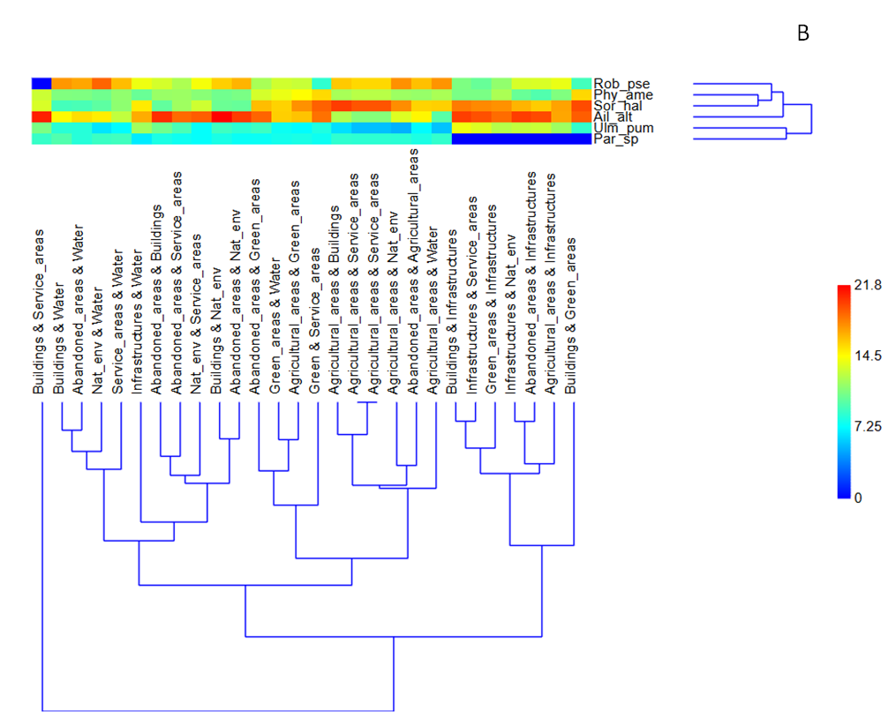
A
Figure S3 – Hierarchical clustering based on SIMPER test indicating species that contributed the most (% contribution) to dissimilarities among taxa assemblage in urban categories (A) and urban elements (B)

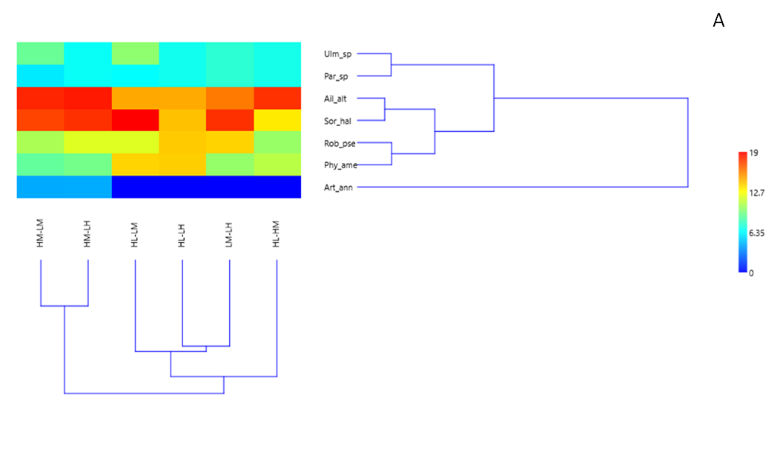
B

