Urban Ecosystems
Biodiversity in the City: Effects of Local and Landscape Characteristics on Ant Community in Urban Squares of Rio de Janeiro

Guilherme Martins Violante^{1*}, https://orcid.org/0000-0002-9901-4765
Paula Koeler Lira², https://orcid.org/0000-0002-4254-1054
Jacques Hubert Charles Delabie³, https://orcid.org/0000-0002-2695-1061
Jarbas Marçal Queiroz⁴, https://orcid.org/0000-0002-4175-1834

¹ Programa de Pós-Graduação em Biologia Animal, Universidade Federal Rural do Rio de Janeiro, ICBS, Seropédica, RJ, Brazil;
² Pontifícia Universidade Católica do Rio de Janeiro, Departamento de Biologia, Rio de Janeiro, RJ, Brazil;
³ Laboratório de Mirmecologia, CEPEC/CEPLAC, Ilhéus, BA, Brazil & Departamento de Ciências Agrárias e Ambientais, Universidade Estadual de Santa Cruz, Ilhéus, BA, Brazil;
⁴ Departamento de Ciências Ambientais, IF, Universidade Federal Rural do Rio de Janeiro, Seropédica, Rio de Janeiro, Brazil.

Email: gm.violante0@gmail.com (*corresponding author)

Supplementary Methods S1. Selection of urban squares
Thirty public urban squares were selected in the city of Rio de Janeiro. The selection process was conducted as follows. Initially, urban squares with easy accessibility via public transportation and located in safe areas were chosen. Both accessibility and safety were assessed using Google Maps by checking, for example, the presence of nearby metro stations and user comments regarding safety. Subsequently, field visits were conducted to verify whether each square contained at least 15 trees with a minimum diameter at breast height of 10 cm and spaced about 10 meters apart within each square. The minimum distance between selected trees was established to reduce the chances of ants from the same colony being attracted to more than one sampling station. After the visits, 65 squares were identified as potential study sites.
For each of the 65 candidate squares, a 500 m circular buffer was generated. Within each buffer, forest cover and forest configuration were quantified using three landscape metrics: percentage of forest cover (PLAND), percentage of urban land cover (URB), and forest edge density (ED; m/ha). ED represents the sum of all forest edge lengths relative to the landscape area (m/ha) (MacGarigal and Marks 1995).
To select the widest possible gradient of forest cover and fragmentation, and urban cover, and to avoid spatial dependence, the full distribution of PLAND, URB, and ED values was inspected, and squares occupying underrepresented portions of these gradients were prioritized for inclusion. When candidate urban squares had overlapping 500 m buffers, the square whose metric values were more redundant relative to the gradient already assembled was excluded.
Finally, the 30 public squares selected were those that provided the best spatial distribution across the city and were located in landscapes with the least overlap and the greatest possible variation in terms of forest cover and configuration.

Supplementary Methods S2. Selection of landscape scale
Before fitting the local and landscape models used to assess the diversity of native ants, native functional groups, and non-native species, we perform a scale-of-effect analysis to identify the most appropriate spatial extent for each response variable. To do so, we applied the multifit function (R package multifit), which automates the procedure by fitting comparable models across multiple buffer sizes of the same landscape metric and selecting the spatial scale with the lowest Akaike Information Criterion (AIC).
For each response variable, multifit was used to fit models including the FOR, ED, and URB metrics measured at 200, 250, and 500 m radii. All models were fitted using the same statistical structure (linear models with Gamma errors), and the Akaike Information Criterion (AIC) was used as the selection criterion. For each metric, the function identifies the radius at which model support is maximized (i.e., the minimum AIC), which is then retained as the scale of effect for subsequent analyses.
(a)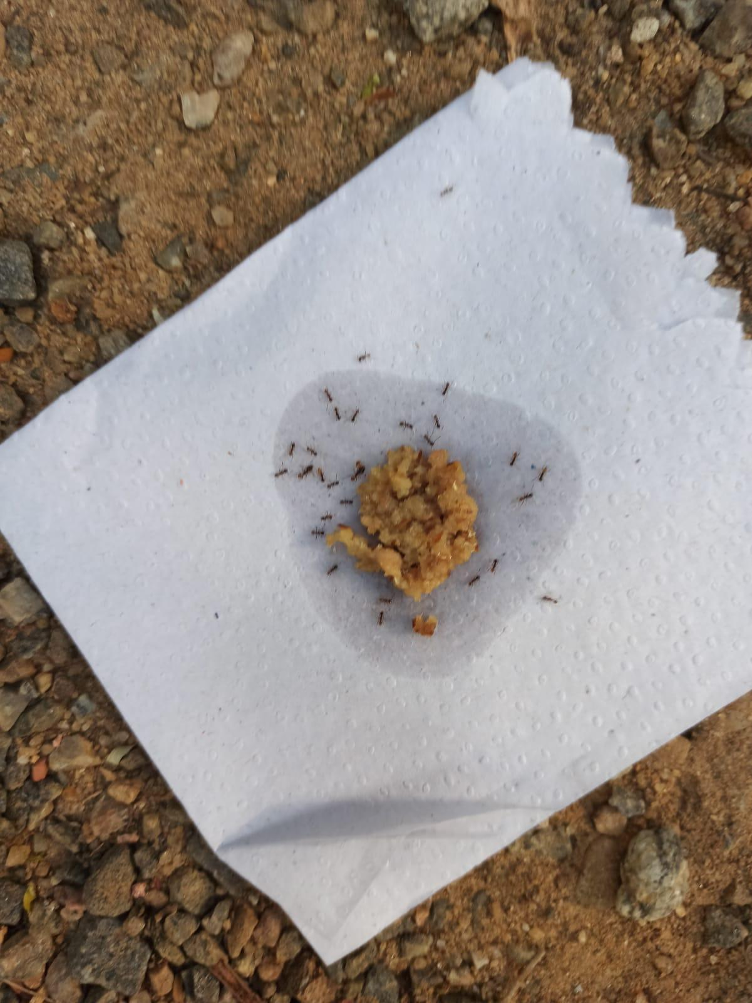 | (b) 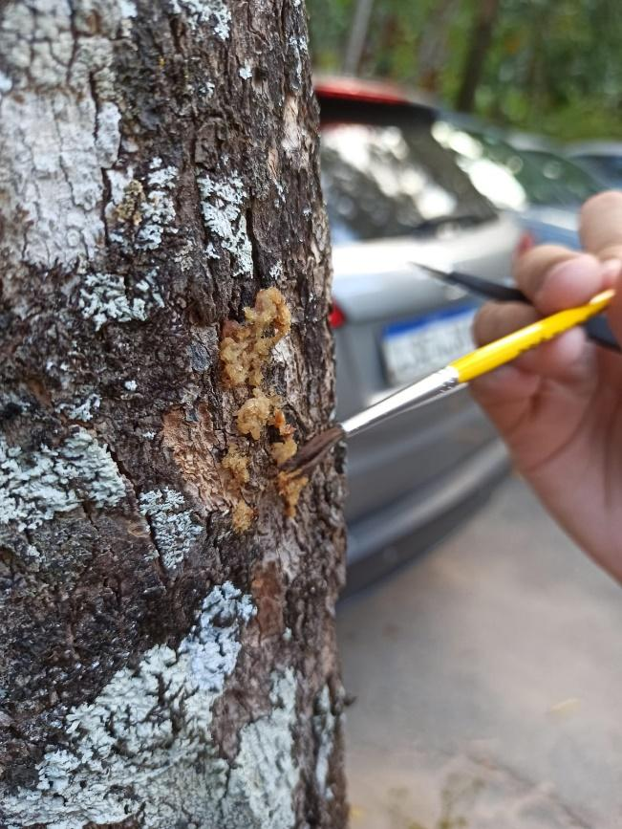

Fig. S1 Ants were sampled using sardine baits placed: (a) on the ground, one meter away from the tree and on top of a napkin; and (b) on the tree trunk at breast height. Each sampling point included two ground baits, spaced at least one meter apart, and two trunk baits placed on opposite sides of the tree.

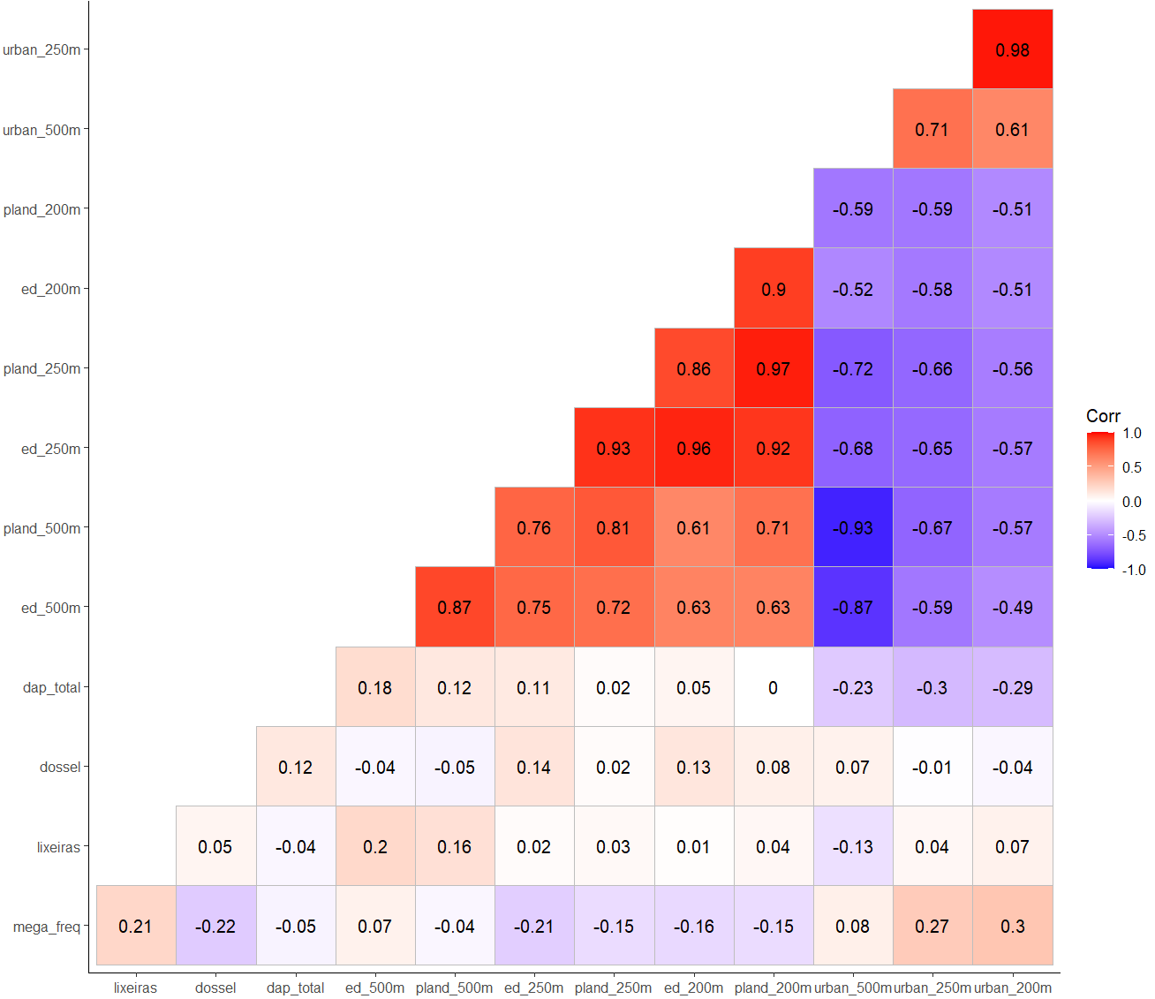
Fig. S2 Correlation matrix between the local and landscape predictors. Lixeiras - trash bin density; dossel – percentage of canopy cover; dap_total - diameter at breast height of trees; ed_500m - edge density with 500 m buffer; ed_250 m - edge density with 250 m buffer; ed_200m - edge density with 200 m buffer; pland_500m - percentage of forest cover with 500 m buffer; pland_250 m - percentage of forest cover with 250 m buffer; pland _200m - percentage of forest cover with 200 m buffer; urb_500 m percentage of urban cover with 500 m buffer; urb_250m - percentage of urban cover with 250 m buffer; urb_200m - percentage of urban cover with 500 m buffer. Darker blue and red indicates strong negative and positive correlations, respectively.

