Urban Ecosystems
Biodiversity in the City: Effects of Local and Landscape Characteristics on Ant Community in Urban Squares of Rio de Janeiro

Guilherme Martins Violante^{1*}, https://orcid.org/0000-0002-9901-4765
Paula Koeler Lira², https://orcid.org/0000-0002-4254-1054
Jacques Hubert Charles Delabie³, https://orcid.org/0000-0002-2695-1061
Jarbas Marçal Queiroz⁴, https://orcid.org/0000-0002-4175-1834

¹ Programa de Pós-Graduação em Biologia Animal, Universidade Federal Rural do Rio de Janeiro, ICBS, Seropédica, RJ, Brazil;
² Pontifícia Universidade Católica do Rio de Janeiro, Departamento de Biologia, Rio de Janeiro, RJ, Brazil;
³ Laboratório de Mirmecologia, CEPEC/CEPLAC, Ilhéus, BA, Brazil & Departamento de Ciências Agrárias e Ambientais, Universidade Estadual de Santa Cruz, Ilhéus, BA, Brazil;
⁴ Departamento de Ciências Ambientais, IF, Universidade Federal Rural do Rio de Janeiro, Seropédica, Rio de Janeiro, Brazil.

Email: gm.violante0@gmail.com (*corresponding author)

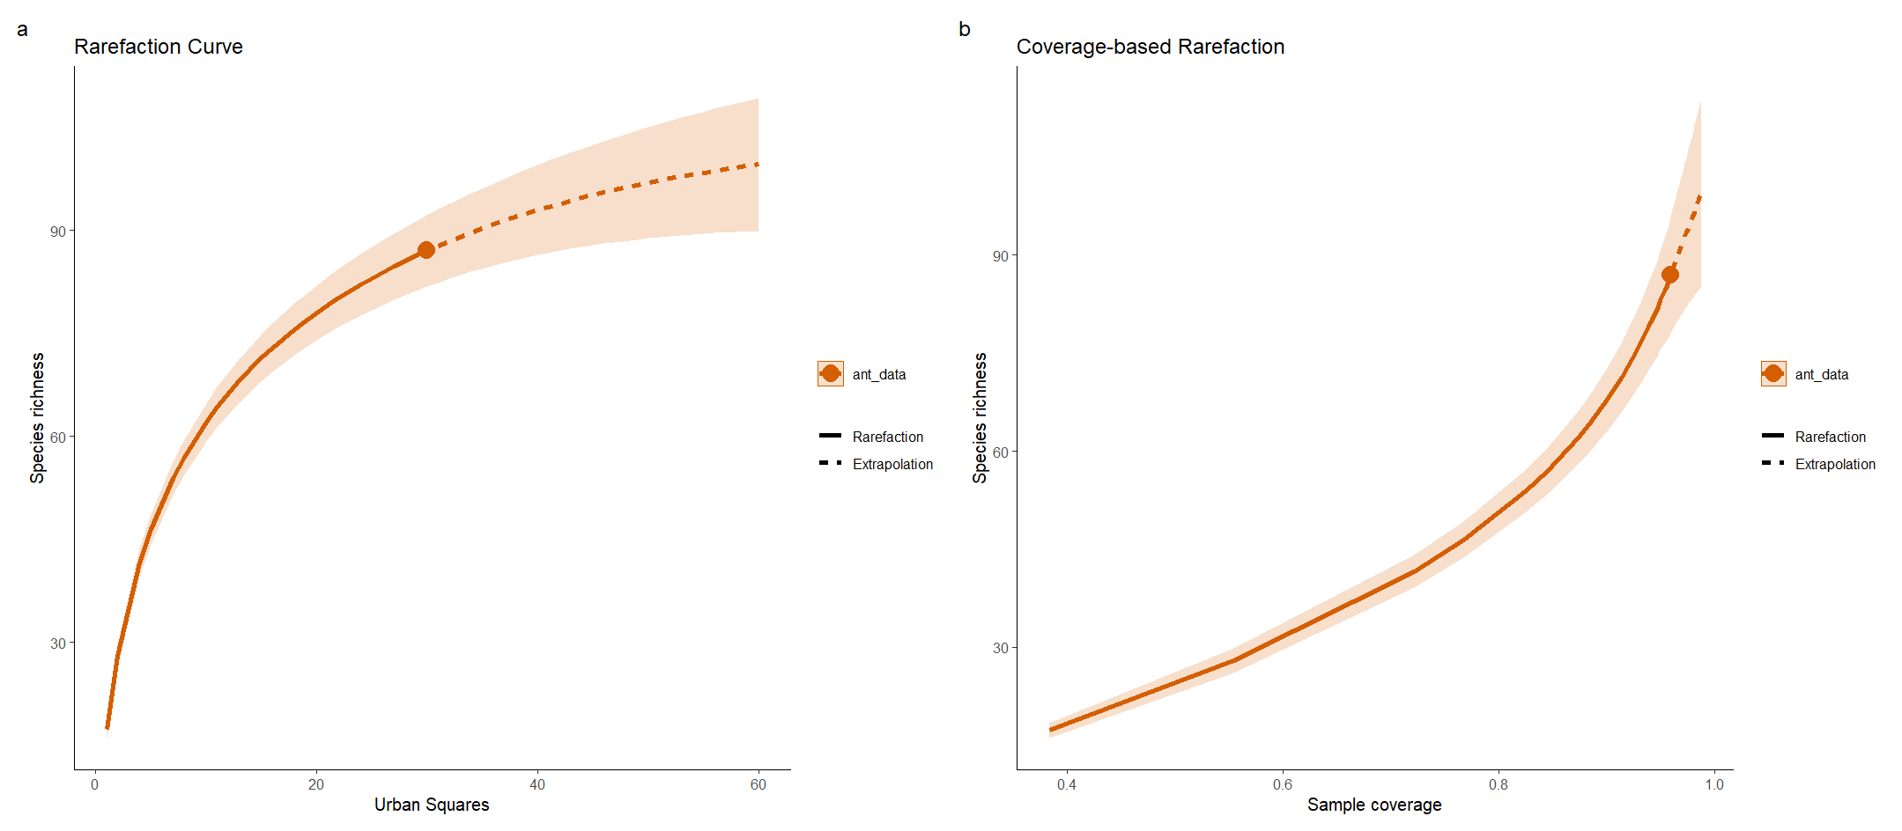
Figure S3. Sample-size-based species accumulation (rarefaction) curve (a), and coverage-based rarefaction/extrapolation curve (b) of ant species collected in 30 urban squares in Rio de Janeiro, Brazil. Solid lines represent interpolated estimates, dashed lines represent extrapolated estimates, and shaded areas indicate 95% confidence intervals.

(a) 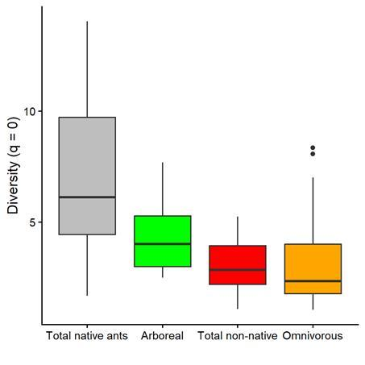 | (b) 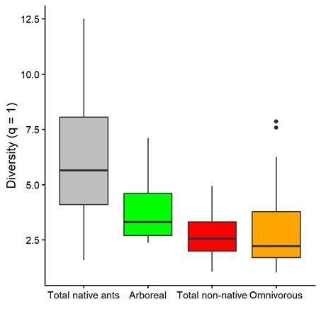
(c) 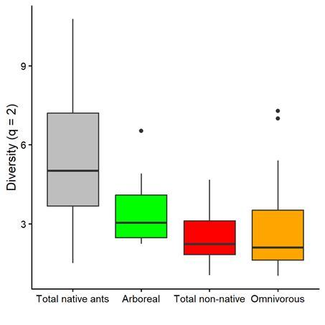
Figure S4. Variation in coverage-standardized ant diversity, expressed as Hill numbers, for (a) q = 0 (species richness), (b) q = 1 (Shannon diversity), and (c) q = 2 (Simpson diversity) of total native ants, native arboreal ants, native leaf-litter omnivorous and scavengers, and total non-native ants across the 30 sampled urban squares in the municipality of Rio de Janeiro, Brazil.

(a)
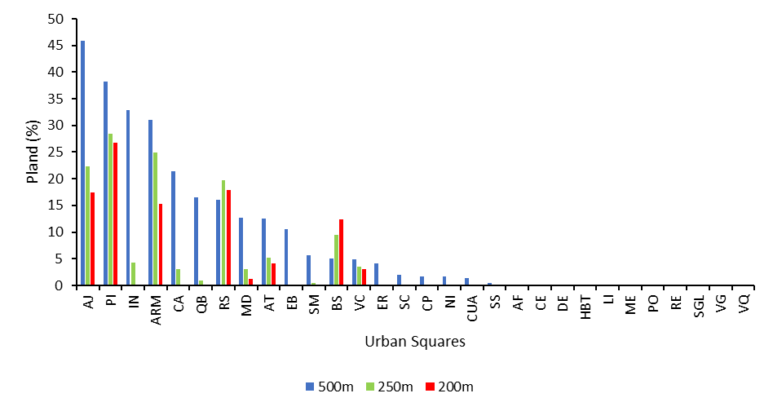
(b) 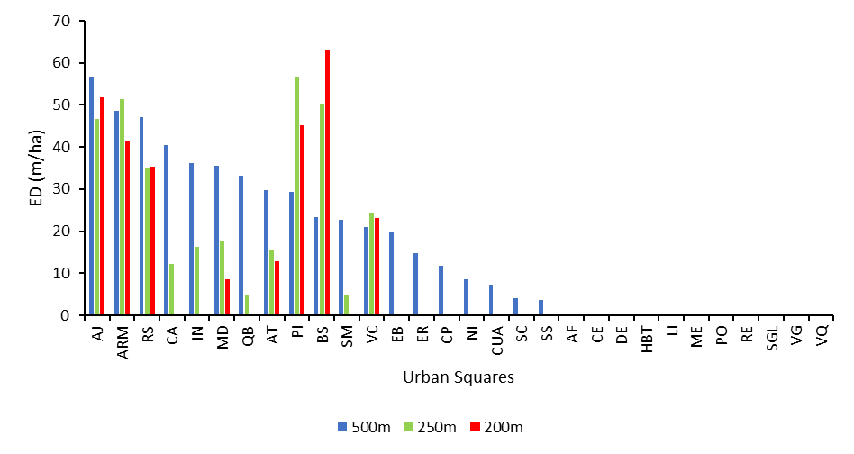
Fig. S5 Variation in (a) forest cover (PLAND) and (b) forest fragmentation, calculated using the edge density (ED) metric, of circular landscapes at three spatial scales (200, 250, and 500 meters) surrounding the 30 sampled squares in Rio de Janeiro, Brazil. AF - Praça Afonso Pena; AJ - Praça Almirante Júlio de Noronha; ARM - Praça Professor Arnaldo de Morais; AT - Praça Atahualpa; BS - Praça Engenheiro Bernardo Saião; CA - Praça Cardeal Arcoverde; CE - Praça da Cetel; CP - Praça Condessa Paulo de Frontin; CUA - Praça Cuauhtemoque; DE - Praça Drault Ernanny; EB - Praça Edmundo Bittencourt; ER - Praça Edmundo Rego; HBT - Praça Heitor Bastos Tigre; IN - Praça dos Ingleses (Dag Hammarskjöld); LI - Praça da Light; MD - Praça Medalha Milagrosa; ME - Praça Albert Sabin (Merk); NI - Praça Nicarágua; PI - Praça Pio XI; PO - Praça do Pomar; QB - Praça Quintino Bocaiuva; RE - Praça da República; RS - Praça Radial Sul; SC - Praça Serzelo Corrêa; SGL - Praça Soldado general da Cruz; SM - Praça Samuel Mac Dowel; SS - Praça São Salvador; VC - Praça da Vista Chinesa; VG - Praça Professora Virginia Cidade; VQ - Praça Vinte e Quatro de Outubro.
Table S1 List of the 87 ant species divided by subfamily and genus, indicating the number of squares in which each species was collected among the 30 sampled urban squares in the municipality of Rio de Janeiro, Brazil. Information is also provided on whether the species is Native or Non-native, its classification into one of four functional groups (leaf-litter omnivores and scavengers; generalist leaf-litter predators; arboreal; fungus-growing), and the stratum in which it was collected (Arboreal and/or Ground).
Species | No. of squares | Native or Non-native | Functional group | Stratum
Dolichoderinae
Azteca
Azteca sp.1 | 1 | Native | Arboreal | Arboreal
Azteca ulei Forel, 1904 | 5 | Native | Arboreal | Arboreal, Ground
Dolichoderus
Dolichoderus lamellosus (Mayr, 1870) | 2 | Native | Arboreal | Arboreal
Dolichoderus lutosus (Smith, 1858) | 2 | Native | Arboreal | Arboreal, Ground
Dorymyrmex
Dorymyrmex brunneus Forel, 1908 | 1 | Native | Leaf-litter omnivores and scavengers | Ground
Dorymyrmex thoracicus Gallardo, 1916 | 1 | Native | Leaf-litter omnivores and scavengers | Ground
Linepithema
Linepithema humile (Mayr, 1868) | 6 | Native | Leaf-litter omnivores and scavengers | Arboreal, Ground
Tapinoma
Tapinoma melanocephalum (Fabricius, 1793) | 14 | Non-native | Leaf-litter omnivores and scavengers | Arboreal, Ground
Ectatomminae
Ectatomma
Ectatomma brunneum Smith, 1858 | 1 | Native | Generalist leaf-Leaf-litter predators | Ground
Ectatomma edentatum Roger, 1863 | 3 | Native | Generalist leaf-Leaf-litter predators | Ground
Holcoponera
Holcoponera moelleri Forel, 1912 | 2 | Native | Generalist leaf-Leaf-litter predators | Ground
Holcoponera striatula (Mayr, 1884) | 2 | Native | Generalist leaf-Leaf-litter predators | Ground
Formicinae
Brachymyrmex
Brachymyrmex admotus Mayr, 1887 | 27 | Native | Leaf-litter omnivores and scavengers | Arboreal, Ground
Brachymyrmex heeri Forel, 1874 | 7 | Native | Leaf-litter omnivores and scavengers | Arboreal, Ground
Brachymyrmex patagonicus Mayr, 1868 | 21 | Native | Leaf-litter omnivores and scavengers | Arboreal, Ground
Brachymyrmex sp.1 | 15 | Native | Leaf-litter omnivores and scavengers | Arboreal, Ground
Brachymyrmex sp.2 | 1 | Native | Leaf-litter omnivores and scavengers | Arboreal, Ground
Camponotus
Camponotus atriceps (Smith, 1858) | 2 | Native | Arboreal | Arboreal, Ground
Camponotus cingulatus Mayr, 1862 | 1 | Native | Arboreal | Ground
Camponotus crassus Mayr, 1862 | 16 | Native | Arboreal | Arboreal, Ground
Camponotus fastigatus Roger, 1863 | 12 | Native | Arboreal | Arboreal, Ground
Camponotus melanoticus Emery, 1894 | 5 | Native | Leaf-litter omnivores and scavengers | Ground
Camponotus novogranadensis Mayr, 1870 | 7 | Native | Arboreal | Arboreal, Ground
Camponotus renggeri Emery, 1894 | 3 | Native | Leaf-litter omnivores and scavengers | Arboreal, Ground
Camponotus sericeiventris (Guérin-Méneville, 1838) | 3 | Native | Arboreal | Arboreal, Ground
Camponotus trapeziceps Forel, 1908 | 1 | Native | Arboreal | Arboreal
Camponotus vittatus Forel, 1904 | 4 | Native | Arboreal | Arboreal, Ground
Cardiocondyla
Cardiocondyla obscurior Wheeler, 1929 | 5 | Non-native | Arboreal | Arboreal, Ground
Nylanderia
Nylanderia fulva (Mayr, 1862) | 3 | Native | Leaf-litter omnivores and scavengers | Arboreal, Ground
Nylanderia sp.1 | 1 | Native | Leaf-litter omnivores and scavengers | Arboreal
Paratrechina
Paratrechina longicornis (Latreille, 1802) | 19 | Non-native | Leaf-litter omnivores and scavengers | Arboreal, Ground
Pheidole
Pheidole alienata Borgmeier, 1929 | 8 | Native | Leaf-litter omnivores and scavengers | Ground
Pheidole fallax Mayr, 1870 | 2 | Native | Leaf-litter omnivores and scavengers | Ground
Pheidole megacephala (Fabricius, 1793) | 29 | Non-native | Leaf-litter omnivores and scavengers | Arboreal, Ground
Pheidole moerens Wheeler, 1908 | 8 | Non-native | Leaf-litter omnivores and scavengers | Arboreal, Ground
Pheidole obscurithorax Naves, 1985 | 17 | Native | Leaf-litter omnivores and scavengers | Arboreal, Ground
Pheidole radoszkowskii Mayr, 1884 | 5 | Native | Leaf-litter omnivores and scavengers | Arboreal, Ground
Pheidole sp.1 | 1 | Native | Leaf-litter omnivores and scavengers | Arboreal
Pheidole sp.2 | 4 | Native | Leaf-litter omnivores and scavengers | Ground
Pheidole sp.3 | 2 | Native | Leaf-litter omnivores and scavengers | Arboreal
Pheidole sp.4 | 1 | Native | Leaf-litter omnivores and scavengers | Ground
Pheidole sp.5 | 1 | Native | Leaf-litter omnivores and scavengers | Ground
Pheidole sp.6 | 6 | Native | Leaf-litter omnivores and scavengers | Ground
Pheidole sp.7 | 13 | Native | Leaf-litter omnivores and scavengers | Arboreal, Ground
Pheidole sp.8 | 1 | Native | Leaf-litter omnivores and scavengers | Ground
Pheidole sp.9 | 3 | Native | Leaf-litter omnivores and scavengers | Ground
Pheidole sp.10 | 1 | Native | Leaf-litter omnivores and scavengers | Ground
Pheidole subarmata Mayr, 1884 | 16 | Native | Leaf-litter omnivores and scavengers | Arboreal, Ground
Myrmicinae
Acromyrmex
Acromyrmex brunneus (Forel, 1912) | 5 | Native | Fungus-growing | Arboreal, Ground
Acromyrmex coronatus (Fabricius, 1804) | 1 | Native | Fungus-growing | Arboreal
Acromyrmex rugosus (Smith, 1858) | 3 | Native | Fungus-growing | Ground
Acromyrmex sp.1 | 1 | Native | Fungus-growing | Ground
Atta
Atta robusta Borgmeier, 1939 | 1 | Native | Fungus-growing | Ground
Atta sexdens (Linnaeus, 1758) | 4 | Native | Fungus-growing | Arboreal, Ground
Cephalotes
Cephalotes angustus (Mayr, 1862) | 10 | Native | Arboreal | Arboreal, Ground
Cephalotes maculatus (Smith, 1876) | 3 | Native | Arboreal | Ground
Cephalotes minutus (Fabricius, 1804) | 17 | Native | Arboreal | Arboreal, Ground
Cephalotes notatus (Mayr, 1866) | 2 | Native | Arboreal | Arboreal, Ground
Crematogaster
Crematogaster curvispinosa Mayr, 1862 | 10 | Native | Arboreal | Arboreal, Ground
Crematogaster distans Mayr, 1870 | 2 | Native | Arboreal | Arboreal, Ground
Crematogaster erecta Mayr, 1866 | 12 | Native | Arboreal | Arboreal, Ground
Monomorium
Monomorium floricola (Jerdon, 1851) | 9 | Non-native | Arboreal | Arboreal, Ground
Sericomyrmex
Sericomyrmex mayri Forel, 1912 | 2 | Native | Fungus-growing | Ground
Solenopsis
Solenopsis geminata (Fabricius, 1804) | 7 | Native | Leaf-litter omnivores and scavengers | Arboreal, Ground
Solenopsis globularia (Smith, 1858) | 4 | Native | Leaf-litter omnivores and scavengers | Ground
Solenopsis invicta Buren, 1972 | 13 | Native | Leaf-litter omnivores and scavengers | Arboreal, Ground
Solenopsis saevissima (Smith, 1855) | 3 | Native | Leaf-litter omnivores and scavengers | Arboreal, Ground
Solenopsis sp.1 | 2 | Native | Leaf-litter omnivores and scavengers | Arboreal, Ground
Solenopsis sp.2 | 5 | Native | Leaf-litter omnivores and scavengers | Arboreal, Ground
Solenopsis sp.3 | 2 | Native | Leaf-litter omnivores and scavengers | Arboreal, Ground
Tetramorium
Tetramorium lanuginosum Mayr, 1870 | 1 | Non-native | Leaf-litter omnivores and scavengers | Arboreal, Ground
Tetramorium simillimum (Smith, 1851) | 8 | Non-native | Leaf-litter omnivores and scavengers | Arboreal, Ground
Wasmannia
Wasmannia auropunctata (Roger, 1863) | 16 | Native | Leaf-litter omnivores and scavengers | Arboreal, Ground
Wasmannia rochai Forel, 1908 | 8 | Native | Leaf-litter omnivores and scavengers | Arboreal, Ground
Ponerinae
Hypoponera
Hypoponera opaciceps (Mayr, 1887) | 1 | Native | Generalist leaf-Leaf-litter predators
Neoponera
Neoponera villosa (Fabricius, 1804) | 3 | Native | Arboreal | Arboreal, Ground
Odontomachus
Odontomachus bauri Emery, 1892 | 8 | Native | Generalist leaf-Leaf-litter predators | Ground
Pachycondyla
Pachycondyla striata Smith, 1858 | 1 | Native | Generalist leaf-Leaf-litter predators | Ground
Pseudomyrmecinae
Pseudomyrmex
Pseudomyrmex curacaensis (Forel, 1912) | 1 | Native | Arboreal | Arboreal
Pseudomyrmex gibbinotus (Forel, 1908) | 2 | Native | Arboreal | Arboreal
Pseudomyrmex gracilis (Fabricius, 1804) | 11 | Native | Arboreal | Arboreal, Ground
Pseudomyrmex oculatus (Smith, 1855) | 8 | Native | Arboreal | Arboreal, Ground
Pseudomyrmex simplex (Smith, 1877) | 3 | Native | Arboreal | Arboreal, Ground
Pseudomyrmex sp.1 | 9 | Native | Arboreal | Arboreal, Ground
Pseudomyrmex sp.2 | 1 | Native | Arboreal | Ground
Pseudomyrmex tenuissimus (Emery, 1906) | 1 | Native | Arboreal | Arboreal
Pseudomyrmex urbanus (Smith, 1877) | 8 | Native | Arboreal | Arboreal, Ground

Table S2 List of the 30 sampled squares in the municipality of Rio de Janeiro, Brazil. For each square, the following information is provided: 1) square size measured in hectares using Google Earth; 2) collection date; 3) number of native ant species collected; and 4) number of non-native ant species.
Abbreviation | Square | Neighborhood | Size (ha) | Collection Date | Longitude | Latitude | Native | Non-native
AF | Afonso Pena | Tijuca | 1,057 | 23/11/2022 | -22,9180 | -43,2181 | 10 | 1
AJ | Almirante Júlio de Noronha | Leme | 1,285 | 16/01/2023 | -22,9621 | -43,1649 | 15 | 1
ARM | Professor Arnaldo de Morais | Lagoa | 0,776 | 08/12/2022 | -22,9752 | -43,1996 | 18 | 6
AT | Atahualpa | Leblon | 0,305 | 16/12/2022 | -22,9876 | -43,2282 | 15 | 5
BS | Engenheiro Bernardo Saião | Botafogo | 0,734 | 03/01/2023 | -22,9534 | -43,1793 | 26 | 3
CA | Cardeal Arcoverde | Copacabana | 0,906 | 04/01/2023 | -22,9648 | -43,1804 | 5 | 1
CE | Cetel | Vila da Penha | 0,25 | 23/01/2023 | -22,8418 | -43,3116 | 6 | 1
CP | Condessa Paulo de Frontin | Rio comprido | 1,617 | 11/01/2023 | -22,9246 | -43,2092 | 15 | 4
CUA | Cuauhtemoque | Flamengo | 13,1 | 27/12/2022 | -22,9379 | -43,1732 | 13 | 2
DE | Drault Ernanny | Recreio | 0,478 | 22/11/2022 | -23,0210 | -43,4633 | 21 | 4
EB | Edmundo Bittencourt | Copacabana | 0,613 | 26/01/2023 | -22,9670 | -43,1901 | 6 | 2
ER | Edmundo Rego | Grajaú | 0,76 | 06/02/2023 | -22,9225 | -43,2645 | 10 | 1
HBT | Heitor Bastos Tigre | Recreio | 0,41 | 31/01/2023 | -23,0167 | -43,4723 | 23 | 3
IN | Ingleses (Dag Hammarskjöld) | Jardim Botânico | 0,295 | 02/02/2023 | -22,9629 | -43,2260 | 31 | 4
LI | Light | Irajá | 0,427 | 17/11/2022 | -22,8525 | -43,3236 | 10 | 3
MD | Medalha Milagrosa | Urca | 0,411 | 17/01/2023 | -22,9541 | -43,1696 | 19 | 4
ME | Albert Sabin (Merk) | Taquara | 0,229 | 01/02/2023 | -22,9346 | -43,3686 | 11 | 2
NI | Nicarágua | Flamengo | 0,49 | 19/01/2023 | -22,9420 | -43,1771 | 10 | 2
PI | Pio XI | Jardim Botânico | 0,259 | 26/12/2022 | -22,9616 | -43,2174 | 19 | 6
PO | Pomar | Barra | 1,707 | 02/12/2022 | -23,0110 | -43,3091 | 15 | 5
QB | Quintino Bocaiuva | Lagoa | 0,798 | 24/12/2022 | -22,9611 | -43,2029 | 9 | 1
RE | República | Centro | 0,301 | 07/02/2023 | -22,9066 | -43,1885 | 15 | 5
RS | Radial Sul | Botafogo | 0,235 | 12/01/2023 | -22,9475 | -43,1895 | 13 | 3
SC | Serzelo Corrêa | Copacabana | 0,403 | 04/12/2022 | -22,9692 | -43,1840 | 11 | 4
SGL | Soldado general da Cruz | Barra | 1,872 | 05/12/2022 | -23,0100 | -43,3213 | 16 | 5
SM | Samuel Mac Dowel | Taquara | 0,201 | 28/12/2022 | -22,9222 | -43,3881 | 19 | 3
SS | São Salvador | Flamengo | 0,675 | 12/12/2022 | -22,9340 | -43,1803 | 11 | 1
VC | Vista Chinesa | Taquara | 0,461 | 29/12/2022 | -22,9215 | -43,3800 | 20 | 5
VG | Professora Virginia Cidade | Coelho Neto | 0,431 | 28/11/2022 | -22,8309 | -43,3453 | 4 | 5
VQ | Vinte e Quatro de Outubro | Inhaúma | 0,362 | 18/11/2022 | -22,8728 | -43,2814 | 10 | 1

Table S3 Results of model selection based on Akaike Information Criterion (AICc) for q = 0 (species richness) of total native ant species, native functional groups (arboreal and leaf litter omnivores and scavengers ants) and non-native ants across 30 urban squares in Rio de Janeiro. Models with ΔAICc ≤ 2 were considered plausible. If the null model was among the most plausible models, it was assumed that none of the explanatory variables had an effect on the response variable. AICc: Akaike Information Criterion corrected for small sample sizes; ∆AICc: difference between the AICc of a given model and that of the most plausible model; K: number of estimated parameters; Wi: Akaike weight (based on AICc); Estimate: parameter estimate for the explanatory variable; Conf.low and Conf.high: lower and upper bounds of the 85% confidence interval (IC85%) for the parameter estimate
Response variable | Explanatory variable | AICc | ΔAICc | K | Wi | Estimate | Conf.low | Conf.high
Total native | ED (250 m) | 153 | 0 | 3 | 0.4063 | 0.013 | 0.006 |  | 0.020
 | Canopy Cover | 153.3 | 0.3 | 3 | 0.3426 | 0.045 | 0.023 |  | 0.067
 | URB (500 m) | 156.2 | 3.2 | 3 | 0.0825 | -0.009 | -0.016 |  | -0.003
 | FOR (500 m) | 156.3 | 3.3 | 3 | 0.0782 | 0.014 | 0.005 |  | 0.024
 | Pheidole megacephala occurrence | 157.4 | 4.5 | 3 | 0.0435 | -0.035 | -0.059 |  | -0.010
 | Null | 158.6 | 5.6 | 2 | 0.0242 | - | - |  | -
 | Trash bin density* | 160.7 | 7.8 | 3 | 0.0083 | 0.007 | -0.010 |  | 0.025
 | Degree of impervious surface* | 161 | 8 | 3 | 0.0073 | -0.066 | -0.428 |  | 0.294
 | Diameter at breast height* | 161 | 8.1 | 3 | 0.0072 | -0.002 | -0.019 |  | 0.015
Arboreal | Canopy Cover | 73.3 | 0 | 3 | 0.276 | 0.026 | 0.009 |  | 0.043
 | URB (250 m) | 74 | 0.7 | 3 | 0.198 | -0.009 | -0.015 |  | -0.002
 | FOR (250 m) | 74.2 | 0.9 | 3 | 0.173 | 0.015 | 0.004 |  | 0.027
 | ED (250 m) | 74.3 | 1 | 3 | 0.166 | 0.007 | 0.002 |  | 0.012
 | Null | 76 | 2.7 | 2 | 0.072 | - | - |  | -
 | Degree of impervious surface* | 77 | 3.7 | 3 | 0.043 | 0.220 | -0.055 |  | 0.494
 | Diameter at breast height* | 77.8 | 4.5 | 3 | 0.029 | 0.007 | -0.007 |  | 0.022
 | Trash bin density* | 78.4 | 5.1 | 3 | 0.021 | 0.002 | -0.011 |  | 0.016
 | Pheidole megacephala occurrence* | 78.5 | 5.2 | 3 | 0.021 | 0.001 | -0.022 |  | 0.024
Leaf-litter omnivores and scavengers | Canopy Cover | 116.8 | 0 | 3 | 0.403 | 0.052 | 0.021 |  | 0.082
 | URB (200 m) | 117.7 | 0.9 | 3 | 0.262 | -0.013 | -0.023 |  | -0.005
 | ED (200 m) | 119.6 | 2.7 | 3 | 0.102 | 0.010 | 0.002 |  | 0.019
 | FOR (500 m) | 120 | 3.2 | 3 | 0.083 | 0.014 | 0.002 |  | 0.027
 | Null | 120.9 | 4.1 | 2 | 0.052 | - | - |  | -
 | Degree of impervious surface* | 122.3 | 5.4 | 3 | 0.027 | -0.329 | -0.824 |  | 0.165
 | Pheidole megacephala occurrence* | 122.3 | 5.4 | 3 | 0.027 | -0.023 | -0.056 |  | 0.012
 | Diameter at breast height* | 122.5 | 5.7 | 3 | 0.023 | -0.014 | -0.038 |  | 0.010
 | Trash bin density* | 122.8 | 6 | 3 | 0.02 | 0.011 | -0.011 |  | 0.034
Non-Native | URB (500 m) | 60.9 | 0 | 3 | 0.500 | -0.012 | -0.018 |  | -0.006
 | FOR (250 m) | 62.1 | 1.3 | 3 | 0.267 | 0.024 | 0.011 |  | 0.040
 | ED (250 m) | 63.8 | 2.9 | 3 | 0.116 | 0.009 | 0.003 |  | 0.016
 | Null | 65.7 | 4.8 | 2 | 0.0.45 | - | - |  | -
 | Trash bin density* | 67.4 | 6.5 | 3 | 0.020 | 0.009 | -0.006 |  | 0.025
 | Canopy Cover* | 67.5 | 6.6 | 3 | 0.018 | 0.015 | -0.013 |  | 0.042
 | Diameter at breast height* | 67.6 | 6.7 | 3 | 0.017 | 0.009 | -0.008 |  | 0.027
 | Degree of impervious surface* | 67.7 | 6.8 | 3 | 0.017 | -0.169 | -0.522 |  | 0.185
* Indicates models whose confidence intervals overlap zero.

Table S4 Results of model selection based on Akaike Information Criterion (AICc) for q = 1 (exponential of Shannon entropy) of total native ant species, native functional groups (arboreal and leaf litter omnivores and scavengers ants) and non-native ants across 30 urban squares in Rio de Janeiro. Models with ΔAICc ≤ 2 were considered plausible. If the null model was among the most plausible models, it was assumed that none of the explanatory variables had an effect on the response variable. AICc: Akaike Information Criterion corrected for small sample sizes; ∆AICc: difference between the AICc of a given model and that of the most plausible model; K: number of estimated parameters; Wi: Akaike weight (based on AICc); Estimate: parameter estimate for the explanatory variable; Conf.low and Conf.high: lower and upper bounds of the 85% confidence interval (IC85%) for the parameter estimate
Response variable | Explanatory variable | AICc | ΔAICc | K | Wi | Estimate | Conf.low | Conf.high
Total native | ED (250 m) | 143.9 | 0 | 3 | 0.4666 | 0.013 | 0.007 | 0.020
 | Canopy Cover | 145 | 1.1 | 3 | 0.272 | 0.043 | 0.022 | 0.064
 | URB (500 m) | 147 | 3.1 | 3 | 0.0987 | -0.010 | -0.016 | -0.004
 | FOR (500 m) | 147.2 | 3.3 | 3 | 0.0889 | 0.014 | 0.006 | 0.024
 | Pheidole megacephala occurrence | 149 | 5.1 | 3 | 0.0373 | -0.034 | -0.058 | -0.010
 | Null | 150.3 | 6.4 | 2 | 0.0189 | - | - | -
 | Trash bin density | 152.5 | 8.6 | 3 | 0.0065 | 0.006 | -0.009 | 0.024
 | Degree of impervious surface | 152.8 | 8.8 | 3 | 0.0056 | -0.048 | -0.395 | 0.299
 | Diameter at breast height | 152.8 | 8.9 | 3 | 0.0055 | -0.001 | -0.018 | 0.015
Arboreal | Canopy Cover | 67.5 | 0 | 3 | 0.267 | 0.026 | 0.010 | 0.043
 | URB (250 m) | 67.8 | 0.4 | 3 | 0.223 | -0.009 | -0.015 | -0.003
 | ED (250 m) | 68.2 | 0.8 | 3 | 0.181 | 0.007 | 0.002 | 0.012
 | FOR (250 m) | 68.5 | 1.1 | 3 | 0.158 | 0.015 | 0.004 | 0.026
 | Null | 70.4 | 3 | 2 | 0.06 | - | - | -
 | Degree of impervious surface | 71.1 | 3.7 | 3 | 0.043 | 0.238 | -0.029 | 0.504
 | Diameter at breast height | 71.7 | 4.2 | 3 | 0.032 | 0.010 | -0.004 | 0.024
 | Trash bin density | 72.9 | 5.4 | 3 | 0.018 | 0.002 | -0.011 | 0.016
 | Pheidole megacephala occurrence | 72.9 | 5.5 | 3 | 0.017 | 0.001 | -0.022 | 0.024
Leaf-litter omnivores and scavengers | Canopy Cover | 111.8 | 0 | 3 | 0.412 | 0.051 | 0.021 | 0.079
 | URB (200 m) | 112.6 | 0.9 | 3 | 0.267 | -0.013 | -0.022 | -0.005
 | ED (200 m) | 114.7 | 2.9 | 3 | 0.097 | 0.010 | 0.002 | 0.019
 | FOR (500 m) | 115.1 | 3.4 | 3 | 0.076 | 0.013 | 0.002 | 0.026
 | Null | 116 | 4.2 | 2 | 0.051
 | Pheidole megacephala occurrence | 117.1 | 5.3 | 3 | 0.029 | -0.024 | -0.056 | 0.009
 | Degree of impervious surface | 117.2 | 5.4 | 3 | 0.027 | -0.331 | -0.808 | 0.144
 | Diameter at breast height | 117.6 | 5.9 | 3 | 0.022 | -0.013 | -0.037 | 0.011
 | Trash bin density | 117.9 | 6.1 | 3 | 0.02 | 0.010 | -0.011 | 0.033
Non-Native | URB (500 m) | 54.3 | 0 | 3 | 0.5306 | -0.012 | -0.017 | -0.006
 | FOR (250 m) | 55.5 | 1.2 | 3 | 0.2878 | 0.025 | 0.012 | 0.040
 | ED (250 m) | 57.4 | 3.1 | 3 | 0.1124 | 0.010 | 0.004 | 0.016
 | Null | 60.3 | 6 | 2 | 0.0266 | - | - | -
 | Degree of impervious surface | 61.8 | 7.5 | 3 | 0.0123 | -0.226 | -0.564 | 0.114
 | Trash bin density | 62 | 7.7 | 3 | 0.0115 | 0.008 | -0.006 | 0.024
 | Canopy Cover | 62.4 | 8 | 3 | 0.0095 | 0.011 | -0.016 | 0.037
 | Diameter at breast height | 62.4 | 8.1 | 3 | 0.0093 | 0.008 | -0.009 | 0.025
* Indicates models whose confidence intervals overlap zero.

Table S5 Results of model selection based on Akaike Information Criterion (AICc) for q = 2 (inverse Simpson index) of total native ant species, native functional groups (arboreal and leaf litter omnivores and scavengers ants) and non-native ants across 30 urban squares in Rio de Janeiro. Models with ΔAICc ≤ 2 were considered plausible. If the null model was among the most plausible models, it was assumed that none of the explanatory variables had an effect on the response variable. AICc: Akaike Information Criterion corrected for small sample sizes; ∆AICc: difference between the AICc of a given model and that of the most plausible model; K: number of estimated parameters; Wi: Akaike weight (based on AICc); Estimate: parameter estimate for the explanatory variable; Conf.low and Conf.high: lower and upper bounds of the 85% confidence interval (IC85%) for the parameter estimate
Response variable | Explanatory variable | AICc | ΔAICc | K | Wi | Estimate | Conf.low | Conf.high
Total native | ED (250 m) | 132.8 | 0 | 3 | 0.526 | 0.013 | 0.007 | 0.019
 | Canopy Cover | 134.9 | 2.1 | 3 | 0.1848 | 0.041 | 0.021 | 0.060
 | URB (500 m) | 135.6 | 2.8 | 3 | 0.1283 | -0.010 | -0.016 | -0.005
 | FOR (500 m) | 136 | 3.2 | 3 | 0.108 | 0.015 | 0.007 | 0.023
 | Pheidole megacephala occurrence | 138.7 | 5.9 | 3 | 0.0273 | -0.033 | -0.055 | -0.010
 | Null | 140.1 | 7.3 | 2 | 0.0134 | - | - | -
 | Trash bin density | 142.3 | 9.5 | 3 | 0.0045 | 0.006 | -0.009 | 0.022
 | Degree of impervious surface | 142.6 | 9.8 | 3 | 0.0039 | -0.021 | -0.352 | 0.309
 | Diameter at breast height | 142.6 | 9.8 | 3 | 0.0039 | 0.000 | -0.016 | 0.016
Arboreal | Canopy Cover | 61.9 | 0 | 3 | 0.328 | 0.026 | 0.010 | 0.042
 | ED (250 m) | 62.5 | 0.6 | 3 | 0.241 | 0.007 | 0.002 | 0.013
 | FOR (250 m) | 63.2 | 1.3 | 3 | 0.175 | 0.015 | 0.003 | 0.026
 | Null | 65.1 | 3.2 | 2 | 0.067 | - | - | -
 | Degree of impervious surface | 65.3 | 3.4 | 3 | 0.061 | 0.263 | 0.000 | 0.525
 | Diameter at breast height | 65.6 | 3.7 | 3 | 0.052 | 0.012 | -0.001 | 0.026
 | URB (250 m) | 66.3 | 4.4 | 3 | 0.036 | -0.033 | -0.053 | -0.012
 | Trash bin density | 67.5 | 5.6 | 3 | 0.02 | 0.002 | -0.011 | 0.016
 | Pheidole megacephala occurrence | 67.6 | 5.6 | 3 | 0.02 | 0.002 | -0.021 | 0.025
Leaf-litter omnivores and scavengers | Canopy Cover | 105.3 | 0 | 3 | 0.419 | 0.049 | 0.021 | 0.076
 | URB (200 m) | 106.2 | 0.9 | 3 | 0.273 | -0.013 | -0.022 | -0.005
 | ED (200 m) | 108.4 | 3 | 3 | 0.091 | 0.009 | 0.002 | 0.018
 | FOR (500 m) | 108.9 | 3.6 | 3 | 0.069 | 0.013 | 0.001 | 0.025
 | Null | 109.6 | 4.3 | 2 | 0.049
 | Degree of impervious surface | 110.8 | 5.4 | 3 | 0.028 | -0.333 | -0.788 | 0.122
 | Pheidole megacephala occurrence | 110.5 | 5.2 | 3 | 0.032 | -0.025 | -0.056 | 0.007
 | Diameter at breast height | 111.4 | 6.1 | 3 | 0.02 | -0.012 | -0.034 | 0.011
 | Trash bin density | 111.6 | 6.2 | 3 | 0.019 | 0.009 | -0.010 | 0.031
Non-Native | URB (500 m) | 48.9 | 0 | 3 | 0.5582 | -0.012 | -0.017 | -0.007
 | FOR (250 m) | 50.2 | 1.3 | 3 | 0.2914 | 0.026 | 0.013 | 0.040
 | ED (250 m) | 52.3 | 3.4 | 3 | 0.1041 | 0.010 | 0.004 | 0.016
 | Null | 55.9 | 7 | 2 | 0.0173 | - | - | -
 | Degree of impervious surface | 56.9 | 8 | 3 | 0.0102 | 0.008 | -0.006 | 0.023
 | Trash bin density | 57.6 | 8.7 | 3 | 0.0073 | -0.269 | -0.601 | 0.065
 | Canopy Cover | 58 | 9.1 | 3 | 0.006 | 0.007 | -0.020 | 0.034
 | Diameter at breast height | 58.2 | 9.3 | 3 | 0.0055 | 0.007 | -0.010 | 0.024
* Indicates models whose confidence intervals overlap zero.

(a) 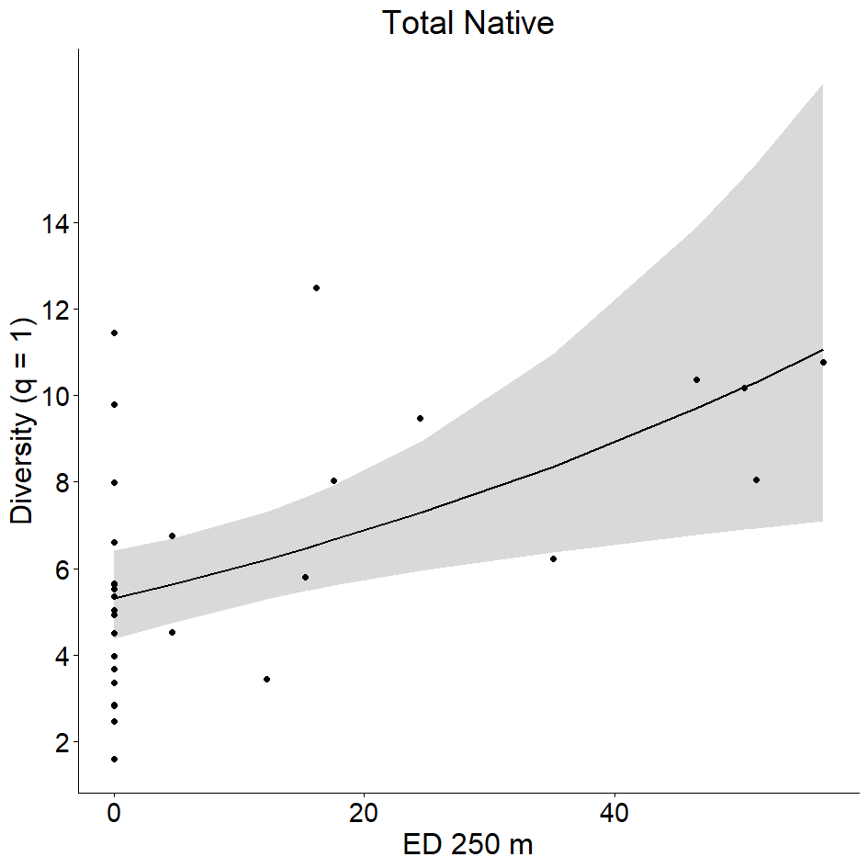 | (b) 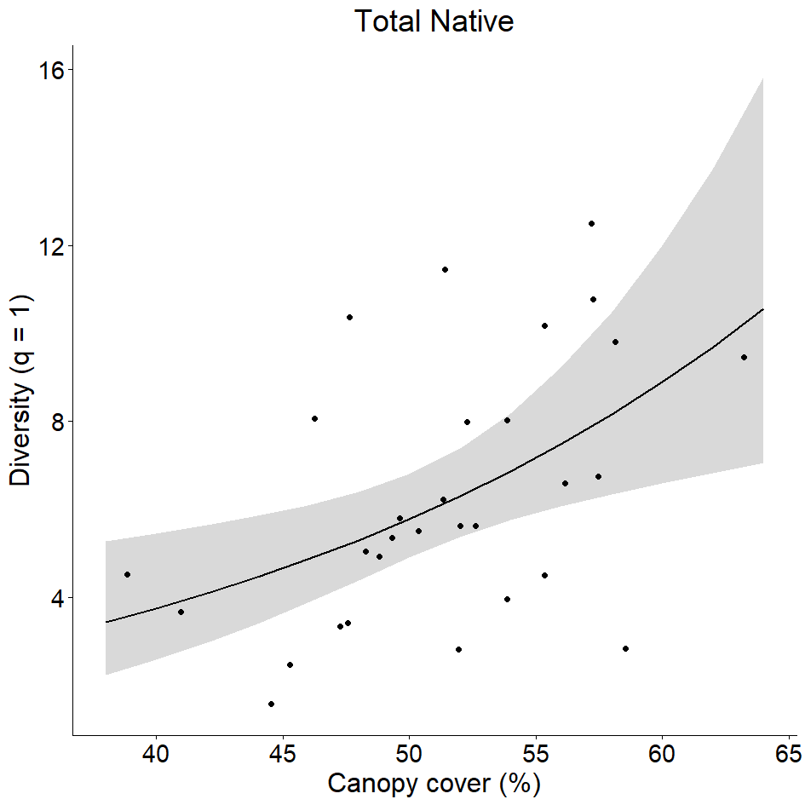
(c) 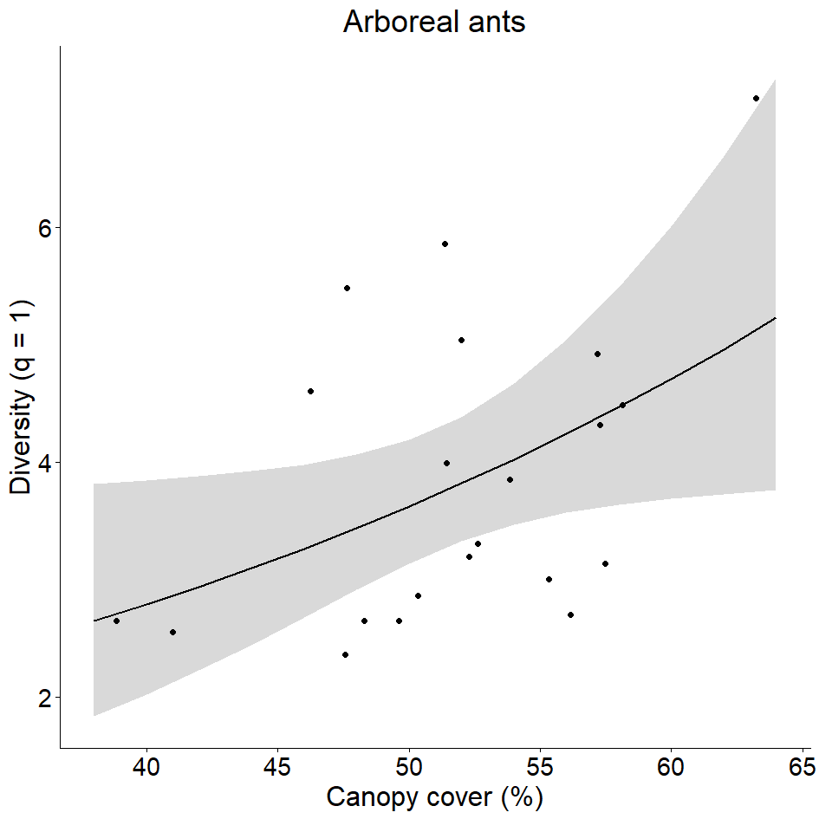 | (d) 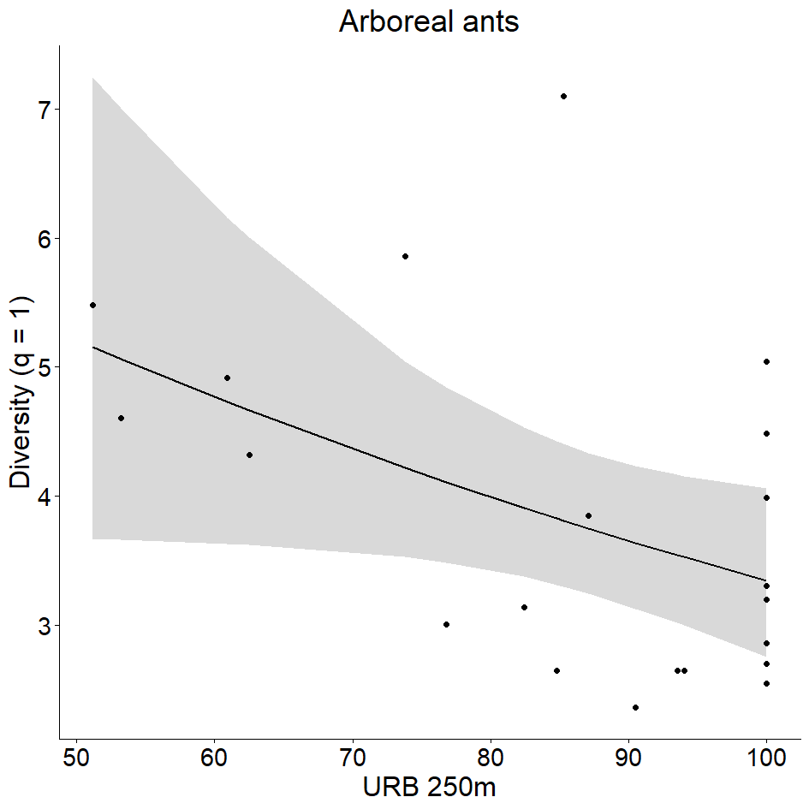
(e) 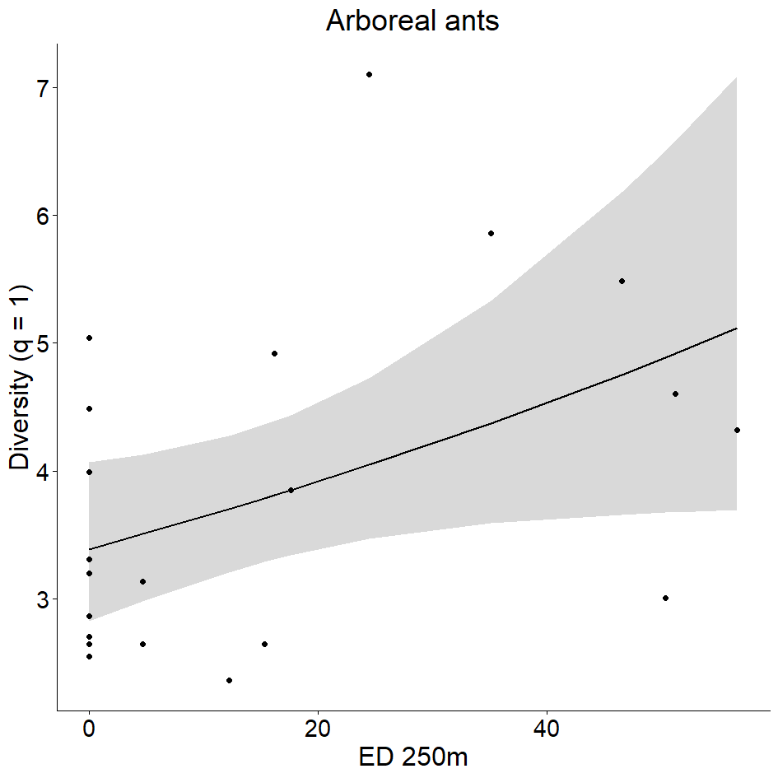 | (f) 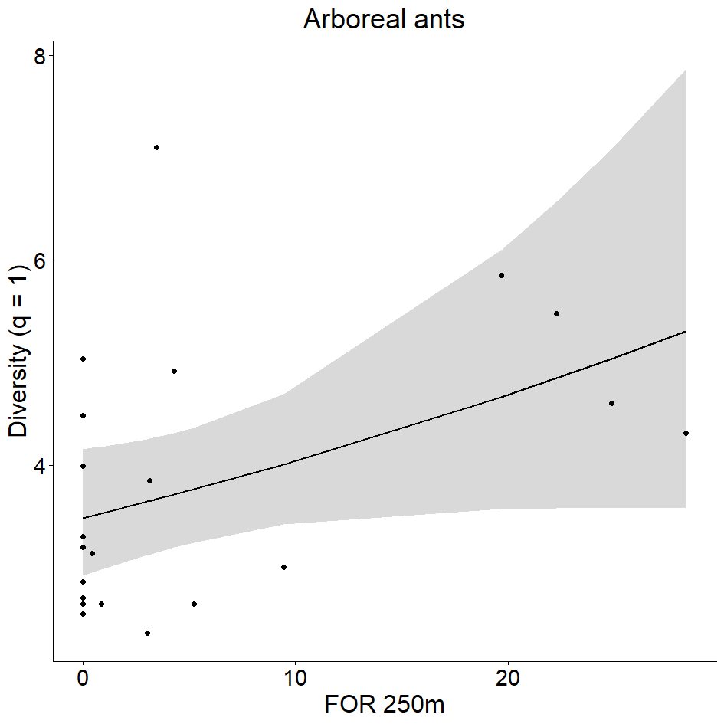
(g) 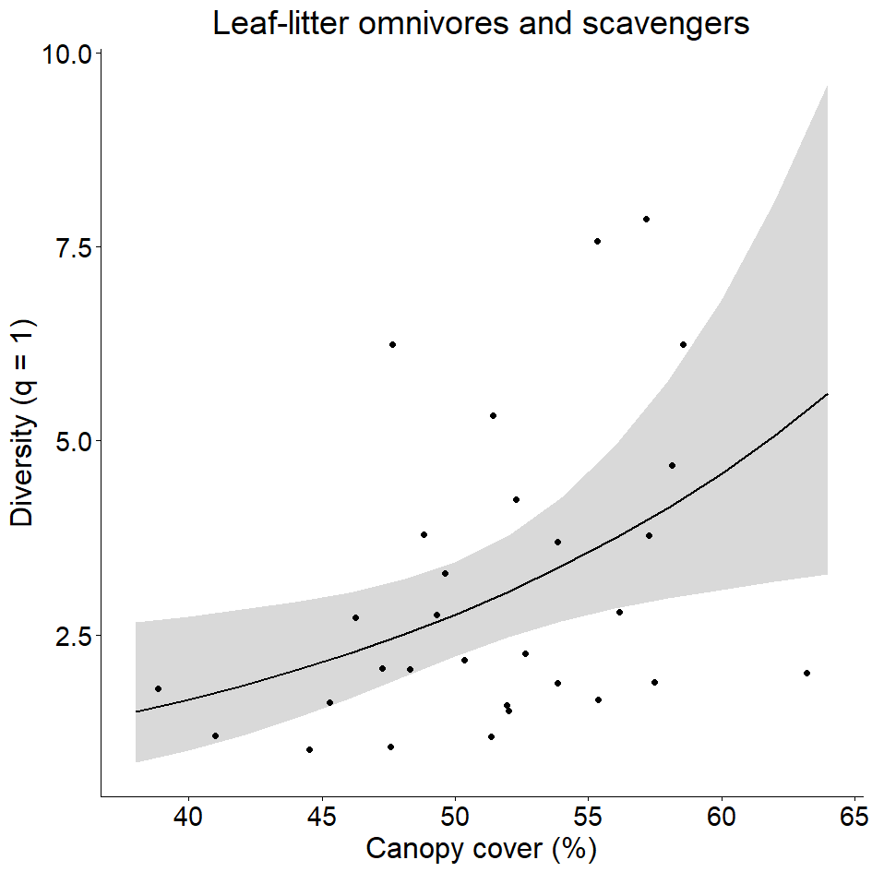 | (h) 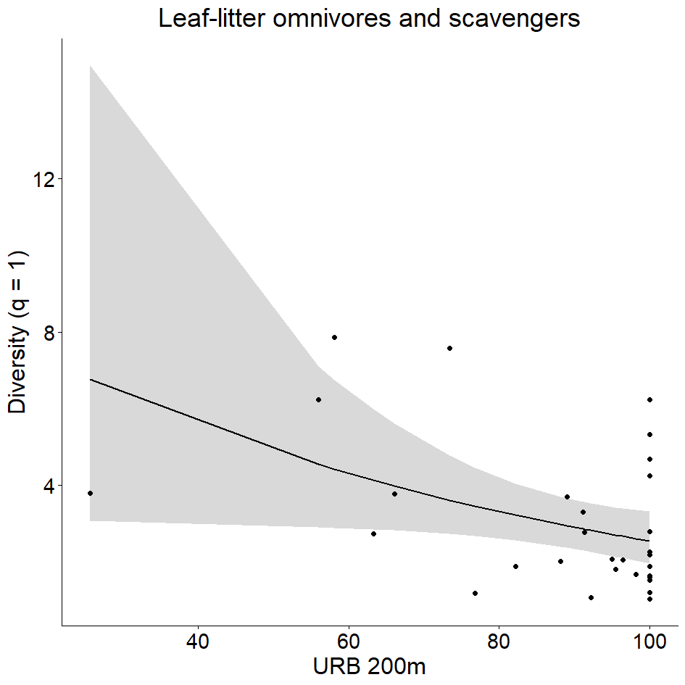
(i) 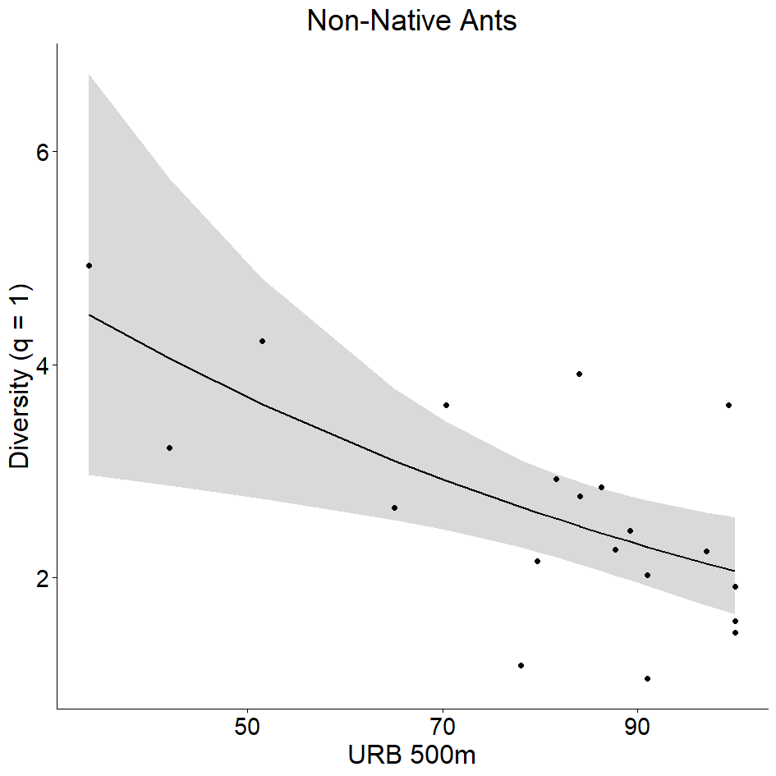 | (j) 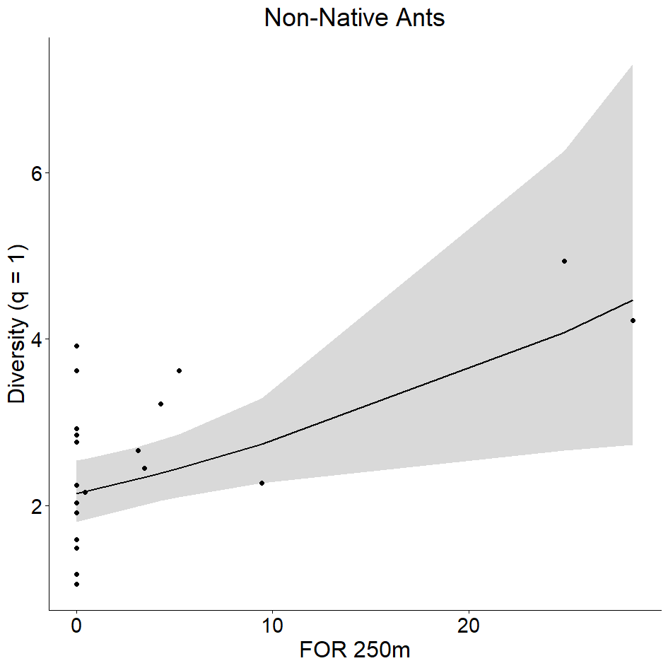
Fig. S6 Most plausible models describing q = 1 (exponential of Shannon entropy) of total native ants (a, b), native arboreal species (c-f), native leaf litter omnivores and scavengers (g, h) and non-native species (i, j) in 30 urban squares in Rio de Janeiro, Brazil. The solid line represents the predicted relationship between variables, while the gray area corresponds to the 95% confidence interval of the fitted model.

(a) 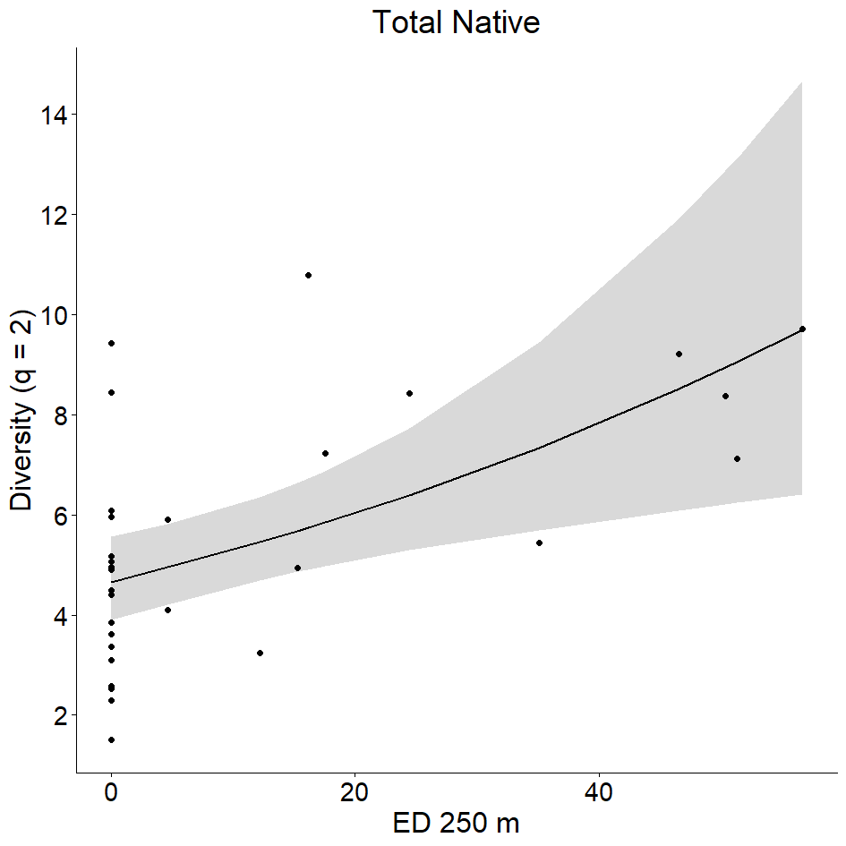 | (b) 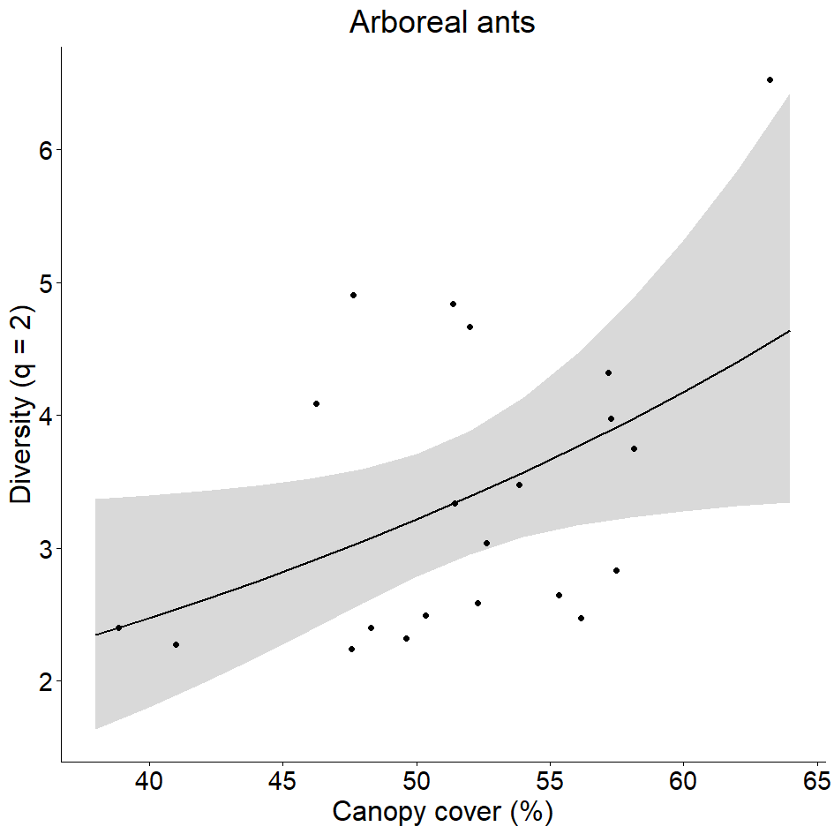
(c) 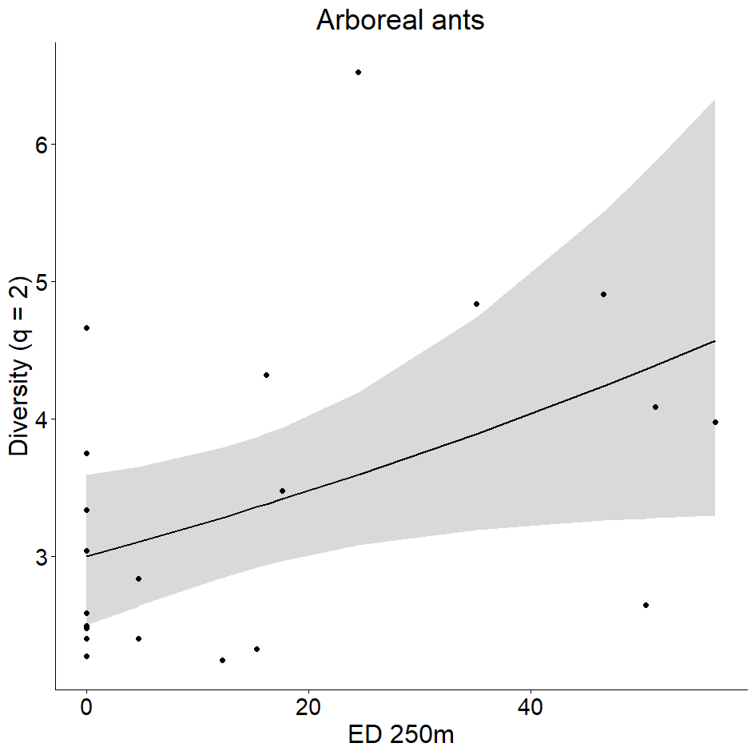 | (d) 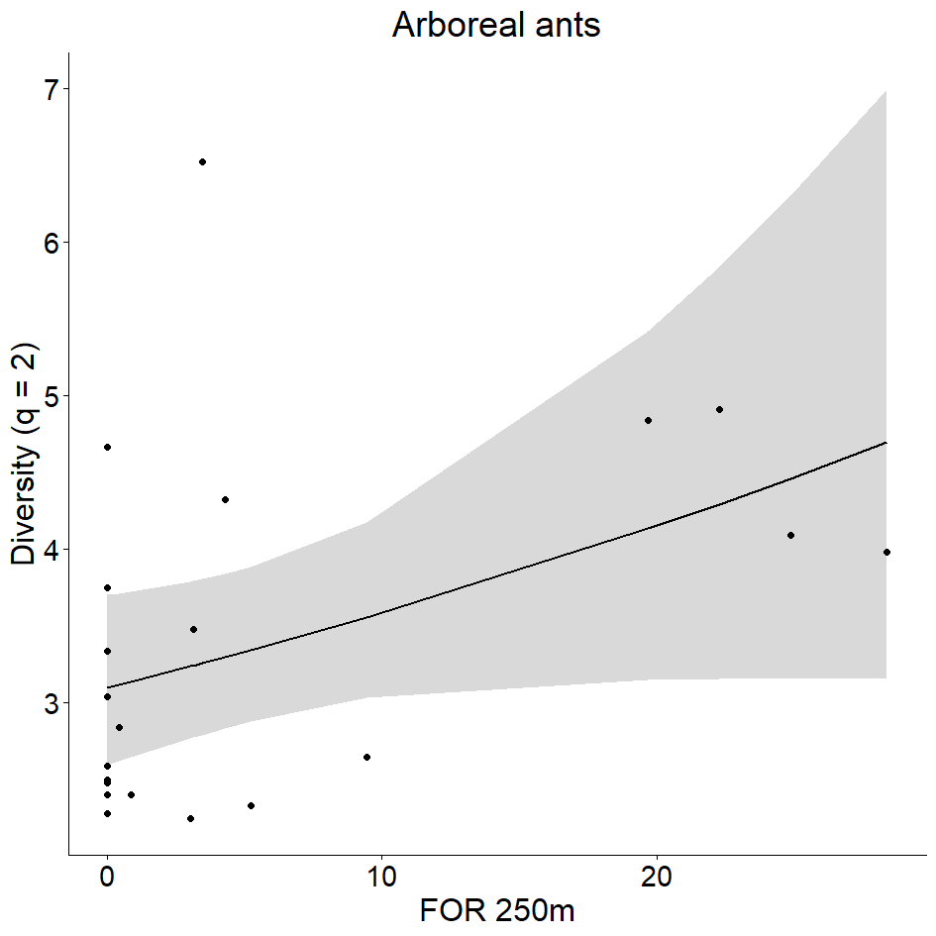
(e) 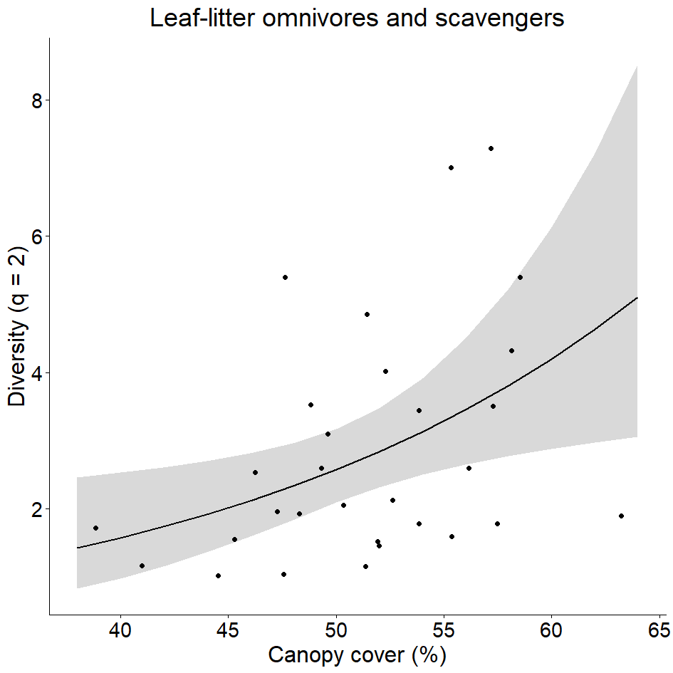 | (f) 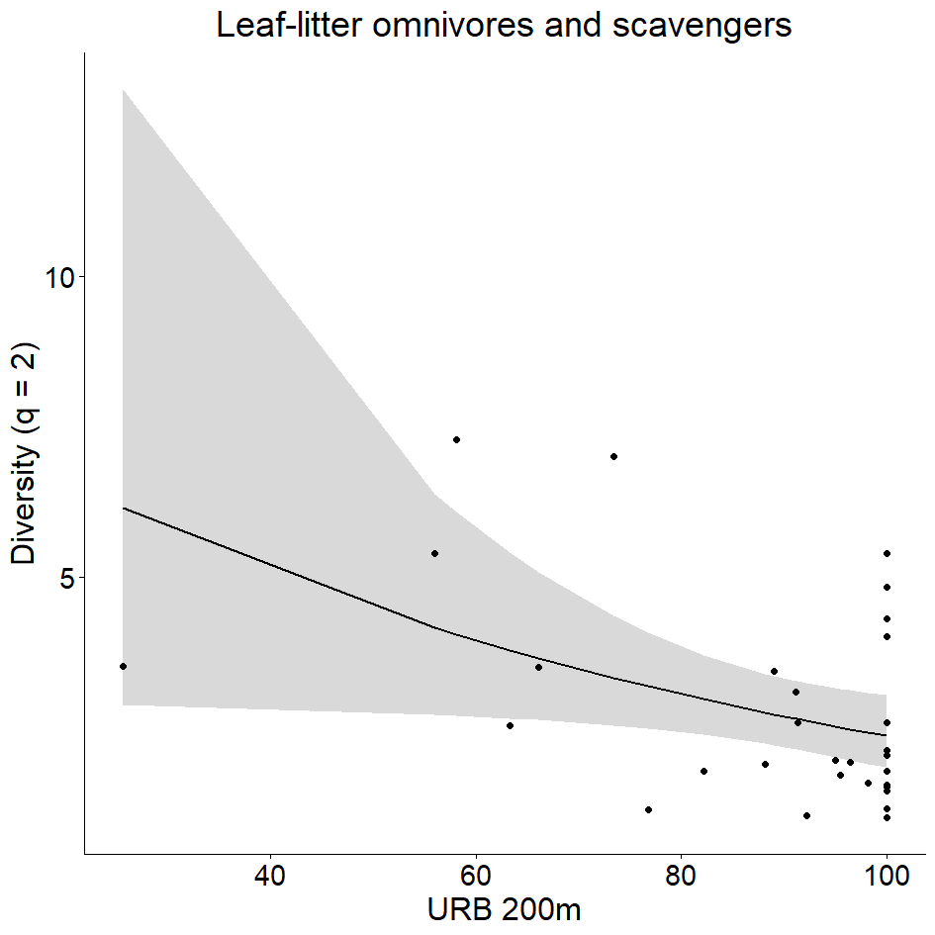
(g) 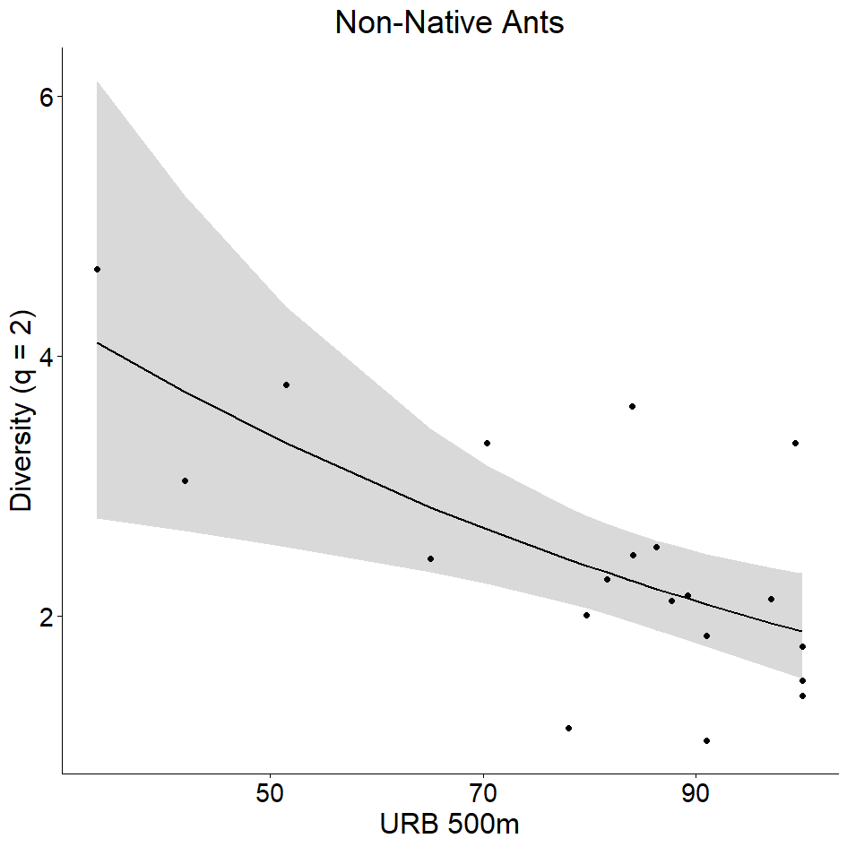 | (h) 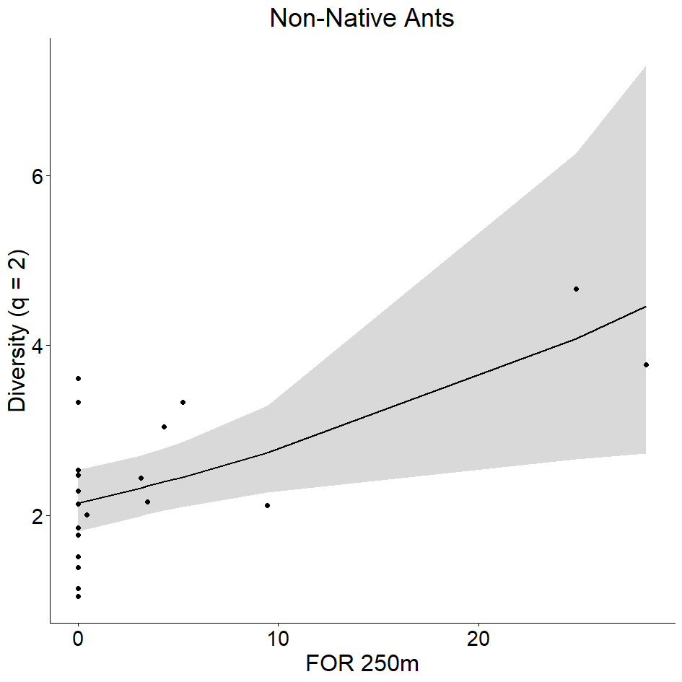
Fig. S7 Most plausible models describing q = 2 (inverse Simpson index) of total native ants (a), native arboreal species (b-d), native leaf litter omnivores and scavengers (e, f) and non-native species (g, h) in 30 urban squares in Rio de Janeiro, Brazil. The solid line represents the predicted relationship between variables, while the gray area corresponds to the 95% confidence interval of the fitted model.

