Towards an Improved Understanding of the Magnitude and Drivers of Carbon and Nitrogen Storage and Accumulation in Urban Saltmarshes: A Case Study from New England (USA)
Jahson B. Alemu I^{1,2*}, Conor Ofsthun³, Grace Medley³, Alison Bowden², Alex Cammett¹, Emma Gildesgame², Samuel E. Munoz^{1,4}, Aron Stubbins^{1,4,5}, A. Randall Hughes¹
¹Marine Science Center, Department of Marine and Environmental Sciences, Northeastern University, Nahant, MA, USA
²The Nature Conservancy, Boston, MA, USA
³Woods Hole Group Inc, Bourne, MA, USA
⁴Department of Civil and Environmental Engineering, Northeastern University, Boston, MA, USA
⁵Department of Chemistry and Chemical Biology, Northeastern University, Boston, MA, USA
*Correspondence:
Jahson B Alemu I
jahsonb@gmail.com

Table of Tables
Table S1 Study site sampling coordinates 3
Table S2 Results of linear mixed-effects models for sediment properties, including estimates, standard errors, degrees of freedom, and p-values (Significant results (p<0.05) are in bold). 5
Table S3 Summary statistics of soil properties by habitat type and depth, including mean ± SD for Dry Bulk Density, Total Organic Carbon, Soil Carbon density, Total Nitrogen, Carbon-to-Nitrogen (C:N) Ratio, Silt content, Sand Content, and Silt-to-Sand (S:S) Ratio 6

Table of Figure
Fig. S1 Comparison of Core Depth (Field-Measured) and Core Length (Lab-Measured) 4
Fig. S2 Site-specific stratigraphic core profiles showing downcore trends in dry bulk density (DBD), total organic carbon (TOC), soil carbon density (SCD), total nitrogen (TN), carbon-to-nitrogen (C:N) ratios, and silt-to-sand ratios across habitats 7
Fig. S3 GAM partial effect plots depicting effects of grain size using the proxy silt-to-sand (SS) ratio nested in habitat on carbon stock. This relationship explains 35.1% of the deviance in the response variable. Gray regions indicate ± 2 standard errors. Phrag=Upland Transitional Marsh. 7
Fig. S4 GAM partial effect plots depicting effects of grain size using the proxy silt-to-sand (SS) ratio nested in habitat on nitrogen stock. This relationship explains 28.84% of the deviance in the response variable. Gray regions indicate ± 2 standard errors. Phrag=Upland Transitional Marsh. 8
Fig S5 GAM partial effect plots depicting effects of dry bulk density nested in habitat on carbon stock. This relationship explains 34.58% of the deviance in the response variable. Gray regions indicate ± 2 standard errors. Phrag=Upland Transitional Marsh. 8
Fig S6 GAM partial effect plots depicting effects of dry bulk density nested in habitat on nitrogen stock. This relationship explains 38.56% of the deviance in the response variable. Gray regions indicate ± 2 standard errors. Phrag=Upland Transitional Marsh. 9
Fig S7 GAM partial effect plots depicting effects of grain size using the proxy silt-to-sand (SS) ratio nested in depth on carbon stock. This relationship explains 7.61% of the deviance in the response variable. Gray regions indicate ± 2 standard errors. . s1=<30cm, s2=30-60cm, s3=61-100cm 9
Fig S8 GAM partial effect plots depicting effects of grain size using the proxy silt-to-sand (SS) ratio nested in depth on nitrogen stock. This relationship explains 6.47% of the deviance in the response variable. Gray regions indicate ± 2 standard errors. s1=<30cm, s2=30-60cm, s3=61-100cm 10
Fig S9 GAM partial effect plots depicting effects of dry bulk density nested in depth on carbon stock. This relationship explains 22.72% of the deviance in the response variable. Gray regions indicate ± 2 standard errors. s1=<30cm, s2=30-60cm, s3=61-100cm 10
Fig S10 GAM partial effect plots depicting effects of dry bulk density nested in depth on nitrogen stock. This relationship explains 26.14% of the deviance in the response variable. Gray regions indicate ± 2 standard errors. s1=<30cm, s2=30-60cm, s3=61-100cm 11

Table S1 Study site sampling coordinates
Study site and habitat | Coordinates (decimal degrees)
Site 1  High Marsh  Low Marsh  Mudflat | 42.3919 ̊N, 70.9883 ̊W  42.3912 ̊N, 70.9889 ̊W  42.3925 ̊N, 70.9875 ̊W
Site 2  Upland Transitional Marsh  High Marsh | 42.3832 ̊N, 70.9965 ̊W  42.3835 ̊N, 70.9961 ̊W
Site 3  High Marsh  Low Marsh  Mudflat | 42.3898 ̊N, 70.9864 ̊W  42.3901 ̊N, 70.9848 ̊W  42.3897 ̊N, 70.9867 ̊W
Site 4  Upland Transitional Marsh  High marsh  Low Marsh  Mudflat | 42.3906 ̊N, 70.9939 ̊W  42.3890 ̊N, 70.9913 ̊W  42.3882 ̊N, 70.9903 ̊W  42.3872 ̊N, 70.9904 ̊W

Fig. S1 Comparison of Core Depth (Field-Measured) and Core Length (Lab-Measured)
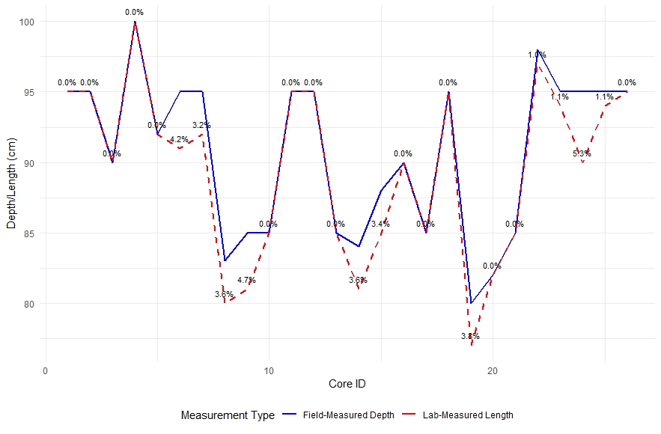

Table S2 Results of linear mixed-effects models for sediment properties, including estimates, standard errors, degrees of freedom, and p-values (Significant results (p<0.05) are in bold).
 | Dry Bulk Density (DBD, g/cm3) |  |  | Total Organic Carbon (TOC, %) |  |  | Soil Carbon Density (SCD, gC/cm3) |  |  | Total Nitrogen (TN, %) |  |  | Carbon-to-Nitogen ratio (C:N, unitless) |  |  | Silt-to-sand Ratio (S:S, unitless)
Predictors | Estimates | CI | p | Estimates | CI | p | Estimates | CI | p | Estimates | CI | p | Estimates | CI | p | Estimates | CI | p
(Intercept) | 0.51 | 0.39 – 0.63 | <0.001 | 0.32 | 0.28 – 0.36 | <0.001 | 0.05 | 0.04 – 0.06 | <0.001 | 0.46 | 0.32 – 0.61 | <0.001 | 22.58 | 20.52 – 24.64 | <0.001 | 1.08 | 0.37 – 1.79 | 0.003
Habitat [Low Marsh] | -0.11 | -0.19 – -0.03 | 0.01 | 0.04 | 0.01 – 0.07 | 0.006 | 0 | -0.01 – 0.01 | 0.766 | 0.13 | 0.04 – 0.22 | 0.004 | -1.44 | -2.75 – -0.12 | 0.032 | -0.14 | -0.56 – 0.28 | 0.513
Habitat [Mudflat] | 0.05 | -0.03 – 0.13 | 0.252 | -0.09 | -0.12 – -0.07 | <0.001 | -0.02 | -0.03 – -0.02 | <0.001 | -0.15 | -0.24 – -0.06 | 0.001 | -5.23 | -6.55 – -3.91 | <0.001 | 0.26 | -0.16 – 0.68 | 0.229
Habitat [Transitional Marsh] | 0.05 | -0.04 – 0.14 | 0.277 | -0.1 | -0.13 – -0.07 | <0.001 | -0.02 | -0.03 – -0.01 | <0.001 | -0.08 | -0.18 – 0.02 | 0.108 | -5.51 | -6.99 – -4.03 | <0.001 | 0.94 | 0.46 – 1.41 | <0.001
Depth [30-60cm] | -0.01 | -0.08 – 0.06 | 0.757 | -0.01 | -0.03 – 0.01 | 0.434 | -0.01 | -0.01 – 0.00 | 0.133 | 0 | -0.08 – 0.08 | 0.943 | -0.92 | -2.08 – 0.25 | 0.123 | 0.14 | -0.24 – 0.51 | 0.474
Depth [61-100cm] | -0.09 | -0.16 – -0.02 | 0.011 | 0.04 | 0.02 – 0.06 | 0.001 | 0 | -0.00 – 0.01 | 0.298 | 0.18 | 0.10 – 0.25 | <0.001 | -1.96 | -3.06 – -0.87 | <0.001 | 0.14 | -0.21 – 0.49 | 0.421
Habitat [Low Marsh] * Depth [30-60cm] | 0 | -0.12 – 0.11 | 0.935 | -0.03 | -0.07 – 0.01 | 0.125 | -0.01 | -0.02 – 0.01 | 0.331 | -0.07 | -0.20 – 0.05 | 0.244 | -0.9 | -2.71 – 0.91 | 0.329 | -0.25 | -0.85 – 0.35 | 0.412
Habitat [Mudflat] * Depth [30-60cm] | 0.06 | -0.05 – 0.18 | 0.26 | 0 | -0.04 – 0.04 | 0.921 | 0 | -0.01 – 0.01 | 0.383 | -0.02 | -0.14 – 0.11 | 0.812 | 1.42 | -0.40 – 3.24 | 0.127 | -0.36 | -0.94 – 0.22 | 0.228
Habitat [Transitional Marsh] * Depth [30-60cm] | 0.11 | -0.01 – 0.24 | 0.077 | -0.04 | -0.08 – 0.01 | 0.113 | 0 | -0.01 – 0.01 | 0.644 | -0.12 | -0.26 – 0.02 | 0.092 | 0.82 | -1.21 – 2.86 | 0.427 | -0.15 | -0.80 – 0.51 | 0.659
Habitat [Low Marsh] * Depth [61-100cm] | 0.09 | -0.02 – 0.19 | 0.112 | -0.05 | -0.09 – -0.02 | 0.005 | -0.01 | -0.02 – 0.00 | 0.209 | -0.13 | -0.24 – -0.01 | 0.034 | -1.04 | -2.75 – 0.67 | 0.235 | -0.21 | -0.77 – 0.35 | 0.467
Habitat [Mudflat] * Depth [61-100cm] | 0.12 | 0.01 – 0.23 | 0.029 | -0.02 | -0.05 – 0.02 | 0.352 | 0 | -0.01 – 0.01 | 0.483 | -0.09 | -0.21 – 0.03 | 0.129 | 1.76 | 0.03 – 3.49 | 0.046 | -0.14 | -0.69 – 0.41 | 0.62
Habitat [Transitional Marsh] * Depth [61-100cm] | 0.44 | 0.30 – 0.57 | <0.001 | -0.07 | -0.11 – -0.02 | 0.006 | 0.02 | 0.00 – 0.03 | 0.007 | -0.32 | -0.47 – -0.17 | <0.001 | 2.42 | 0.24 – 4.61 | 0.03 | 1.35 | 0.65 – 2.05 | <0.001
Random Effects
σ² | 0.03 |  |  | 0 |  |  | 0 |  |  | 0.04 |  |  | 8.64 |  |  | 0.88
τ₀₀ | 0.01 _{Site} |  |  | 0.00 _{Site} |  |  | 0.00 _{Site} |  |  | 0.02 _{Site} |  |  | 3.65 _{Site} |  |  | 0.44 _{Site}
ICC | 0.27 |  |  | 0.27 |  |  | 0.17 |  |  | 0.31 |  |  | 0.3 |  |  | 0.33
N | 4 _{Site} |  |  | 4 _{Site} |  |  | 4 _{Site} |  |  | 4 _{Site} |  |  | 4 _{Site} |  |  | 4 _{Site}
Observations | 455 |  |  | 455 |  |  | 455 |  |  | 455 |  |  | 455 |  |  | 441
Marginal R² / Conditional R² | 0.227 / 0.435 |  |  | 0.412 / 0.572 |  |  | 0.224 / 0.357 |  |  | 0.239 / 0.473 |  |  | 0.242 / 0.467 |  |  | 0.181 / 0.455

Table S3 Summary statistics of soil properties by habitat type and depth, including mean ± SD for Dry Bulk Density, Total Organic Carbon, Soil Carbon density, Total Nitrogen, Carbon-to-Nitrogen (C:N) Ratio, Silt content, Sand Content, and Silt and Clay-to-Sand (S:S) Ratio
Habitat | Depth  (cm) | DBD  (g cm⁻³) | TOC  (%) | SCD  (gC cm⁻³) | TN  (%) | C: N ratio  (unitless) | Silt  (%) | Sand  (%) | S:S ratio  (unitless)
Upland Transitional Marsh | <30 | 0.5 ± 0.07 | 5.55 ± 2.69 | 0.03 ± 0.01 | 0.41 ± 0.29 | 17.19 ± 7.24 | 45.44 ± 25.61 | 39.53 ± 19.89 | 1.78 ± 1.8
Upland Transitional Marsh | 31-60 | 0.6 ± 0.08 | 4.06 ± 3.25 | 0.02 ± 0.02 | 0.29 ± 0.25 | 17.1 ± 6.25 | 39.49 ± 28.84 | 35.19 ± 15.49 | 1.77 ± 1.83
Upland Transitional Marsh | 61-100 | 0.81 ± 0.12 | 6.04 ± 1.43 | 0.05 ± 0.01 | 0.41 ± 0.16 | 15.87 ± 4.27 | 67.51 ± 19.03 | 21.48 ± 9.07 | 3.79 ± 1.79
High Marsh | <30 | 0.51 ± 0.24 | 9.87 ± 3.44 | 0.05 ± 0.02 | 0.45 ± 0.18 | 22.47 ± 2.68 | 36.56 ± 16.72 | 51.92 ± 18.22 | 1.03 ± 1.07
High Marsh | 31-60 | 0.49 ± 0.21 | 9.2 ± 3.48 | 0.04 ± 0.01 | 0.45 ± 0.2 | 21.5 ± 2.67 | 36.52 ± 17.44 | 51.05 ± 20.23 | 1.12 ± 1.35
High Marsh | 61-100 | 0.42 ± 0.19 | 12.86 ± 6.43 | 0.05 ± 0.03 | 0.63 ± 0.31 | 20.49 ± 2.78 | 41.44 ± 19.36 | 47.4 ± 17.81 | 1.2 ± 1.14
Low Marsh | <30 | 0.4 ± 0.13 | 11.23 ± 4.16 | 0.04 ± 0.02 | 0.52 ± 0.19 | 21.67 ± 1.82 | 28.36 ± 7.93 | 59.19 ± 13.47 | 0.53 ± 0.27
Low Marsh | 31-60 | 0.39 ± 0.11 | 8.85 ± 3.36 | 0.03 ± 0.01 | 0.45 ± 0.16 | 19.92 ± 2.25 | 23.74 ± 12.5 | 52.87 ± 27.04 | 0.50 ± 0.29
Low Marsh | 61-100 | 0.4 ± 0.18 | 10.77 ± 4.99 | 0.04 ± 0.02 | 0.57 ± 0.24 | 18.8 ± 1.92 | 24.92 ± 15.41 | 50.81 ± 26.22 | 0.52 ± 0.30
Mudflat | <30 | 0.59 ± 0.27 | 4.41 ± 1.67 | 0.02 ± 0.01 | 0.25 ± 0.09 | 18.07 ± 2.76 | 46.24 ± 20.03 | 46.68 ± 13.97 | 1.26 ± 1.03
Mudflat | 31-60 | 0.64 ± 0.26 | 4.09 ± 1.91 | 0.02 ± 0.01 | 0.23 ± 0.11 | 18.44 ± 2.68 | 41.96 ± 18.21 | 50.23 ± 13.06 | 0.98 ± 0.67
Mudflat | 61-100 | 0.61 ± 0.26 | 5.55 ± 3.44 | 0.03 ± 0.01 | 0.33 ± 0.22 | 17.65 ± 2.86 | 45.58 ± 18.53 | 46.48 ± 11.14 | 1.13 ± 0.74

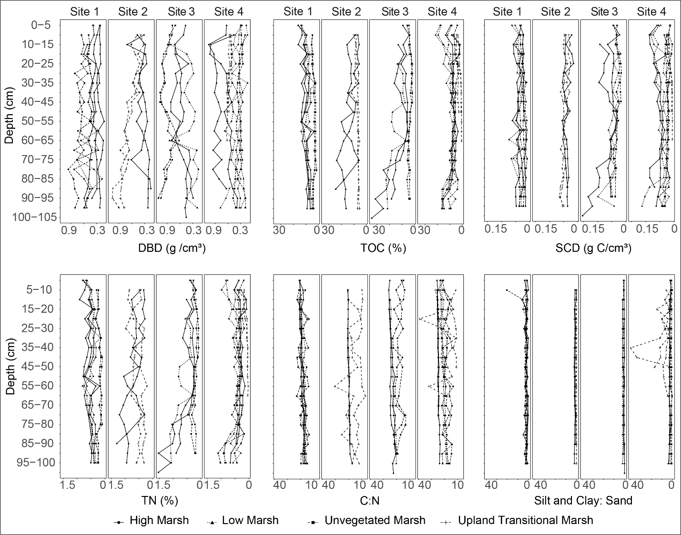
Fig. S2 Site-specific stratigraphic core profiles showing downcore trends in dry bulk density (DBD), total organic carbon (TOC), soil carbon density (SCD), total nitrogen (TN), carbon-to-nitrogen (C:N) ratios, and silt and clay-to-sand ratios across habitats
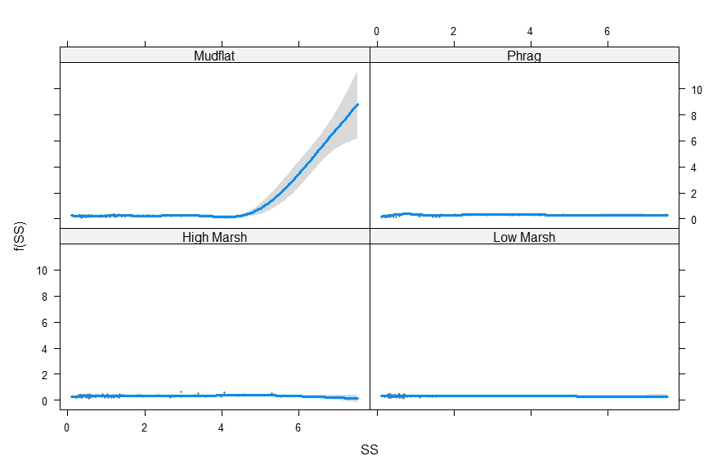
Fig. S3 GAM partial effect plots depicting effects of grain size using the proxy silt-to-sand (SS) ratio nested in habitat on carbon stock. This relationship explains 35.1% of the deviance in the response variable. Gray regions indicate ± 2 standard errors. Phrag=Upland Transitional Marsh.
Fig. S4 GAM partial effect plots depicting effects of grain size using the proxy silt-to-sand (SS) ratio nested in habitat on nitrogen stock. This relationship explains 28.84% of the deviance in the response variable. Gray regions indicate ± 2 standard errors. Phrag=Upland Transitional Marsh.
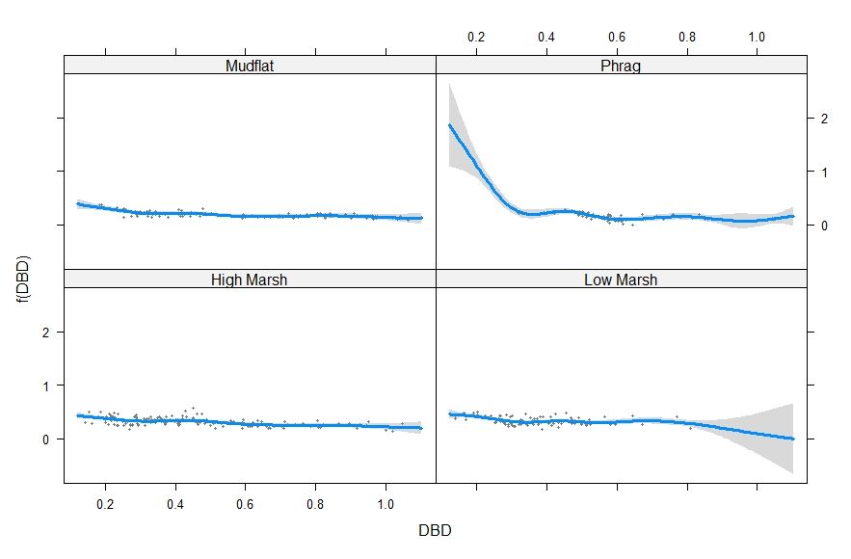
Fig S5 GAM partial effect plots depicting effects of dry bulk density nested in habitat on carbon stock. This relationship explains 34.58% of the deviance in the response variable. Gray regions indicate ± 2 standard errors. Phrag=Upland Transitional Marsh.
Fig S6 GAM partial effect plots depicting effects of dry bulk density nested in habitat on nitrogen stock. This relationship explains 38.56% of the deviance in the response variable. Gray regions indicate ± 2 standard errors. Phrag=Upland Transitional Marsh.
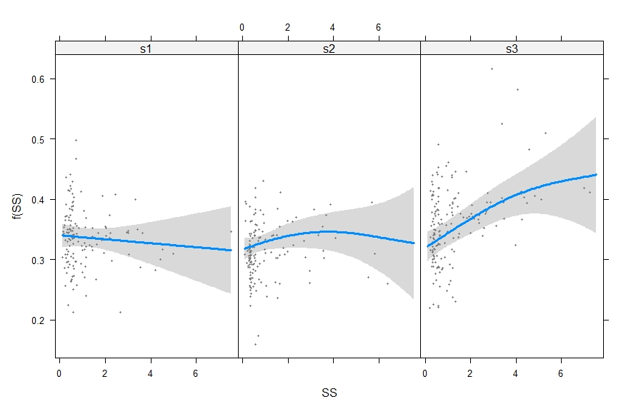
Fig S7 GAM partial effect plots depicting effects of grain size using the proxy silt-to-sand (SS) ratio nested in depth on carbon stock. This relationship explains 7.61% of the deviance in the response variable. Gray regions indicate ± 2 standard errors. . s1=<30cm, s2=30-60cm, s3=61-100cm

Fig S8 GAM partial effect plots depicting effects of grain size using the proxy silt-to-sand (SS) ratio nested in depth on nitrogen stock. This relationship explains 6.47% of the deviance in the response variable. Gray regions indicate ± 2 standard errors. s1=<30cm, s2=30-60cm, s3=61-100cm
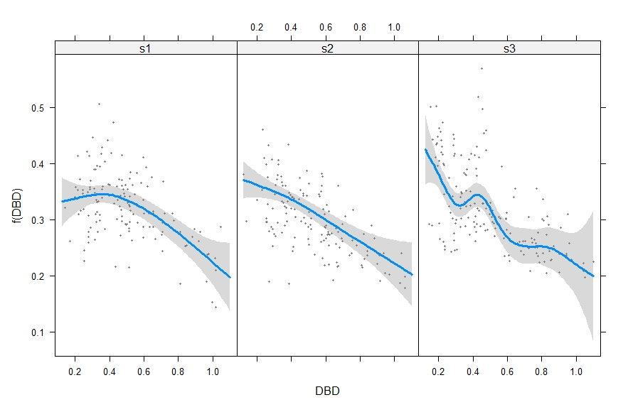
Fig S9 GAM partial effect plots depicting effects of dry bulk density nested in depth on carbon stock. This relationship explains 22.72% of the deviance in the response variable. Gray regions indicate ± 2 standard errors. s1=<30cm, s2=30-60cm, s3=61-100cm
Fig S10 GAM partial effect plots depicting effects of dry bulk density nested in depth on nitrogen stock. This relationship explains 26.14% of the deviance in the response variable. Gray regions indicate ± 2 standard errors. s1=<30cm, s2=30-60cm, s3=61-100cm

