Table S1 Total abundance of ground invertebrates and functional roles in urban parks.
Site | DFP | CKS | PMP | Total | Percentage
Entognatha
Collembola
Arthropleona (springtails)# | 6,837 | 5,680 | 3,698 | 16,215 | 29.97
Symphypleona (springtails)# | 7,015 | 4,989 | 6,076 | 18,080 | 33.42
Insecta
Diptera% | 219 | 123 | 392 | 734 | 1.36
Larva## | 43 | 12 | 24 | 79 | 0.15
Coleoptera
Staphylinidae (rove beetles) $$ | 165 | 199 | 155 | 519 | 0.96
Scarabaeinae (dung beetles)* | 48 | 24 | 98 | 170 | 0.31
Carabidae (ground beetles) $$ | 3 | 0 | 0 | 3 | 0.01
Others% | 366 | 93 | 65 | 524 | 0.97
Hymenoptera
Formicidae% | 1,629 | 3,069 | 3,925 | 8,623 | 15.94
Others (etc. wasps)@ | 73 | 56 | 50 | 179 | 0.33
Dermaptera% | 90 | 0 | 22 | 112 | 0.21
Hemiptera& | 113 | 165 | 195 | 473 | 0.87
Orthoptera& | 44 | 32 | 20 | 96 | 0.18
Lepidoptera
Larva& | 9 | 2 | 4 | 15 | 0.03
Thysanoptera& | 10 | 12 | 19 | 41 | 0.08
Embioptera## | 0 | 1 | 0 | 1 | 0
Blattodea
Blattoidae% | 1 | 12 | 19 | 32 | 0.06
Termitoidae## | 0 | 1 | 0 | 1 | 0
Psocoptera## | 5 | 2 | 4 | 11 | 0.02
Malacostraca
Isopoda## | 34 | 39 | 69 | 142 | 0.26
Arachnida
Sarcoptiforme (oribatid mites)# | 904 | 1,052 | 508 | 2,464 | 4.55
Mesostigmata (gamasid mites)$ | 1,829 | 1,891 | 691 | 4,411 | 8.15
Araneae (ambush spiders)$$ | 534 | 368 | 254 | 1,156 | 2.14
Chilopoda$$ | 6 | 3 | 10 | 19 | 0.04
Diplopoda## | 3 | 0 | 0 | 3 | 0.01
Total abundance | 19,980 | 17,825 | 16,298 | 54,103 | 100.00
The superscript symbols indicate the different functional groups. Micro-invertebrates (< 2 mm): #deritivores (feeding on plant litter, fungi), $predator (feeding on other invertebrates). Macro-invertebrates (≥ 2 mm): ##detritivores, *detritivore-feces (feeding on feces), $$predator, %omnivores (feeding on litter, fruits, invertebrates, scavengers), &herbivores (feeding on plants), @parasitoid (wasps that may feed on fruits or invertebrates). Functional group classified with McCary and Schmitz (2021).
Table S2 Statistics of one-way ANOVA and Tukey’s Honest Significant Difference test for the differences in above-belowground properties among urban parks.
 | one-way ANOVA | Tukey’s Honest Significant Difference test
 |  | CKS- DFP | PMP-DFP | PMP-CKS
Properties | F_{2,21} (p-value) | Diff. (p-value) | Diff. (p-value) | Diff. (p-value)
Park visitor level
Number of visitors hr⁻¹ | 1.338 (0.284 | -1.450 (0.926 | -6.083 (0.282 | -4.633 (0.470
Vegetation composition
Number of trees$ | 1.162 (0.356 | 1.083 (0.633 | 1.750 (0.331 | 0.667 (0.836
Number of tree species$ | 2.543 (0.133 | 0.500 (0.810 | 1.750 (0.127 | 1.250 (0.309
Mean DBH (cm) $ | 0.243 (0.790 | 10.203 (0.772 | 5.337 (0.930 | -4.867 (0.941
Mean Tree height (cm) $ | 1.324 (0.313 | 2.851 (0.641 | -2.167 (0.769 | -5.018 (0.286
Grass height (cm) | 0.840 (0.446 | -0.084 (0.650 | -0.119 (0.432 | -0.035 (0.929
Grass coverage (%) | 1.506 (0.245 | -0.038 (0.449 | 0.014 (0.897 | 0.051 (0.238
Soil properties
Pebble (%) | 1.526 (0.241 | -3.155 (0.283 | -0.219 (0.994 | 2.936 (0.332
Sand (%) | 1.449 (0.257 | -3.791 (0.465 | 1.399 (0.898 | 5.190 (0.250
Silt and clay (%) | 4.647 (0.021 | 6.944 (0.062 | -1.181 (0.912 | -8.125 (0.027
Bulk density (g cm⁻³) | 0.953 (0.402 | -0.043 (0.574 | -0.055 (0.402 | -0.013 (0.952
Soil water content (%) | 1.116 (0.346 | 1.043 (0.877 | 3.123 (0.326 | 2.080 (0.599
pH | 2.871 (0.079 | -0.556 (0.104 | -0.515 (0.139 | 0.041 (0.986
SOM (%) | 6.619 (0.006 | 0.563 (0.072 | 0.863 (0.005 | 0.300 (0.440
DOC (mg kg⁻¹ soil dm) | 0.560 (0.579 | -0.063 (0.440 | 0.018 (0.974 | 0.081 (0.581
NO₃⁻-N (mg kg⁻¹ soil dm) | 1.783 (0.193 | 1.768 (0.205 | 0.304 (0.951 | -1.464 (0.329
NO₄⁺-N (mg kg⁻¹ soil dm) | 0.957 (0.400 | -0.100 (0.995 | 1.218 (0.496 | 1.318 (0.442
Ground invertebrate composition
Total abundance | 0.968 (0.396 | -67.219 (0.701 | -114.875 (0.367 | -47.656 (0.835
Taxa richness | 3.171 (0.063 | -2.00 (0.051 | -0.875 (0.525 | 1.125 (0.353
Micro-detritivore abundance | 1.507 (0.245 | -94.844 (0.493 | -139.813 (0.229 | -44.969 (0.849
Macro-detritivore abundance | 0.862 (0.437 | -0.906 (0.676 | 0.469 (0.899 | 1.375 (0.416
Detritivore-feces abundance | 1.630 (0.220 | -0.750 (0.835 | 1.563 (0.469 | 2.313 (0.204
Micro-predator abundance | 3.364 (0.044 | 1.938 (0.992 | -35.563 (0.082 | -37.500 (0.065
Macro-predator abundance | 2.439 (0.112 | -4.219 (0.559 | -8.937 (0.093 | -4.719 (0.486
Herbivore abundance | 0.252 (0.779 | 1.094 (0.916 | 1.938 (0.761 | 0.844 (0.949
Omnivore abundance | 3.580 (0.046 | 39.531 (0.359 | 75.594 (0.036 | 36.062 (0.424
Parasitoid abundance | 1.362 (0.278 | -0.531 (0.480 | -0.719 (0.272 | -0.187 (0.910
$The degree of freedom is F_{2,9} for the tree properties. Bold texts represent the result of significant differences among urban parks at alpha level = 0.05

Table S3. The aboveground and belowground properties (mean±SD) between two vegetation types among three parks.
 | DFP |  | CKS |  | PMP
 | T | G | T | G | T | G
Park visitor level
Number of visitors hr⁻¹ | 1.1±0.2 | 14.3±8.7 | 7.7±11.7 | 4.8±8.8 | 1.6±1.9 | 1.6±2.7
Vegetation composition
Number of trees | 3.0±0.0 | 0 | 4.1±1.3 | 0 | 4.8±2.5 | 0
Number of tree species | 1.3±0.5 | 0 | 1.8±1.0 | 0 | 3.0±1.6 | 0
Mean tree DBH (cm) | 27.5±5.9 | 0 | 37.7±20.0 | 0 | 32.9±29.2 | 0
Mean tree height (cm) | 10.6±2.4 | 0 | 13.4±4.5 | 0 | 8.4±5.6 | 0
Grass height (cm) | 16.7±4.9 | 13.1±6.1 | 8.2±0.9 | 16.8±3.6 | 10.7±7.2 | 13.3±5.7
Grass coverage (%) | 89.6±7.2^{ab} | 97.0±1.7^{b} | 73.9±14.5^{ab} | 99.9±0.3ª | 92.5±8.7^{ab} | 99.4±1.0ª
Soil properties
Pebble (%) | 1.9±1.3 | 6.9±6.3 | 1.5±1.3 | 1.0±1.0 | 5.8±6.4 | 2.6±2.2
Sand (%) | 68.0±3.8 | 67.3±6.7 | 59.3±2.5 | 68.4±6.0 | 66.3±8.8 | 71.8±5.0
Silt (%) | 30.1±3.8 | 25.8±6.8 | 39.2±1.9 | 30.6±6.8 | 27.9±6.8 | 25.6±3.2
Bulk density (g cm⁻³) | 1.3±0.1 | 1.2±01 | 1.3±0.0 | 1.2±0.0 | 1.3±0.1 | 1.2±0.0
Soil water content (%) | 21.8±2.6 | 26.7±4.0 | 21.3±2.3 | 29.3±1.7 | 25.0±4.6 | 29.8±1.0
pH | 6.2±0.2^{ab} | 7.1±0.7^{b} | 6.2±0.3^{ab} | 6.0±0.2ª | 6.3±0.6^{ab} | 6.0±0.2ª
SOM (%) | 2.4±0.6 | 2.6±0.3 | 2.7±0.4 | 3.3±0.1 | 3.0±0.5 | 3.7±0.1
DOC (mg kg⁻¹ soil dm) | 50.1±6.6 | 23.9±3.5 | 33.4±2.7 | 26.7±3.6 | 52.4±36.8 | 28.4±2.9
NO₃⁻-N (mg kg⁻¹ soil dm) | 4.4±1.2 | 1.9±1.3 | 6.3±2.4 | 3.5±1.3 | 4.3±2.0 | 2.6±1.5
NO₄⁺-N (mg kg⁻¹ soil dm) | 5.4±2.1 | 4.9±1.7 | 6.7±2.3 | 3.4±1.2 | 7.0±2.0 | 5.8±2.3
SDOM-C1 (%) | 32.5±10.2 | 21.2±4.2 | 51.4±14.2 | 35.3±5.5 | 36.7±19.8 | 36.2±2.5
SDOM-C2 (%) | 39.5±10.0 | 54.2±5.6 | 28.2±7.9 | 47.0±1.8 | 30.4±6.7 | 43.6±3.6
SDOM-C3 (%) | 28.0±2.7 | 24.5±2.4 | 20.3±8.6 | 17.7±6.4 | 32.9±24.2 | 20.1±5.7
Invertebrates
Taxa richness | 18.0±1.4ª | 15.2±1.0^{ab} | 14.2±2.2^{b} | 15.0±1.6^{ab} | 15.5±1.0^{ab} | 16.0±0.8^{ab}
Total abundance | 591.6±74.8 | 656.8±224.9 | 543.6±80.5 | 570.4±57.6 | 568.6±193.1 | 450.0±277.1
Micro-detritivores | 392.9±50.1 | 529.3±253.5 | 357.4±99.1 | 375.2±33.3 | 384.6±219.5 | 258.1±200.4
Macro-detritivores | 4.2±1.2ª | 0.9±0.8ª | 0.7±0.6ª | 2.6±1.9ª | 2.0±1.6ª | 4.1±3.2ª
Detritivore-feces | 2.6±2.0 | 0.4±0.4 | 1.5±1.5 | 0±0 | 4.8±5.1 | 1.4±1.9
Micro-predators | 65.6±16.3 | 48.7±55.0 | 89.8±23.5 | 28.4±11.9 | 22.4±7.3 | 20.8±11.1
Macro-predators | 25.7±16.4 | 18.4±4.7 | 16.0±4.3 | 19.6±8.1 | 11.9±4.9 | 14.2±3.1
Herbivores | 6.3±2.4 | 4.7±1.4 | 3.5±1.1 | 9.7±3.9 | 3.4±1.5 | 11.4±10.7
Omnivores | 85.5±77.1 | 35.7±16.5 | 69.1±8.1 | 131.2±60.2 | 135.4±68.1 | 137.0±59.9
Parasitoids | 1.9±0.8 | 2.7±0.4 | 1.4±0.6 | 2.1±1.4 | 1.4±0.1 | 1.7±1.4
N = 4 for each vegetation type per park for all other aboveground-belowground properties. Bold values represent the significantly interaction effect of vegetation cover type and park with two-way ANOVA at alpha level = 0.05, where the statistic values were reported in Table S4. Subscript letters indicating groups from Tukey’s Honest Significant Difference test. For those properties of plants and soils exhibiting significant interaction effect, the significant differences only occurred in the grass pair of DFP and PMP while tree covers group exhibited comparable properties among parks.

Table S4 Statistics of two-way ANOVA for the differences in above-belowground properties between two vegetation types among urban parks and their interaction effect.
 | Vegetation type | Park | Vegetation type: Park
 | F_{1,18} (p-value) | F_{2,18} (p-value) | F_{2,18} (p-value)
Park visitor level
Number of visitors hr⁻¹ | 1.43 (0.247 | 1.61 (0.227 | 2.94 (0.078
Vegetation composition
Number of trees$ | 69.53 (<0.01 | 1.16 (0.335 | 1.16 (0.335
Number of tree species$ | 37.57 (<0.01 | 2.54 (0.106 | 2.54 (0.106
Mean DBH (cm) $ | 29.90 (<0.01 | 0.24 (0.787 | 0.24 (0.787
Mean Tree height (cm) $ | 73.07 (<0.01 | 1.32 (0.291 | 1.32 (0.291
Grass height (cm) | 1.46 (0.243 | 0.73 (0.496 | 2.77 (0.090
Grass coverage (%) | 17.96 (<0.01 | 3.18 (0.066 | 4.17 (0.033
Soil properties
Pebble (%) | 0.07 (0.801 | 1.65 (0.221 | 2.29 (0.130
Sand (%) | 3.78 (0.068 | 1.70 (0.211 | 1.42 (0.268
Silt and clay (%) | 5.43 (0.032 | 5.51 (0.013 | 0.73 (0.495
Bulk density (g cm⁻³) | 14.79 (<0.01) | 1.51 (0.247) | 0.25 (0.779
Soil water content (%) | 23.40 (<0.01 | 2.28 (0.131 | 0.71 (0.506
pH | 0.61 (0.446 | 3.92 (0.039 | 5.02 (0.018
SOM (%) | 9.29 (0.007 | 9.22 (0.002 | 0.98 (0.394
DOC (mg kg⁻¹ soil dm) | 20.56 (<0.01 | 1.13 (0.344 | 1.95 (0.172
NO₃⁻-N (mg kg⁻¹ soil dm) | 11.91 (0.003 | 2.58 (0.103 | 0.26 (0.776
NO₄⁺-N (mg kg⁻¹ soil dm) | 4.17 (0.056 | 1.11 (0.350 | 1.14 (0.342
SDOM-C1 (%) | 4.13 (0.057 | 4.38 (0.028 | 1.03 (0.376
SDOM-C2 (%) | 34.35 (<0.01 | 5.75 (0.012 | 0.39 (0.683
SDOM-C3 (%) | 1.92 (0.183 | 1.17 (0.332 | 0.51 (0.607
Ground invertebrate composition
Total abundance | 0.02 (0.902 | 0.89 (0.429 | 0.63 (0.546
Taxa richness | 0.74 (0.401 | 3.97 (0.037 | 3.76 (0.043
Micro-detritivore abundance | 0.02 (0.893 | 1.47 (0.256 | 1.25 (0.310
Macro-detritivore abundance | 0.08 (0.777 | 1.25 (0.311 | 6.14 (0.009
Detritivore-feces abundance | 5.49 (0.031 | 1.87 (0.183 | 0.31 (0.740
Micro-predator abundance | 6.14 (0.023 | 5.14 (0.017 | 2.79 (0.088
Macro-predator abundance | 0.02 (0.894 | 2.33 (0.125 | 1.04 (0.373
Herbivore abundance | 4.53 (0.047 | 0.32 (0.727 | 2.25 (0.134
Omnivore abundance | 0.04 (0.838 | 3.78 (0.042 | 2.08 (0.154
Parasitoid abundance | 2.29 (0.148 | 1.34 (0.286 | 0.20 (0.822

Table S5 Global fitness-test of hypothesized alternative structural equation model.
Model | Chi-Squared test | Fisher's C test | AICc
Hypothesized full model (Model 1)
Grass_coverage.sqrt~Avg_DBH  Micro.detritivores ~Grass_coverage.sqrt + Avg_DBH  SW~Grass_coverage.sqrt  DOC.log ~ SW + Micro.detritivores + Grass_coverage.sqrt + Avg_DBH  Hydrolase ~ DOC.log + SW + Micro.detritivores + Grass_coverage.sqrt  Oxidase~ DOC.log + SW + Micro.detritivores + Grass_coverage.sqrt  N ~ Hydrolase + Oxidase  Tryp.Humic.ratio.R.sqrt ~ Hydrolase + Oxidase  SOM ~ Tryp.Humic.ratio.R.sqrt | 71.92  p < 0.001  (df = 25) | 81.33  p = 0.007  (df = 50) | 555.21
Weak contribution of micro.detritivores (Model 2)
Grass_coverage.sqrt~Avg_DBH  SW~Grass_coverage.sqrt  DOC.log ~ SW + Grass_coverage.sqrt + Avg_DBH  Hydrolase ~ DOC.log + SW + Grass_coverage.sqrt  Oxidase~ DOC.log + SW + Grass_coverage.sqrt  N ~ Hydrolase + Oxidase  Tryp.Humic.ratio.R.sqrt ~ Hydrolase + Oxidase  SOM ~ Tryp.Humic.ratio.R.sqrt | 59.50  p < 0.001  (df = 20) | 70.41  p = 0.002  (df = 40) | 470.92
Weak contribution of micro.detritivores and oxidase on recalcitrant matter (Model 3)
Grass_coverage.sqrt~Avg_DBH  SW~Grass_coverage.sqrt  DOC.log ~ SW + Grass_coverage.sqrt + Avg_DBH  Hydrolase ~ DOC.log + SW + Grass_coverage.sqrt  N ~ Hydrolase  Tryp.Humic.ratio.R.sqrt ~ Hydrolase  SOM ~ Tryp.Humic.ratio.R.sqrt | 55.78  p < 0.001  (df = 17) | 69.73  p = 0.001  (df = 34) | 401.86
Weak contribution of micro.detritivores and oxidase on recalcitrant matter, with additional paths of soil water content with soil organic matter and nutrient content identified by tests of directed separation (Table S6) (Model 4)

Grass_coverage.sqrt~Avg_DBH  SW~Grass_coverage.sqrt  DOC.log ~ SW + Grass_coverage.sqrt + Avg_DBH  Hydrolase ~ DOC.log + SW + Grass_coverage.sqrt  N ~ Hydrolase + SW  Tryp.Humic.ratio.R.sqrt ~ Hydrolase  SOM ~ Tryp.Humic.ratio.R.sqrt + SW | 22.47  p = 0.096  (df = 15) | 31.89  p = 0.373  (df = 30) | 374.36

Table S6 Directed separation test for identifying potential missing links in the model pathways with hypothesized weak contribution of micro.detritivores and oxidase on recalcitrant matter (Model 3).
Independ.Claim | DF | Crit.Value | p-value
SW ~ Avg_DBH + ... | 21 | -1.806 | 0.085
Hydrolase ~ Avg_DBH + ... | 19 | -0.378 | 0.710
N ~ Avg_DBH + ... | 21 | -0.592 | 0.560
Tryp.Humic.ratio ~ Avg_DBH + ... | 21 | 0.314 | 0.757
SOM ~ Avg_DBH + ... | 21 | -1.115 | 0.278
N ~ Grass_coverage.sqrt + ... | 20 | -0.762 | 0.455
Tryp.Humic.ratio ~ Grass_coverage.sqrt + ... | 20 | 1.904 | 0.071
SOM ~ Grass_coverage.sqrt + ... | 20 | 0.177 | 0.861
N ~ DOC.log + ... | 18 | -1.551 | 0.138
Tryp.Humic.ratio.sqrt ~ DOC.log + ... | 18 | 0.145 | 0.886
SOM ~ DOC.log + ... | 18 | -0.149 | 0.883
N ~ SW + ... | 20 | 3.719 | 0.001
Tryp.Humic.ratio.sqrt ~ SW + ... | 20 | 0.571 | 0.574
SOM ~ SW + ... | 20 | 5.691 | < 0.001
SOM ~ Hydrolase + ... | 18 | 0.990 | 0.335
Tryp.Humic.ratio.sqrt ~ N + ... | 21 | -0.961 | 0.347
SOM ~ N + ... | 20 | 2.410 | 0.026
Chi-Squared = 55.78 with p-value < 0.001 and on 17 degrees of freedom. Fisher’s C = 69.73 with p-value < 0.001 and on 34 degrees of freedom. AICc = 401.86. Bold value indicates the potential additional link that are not independent and should be considered for inclusion in the structural equation model.

Table S7 Hypothesized pathways in the final structural equation model (Model 4).
Response | Predictor | Est. | Std.Error | DF | Crit.Value | p-value | Std.Est.
Grass_coverage.sqrt | Avg_DBH | -0.82 | 0.12 | 22 | -6.61 | < 0.001 | -0.82
SW | Grass_coverage.sqrt | 0.57 | 0.18 | 22 | 3.24 | 0.0038 | 0.57
DOC.log | Avg_DBH | -0.59 | 0.33 | 20 | -1.80 | 0.0876 | -0.59
DOC.log | Grass_coverage.sqrt | -0.21 | 0.31 | 20 | -0.69 | 0.4952 | -0.21
DOC.log | SW | 0.24 | 0.23 | 20 | 1.03 | 0.3135 | 0.24
Hydrolase | Grass_coverage.sqrt | 0.39 | 0.12 | 20 | 3.33 | 0.0034 | 0.39
Hydrolase | DOC.log | 0.00 | 0.11 | 20 | 0.03 | 0.9803 | 0.00
Hydrolase | SW | 0.62 | 0.12 | 20 | 5.00 | < 0.001 | 0.62
N | Hydrolase | 0.37 | 0.16 | 21 | 2.39 | 0.0265 | 0.37
N | SW | 0.59 | 0.16 | 21 | 3.81 | 0.0010 | 0.59
Tryp.Humic.ratio.sqrt | Hydrolase | -0.46 | 0.19 | 22 | -2.42 | 0.0240 | -0.46
SOM | Tryp.Humic.ratio.sqrt | -0.10 | 0.14 | 21 | -0.74 | 0.4683 | -0.10
SOM | SW | 0.76 | 0.14 | 21 | 5.37 | < 0.001 | 0.76
Response | family | R²
Grass_coverage.sqrt | gaussian | 0.66
SW | gaussian | 0.32
DOC.log | gaussian | 0.37
Hydrolase | gaussian | 0.82
N | gaussian | 0.85
Tryp.Humic.ratio.sqrt | gaussian | 0.21
SOM | gaussian | 0.64
Chi-Squared = 22.47 with p-value = 0.096 and on 15 degrees of freedom. Fisher’s C = 31.89 with p-value = 0.373 and on 30 degrees of freedom AICc = 374.36. Bold value indicates the significant pathway.

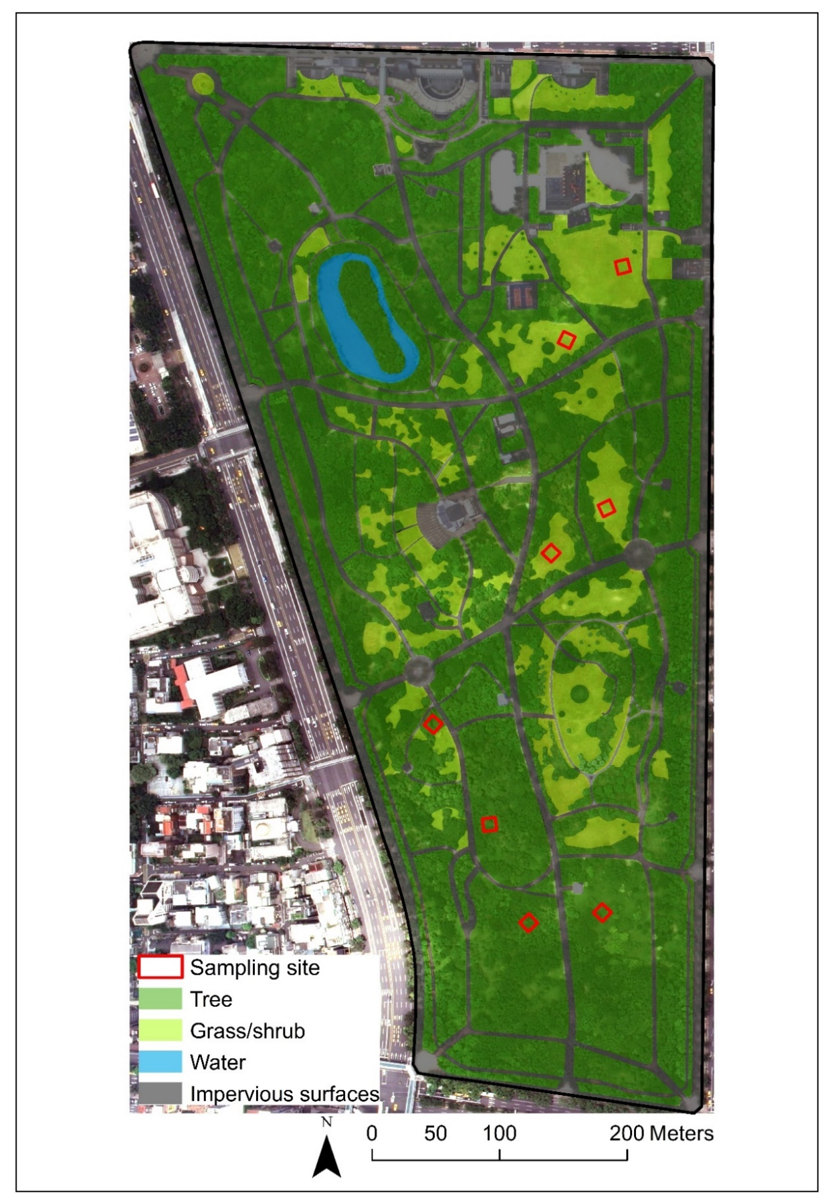
Fig. S1 The vegetation cover map of Daan Forest Park (DFP) digitalized from the digital colored orthophoto map July 2016 and in-situ observation via Esri ArcGIS v10.0. The digital colored orthophoto map was acquired from Aerial Survey Office in Taiwan.

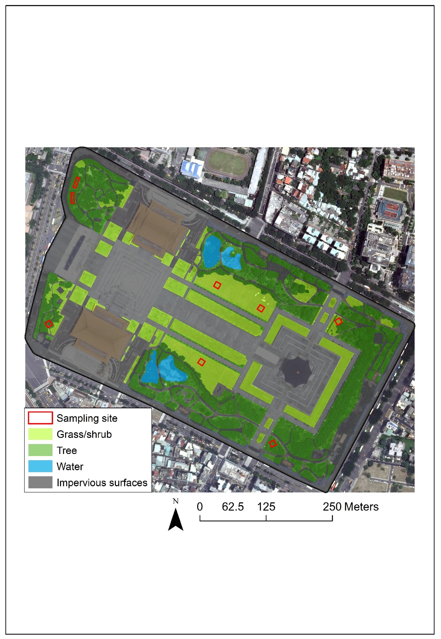
Fig. S2 The vegetation cover map of Chiang Kai-Shek Memorial Hall (CKS) digitalized from the digital colored orthophoto map July 2016 and in-situ observation via Esri ArcGIS v10.0. The digital colored orthophoto map was acquired from Aerial Survey Office in Taiwan.

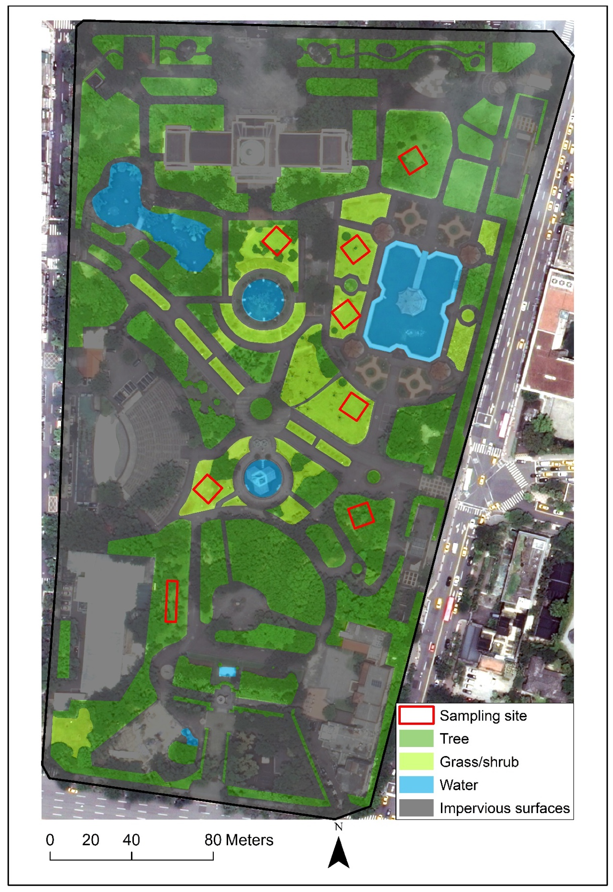
Fig. S3 The vegetation cover map of 228 Peace Memorial Park (PMP) digitalized from the digital colored orthophoto map July 2016 and in-situ observation via Esri ArcGIS v10.0. The digital colored orthophoto map was acquired from Aerial Survey Office in Taiwan.

DFP- G 1 | CKS- G 1 | PMP- G 1
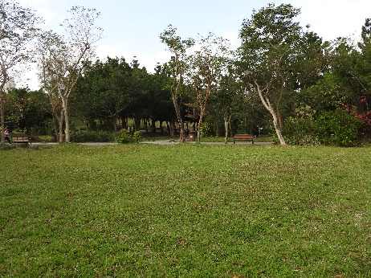 | 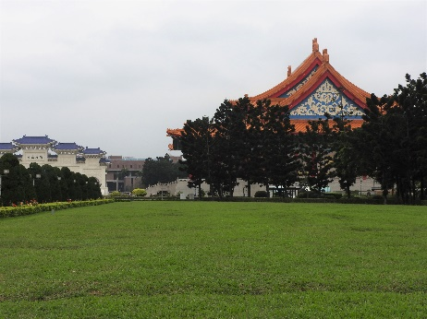 | 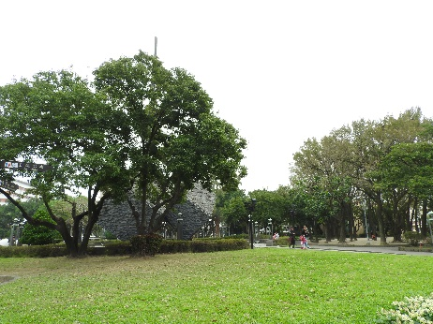
DFP- G 2 | CKS- G 2 | PMP- G 2
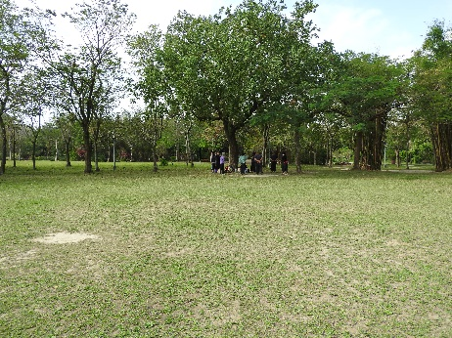 | 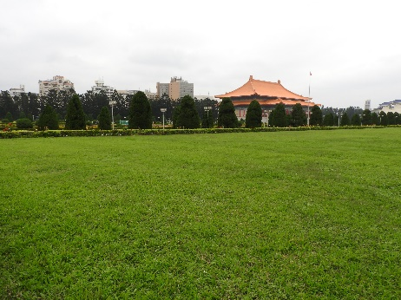 | 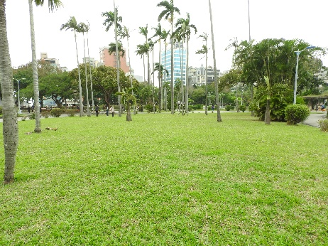
DFP- G 3 | CKS- G 3 | PMP- G 3
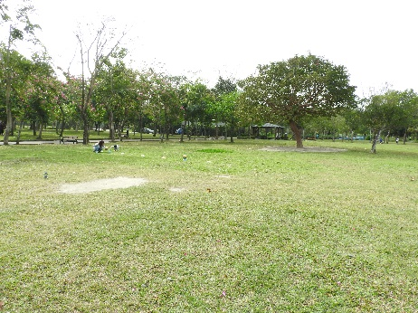 | 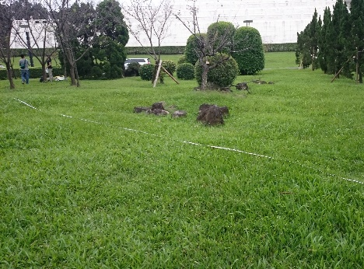 | 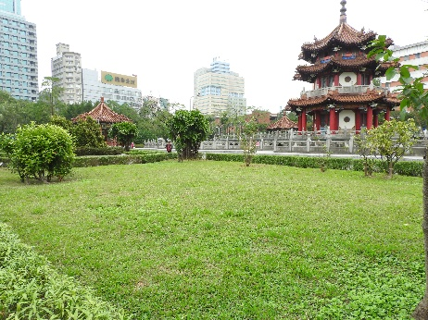
DFP- G 4 | CKS- G 4 | PMP- G 4
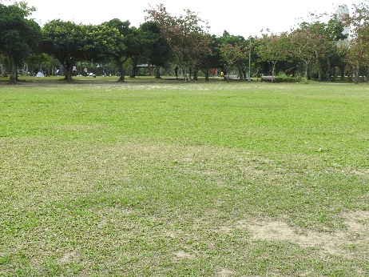 | 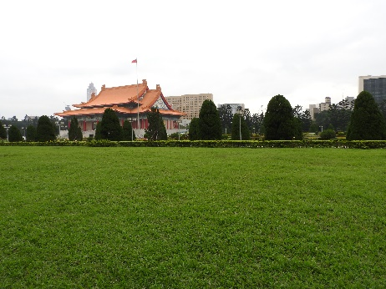 | 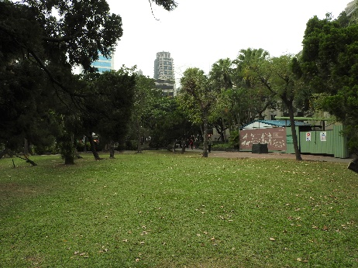
Fig. S4 Photos of sampling sites showing the locations of grass plots in the three urban parks, taken by Chia Hsieh on January 11, 2017. Ground vegetation was dominantly composed of planted Axonopus compressus.

DFP-T 1 | CKS-T 1 | PMP- T 1
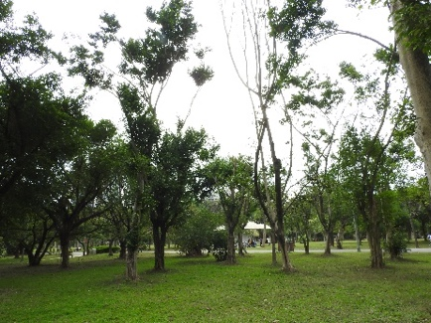 | 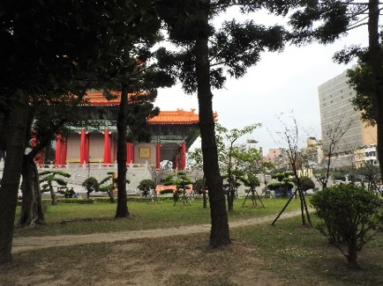 | 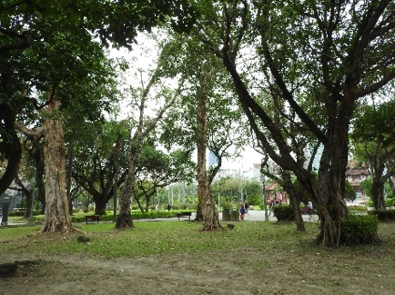
DFP- T 2 | CKS- T 2 | PMP- T 2
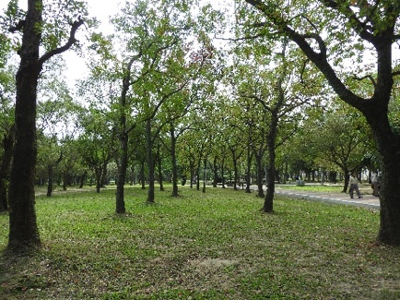 | 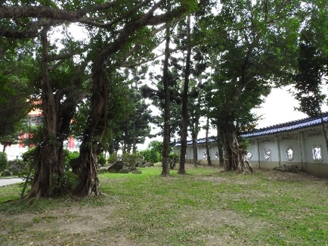 | 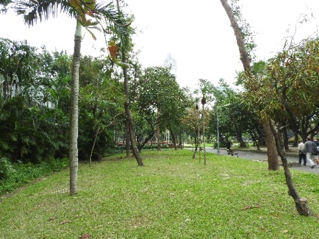
DFP- T 3 | CKS- T 3 | PMP- T 3
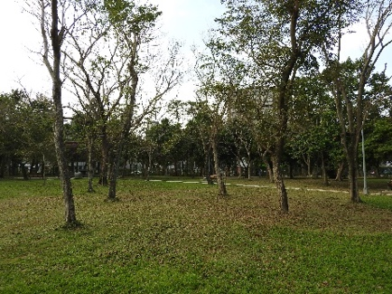 | 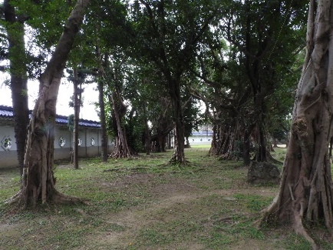 | 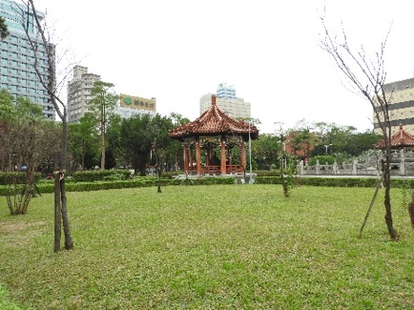
DFP- T 4 | CKS- T 4 | PMP- T 4
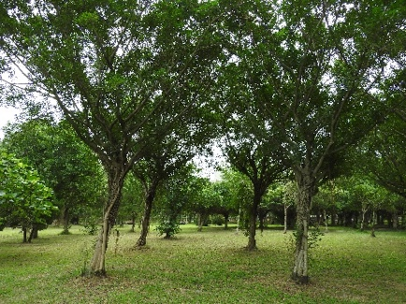 | 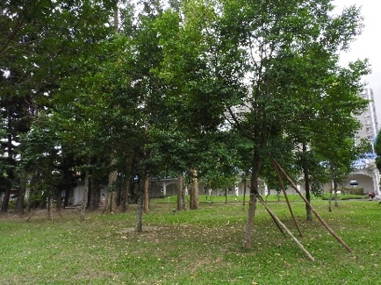 | 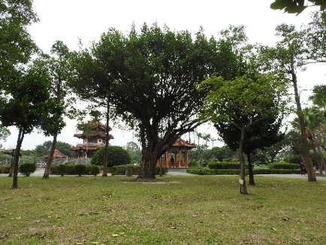
Fig. S5 Photos of sampling sites showing the locations of tree plots in the three urban parks, taken by Chia Hsieh on January 11, 2017. DFP-T1: Ficus microcarpa (N = 1) and Ficus benjamina (N = 2); DFP-T2: Sapium sebiferum (N = 3); DFP-T3: Pterocarpus indicus (N = 4); DFP-T4: Ficus benjamina (N =3). CKS-T1: Ficus macrocarpa (N =1), Pachira macrocarpa (N = 2), and Araucaria cunninghamii (N =3); CKS-T2: Ficus macrocarpa (N = 1) and Araucaria cunninghamii (N = 2); CKS-T3: Ficus macrocarpa (N = 4); CKS-T4: Michelia compressa (N =4); PMP- T1: Ficus macrocarpa (N = 1), Ficus religiosa (N = 1), and Melaleuca leucadendra (N = 3); PMP- T2: Roystonea regia (N = 1), Terminalia catappa (N = 1), Mangifera indica (N = 2), Phoenix humilis (N = 2), and Grevillea robusta (N = 2); PMP- T3: Prunus campanulate (N = 2); PMP- T4: Acer serrulatum (N = 1), Ficus macrocarpa (N = 1), and Garcinia subelliptica (N = 2). Ground vegetation was dominantly composed of planted Axonopus compressus with sparse distributions of native Duchesnea chrysantha, Oxalis corniculate, and Hydrocotyle batrachium.
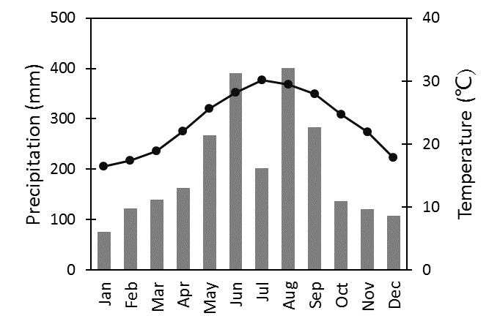
Fig. S6 Long-term monthly temperature and monthly total precipitation of nearest Taipei weather station (Station ID: 466920; 121.51°E, 25.04°N) from 2006 to 2015. Climatic data acquired from Taiwan Central Weather Bureau (https://codis.cwa.gov.tw/StationData; accessed on December 12, 2015). Line indicates long-term monthly temperature ranges from 16.4℃ (January) to 30.1℃ (July). Bars represent long-term monthly total precipitation ranges from 76.3 mm (January) to 400.2 mm (August).

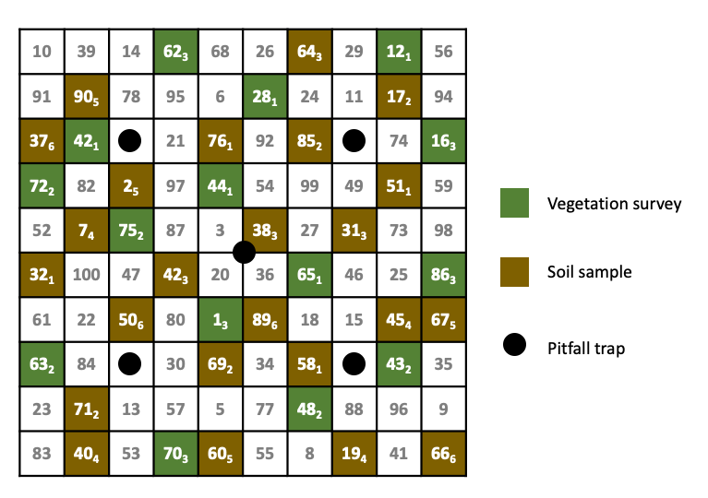

Fig. S7 Diagram of 1-m² sampling grid system for vegetation survey, soil survey, and ground invertebrate pitfall traps in each 100 m² sampling site. The number of each 1-m² sampling grid was generated by non-repeated random sampling between 1 to 100 and identical among all sampling sites. The five locations of pitfall traps were fixed and used as reference points because any additional marks or signs were not allowed for landscape managements and recreational activities in the parks. The fifteen sampling grids for the three-time vegetation survey and twenty-four sampling grids for soil sampling were selected by randomly sampled thirty-nine numbers between 1 to 100 without the numbers of pitfall traps. This sampling was performed separately for each sampling site. The lower-case number in each 1-m² grid indicate the order the vegetation survey and soil sampling as an example. When sampling grids included tree, soil cores were collected at a minimum distance of 30 cm from any part of the tree in contact with the ground.

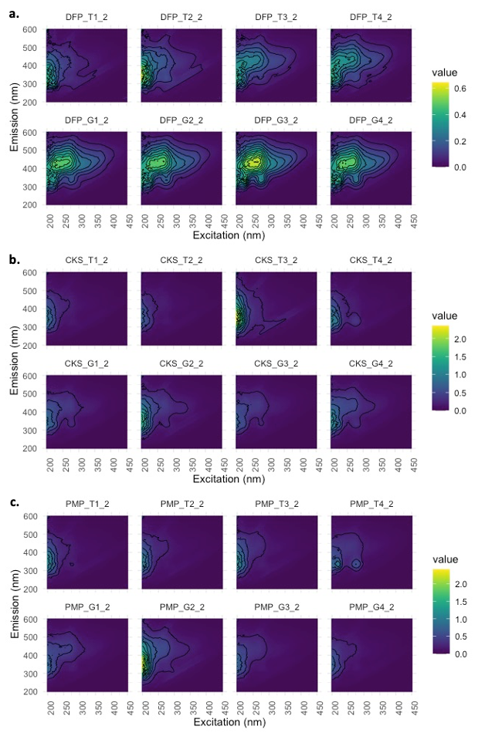
Fig. S8 The calibrated and smoothed excitation-emission matrixes of urban park soil samples in February from (a) Daan Forest Park (DFP), (b) Chiang Kai-Shek Memorial Hall (CKS), and (c) 228 Peace Memorial Park (PMP). The values are the relative loadings as the fluorescence differences in different components in different samples.

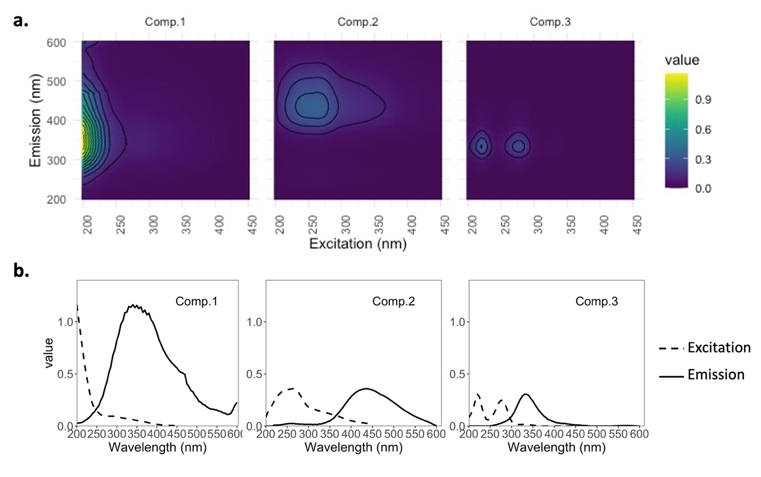
Fig. S9 The three-dimensional excitation-emission matrix (a) and excitation-emission spectral loading (b) of three components decomposed from the urban park soil by PARAFAC method. Comp.1: aromatic tryptophan-like component, with ex/em peak of < 220 nm and 340 nm (Chen et al. 2003; He et al. 2016). Comp.2: humic acid-like component, with ex/em peak of 265 nm and 435 nm (Coble et al. 1998; Ohno and Bro 2006). Comp.3: tryptophan-like component, with ex/em peak of 220, 280 nm and 335 nm (Coble et al. 1998).

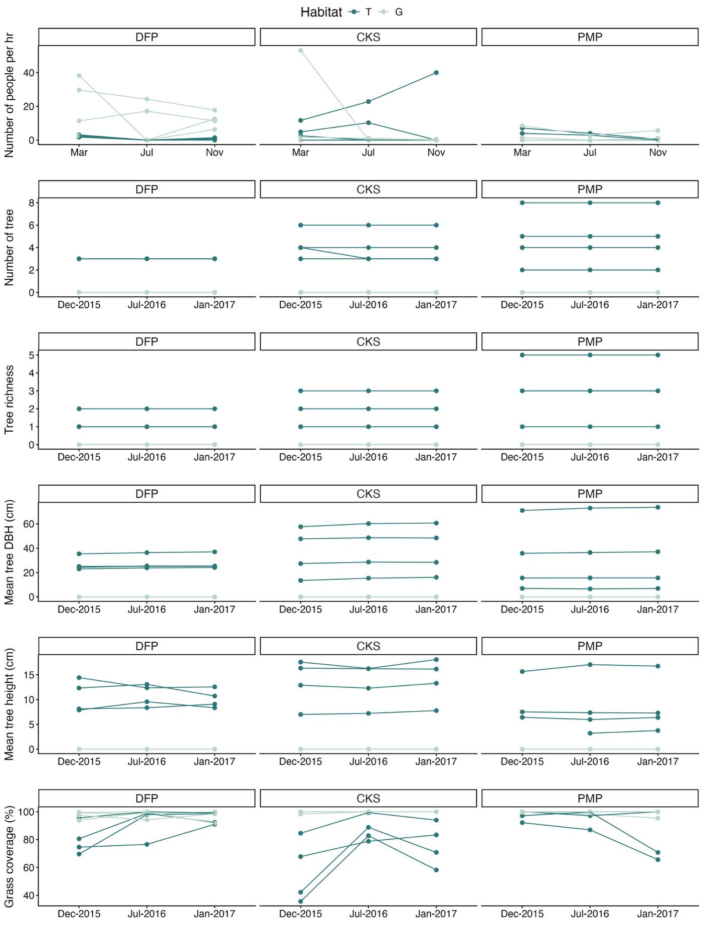
Fig. S10 Temporal patterns of the aboveground-belowground properties analyzed. Months without specificized years indicate 2016.
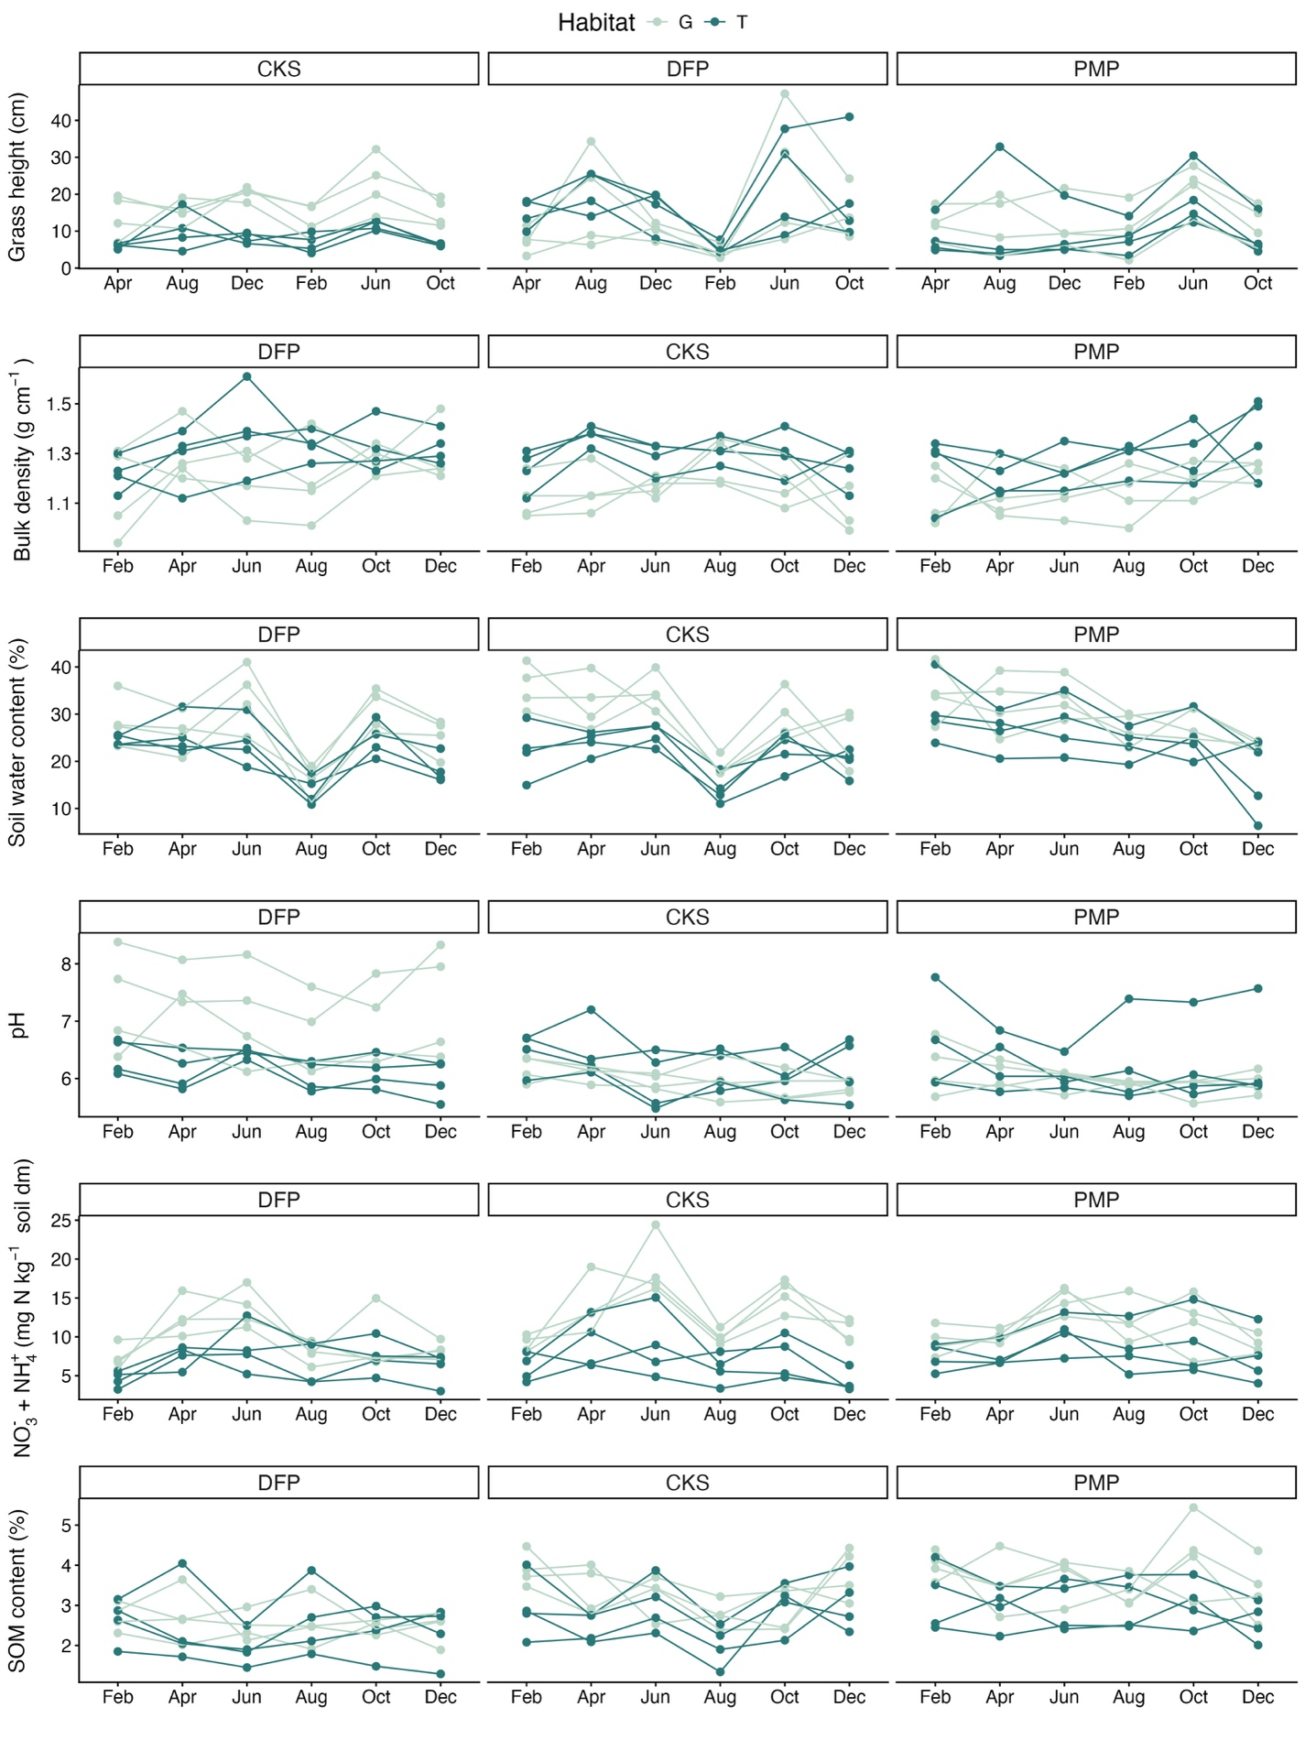
Fig. S10 Continued.
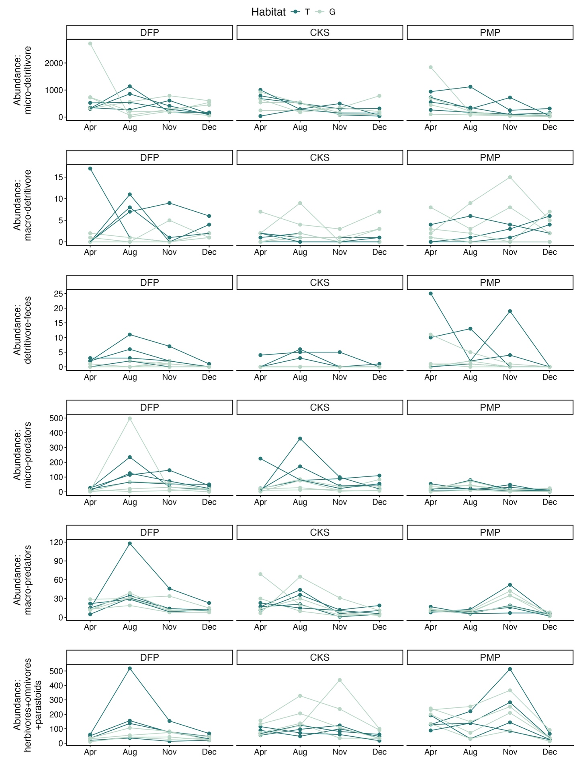
Fig. S10 Continued.
Appendix S1 – Park condition survey protocol
The park condition surveys were conducted to provide context of park visitor use by point observation in March, July and November 2016 following modified protocol from (Sarah et al. 2015). One weekday and one weekend day were included in each survey. The number and behaviors of park visitors inside a sampling plot were recorded in 10 minutes during morning (08:00-10:00), afternoon (13:00-15:00) and evening (17:00-19:00) in each day. The numbers of visitors during three time periods were averaged for daily estimation. Then the daily estimations for a weekday and for a weekend day were averaged with the weight of occurring frequencies (i.e., five vs. two) and calculated into the unit in an hour as an index of averaged park visitor level.

Appendix S2 – Methods of soil physical and chemical properties
Soil water content and bulk density
Soil water content and bulk density were quantified with one core sample by gravimetric method and core method (Blake and Hartge 1986), respectively, with following equations:

$soil water content \left(\%\right)=\frac{w_{w}-w_{d}}{w_{d}}×100\%$
$$bulk density \left(g {cm}^{-3}\right)=\frac{w_{d}-w_{o}}{\left(v_{1}-v_{2}\right)}$$

where w_{w} (g) is the wet sample mass, w_{d} (g) is the dry sample mass after oven drying at 105℃ for 72 h, w_{o} (g) is the other ingredients (diameter > 2 mm) mass retained on a No. 10 mesh (2-mm aperture), v₁ (cm³) is the volume of soil core (${1.9}^{2}π×10 cm≅ 113.41$cm³), and v₂ (cm³) is the volume of other materials. The oven-dried, sieved soil samples were sequentially ground and sieved through a No. 230 mesh (0.063-mm aperture) for particle size analysis. Soil texture was determined as the relative mass percentages of pebbles (>2mm), sand (0.02-2 mm), and silt with clay (<0.02 mm).

Soil organic matter content
Soil organic matter (SOM) content was sequentially evaluated by igniting 5 g 2-mm-sieved and oven-dried soil from those soil sample used to assess the bulk density and soil texture at 360℃ for 2 h (Salehi et al. 2011) in the furnace (48000 Furnace, Thermolyne). The SOM content was measured by

SOM_{LOI} (%) = $\frac{w_{ds}-w_{i}}{w_{ds}}×100\%$
where w_{ds} (g) is the sieved, oven-dried soil mass, and w_{i} (g) is the soil mass after ignition.
Nitrate and ammonium concentration
Extractable nitrate (NO₃⁻) and ammonium (NH₄⁺) were extracted by 0.8 g air-dried, < 2-mm composite soil in 8 mL 1 M KCl (1:10 soil: 1 M KCl ratio; Keeney and Nelson 1986). Soil suspension was prepared in a 50 mL plastic centrifuge tube with shaking at room temperature for 30 minutes. Then the soil suspensions were centrifuged at 900 x g for 30 minutes in a Universal 32 Benchtop non-refrigerated centrifuge, Hettich. The clean supernatants were collected for the colorimetric analyses of nitrate and ammonium. The nitrate in soil solution was evaluated with ultraviolet spectrophotometric screening method (American Public Health Association 1992), based on the difference in absorbance between nitrate and organic matters. The concentration of nitrate can be evaluated by converting the net absorbance of nitrate (A_{220nm} – 2 A_{275nm}) with a standard curve. The absorbances at 220 nm and 275 nm of samples were measured in a U-2900 spectrophotometer (Hitachi, Ltd.) with 1 cm quartz cuvettes. R-squared values of standard curves in this study were larger than 0.999 while NO₃⁻ below 10 mg L⁻¹. The data report unit was transformed from mg-N L⁻¹ to mg-N kg⁻¹ in air-dried soil mass basis:

NO₃⁻ -N (mg kg⁻¹ soil dm) = NO₃⁻ -N (mg L⁻¹) / $\left(\frac{soil dried mass (g)}{volume of 1 M KCl (mL)}\right)$

The ammonium was determined by Ammonia-Nessler method (Hach company 2012; Jeong et al. 2013), based on the Nesslerization in which potassium tetraiodomercurate (II) (K₂HgI₄) reacts with NH₄⁺ to produce yellow-brown colored compound (absorption ranges from 400 nm to 425 nm). The absorbance at 425 nm of Nessler compounds from a sample was measured with Hack kit (Cat. No. 2458200, Hach Company) in a U-2900 spectrophotometer (Hitachi, Ltd.) with 1 cm quartz cuvettes. R-squared values of standard curves in this study were larger than 0.99 while NH₄⁺ below 2.5 mg L⁻¹. The data report unit was transformed from mg-N L⁻¹ to m-N g kg⁻¹ in air-dried soil mass basis:

NH₄⁺ -N (mg kg⁻¹ soil dm) = NH₄⁺-N (mg L⁻¹) / $\left(\frac{soil dried mass (g)}{volume of 1 M KCl (mL)}\right)$

Appendix S3 – Methods for soil dissolved organic matter characterization
Soil dissolved organic carbon concentration
Soil dissolved organic matters were extracted by 10 g air-dried < 2-mm soil in 100 mL Milli-Q water (1:10 soil: water ratio) by shaking in amber glass bottles at room temperature for 30 minutes (Zhou and Wong 2000; Ohno and Bro 2006), followed by filtration through 0.45 μm Nylon membrane (Critical Process Filtration, Inc.). Filtrates were stored in 50 mL amber HDPE bottles at 4°C and analyzed for SDOM properties and soil dissolved organic carbon (SDOC) concentration within seven days of sampling. The concentration of SDOM was indicated by the concentration of total dissolved organic carbon (DOC) in the SDOM and measured by an Aurora 1030W Total Organic Carbon Analyzer (OI Analytical, Corp.) with heated-persulfate oxidation method. Dissolved inorganic carbon (DIC) in the samples was removed by acidizing the soil solution with 5% phosphoric acid. Then the concentrations of DOC in samples were determined by the number of carbon dioxide molecules via oxidizing DOC with 10% persulfate in the presence of heat (95 to 100°C). The data report unit is transformed from mg-C L⁻¹ to mg-C kg⁻¹ in air-dried soil mass basis:

DOC (mg-C kg⁻¹ soil dm) = DOC (mg-C L⁻¹) / ($\frac{soil dried mass (g)}{ volume of Milli-Q water (mL)})$

Fluorescent properties of soil dissolved organic matter
Fluorescent spectra of filtered samples were scanned for fluorescent indices and excitation-emission matrix (EEM) with respective instrument setting (Appendix Table 1) and calibration (Appendix Fig. 1) by F-7000 spectrophotometer (Hitachi, Ltd.) with 1 cm quartz cuvettes. For fluorescent indices, we measured the emission spectra from 220 to 600 nm with excitation wavelength at 370 nm for Fluorescence index (FI; McKnight et al. 2001) or at 254 nm for Humification index (HIX; Zsolnay et al. 1999). The FI was quantified with the ratio of the intensity of emission wavelength at 450 nm to 500 nm ($I_{λ_{em450}}/I_{λ_{em500}}$ ). The HIX was quantified with the ratio of the integrated intensity of emission wavelength of 435-480 nm to 300-345 nm ($\int_{{λ_{em}}_{435}}^{λ_{em480}}{I_{λ_{em}}}/\int_{{λ_{em}}_{300}}^{λ_{em345}}{I_{λ_{em}}}$).
We collected the EEMs of the filtered sample and Milli-Q water with the instrument setting in Appendix Table 1. We applied the Raman area of Milli-Q water measured from wavelength scanning to EEMs for intra-laboratory calibration and normalization to Raman Unit (R. U.) for inter-laboratory comparison following the processes of Murphy et al. (2010). All calibrated sample EEMs (6 surveys x 3 parks x 2 vegetation types x 4 replicates, n= 144) were aggregated as the dataset for PARAFAC analysis.
We conducted PARAFAC analysis via the R package staRdom, based on the toolbox drEEM from Murphy et al. (2013) with R v4.3.1. Before decomposing the calibrated sample EEMs by PARAFAC model, we removed the scattering and performed interpolation to fill the removed scattering by spline interpolation method without extrapolating. Examples of calibrated sample EEMs of urban park soils in three parks are shown in Appendix Fig. 2. The smoothed EEMs then applied to PARAFAC models with assumption of non-negative values (i.e., non-negative constraints) from two components to five components. The validation of PARAFAC model was followed by the criteria: (i) high value of the core consistency (>90%); (ii) high percentage of explanation (>90%); (iii) random residuals; (iv) reasonable shape and positions of spectra (Bro and Kiers 2003; Murphy et al. 2013). The PARAFAC model of three components was considered as the best model with the maximum number in decomposed components, highest values of core consistency, and percentage of explanation (Appendix Table 2; Appendix Fig. 2). Parameters for PARAFAC models and can be found in EEM_PARAFAC.RData and SDOM_PARAFAC_analysis.R along with this publication.

Appendix Table 1 Instrument settings for fluorescent indices and excitation-emission matrix
 | Fluorescent indices | Excitation-emission matrix | Raman area of  Milli-Q water
measurement type | Wavelength scan | 3-D scan | Wavelength scan
ex start and end wavelength | 370.0 nm (FI)  254.0 nm (HIX) | 200.0 nm,  450.0 nm | 350.0 nm
ex and em sampling interval | -- | 5.0 nm,  5.0 nm | --
ex and em slit | -- | 5.0 nm,  5.0 nm | --
em start and end wavelength | 220.0 nm,  600.0 nm | 220.0 nm,  600.0 nm | 220.0 nm,  600.0 nm
em sampling interval | 5.0 nm | -- | 5.0 nm
scan speed | 60,000 nm/min | 60,000 nm/min | 60,000 nm/min
PMT voltage | 650 V | 650 V | 650 V

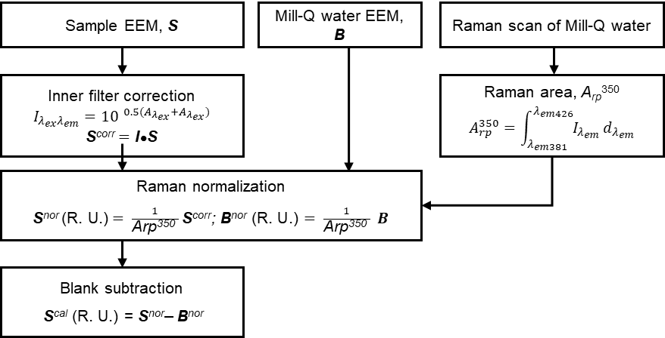
Appendix Fig. 1. The flow diagram for the calibration of excitation-emission matrixes (EEMs). Each sample EEM (S) was firstly corrected with inner filer effect (I) and then normalized by Raman area of Milli-Q water (A_{rp} ³⁵⁰) into Raman unit. The corrected and normalized sample EEM (S^{nor}) was then calibrated with the blank subtraction with the normalized Milli-Q EEM (B^{nor}) as S^{cal}, allowing inter-laboratory and inter-survey comparison.

Appendix Table 2 PARAFAC model reports
PARAFAC model | model1 | model2 | model3 | model4
Number of components | 2 | 3 | 4 | 5
core consistency | 99.99 | 97.35 | 44.35 | 32.56
percentage of explanation | 97.66 | 98.88 | 99.07 | 99.23

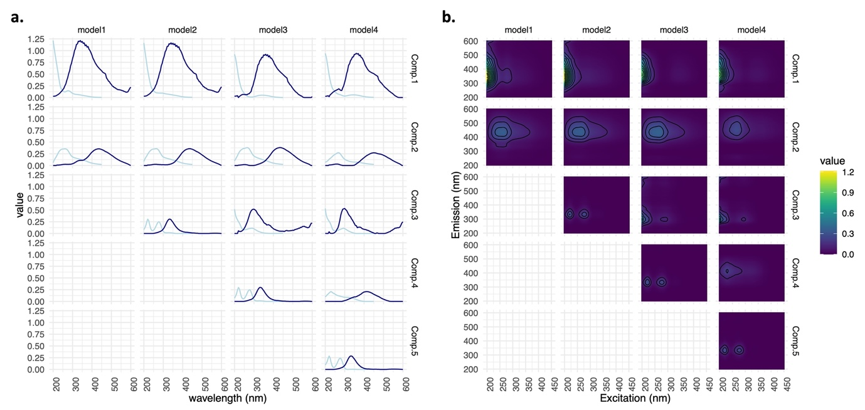
Appendix Fig. 2. PARAFAC model comparison of the decomposed excitation-emission matrixes of all samples (n = 144) from two to five components. (a) The excitation-emission spectra of each decomposed component and (b) respective excitation-emission matrixes. The values are the relative loadings as the fluorescence differences in different components in different samples.

Absorbance properties of soil dissolved organic matter
Absorbance spectra of filtered samples were scanned from 200 nm to 800 nm in a U-2900 spectrophotometer (Hitachi, Ltd.) with 1 cm quartz cuvettes. The scan interval was 0.5 nm, and the scan speed was 100 nm/min. The index of specific ultraviolet absorbance at 254 nm for aromaticity (Weishaar et al. 2003) was calculated by:

SUVA₂₅₄ (L mg⁻¹ m⁻¹) $=\frac{a_{254 }}{DOC (mg L^{-1})}=\frac{2.303 ×A_{254 nm}/0.01 (path length,m) }{DOC (mg L^{-1})}$

The spectral slope S₂₇₅₋₂₉₅ for molecular weight (Helms et al. 2008) was calculated by the linear regression slope of log-transformed absorbance coefficient interval of 275-295 nm (a₂₇₅-a₂₉₅), with the absorbance coefficient a_{nm} = 2.303 x A _{nm}/0.01 m.

Appendix S4 – Methods for soil microbial enzyme assay
Soil microbial extracellular enzyme activities (EEAs) were assayed by colorimetric methods or fluorescent methods with the substrates and incubation times shown in Appendix Table 3. To better understand the microbial EEAs in the field, BG, NAG, and LAP were incubated at the mean monthly temperature from 2006 to 2015 in June, August, October and December (Fig. S9). PO and PER were only incubated at room temperature (~25℃) because of short incubation time. The soil suspension for EEAs was prepared by homogenizing 5 g air-dried soil sample with 10 mL 50 mM sodium acetate buffer (pH 5.0) for 2 minutes with a high-speed shaker. The soil suspension was kept in homogenized condition by stirring during pipetting soil sample to the 96-well microplate.
In fluorescent assays of BG and NAG in black 96-well microplates, 200 μL buffer was added to the wells for negative control and reference standard. Next, 50 μL substrate and MUB standard were added to former wells in order. Then, 200 μL soil suspension was then added to the wells for soil sample, soil control, and quench control. At last, 50 μL substrate, buffer, and MUB standard were added to the former wells by order. The microplates were incubated in an incubator, and the reaction was stopped by adding 10 μL 0.5 M NaOH to all wells. The fluorescence of fluorescent products was measured at 365 nm excitation wavelength and 450 nm emission wavelength by the FLUOstar OPTIMA microplate reader (BMG LABTECH). The activities of BG and NAG were calculated by following formula:

Activity (n mol h⁻¹ g⁻¹ soil dm) =
$$\frac{Net fluorescence}{Emission coeff. ×0.2 \left(homogenate volume, mL\right)×time \left(h\right)×\frac{5 (soil dried mass,g)}{10 (buffer volume,mL)}}$$

where
$$Net fluorescence=\frac{Assay-Control}{Quench coeff.}-Negative Control$$
$$Emission coeff.\left(fluorescence, {nmol}^{-1}\right)=\frac{Reference}{0.5 nmol}$$
$$Quench coeff.=\frac{Quench-Control}{Reference}$$

In colorimetric assays of PO and PER, 200 μL buffer was added to 1.5 mL Eppendorf tubes for negative control and 50 μL substrate was then added to the Eppendorf tubes. Next, 200 μL soil suspension was added to 1.5 mL Eppendorf tubes for soil sample and soil control. Then, 50 μL substrate and buffer were added to former Eppendorf tubes in order. For PER, 10 μL 0.3% H₂O₂ was then added to all Eppendorf tubes. The samples were incubated in an incubator, and the reaction was stopped by centrifuge the samples for 5 minutes with 12,000 x g at 4℃. The 80 μL supernatant of centrifuged samples were added into a transparent 96-well microplate, and the concentration of product was measured by the absorbance at 450 nm with the THERMO Multiscan EX microplate reader (Thermo Fisher Scientific). The activities of PO and PER were calculated by following formula:

Activity (μ mol h⁻¹ g⁻¹ soil dm) =
$$\frac{Net abs.}{\left(7.9{ μmol}^{-1} {cm}^{-1}×l (cm)\right)×0.2 \left(homogenate volume, mL\right)×\frac{5}{60} \left(time, h\right)×\frac{5 (soil dried mass,g)}{10 (buffer volume,mL)}}$$
where
$$Net abs.=Abs. of sample assay-Abs. of soil control-Abs. of negative control$$
l = $path length in well$s

Assay | Substrate | Storage | Incubation time
β-glucosidase (BG) | 200 μM 4-methyllumbelliferyl β-D glucopyranoside* | -20℃  per sampling | 1 h
β-N-acetylglucosaminidase  (NAG) | 200 μM 4- methyllumbelliferyl N-acetyl-β-D glucopyranoside* | -20℃  per sampling | 0.5 h
BG, NAG standard | 10 μM 4-methylumbelliferone (MUB)* | -20℃  per sampling
Leucine aminopeptidase (LAP) | 5 mM leucine p-nitroanilide | 4℃  per sampling | 8 h
LAP standard | 1 mM p-nitroaniline | 4℃  per sampling
Peroxidase (PER) | 25 mM L-3,4-dihydroxyphenylalanine  0.3% H₂O₂* | make fresh | 5 min
Phenol oxidase (PO) | 25 mM L-3,4-dihydroxyphenylalanine | make fresh | 5 min
Sodium acetate buffer | 50 mM sodium acetate, titrated to pH 5.0 with glacial acetic acid | 4℃  per sampling
Appendix Table 3 Substrates and incubation times in the soil microbial extracellular enzyme activities assays
All chemicals were obtained from Sigma except leucine p-nitroanilide was purchased from Alfa Aesar; * represents the chemical was made with Milli-Q water as solvent rather than sodium acetate buffer. Incubation temperature for BG, NAG, and LAP: 28.2℃ in June, 29.5℃ in August, 24.7℃ in October, and 17.8℃ in December. Incubation temperature for PER and PO: 25℃

Reference
American Public Health Association (1992) 4500-NO3-B ultraviolet spectrophotometric screening method. In: Standard methods for the examination of water and wastewater. American Public Health Association, Washington, D.C.
Blake GR, Hartge KH (1986) Bulk density. In: Klute A (ed) Methods of soil analysis part 1: physical and mineralogical methods, 2nd edn. American Society of Agronomy, Madison, pp 363–382
Bro R, Kiers HAL (2003) A new efficient method for determining the number of components in PARAFAC models. J Chemom 17:274–286. https://doi.org/10.1002/cem.801
Chen W, Westerhoff P, Leenheer JA, Booksh K (2003) Fluorescence excitation−emission matrix regional integration to quantify spectra for dissolved organic matter. Environ Sci Technol 37:5701–5710. https://doi.org/10.1021/es034354c
Coble PG, Del Castillo CE, Avril B (1998) Distribution and optical properties of CDOM in the Arabian sea during the 1995 southwest monsoon. Deep-Sea Res Top Stud Oceanogr 45:2195–2223. https://doi.org/10.1016/S0967-0645(98)00068-X
Hach company (2012) Hach method 8038: ammonia - Nessler method
He W, Lee J-H, Hur J (2016) Anthropogenic signature of sediment organic matter probed by UV–Visible and fluorescence spectroscopy and the association with heavy metal enrichment. Chemosphere 150:184–193. https://doi.org/10.1016/j.chemosphere.2016.01.116
Helms JR, Stubbins A, Ritchie JD, et al (2008) Absorption spectral slopes and slope ratios as indicators of molecular weight, source, and photobleaching of chromophoric dissolved organic matter. Limnol Oceanogr 53:955–969. https://doi.org/10.4319/lo.2008.53.3.0955
Jeong H, Park J, Kim H (2013) Determination of NH4+ in environmental water with interfering substances using the modified Nessler method. J Chem 2013:e359217. https://doi.org/10.1155/2013/359217
Keeney DR, Nelson DW (1986) Nitrogen inorganic forms. In: Page AL (ed) Methods of soil analysis part 2: chemical and microbiological properties, 2nd edn. American Society of Agronomy, Madison, pp 643–698
Li G, Wang Q, Zhang R, et al (2026) Influence of Vegetation Type and Park Age on Soil Dissolved Organic Matter Composition in Subtropical Urban Parks. Land Degradation & Development n/a: https://doi.org/10.1002/ldr.70333
McCary MA, Schmitz OJ (2021) Invertebrate functional traits and terrestrial nutrient cycling: Insights from a global meta-analysis. J Anim Ecol 90:1714–1726. https://doi.org/10.1111/1365-2656.13489
McKnight DM, Boyer EW, Westerhoff PK, et al (2001) Spectrofluorometric characterization of dissolved organic matter for indication of precursor organic material and aromaticity. Limnol Oceanogr 46:38–48. https://doi.org/10.4319/lo.2001.46.1.0038
Murphy KR, Butler KD, Spencer RGM, et al (2010) Measurement of dissolved organic matter fluorescence in aquatic environments: an interlaboratory comparison. Environ Sci Technol 44:9405–9412. https://doi.org/10.1021/es102362t
Murphy KR, Stedmon CA, Graeber D, Bro R (2013) Fluorescence spectroscopy and multi-way techniques. PARAFAC. Anal Chem 5:6557. https://doi.org/10.1039/c3ay41160e
Ohno T, Bro R (2006) Dissolved organic matter characterization using multiway spectral decomposition of fluorescence landscapes. S Soil Sci Soc Am J 70:2028–2037. https://doi.org/10.2136/sssaj2006.0005
Salehi MH, Beni OH, Harchegani HB, et al (2011) Refining soil organic matter determination by loss-on-Ignition. Pedosphere 21:473–482. https://doi.org/10.1016/S1002-0160(11)60149-5
Sarah P, Zhevelev HM, Oz A (2015) Urban park soil and vegetation: effects of natural and anthropogenic factors. Pedosphere 25:392–404. https://doi.org/10.1016/S1002-0160(15)30007-2
Weishaar JL, Aiken GR, Bergamaschi BA, et al (2003) Evaluation of specific ultraviolet absorbance as an Indicator of the chemical composition and reactivity of dissolved organic carbon. Environ Sci Technol 37:4702–4708. https://doi.org/10.1021/es030360x
Zhou LX, Wong JWC (2000) Microbial decomposition of dissolved organic matter and its control during a sorption experiment. J Environ Qual 29:1852–1856. https://doi.org/10.2134/jeq2000.00472425002900060017x
Zsolnay A, Baigar E, Jimenez M, et al (1999) Differentiating with fluorescence spectroscopy the sources of dissolved organic matter in soils subjected to drying. Chemosphere 38:45–50. https://doi.org/10.1016/S0045-6535(98)00166-0

