Supplementary material for:
Wealth does not buy richness: Plant and soil bacterial diversity in temperate suburban lawns are not influenced by income
Alassane Sow, Kate Gorman, Brandon Kristy, Elsa Youngsteadt

Table of contents
Supplementary text
Text S1. Methods and results for SEM of community composition 1
Supplementary tables
Table S1. Primers 3
Table S2. Alternative statistical results with and without outlier site 3
Table S3. AIC and Fisher’s C tests for SEMs with and without outlier site 4
Table S4. Tests of directed separation for path diagrams with and without outlier site 4
Table S5. SEM coefficients with and without outlier site 5
Table S6. Plant genera present at the 30 study sites (filled table cells indicate presence) 6
Table S7. Tests of spatial autocorrelation 11
Table S8. SEM results for community composition (AIC, Fisher’s C) 11
Table S9. SEM results for community composition (tests of directed separation) 12
Table S10. SEM results for community composition (coefficients) 13
Supplementary figures
Fig S1. Rarefaction curves of bacterial OTUs from each residential lawn 14
Fig S2. Relative abundance of the 10 most abundant bacterial families 15
Fig S3. Results of SEM models explaining soil bacterial richness (outlier included) 16
Fig S4. dbRDA ordination plot with the outlier site 13 included 17
Fig S5. dbRDA ordination plot including low-abundance OTUs 18
Fig S6. dbRDA ordination plot, significant OTUs only 19
Fig S7. Bacterial community dissimilarity vs. geographic distances 20
Fig S8. SEM results for community composition (outlier excluded) 21
Fig S9. SEM results for community composition (outlier included) 22

Text S1. Methods and results for piecewise SEM of bacterial community composition

Methods. To analyze compositional data within a structural equation modeling framework, we first conducted unconstrained ordinations of plant and OTU datasets, then used the site scores on the first axis of each ordination in downstream SEM analyses, considering the same three basic model structures as for richness in the main text (Fig. S1). We again conducted all analyses with and without the outlier site 13.
For the unconstrained ordinations, we used principal coordinates analyses with Jaccard distances derived from the presence-absence matrix of plant genera, and Bray-Curtis distances derived from log-transformed OTU abundances, in vegan v. 2.7-1 (Oksanen et al. 2022).

Results. For the plant genus ordination, the first two axes captured 20.3% and 8.8% of variation in the dataset, respectively (19.8% and 9.0% when the outlier site was included). For the OTU ordination, the first two axes captured 18.7% and 11.7% of variation (24.6% and 10.6% when the outlier site was included). We considered only the first axis of each ordination in downstream SEMs.
SEM results were extremely similar to those considering richness rather than composition. The best supported path model was the reduced model including only pH as a mediator linking income to bacterial community composition (Fig. S1). Results were similar when the outlier site was included (Fig. S2, Tables S1-S3).

Oksanen, J., G. Simpson, F. Blanchet, R. Kindt, P. Legendre, P. Minchin, R. O'Hara, P. Solymos, M. Stevens, E. Szoecs, H. Wagner, M. Barbour, M. Bedward, B. Bolker, D. Borcard, B. T, G. Carvalho, M. Chirico, M. De Caceres, S. Durand, H. Evangelista, R. FitzJohn, M. Friendly, B. Furneaux, G. Hannigan, M. Hill, L. Lahti, C. Martino, D. McGlinn, M.-H. Ouellette, E. Ribeiro Cunha, T. Smith, A. Stier, C. Ter Braak, and J. Weedon. 2022. Vegan: community ecology package. R package version 2.7-1. CRAN.R-project.org/package=vegan.

Table S1. Primers used for paired-end library preparation and Illumina Miseq sequencing

Primer | Sequence
341F | CCTACGGGNGGCWGCAG
805R | GACTACHVGGGTATCTAATCC

Table S2. Alternative statistical results with and without outlier site 13

 |  |  |  | results with site 13 |  |  | results without site 13
Model | Response | Predictor | Analysis type | df | F | p | df | F | p
1 | pH | income | linear model, ANOVA | 1, 28 | 3.85 | 0.060 | 1, 27 | 4.2 | 0.049
2 | OTU richness | income | linear model, ANOVA | 1, 22 | 0.43 | 0.515 | 1, 21 | 0.22 | 0.640
 |  | pH |  | 1, 22 | 21.5 | 0.000 | 1, 21 | 9.66 | 0.005
 |  | plant richness |  | 1, 22 | 0.28 | 0.596 | 1, 21 | 0.57 | 0.455
 |  | income * pH |  | 1, 22 | 0.05 | 0.812 | 1, 21 | 0.11 | 0.741
 |  | income * plant richness |  | 1, 22 | 0.01 | 0.919 | 1, 21 | 0.00 | 0.959
 |  | pH * plant richness |  | 1, 22 | 0.03 | 0.827 | 1, 21 | 0.00 | 0.975
 |  | income * pH * plant richness |  | 1, 22 | 0.28 | 0.600 | 1, 21 | 0.73 | 0.400
3 | OTU composition | pH | dbRDA,  permutation test | 1, 26 | 11.36 | 0.001 | 1, 25 | 3.46 | 0.002
 |  | income |  | 1, 26 | 0.80 | 0.500 | 1, 25 | 1.02 | 0.376
 |  | plant richness |  | 1, 26 | 0.51 | 0.762 | 1, 25 | 0.62 | 0.803

Table S3. AIC and Fisher’s C tests for SEMs shown in Fig. 5 (outlier excluded) and Fig. S2 (outlier included).

outlier | model | AIC | Fisher's C | df | p
excluded | full | 648.1 | 1.480 | 2 | 0.477
 | plant | 612.9 | 1.061 | 2 | 0.588
 | soil | 468.7 | 0.815 | 2 | 0.665
included | full | 681.3 | 1.313 | 2 | 0.519
 | plant | 644.7 | 1.318 | 2 | 0.517
 | soil | 497.1 | 1.385 | 2 | 0.500

Table S4. Tests of directed separation for path diagrams shown in Fig. 5 and Fig. S3.
outlier | model | independence claim | df | critical value | p
excluded | full | pH ~ plant_genera | 26 | -0.721 | 0.477
 | plant | OTU richness ~ income | 26 | 0.548 | 0.588
 | soil | OTU richness ~ income | 26 | -0.437 | 0.665
included | full | pH ~ plant_genera | 27 | -0.654 | 0.518
 | plant | OTU richness ~ income | 27 | 0.656 | 0.517
 | soil | OTU richness ~ income | 27 | -0.683 | 0.500

Table S5. Coefficients, standardized coefficients, and significance for each path in Fig. 5 and Fig. S3.
outlier | model | response | predictor | estimate | SE | std. estimate | df | crit. value | p | signif
excluded | full | OTU richness | plant genera | -11.11 | 14.89 | -0.12 | 25 | -0.75 | 0.463
 |  | OTU richness | income | 0.00 | 0.00 | -0.09 | 25 | -0.53 | 0.599
 |  | OTU richness | pH | 501.14 | 150.24 | 0.58 | 25 | 3.34 | 0.003 | **
 |  | plant genera | income | 0.00 | 0.00 | -0.20 | 27 | -1.07 | 0.296
 |  | pH | income | 0.00 | 0.00 | 0.37 | 27 | 2.06 | 0.049 | *
 | plant | OTU richness | plant genera | -19.98 | 16.80 | -0.22 | 27 | -1.19 | 0.245
 |  | plant genera | income | 0.00 | 0.00 | -0.20 | 27 | -1.07 | 0.296
 | soil | OTU richness | pH | 493.06 | 135.04 | 0.57 | 27 | 3.65 | 0.001 | **
 |  | pH | income | 0.00 | 0.00 | 0.37 | 27 | 2.06 | 0.049 | *
included | full | OTU richness | plant genera | -9.33 | 15.51 | -0.08 | 26 | -0.60 | 0.553
 |  | OTU richness | income | 0.00 | 0.00 | -0.11 | 26 | -0.76 | 0.456
 |  | OTU richness | pH | 652.52 | 130.63 | 0.73 | 26 | 4.99 | 0.000 | ***
 |  | plant genera | income | 0.00 | 0.00 | -0.20 | 28 | -1.09 | 0.283
 |  | pH | income | 0.00 | 0.00 | 0.34 | 28 | 1.96 | 0.059
 | plant | OTU richness | plant genera | -21.81 | 20.48 | -0.19 | 28 | -1.06 | 0.296
 |  | plant genera | income | 0.00 | 0.00 | -0.20 | 28 | -1.09 | 0.283
 | soil | OTU richness | pH | 631.91 | 118.92 | 0.71 | 28 | 5.31 | 0.000 | ***
 |  | pH | income | 0.00 | 0.00 | 0.35 | 28 | 1.96 | 0.059

Table S6. Plant genera present at the 30 study sites (filled table cells indicate presence).
 | Site
Plant genus | 1 | 2 | 3 | 4 | 5 | 6 | 7 | 8 | 9 | 10 | 11 | 12 | 13 | 14 | 15 | 16 | 17 | 18 | 19 | 20 | 21 | 22 | 23 | 24 | 25 | 26 | 27 | 28 | 29 | 30
Poa | 1 | 1 | 1 | 1 | 1 | 1 | 1 | 1 | 1 |  | 1 |  |  | 1 | 1 | 1 | 1 | 1 | 1 | 1 | 1 | 1 | 1 | 1 | 1 |  |  |  |  | 1
Oxalis |  |  |  | 1 | 1 | 1 | 1 |  | 1 | 1 | 1 | 1 | 1 | 1 |  | 1 |  | 1 | 1 | 1 |  | 1 | 1 |  | 1 |  | 1 | 1 | 1
Hedera | 1 |  |  | 1 |  | 1 |  | 1 |  |  | 1 |  |  |  |  | 1 | 1 |  | 1 | 1 | 1 |  | 1 | 1 | 1 | 1 | 1 | 1 | 1 | 1
Dichondra | 1 | 1 |  |  | 1 |  |  |  | 1 | 1 |  | 1 |  |  |  | 1 | 1 | 1 |  | 1 | 1 | 1 | 1 |  | 1 | 1 | 1
Viola |  | 1 | 1 | 1 | 1 | 1 | 1 | 1 | 1 |  | 1 |  |  |  | 1 | 1 | 1 |  | 1 |  |  |  |  | 1 |  |  | 1 |  | 1
Microstegium |  | 1 | 1 |  | 1 | 1 | 1 |  |  | 1 | 1 | 1 | 1 |  |  | 1 | 1 |  | 1 |  | 1 |  |  |  |  |  |  | 1 | 1
Trifolium | 1 | 1 | 1 |  | 1 | 1 | 1 |  |  | 1 | 1 | 1 | 1 | 1 |  |  |  |  |  |  |  |  |  |  | 1 | 1 | 1
Parthenocissus |  |  |  |  |  | 1 |  | 1 |  |  |  |  |  | 1 |  | 1 | 1 |  | 1 | 1 | 1 |  | 1 | 1 |  | 1 | 1 | 1
Potentilla | 1 |  | 1 |  | 1 | 1 |  |  |  |  |  | 1 |  |  |  |  | 1 |  |  | 1 |  | 1 | 1 |  | 1 | 1 |  |  | 1 | 1
Acer |  |  | 1 | 1 | 1 | 1 | 1 |  |  |  |  |  | 1 |  |  |  |  |  | 1 |  |  |  | 1 |  | 1 |  | 1
Glechoma |  | 1 | 1 |  | 1 | 1 |  |  |  |  |  |  |  |  |  |  |  |  |  |  |  |  | 1 |  |  | 1 | 1 | 1 | 1
Liriope |  |  |  | 1 | 1 |  |  |  |  |  | 1 | 1 |  | 1 |  |  | 1 |  |  |  | 1 |  |  | 1 |  |  |  |  |  | 1
Lolium |  |  |  |  |  |  | 1 |  |  |  |  |  |  | 1 |  | 1 |  |  |  |  | 1 | 1 |  | 1 |  | 1 | 1 | 1
Plantago |  |  |  | 1 |  | 1 |  |  |  | 1 |  | 1 | 1 |  |  | 1 | 1 |  |  |  |  |  |  | 1
Phyllanthus |  | 1 |  | 1 | 1 |  |  |  |  |  |  |  | 1 |  |  |  |  |  | 1 |  | 1 |  |  |  | 1
Quercus | 1 |  |  | 1 | 1 |  |  |  | 1 |  |  | 1 | 1 |  | 1
Ampelopsis |  |  |  | 1 |  |  |  |  |  |  |  |  |  |  |  |  |  |  |  | 1 |  |  |  | 1 | 1 |  |  | 1 | 1
Phytolacca |  | 1 |  | 1 | 1 |  |  |  |  |  |  |  | 1 |  |  |  |  |  |  |  |  |  |  |  |  |  |  | 1 |  | 1
Rosa |  |  |  |  |  |  |  |  |  |  | 1 |  |  |  | 1 | 1 |  |  | 1 |  |  |  |  |  |  |  |  | 1 | 1
Vinca |  |  |  | 1 |  |  |  |  | 1 |  |  |  |  |  |  | 1 |  | 1 |  |  |  |  |  |  |  |  | 1 | 1
Acalypha | 1 |  |  | 1 |  |  |  |  |  |  |  |  |  |  |  |  |  |  | 1 |  | 1 |  |  |  |  |  |  | 1
Cynodon |  | 1 |  |  |  |  |  |  |  |  |  |  |  | 1 |  |  | 1 |  |  |  |  |  | 1 |  |  |  |  |  | 1
Desmodium |  |  |  | 1 |  |  |  |  |  |  |  |  | 1 |  |  |  |  |  |  |  | 1 |  |  |  | 1 | 1
Festuca |  |  | 1 | 1 |  |  | 1 |  |  | 1 |  |  | 1
Helleborus |  |  |  |  |  |  |  |  | 1 |  |  |  |  |  |  |  | 1 |  |  |  |  |  |  | 1 | 1 |  |  |  | 1
Taraxacum |  | 1 |  | 1 | 1 |  |  |  |  |  | 1 |  |  |  |  |  |  |  | 1
Gaultheria | 1 |  |  |  | 1 | 1 |  |  |  |  |  |  |  |  |  |  |  |  |  |  | 1
Hemerocallis |  |  |  |  |  |  | 1 |  |  |  |  |  |  |  |  |  |  |  |  |  |  |  | 1 | 1 |  |  | 1
Hypochaeris |  |  |  |  |  |  |  |  |  | 1 |  | 1 |  |  |  |  |  | 1 |  |  |  | 1
Ilex |  |  |  |  |  |  |  |  |  |  |  |  |  |  | 1 | 1 |  | 1 |  |  |  |  |  |  |  | 1
Nandina |  |  |  |  |  |  |  |  |  |  |  |  |  |  |  |  | 1 |  |  | 1 | 1 |  |  | 1
Pinus |  |  |  |  |  | 1 | 1 |  |  |  |  |  |  |  |  |  |  |  | 1 |  |  |  | 1
Prunus |  |  |  |  |  |  |  |  | 1 |  |  |  |  |  |  |  |  |  |  |  |  |  |  |  | 1 |  | 1 |  |  | 1
Veronica | 1 |  |  |  |  |  |  | 1 |  |  | 1 |  |  |  |  |  |  |  |  |  | 1
Buxus |  | 1 |  |  |  |  |  |  |  |  |  |  |  |  |  |  | 1 |  |  |  |  |  |  |  |  |  | 1
Chimaphila |  |  |  |  |  |  |  |  |  |  |  | 1 | 1 |  |  |  |  |  |  |  |  |  |  |  | 1
Coreopsis |  | 1 |  |  |  |  |  |  |  |  |  |  |  |  |  | 1 | 1
Hydrangea |  | 1 |  |  |  |  |  |  |  |  |  |  |  |  |  |  |  |  |  | 1 |  |  | 1
Lonicera |  |  |  |  |  |  |  |  |  |  |  |  |  |  |  |  | 1 |  | 1 |  |  |  |  |  |  |  |  | 1
Nyssa | 1 |  | 1 |  |  |  |  |  | 1
Ranunculus |  |  |  |  |  |  |  |  |  |  |  |  |  |  |  |  | 1 |  |  | 1 | 1
Rumex |  |  |  |  |  |  |  |  |  | 1 |  | 1 | 1
Salvia |  |  |  |  |  |  |  |  |  |  |  |  |  |  |  |  |  | 1 |  |  |  |  |  |  | 1 |  |  | 1
Ulmus |  |  |  |  |  |  | 1 |  |  | 1 |  |  |  |  |  |  |  |  |  |  |  | 1
Ajuga |  |  |  |  | 1 |  |  |  |  |  | 1
Arctostaphylos |  |  |  | 1 |  |  |  |  |  |  |  |  |  |  |  |  |  |  |  |  |  |  |  |  |  | 1
Centella |  |  |  |  |  |  |  |  | 1 |  |  |  |  |  |  |  |  |  |  |  | 1
Cercis |  |  |  |  |  |  |  |  |  | 1 |  |  |  |  |  |  |  |  | 1
Euonymus |  |  |  |  |  |  |  |  |  |  |  |  |  |  | 1 |  | 1
Euphorbia |  |  |  |  |  |  |  |  |  |  |  |  |  |  |  |  |  |  |  |  |  | 1 |  | 1
Impatiens |  |  |  |  |  |  |  | 1 |  | 1
Kummerowia |  |  |  |  |  | 1 |  |  |  |  | 1
Lagerstroemia |  |  |  |  |  |  |  |  |  | 1 |  |  |  |  |  |  |  | 1
Lepidium |  | 1 |  |  |  |  |  |  |  | 1
Lespedeza |  |  |  |  |  | 1 |  |  |  |  |  |  | 1
Ligustrum |  |  |  |  |  |  |  |  |  | 1 |  |  |  |  |  |  |  |  |  |  |  |  |  | 1
Lilium |  |  |  |  |  |  |  |  | 1 |  |  |  |  |  |  |  |  |  |  | 1
Liriodendron |  | 1 |  |  |  |  |  |  |  |  |  |  | 1
Menispermum |  |  |  |  |  |  | 1 |  |  |  | 1
Mentha |  | 1 |  |  |  |  |  |  |  | 1
Modiola | 1 |  |  |  |  |  |  |  |  |  |  |  |  |  |  |  |  |  |  |  |  |  |  |  |  |  |  |  |  | 1
Ophiopogon |  |  |  |  |  |  |  |  |  |  |  |  |  |  |  |  |  |  |  |  | 1 |  |  |  |  |  |  |  | 1
Perilla |  |  |  |  | 1 |  |  |  |  |  | 1
Persicaria |  | 1 |  |  | 1
Phlox |  | 1 |  |  |  |  |  |  |  |  |  |  |  |  |  |  |  | 1
Rhododendron |  |  |  |  |  |  |  |  |  |  | 1 |  |  |  |  |  |  |  |  |  |  |  |  |  |  |  | 1
Rubus |  |  |  |  |  |  |  |  |  |  |  |  |  |  |  | 1 |  |  |  | 1
Smilax |  |  |  |  |  |  |  |  |  |  |  |  |  |  |  |  |  |  |  |  |  |  |  |  |  |  |  | 1 | 1
Solanum |  |  |  |  |  |  |  |  |  |  |  | 1 |  |  |  |  |  |  |  |  | 1
Toxicodendron |  |  | 1 |  |  |  |  |  |  |  |  |  | 1
Tradescantia |  |  |  |  |  |  | 1 |  |  |  |  |  |  |  |  |  |  |  |  |  |  |  |  |  |  |  |  |  | 1
Wisteria |  |  |  |  |  |  |  |  |  |  |  |  |  |  |  |  |  |  |  | 1 |  |  |  |  |  |  | 1
Aconitum |  |  |  |  |  |  |  |  |  |  |  |  |  |  |  |  |  |  |  |  |  |  |  |  | 1
Acuba |  |  |  |  |  |  |  |  |  |  |  |  |  |  |  |  | 1
Akebia |  |  |  |  |  |  |  |  |  |  |  |  |  |  |  |  |  |  |  |  |  |  |  |  | 1
Amaranthus |  |  |  | 1
Anthemis |  |  |  |  |  |  |  |  |  | 1
Arabidopsis |  |  |  |  |  |  |  |  |  |  |  |  |  |  |  | 1
Artemisia |  |  |  |  |  |  |  |  |  |  |  |  |  |  |  |  |  |  |  |  |  |  |  |  |  | 1
Asclepias |  | 1
Aucuba |  |  |  |  |  |  |  |  | 1
Bowlesia |  | 1
Campsis |  |  |  |  |  |  |  |  |  |  |  |  |  |  |  |  |  |  |  |  |  |  |  |  |  |  | 1
Capsella |  |  |  |  |  |  |  |  |  |  |  |  |  |  |  |  |  |  |  |  |  | 1
Carex |  |  |  |  |  |  |  |  |  |  |  |  |  |  |  | 1
Carya |  |  |  |  |  |  |  |  |  |  |  |  |  |  |  | 1
Catharanthus |  |  |  |  |  |  |  |  |  |  | 1
Cerastium |  |  |  |  |  |  |  |  |  |  |  |  |  |  |  |  | 1
Chelidonium |  | 1
Chenopodium |  |  |  |  |  |  |  |  |  |  |  |  |  |  |  |  |  |  |  | 1
Clematis |  |  |  |  |  |  |  |  |  |  |  | 1
Commelina |  |  |  |  |  |  |  |  |  | 1
Cucurbita | 1
Cyclamen |  |  |  |  |  |  |  |  | 1
Dichanthelium |  |  |  |  |  |  | 1
Digitaria |  |  |  |  |  |  | 1
Diodia |  |  |  | 1
Disporum |  |  |  |  |  |  |  |  | 1
Dryopteris |  |  |  |  |  |  |  |  | 1
Elephantopus |  |  |  |  |  |  |  |  |  |  |  |  |  |  |  |  |  |  |  |  |  |  |  |  | 1
Erechtites |  |  |  |  |  |  |  |  |  |  |  |  |  |  |  |  |  |  |  | 1
Eschscholzia |  |  |  |  |  |  |  |  |  |  |  |  |  |  |  |  |  |  |  |  |  |  | 1
Fatoua |  |  |  |  | 1
Gamochaeta |  |  |  |  |  |  |  |  |  |  |  | 1
Geranium |  |  |  |  |  |  |  |  |  |  |  |  |  |  |  |  |  |  |  | 1
Gratiola |  |  |  |  |  |  |  |  |  |  |  |  |  |  |  |  |  |  |  |  |  |  |  | 1
Heracleum |  | 1
Heuchera |  |  |  |  |  |  |  |  |  |  |  |  |  |  |  |  |  |  |  |  |  |  | 1
Hibiscus |  |  |  |  |  |  |  |  |  |  |  |  |  |  |  |  |  |  |  |  |  |  |  |  |  | 1
Hosta |  |  |  |  |  |  |  |  |  |  |  |  |  |  |  |  |  |  |  |  |  |  |  | 1
Hydrocotyle |  | 1
Hygroamblystegium |  |  |  | 1
Hypericum |  |  |  |  |  |  |  |  | 1
Isotria |  |  |  |  |  |  |  |  |  |  |  |  |  |  |  |  |  |  |  |  |  |  |  |  | 1
Juniperus |  |  |  |  |  |  |  |  |  |  |  |  |  |  |  |  |  |  |  |  |  |  |  |  |  |  |  | 1
Lamium |  |  |  |  |  |  |  |  |  |  |  |  |  |  |  |  |  |  |  |  |  |  |  |  |  |  |  |  | 1
Liquidambar |  |  |  |  |  | 1
Lobelia |  |  |  |  |  |  |  |  |  |  |  |  |  |  |  | 1
Ludwiga |  |  |  |  |  |  | 1
Lysimachia |  |  |  |  |  |  |  |  |  |  |  |  |  |  |  |  |  |  |  |  |  |  | 1
Maianthemum |  |  |  |  |  |  |  |  |  |  |  |  |  |  |  |  |  |  |  |  |  |  |  |  |  |  |  |  | 1
Mollugo |  |  |  |  |  |  |  |  |  |  |  |  |  |  |  |  |  |  |  |  |  |  |  |  | 1
Monarda |  | 1
Morus |  |  |  |  |  |  |  |  |  |  |  |  |  |  |  |  |  |  | 1
Myrtus |  |  |  |  |  |  |  |  |  |  |  |  |  |  |  |  |  |  |  |  |  | 1
Oreganos |  |  |  |  |  |  |  |  |  |  |  |  |  |  |  |  |  |  |  |  |  |  |  |  | 1
Packera |  |  |  |  |  |  |  |  |  |  |  |  |  |  |  |  |  |  |  |  |  |  |  |  |  |  | 1
Pelazoneuron |  |  |  |  |  |  |  |  |  |  |  |  |  |  |  |  |  |  |  |  |  |  | 1
Plectranthus |  |  |  |  |  |  |  |  |  |  |  |  |  |  |  |  |  |  |  |  |  |  |  | 1
Portulaca |  |  |  |  |  |  |  |  |  |  | 1
Ribes |  |  |  |  |  |  |  |  | 1
Sambucus |  | 1
Sericocarpus |  |  |  |  |  |  |  |  |  | 1
Setaria |  |  |  |  |  |  |  |  |  |  |  |  |  |  |  |  |  |  |  |  |  |  |  |  | 1
Soliva |  |  |  |  |  |  |  |  |  |  |  |  |  |  | 1
Tagetes |  |  |  |  |  |  |  |  |  |  | 1
Taxus |  |  |  |  |  |  |  |  |  |  |  |  |  |  |  |  |  |  |  |  |  |  |  |  |  |  | 1
Tiarella |  |  |  |  |  |  |  |  |  |  |  |  |  |  |  |  |  |  |  |  |  |  | 1
Tridax |  |  |  |  |  |  |  |  |  | 1
Urena |  |  |  |  |  |  |  |  |  |  |  |  |  |  |  |  |  |  |  |  |  |  |  |  |  |  |  | 1
Vaccinium |  |  |  |  |  |  |  |  |  |  |  |  |  |  |  |  |  | 1
Viburnum |  |  |  |  |  |  |  |  |  |  |  |  |  |  |  |  |  |  |  | 1
Youngia |  |  |  |  | 1
Zantedeschia |  |  |  |  |  |  |  |  |  |  |  |  |  |  |  |  |  | 1
Total genera | 12 | 25 | 10 | 20 | 20 | 16 | 16 | 6 | 17 | 19 | 18 | 14 | 15 | 7 | 7 | 18 | 19 | 11 | 15 | 17 | 17 | 10 | 17 | 16 | 21 | 12 | 18 | 16 | 15 | 7

Table S7. Tests of spatial autocorrelation in the residuals of each component model in the piecewise SEMs
outlier | component model | Moran's I | p
excluded | OTU richness ~ plant genera + pH + income | -0.154 | 0.866
 | plant genera ~ income | -0.126 | 0.797
 | pH ~ income | 0.023 | 0.295
included | OTU richness ~ plant genera + pH + income | -0.107 | 0.753
 | plant genera ~ income | -0.121 | 0.791
 | pH ~ income | 0.036 | 0.250

Table S8. AIC and Fisher’s C tests for SEMs shown in Fig. S1 (outlier excluded) and Fig. S2 (outlier included).
outlier | model | AIC | Fisher's C | df | p
excluded | full | 129.7 | 2.414 | 2 | 0.299
 | plant | 110.0 | 6.152 | 2 | 0.046
 | soil | 63.1 | 1.766 | 2 | 0.413
included | full | 138.2 | 2.962 | 2 | 0.227
 | plant | 115.4 | 4.172 | 2 | 0.124
 | soil | 68.3 | 0.158 | 2 | 0.924

Table S9. Tests of directed separation for path diagrams shown in Fig. S1 and Fig. S2.
outlier | model | independence claim | df | critical value | p
excluded | full | pH ~ plant_comp | 26 | 1.060 | 0.299
 | plant | OTU_comp ~ income | 26 | -2.094 | 0.046
 | soil | OTU_comp ~ income | 26 | -0.831 | 0.413
included | full | pH ~ plant_genera | 27 | 1.235 | 0.228
 | plant | OTU_comp ~ income | 27 | -1.587 | 0.124
 | soil | OTU_comp ~ income | 27 | -0.096 | 0.924

Table S10. Coefficients, standardized coefficients, and significance for each path in Fig. 1 and Fig. S1.
outlier | model | response | predictor | estimate | SE | std. estimate | df | crit. value | p | signif
excluded | full | OTU comp. | plant comp. | -0.08 | 0.09 | -0.11 | 25 | -0.87 | 0.394
 |  | OTU comp. | income | 0.00 | 0.00 | -0.11 | 25 | -0.85 | 0.405
 |  | OTU comp. | pH | -0.73 | 0.14 | -0.71 | 25 | -5.33 | 0.000 | **
 |  | plant comp. | income | 0.00 | 0.00 | 0.06 | 27 | 0.29 | 0.771
 |  | pH | income | 0.00 | 0.00 | 0.37 | 27 | 2.06 | 0.049 | *
 | plant | OTU comp. | plant comp. | -0.20 | 0.14 | -0.26 | 27 | -1.42 | 0.166
 |  | plant comp. | income | 0.00 | 0.00 | 0.06 | 27 | 0.29 | 0.771
 | soil | OTU comp. | pH | -0.80 | 0.12 | -0.78 | 27 | -6.44 | 0.000 | **
 |  | pH | income | 0.00 | 0.00 | 0.37 | 27 | 2.06 | 0.049 | *
included | full | OTU comp. | plant comp. | -0.05 | 0.09 | -0.06 | 26 | -0.55 | 0.588
 |  | OTU comp. | income | 0.00 | 0.00 | -0.01 | 26 | -0.10 | 0.921
 |  | OTU comp. | pH | -0.74 | 0.11 | -0.82 | 26 | -7.00 | 0.000 | ***
 |  | plant comp. | income | 0.00 | 0.00 | 0.07 | 28 | 0.39 | 0.697
 |  | pH | income | 0.00 | 0.00 | 0.35 | 28 | 1.96 | 0.060 | .
 | plant | OTU comp. | plant comp. | -0.20 | 0.14 | -0.26 | 28 | -1.42 | 0.167
 |  | plant comp. | income | 0.00 | 0.00 | 0.07 | 28 | 0.39 | 0.697
 | soil | OTU comp. | pH | -0.76 | 0.09 | -0.84 | 28 | -8.09 | 0.000 | ***
 |  | pH | income | 0.00 | 0.00 | 0.35 | 28 | 1.96 | 0.060 | .

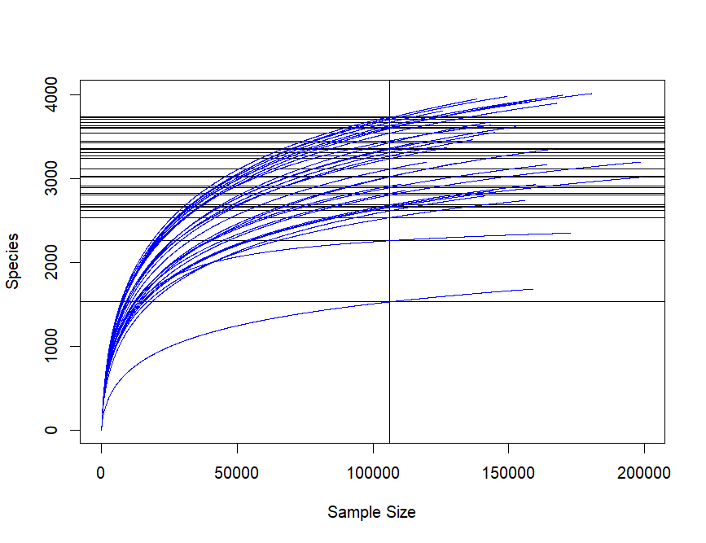
Fig S1. Rarefaction curves of bacterial OTUs from each residential lawn. Each site had sufficient sequencing depth thus, we rarified samples to the minimum sample size, 106,251 sequences.

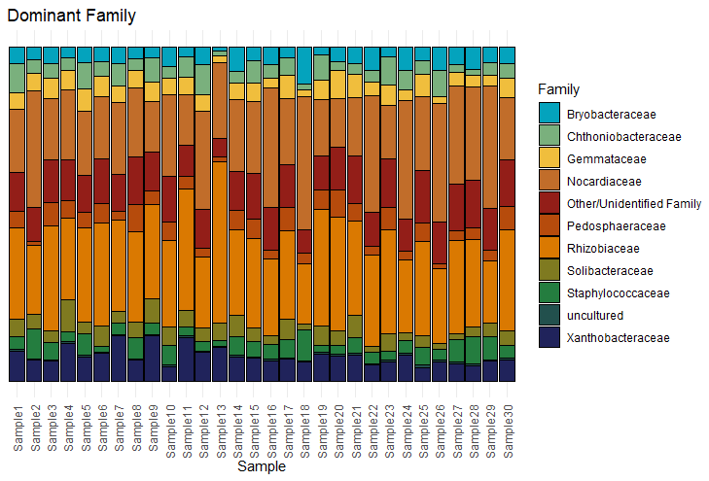
Figure S2. Rhizobiaceae is the most abundant family across suburban lawns in Raleigh, North Carolina. Each column displays for each site the relative abundance of the 10 overall most abundant families.

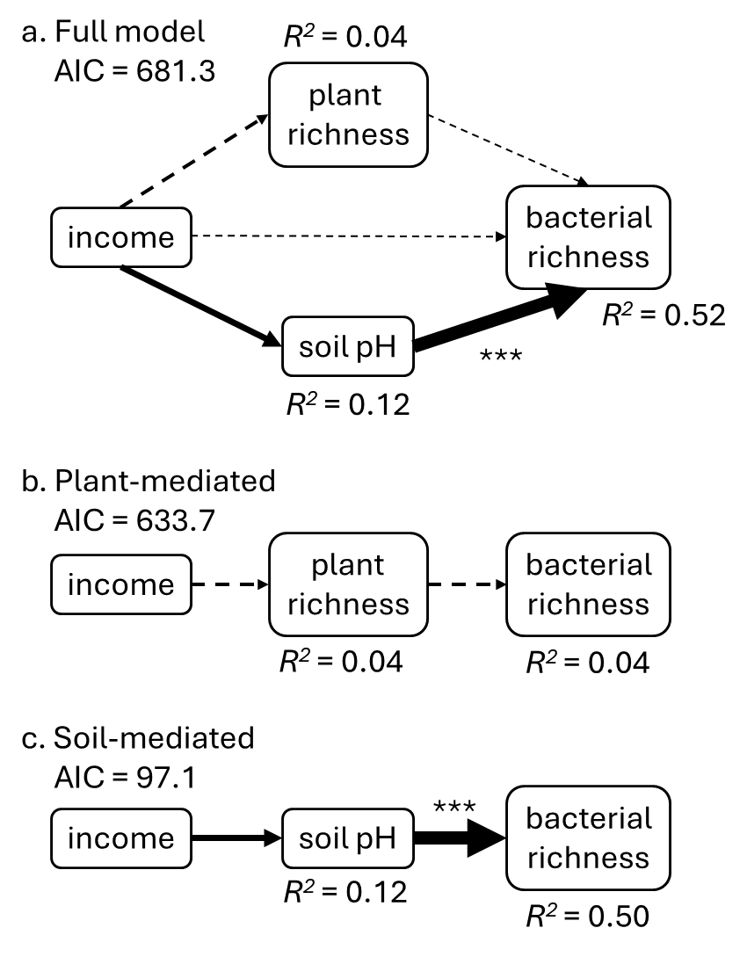
Fig S3. Results of piecewise structural equation models assessing direct and indirect effects of affluence on soil bacterial richness, for the dataset with the outlier site included. The width of each arrow is proportional to its standardized effect size; solid lines represent positive effects, and dashed lines negative effects. AIC is shown for each path diagram, and R² values are shown for each response variable. Significance of individual pathways is indicated by asterisks (*, p < 0.05; ***, p < 0.001).

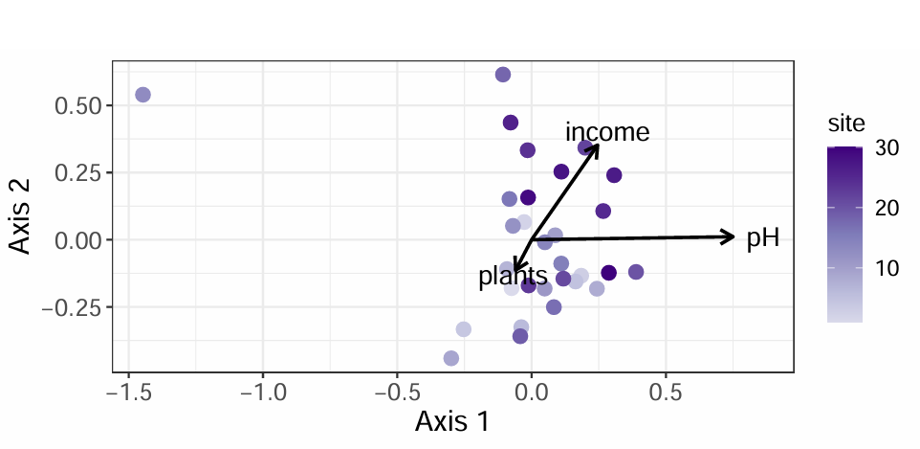
Figure S4. dbRDA ordination plot, as in Fig. 5 in the main text, except with the outlier site 13 included. For statistical tests, see Table S2.

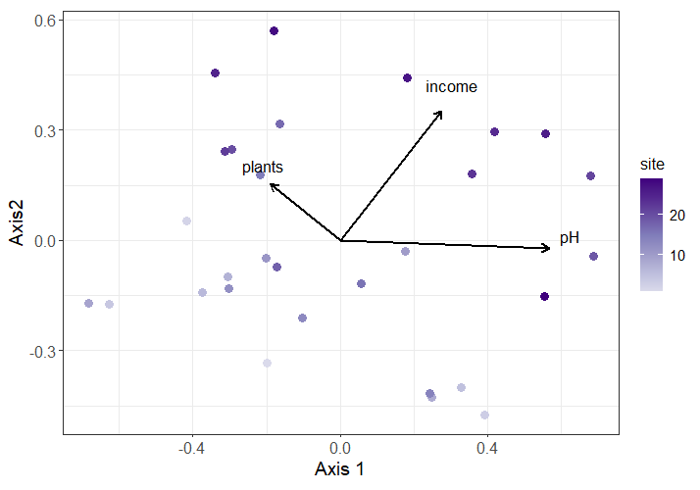
Figure S5. dbRDA ordination plot, as in Fig 5 in the main text, except without excluding low abundance OTUs. Axis 1 is still aligned with pH, the most significant variable (F=2.63, p = 0.001).
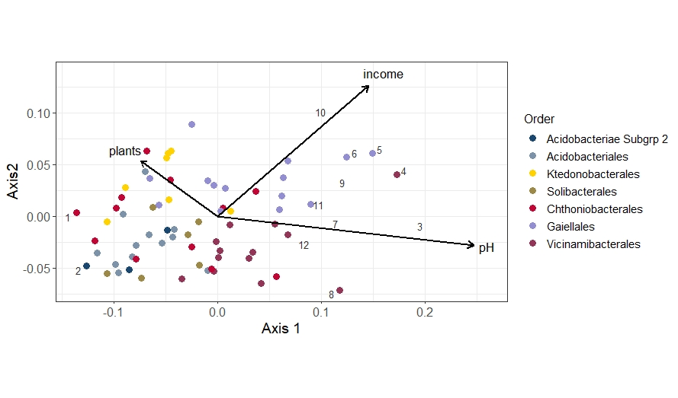
Figure S6. dbRDA ordination plot, as in Fig. 5 in the main text but showing only those OTUs with significant loadings on Axis 1.

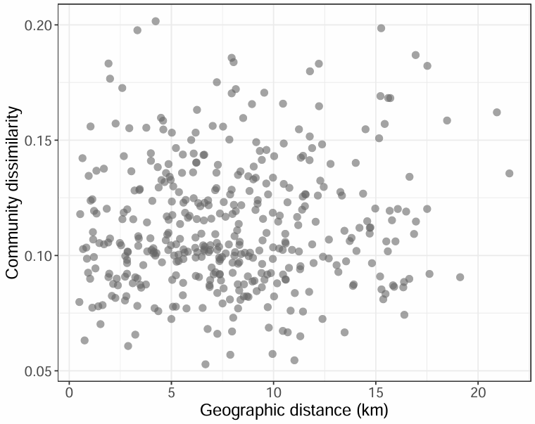
Figure S7. Bacterial community dissimilarity was not correlated with geographic distances among sites (Mantel test r = 0.08, p = 0.222). Each point represents one pair of sites. Results were similar with outlier site 13 included (r = 0.11, p = 0.374). We conducted the Mantel test with 999 permutations in ‘vegan’; the community dissimilarities were the same Bray-Curtis distances used in the dbRDA.

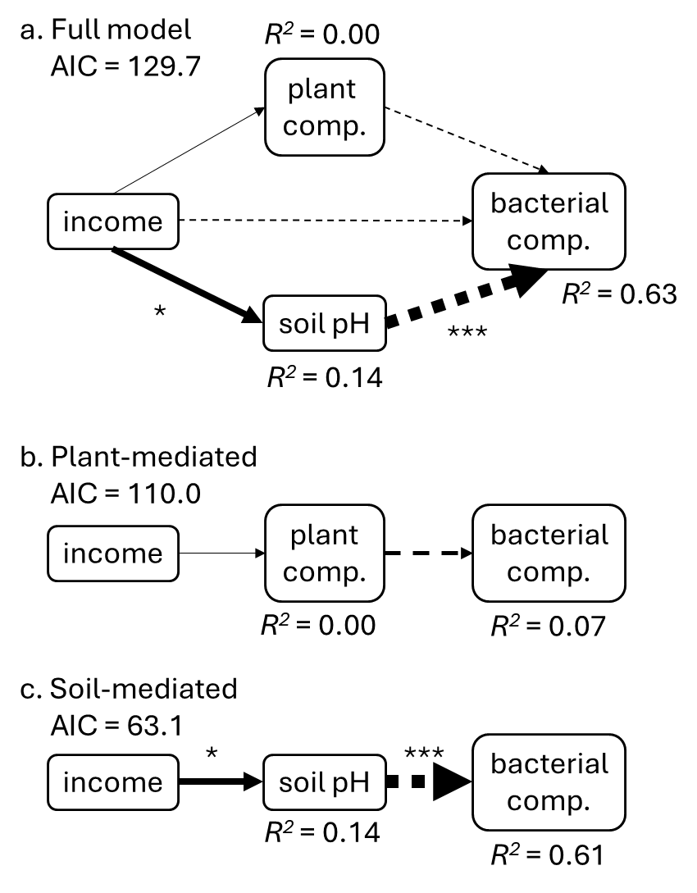
Figure S8. Results of piecewise structural equation models assessing direct and indirect effects of affluence on soil bacterial composition. The width of each arrow is proportional to the absolute value of its standardized effect size; solid lines represent positive effects, and dashed lines negative effects. AIC is shown for each path diagram, and R2 values are shown for each response variable. Significance of individual pathways is indicated by asterisks (*, p < 0.05; ***, p = 0.001). This figures shows results with the outlier site excluded; Fig. S9 shows results with this site included.

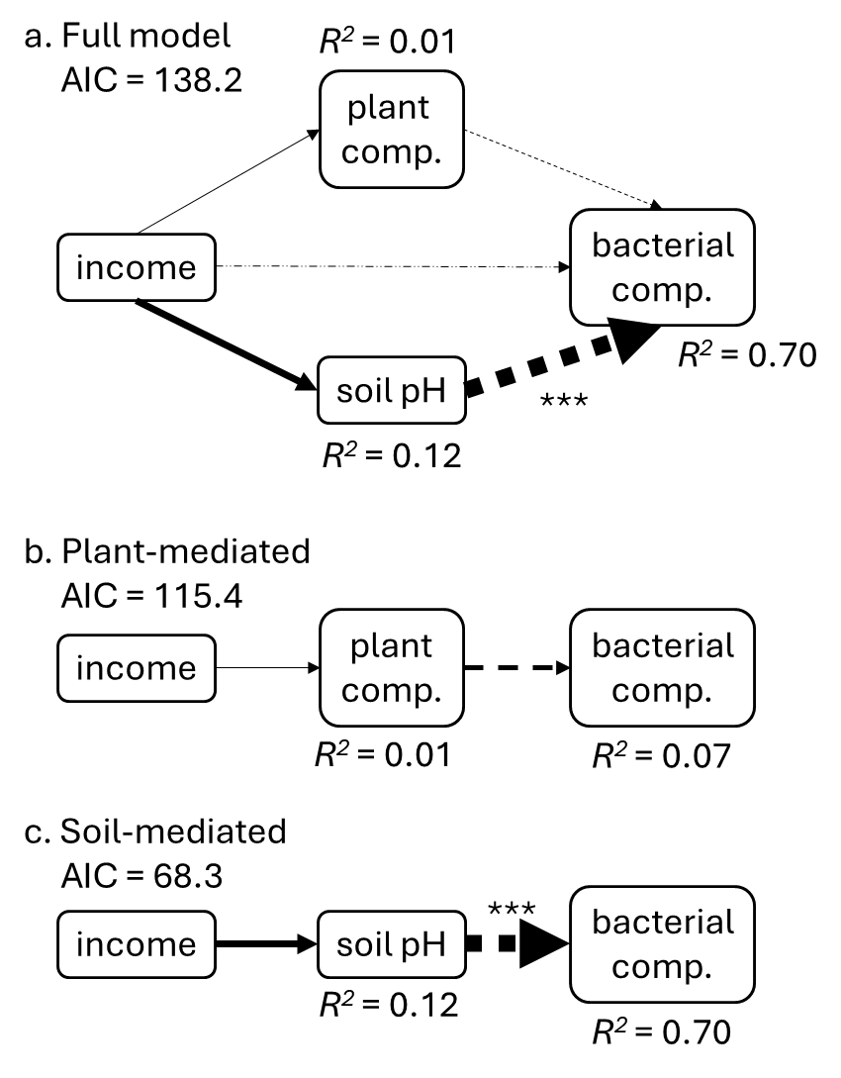
Figure S9. As figure S8, based on the full dataset with the outlier site included. Results are similar, except the relationship between income and soil pH is no longer significant (p = 0.06).

