Urban Ecosystems – Original research article

Green area size rather than urbanization ecological index modulate the specialization of flower-visitor networks of Leguminosae trees in a tropical metropolis in Brazil

SUPPLEMENTARY INFORMATION

Fig. S1. Correlation between the possible variables for calculating the urbanization index (A) and the variables selected for calculating the urbanization ecological index (B). Key to the acronyms of the variables: mbds – average building density; ncbd- number of cells with high construction density (>50%); ncwr- number of cells with the presence of paving; ncpc- number of cells with channel presence; dnnga- distance to the nearest remaining forest area; ncpwb- number of cells with the presence of water bodies; mvds- average vegetation density and ncvd- number of cells with high vegetation density (>50%).
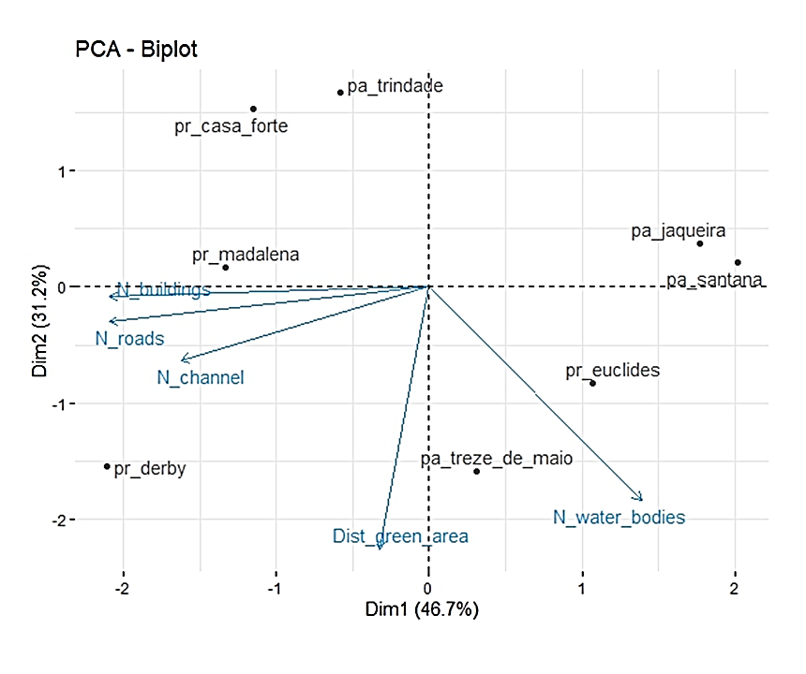
Fig. S2. Contribution of variables used in principal components analysis - PCA. The first component (PC1) presented 46.7% of the explained variance and the second component (PC2) presented 31.2%. The variables that make up the urbanization ecological index were obtained in the region of squares and parks in the city of Recife, Pernambuco, northeast of Brazil.

Fig. S3. Number of visits to the flowers of Leguminosae species for each floral visitor.
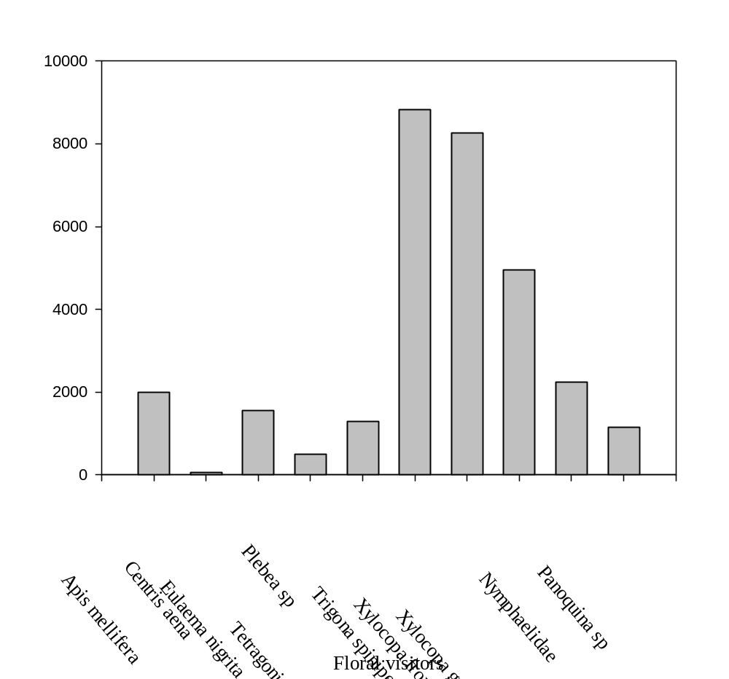
Table S1. Values ​​of the landscape metrics used to obtain the urbanization ecological index and final values ​​of the index of urban green spaces in the city of Recife, Pernambuco, northeastern Brazil.

Location | Distance to the nearest forest remnant area | Number of cells with high density of constructions (>50%) | Number of cells with the presence of paving (roads/ parking) | Number of cells with channel presence | Number of cells with the presence of water bodies (rivers/lakes) | Urbanization ecological index
Squares
Casa Forte | 3.63 | 94 | 98 | 3 | 2 | 26.05
Derby | 7.03 | 98 | 99 | 13 | 16 | 60.31
Euclides da Cunha | 6.22 | 87 | 90 | 0 | 22 | 74.33
Solange Pinto Melo | 6.03 | 99 | 100 | 0 | 7 | 52.29
Parks
Sítio da Trindade | 3.74 | 87 | 97 | 3 | 0 | 24.04
Treze de Maio | 8.26 | 84 | 100 | 0 | 18 | 65.86
Jaqueira | 4.93 | 81 | 84 | 0 | 15 | 36.62
Santana | 4.40 | 85 | 80 | 0 | 21 | 60.45

Table S2. Characterization of Leguminosae species from urban green spaces in the city of Recife, Pernambuco, northeastern Brazil.

Plant specie | Origen | Phytogeographic domain | Flower size | Inflorescence type
Albizia lebbeck | Exotic (Native to South Asia) | Amazon forest | Inconspicuous | Umbeliforme
Cassia grandis | Native | Amazon forest, Cerrado, Atlantic forest, Pantanal | Small | Racemose
Cenostigma pluviosum var. peltophoroides | Native | Atlantic forest | Small | Racemose
Cenostigma pyramidale | Native | Caatinga | Small | Racemose
Clitoria fairchildiana | Native | Amazon forest, Caatinga dry forest, Cerrado, Atlantic forest | Large | Pseudo-racemose
Libidibia ferrea | Native | Caatinga dry forest, Cerrado, Atlantic forest | Small | Panicles
Paubrasilia echinata | Native | Atlantic forest | Small | Racemose
Prosopis juliflora | Exotic (Native to Mexico to Colombia and Venezuela, invasive in Brazil) | Caatinga dry forest | Inconspicuous | Racemose
Senna siamea | Exotic (Native to Asia) | Amazon forest, Caatinga dry forest, Cerrado, Atlantic forest | Small | Panicles
Tamarindus indica | Exotic (Native to India) | Amazon forest, Caatinga dry forest, Cerrado, Atlantic forest | Small | Racemose
Origen, phytogeographical domain and inflorescence type according to Flora e Funga do Brasil, 2024. Foral size according to Faegri & Pijl 1982: inconspicuous (≤4mm), small (> 4mm ≤10 mm), medium (> 10mm ≤ 20 mm), large (> 20mm ≤30 mm), very large (> 30mm).

Table S3. Result of the specialization metric (d’) of each Leguminosae species, average of native species, average of exotic species and statistical test verifying the difference in specialization between native and exotic species in urban green spaces in the city of Recife, Pernambuco, Northeast Brazil.

Área verde | Plant species | Origen | d’
Squares
Casa Forte | Cassia grandis | Native | 0.499
Casa Forte | Cenostigma pluviosum var. peltophoroides | Native | 0.264
Casa Forte | Clitoria fairchildiana | Native | 0.286
Casa Forte | Paubrasilia echinata | Native | 0.26
Derby | Clitoria fairchildiana | Native | 0.269
Derby | Paubrasilia echinata | Native | 0.252
Derby | Tamarindus indica | Exotic | 0.269
Euclides da Cunha | Cenostigma pyramidale | Native | 0.239
Euclides da Cunha | Libidibia ferrea | Native | 0.612
Solange Pinto Melo | Cassia grandis | Native | 0.287
Solange Pinto Melo | Clitoria fairchildiana | Native | 0.169
Solange Pinto Melo | Paubrasilia echinata | Native | 0.181
Solange Pinto Melo | Prosopis juliflora | Exotic | 0.287
Parks
Jaqueira | Albizia lebbeck | Exotic | 0.528
Jaqueira | Cenostigma pluviosum var. peltophoroides | Native | 0.284
Jaqueira | Clitoria fairchildiana | Native | 0.282
Jaqueira | Paubrasilia echinata | Native | 0.234
Jaqueira | Tamarindus indica | Exotic | 0.282
Santana | Cassia grandis | Native | 0.259
Santana | Clitoria fairchildiana | Native | 0.119
Santana | Senna siamea | Exotic | 0.189
Santana | Tamarindus indica | Exotic | 0.119
Sítio da Trindade | Cassia grandis | Native | 0.287
Sítio da Trindade | Cenostigma pluviosum var. peltophoroides | Native | 0.247
Sítio da Trindade | Senna siamea | Exotic | 0.227
Sítio da Trindade | Tamarindus indica | Exotic | 0.161
Treze de Maio | Cenostigma pluviosum var. peltophoroides | Native | 0.167
Treze de Maio | Clitoria fairchildiana | Native | 0.172
Treze de Maio | Paubrasilia echinata | Native | 0.191
Treze de Maio | Senna siamea | Exotic | 0.167
Treze de Maio | Tamarindus indica | Exotic | 0.172

