SUPPLEMENTARY INFORMATION

Table A1. Extracts from the European pruning standards, which are the most up-to-date community-level standards published by the European Arboricultural Council (European Tree Pruning Standard (2024). EAS 01:2024. European Arboricultural Standards (EAS), European Arboricultural Council; available at: https://www.europeanarboriculturalstandards.eu/etps)

Chapter | Paragraph and excerpt from the text.
3.2 General rules
 | 3.2.7 “Dead branches are a natural part of a tree crown and should not be removed unless necessary. They are important for biodiversity support. […]”
 | “3.2.9. “If dead branches must be removed, leaving the base of the dead branches (stubs) can give a more natural appearance to the tree (especially if they are removed by breaking the branch) and support biodiversity. […]”
 | Table 1 “Dead and dying branches in the permanent crown should be retained (completely or reduced) for biodiversity reasons as long as this does not compromise an acceptable level of risk.”
 | 3.2.17 “During any pruning operation, consider any impact on biodiversity. The timing, technique or amount of foliage removed may need to be adapted to maintain or improve biodiversity.”
3.3 Branch removal methods
 | 3.3.6 “With this [Rip cut/controlled breakage] branch removal method, the aim is to support biodiversity […]”.
3.4 Main pruning operations
 | 3.4.0 “Before any pruning work is carried out, the following prerequisites must be completed: […] 4. potential conflicts with biodiversity […]”.
4.2 Development stages
 | Table 3: Development phases of trees as used in this standard. […] Veteran tree: characterised by considerable size/age for a given species, an advanced life stage and high social, cultural and biodiversity values.”
 | 4.2.5 - Within the framework of this pruning standard, a veteran tree is characterised as a tree that: […] shows significant increases in biodiversity value (cavities, wood decay etc.).”
5. Tree pruning matrix
 | 5.1.4 “During any pruning operation, be aware of the impact on biodiversity. To account for biodiversity, the timing, pruning technique, amount of foliage removed, or any other aspect of pruning might need to be adapted.”
5.10 Veteran Tree management
 | 5.10.4 “The intervention must not adversely affect the significant microhabitats and the biodiversity value of the tree and its surroundings.”
6.2 Palm trees - Pruning techniques
 | 6.2.5 “[…] The cover serves as protection against environmental agents and is a place of rich biodiversity. […]”.
7.3 Arisings
 | 7.3.2 “Whenever acceptable, arisings should be used locally to conserve resources on site and support biodiversity”

Figure A1. Examples of TreMs conservation implemented in public parks in Milan (Italy) in the framework of an experimental project of conservative tree management by the authors.

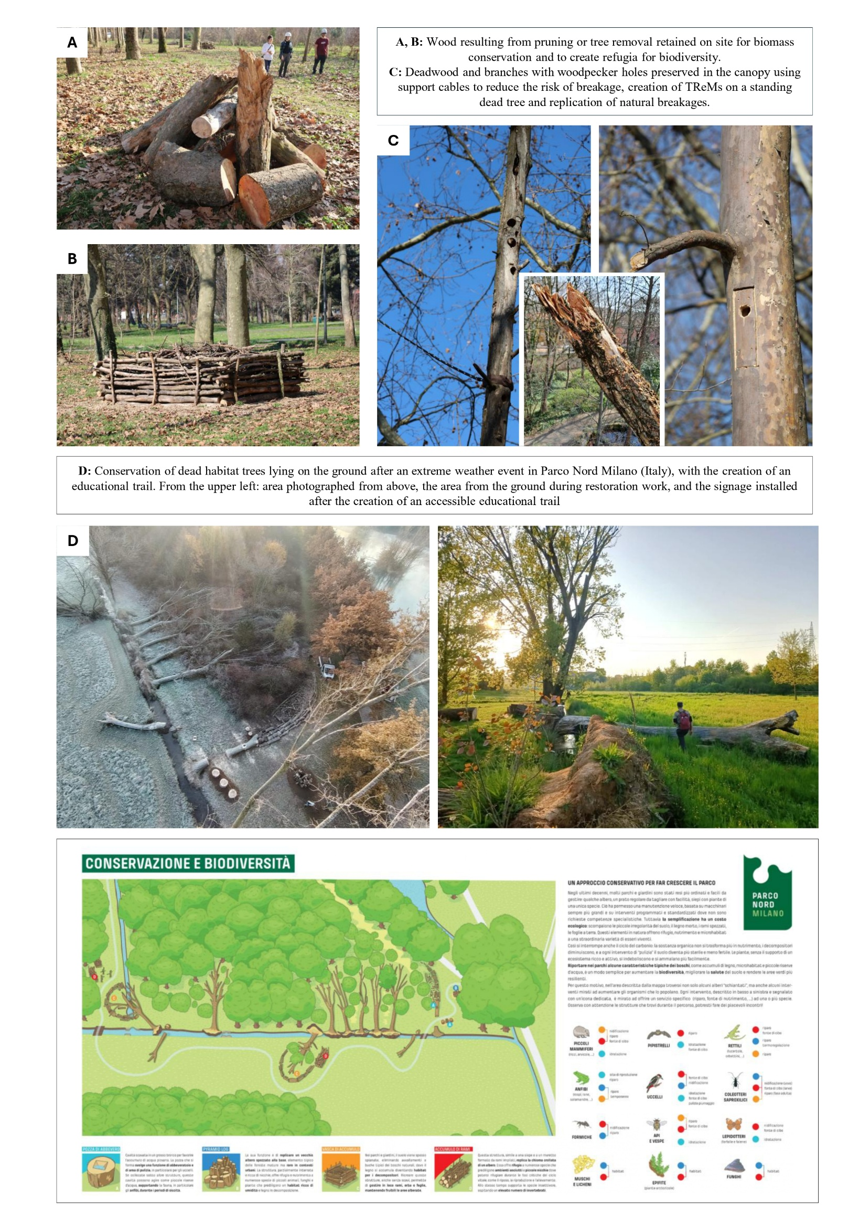

Figure A2. The image illustrates how identifying habitat trees within a municipality can provide valuable information for planning, studying ecological networks, and prioritizing conservation and management actions for the tree heritage. Red points represents habitat trees and blue area is a buffer of 250 metres as example of species dispersion capacity.

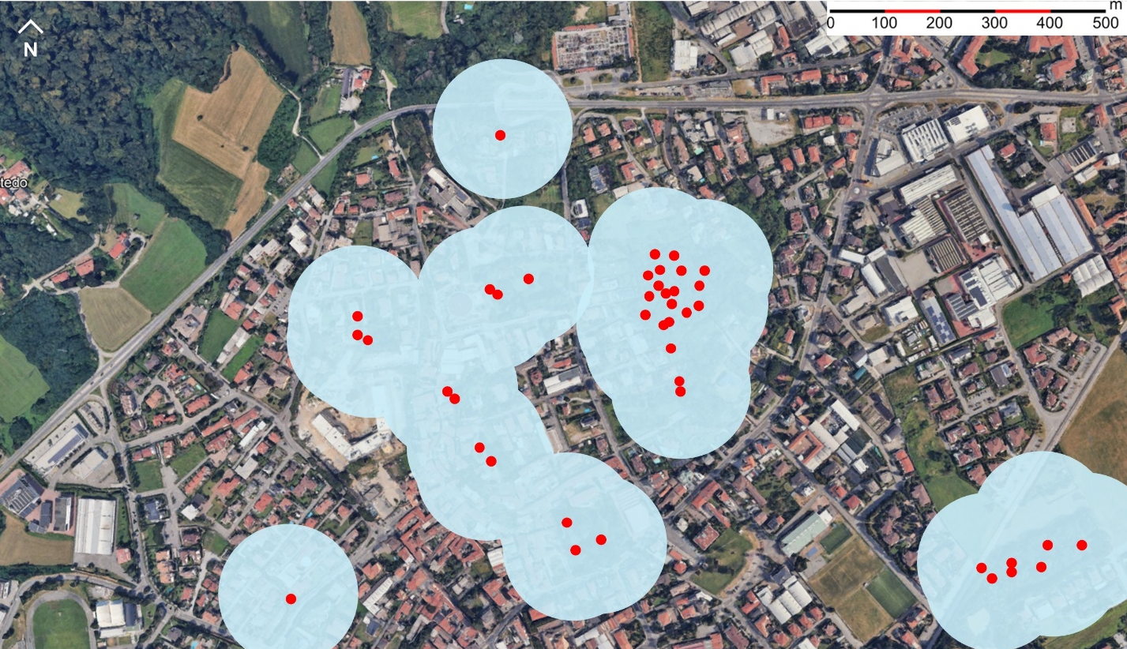

Figure A3. The felling of large trees is still frequently showcased by operators and companies, often with images that frame the event in a trophy-like manner and signal human dominance over nature. By contrast, the culling of wild animals—even when conducted for wildlife management purposes—is culturally framed with greater restraint. Trophy-style depictions are generally avoided, as social norms of respect toward wildlife remain strong. This asymmetry indicates that cultural norms commonly applied to wildlife have not yet been extended to trees, despite their ecological value and status as living organisms. Such differences in representation highlight how societal values shape the perceived legitimacy and visibility of different management actions within conservation contexts.
The images shown in this figure were sourced from publicly accessible digital media profiles. All identifying details of authors and photographed individuals have been removed to preserve privacy. These are examples to illustrate how the felling of large trees is commonly represented and valorized in digital media, and how such content can attract positive audience engagement.

