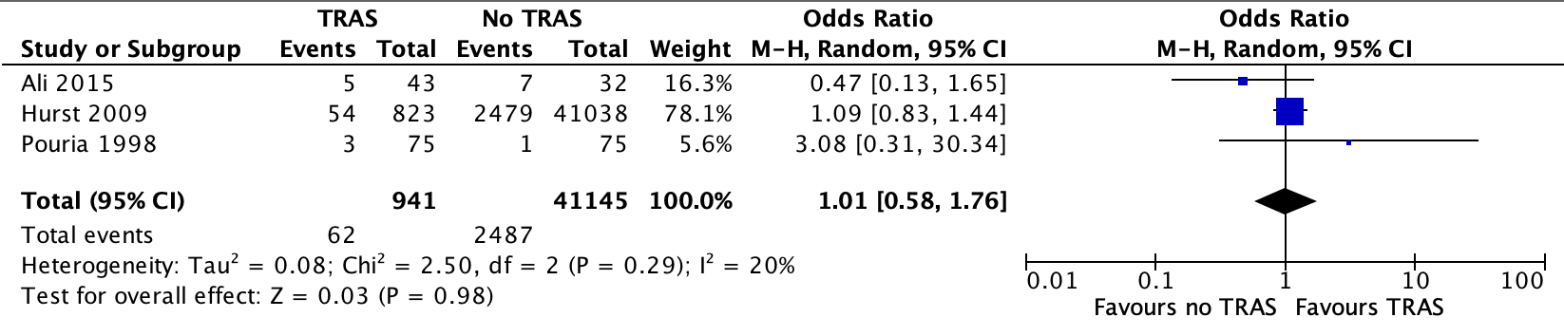
A
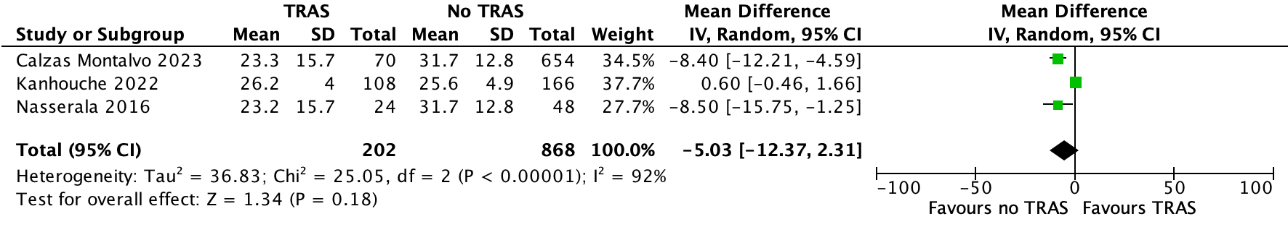
B
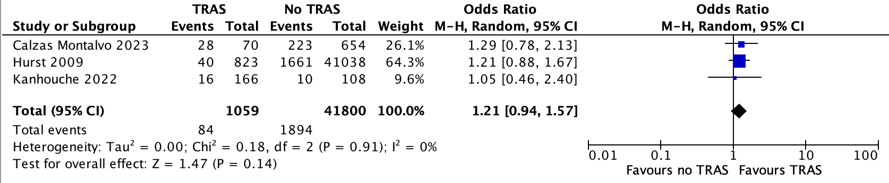
C
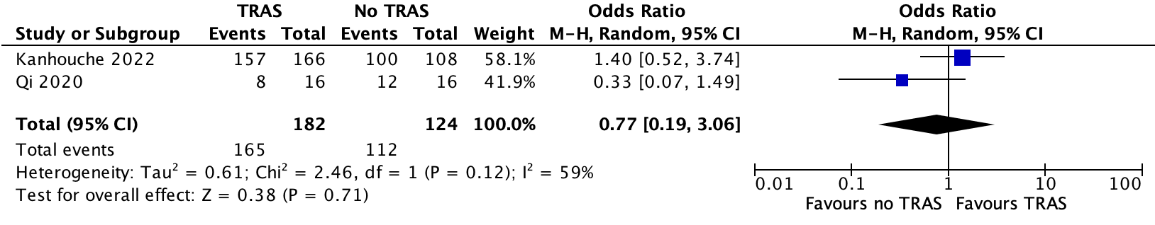
D
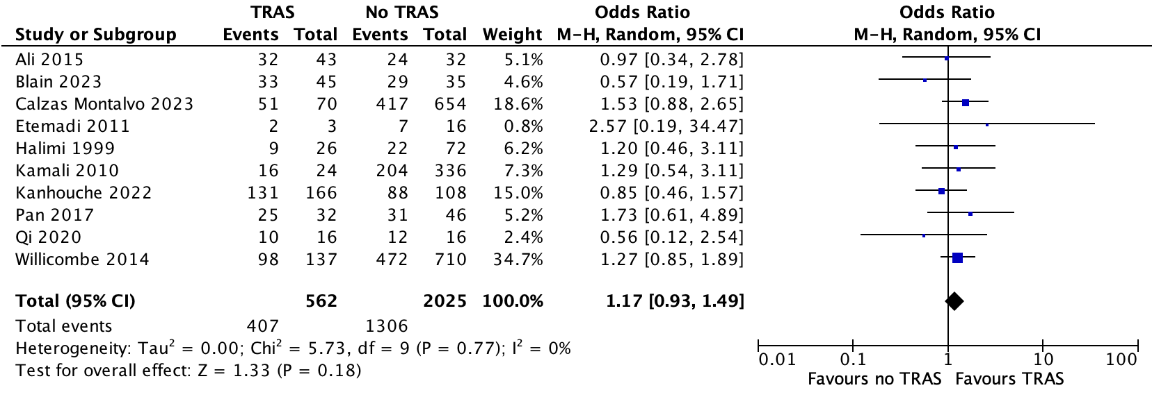
E
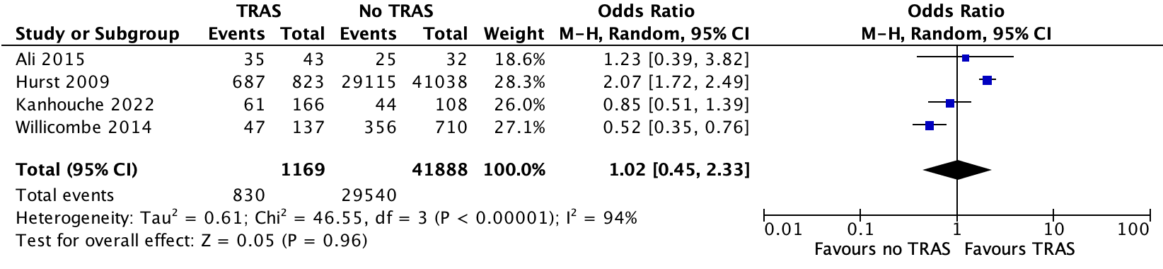
F
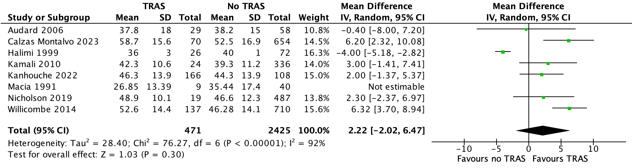
G
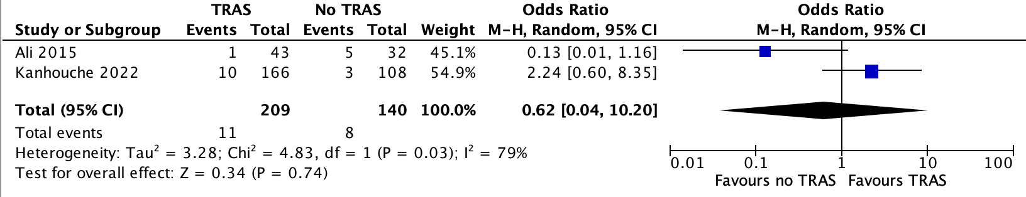
H
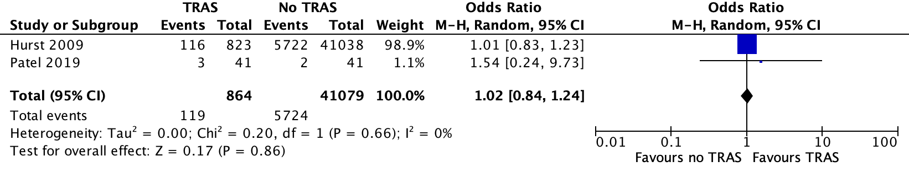
I
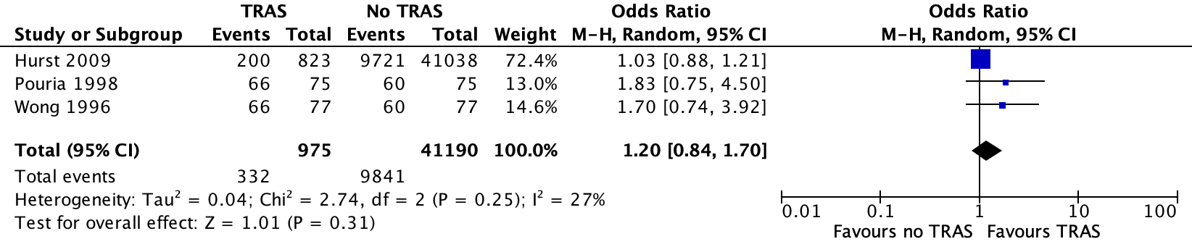
J
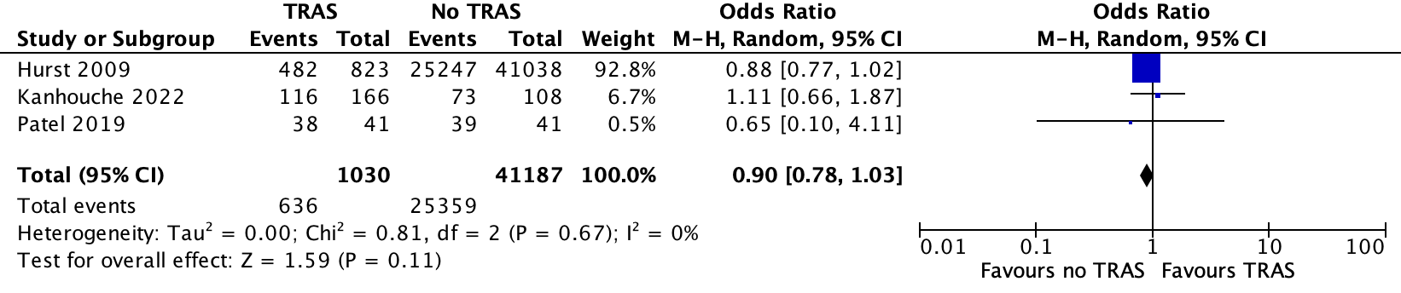
K
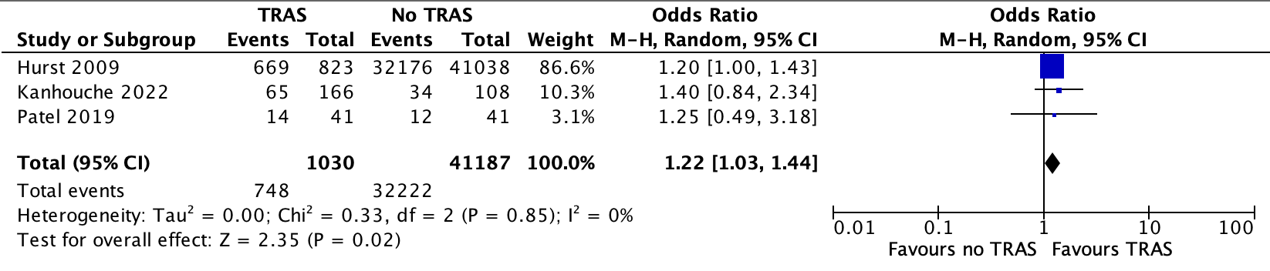
L

Supplementary figure 2. Forest plots on the association between TRAS and factors such as A) peripheral vascular disease, B) body mass index, C) smoker, D) hemodialysis, E) male sex, F) Caucasian ethnicity, G) donor age (years). H) re-transplantation, I) immunosuppression with sirolimus, J) cyclosporine, K) tacrolimus, or L) mycophenolate mofetil.

