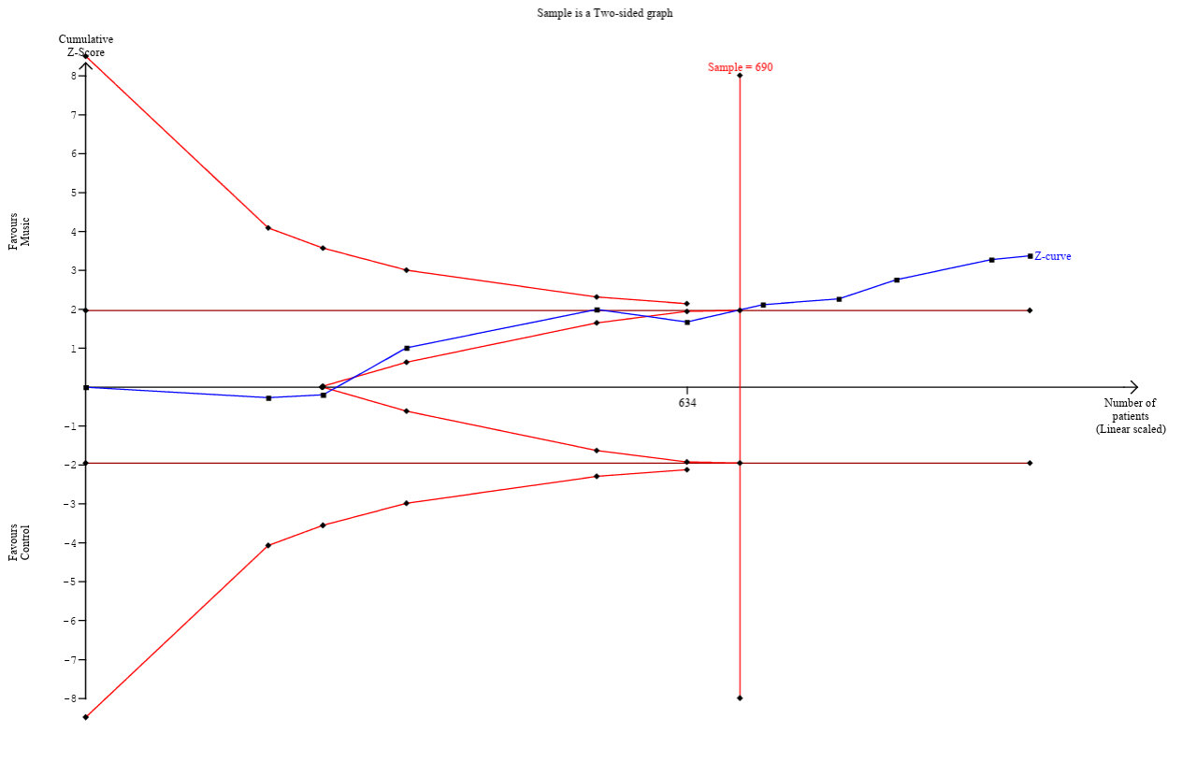
Supplementary Figure 1. Trial sequential analysis for VAS.
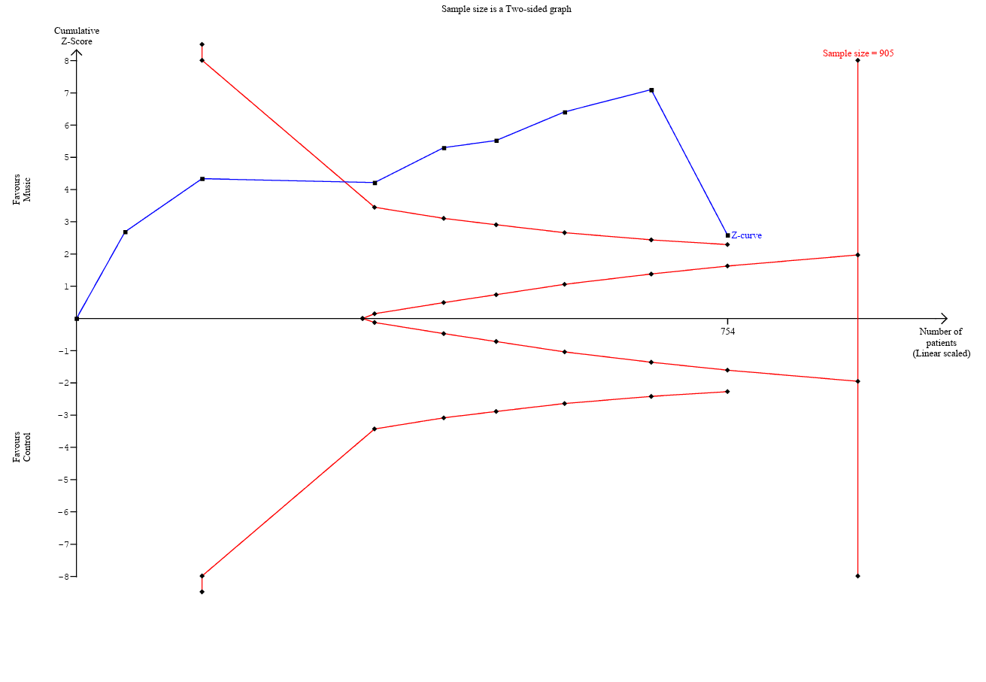
Supplementary Figure 2. Trial sequential analysis for STAI.

