Supplemental Online Content

eTable 1. Search Strategy
eTable 2. Creatine supplementation protocols across included studies
eFigure 2. Serum creatinine - Short Term Subgroup Leave-One-Out Meta-Analysis
eFigure 3. Serum creatinine - Short Term Subgroup Baujaut Plot
eFigure 4. Serum creatinine - Load + Maintenance Subgroup Leave-One-Out Meta-Analysis
eFigure 5. Serum creatinine - Load + Maintenance Subgroup Baujaut Plot
eFigure 6. Serum creatinine - Long Term Subgroup Leave-One-Out Meta-Analysis
eFigure 7. Serum creatinine - Long Term Subgroup Baujaut Plot
eFigure 8. Effect Size by Physical Activity Status on Load + Maintenance Subgroup
eFigure 9. BMI vs Effect size on Load + Maintenance Subgroup
eFigure 10. Meta-regression: BMI and Physical Activity Status on Load + Maintenance Subgroup
eFigure 11. Moderator Effects Comparison Between BMI and Physical Activity Status on Load + Maintenance Subgroup
eFigure 12. Partial Effect of BMI on Effect Size on Load + Maintenance Subgroup
eFigure 13. Serum Creatinine Trial Sequential Analysis
eFigure 14. Urinary Creatinine Forest Plot
eFigure 15. Proteinuria Forest Plot
eFigure 16. Albuminuria Forest Plot
eFigure 17. Urinary creatinine - Leave-One-Out Meta-Analysis
eFigure 18. Urinary creatinine - Baujaut Plot
eFigure 19. Albuminuria Leave-One-Out Meta-Analysis
eFigure 20. Albuminuria Baujaut Plot
eFigure 21. Risk of Bias Assessment
eTable 3. Summary of findings and certainty of evidence assessment.
eFigure 22. Funnel Plot for Serum Urea
eFigure 23. Funnel Plot for Serum Creatinine
eFigure 24. Funnel Plot for Glomerular Filtration Rate

eTable 1. Search Strategy

MEDLINE | ("creatine supplementation"[TIAB] OR "creatine" [TIAB]) AND ("renal function" OR "kidney function" OR "renal insufficiency" OR "kidney disease" OR "chronic kidney disease" OR "CKD" OR "kidney impairment") NOT ("creatine kinase"[TIAB] OR "creatine-phosphokinase"[TIAB] OR "CK" [TIAB])
Embase | ('creatine supplementation':ti,ab OR 'creatine':ti,ab) AND ('renal function' OR 'kidney function' OR 'renal insufficiency' OR 'kidney disease' OR 'chronic kidney disease' OR 'CKD' OR 'kidney impairment') NOT ('creatine kinase':ti,ab OR 'creatine-phosphokinase':ti,ab OR 'CK':ti,ab)
Cochrane | ("creatine supplementation":ti,ab OR "creatine":ti,ab) AND ("renal function" OR "kidney function" OR "renal insufficiency" OR "kidney disease" OR "chronic kidney disease" OR "CKD" OR "kidney impairment") NOT ("creatine kinase":ti,ab OR "creatine-phosphokinase":ti,ab OR "CK":ti,ab)
Google Scholar | allintitle: creatine supplementation renal OR kidney

eTable 2. Creatine supplementation protocols across included studies

Study | Creatine form | Patients | Route of administration | Protocol | Follow-up (days)
Almeida, 2013 | monohidrated | males under training program | oral | 0.3 g/kg/d x 7d | 7
Alves, 2013 | monohidrated | women with fibromyalgia | oral | 20 g/d x 5 d + 5 g/d x 25 d | 30
Armentano, 2007 | monohidrated | military | oral | 5 g/d x 6 d + 20 g/d x 8 d | 14
Bender, 2008 | monohidrated | Parkinson’s disease patients | oral | 20 g/d x 6 d + 2 g/d x 180 d + 4 g/d x 540 d | 726
Bennet, 2001 | monohidrated | military | oral | 20 g/d x 6 d + 6 g/d x 28 d | 34
Carvalho 0.03g/kg, 2011 | monohidrated | males under training program | oral | 20 g/d x 7 d + 0.03 g/kg/d x 49 d | 56
Carvalho 5g, 2011 | monohidrated | males under training program | oral | 20 g/d x 7 d + 5 g/d x 49 d | 56
Dalton, 2017 2g CNL | nitrate | healthy adults | oral | 2 g/d x 7 d | 7
Dalton, 2017 4g CNH | nitrate | healthy adults | oral | 4 g/d x 7 d | 7
de Oliveira Vilar Neto, 2020 3g | monohidrated | healthy males | oral | 3 g/d x 35 d | 35
de Oliveira Vilar Neto, 2020 5g | monohidrated | healthy males | oral | 5 g/d x 35 d | 35
Domingues, 2020 | monohidrated | adults with PAD | oral | 20 g/d x 7 d + 5 g/d x 49 d | 56
Galvan, 2016 CM | monohidrated | healthy males | oral | 5 g/d x 28 d | 28
Galvan, 2016 CNH | nitrate | healthy males | oral | 3 g/d x 28 d | 28
Galvan, 2016 CNL | nitrate | healthy males | oral | 1.5 g/d x 28 d | 28
Gotshalk, 2002 | monohidrated | older men | oral | 0.3 g/kg/d x 7 d | 7
Groeneveld, 2005 | monohidrated | ALS patients | oral | 10 g/d x 310 d | 310
Gualano, 2008 | monohidrated | healthy males | oral | 0.3 g/kg/d x 7 d + 0.15 g/kg/d x 77 d | 84
Gualano, 2011 | monohidrated | DM2 adults | oral | 5 g/d x 84 d | 84
Hayashi, 2014 | monohidrated | cSLE patients | oral | 0.1 g/kg/d x 84 d | 84
Kreider, 1998 | monohidrated | male athletes | oral | 15 g/d x 28 d | 28
Lobo, 2015 | monohidrated | older women | oral | 1 g/d x 360 d | 360
Study | Creatine form | Patients | Route of administration | Protocol | Follow-up (days)
Lugaresi, 2013 | monohidrated | healthy males | oral | 20 g/d x 5 d + 5 g/d x 84 d | 89
Lyoo, 2012 | monohidrated | women with major depressive disorder | oral | 3 g/d x 7 d + 5 g/d x 49 d | 56
Marini, 2020 | monohidrated | hemodialysis patients | oral | 20 g/d x 7 d + 5 g/d x 21 d | 28
Marini, 2024 | monohidrated | hemodialysis patients | oral | 5 g/d x 360 d | 360
Mihic, 2000 | monohidrated | healthy adults | oral | 20 g/d x 5 d | 5
Neves, 2011 | monohidrated | postmenopausal women | oral | 20 g/d x 7 d + 5 g/d x 77 d | 84
Robinson, 2000 - CrLoad | monohidrated | healthy patients | oral | 20 g/d x 5 d | 5
Robinson, 2000 - CrLoad+G | monohidrated | healthy patients | oral | 20 g/d x 5 d | 5
Robinson, 2000 - CrMaint | monohidrated | healthy patients | oral | 20 g/d x 5 d + 3 g/d x 56 d | 61
Robinson, 2000 - CrMaint+Ex | monohidrated | healthy patients | oral | 20 g/d x 5 d + 3 g/d x 56 d | 61
Solis, 2016 | monohidrated | JDM patients | oral | 0.1 g/kg/d x 84 d | 84
Study | Creatine form | Patients | Route of administration | Protocol | Follow-up (days)
Volek, 2001 | monohidrated | healthy males | oral | 0.3g/kg/d x 7 d | 7
BMI: body mass index; ALS: amyotrophic lateral sclerosis; DM2: diabetes mellitus type 2; JDM: juvenile dermatomyositis; cSLE: childhood-onset systemic lupus erythematosus; PAD: peripheral artery disease; CM: creatine monohidrated; CNH: creatine nitrate high dose; CNL: creatine nitrate low dose; CrLoad: creatine load; CrLoad + Gl: creatine load + glucose; CrMaint: creatine maintenance; CrMaint + Ex: creatine maintenance + exercise

eFigure 2. Serum creatinine - Short Term Subgroup Leave-One-Out Meta-Analysis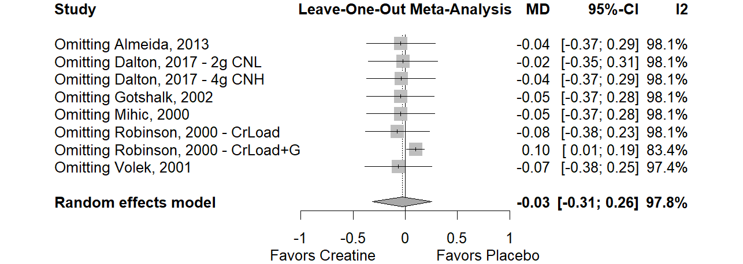
eFigure 3. Serum creatinine - Short Term Subgroup Baujaut Plot 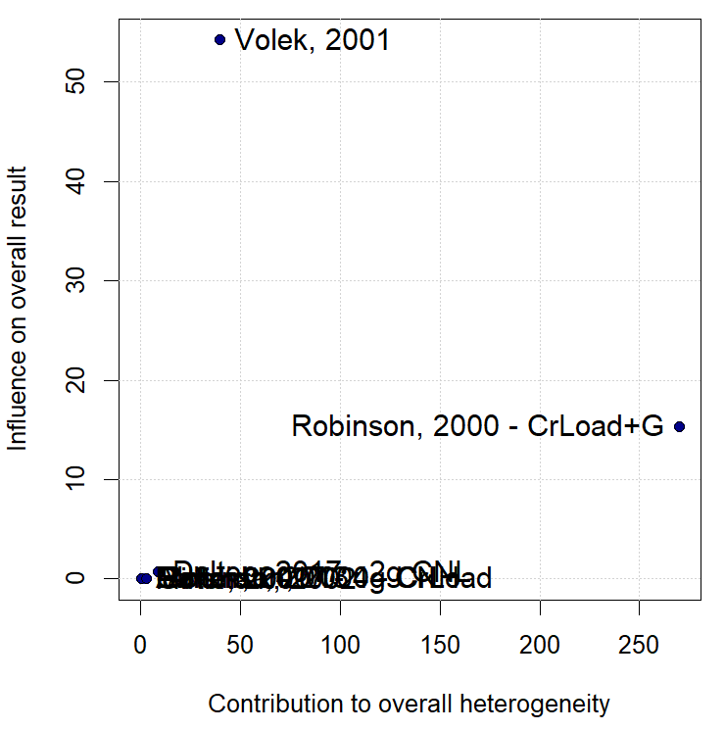

eFigure 4. Serum creatinine - Load + Maintenance Subgroup Leave-One-Out Meta-Analysis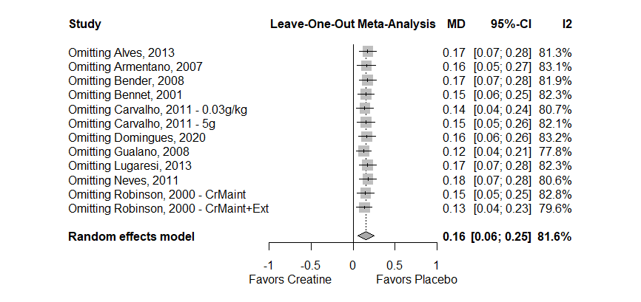
eFigure 5. Serum creatinine - Load + Maintenance Subgroup Baujaut Plot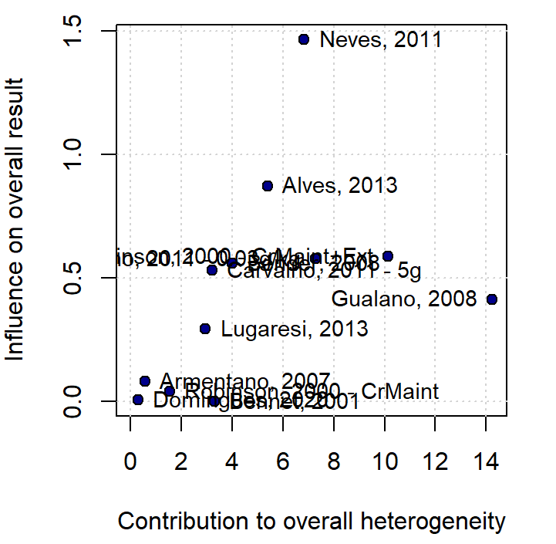
eFigure 6. Serum creatinine - Long Term Subgroup Leave-One-Out Meta-Analysis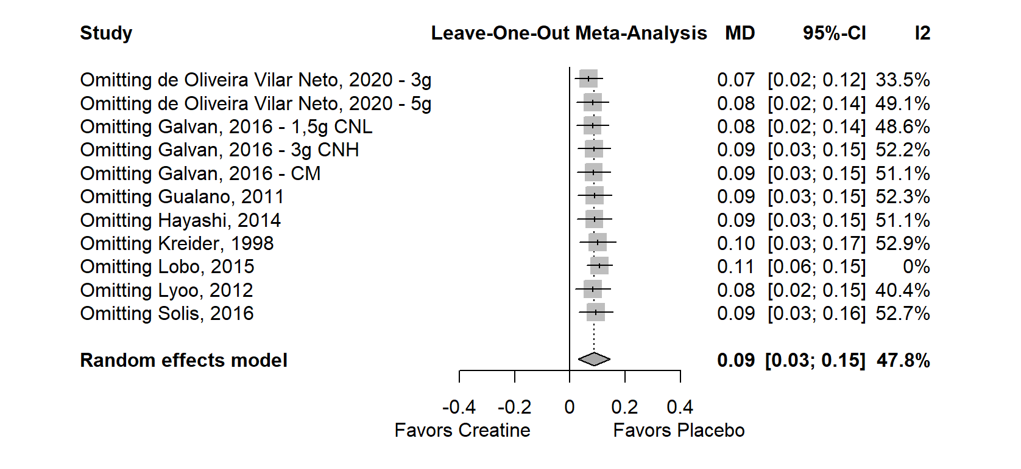

eFigure 7. Serum creatinine - Long Term Subgroup Baujaut Plot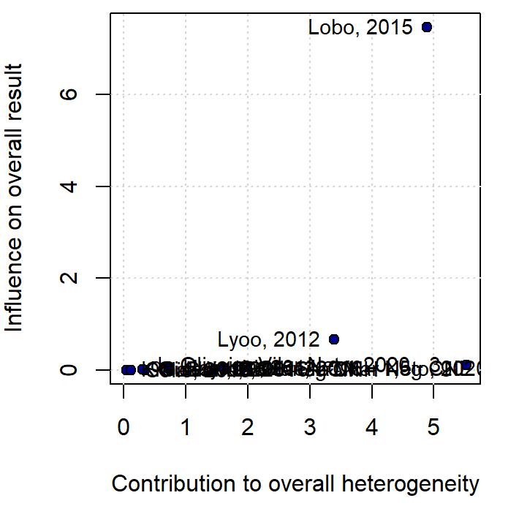

eFigure 8. Effect Size by Physical Activity Status on Load + Maintenance Subgroup
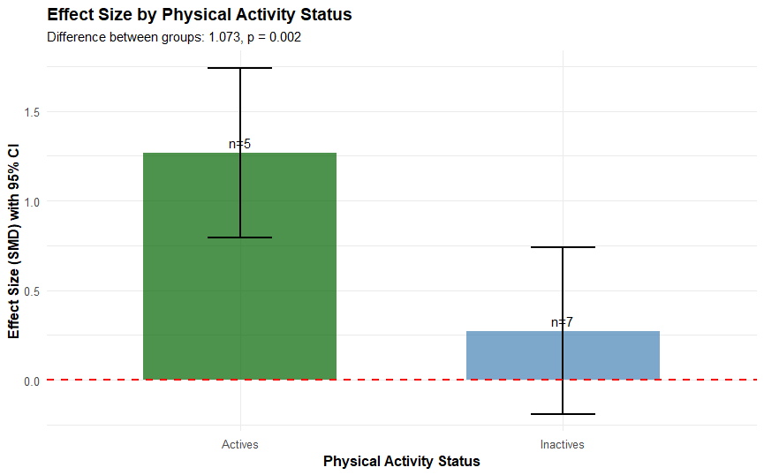

eFigure 9. BMI vs Effect size on Load + Maintenance Subgroup
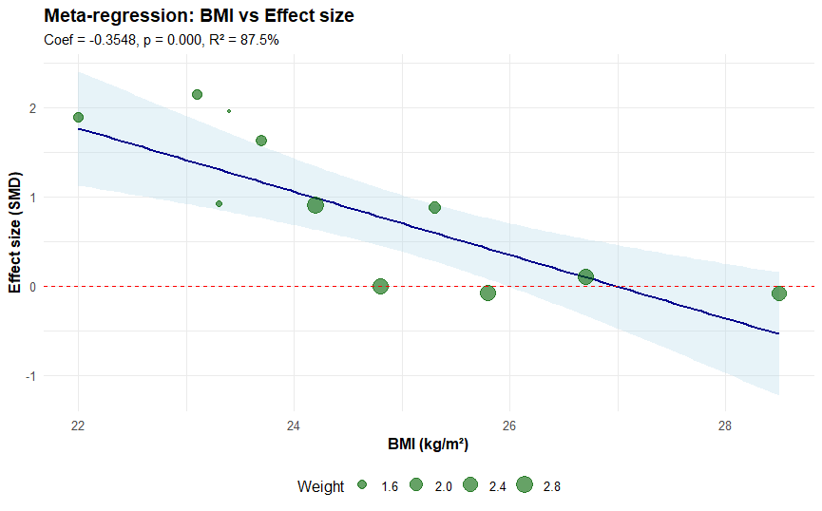

eFigure 10. Meta-regression: BMI and Physical Activity Status on Load + Maintenance Subgroup
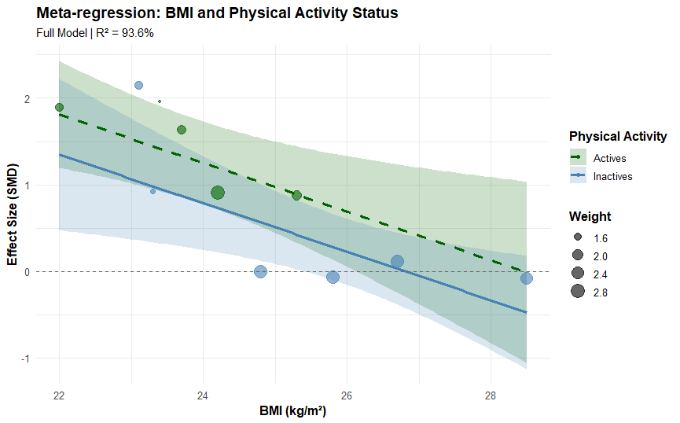

eFigure 11. Moderator Effects Comparison Between BMI and Physical Activity Status on Load + Maintenance Subgroup

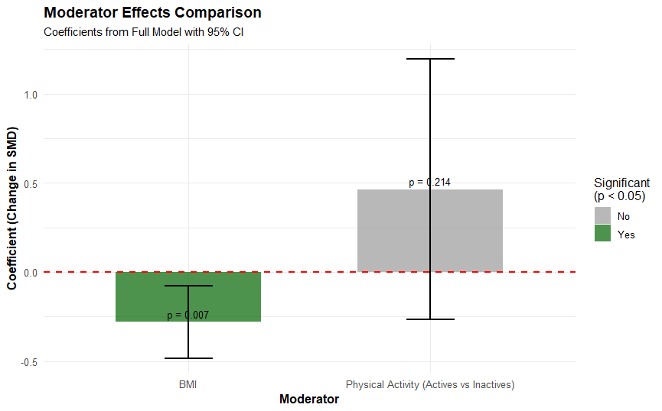

eFigure 12. Partial Effect of BMI on Effect Size on Load + Maintenance Subgroup
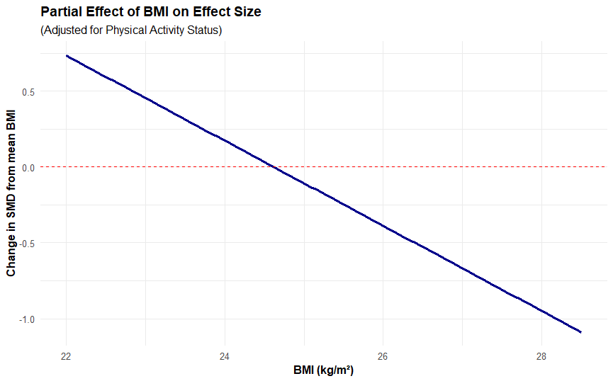

eFigure 13. Serum Creatinine Trial Sequential Analysis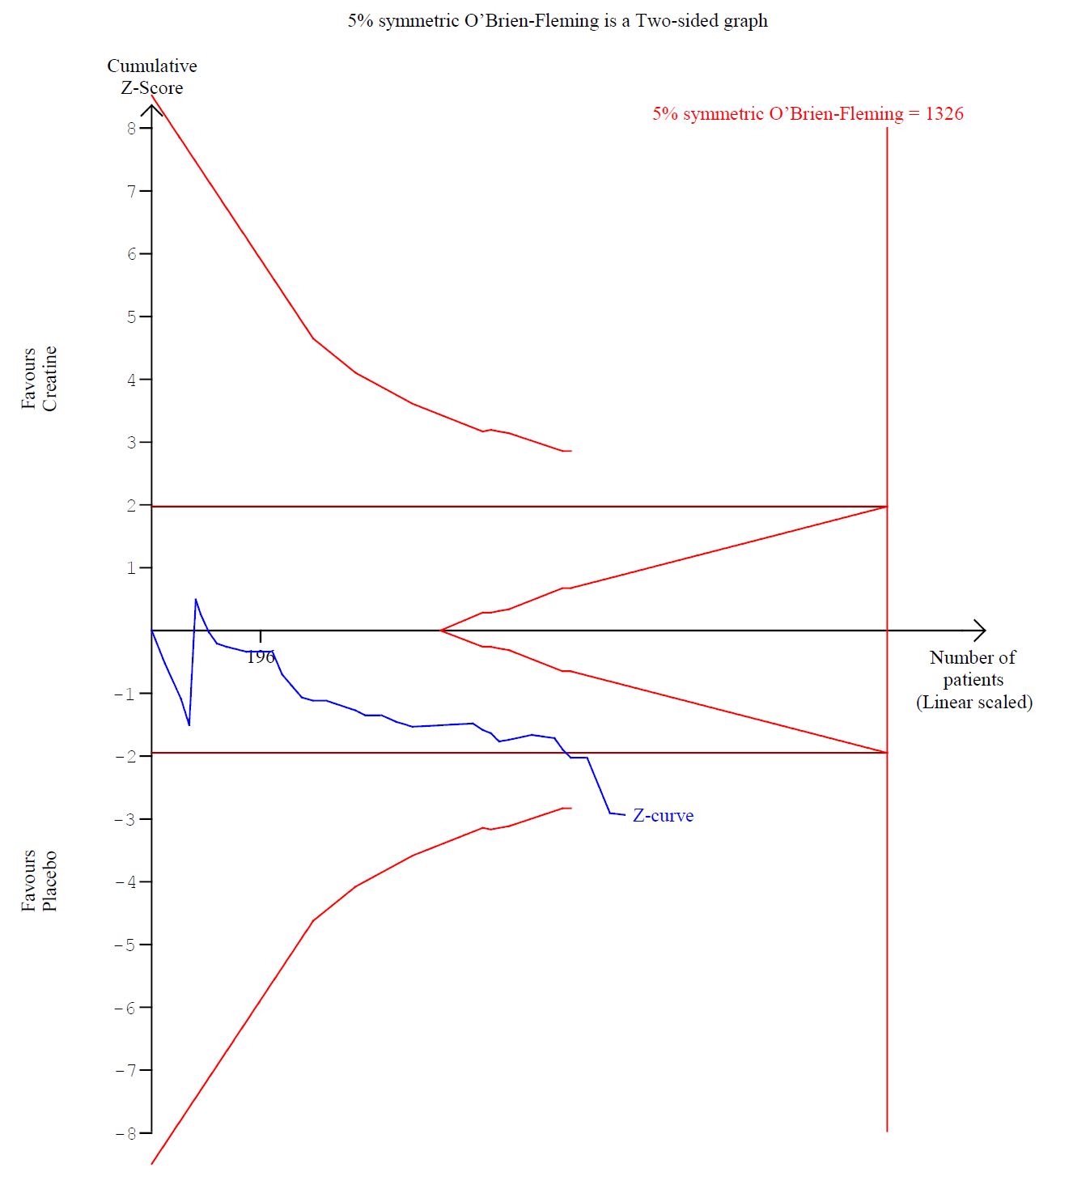

eFigure 14. Urinary Creatinine Forest Plot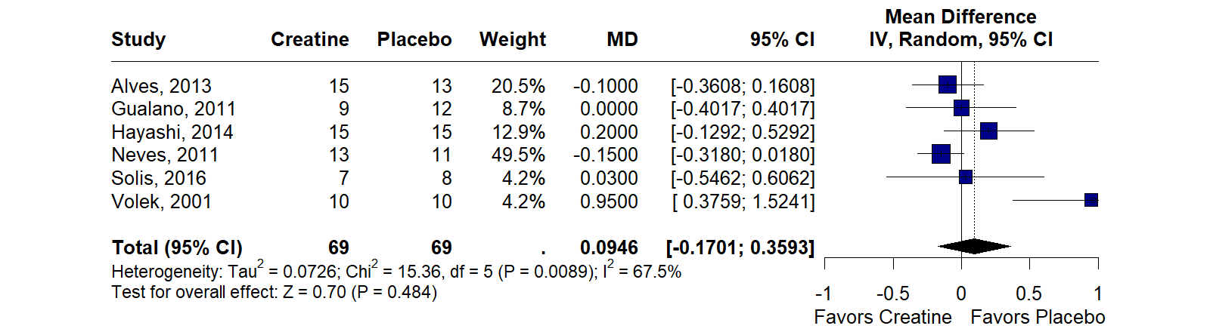
eFigure 15. Proteinuria Forest Plot
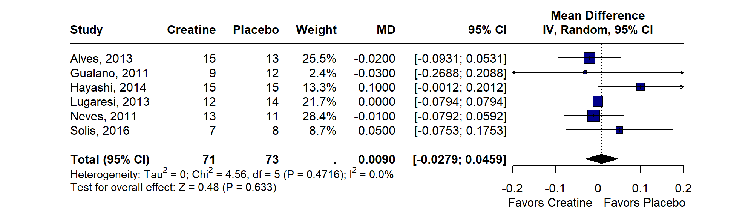
eFigure 16. Albuminuria Forest Plot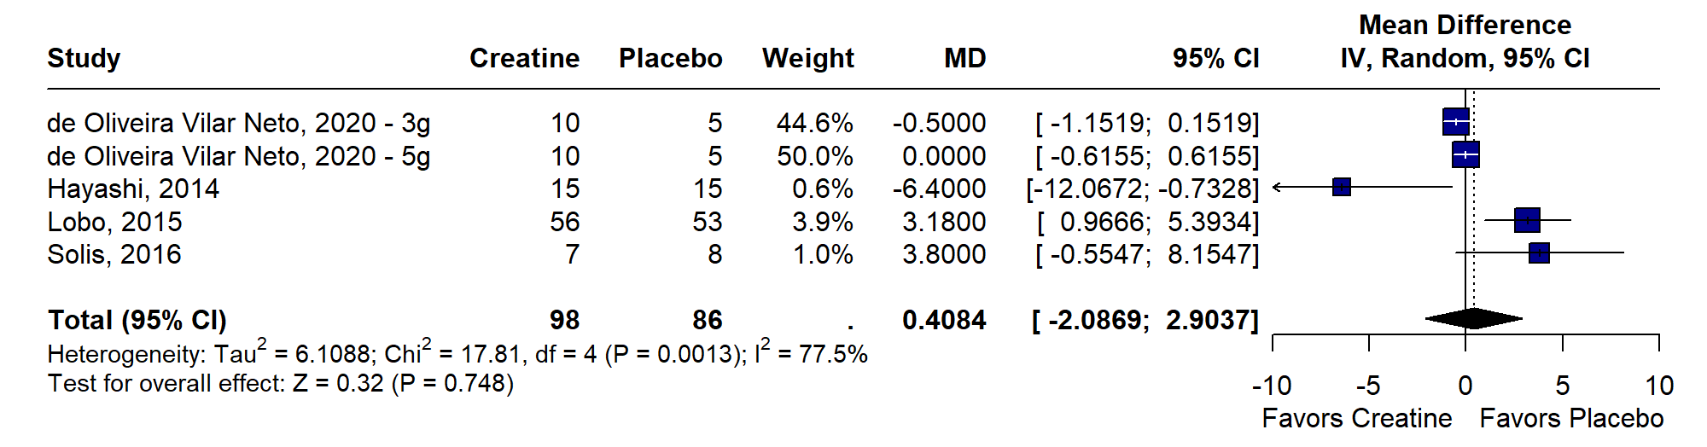

eFigure 17. Urinary creatinine - Leave-One-Out Meta-Analysis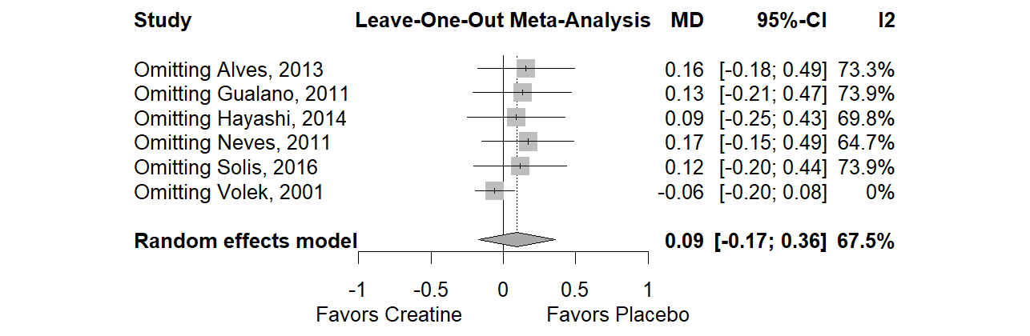

eFigure 18. Urinary creatinine - Baujaut Plot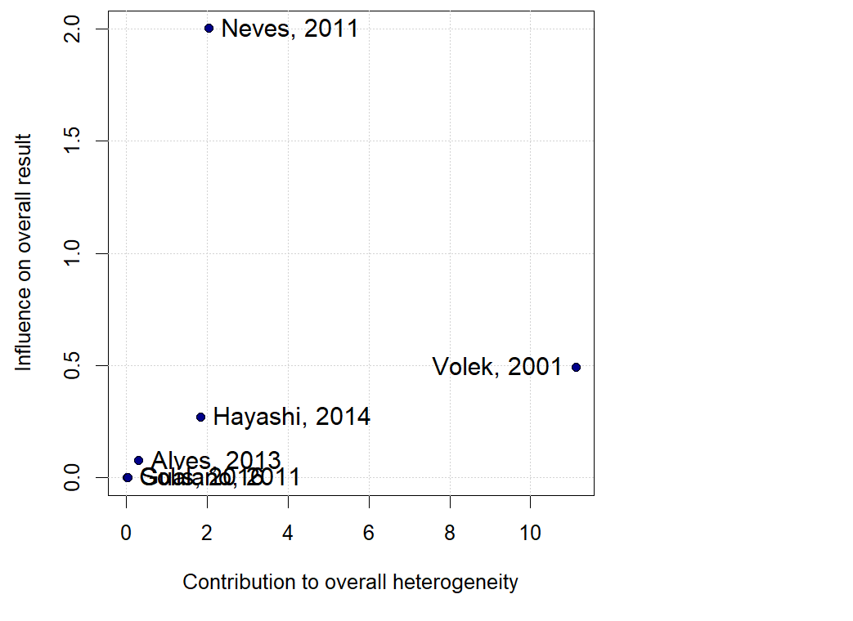

eFigure 19. Albuminuria Leave-One-Out Meta-Analysis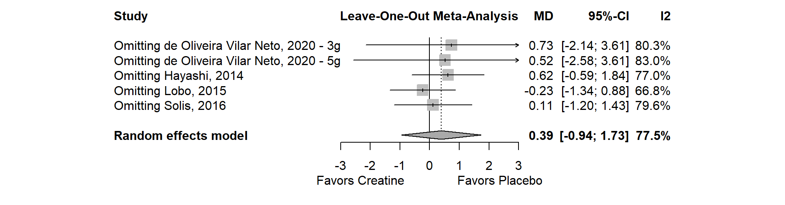

eFigure 20. Albuminuria Baujaut Plot
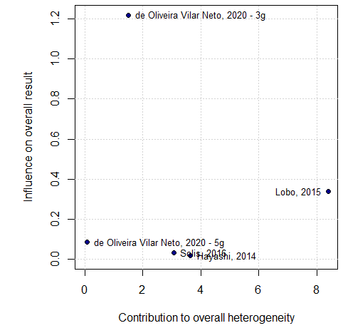

eFigure 21. Risk of Bias Assessment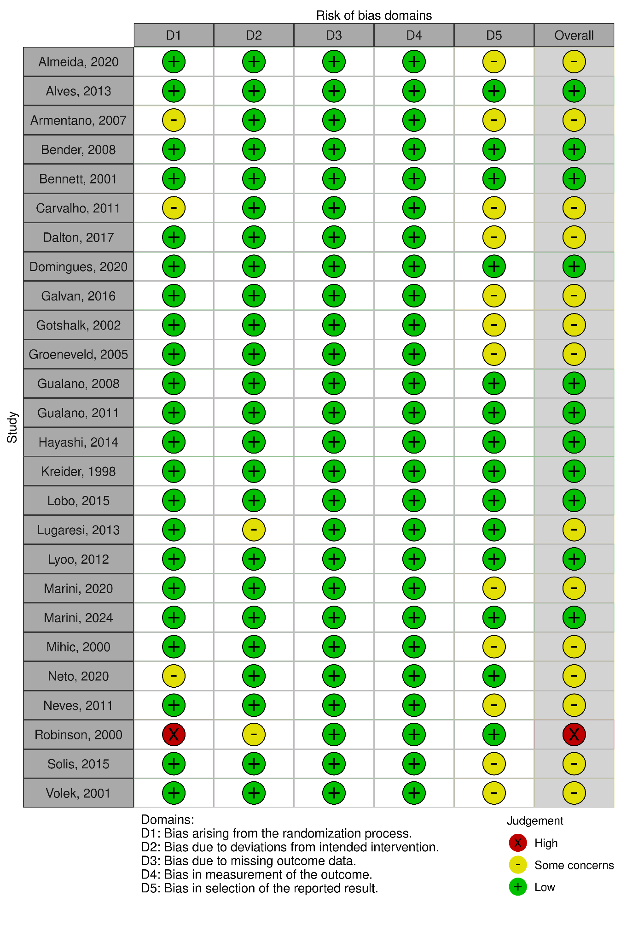
eTable 2. Summary of findings and certainty of evidence assessment.

Outcome | No participants |  | Mean difference [CI 95%] | P-value | Certainty of Evidence (GRADE)
Outcome | Creatine | Placebo | Mean difference [CI 95%] | P-value | Certainty of Evidence (GRADE)
Serum creatinine - long-term supplementation subgroup | 180 | 150 | 0.0880 [0.0305; 0.1456] | 0.003 | ⨁⨁⨁⨁  High^{b}
Serum creatinine - patients undergoing hemodialysis | 33 | 35 | 2.7355 [2.2439; 3.2271] | <0.001 | ⨁⨁⨁⨁  High
Serum urea | 401 | 309 | -0.5238 [-2.9771; 1.9295] | 0.676 | ⨁⨁⨁⨁  High
GFR | 132 | 126 | -2.19 [-9.18; 4.80] | 0.539 | ⨁⨁⨁◯  Moderate^{c,d}
Albuminuria | 98 | 86 | 0.4084 [-2.0869; 2.9037] | 0.748 | ⨁◯◯◯  Very low^{e,f}
Proteinuria | 71 | 73 | 0.0090 [-0.0279; 0.0459] | 0.633 | ⨁⨁⨁◯  Moderateª
Urinary creatinine | 59 | 59 | -0.0581 [-0.1957; 0.0795] | 0.408 | ⨁⨁⨁◯  Moderateª
CI: confidence interval; MD: mean difference

Explanations
a. The confidence interval crosses the line of no effect, including both potential benefit and harm, indicating serious imprecision.
b. Although initial heterogeneity was moderate (I² = 47.3%), sensitivity analysis using the leave-one-out method resolved the inconsistency, supporting a consistent direction of effect across studies.
c. Although initial heterogeneity was moderate (I² = 35.2%), sensitivity analysis using the leave-one-out method resolved the inconsistency, supporting a consistent direction of effect across studies.
d. The confidence interval crosses the line of no effect, including both potential benefit and harm, indicating serious imprecision.
e. Substantial and unexplained heterogeneity was observed across studies (I² = 76%), with considerable variation in the direction and magnitude of effects, leading to very serious inconsistency.
f. The confidence interval crosses the line of no effect, including both potential benefit and harm, indicating serious imprecision.

eFigure 22. Funnel Plot for Serum Urea
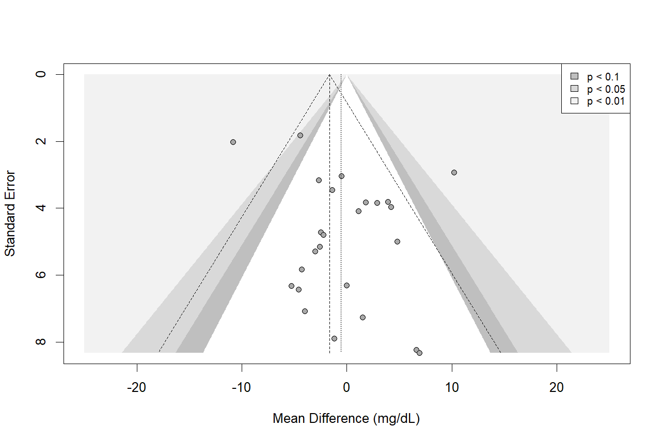
eFigure 23. Funnel Plot for Serum Creatinine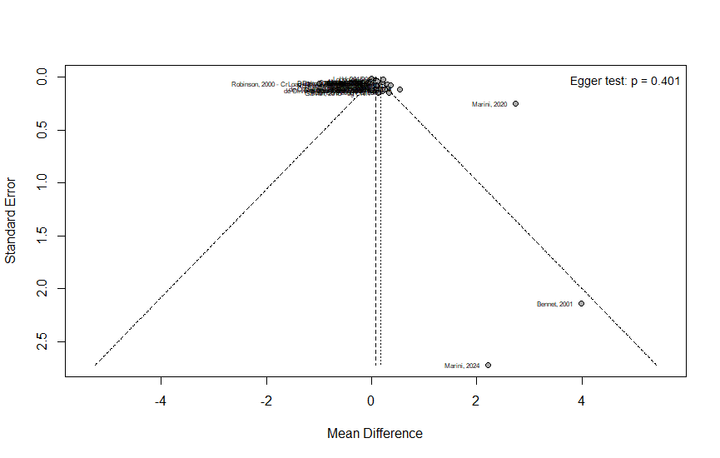
eFigure 24. Funnel Plot for Glomerular Filtration Rate