Online Resource

Herbivory by aboveground insects impacts plant root morphological traits

Johannes Heinze^{1,2}

¹ Institute of Biochemistry and Biology, University of Potsdam, Maulbeerallee 1, 14469 Potsdam, Germany
² Berlin-Brandenburg Institute of Advanced Biodiversity Research (BBIB), 14195 Berlin, Germany, Altensteinstr. 6, 14195 Berlin, Germany

Corresponding author:
Johannes Heinze; University of Potsdam; Institute of Biochemistry and Biology; Biodiversity Research/Systematic Botany; Maulbeerallee 1, D-14469 Potsdam, Germany
Tel.: +49-331-977 4863; E-mail: jheinze@uni-potsdam.de

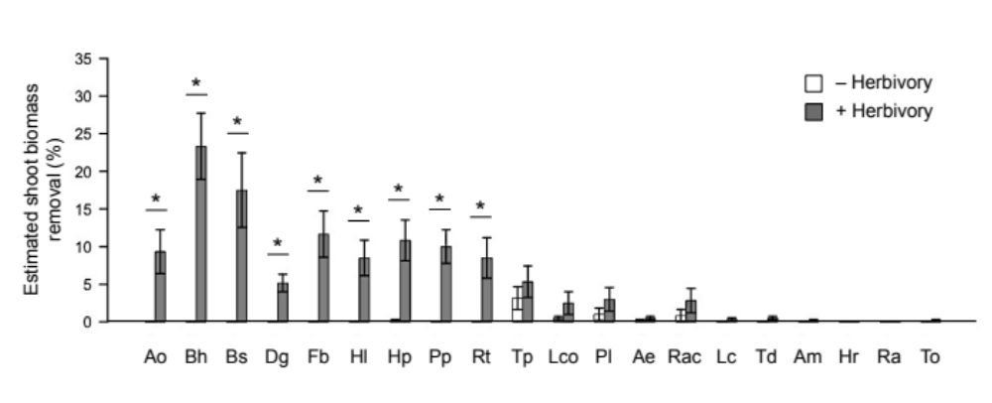

Figure S1 Estimated shoot biomass removal of 20 plant species grown without (white bars) and with (grey bars) aboveground insect herbivores. Data represent mean ± SE (n = 6). Asterisks between bars indicate significant difference after t-test analysis: * P < 0.05. Species are ordered according to Figure 1 in the manuscript. Species abbreviations are as follows: Ao, Anthoxanthum odoratum; Bh, Bromus hordeaceus; Bs, Bromus sterilis; Dg, Dactylis glomerata; Fb, Festuca brevipila; Hl, Holcus lanatus; Hp, Helictotrichon pubescens; Pp, Poa pratensis; Rt, Rumex thyrsiflorus; Tp, Trifolium pratense; Lco, Lotus corniculatus; Pl, Plantago lanceolata; Ae, Arrhenatherum elatius; Rac, Rumex acetosella; Lc, Luzula campestris; Td, Trifolium dubium; Am, Achillea millefolium; Hr, Hypochaeris radicata; Ra, Ranunculus acris; To, Taraxacum officinale.

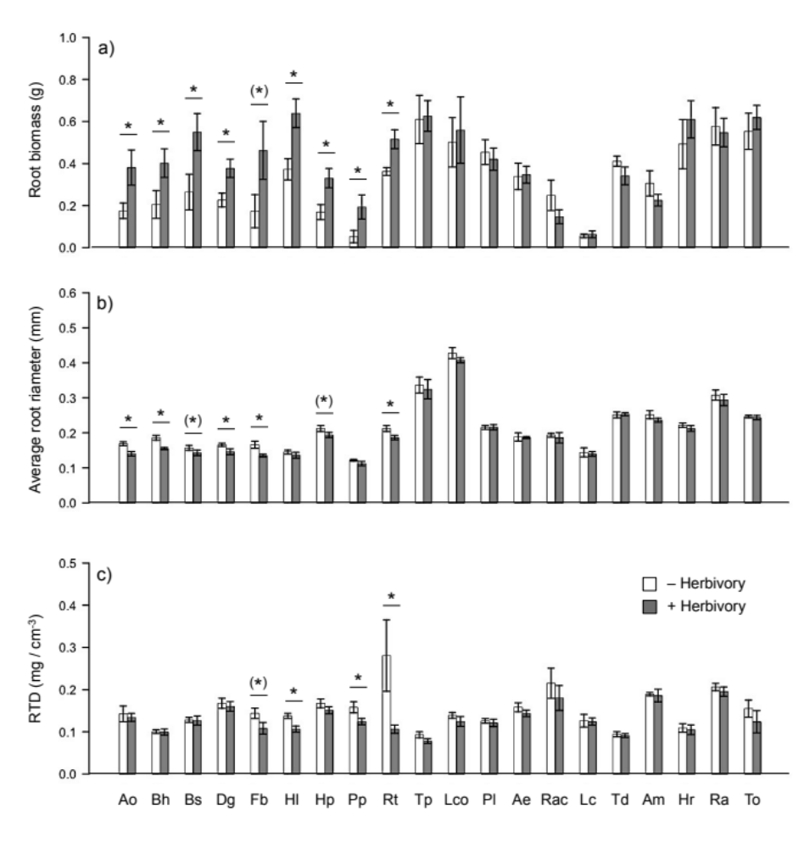
Figure S2 Root biomass (a), average root diameter (b) and root tissue density (RTD, c) of 20 plant species grown without (white bars) and with (grey bars) aboveground insect herbivores. Data represent mean ± SE (n = 6). Asterisks between bars indicate significant difference after t-test analysis: * P < 0.05; ⁽*⁾ P < 0.1. Species abbreviations are given in figure legend of Fig. S1.

Table S1 Total nitrogen and phosphorus concentrations in the 40 different soils used in the experiment. Soils contained 90% sterilized soil:sand mixtures (1:1) inoculated with 10% ‘home’ or ‘away’ soil of the 20 species.
 | Total nitrogen (g * kg-1) |  |  |  |  |  |  | Total phosphorus (g * kg-1)
 | Home |  |  | Away |  |  | P | Home |  |  | Away |  |  | P
Arrhenatherum elatius | 0.393 | ± | 0.099 | 0.398 | ± | 0.077 | n.s. | 0.255 | ± | 0.040 | 0.249 | ± | 0.037 | n.s.
Achillea millefolium | 0.395 | ± | 0.101 | 0.402 | ± | 0.140 | n.s. | 0.252 | ± | 0.041 | 0.252 | ± | 0.052 | n.s.
Anthoxanthum odoratum | 0.384 | ± | 0.098 | 0.379 | ± | 0.112 | n.s. | 0.249 | ± | 0.042 | 0.247 | ± | 0.046 | n.s.
Bromus hordeaceus | 0.401 | ± | 0.100 | 0.389 | ± | 0.063 | n.s. | 0.247 | ± | 0.039 | 0.245 | ± | 0.033 | n.s.
Bromus sterilis | 0.41 | ± | 0.096 | 0.403 | ± | 0.126 | n.s. | 0.25 | ± | 0.039 | 0.248 | ± | 0.049 | n.s.
Dactylis glomearta | 0.412 | ± | 0.111 | 0.399 | ± | 0.075 | n.s. | 0.251 | ± | 0.042 | 0.251 | ± | 0.036 | n.s.
Festuca brevipila | 0.379 | ± | 0.095 | 0.396 | ± | 0.126 | n.s. | 0.253 | ± | 0.043 | 0.25 | ± | 0.051 | n.s.
Holcus lanatus | 0.388 | ± | 0.096 | 0.398 | ± | 0.076 | n.s. | 0.251 | ± | 0.042 | 0.247 | ± | 0.037 | n.s.
Helictotrichon pubescens | 0.383 | ± | 0.096 | 0.377 | ± | 0.122 | n.s. | 0.246 | ± | 0.040 | 0.252 | ± | 0.048 | n.s.
Hypochaeris radicata | 0.377 | ± | 0.100 | 0.386 | ± | 0.068 | n.s. | 0.248 | ± | 0.039 | 0.247 | ± | 0.034 | n.s.
Luzula campestris | 0.398 | ± | 0.096 | 0.386 | ± | 0.127 | n.s. | 0.248 | ± | 0.039 | 0.249 | ± | 0.049 | n.s.
Lotus corniculatus | 0.393 | ± | 0.098 | 0.389 | ± | 0.128 | n.s. | 0.257 | ± | 0.038 | 0.245 | ± | 0.048 | n.s.
Plantago lanceolata | 0.375 | ± | 0.095 | 0.389 | ± | 0.131 | n.s. | 0.248 | ± | 0.040 | 0.246 | ± | 0.051 | n.s.
Poa pratensis | 0.402 | ± | 0.103 | 0.394 | ± | 0.096 | n.s. | 0.249 | ± | 0.042 | 0.253 | ± | 0.041 | n.s.
Ranunculus acris | 0.399 | ± | 0.095 | 0.401 | ± | 0.142 | n.s. | 0.251 | ± | 0.038 | 0.254 | ± | 0.052 | n.s.
Rumex acetosella | 0.413 | ± | 0.110 | 0.399 | ± | 0.124 | n.s. | 0.254 | ± | 0.041 | 0.249 | ± | 0.047 | n.s.
Rumex thyrsiflorus | 0.387 | ± | 0.094 | 0.397 | ± | 0.124 | n.s. | 0.249 | ± | 0.039 | 0.252 | ± | 0.049 | n.s.
Trifolium dubium | 0.374 | ± | 0.098 | 0.395 | ± | 0.051 | n.s. | 0.249 | ± | 0.041 | 0.248 | ± | 0.030 | n.s.
Taraxacum officinale | 0.405 | ± | 0.094 | 0.402 | ± | 0.138 | n.s. | 0.257 | ± | 0.038 | 0.249 | ± | 0.051 | n.s.
Trifolium pratense | 0.389 | ± | 0.095 | 0.403 | ± | 0.116 | n.s. | 0.251 | ± | 0.042 | 0.251 | ± | 0.048 | n.s.
P (Species x Soil) | n.s. |  |  | n.s. |  |  |  | n.s. |  |  | n.s.
Note: Nutrient differences among soil types were tested using chemical digestion and photometric methods according to Heinze et al. 2016.
Within rows differences in nutrients between “home” and “away” soils were tested with two-sample t-tests for each species. P-values at the end of columns represent results of ANOVAs testing for differences between species soils. Data represent mean ± SE (n = 9).
Table S2 ANOVA results from generalized linear mixed effects models that tested the effects of functional group (a; grasses vs. forbs), species (b; 20 species), soil biota (‘home’ vs. ‘away’) and herbivory treatment (‘+ herbivory’ vs. ‘- herbivory’) on the estimated shoot biomass removal, number of damaged plant individuals, root biomass, specific root length (SRL), specific root surface area (SRSA), average root diameter (AD) and root tissue density (RTD). Significant effects (p < 0.05) are reported in bold.
 |  | Est. shoot removal |  |  | # dam. individuals |  |  | Root biomass |  |  | SRL |  |  | SRSA |  |  | AD |  |  | RTD
(a) | Df | F | P |  | F | P |  | F | P |  | F | P |  | F | P |  | F | P |  | F | P
Func. gr. (F) | 1 | 30.24 | < 0.001 |  | 9.08 | < 0.001 |  | 7.01 | 0.016 |  | 24.05 | < 0.001 |  | 14.02 | 0.002 |  | 19.51 | 0.001 |  | 1.43 | 0.169
Soil biota (SB) | 1 | 13.05 | < 0.001 |  | 1.40 | 0.979 |  | 0.08 | 0.783 |  | 1.57 | 0.211 |  | 0.07 | 0.788 |  | 1.89 | 0.171 |  | 0.19 | 0.663
Herbivory (H) | 1 | 83.04 | < 0.001 |  | 11.47 | < 0.001 |  | 37.27 | < 0.001 |  | 58.01 | < 0.001 |  | 43.43 | < 0.001 |  | 20.16 | < 0.001 |  | 13.78 | < 0.001
F x SB | 1 | 2.98 | 0.085 |  | 0.99 | 0.196 |  | 0.53 | 0.468 |  | 2.34 | 0.127 |  | 0.86 | 0.354 |  | 0.45 | 0.504 |  | 0.99 | 0.320
F x H | 1 | 39.98 | < 0.001 |  | 11.53 | < 0.001 |  | 6.31 | 0.013 |  | 11.80 | < 0.001 |  | 2.35 | 0.026 |  | 2.09 | 0.045 |  | 2.09 | 0.089
SB x H | 1 | 16.09 | < 0.001 |  | 1.13 | 0.125 |  | 2.57 | 0.145 |  | 1.62 | 0.205 |  | 0.38 | 0.538 |  | 0.79 | 0.375 |  | 0.51 | 0.474
F x SB x H | 1 | 2.06 | 0.153 |  | 0.01 | 0.899 |  | 0.01 | 0.946 |  | 2.91 | 0.119 |  | 1.68 | 0.197 |  | 0.22 | 0.642 |  | 1.42 | 0.151
Error | 232
(b) | Df | F | P |  | F | P |  | F | P |  | F | P |  | F | P |  | F | P |  | F | P
Species (S) | 19 | 18.44 | < 0.001 |  | 0.36 | < 0.001 |  | 14.78 | < 0.001 |  | 37.05 | < 0.001 |  | 18.59 | < 0.001 |  | 100.42 | < 0.001 |  | 8.47 | < 0.001
Soil biota (SB) | 1 | 46.35 | < 0.001 |  | 0.10 | 0.998 |  | 0.10 | 0.754 |  | 1.75 | 0.188 |  | 0.10 | 0.753 |  | 1.62 | 0.223 |  | 0.30 | 0.616
Herbivory (H) | 1 | 296.78 | < 0.001 |  | 0.86 | < 0.001 |  | 48.19 | < 0.001 |  | 63.66 | < 0.001 |  | 46.93 | < 0.001 |  | 17.56 | < 0.001 |  | 18.39 | < 0.001
S x SB | 19 | 5.31 | < 0.001 |  | 0.06 | 0.899 |  | 1.30 | 0.189 |  | 1.09 | 0.365 |  | 1.29 | 0.195 |  | 0.30 | 0.998 |  | 1.35 | 0.143
S x H | 19 | 19.32 | < 0.001 |  | 0.09 | < 0.001 |  | 4.15 | < 0.001 |  | 3.30 | < 0.001 |  | 2.06 | 0.009 |  | 2.49 | 0.024 |  | 2.58 | < 0.001
SB x H | 1 | 57.20 | < 0.001 |  | 0.04 | 0.168 |  | 2.37 | 0.126 |  | 1.80 | 0.182 |  | 0.46 | 0.498 |  | 0.67 | 0.415 |  | 0.61 | 0.426
S x SB x H | 19 | 5.36 | < 0.001 |  | 0.03 | 0.459 |  | 1.12 | 0.332 |  | 0.70 | 0.816 |  | 0.78 | 0.723 |  | 0.74 | 0.773 |  | 1.11 | 0.175
Error | 160

